Figure list
Figure 1. Tomáš Staudek’s aesthetic measurement of vases
Figure 2. The process of the research
Figure 3. The yacht G
Figure 4. Preference ranking and scores of the Taiwanese elements going to be blended (Score; Selection; Percentage)
Figure 5. The feature curves of the G yacht
Figure 6. The selected feature curves of Taiwanese leopard cat
Figure 7. Taiwanese aboriginal patterns
Figure 8. The blending interface
Figure 9. The blending results with different weights from the waterline of the datum hull and the top view of Taiwanese leopard cat
Figure 10. The blending results from the side outline of the datum hull and the side outline of Taiwanese leopard cat
Figure 11. The blending results from the deck fence and part of the Taiwanese leopard cat’s outline
Figure 12. The blending results from the top view of main deck and the hundred pacer’s head
Figure 13. The results of aesthetic test
Figure 14. The final result
Figure 15. The rendering diagram of the final result

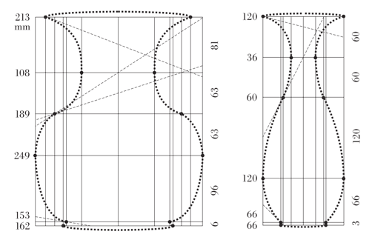
Figure 1. Tomáš Staudek’s aesthetic measurement of vases
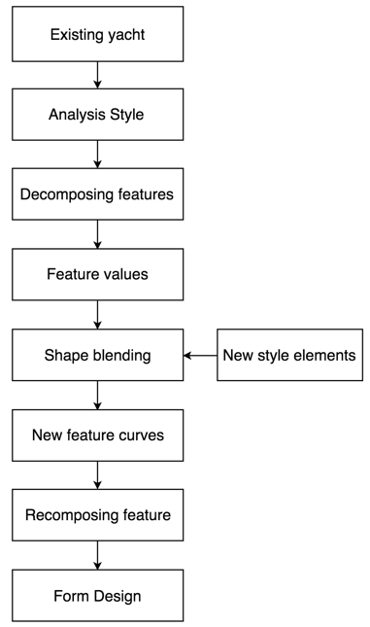
Figure 2. The process of the research
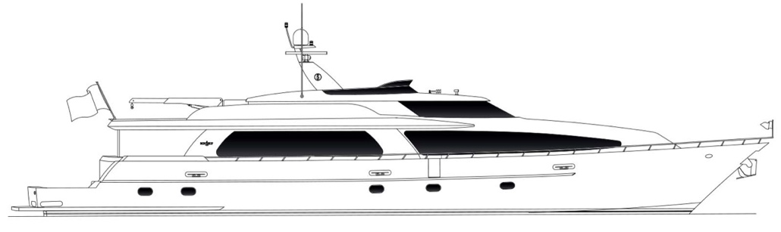
Figure 3. The yacht G
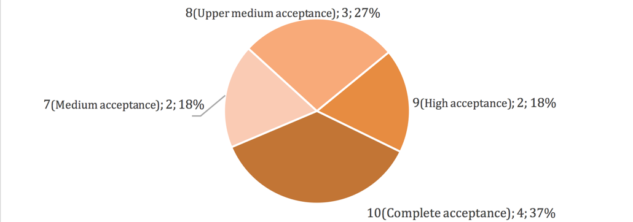
Figure 4. Preference ranking and scores of the Taiwanese elements going to be blended (Score; Selection; Percentage)
(a) The outline of the main deck (side view)
(b) The fence of the deck (side view)
(c) Rooftop
(d) The outline of the main deck (top view)
Figure 5. The feature curves of the G yacht
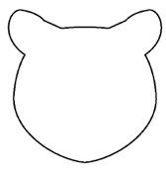
(a) Outline of head (front view)
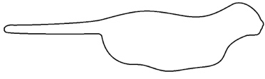
(b) Outline of a section (side view)
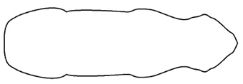
(c) Outline of a section (top view)
Figure 6. The selected feature curves of Taiwanese leopard cat

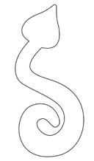
- Hundred pacer (Deinagkistrodon)
(b) The eye of sun
Figure 7. Taiwanese aboriginal patterns
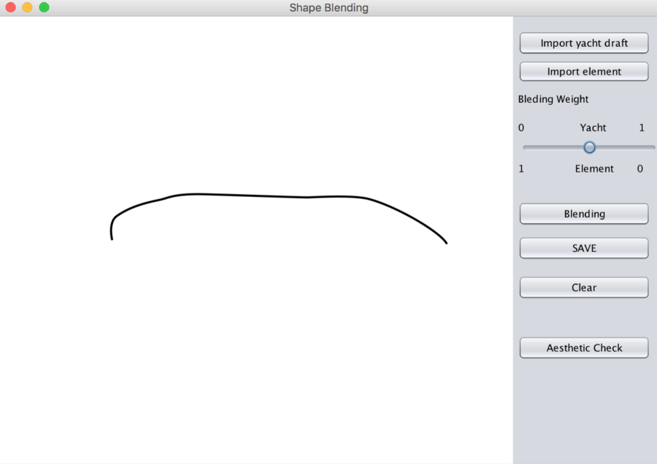
Figure 8. The blending interface

(a) the weight of ship, W_{S}: 0.4; the weight of element, W_{E}:0.6
(b) the weight of ship, W_{S}: 0.5; the weight of element, W_{E}:0.5
(c) the weight of ship, W_{S}: 0.8; the weight of element, W_{E}:0.2
Figure 9. The blending results with different weights from the waterline of the datum hull and the top view of Taiwanese leopard cat

(a) the weight of ship, W_{S}: 0.4; the weight of element, W_{E}:0.6
(b) the weight of ship, W_{S}: 0.5; the weight of element, W_{E}:0.5
(c) the weight of ship, W_{S}: 0.8; the weight of element, W_{E}:0.2
Figure 10. The blending results from the side outline of the datum hull and the side outline of Taiwanese leopard cat

- The deck fence

- The blending result

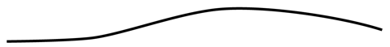
- The part of the outline from Taiwanese leopard cat
Figure 11. The blending results from the deck fence and part of the Taiwanese leopard cat’s outline

Figure 12. The blending results from the top view of main deck and the hundred pacer’s head

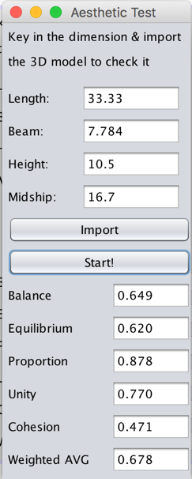
(a) the first result
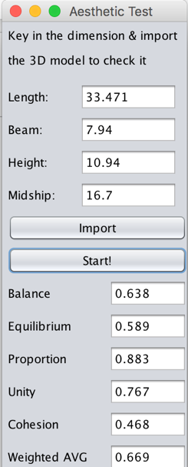
(b) the second result
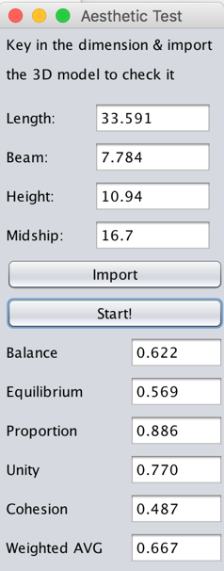
(c) the third result
Figure 13. The results of aesthetic test
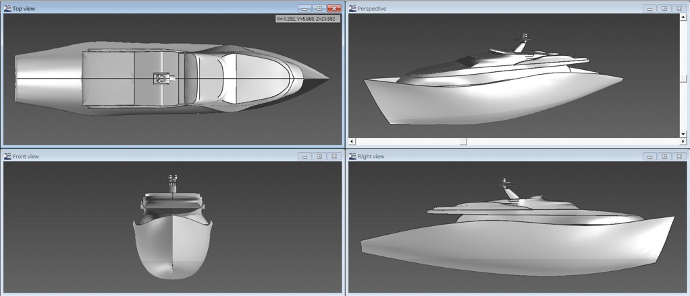
Figure 14. The final result
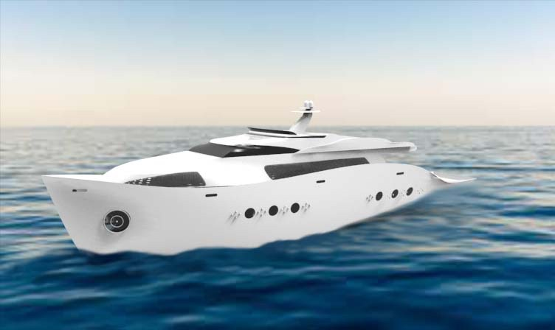
Figure 15. The rendering diagram of the final result

