**Appendix**

A.1 Eight selected yacht samples

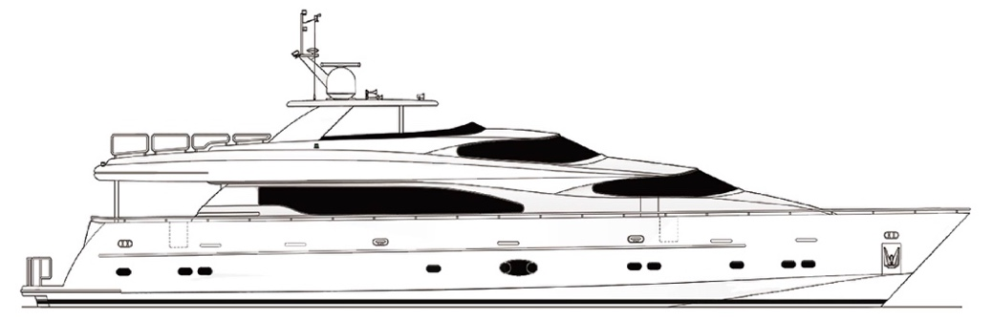

1. Raised pilothouse yacht A

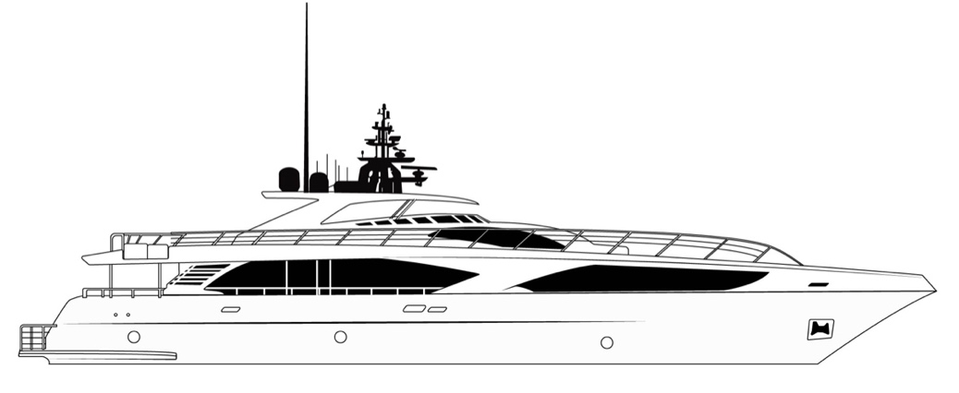

1. Luxury leisure yacht B

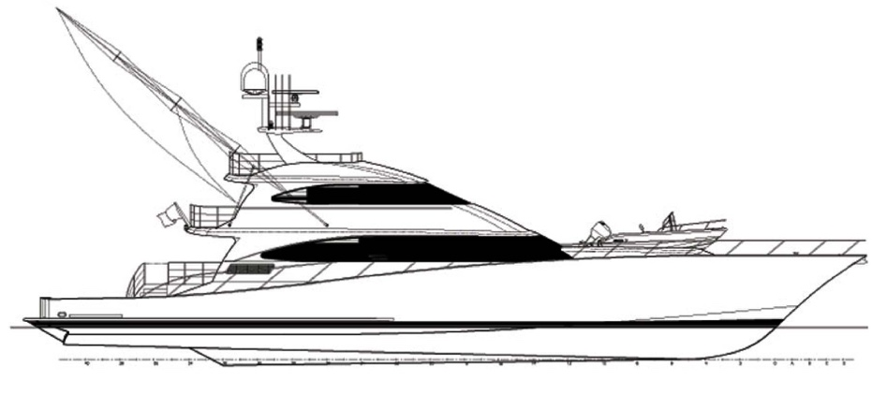

1. Luxury sport fisher yacht C

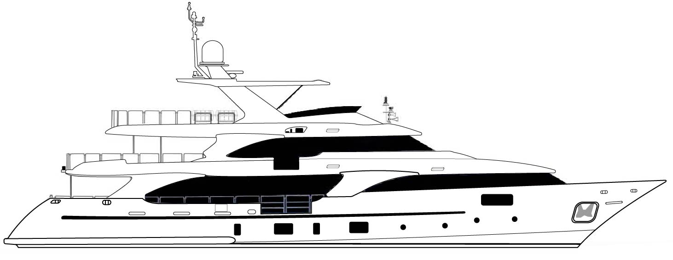

1. Luxury leisure yacht D

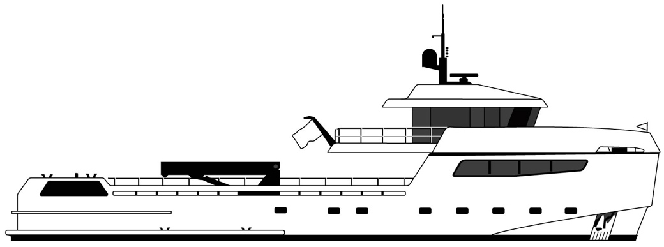

1. Sailing support yacht E

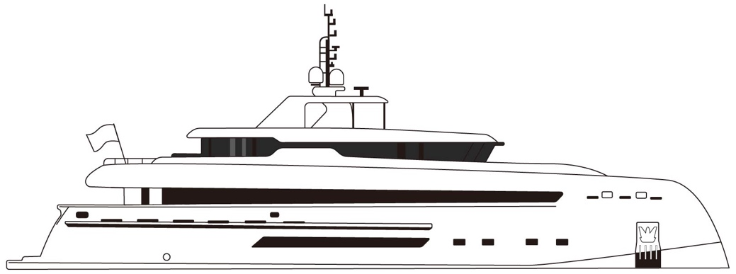

1. Luxury leisure yacht F

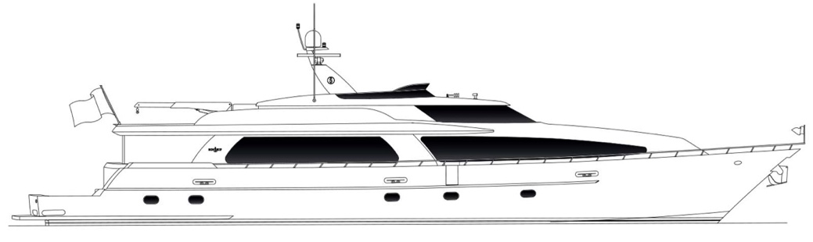

1. Luxury leisure yacht G

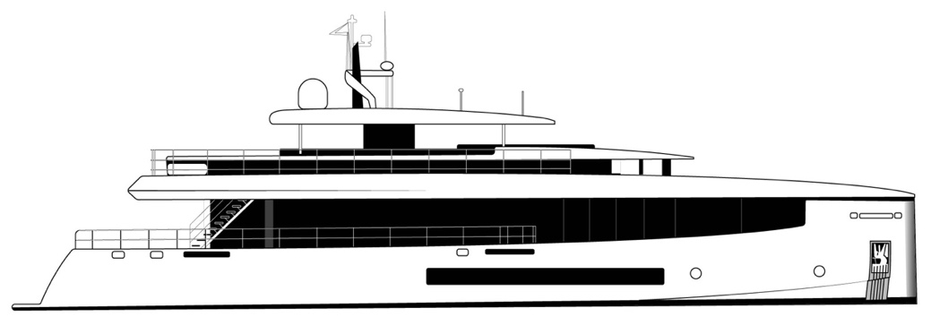

(h) Luxury leisure yacht H

A.2 Taiwan's feature pictures used in the survey

|  |  |  |
| --- | --- | --- |
|  |  | |
| 1. Butterfly | 1. Taiwanese salmon | |
|  |  | |
| 1. Taiwanese Leopard cat | 1. Hakka pattern | |
|  | |  | |
| 1. Taiwanese aborigine pattern | | 1. Taiwanese aboriginal canoe | |
|  |  | |
| 1. Orchid | 1. Taipei 101 | |

(Resources: Google Images, www.google.com.tw/imghp)