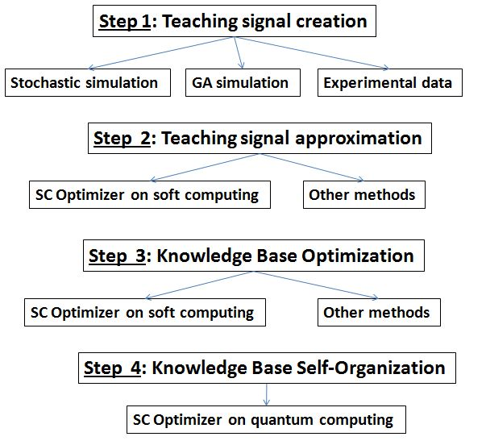
Figure A1. Main steps of the information technology for ICS design

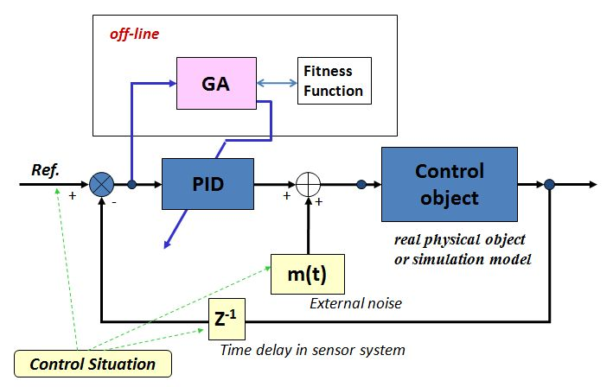
Figure A2. The general structure of stochastic simulation system

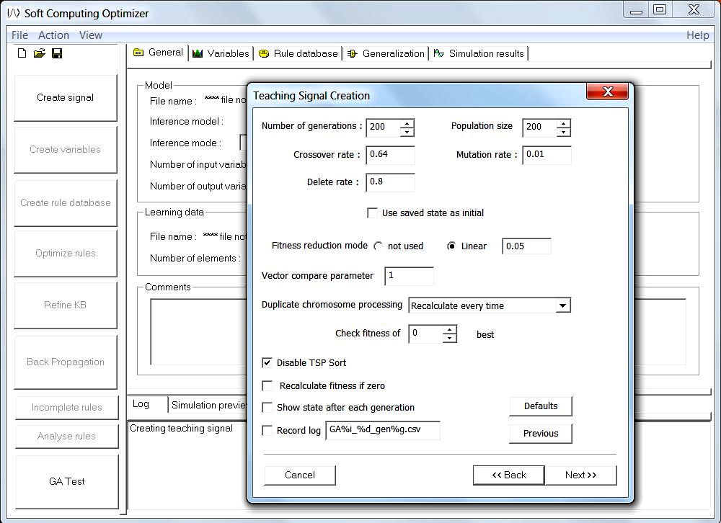
Figure A3. Main menu SCO and GA parameters window

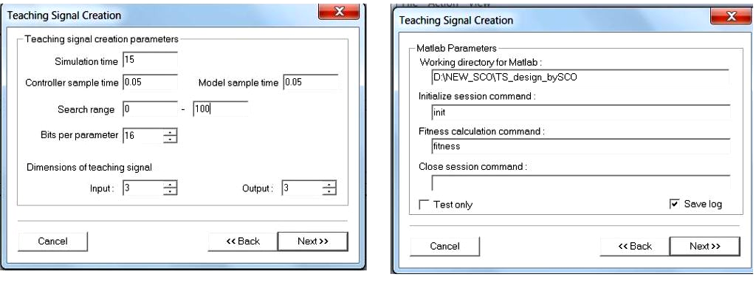
Figure A4. Windows of TS creation

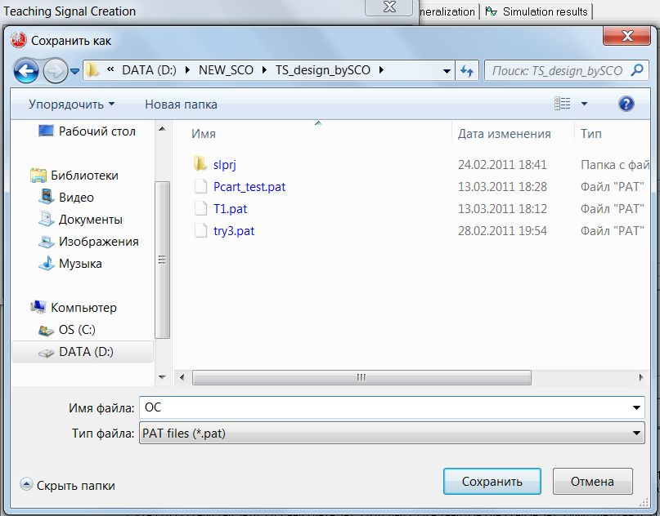
Figure A5. Window of saving TS

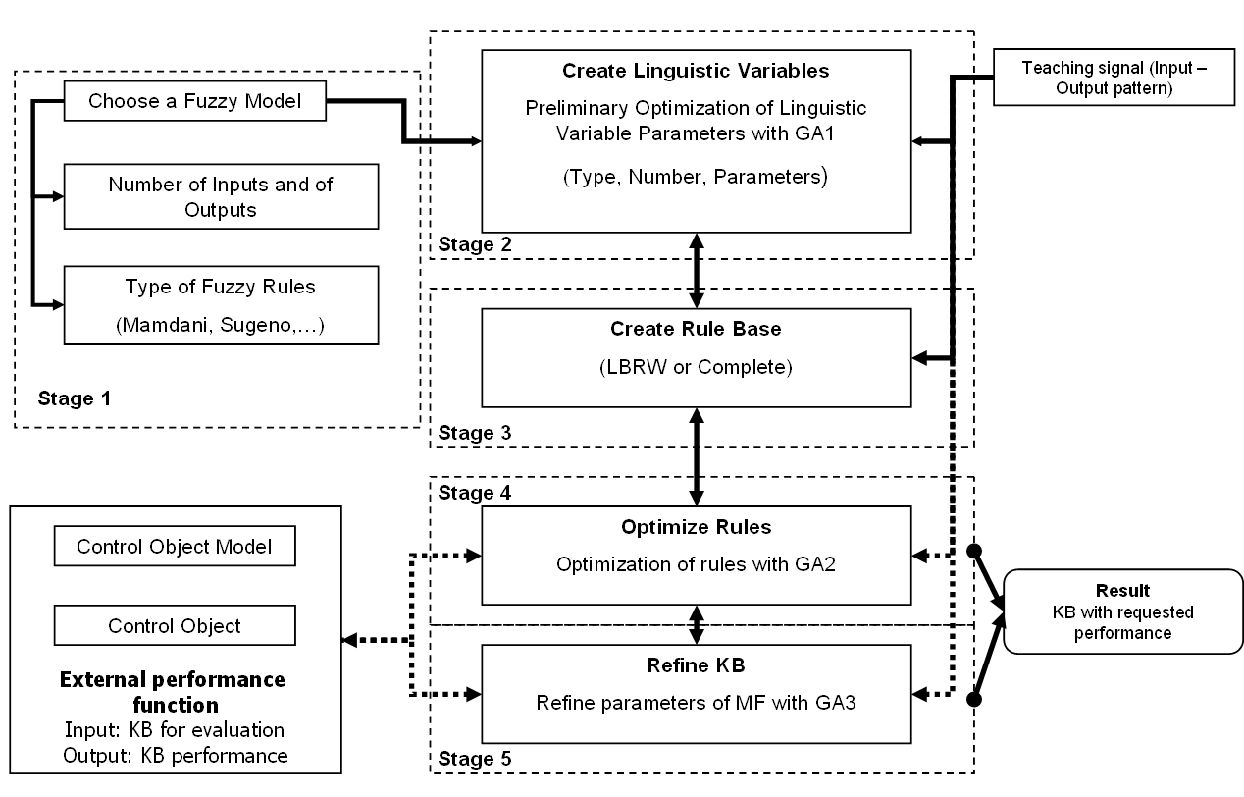
Figure A6: Flow chart of SC Optimizer

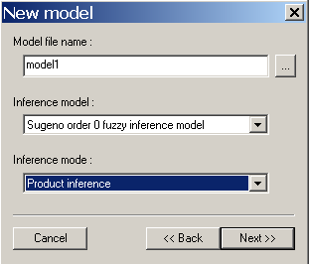 | 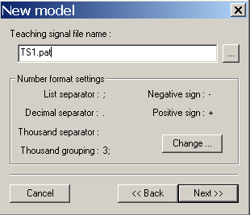
(а) | (b)
Figure A7. New model creation windows

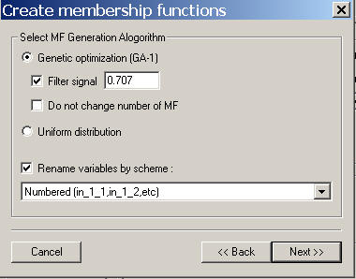
Figure A8. Create MFs window

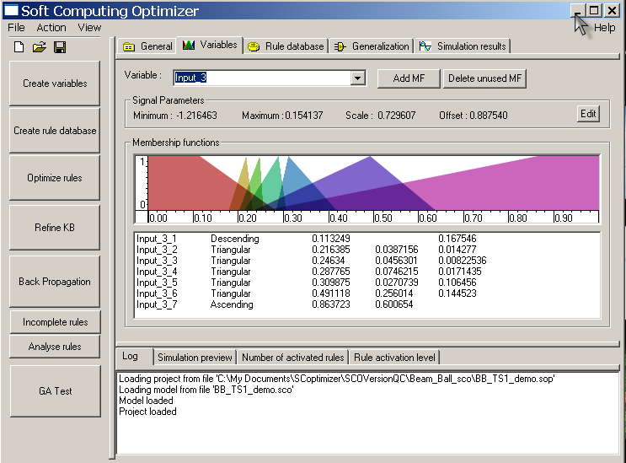 Figure A9. Example of designed MFs

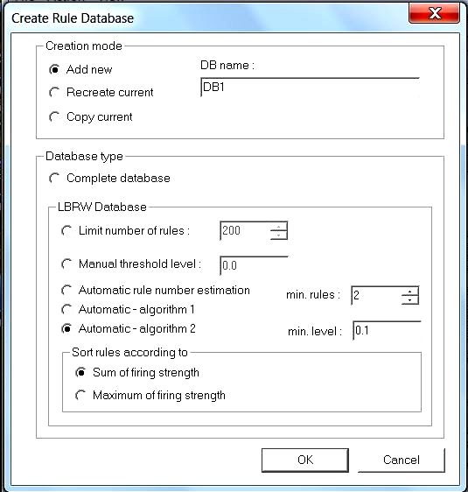
Figure A10. Create rules window

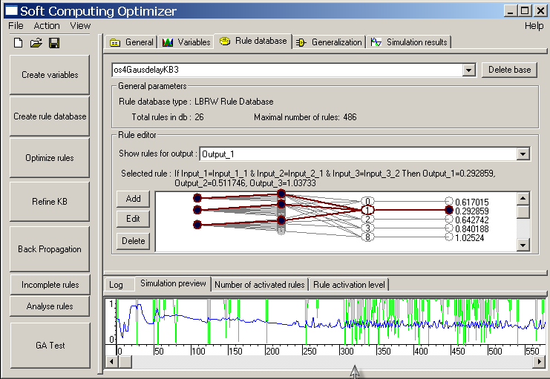 Figure A11. Example of designed rules database

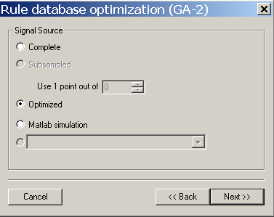
Figure A12. Rule database optimization window

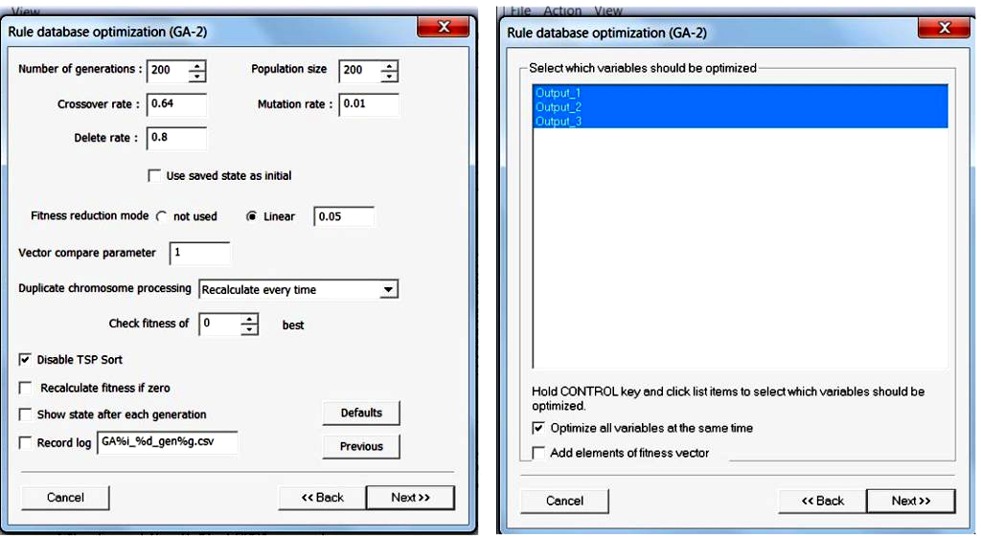
Figure A13. Choice of GA parameters and selecting variables

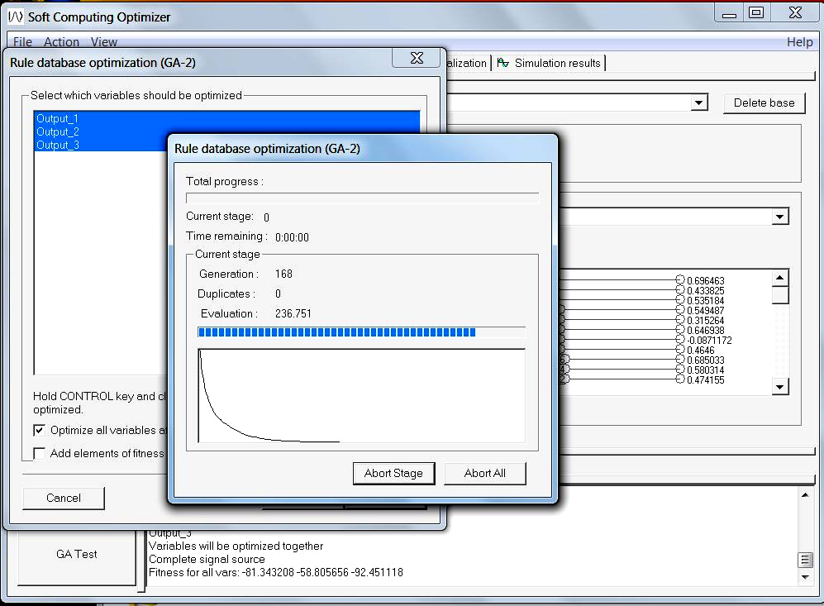
Figure A14. Progress window of optimization process

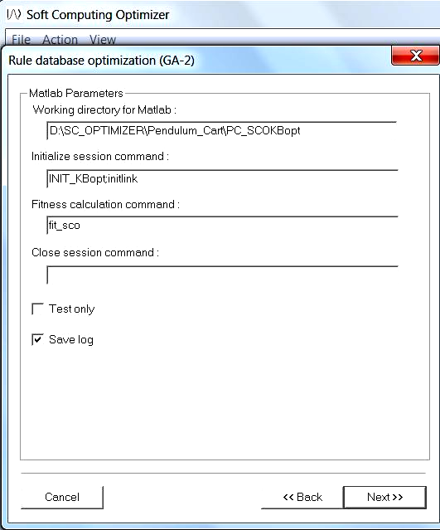
Figure A15. Window for connection to Matlab/Simulink model

