Figure 21. The quality of the ICM based on KBO on soft and quantum computing in the conditions of strong noise in the control channels

Figure 22. Noise in the control channel

(a) | (b)
Figure 23. Control signals generated by ICS based on soft (a) and quantum (b) computing
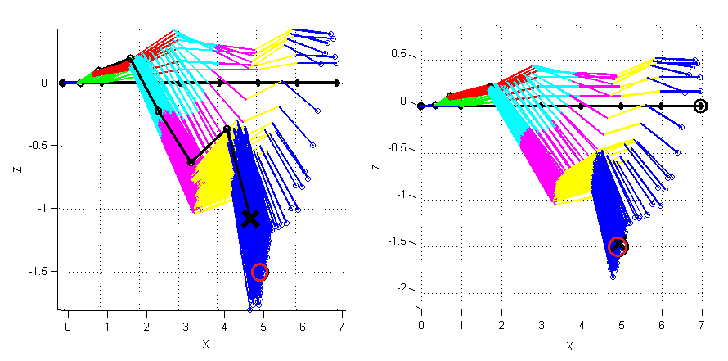
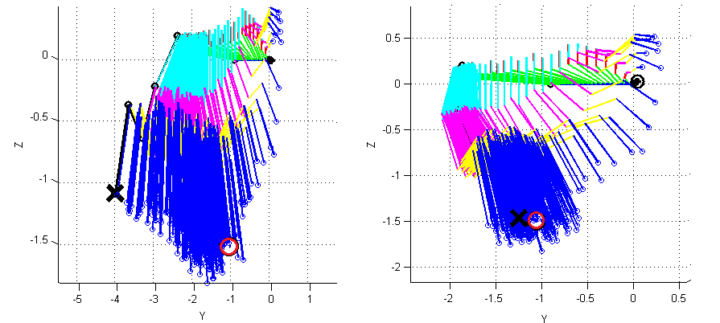
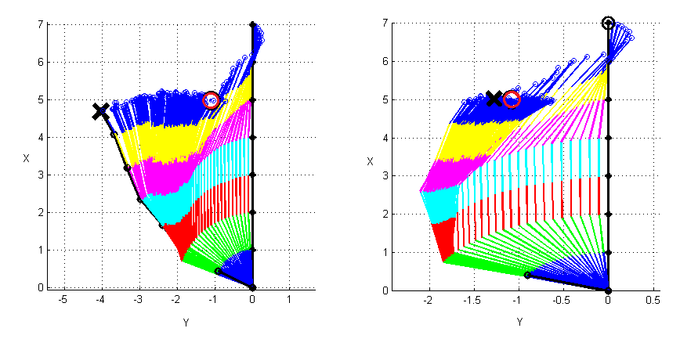
(a) | (b)
Figure 24. The position of the manipulator in space when operating ICS based on soft (a) and quantum computing (b)

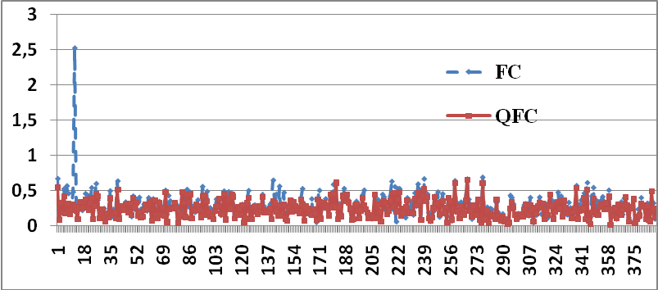
Figure 25. Functional device metric positioning error [m]: FC is the result of ICS operation based on soft computing, QFC is the result of ICS operation based on quantum computing

Figure 26. The quality of the ICM based on KBO on soft and quantum computing in the conditions of strong noise in MS
Figure 27. Noise in the control channel

0  100  200  300  0  20  40  60  80  q1  0  100  200  300  0  5  10  15  q2  0  100  200  300  -100  -50  0  50  100  q3  0  100  200  300  -50  0  50  q4  0  100  200  300  -40  -20  0  20  40  q5  0  100  200  300  0  20  40  60  q6  0  100  200  300  -100  -50  0  50  100  q7  Current position  Reference signal  Error | 0  100  200  300  0  20  40  60  80  q1  0  100  200  300  0  5  10  15  q2  0  100  200  300  -100  -50  0  50  100  q3  0  100  200  300  -60  -40  -20  0  20  40  q4  0  100  200  300  -40  -20  0  20  40  q5  0  100  200  300  0  10  20  30  40  50  q6  0  100  200  300  -100  -50  0  50  100  0  Current position  Reference signal  Error
(a) | (b)
Figure 28. Measured signals during operation ICS based on soft (a) and quantum (b) computing
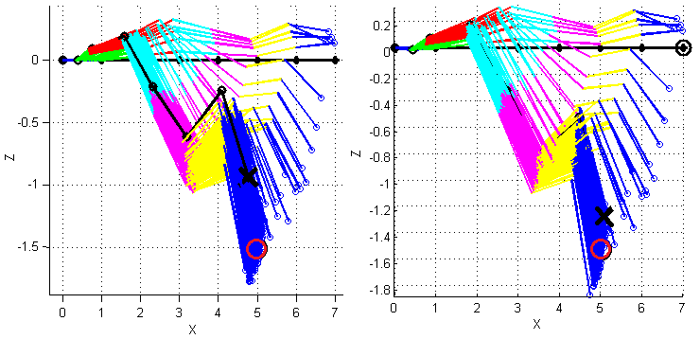
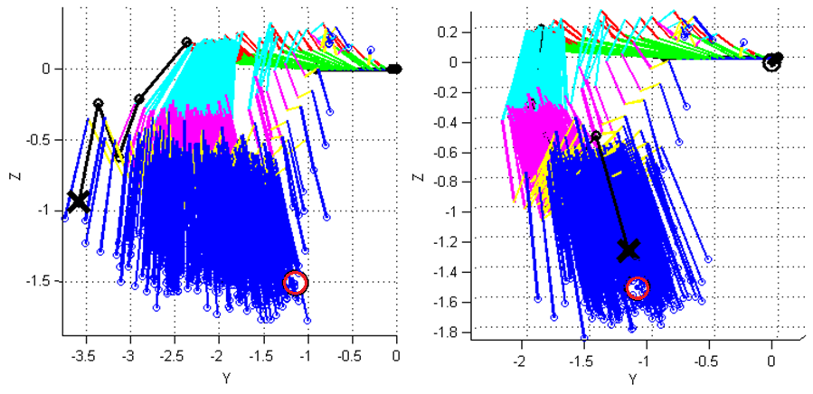
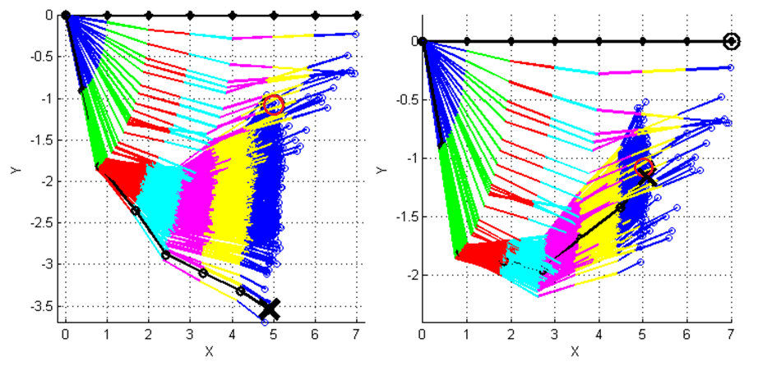
(a) | (b)
Figure 29. The position of the manipulator in space when operating ICS based on soft (a) and quantum computing (b)

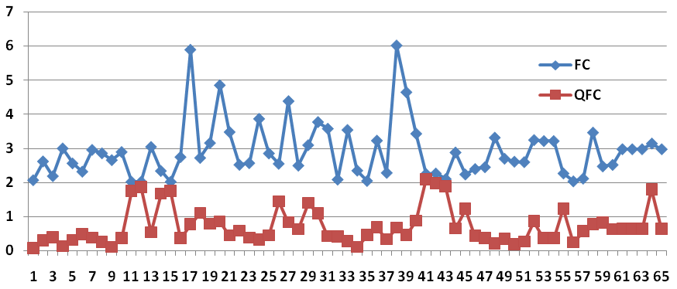
Figure 30. Functional device metric positioning error [m]: FC is the result of ICS operation based on soft computing, QFC is the result of ICS operation based on quantum computing

