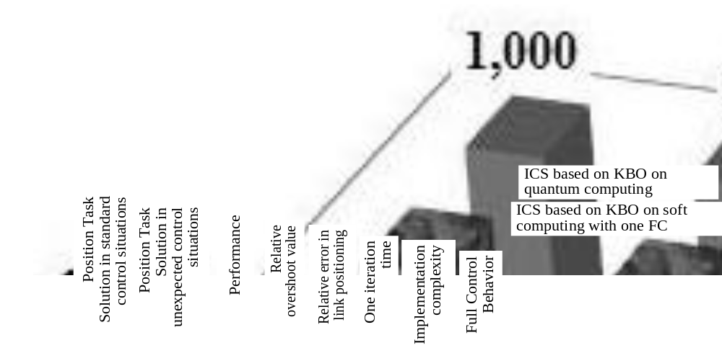
Figure 41. Comparison of the results of ICS based on KBO on soft computing with one FC and ICS based on quantum computing when testing Matlab / Simulink models

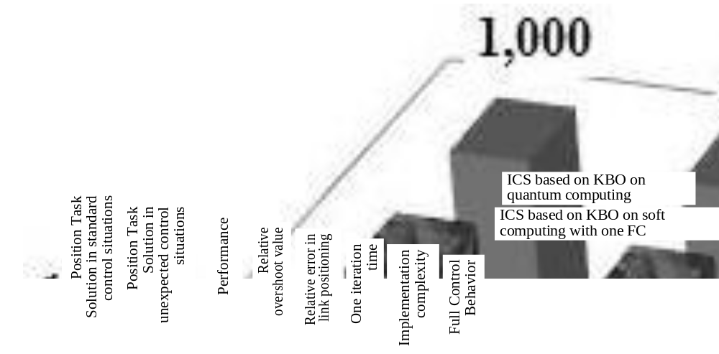Figure 42. Comparison of the results of ICS based on KBO on soft computing with one FC and ICS based on quantum computing when testing manipulator Testbench

