Appendix 1: Emotional Learning and Its utilization in Control Engineering [56]. The Limbic System, as part of the mammalian creatures' brain, is mainly in charge of the emotional processes. The Limbic System located in the cerebral cortex consists mainly of following components: Amygdala, Orbitofrontal Cortex, Thalamus, Sensory Cortex, Hypothalamus, Hippocampus and some other less important areas. In this section, we try to describe briefly these main components and their tasks. Fig. A1.1 illustrates the anatomy of the main components of Limbic System. The first sign of affective conditioning of the system appears in Amygdala which is a small almond-shaped in sub-cortical area. This component is placed in a way to communicate with all other Sensory Cortices and areas within the Limbic System. The Amygdala connections to/from other components are illustrated in Fig. A1.2. The studies show that a stimulus and its emotional consequences are associated in the Amygdala area. In this region, highly analyzed stimuli in the Sensory Cortices, as well as coarsely categorized stimuli in the Thalamus are associated with an emotional value.
In a reciprocal connection, the Orbitofrontal Cortex, as of another component of the brain system, interacts with the Amygdala. The main interrelated function of this component is: Working Memory, Preparatory Set and Inhibitory Control. The current and recent past events are represented in the Working Memory. The Preparatory Set is the priming of other structures in anticipation of impending action. Inhibitory Control is the selective suppression of areas that may be inappropriate in the current situation. More specifically, the Orbitofrontal Cortex takes action in omission of the expected reward or punishment and control the extinction of the learning in the Amygdala. Another component in this area is Thalamus which lies next to the basal ganglia. It is a non-homogeneous sub-cortical structure and a way-station between cortical structures and sub-cortical. Moreover, various parts of the Thalamus also relay the majority of sensory information from the peripheral sensory systems to the Sensory Cortices. Particularly, the Thalamic Sensory Inputs going to the Amygdala are believed to mediate inherently emotionally charged stimuli as well as coarsely resolved stimuli in general. The Thalamus signal going to the Amygdala evades the processes involved in the Sensory Cortex and other components of the system. Therefore, Amygdala receives a non-optimal but fast stimulus from the Thalamus which among the input stimuli is often known as a characteristic signal.
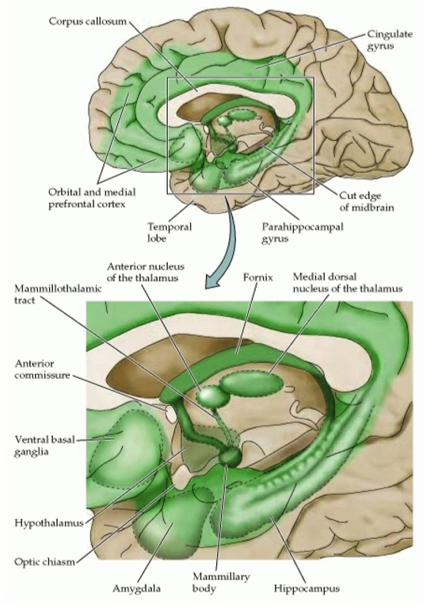
Fig. A1.1. The major brain structures associated with the Limbic System
The next component is the Sensory Cortex close to the Thalamus which receives its input from the latter one. In fact, Sensory Cortex processes the information from the sensory areas. The Sensory Cortex sends highly analyzed input to the Amygdala and Orbitofrontal. Generally, the mammalians use these areas of their Limbic System for higher perceptual processing. Below the Thalamus, lies another component named Hypothalamus which is apparently in charge of regulation of the endocrine system, the autonomous nervous system and primary behavioral surviving states. The lateral region of Hypothalamus is connected to various regions of the Amygdala and vice versa. The connections are believed to have a major role in motivational control of the Structures within the Hypothalamus. Furthermore, one of the most complex and twisting components of the Limbic System is Hippocampus which is located in the same area as the Amygdala. Its main role is the mapping of the environment based on environmental cue. The Hippocampus has other functions such as spatial navigation, laying down of the long-term memory and formation of the contextual representations.
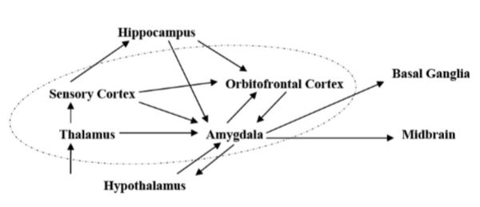
Fig. A1.2. Connections of the Amygdala with other components of the Limbic System
The main issue in using the emotional learning for different applications is defining the sensory and emotional signals in such a way that properly represent the state and objectives of the system. Some of researchers have developed intelligent systems based on BELBIC which in this section some of the designed applications are briefly introduced and the results of simulation are demonstrated in some applications. Rouhani and co-workers used BELBIC in a neuro-fuzzy model of microheat exchanger. First, a locally linear learning algorithm called Locally Linear Mode Tree (LoLiMoT) was applied to build the neuro-fuzzy model. Then, the BELBIC based on PID control was adopted for the micro-heat exchanger plant. The performance of presented controller was compared with classic PID controller. Fig. A1.3 and Fig. A1.4 show the closed-loop system response using BELBIC and PID controller respectively. As shown the performance of the system using BELBIC is much better than that of PID controller.
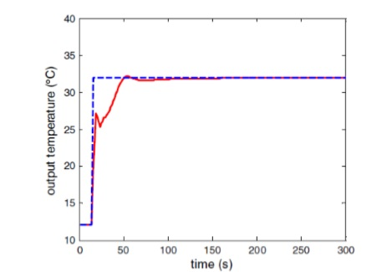
Fig. A1.3. Closed-loop system response using BELBIC with LoLiMoT identifier
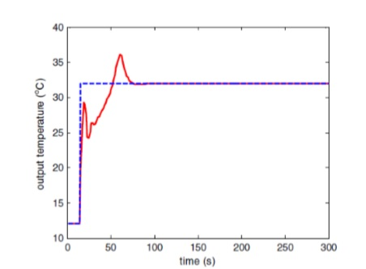
Fig. A1.4. Closed-loop system response using PID with LoLiMoT identifier
Jafarzadeh et al. proposed an intelligent autopilot for a 2-DoF helicopter model based on BELBIC. The majority of previous systems were based on the linearization model or through several linearization techniques for helicopter that made the proposed controls unreliable. The designed model used a BELBIC controller and feedback linearization technique to a nonlinear model of a helicopter. In this method, the states of the system have been separated into two parts, and each part has been controlled by one of the control inputs. The performance of the two mentioned controllers simulated the in Simulink. The simulation results of controller system by BELBIC controller and feedback linearization controller have been demonstrated in the Fig. A1.5, and in Fig. A1.6, the control inputs of the system have been shown.
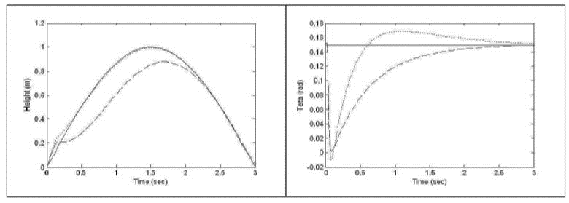
Fig. A1.5. Height (left) and Collective rotor blade angle (right) of helicopter (Solid: set point, Dashed: feedback linearization, Dotted: BELBIC)
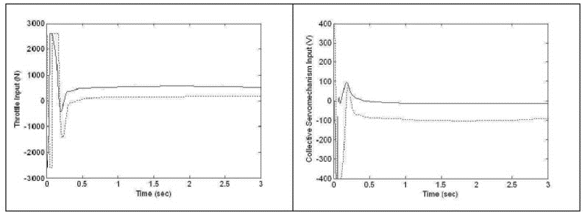
Fig. A1.6. First (left) and second (right) control input of helicopter (Solid: feedback linearization, Dotted: BELBIC)
It can be seen from these simulations that the tracking performance of BELBIC controller for the height is better than Feedback linearization controller, but in the sense of steady state the performance of both controllers is satisfactory. However, stability guarantee is an important drawback for this controller.
An intelligent control based on BELBIC has been introduced for speed and flux control of an induction motor. It was a novel and simple model of induction motor drives control which controlled motor speed and flux accurately, without needing to use any conventional controllers and independent of motor parameters. In order to evaluate this emotional controller, digital computer simulations have been performed using Matlab/Simulink. The results showed that the emotional controller had some gains, which gave good freedom for choosing desired responses in terms of overshot, settling time, steady state error and smoothness. These made the controller effective and flexible in high performance applications. Moreover, Simple structure, fast auto learning and high tracking potency of BELBIC have been made to present a new control plant that is independent of motor parameters and controls speed and flux simultaneously.
As a demonstration of the performance of the BELBIC controller in real-world applications beyond numerical simulation, it will be implemented on a KUKA Lightweight Robot (LWR), a 7DoF KUKA LWR4+ [57]. Bio-inspired by the human arm and with a payload of 7 kg and its 7 axes, all equipped with internal position as well as force-/torque-sensors, this redundant robot offers a range of features which are essential for the considered application. The seven revolute joints of the industrial robot are driven by brushless motors via harmonic drives. The working envelope is described in Figure A1.7.
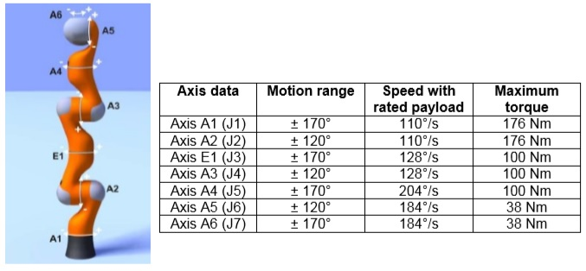
Fig. A1.7. Axes-nomination of the KUKA LWR4+ (KUKA, 2012) (left); Description of the work envelope of the KUKA LWR4+ (right)
The scientific work [57] is dedicated to the tasks of namely path following and position control. The tracking of complex freeform-trajectories by robotic manipulators is essential to many manufacturing processes like grinding, welding, polishing or gluing. Besides pick-and-place operations, path following is the most common type of automation tasks. With conventional controllers satisfactory performance is obtained for basic constrained motions and therefore they are still widely used in industry. The use of these conventional control schemes is however restricted to robotic manipulators with well-known dynamic and kinematic parameters following rather simple continuous paths in a disturbance-free environment. The desire to extend position control to robotic manipulators with unknown parameters following discontinuous freeform paths in the presence of disturbances explains the interest in the trajectory tracking control problem.
As a verification of the performance of the suggested control scheme, the controller is evaluated through simulation in a Matlab/Simulink-environment. For the simulation a two-link planar robotic manipulator with revolute joints. Excellent simulation-results were obtained. Robot-external disturbances are added as time-dependent 2-dimensional function. Internal uncertainties are added in the form of maximal +/-10% deviations from the dynamic parameters-values. Switching constraints are implemented in the form of a desired trajectory switching between different curved and straight segments as shown in Figure A1.8. The desired continuous trajectory is not differentiable.
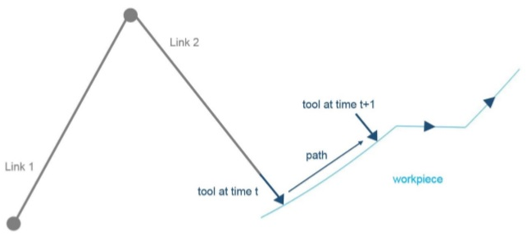
Fig. A1.8. Trajectory to be tracked by the tool on the workpiece surface in the simulated application; the arrows indicate the movement-direction
Table A1.1 shows the performance of the three considered controllers for trajectory tracking of discontinuous freeform paths, exhibited on the example shown in Figure A1.8.
Table A1.1. Absolute maximal, minimal and mean position errors for both manipulator-links using PID-, Computed Joint Torque (CJT)-control and BELBIC-SMC.
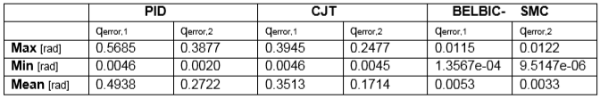
In order to demonstrate the efficiency of the suggested controller in real-world applications beyond numerical simulation, an experimental validation is performed. The first experiment is a goal-reaching task. The task is about moving the robot’s joints consecutively to a specified goal position. Table A1.2 shows that the BELBIC-SMC-concept outperforms PID- and Computed Joint Torque-control.
Table A1.2. Absolute maximal, minimal and mean position errors for all manipulator-links using PID-, Computed Joint Torque (CJT)-control and BELBIC-SMC when reaching a desired goal position. 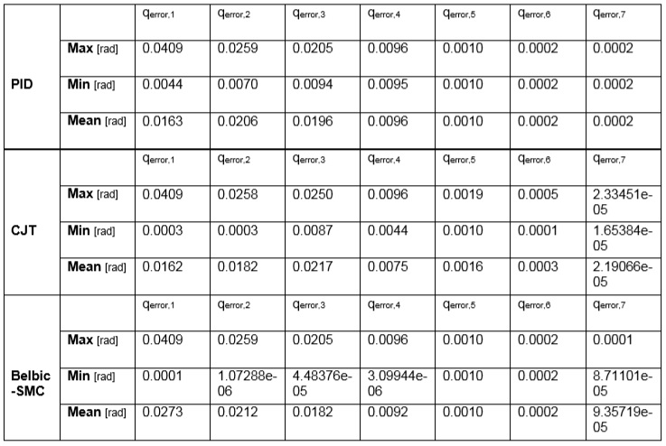
The simulation verifies the tracking performance of the BELBIC-SMC-controller for the chosen case. The BELBIC-SMC-controller outperforms both, the PID- and the Computed Joint Torque-controller. The freeform-shape and especially the discontinuity of the path deteriorate the tracking performance of the conventional controllers.

