Appendix 1. Contemporary models of affect, motivation, emotion and cognitive control for Kansei /Kawaii / Affective Engineering
Let us briefly consider the models of negative affect, pain and emotion that play important role in Kansei engineering and cognitive control.
Example. In humans and other primates, the cingulate – a thick belt of cortex encircling the corpus callosum – is one of the most prominent features on the mesial surface of the brain (Fig. 33a). Early research suggested that the rostral cingulate cortex (Brodmann’s ‘precingulate’; architectonic areas) plays a key part in affect and motivation (Fig. 33b). More recent research has enlarged the breadth of functions ascribed to this region; in addition to emotion, the rostral cingulate cortex has a central role in contemporary models of pain and cognitive control. The most basic question is whether emotion, pain and cognitive control are segregated into distinct subdivisions of the rostral cingulate or are instead integrated in a common region. There is a growing recognition that aMCC might implement a domain-general process that is integral to negative affect, pain and cognitive control [22].
Cognitive control is a range of elementary processes (such as attention, inhibition and learning) that are engaged when automatic or habitual responses are insufficient to sustain goal-directed behavior. Control can be engaged proactively or reactively. Activation foci maps between negative affect, pain and cognitive control is shown on Fig. 33d.
(a) (b)
(c)
(d)
Figure 33. (a) – Divisions of the human rostral cingulate cortex; (b) – Negative affect, pain and cognitive control activate a common region within the anterior subdivision of the midcingulate cortex - aMCC (The map depicts the results of a coordinate-based meta-analysis (CBMA) of 380 activation foci derived from 192 experiments and involving more than 3,000 participants); (c) – Activation likelihood estimate (AlE) maps of the three behavioral domains (left) and pairwise ALE minimum conjuction maps; (d) – Activation foci maps [22]
Example: Emotional learning occurs mainly in the amygdala. The system operation consists of two levels: the amygdale learns to predict and react to a given reinforcement signal. This subsystem cannot unlearn a connection. The incompatibility between predictions and the actual reinforcement signals causes inappropriate responses from the amygdala. As depicted in Fig. 34, the system on Fig. 34a, consists of four main parts [54]. Sensory input signals first enter the thalamus. Since the thalamus must provide a fast response to stimuli, in this model the maximum over all stimuli S is sent directly to the amygdala as another input. The amygdala receives inputs from the thalamus and sensory cortex, while the orbitofrontal cortex (OFC) part receives inputs from the sensory cortex and the amygdala. The system also receives a reinforcing signal (REW – emotional signal).
For each Anode in the amygdala, there is a plastic connection weight V_{i}. Any input is multiplied by this weight to provide the output of the node. The O nodes show similar behavior, with a connection weight W_{i} applied to the input signal to create an output. There is one output node in common for all outputs of the model, called E (see Fig. 34a). The E node sums the outputs from A except for the A_{th} and then subtracts the inhibitory outputs from the O nodes. The result is the output from the model.
(a) (b)
Figure 34.Graphical depiction of the brain emotional learning process (a) and the process of generating emotional reactions in the limbic part of human brain (b).
The OFC learns to prevent the system output if such mismatches occur. The learning in the amygdala and the OFC is performed by updating the plastic connection weights, based on the received reinforcing and stimulus signals.
Example. Let us consider briefly Brain Emotional Learning Based Intelligent Controller (BELBIC) structure [53]. In a biological system, emotional reactions are utilized for fast decision‐making in complex environments or emergency situations. It is thought that the amygdala and the orbitofrontal cortex are the most important parts of the brain involved in emotional reactions and learning. The amygdala is a small structure in the medial temporal lobe of the brain that is thought to be responsible for the emotional evaluation of stimuli. This evaluation is in turn used as a basis for emotional states and reactions and is used for attention signals and laying down long‐term memories. The amygdala and the orbitofrontal cortex compute their outputs based on the emotional signal (the reinforcing signal) received from the environment. The final output (the emotional reaction) is calculated by subtracting the amygdala’s output from the orbitofrontal cortex’s (OFC) output (see Fig. 34b). A control system strategy, based on brain emotional learning, was proposed by Caro Lucas in the early 2000s (Lucas et al., 2004). The limbic model used was based on the neural link, between the amygdale and the orbitofrontal cortex, proposed by Balkenius and Moren. This control paradigm is commonly designated by BELBIC which stands for brain emotional learning based intelligent control. The reasoning behind the integration of the limbic model into a closed loop control system can be tracked down to the seemingly robust way that the brain performs decision making. Actually, control has all to do with decision making: the controller goal is to devise the best input actions based on the incoming information according to the system states. These actions can be taken considering the past, the present or even forecasts on the future system states. Hence the controller produces a mapping between its input signals and the output control signals by means of an arbitrary decision function which can be described by means of differential equations, as in PID-controllers, or by an inference mechanism such as in Fuzzy or Neuro-Fuzzy control. Alternatively it can be based on the result of the optimization of a cost function such as linear quadratic regulators (LQR) or model predictive control (MPC). In the BELBIC control system architecture this input-to-output transformation is imposed by means of the limbic system model. In this case, both the external stimuli and reward signals are generated in such a way as to produce a closed loop system response according to some target characteristics. In addition, due to the recursive nature of the weights update law, this controller is able to gradually learn how to handle changes in the system dynamics. A key point in BELBIC is the external stimulus and reward signals definition.
Notice that there are not universal rules to carry out this task. This choice is flexible and must be custom defined according to the end application. For example in Lucas et al. the reward signal r(t) is obtained as a weighted sum of the error signal and the control effort and the external stimulus signal i(t) is defined as a linear combination of the system output and its first derivative.
It should be observed that it essentially converts two sets of inputs (sensory inputs and emotional cues or reinforcing signals) into the decision signal (the emotional reaction) as its output. Closed loop configurations using this block (BELBIC) in the feedforward control loop of the total system in an appropriate manner have been implemented so that the input signals have the proper interpretations. The block implicitly implemented the critic, the learning algorithm and the action selection mechanism used in the functional implementations of emotionally based (or, generally, reinforcement learning based) controllers, all at the same time.
Reza Keramat et al. [54] consider that in practical systems important information originates from two sources. One of the sources is the experts, who define their knowledge of the system using the natural language. The other consists of measurements and mathematical models derived from physical laws. Hence, what matters is how to incorporate these types of information into the design of systems. The question is that how it is possible to formulate human knowledge within a framework similar to mathematical models.
In other words, the main question is “How is it possible to convert human knowledge to a mathematical formula?”
Basically, the main function of a fuzzy system is to make such a conversion possible. Fuzzy systems are based on knowledge or rules. The core of a fuzzy system is a knowledge base following the IF-THEN fuzzy rules. If a fuzzy system is used by a controller, the controller is called “fuzzy controller”.
The fuzzy controller designed for the full bridge DC-DC converter takes two inputs: error (e) and error variations (Δe). The membership input functions for this controller are in the range of [-5, 5]. Membership functions for each of the two input components of error and error variations are shown in Fig. 35.
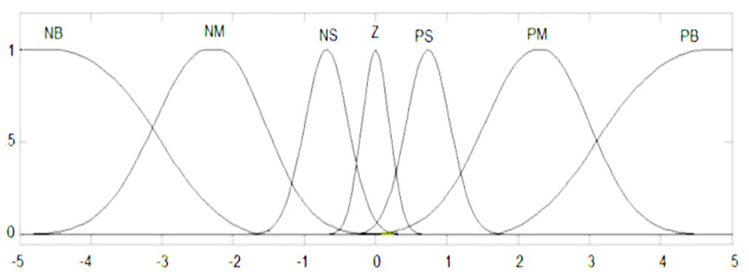
Figure 35.The membership functions for e and Δe.
Seven membership functions are used here for the input: negative big (NB), negative medium (NM), negative small (NS), zero (Z), positive big (PB), positive medium (PM), and positive small (PS). The controller output is assumed to be equal to the duty cycle, which varies between 0 and 0.5. Figure 36 displays the controller output functions.
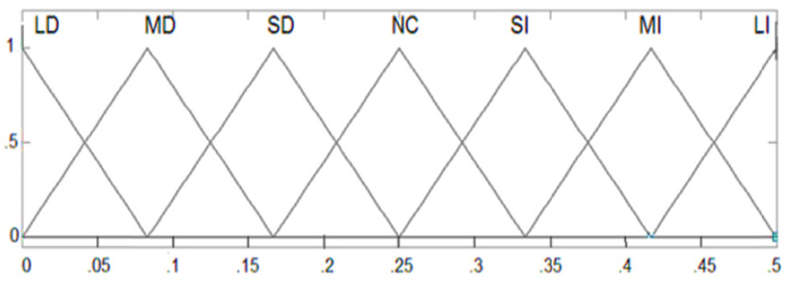
Figure 36.The output membership functions.
Reza Keramat et al. show the effectiveness of BELBIC for the full bridge DC-DC converter. Figure 37 shows the system output voltage after the application of the fuzzy and BELBIC controllers.
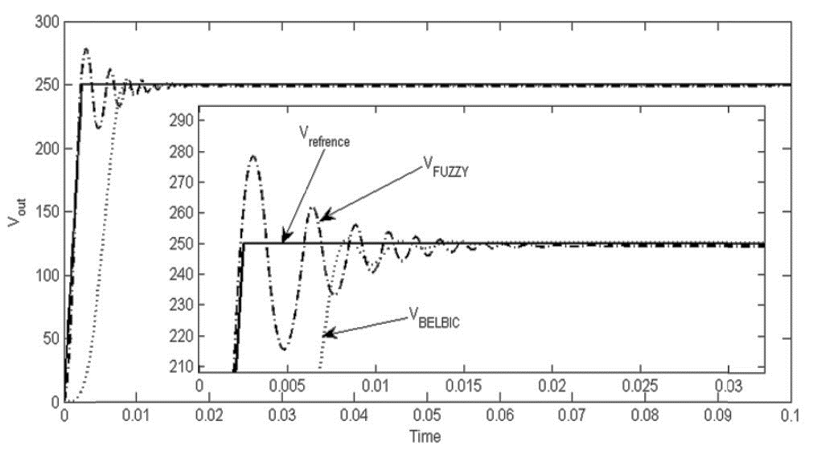
Figure 37.The comparison of the fuzzy controller with the BELBIC.
As seen in this figure, the BELBIC has a slight overshoot while the fuzzy controller has a considerable overshoot (the initial overshoot is 35 V). The time required for stabilization is almost the same in both cases. It is therefore concluded that the BELBIC outperforms the fuzzy controller.
In Reza Keramat’s experiment the BELBIC controller outperforms the fuzzy controller. Considering the uncertainty of system parameters (including inductance, capacitance, and input voltage and acceptable variations of load), the BELBIC presents better performance than the fuzzy controller. Although fuzzy control is a robust and effective method for a large number of engineering systems, but its design (and consequently its performance) is almost depend on the experience and tact of the designer. Furthermore, after design and installation, its performance is not improved, and in other word, it is not a learning-based or intelligent controller.
It can be stated that a Learning Based Intelligent Control which 'may' in the first step, act not as satisfying as any another modern controller, any straight-forward-designed controller after few iterations thanks to its learning automata feature. Based on this deduction, we felt no need to emphasize the comparison of these controllers after setting optimization.

