Development of Green Polymer Electrolyte Through Hot Press Method

Nidhi Asthana, Mrigank Mauli Dwivedi, , Kamlesh Pandey

National Centre of Experimental Mineralogy and Petrology,

University of Allahabad, Allahabad-211002, India

Email: kamleshpandey@outlook.com

Abstract

To develop the green polymeric membrane electrolyte, ε-Polycaprolactone (PCL) was used as a host and the Ionic liquid (IL)(1-Ethyl-3-methylimidazolium tosylate) as a dopant. The IL is a source of mobile charges in the polymer electrolyte system. The composite membrane has been prepared by Hot Press method and then we characterised this membrane for ionic transportation. Formation of nanocomposite system has been ascertained from their XRD pattern. Interaction phenomenon was studied by ATR based FTIR and Laser Raman spectroscopic technique. Variation of conductivity with composition and temperature was studied with the aid of impedance spectroscopy data.

**Keywords:** Green Polymer Electrolyte, XRD, FTIR, Ionic liquid, Hot Press Method

**Introduction:**

The use of synthetic polymer materials has caused significant environmental problems. Therefore, biopolymers and its composite materials are becoming important due to their better compatibility and biodegradability [1]. Poly ε-caprolactone (PCL) is one among them with immense potential as biomaterial for various biomedical applications [2-3]. It is semi crystalline polymer with a low melting point (Tm~60°C) and glass transition temperature (Tg=-60°C) [4]. It can be prepared by either ring opening polymerization of ε-caprolactone using a variety of anionic, cationic, and co-ordination catalyst or via free radical ring opening polymerization of 2-methyl -1-3-dioxapane[5]. Polycaprolactone (PCL), non toxic synthetic aliphatic polyester is especially suitable for drug delivery devices, because it is completely degradable inside the body. As a type of polymer, it is susceptible to be degraded by many types of bacteria [6-7]. PCL degrades at slower rate and therefore it is originally used in drug delivery devices. It has great interest in tissue engineering because it posses superior rheological and viscoelastic properties [8-10]. PCL is now enjoying a wide range of application from packaging to biomedical implants [11]. Very few attempts have been focused to develop the compostable electrochemical devices like battery using biodegradable polymer electrolyte with PCL as polymer host [12-16]. This type of development leads to minimize the electrolyte hazards waste. It also provides the alternatives to maintaining sustainable development of ecologically alternative technology [17]. The green polymer composites recently become more popular due to its need for innovations in development of materials from biodegradable polymer and reduction in the volume of harmful gases release in to the atmosphere. The green polymer composites have attracted the tremendous research interest because of its source like Agricultural resources. It also improves the manufacturing and recycling process with the better environmental compatibility [18]. To enhance the ionic conductivity, doping of inorganic / organic salts is an innovative technique. It leads to improve the mechanical stability, membrane permeability and porosity. Recently the use of ionic liquid (IL) (i.e. 1-Ethyl -3-methylimidazolium tosylate) as a salt/filler replaces the inorganic/organic salt /filler, providing the eco-friendly membrane for the device application. An ionic liquid is generally defined as a salt in which the ions are poorly coordinated, with a substantially low melting point (below 100°C) [19]. In general, ILs has negligible vapour pressure, non volatile, non inflammable and atmospheric pollution free characteristic. It is thermally stable which is better in chemical processes that require heat input also. These unique characteristics make them useful for many applications and meet the criteria of “Green Chemistry”. Recently, Ionic liquids are become hot contender due to some of their important properties like large electrochemical window and capacity of elimination hazards associated with the composite membrane. It has the dual properties as ion supplying materials or like the plasticizer which collectively enhance the ionic conductivity [20-22]. Imidazolium based ionic liquid is most widely studied salt. It shows better miscibility with the polymer and provides better porous structure [23-26]. In this work, 1-Ethyl -3-methylimidazolium tosylate (Ionic liquid) was used as dopant in PCL-based polymer composite electrolyte membrane. The membrane was characterized by the study of the structural and electrical properties using different experimental tools like- X-ray diffraction (XRD), SEM, C-V measurement, FTIR, Laser Raman and AC Impedance spectroscopy.

Materials and Methods

Nanocomposite polymer electrolyte films were prepared by well known “Hot Press Method”. Polycaprolactone [(PCL) (MW~14,000 sigma Aldrich)], Ionic liquid (1-Ethyl-3-methylimidazolium tosylate) (282.36g/mol) (Aldrich, AR grade) were used as polymer matrix and salt respectively. The composite film was prepared by casting it in stainless steel dye and synthesized by hot press method. For the hot press membrane synthesis, we used 55-60°C temperature and 2Kg/cm2 pressure conditions in a specially designed stainless steel die. The possible schematic structure of synthesized polymer composite membrane is shown in Fig. 1.

Structural behaviour of [(100-*x*) PCL-x IL {where *x*=3%, 10% and20%} system was evaluated by XRD pattern and recorded between 2θ=20°-60°at room temperature using Phillips X-pert diffractometer. The SEM image was obtained by JOEL, Electron Probe Micro Analyzer model JXA-8100. For making the surface electrically conductive, the sample was coated with graphite to a thickness ~20 nm using JEOL vacuum evaporator model JEE-420. The coated sample was randomly scanned and photographs were taken with SEM. To determine the electrochemical window, C-V measurement was performed on C-H Workstation (C-H instrument model CH608). The infrared spectrum was recorded on Bruker Alpha (Germany) FTIR with ATR spectrophotometer in a range 4000 – 600 cm-1 at room temperature. Raman spectra were collected with Uniram Confocal Raman Spectrophotometer with laser source at 785nm with variable power in the spectra range (0-2000cm-1). The electrical conductivity was evaluated from complex impedance plot obtained using computer controlled Hioki (JAPAN)-LCZ HI Tester (model 3520-01) in the frequency range of 1Hz to 100KHz.

**Results and Discussion**

The XRD pattern of Pure PCL, [0.97 PCL-0.03(1-Ethyl-3-methylimidazolium tosylate)] and [0.80 PCL -0.20 (1-Ethyl-3-methylimidazolium tosylate)] composite membranes are shown in Fig. 2. The XRD spectrum of pure PCL shows few crystalline peaks with semi crystalline nature. Two crystalline peaks at about 23.8° and 21.3°, indicating highly ordered chain folding characteristics. The less ordered amorphous regions in which the polymer chains are randomly arranged are thought to be initial sites of hydrolysis. The addition of Ionic Liquid (20wt %) reduces the crystallinity. The disappearance of doublet at 23.8° with broadening of 21.3°shows the modification of the matrix due to the incorporation of Ionic liquid in composite membrane.

The degree of crystallinity of the samples were calculated from the X-ray diffraction pattern, based on the following equation: [27]

$$X_{c}=\frac{A_{C}}{A_{c}+A_{a}}$$

where *Xc* is degree of crystallinity, *Ac* is crystallized area on the X-ray diffractogram and *Aa* is amorphous area on the X-ray diffractogram. The degree of crystallinity of pure PCL is found to be ~ 91% and after the composite formation it reduces to ~35%. The dispersion of IL enhances the relative broadness of the characteristic peaks, indicating the increase in amorphisity. The increase in amorphisity of electrolyte is clearly observed due to possible interaction of PCL and IL as shown in schematic structure of composite material (shown in material and method section). The free flow of ions enhances the overall ionic conductivity of the membrane. The average crystallite size of the [0.80 PCL -0.20 (1-Ethyl-3-methylimidazolium tosylate)] composite membranes was evaluated by the Scherer’s formula [28] and was found to be ~49 nm.

To study the surface morphology and estimation of particle size, the SEM image of hot press synthesized pure PCL membrane and 80PCL- 20IL electrolyte membrane are shown in Fig. 3. The heterogeneous nature of the composite electrolyte clearly indicates the interaction of ionic liquid with the polymeric host. On the inspection of surface morphology the distribution of nano size crystallite is observed, which supports the average size calculation of crystallite in the XRD results.

The FTIR spectra of pure PCL and [0.80 PCL -0.20 (1-Ethyl-3-methylimidazolium tosylate)] nanocomposite membranes are shown in Fig. 4. The main FTIR peaks of PCL at 2865 cm-1 and 2943 cm-1 correspond to symmetric and asymmetric vibrations of CH2 group and the C=O vibration of ester occurs at 1727 cm-1. The CH2 band vibration of the polymer is present at 1369 cm-1, 1420cm-1 and 1450 cm-1. The Ester C-O-O vibrations occur at 1190 cm-1 and 1240 cm-1. The peak at 1107 cm-1, 1045 cm-1 and 960 cm-1 are due to O-C vibrations with the CH2 rocking vibrations occurring at 731cm-1[29]. To study the effect of IL in the nanocomposite membrane, we compare the specific area of FTIR (i.e. 2260cm-1 to 2400 cm-1). The enlarged view of this area is also shown in the inset of Fig. 4. Here we observe that peak area increases by 200% after the addition of 3% IL (1-Ethyl-3-methylimidazolium tosylate) and by 350% after the addition of 20% IL (1-Ethyl-3-methylimidazoliumtosylate). This indicates that the number of more mobile charge carriers are generated due to dissociation of IL (1-Ethyl-3-methylimidazolium tosylate) and it is responsible for the quantitative change of transmittance parameter in the FTIR measurement [30]. It also indicates the better interaction of polymer salt in the nanocomposite electrolyte. The Raman study of Pure PCL and [0.80 PCL -0.20 (1-Ethyl-3-methylimidazolium tosylate)] composite membranes are shown in Fig. 5.

The Raman spectrum of pure PCL exhibits three well defined peaks at 1295cm-1 (CH2 wagging mode) at 1430 cm-1 (CH2scissoring mode) and 1722 cm-1 (C=O stretching mode) a small peak at 1151cm-1is assigned to the stretching vibration of ethereal C-O-C, a series of peaks between 1033 cm-1 and 1107 cm-1, which are assigned to the skeleton stretching and a typical finger print in the region between 500 cm-1 and 1000 cm-1 [31]. A comparative study show that peak area and height are reduced in the low wave number side support the better interaction in composite electrolyte. The peak around 65 cm-1, it could be assigned to rafting motion i.e. oscillating hindered translations of central ion inside cage made by the neighbouring ions [32]. The peak around the 100 cm-1wave number is giving the signature of imidazolium ion [33]. The peak around the 1089 cm-1 show the less intensity and with two clear peaks at 1068 cm-1 and 1041cm-1. Similarly, the peak at 1109 cm-1, 1298 cm-1 and 1444 cm-1 are 1725 cm-1 become more intense after complexation. To check the optimum ratio for the best electrical conductivity, the variation in conductivity with varying composition of ionic liquid in [(100-*x*) PCL-*x*IL] (where *x*=3% 10%, 20%) composite electrolyte system was recorded and shown in Fig. 6. Here it is clear that conductivity is unchanged initially upto 3% of ionic liquid composition then it starts decreasing and again increasing trend is obtained. The decrease in conductivity in the mid concentration range is possibly due to short range polymer–ion interaction i.e. small number of free charge carrier release due to dissociation of ionic liquid dissolved in electrolyte medium after this again increase is due to long range columbic force leading to re-dissociation of ions giving better conductivity. The maximum conductivity is obtained in 20% IL composition system. Beyond this concentration the synthesis and handling of film is difficult due to rubbery nature of the film. This type of behaviour could be explained on the basis of free volume model. The increase in conductivity depends on increase of number of charge carriers, which are facilitated from the salt during the increase of temperature [34]. During the temperature elevation in conducting measurement, the pseudo energy transmitted to the polymer matrix and expands the polymer matrixes, which promote the segmental motion. In present case the observed change is not much significant and incomplete range of measured temperature the conductivity is almost unchanged. The variation of bulk electrical conductivity (calculated by the cole-cole plot) with temperature of [0.80PCL-0.20 (1-Ethyl-3-methylimidazolium tosylate)] is presented in Fig. 7(a). In the temperature dependence conductivity initially it is found that increase in conductivity is due to removal of adsorbed water on the polymeric composite film, beyond this the conductivity remains almost constant. This type of straight temperature dependent nature of nano composite polymer electrolyte (NCPE) is peculiar nature of hot press synthesized polymer electrolyte system [35]. In the Temperature dependence of conductivity for the [0.80 PCL -0.20 (1-Ethyl-3-methylimidazolium tosylate)] polymer electrolyte the Vogel–Tamman–Fulcher (VTF) equation [36] is used for the linear fit and is given as:

$${lnσ T}^{0.5}=lnA-\frac{B}{T-T_{0}}$$

where A is the pre-exponential factor which depends on the number density of charge carriers, B is the pseudo activation energy in unit of K for the redistribution of free volume, T is absolute temperature and T0 is the quasi-equilibrium glass transition temperature at which free volume disappears or ionic conduction becomes frozen. T0 is usually 60K, is equal or lower than glass transition temperature (Tg). For the synthesised electrolyte system, calculated values of constant A and B is 1.5 x 10-1 and 3462 respectively. Figure 6 presents a good fit of conductivity to the VTF equation with regression value of ~ -0.9784.

The variation of conductivity with frequency and temperature of [0.80 PCL -0.20 (1-Ethyl-3-methylimidazolium tosylate)] electrolyte system is shown in Fig. 7(b). The change in conductivity shows an increasing trend with increase in temperature but it decreases with increasing frequency and then enhancement. The initial decrease in conductivity, similar to earlier discussion, is due to removal of surface adsorbed water (moisture) and then conductivity slowly increases with temperature and frequency. The decrease in conductivity at higher frequency region is due to short range interaction of ion with electrolyte. This can also be explained on the basis of electrical relaxation occurring in the lower frequency range. The variation of dielectric constant (ε') and loss (ε") with frequency of [0.80 PCL -0.20 (1-Ethyl-3-methylimidazolium tosylate)] electrolytes are shown in Fig. 8. In both the cases low frequency relaxation was observed, which is the indication of electrode polarization. The C-V measurement of hot press synthesized electrolyte membrane is shown in Fig. 9. From the figure, electrochemical stability of the membrane was found to be ± 0.8V.

Conclusion

Polymeric membranes of PCL: Ionic Liquid were synthesized by “Hot Press Method” and characterized by XRD diffraction, FTIR, Laser Raman spectroscopy and Impedance spectroscopy. Based on experimental results it was concluded that the membrane [PCL: 20% Ionic liquid] showed the better performance regarding to shrinkage, mechanical and thermal resistance. It also showed that an increase in ionic liquid concentration in the membrane leads to higher Ionic conductivity because more carriers are available for the transport. Regarding the effect of temperature, the nature of electrical conductivity is explained on the VTF nature. Dielectric relaxation behaviour shows the low frequency dispersion. Membrane is electrochemically stable in the ± 0.8V range. Therefore, it can be highlighted that the use of polymer/ ionic liquid facilitated the ionic transport in membranes and it can be considered a potential alternative for the device application.

**Acknowledgments**

Authors are grateful to SERB-DST, Govt of India for sanctioning the financial support as project. We are also thankful to Dr. K.N. Uttam, Dept. of Physics, University of Allahabad for Micro-Raman facility and Prof. S.L. Agrawal APSU Rewa (MP) for C-V measurement.

**References**

1. R. Augustine, N. Kalarikkal, S. Thomas. (2014) Role of wound dressings in the management of chronic and acute diabetic wounds: A Holistic Approach to Diagnosis and Treatment, Oakville: Apple Academic Press, 273-314.
2. S.W. Shalaby, K. J. L. Burg, (2003) editors, Absorbable and biodegradable polymers (advances in polymeric materials) Boca Roton: CRC Press.
3. E. Piskin, (1995)Biodegrdable polymers as biomaterials. J. Biomat Science Polym Ed**.** 6; 775-795.doi:10.1163/156856295X00175
4. M. A. Woodruff, D. W. Hutmacher. (2010) The return of a forgotten polymer Polycaprolactone in the 21st century. Prog. Polym. Sci. 35, 1217-1256. doi:10.1016/j.progpolymsci.2010.04.002
5. C.G. Pitt. (1990) Poly-α-caprolactone and its copolymers. In: Chasin M,Langer R, editors. Biodegradable polymers as drug delivery systems. New York: Marcel Dekker; 45,71–120.
6. A.D. Campos,S. M. M. Franchetti. (2005)Braz. Arch. Biol. Techn. 48, 235-243doi:10.1590/S1516-9132005000200010
7. Y. Tokiwa, B. P. Calabia, C. U. Ugwu, S. Aiba, (2009) Biodegradability of Plastics, Int. J. Mol. Sci. 10, 3722-3742**,** doi:10.3390/ijms10093722
8. Luciani, V. Coccoli, S. Orsi, L. Ambrosio, P. A. Netti. (2008) PCL microspheres based functional scaffolds by bottom-up approach with predefined microstructural properties and release profiles. Biomaterials 29, 4800–4807. doi:10.1016/ j.biomaterials.2008.09.007
9. Marrazzo , E. Di Maio, S. Iannace. (2008) Conventional and nanometric nucleating agents in poly(epsilon-caprolactone) foaming: crystals vs. bubbles nucleation. Polym Eng Sci 48, 336–344. doi:10.1002/pen.20937
10. Zein,D.W. Hutmacher,K.C. Tan, S.H. Teoh. (2002) Fused deposition modeling of novel scaffold architectures for tissue engineering applications. Biomaterials,23, 1169–1185. doi:10.1016/S0142-9612(01)00232-0
11. Y. Wang,M. A Rodriguez-Perez., R.L. Reis, J. F. Mano. (2005)Thermal and thermo-mechanicalbehaviour of polycaprolactone and starch/polycaprolactone blends for biomedical applications. Macromolecular Materials and Engineering,290, 792–801 doi:10.1002/mame.200500003.
12. C. P. Fonseca, D. S. Rosa, F. Gaboardi, S. Neves (2006) Development of a biodegradable polymer electrolyte for rechargeable batteries. Journal of Power Sources,155, 381–384. doi:10.1016/j.jpowsour.2005.05.004
13. H. J. Woo, S. R. Majid, A. K. Arof. (2011) Conduction and thermal properties of a proton conducting polymer electrolyte based on poly (α-caprolactone). Solid State Ionics, 199–200, 14–20. doi:10.1016/j.ssi.2011.07.007
14. C. P. Fonseca, S. Neves. (2006) Electrochemical properties of a biodegradable polymer electrolyte applied to a rechargeable lithium battery. Journal of Power Sources, 159, 712–716. doi:10.1016/j.jpowsour.2005.10.095
15. C. P. Fonseca, Jr. F. Cavalcante,F. A. Amaral, C. A. Zani Souza,S.Neves. (2007) Thermal and conduction properties of a PCL-biodegradable gel polymer electrolyte with LiClO4, LiF3CSO3, and LiBF4 salts. International Journal of Electrochemical Science, 2, 52–63
16. B. C. Ng, H. Y. Wong,K. W. Chew,Z. Osman (2011)Development and characterization of poly-α-caprolactonebased polymer electrolyte for lithium rechargeable battery. International Journal of Electrochemical Science, 6, 4355–4364
17. Pandey, J.K.; Chu, W.S.; Lee, C.S.; Ahn, S.H. Preparation characterization and performance evaluation of nanocomposites from natural fiber reinforced biodegradable polymer matrix for automotive applications. Presented at the International Symposium on Polymers and the Environment: Emerging Technology and Science, Bioenvironmental Polymer Society (BEPS), Vancouver, WA, USA, 17–20 October 2007.
18. Sinha, S.R.; Bousmina, M. Biodegradable polymer/layered silicate nanocomposites. In Polymer Nanocomposites; Mai, Y., Yu, Z., Eds.; Wood head Publishing and Maney Publishing: Cambridge, England, 57-129
19. R.D. Rogers, K.R. Seddon, (2002) (Ed.), ACS symposium series vol 818, American chemical Society Washington D.C.
20. A.L. Saroj, R. K. Singh, S. Chandra. (2013) Studies on polymer electrolyte (polyvinyl pyrrolidone, PVP) complexed with ionic liquid: Effect on complexation on thermal stability conductivity and reduction behavior; Mater Sci. Eng. B 178,231-238. doi:10.1016/j.mseb.2012.11.007
21. Lewandoweski, A Swiderska-Mocek,L. Waliszeweski, M. Galinski. (2012) Lithium redox behavior in N-methyl-n-propylpyrrolidiniumbis (trifluromethanesulphonyl) imide room temperature ionic liquid, J. Power Source, 197, 292-296.doi: 10.1016/j.jpowsour.2011.08.109
22. K. Nath, A. Kumar. (2014) Swift heavy ion irradiation induced enhancement in electrochemical properties of ionic liquid based PVdF-HFP-layered silicate nanocomposite electrolyte membranes, Journal of Membrane Science, **453,** 192-201. doi:10.1016/j.memsci.2013.10.061
23. V. Aravindan, P.Vickraman (2008) Characterization of SiO2 and Al2O3 Incorporated PVDF – HFP based Composite Electrolytes with LiPF3(CF3CF2)3. J. App. Poly. Sci.108, 1314-1322. doi:10.1002/app.27824
24. M. J. Koh, H. Y. Hwang,D. J. Kim,H. J., Kim, Y.T., Hong,S.Y. Nam, (2010) Preparation andCharacterization of Porous PVdF-HFP/clay Nanocomposite Membranes. J. Mater. Sci. Technol. 26**,** 633-638. doi:10.1016/S1005-0302(10)60098-9
25. B.S. Lalia, K. Yamada,M.S. Hundal, J.S.Park, G.G. Park, Q.Y.Lee, C.S.Kim, S.S. Sekhon, (2009) Physicochemical studies of PVdF–HFP-based polymer–ionic liquid composite electrolytes, Appl Phys A 96, 661-670.doi:10.1007/s00339-009-5129-y
26. J. Fuller, A. C. Breda, R.T.Carlin, (1997) Ionic liquid-polymer gel electrolytes. J. Electrochem. Soc.144**,** 67-70.doi:10.1149/1.1837555
27. L. E. Alexander, (1979)“X-ray Diffraction Methods in Polymer Science”, edited by R. E. Krieger, Krieger, New York, pp 423-424.
28. P. Scherrer, (1918) Bestimmung der Grsse undder InnerenStruktur vonKolloidteilchen Mittels Rntgenstrahlen, Nachrichten von der GesellschaftderWissenschaften, Gttingen, Mathematisch- Physikalische Klasse, 2**,** 98-100.
29. S. Suganya,T. Senthil Ram,B.S. Lakshmi, and V.R. Giridev, (2011) Herbal drug incorporated antibacterial nanofibrous mat fabricated by electrospinning: An excellent matrix for wound dressings. J. Appl. Polym. Sci. 121, 2893-2899. doi:10.1002/app.33915
30. N. Asthana, M.M. Dwivedi and K. Pandey (2017) Development of PVB-Nano Cellulose based Polymer Electrolyte and correlation of Optical Behavior with Ionic Conductivity. Advances in chemical sciences 6, 1-12. doi: 10.14355/sepacs.2017.06.001
31. G. Kister G. Cassanas M. Bergounhen D. Hograu. M. Vert, (2000) Structural Characterisation and hydrolytic degradation of solid Co-polymers of d,1-lactide co-ε caprolactane by Raman Spectroscopy, Polymer, 41,925-932. doi:10.1016/S0032-3861(99)00223-2
32. M.C.C. Ribeiro, (2010) Polarization effect in molecular dynamics simulations of glass-formers Ca (NO3)2.nH2O, n=4,6 and 8. J. Chem Phys. 132, 134512-134522, doi:10.1063/1.3386678
33. T.Fujsawa, K. Nishikawa and H. Shirota, (2009) Comparison of interionic /intermolecular vibrational dynamics between ionic liquids and concentrated electrolyte solution.J. Chem Phys. 131, 244519./ pp 1-14 doi: 10.1063/1.3280028
34. K.Pandey, M.M. Dwivedi, N.Asthana (2014) Effect of Synthesis Process on Ionic Conduction and Mobility of Flyash Based Polymer Composite Electrolyte, , 3(4), 329-333, doi.org/10.1166/jap.2014.1151
35. R.C. Agrawal, Angesh Chandra, (2007) Ion transport and electrochemical cell performance studies on hot –press-synthesized Ag+ ion conducting electroactive polymeric membranes : (1-x)PEO:{0.7(0.75AgI:0.25AgCl):0.3MI]. Journal of Physics D, 40(22) 7024-7031. doi:10.1088/0022-3727/ 40/ 22/024
36. J.R. MacCallum, C.A.Vincent. (1987). Polymer Electrolyte Reviews. Elsevier, London 1.

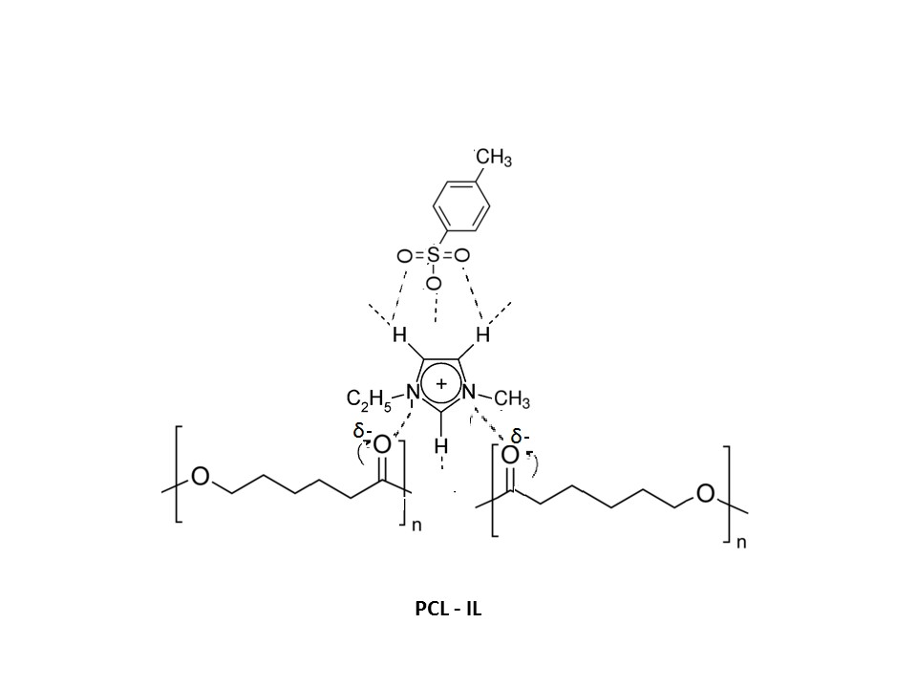

Figure-1 Possible schematic structure of synthesized polymer composite membrane.

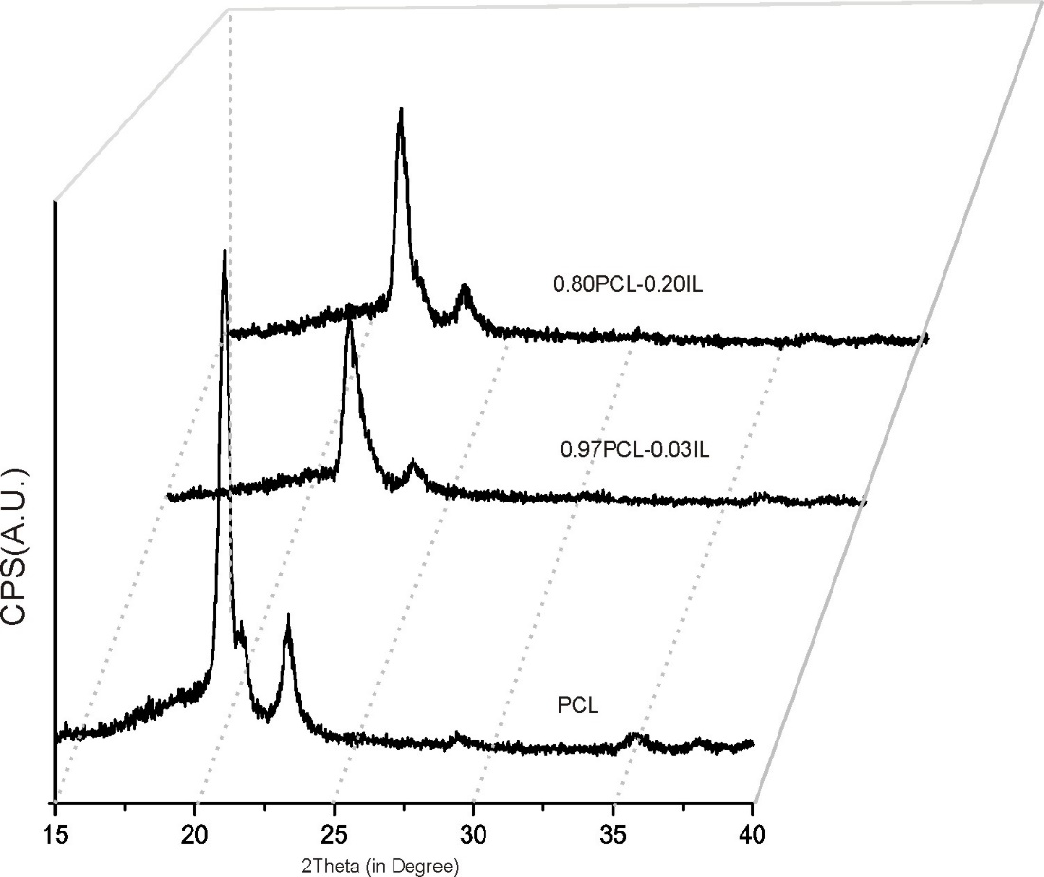

Figure 2: XRD spectra of the PCL and different PCL+IL composite system

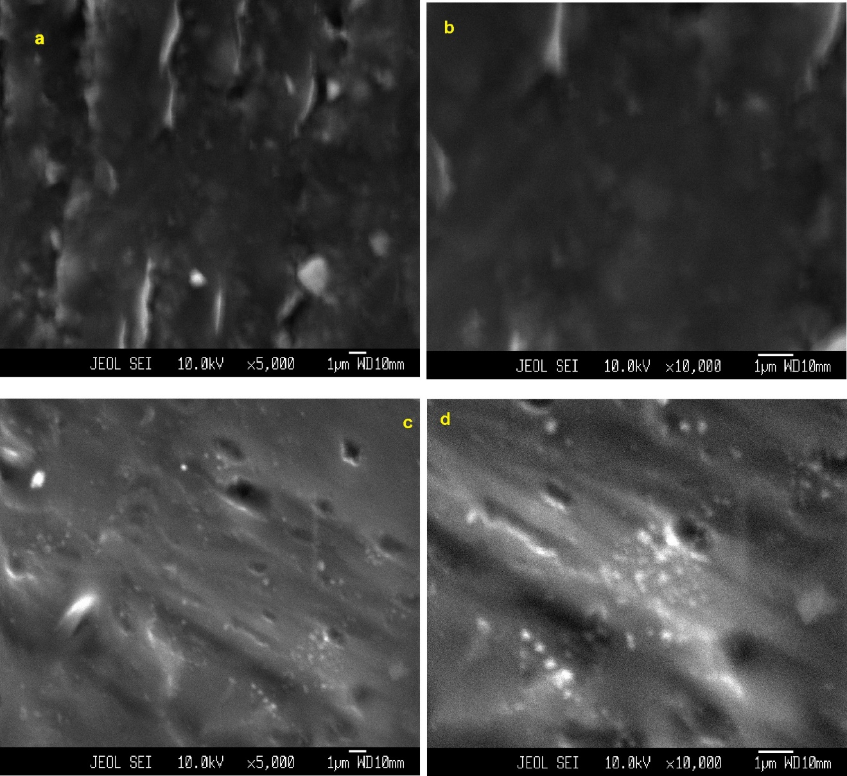

Figure 3: SEM image of (a) & (b) PCL membrane, (c) & (d) 80PCL-20IL electrolyte at two

Magnifications

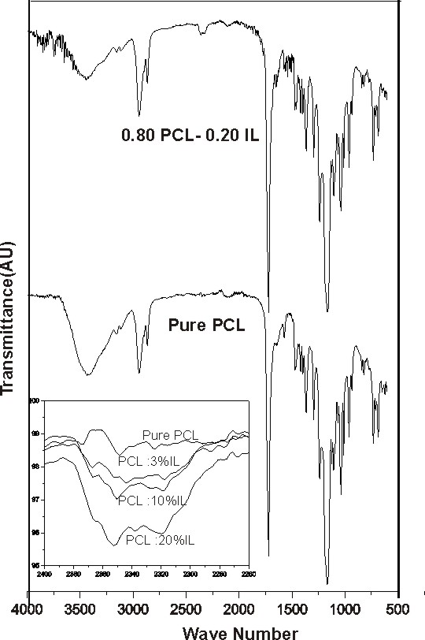

Figure 4: FTIR spectra of different constituent in polymer composite membrane.

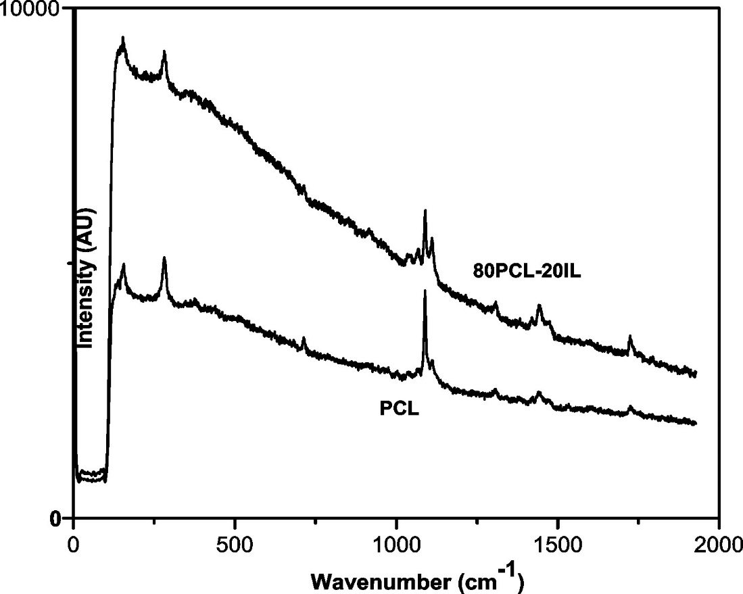

Figure 5: Raman Study of different constituent of polymer composite membrane.

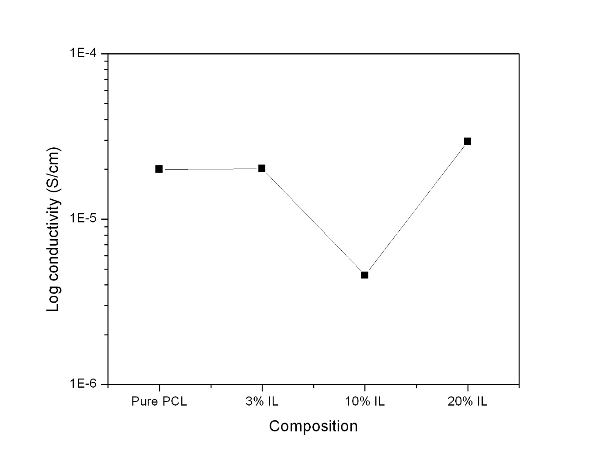

Figure 6: Variation of conductivity with different IL composition in polymer composite.

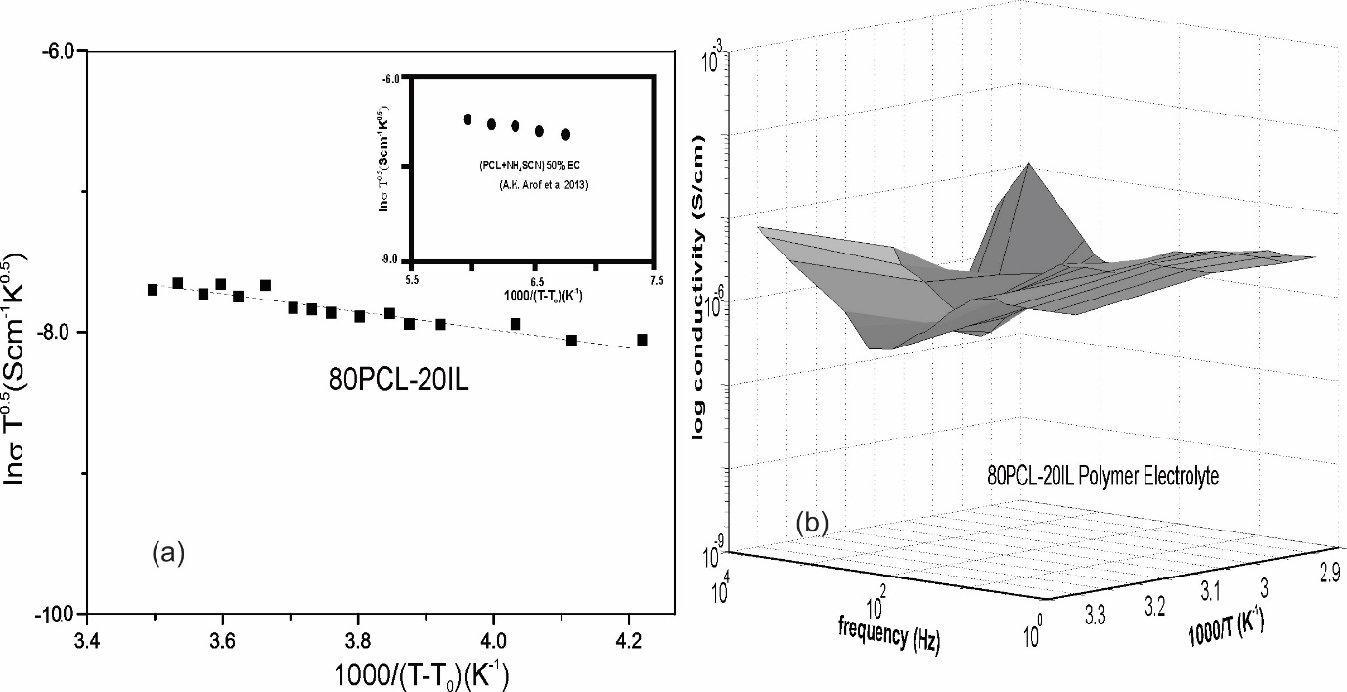

Figure 7(a): Variation of ln σ with Temperature and (b): variation of conductivity with frequency and temperature in polymer composite membrane.

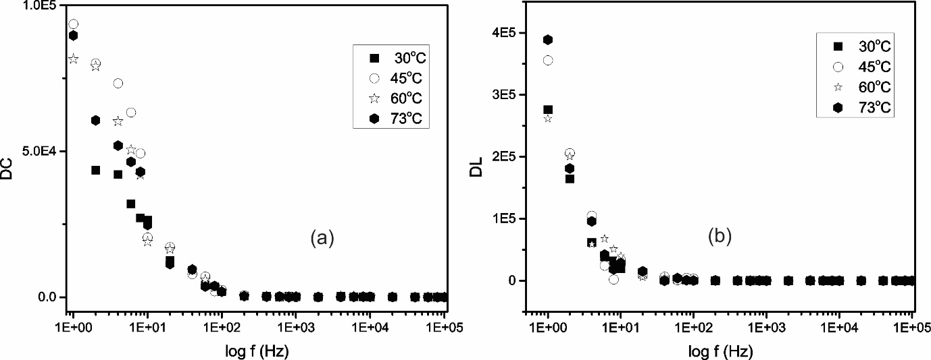

Figure 8: Change in dielectric constant (ε') and loss (ε") with frequency of 80PCL-20IL

electrolytes at different temperatures.

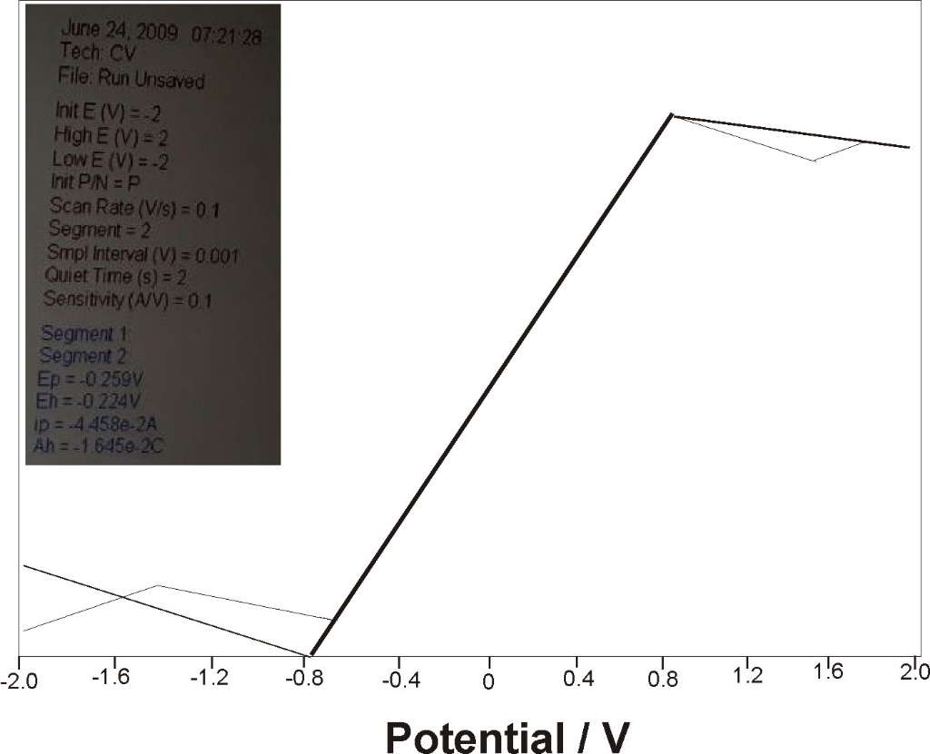

Fig. 9: C-V Plot of 0.80PCL -0.20IL composite electrolyte.