[Author’s brief introduction]
Ge Zhai (1995-) Male Town Planning, Land Use Planning, University College London, e-mail: uczlgz3@ucl.ac.uk

The Impact of the Agency role-based model on decision making in Real Estate Development Projects

Ge Zhai
Bartlett School of Planning, University College London, London WC1H 0NN, U.K.
Abstract：The professionalism of real estate development makes the decision-making environment of development relatively complicated. Building the decision model can help investors make reasonable decisions in real estate development. This paper analyses the construction project of Berlin Brandenburg Airport by using the agency role-based model of real estate development proposed by Adams & Tiesdell. The research found that the existing research is looking for different objective factors from real estate development cases, without analysing the influence of actors involved in the development process on the entire real estate development decision. In the process of real estate development, not only the changes in the market environment should be considered, but also the influence of different roles on decision-making in the development process. The conclusion of this paper provides a useful supplement to the real estate development model and proposes specific improvement measures.
Keywords: decision-making; development model; Berlin Brandenburg Airport; input market; output market

1.Introduction
Real estate development is a commercial process that encompasses activities from renovating and re-leasing existing buildings, to purchasing undeveloped land and the sale of developed land or parcels to others. ^{[1]} Real estate development investment has its own special characteristics: the product is immovable, the investment cycle is long, the amount of capital required is large, and the market information is incomplete. ^{[2]} At the same time, the professional and entrepreneurial characteristics of real estate development cause the decision-making environment for development to be very complicated ^{[3]}, leading to great risks in real estate investment projects. Therefore, the real estate industry is a high-input, capital-intensive industry. ^{[4]}
Some scholars have conducted investment risk analysis on different stages and factors of real estate development, and built models with different methods to help investors make reasonable decisions in real estate development; for example, the fuzzy comprehensive evaluation method^{[5]}, the land supply system model^{[6]}, and the Monte Carlo simulation ^{[7]}. All three seek different objective factors from different real estate development cases, and do not analyse the influence of different actors involved in the development process on the whole real estate development decision. Urban development is a complex process that requires coordination of finance, materials, labour and expertise among many actors in a broad social, economic and political environment^{[8]}. In this extended process, the relationship between people is often cultivated over many years ^{[9]}.
2.Problem Statement
This paper will attempt to critically evaluate and summarise the agency role-based model of real estate development proposed by Adams & Tiesdell, and analyse how to change this model to help improve decision-making. The construction project of Berlin Brandenburg Airport was selected in this paper, and will be analysed according to the agency model. As the largest infrastructure built in Berlin since the beginning of the new century, Berlin Brandenburg Airport is of great significance in promoting the aviation industry in Berlin, and the wider economic development of Berlin as a whole, however, the airport has not been officially delivered yet. Such a large infrastructure development project needs to be coordinated by many actors in the political, economic, social and other environments, but frequent changes in the investor body of the project, lack of experience of the designer, and corruption of the government and regulatory agencies have resulted in disastrous performance in the project implementation process. By analysing the problems caused by the above roles and based on the adjustment of the agency role model, this paper analyses the decision-making in real estate development projects and finally draws conclusions about improving the model.
3.Theoretical basis
The agency role-based model was proposed by Adams & Tiesdel, as shown in Figure 1. In this model, there are eighteen types of role ascribed to seven different markets, representing five different interests. The political market, land market, financial market, labour market and materials market are input markets, which provide policy support, capital, raw materials, land and labour for the whole real estate development project. Development interests form the core component of real estate development. The investment market and occupier market belong to the output market, corresponding to two actors, investors and occupiers, the two roles which act on behalf of customers' interests.
There are different roles in each market: role refers to the role of actors in the development process, such as investors and developers; actors are also referred to as the agents or agencies of particular individuals and organisations; and agency refers to the capacities of individuals and organisations to make their own free choice of strategic activities independently. Because of the constant interaction between structure and agency, the rules of the structure may potentially be changed by the agency behaviour^{[10]}, therefore, structure and agent should be considered at the same time ^{[11]}. This structure may give priority to the strategic interests of actors and change due to the strategy of pursuing interests. Those markets will be connected through benefits, and although the whole model seems to be static, the interaction between roles and markets often has an unpredictable influence on development benefits in the process of resource flow^{[9]}. At the same time, arguably, people paid too much attention to the decisions made by senior managers in the workplace, resulting in the neglect of the role caused by the change of external environment^{[12]}.
Figure 1： Agency role-based model of real estate development^{[9]}
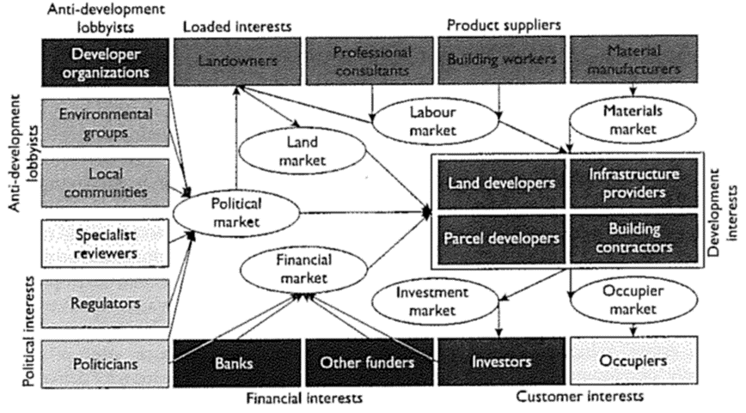
4.Discussion and analysis
Berlin Brandenburg Airport is an international airport under construction near the German capital of Berlin, 18 kilometres (11 miles) south of the city centre. It was originally intended to replace Schönefeld and Tegel airports as the only commercial airports serving Berlin and Brandenburg. However, the current plan is to only replace Tegel Airport, and Schönefeld Airport, which is currently being expanded, still needs to meet the increasing passenger flow ^{[13]}. After nearly 15 years of planning, construction of the airport began in 2006. However, due to poor construction planning, cost overruns and management corruption^{[14]}, the airport opening may be delayed until 2021. Since the airport is not completed yet, the model analysis based on the agent role in this paper does not include two output markets. Next, the project will be analysed in detail in terms of the five input markets, and how to adjust this model to improve decision-making will be explained.
4.1 Political market
When evaluating the Berlin Brandenburg Airport project, some news media believed that failure of management was an important reason for the project not being completed on time. Management corruption and poor control of the project schedule led to frequent management turnover. In 2013, the airport construction company paid a €2m bribe to an airport construction supervisor in exchange for €25m in additional investment, in order to get more money for the renovation of the fire protection system after discovering potential problems. So far, in the construction of the new airport project, the airport technical director, drainage system engineer, the airport construction director and other staff have been suspected of corruption. In May 2016, an engineer working at Berlin's new airport was poisoned, and German media said the man was the whistle blower involved in a corruption scandal involving an airport construction company^{[15]}.
According to the agency role model, the corruption and poor control of the project schedule are caused by the internal decision-making departments of the government. In this project, the government is not only the policy-maker of the early planning, but also plays the role of the project regulatory agency, and needs to take into account the role of specialist reviewers. As a result, a single individual undertaking multiple-role tasks will lead to a decline in the role execution quality. Corruption is inevitable when both the regulated and the regulators belong to the government. For their part, developer organisations are reluctant to shoulder the sole responsibility for building infrastructure. Because of the high cost of infrastructure, it will greatly increase the development cost met by developer organisations. Therefore, synergistic effect is used to enable each actor in the market to control the process of each link of project construction, and share the responsibility for infrastructure construction, so as to mobilise the enthusiasm of actors in different links, reduce the risk cost of large-scale infrastructure construction, and protect the interests of developer organisations.
4.2 Labour market
During the construction of the project, a series of issues of improper employment occurred. The fire safety systems engineer, Alfredo di Mauro, was not a qualified engineer, in fact he was an engineering draughtsman^{[16]}. The inefficiency of construction workers has also led to delays, which are bad for the German government and good for builders. Government development has been delayed, but day-to-day expenses, including employment, are still being met. For the construction companies in developed countries faced with a shrinking construction market, delay and go-slow are undoubtedly very attractive.
According to the agency role model analysis, in the labour market, professional consultants are the key to the success of the overall project development. The lack of professional consultants' experience has led to the unplanned expansion of the airport, by adding two wings midway through construction. Due to the expansion of the airport, new modules such as fire water and fire control have to be added, and the layout of the existing pipeline system and equipment area needs to be adjusted. Macro planning, but also by the construction of half of the site existing conditions. Therefore, the adjustment of a planning scheme is almost equivalent to the redesign, and because a considerable proportion of the build has been completed, the complexity of the engineering site will inevitably lead to difficulty in the implementation of the new design part of the project. Specialist review was also introduced into the labour market to ensure the feasibility analysis of the planning scheme before the start of the project construction, so as to reduce the later construction risk. At the same time, the introduction of competition mechanism to mobilise the working enthusiasm of building workers also plays a decisive role in whether the project can be delivered on schedule.
4.3 Marterials market
The most important cause of sustained delays is the fire and alarm system. Inspectors found flaws in wiring, programming and the implementation of highly complex systems designed by Siemens and Bosch. Due to the lack of proper oversight, in particular, many instances of poor workmanship were found by the circuit inspectors concerned. Cable pipes carried too many cables, or cables were put together in incompatible ways, such as by placing telephone lines next to high-voltage wires. In an assessment published on July 29, 2014, the Technischer Uberwachungsverein found that some lightning rods were missing and that the backup generators powering the sprinkler system were not providing enough power^{[17]}.
According to the agency role model, the role in the materials market is filled by the materials manufacturers. In the process of airport construction, a variety of raw materials were not quality-tested, resulting in failure to pass the completion inspection. As materials manufacturers are the only player in the materials market, there is no market competition pressure and no regulatory agency. Therefore, the quality of raw materials controlled by construction materials suppliers is arguably reduced in exchange for higher profits. In the materials market, the key to improving decision-making is how to play the role of a supervisory body and introduce this role in the current market.
4.4 Land market
In 1991, after an extensive comparative study of site selection and plan, due to the shortage of land resources in Berlin, the new airport could only be located in the Brandenburg state near Berlin, which required the approval of the two states and the federal government for the construction plan of the new airport. The location of the new airport (BER) is shown in Figure 2. According to the agency role model, landowners represent vested interests in the land market, and the state of Brandenburg, which is the land supplier for the airport project, has a 37% stake in Flughafen Berlin Brandenburg holdings limited (BBF).
Figure 2: The map of Berlin showing all airports
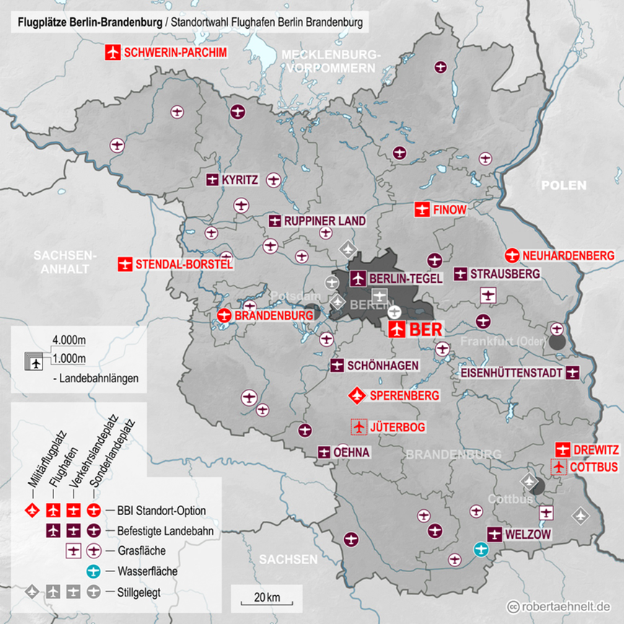
Sources: https://de.wikipedia.org/wiki/Flughafen_Berlin_Brandenburg#/media/File:Standortwahl_BBI-BER.png
4.5 Financial market
As of 2009, Berlin Brandenburg Airport had a budget of €2.83 billion. The BBF raised €2.4 billion through credit to continue financing the project ^{[18]}. In the construction process, due to the underestimate of the actual cost, construction defects and the increase in the cost of sound insulation for nearby houses, the cost of the airport increased significantly. The series of delays is expected to lead to a series of lawsuits against FBB, which could lead to massive damages for affected airlines and airport operations. At the end of 2012, total spending at Berlin Brandenburg Airport was €4.3 billion, nearly double the original cost estimate. The BBF signed a €2.4 billion loan on February 13, 2017, containing €1.1 billion financings and €1.3 billion repayments of previous bad loans. The federal government, Berlin and the state of Brandenburg guaranteed the debt. Costs will rise further as the airport will not open until 2017. It is not expected to be operational until 2020, when the total cost is €6.5 billion. At present, Wilfried von Aswegen ^{[19]}and other experts point out that the airport may not be profitable in the future.
According to the agency role model, there are four roles of the financial market: Politicians, Banks, Other funders and Investors. From their respective financial interests, they finance project development through the financial market. Essentially, they are equal and interchangeable. According to economic principles, when the supply of a commodity declines, the supply of its substitute will increase^{[20]}. As a government-owned airport operator, Flughafen Berlin Brandenburg falls into the position of politicians in the model. This enterprise will be operated as a state-owned enterprise. If it goes bankrupt, it will be a significant event of credit default of government debt. So, at the end of 2017, the German federal government, Berlin and the state of Brandenburg chose to continue debt guarantees for the project. However, in the decade since the new airport was built, the development of the European aviation market has sent passenger turnover soaring in Berlin, while the old aviation infrastructure has struggled to cope. In 2016, the utilization rate of Schönefeld Airport had reached 130%, and at Tegel Airport has reached 160%. The existing aviation facilities are overburdened. The importance of Berlin Brandenburg Airport for the future development of Berlin's aviation industry is self-evident. Therefore, based on the model analysis, the bank and other funders and investors have no positive feedback on the decision-making in the financial market, which only belongs to the politicians' dominant position, which is a particular point of this case. At present, there are still no suitable suggestions for improvement in this part of the model.
5. Conclusion
Real estate development directly changes the urban form and provides a new perspective for us to look at urban changes. In this complex process, we should consider not only the changes in the market environment but also the influence of different roles in the development process on decision-making. Although the Berlin Brandenburg Airport development project was a failure to some extent, the lessons learned from this project can be applied to other projects.
1. Add the role of specialist reviewer in the labour market, conduct a feasibility analysis before the preliminary planning of professional consultants is finalized, and avoid the occurrence of late modification and project delay.
2. The role of the regulators in the political market should be promoted as another main line of project development in every market throughout the development process. Only by carrying out strict supervision in each market and at each stage, can we keep the whole project running efficiently.
3. In view of the strong position of politicians in the financial market in the development projects of state-owned enterprises, the politicians concerned can ensure the safe supply of funds for the project development by means of supervision.
Reference List:
[1] Peiser, R.B. & Hamilton, D., 2012. Professional real estate development the ULI guide to the business .3rd ed., Washington, D.C.: Urban Land Institute.
[2] Peca, S.P., 2009. Real estate development and investment: a comprehensive approach, Hoboken, N.J.: Wiley.
[3] Miles, M.E., Berens, G., Weiss, M.A., & Urban Land Institute, 1996. Real estate development: principles and process (p. 121). Washington, DC: Urban Land Institute.
[4] Zhe, Yan., 1999. Reconsidering the prevention of real estate financial risks. Journal of Chongqing Jianzhu University, 03(8), pp. 15-22.
[5] Zhijuan, T., Wei, G. 1998. Fuzzy evaluation of real estate investment risk. Journal of Tianjin University of Urban Construction, 03, pp. 41-46.
[6] Liliang, Q. 2006. Research on the risk of China's current land supply system. City Management and Technology, 01, pp. 39-41.
[7] Xuejing, Y. 2006. Application of Monte Carlo simulation method in real estate investment risk analysis. Southwestern University of Finance and Economics, 11, pp. 77-81.
[8] Guy, S. & Hanneberry, J. eds., 2008. Development and developers: perspectives on property, Hoboken: Wiley.
[9] Adams, D. & Tiesdell, S., 2013. Shaping places: urban planning, design and development, London: Routledge.
British Broadcasting Corporation, 2016. Berlin Brandenburg airport corruption 'whistleblower poisoned' [online]. Available from: https://www.bbc.co.uk/news/world-europe-36185194 (Accessed January 1 2019).
[10] Healey, P. & Barrett, S., 1990. Structure and agency in land and property development processes: some ideas for research. Urban Studies, 27(Feb 90), pp.89–103.
[11] Jessop, B., 2007. State power: a strategic-relational approach, Cambridge: Polity.
Jianmin, C., 2008. Research on risk management methods of real estate investment projects. Journal of Beijing Jiaotong University, 07, p. 154.
[12] Healey, P., 1991. Models of the development process: A review. Journal of Property Research, 8(3), pp.219–238.
[13] Flughafen Berlin Brandenburg. 2016. Construction work at Schönefeld Airport: Upgrading of federal highway B96a, car park P4 closed. [online]. Berlin: ODI. Available from: https://www.berlin-airport.de/en/press/press-releases/2016/2016-04-15-construction-work-b96a/index.php [Accessed 1 January 2019].
[14] Spiegel Online, 2013. Korruptionsverdacht auf BER-Baustelle: Mehdorns Desaster ist perfekt - SPIEGEL ONLINE - Wirtschaft. [online] SPIEGEL ONLINE. Available from: http://www.spiegel.de/wirtschaft/unternehmen
/hauptstadtflughafen-korruptionsverdacht-mehdorn-unter-druck-a-972277.html [Accessed 1 January 2019].
[15] British Broadcasting Corporation, 2016. Berlin Brandenburg airport corruption 'whistleblower poisoned' [online]. Available from: https://www.bbc.co.uk/news/world-europe-36185194 (Accessed January 1 2019).
[16] Local, 2014. Fake engineer made Berlin Airport fire system [online]. Available from: https://www.thelocal.de/20140625/fake-engineer-di-mauro-designed-berlin-airport-fire-system (Accessed January 1 2019).
[17] Wehmeyer, J. C. (2015) Raten Sie mal, was am BER jetzt wieder vergessen wurde [online]. Available from: https://www.bild.de/regional/berlin/flughafen-berlin-brandenburg/teile-der-blitzableiter-vergessen-37060598.bild.html (Accessed 14 January 2019).
[18] Neumann, P., 2008. Kosten für Großflughafen steigen um 160 Millionen Euro, weil mehr Passagiere erwartet werden: Noch nicht gebaut und schon teurer [online]. Available from: https://www.berliner-zeitung.de/kosten-fuer-grossflughafen-steigen-um-160-millionen-euro--weil-mehr-passagiere-erwartet-werden-noch-nicht-gebaut-und-schon-teurer-15595340 (Accessed 1 January 2019).
[19] Von Aswegen, W., 2004, Betrachtungen zur Wirtschaftlichkeit des Flughafens BER: Studie [online]. Available from: https://www.dudoni-online.de/fluglaermbbi/downloads/ber-wirtschaftlichkeit-wva.pdf [Accessed 1 January 2019].
[20] Taussig, F., 1921. Is market price determinate? Quarterly Journal of Economics, 35, pp.394–411.

