Experimental Study on Diffusion of Diving Aquifer in a Site of Jilin City
Dong Weihong*Wang Ruiqing,
(School of Construction Engineering, Jilin University, Changchun, Jilin 130012)
Abstract: dispersion parameter is an important parameter to establish groundwater solute transport model. Taking a site in Jilin City as an example and using sodium chloride as tracer, the dispersion parameters of the diving aquifer in the natural flow field are solved by using the standard curve distribution method. The experimental results show that under natural flow field, the vertical dispersion degree of diving aquifer is 0.400 m, the transverse dispersion degree is 1.933×10⁻⁵~6.557×10⁻³m; longitudinal dispersion coefficient m 0.246²d, lateral dispersion coefficient 1.191×10⁻⁵~4.039×10⁻³m²d.// The results can provide an important parameter basis for the establishment of groundwater solute transport model, accurate prediction of the temporal and spatial variation of pollutant concentration in groundwater and the formulation of groundwater pollution prevention and control scheme.
Keywords: dispersion test; dispersion parameters; standard curve wiring method; diving aquifer
Middle map classification number: X523 document mark code: A
Study on dispersion test of unconfined aquifer in a site of Jilin City
WANG Ruiqing ,DONG Weihong*
(College of Construction Engineering ,Jilin University ,Changchun 130012,China)
Abstract ：Dispersion parameter is an important parameter for the establishment of groundwater solute transport model.The dispersion test uses sodium chloride as a tracer,which was conducted in a site in Jilin City.The standard curve comparison method was used to solve the dispersion parameters of the aquifer under the natural flow field.The test results show that under the natural flow field,the longitudinal dispersion of unconfined aquifer in Jilin City is 0.400m,and the lateral dispersion is 1.933×10⁻⁵~6.557×10⁻³m;while the vertical dispersion coefficient is 0.246m²d,the lateral dispersion coefficient is 1.191×10⁻⁵~4.039×10⁻³m²d.The above results can provide an important parameter basis for the establishment of groundwater solute transport model,the accurate prediction of temporal and spatial variation of pollutant concentration in groundwater and the formulation of groundwater pollution prevention and control scheme.//
Key words：Dispersion test ;Dispersion parameter s ;Standard curve comparison method ;U nconfined aquife r
When establishing a model of solute transport in groundwater to study the migration law of pollutants in groundwater, the accurate determination of dispersion parameters is one of the key links to ensure the reliability of the model, which directly affects the accuracy and accuracy of the model prediction results^{[1]}. The current effective method for determining dispersion parameters is to conduct dispersion tests. Dispersion test is divided into indoor test and field test. Because of the scale effect of dispersion parameters^{[2]}In order to ensure the reliability of dispersion parameters, most scholars at home and abroad conduct field dispersion tests. For field dispersion tests, most of the domestic scholars focus on two-dimensional dispersion and radial hydrodynamic dispersion in one-dimensional flow field.
The two-dimensional dispersion test of one-dimensional flow field is generally carried out under natural flow field. This method can obtain more accurate dispersion parameters. For example, Wu Yaoguo and others carried out a two-dimensional dispersion test of one-dimensional flow field in Benxi City, and the dispersion parameters of diving aquifer in the test site were determined by linear graphic method^{[3]}; Jiang Xuemin, Shao Jingli, et al .;2D dispersion test of one-dimensional flow field in a mining area in Inner Mongolia, and solving dispersion parameters by correlation coefficient polar method^{[4]}A two-dimensional dispersion test of one-dimensional flow field was carried out in Kashi area by using different analytical methods to solve the dispersion parameters^{[5]}。
Radial hydrodynamic dispersion test is carried out under the artificial flow field formed by pumping or water injection. For such issues, Yu Hong, Yuan Wei, Li Shiyu, Mei Jie^{[6-9]}The dispersion tests were carried out in different regions. Zhang Yinmei^{[10]}The results show that the dispersion parameters increase with the increase of hydraulic gradient, and the radial hydrodynamic dispersion test increases the velocity and hydraulic gradient of groundwater artificially. In addition, the dispersion solution method commonly used in radial hydrodynamic dispersion test can not obtain the transverse dispersion parameters of water-bearing medium.
Based on this, in order to obtain the dispersion parameters of diving aquifer at a site in Jilin City, this paper selects a test site in Jilin City to carry out two-dimensional dispersion test of one-dimensional flow field under natural flow field. The standard curve distribution method is used to solve the field dispersion parameters.

1 Overview of the study area
The dispersion test site is located in Longtan District, Jilin City, Located in Songhua River secondary terrace. The groundwater type in the study area is loose rock pore phreatic water, Mainly occurs in the Quaternary Holocene gravel layer, Average buried depth of bottom plate of diving aquifer m;13 The groundwater level varies greatly between years, The high water period is 4~7 m、 the dry water period is 3~4 m. Groundwater flows are generally north-south, The hydraulic gradient is about 2\8240;. Based on site drilling data, The stratigraphic lithology of the study area is in order from top to bottom: backfill (0~1.5 m), silty clay (1.5~4 m), fine sand (4), gravel (7), fully weathered granite (13 m). Based on the results of pumping tests conducted in the study area, The average permeability coefficient of the aquifer in the study area K 77 m/d.

2. Test methods

2.1 Tracer selection
Ideal tracers used in field dispersion tests should be less toxic, less easily adsorbed by solid particles in aquifers, more sensitive and less expensive^{[11]}At present, the main tracers used at home and abroad can be divided into four categories: ionic compounds, artificial radioisotopes, organic dyes and fluoride^{[12]}Considering that artificial radioisotope is known as radioactive hazard and that organic dyes are easily adsorbed by solid particles in the aquifer, in this experiment, sodium chloride (NaCl), which is less toxic, cheap and easy to monitor, is selected as tracer for field dispersion tests.

2.2 Placement of test wells
In general, monitoring wells in field dispersion tests are arranged along both sides of the main groundwater line^{[13]}. In this test, the test wells are arranged along the main groundwater line in a circular arc with a tracer injection well as a radius of 2 m、4m、6m, respectively. The test wells include 1 tracer injection well ,3 rows (12) tracer monitoring wells, all of which are complete wells, with 13 m; design dispersion angles of 10° and 20°, respectively, as shown in Figure 1.
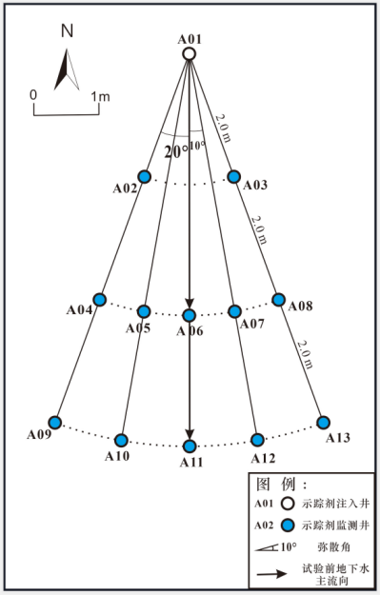
Fig .1 Plan of well for dispersion test

3 Test process

3.1 Trial preparation
(1) Monitoring of the initial groundwater level and monitoring of the water level before each sampling after the start of the test to correct the groundwater mainstream.
(2) The background concentration of chloride ions in each test well is measured, and the average background value of groundwater chloride ions in this test area is mg/L.29.24
(3) Each monitoring well is equipped with a water level meter, a sampler and a test data monitoring record sheet.
(4) A solution of silver nitrate with known concentrations to be used for titration to test chloride concentration in groundwater.
(5) Preparation of tracer solution. The dispersion test added 60 k g of iodine-free edible salt to a plastic container containing 450 L of pure water and stirred to accelerate dissolution until the excess salt at the bottom was no longer dissolved. The concentration of chloride ion in tracer solution was 129.42 g/L.

3.2 Tracer delivery
When the test begins, the tracer solution is injected into the well (A01), and the tracer time is used as the starting time of the dispersion test. Do not make the injection well water level too high (generally above the initial water level within 50 cm) to avoid the formation of groundwater mound, which has a significant impact on the water movement of the test site.

3.3 Data monitoring
After the tracer solution is injected into the well (A01) of the test area, the sampling in the monitoring well of the test area is started immediately, and the buried depth of the groundwater level is determined before each sampling. At the beginning of the experiment, samples were taken every 1 hour and the groundwater level was measured. After sampling, the Cl in water samples were determined by silver nitrate titration－concentration when Cl－If the concentration is greater than the background value, the sampling time is encrypted for 30 minutes, when the Cl is－Concentration restored to Cl groundwater－Concentration background values returned to sampling every 1 hour until Cl in groundwater－When the concentration is basically stable as the background value, stop monitoring. Cl of tracer monitoring wells can be obtained by continuous sampling and chloride concentration determination－The curve of concentration over time.

4 Materials for Calculation of Dispersion Parameters and Results Analysis

4.1 Calculation method of dispersion parameters
There are two methods for calculating dispersion parameters in field dispersion test: analytical method and numerical method. The dispersion parameters of this experiment are calculated by the standard curve wiring method in the analytical method.

Calculation method of 4.1.1 dispersion
The groundwater field in the test site is composed of loose rock type pore phreatic water. Because the hydraulic gradient of the ground water is small (about 2\8240;), the groundwater flow field in the test area is generalized into one-dimensional groundwater flow field with horizontal infinite extension and equal thickness. The tracer migration in groundwater conforms to the two-dimensional hydrodynamic dispersion equation of diving, and its mathematical model such as formula (1)^{[14]}As shown:
C is the concentration (g ·L) of tracer in groundwater⁻¹(C);();()₀Background concentrations (g ·L) of tracers in groundwater in test areas⁻¹); distance x、y longitudinal and transverse transport of tracer (m); D_{L}D; and_{T}For longitudinal and transverse dispersion coefficients (m); and²:: d⁻¹The V is the actual average velocity (m ·d) of groundwater⁻¹(n);();()_{e}To be effective porosity; M to be tracer injection (kg ·m) per unit thickness aquifer⁻¹t is time (d).
Analytical solution of mathematical model (formula (1)) for two-dimensional dispersion instantaneous injection of tracer in one-dimensional flow field^{[15]}To:
If we ignore molecular diffusion to D_{L}=α_{L}V 、D_{T}=α_{T}V replaced by the above formula:
Formula :α_{L}、α_{T}For longitudinal and transverse dispersion (m).
In a dimensionless form:
Among them:
Under formula (4), c can be obtained when the a value is fixed_{R}~t_{R}The c can be obtained by assigning a a series of values_{R}~t_{R}
A series of relational curve clusters to obtain c_{R}~t_{R}Measuring plate curve (Fig .2).

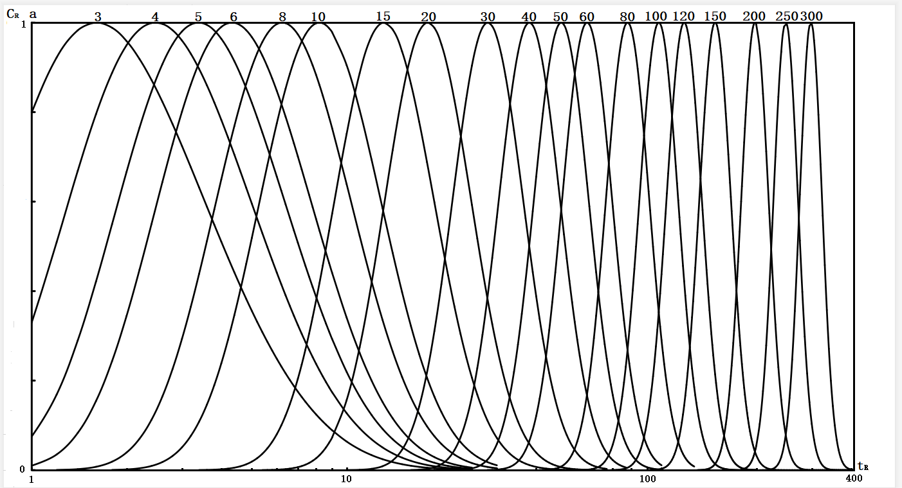
Figure 2 c Figure 2_{R}~t_{R}Standard gauge plate
Finally, the formula of dispersion degree can be obtained by the transformation of formula (6),(7),(8) and (9):
Among them: x_{i}y; and_{i}The vertical and horizontal coordinates of the i well (m);
a_{i}The a value of matching the observation curve of i well with the curve of measuring plate.
Convert the measured concentration values of each monitoring well into dimensionless concentration C_{R}Then, the measured chloride concentration curve obtained from the groundwater mainstream upward monitoring well (y=0) is matched with the measuring plate curve (the vertical and horizontal coordinate scale of the two is the same), and the corresponding a value is obtained. According to formula (12), the longitudinal dispersion α is calculated_{L}The measured curve obtained from the monitoring well (y=0) deviating from the mainstream of groundwater is matched with the measuring plate curve (the vertical and horizontal coordinate scale of the two is the same), and the corresponding a value is obtained, and then the α calculated according to the above calculation is obtained_{L}Value and ValueFormula (13) calculation of transverse dispersion α_{T}。

Calculation method of 4.1.2 dispersion coefficient
A α of Longitudinal Dispersion Degree of Submersible Aquifer Calculated from Formula (12) and Formula (13) respectively_{L}α horizontal dispersion_{T}Insert the following formula:
D of the longitudinal dispersion coefficient of the available site diving aquifer_{L}D of transverse dispersion coefficient_{T}。
Formula (14) and formula (15) V the actual average velocity of groundwater, which can be calculated according to Darcy's law. The formula is as follows:
The K is the permeability coefficient (m ·d) in the formula⁻¹I hydraulic gradient; n; hydraulic gradient_{e}For effective porosity.

4.2 Calculation of dispersion parameters for diving aquifers
According to the groundwater flow field diagram (Fig .3) drawn from the groundwater level in the test period, the actual groundwater mainstream direction is A01-A07-A12 direction. Therefore, the vertical dispersion of the diving aquifer in the site is calculated according to the method in 4.1.1, and the other monitoring wells are used to calculate the transverse dispersion of the groundwater aquifer.
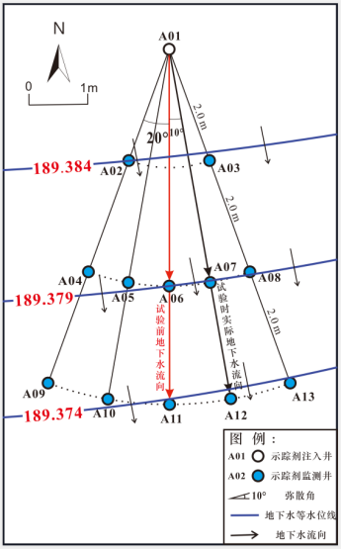
Figure 3 Field flow pattern of the site during the test
A04、A05、A06、A08、A09、A13 measured chlorine ion concentration diachronic curve of the monitoring well is fitted to the standard plate, and the fitting result diagram is shown in figure 4.
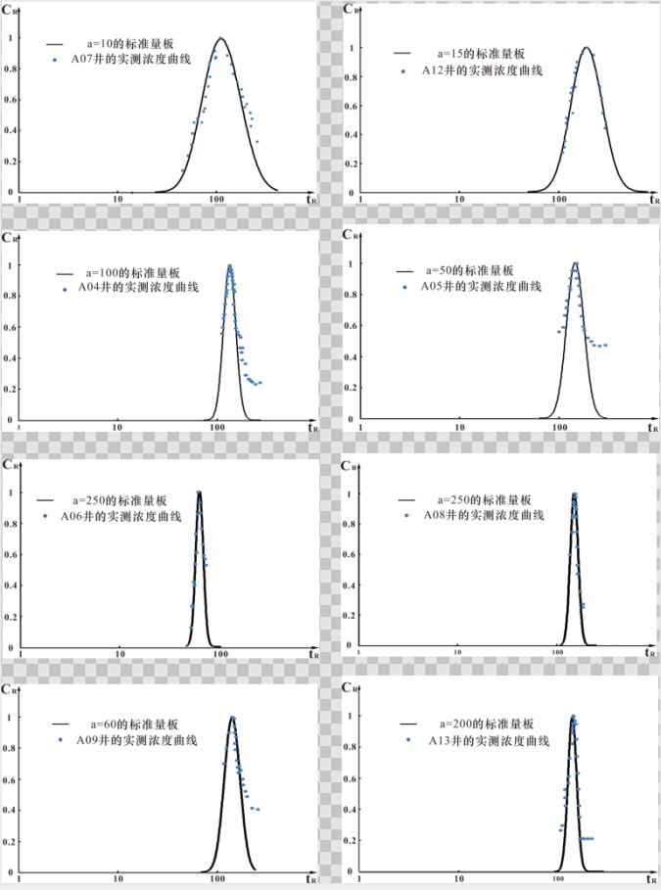
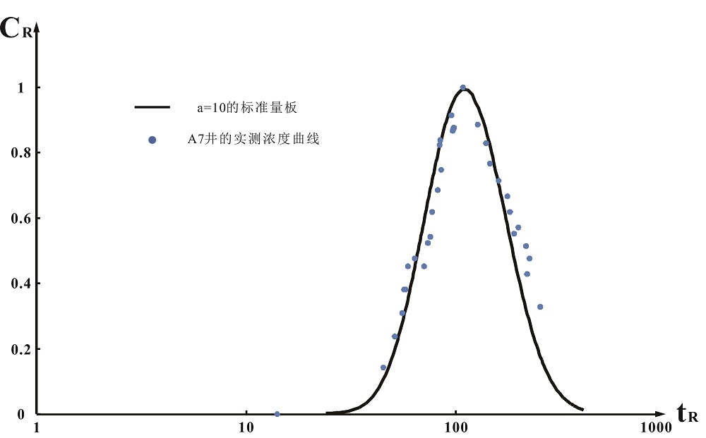
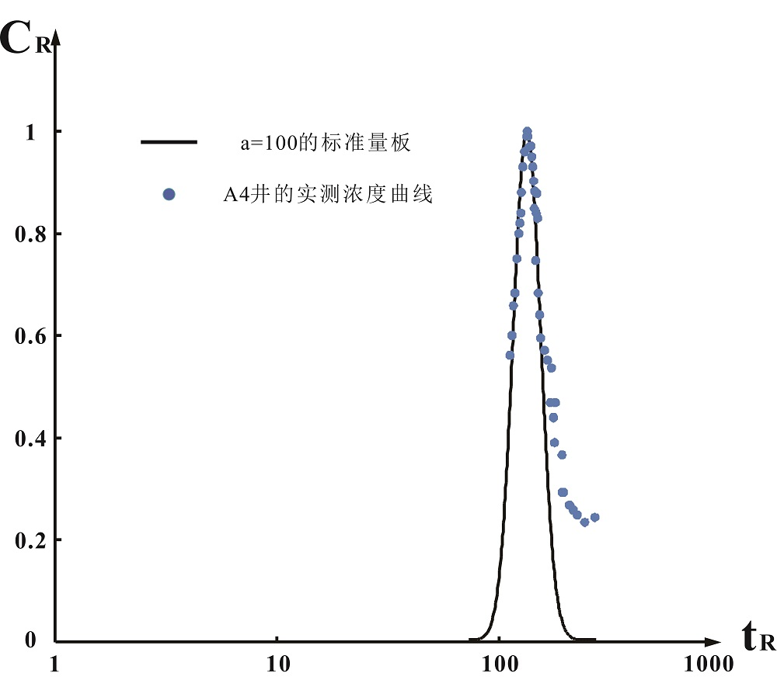
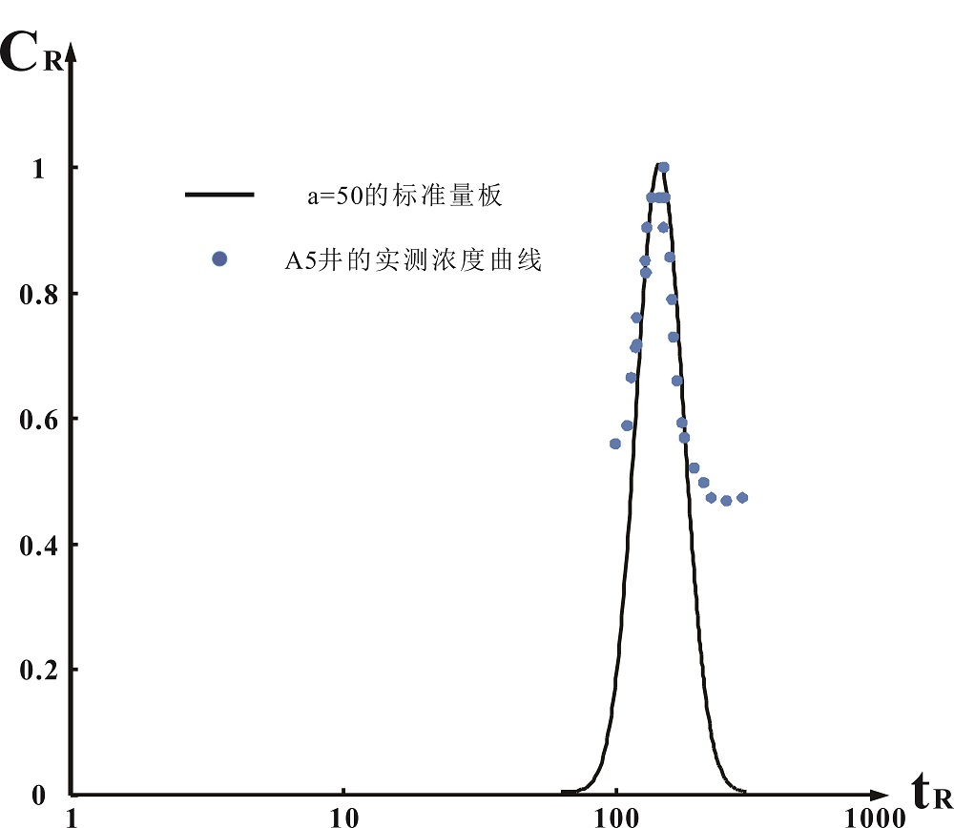
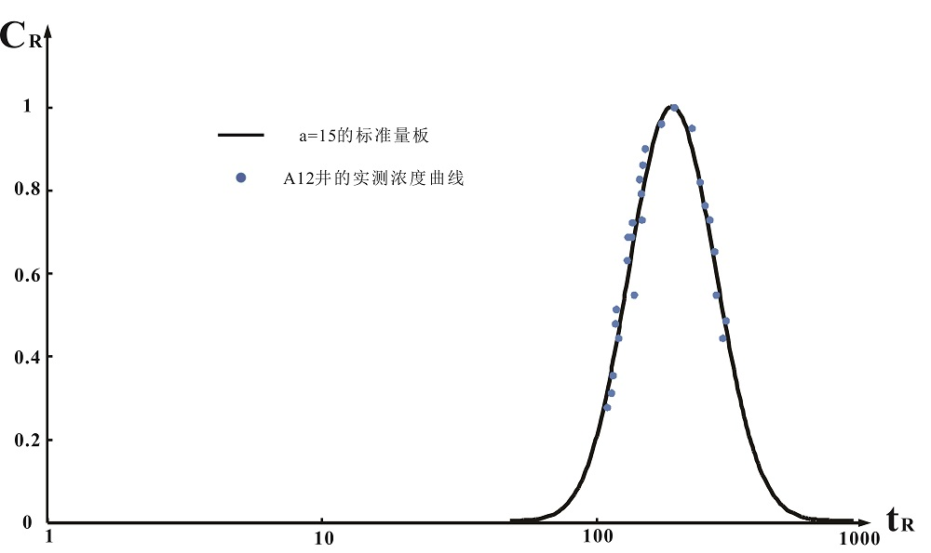
Fig .4 Matching diagram of measured concentration curve and plate curve of each monitoring well
Fig .4.14 A07 Matching diagram of measured curve with measuring plate curve (a=10)
Fig .4.16 A04 Matching diagram of measured curve and measuring plate curve (a=100) Fig 4.16Matching diagram of A04measured curve and measuring plate curve (100)

.1Fig .4-17 A05 Matching diagram of measured curve with measuring plate curve (a=50)

Fig .4.15 A 12 Matching diagram of measured curve and measuring plate curve (a=15) Figure 4.15Matching diagram of A12measured curve and measuring plate curve (15)

4.3 Results and analysis

Calculation of 4.3.1 dispersion
The a values obtained by fitting the measured chloride concentration of each monitoring well in 4.2 with the curve of the measuring plate and the vertical and horizontal coordinates (x) of each monitoring well_{i}y, I_{i}In the substitution formula (12) and formula (13), the results of the dispersion of the diving aquifer in the site are calculated respectively in Table 1.
Table 1 Summary of calculated results of aquifer dispersion
Well No | A07 | A12 | A04 | A05 | A06 | A08 | A09 | A13
α longitudinal dispersion_{L}m // | 0.400 | 0.400 | \ | \ | \ | \ | \ | \
α of transverse dispersion_{T}m // | \ | \ | 1.008  ×10⁻³ | 1.940  ×10⁻³ | 1.933  ×10⁻⁵ | 1.933  ×10⁻⁵ | 6.557  ×10⁻³ | 6.822  ×10⁻⁵
Table 1 shows that the longitudinal dispersion of diving aquifer in Jilin site is 0.400 m, the transverse dispersion is 1.933×10⁻⁵~6.557×10⁻³m. The lateral dispersion obtained from the monitoring well (A04、A05、A09) on the west side of the A01-A07-A12 is generally greater than that obtained from the monitoring well (A08、A13) on the east side, which is inferred to be caused by the heterogeneity of the diving aquifer in the site.

Calculation of 4.3.2 dispersion coefficient
According to formula (14) and formula (15), we can calculate the dispersion coefficient D of diving aquifer_{L}D; and_{T}。
The permeability coefficient of diving aquifer in this dispersion test site is K 77 m/d, the hydraulic gradient is I 2\8240;, according to the hydrogeological manual, the effective porosity n of sand gravel aquifer_{e}Experience 0.25; will be K 、I 、n_{e}The actual average velocity V of groundwater in the submersible aquifer is 0.616 m/d. calculated in substitution formula (16). The
The actual average velocity of groundwater in the groundwater of the diving aquifer of the site can be calculated V the D of the vertical dispersion coefficient of the site can be calculated in the formula (14) and (15) respectively_{L}D of transverse dispersion coefficient_{T}The results are shown in Table 2.
Table 2 Summary of calculations of the dispersion coefficient of the diving aquifer
Well No | A07 | A12 | A04 | A05 | A06 | A08 | A09 | A13
D of longitudinal dispersion coefficient_{L}(m)(b)(b)(c)(c)(c)(c)(c)(c)(c)(c)(c)(c)(c)(c)(c)(c)(c)(d)(c)(c)(c)(c)(c)(c)(c)(c)(c)(c)(c)(c)(c)(c)(c)(c)(d)(c)(c)(c)(c)(c)(c)(c)(c)(d)(c)(c)(c)(c)(c)(c)(c)(c)(c)(c)(c)(c)(c)(c)(c)(c)(c)(c)(c)(c)(c)(c))(c)(c)(c)(c)(c)(c)(c)(c)(c)(c)(c)(c)(c)(c)(c)(c)²:: d⁻¹） | 0.246 | 0.246 | \ | \ | \ | \ | \ | \
D of transverse dispersion coefficient_{T}(m) Annex²:: d⁻¹） | \ | \ | 6.209  ×10⁻⁴ | 1.195  ×10⁻³ | 1.191  ×10⁻⁵ | 1.191  ×10⁻⁵ | 4.039  ×10⁻³ | 4.202  ×10⁻⁵
According to Table 2, the longitudinal dispersion coefficient of diving aquifer in Jilin site is 0.246 m²/ d, transverse dispersion system 1.191×10⁻⁵~4.039×10⁻³m²d.//

Scale effect of 4.3.3 dispersion
By comparing the dispersion of monitoring wells with 4 m、6m distance tracer injection wells, the effect of scale effect on dispersion is discussed.
Table 3 Comparison of Diffusion Size at Different Migration Distance
Diffusion angle | Monitoring well distance from tracer injection well (m) | α of transverse dispersion_{T}(m)
30° | 4 | 1.008×10⁻³
 | 6 | 6.557×10⁻³
10° | 4 | 1.933×10⁻⁵
 | 6 | 6.822×10⁻⁵
Table 3 shows that, Compared with the transverse dispersion calculated from the tracer concentration in the monitoring well at m distance from the tracer injection well, At a diffusion angle of 10°, A 3.5-fold increase in the lateral dispersion of the sand-gravel aquifer in the study area calculated from the monitoring well at a distance of 6 m from the injection well; At a diffusion angle of 30°, The transverse dispersion increased by 6.6 times. The results show that the lateral dispersion of sand and gravel aquifer increases with the increase of tracer migration distance, The larger the dispersion angle, the greater the transverse dispersion. Domenico(1984) and Gelhar (1992) studies have come to a similar conclusion: in the same aquifer, The dispersion increased with the increase of solute transport distance^{[16-17]}。

5. Conclusions
(1) The dispersion parameters of the diving aquifer at the site were obtained by field dispersion tests :0.400 m,1.933×10⁻⁵~6.557×10⁻³m; longitudinal dispersion coefficient m 0.300²d, lateral dispersion coefficient is 1.450×10⁻⁵~4.918×10⁻³m²d.//
(2) This field dispersion test confirms the existence of diffusion parameter scale effects in field tests. In the same aquifer, the transverse dispersion increases with the increase of tracer migration distance, and the larger the dispersion angle, the greater the dispersion.
(3) The method of using standard curve method to solve dispersion parameters of diving aquifer is simple and quick, the result of calculation is more accurate and the applicability is wide, but there are some subjective errors when the measured curve and standard curve fit in the calculation process.
References
- Wang Baojin. Determination of groundwater dispersion coefficient [J].[ Environmental Science Research ,1989,2(1):51-55...
- Chen Chongxi, Li Guomin. Groundwater solute transport theory and model M]. Wuhan: China University of Geosciences Press ,1996:26-31.
- Wu Yaoguo. Analysis of Two-Dimensional Hydrodynamic Diffusion Test and Results of Zhengjia Submersible Aquifer in Benxi [J]. Hydrogeological Engineering Geology ,1998,(1):32-341.
- Jiang Xuemin, Shao Jingli, et al. Study on field test of hydrodynamic dispersion coefficient of groundwater —— Taking a mining area in Inner Mongolia as an example [J].].1 Resources and Environment in Arid Areas ,2013,27(10):176-180.
- Yang Qiyue. Comparative study of several methods for solving dispersion parameters of aquifer —— taking Kashi area as an example [D].].10 Xi'an: Changan University.
- Yu Hong, Guo Kang. Field Diffusion Experimental Study on Submersible Aquifer North of Baishan [J].]; and Groundwater ,2016,38(4):10-12.
- Yuan Wei, Yun Zhihan. Study on the Implementation Method of Field Dispersion Test in Confined Aquifer —— Taking a Water Source in Jilin Province as an Example [J].]; and Urban Geology ,2019,14(3):74-80.
- Li Shiyu, Liu Guodong, et al. Experimental Study on Hydrodynamic Diffusion of Submersible Water Submersible Water in Deyang Plain Area [J].] Study Hydroelectric Energy Science ,2015,33(11):38-40.
- Major, Li Guangwei, et al. Calculation of hydrodynamic dispersion coefficient [J].] in Jiangan Campus by particle swarm optimization based on bionic principle Coalfield Geology and Exploration ,2019,47(6):98-102.
- Zhang Yinmei, Zhang Yanjun, et al. Analysis of Influencing Factors in Tracer Diffusion Test [J].] Groundwater ,2014,36(2):4-6.
- Wang Bingchen. Groundwater Quality Model [M].] Shenyang: Liaoning Science and Technology Press ,1985.
- Jia Lijun, Deng Jiqiang, et al. Study on Water Dynamics Dispersion of Groundwater in NaCl as a Tracer in Northwest Quxian Water Area -- A Case Study of Dongliang Village in Dingbian County [J].].1 Applied Technology ,2016(274):117.
- Lin Xueyu, Jiao Yu. J]. on Scientific Management of Groundwater Resources in Shijiazhuang City Journal of Changchun Institute of Geology ,1987:125-126.
- Liang Wenkang. Explanation Method of Two-Dimensional Diffusion Test Data for One-Dimensional Flow Field [J].] Engineering Survey ,1986:39-40.
- Sun Nezheng. Mathematics Simulation Lecture (3)[ J].] on Groundwater Quality Hydrogeological Engineering Geology ,1982, No .3.
- Domenico P A ,Robbins,G A.A dispersion scale effect in model calibration and field tracer experiments [J]. Journal of Hydrology,1984,70：123-132.
- Gelhar L W,Welty C,Rehfeldt K R.A critical review of data on field-scale dispersion in aquifers [J]. Water Resour.Res,1992,28：1955-1974.

Date of receipt :2020-11-08
Fund project: National Joint Foundation for Natural Science Focus (U 19A20107)
Author: Wang Ruiqing (1996-), male, from Kaifeng, Henan Province, Master's degree.
Author: Dong Weihong (1974-), female, from Changchun, Jilin Province, Ph. D., Professor, Bo, mainly engaged in groundwater resources evaluation and management and hydrogeochemistry. E-mail：dongweihong@jlu.edu.cn.
Wang Ruiqing Tel :1830 4300574 Address :130012, Qianwei North District, Jilin University ,2519 Jiefang Road, Chaoyang District, Changchun City, Jilin Province
E-mail：wangrq18@126.com
Dong Weihong :13504419824 Address :130012, Qianwei North District, Jilin University ,2519 Jiefang Road, Chaoyang District, Changchun City, Jilin Province
E-mail：dongwewihong @jlu.edu.c n

