Study on Ground Engineering and Management of Carbonate Oil Field A under Rolling Development Mode
Chen Hang
(China Aviation Oil Co., Ltd. Southwest, Chengdu, Sichuan ,610000) Email :247776515@qq.com
Abstract: Carbonate rock has the characteristics of complicated accumulation rules, large-scale
development, high yield but unstable production. Therefore, the management and control of surface engineering projects of carbonate rock oil and gas reservoirs faces huge difficulties and challenges. The construction of surface engineering should conform to the principle of integrated underground and ground construction and adapt to the oilfield development model. This paper takes the newly added area A of the carbonated oil field as an example to study the ground engineering under the rolling development mode and aims to provide the construction ideas for the surface engineering under rolling development mode. The overall regional process design adheres to the design concept of "environmental protection, efficiency, and innovation", strictly follows the design specifications, and combines reservoir engineering and oil production engineering programs, oil and gas physical properties and chemical composition, product programs, ground natural conditions, etc. According to the technical and economic analysis and comparison of area A, this paper has worked out a suitable surface engineering construction, pipeline network layout and oil and gas gathering and transportation plan for area A. Some auxiliary management recommendations are also proposed in this paper, like sand prevention management and HSE management for carbonate reservoirs.
Key words: carbonate oil field, rolling development mode, ground engineering, ground
management

Introduction
  - The art of carbonate reservoirs
Carbonate reservoirs occupy an extremely important position in global oil and gas resources. According to statistics from IHS, carbonate oil and gas resources account for about 70% of the global oil and gas resources, proven recoverable reserves account for about 50%, and production accounts for about 60% [1]. Carbonate oil and gas reservoirs are widely distributed in North America, the Middle East, Central Asia and other regions. The main types are reefs, grain beaches, dolomites and weathered crusts. They are usually large in scale and have a buried depth of less than 3 000 m. The Luo, Cretaceous and Neogene are dominated by porous media. Carbonate oil and gas reservoirs abroad are mostly based on continuum theory for development and design; in terms of drilling and completion and engineering technology, a series of technologies such as complex structure wells have been developed to increase production and recovery. China is also very rich in carbonate oil and gas resources. According to the results of the national oil and gas resource dynamic evaluation in 2015, the petroleum geological resources are 340×108 t and the natural gas geological resources are 24.3×1012 m3, accounting for 27.0% of the total oil and gas resources. And 26.9%. In recent years, with the development of carbonate oil and gas fields such

as the Tahe Oil Field, Puguang Gas Field, and Anyue Gas Field, the production of natural gas and crude oil has increased rapidly, becoming an important area for China's oil and gas exploration and development, and for increasing oil and gas reserves and production. Compared with carbonate oil and gas reservoirs in other countries, China's carbonate oil and gas reservoirs have an old geological age, deep burial, and have undergone multiple stages of tectonic movement transformation. Porous reef beaches are mainly dolomite, making development more difficult [2].
Due to the complex geology of carbonate reservoirs and rapid decline in production, surface engineering projects have the following management and control difficulties [3]:
    - The geological environment is changeable, and the production scale is difficult to support. Compared with the construction and development of other oil reservoirs, it is prone to problems such as disconnection between the ground and the ground, the mismatch of production and construction scale, and overcapacity, and the investment risk is high.
    - Production capacity construction. Surface engineering project construction is a complex open system with strong integrity, multiple joints, large internal and external coordination workloads, and features large investment, short construction period, multiple construction units, intensive technology, and harsh geographic and natural environment.
Therefore, for the exploration and development of carbonate oil and gas reservoirs, an integrated mechanism of exploration and development should be adopted, and underground exploration and development and surface engineering construction should be considered as a whole, so that the underground production can be matched with the construction scale of surface storage and transportation projects, and project management and control should be strengthened. So as to realize the dynamic optimal allocation of resources and obtain good economic benefits.

Typical carbonate reservoir- Tahe reservoir
Tahe Oilfield is currently the only large-scale marine carbonate oil and gas field discovered in the Tarim Basin. Due to the complex accumulation conditions, the diverse forms of fractured-vuggy reservoirs, complex oil and gas distribution, and extremely special reservoir types, they are completely different from existing ones. The fracture-type or pore-type oil reservoir- Tahe reservoir has the following basic characteristics.
    - The burial depth of the reservoir is generally between 5 300 and 7 000 m, and it is one of the deeper carbonate reservoirs that have been developed in the world [4].
    - The diversity of storage space covers almost all types of carbonate storage space, including large-scale caves, dissolved pores, dissolved pores and structural fractures. Large-scale caves are the most important storage space. Dissolution pores are only developed in local areas. Fractures are the main connecting channels, forming three main types of reservoirs: cavernous reservoirs, fracture-dissolved cavernous reservoirs and fractured reservoirs collective [5].
    - Strong heterogeneity and strong separation. Different reservoir types are spatially interwoven to form fracture-cavity units with different connectivity, pressure systems and oil-water interfaces, and strong heterogeneity [6].
    - Complicated development rules. Due to the different types of reservoirs in fracture-cavity units, different reserves and energy scales, the development rules of different fracture-cavity units are also different. There are not only units with insufficient energy, rapid pressure drops, and rapid decline in output. But also, units with sufficient energy, units with slow pressure drop, fast water content rise, and rapid decline in output [7].

    - Since the capillary force can be neglected in the karst cave reservoir, the fluid flow in the karst cave has the characteristics of pipe flow, and the fluid flow in the fracture conforms to the characteristics of seepage. Therefore, the fluid flow in the fractured-vuggy reservoir of Tahe Oilfield has pipe flow characteristics. Coupling characteristics of flow and seepage [8].
    - Tahe Oilfield has the characteristics of high temperature, high pressure, super thick, super viscous and high sulfur content. Due to the deep burial and early accumulation of the reservoir, the temperature of the reservoir is as high as 140℃, the average pressure is above 60 MPa, and the crude oil density in the main block is above 0.98 g/cm3, and the main block is as high as 1.04 g/cm3. Crude oil at 50°C has a viscosity of 1 000 mPa·s, up to 1,300,000 mPa·s in some areas. In addition, it has the characteristic of high H2S content [9].
The particularity of carbonate fracture-cavity reservoirs in the Tahe Oilfield determines that the development and construction of this type of reservoir is a process of continuous and rolling evaluation, confirmation of reserves, and rolling development and construction of productivity. The continuous optimization of rolling development, rolling production construction and development plan design runs through the whole process of production capacity construction of fracture-cavity reservoirs.

Principle of ground project in carbonate reservoirs
When considering the construction of surface engineering in carbonate rock oilfields, the construction concept of "the ground is subordinate to the underground, and the ground adapts to the underground" should be established. According to the actual conditions of carbonate rock underground, timely optimize and adjust the ground construction. In particular, in view of the large uncertainty and short production life of carbonate reservoirs, we vigorously promote standardized design and skid-mounted construction to maximize reuse of equipment, reduce investment and maximize benefits [10]. Vigorously develop the "one well, one strategy" differentiated management model to improve oil well management. The strong heterogeneity of fracture-vuggy carbonate rocks determines the severe separation of the reservoir, and a connected fracture-vuggy unit is an oil and gas reservoir. Differences in storage space types, combination relationships, spatial distribution, reservoir size, water body energy, and completion methods have led to different development characteristics and effects. Therefore, it is necessary to formulate "one well, one reservoir" and formulate "one well, one strategy”. Based on the development stage and dynamic and static geological data, a variety of oil and gas well production management strategies have been explored, and a differentiated management model of "one well, one policy" has been initially formed. Different methods are adopted according to the stage of the well. A reasonable working system should be adopted for stable production wells. When the production changes drastically, targeted measures should be considered. According to the characteristics of the fracture-cavity unit and the well, the intermittent production well adopts targeted measures such as acid fracturing, mechanical production, water injection for oil, and water injection pressure cone. The long shut-in well considers sidetracking when there is no potential for acid fracturing, layer modification, and water shutoff. According to the characteristics of the fracture-cavity unit, the single-well karst-cavity unit with insufficient energy was injected with water to replace the oil, and the multi-well fracture-cavity unit was subjected to unit water injection development tests. By sorting out the "lying wells", the efforts of sidetracking were increased, the utilization rate of single wells was increased, and the pace of exploration and

development was accelerated. The "one well, one strategy" differentiated management model has played an important role in improving the recovery of fractured-vuggy carbonate reservoirs. Based on the construction principle of the integration of underground and ground in carbonate oilfields, this paper conducts research on the construction of surface engineering in the newly added area A in carbonate oilfields, aiming to provide ideas for surface engineering to adapt to the rolling development and construction of oilfields.

Data of A field
  - Design Principles
    - To make full and reasonable use of the pressure energy of the oil and gas field, and the topographical features of the block, plan in a unified manner, consider the characteristics of the production data of the oil and gas field, and rationally design the surface engineering plan.
    - Combining the overall process design of the gathering and transportation process in the geographical planning, rationally designing the layout of the gathering and transportation pipeline network, making overall plans and reducing the investment in project construction.
    - to Adopt mature gathering and processing technology, apply high-efficiency equipment, achieve the purpose of simplifying the process, reliable technology, saving investment, and ensuring the long-term stable operation of the gathering and processing system.
    - Adhering to the concepts of innovation, efficiency, safety and environmental protection, highlighting the characteristics of carbonate oil and gas field development plans and gathering and transportation technology.
(6) to implement relevant national, industry and local regulations strictly, save energy and reduce consumption, and do a good job in environmental protection and production safety guarantees.

Overview of A area
Area A is a new block in an oil field, which is a carbonate reservoir. Its surface contour is shown in Figure 6.1. Area A is between 1040m and 1070m above sea level. Currently, there are 6 old wells in area A, they are W1, W2, W3, W4, W6, W6 respectively. The location distribution is shown in Figure 2.1.1.

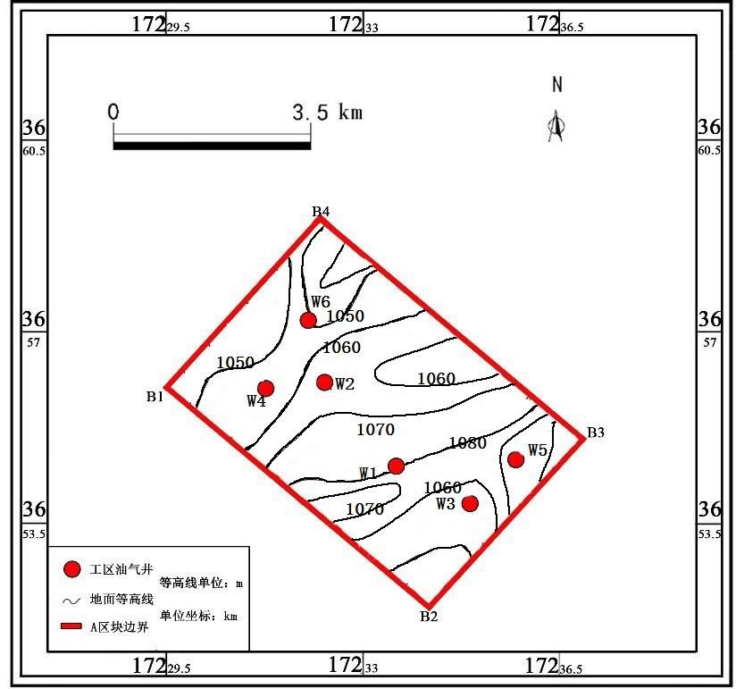

Figure 2.1.1 Location and contour map of area A
According to the production demand of the oil field, 6 new production wells are needed to be added. The locations of the 12 wells are shown in Figure 2.1.2.
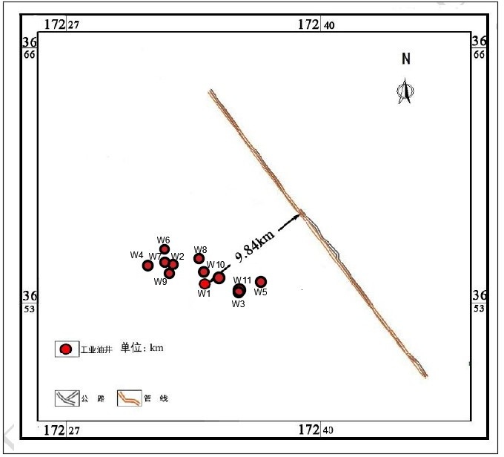

Figure 2.1.2 Lacation layout of all the wells (Note: Well W3 and W11 are relatively close, but not coincident)
The coordinates of the boundary inflection point and the position of the oil well are shown in
Table 2.1.1:

Table 2.1.1 Boundary inflection point and oil well location
Name | X-axis coordinate (m) | Y-axis coordinate (m)
B1 | 17229480 | 3666990
B2 | 17234170 | 3661970

B3 | 17236960 | 3666020
B4 | 17232220 | 3669060
W1 | 17233690 | 3664640
W2 | 17232310 | 3666080
W3 | 17234930 | 3663860
W4 | 17231270 | 3666940
W5 | 17236740 | 3664670
W6 | 17232010 | 3667200
W7 | 17231652.28 | 3656298.04
W8 | 17233307.15 | 3656630.45
W9 | 17231920.64 | 3655394.68
W10 | 17233554.52 | 3655523.36
W11 | 17235239.37 | 3654078.46
W12 | 17234313.99 | 3654970.73

  - Natural and social conditions of area A
The surface of area A is covered by yellow sand, and the main landforms are dunes and depressions between dunes. The climate is arid, rainless and windy and sandy. The annual average temperature is 10.1°C, the highest temperature is 41.3°C, and the lowest temperature is -26.4°C. The area has very little precipitation and evaporation. The annual average precipitation is 24.6mm, and the evaporation is 2606.9mm. It belongs to a typical warm-temperate continental extreme arid desert climate. The annual average ground temperature in area A is 12.4℃. The area is within the range of the oilfield highway network. Conveniently, the relative positions of 12 wells in the entire oilfield are shown in Figure 2.1.3.

Figure 2.1.3 Schematic diagram of traffic in area A
According to GB 50350-2015 "Oil Field Oil and Gas Gathering and Transportation Specifications", the design of oil and gas gathering and transportation projects in the desert and

Gobi areas should be suitable for the harsh environmental conditions in the desert and Gobi areas, and effective sand prevention measures should be adopted in the design of stations and lines. Utilize natural resources such as solar energy and wind power in desert areas and carry out comprehensive planning and effective utilization [11].

Design Basis
According to GB 50350-2015 "Code for Design of Oil and Gas Gathering and Transportation of Oilfields", the design capabilities of equipment and pipelines of oil production wellsites should be based on the oil, gas, and water output of a single well provided by the oilfield development plan and the amount of liquid or gas lift [11]. The gas volume is determined. The production days of oil wells should be calculated as 330d for self-blowing wells.
The design capacity of water-bearing crude oil treatment and transportation facilities of various stations should be determined according to the daily oil production of the oil wells under the jurisdiction of the oilfield development plan, the water content of crude oil and the amount of liquid mixed in the collection process.

Production Data
Area A generally adopts the water injection rolling development model. The area generally follows the principle of efficient development and has the characteristics of phased development and large fluctuations in daily output. The regional rolling development data is shown in Table
2.1.2. This requires that the ground project needs to be constructed in phases during construction, and the equipment should be integrated, and skid mounted as much as possible to adapt to rolling development.

Table 2.1.2 Rolling Development Data Sheet
 | Unit | Well | Production (m3/d) | Measures | Well type | Water injecti on cycle | Water injecti on time  (a) | Simm ering time (d) | Well-openi ng | Daily water injection (m3/d)
Phase 1 | S2 | W5 | 150 | Acid pressure | old | - | - | - | - | -
 |  | W3 | 150 |  | old | - | - | - | - | -
 |  | W11 | 200 |  | New horizontal  well | 8 | 2 | 5 | 200 | 600
 | S4 | W4 | 150 |  | old | 8 | 2 | 5 | 150 | 600
 | S6 | W6 | 200 |  | old | 8 | 2 | 5 | 200 | 600
 | S9 | W1 | 150 |  | old | 8 | 2 | 5 | 150 | 600
 | S10 | W2 | 200 |  | old | 8 | 2 | 5 | 200 | 600
Phase 1 | S1 | W12 | 200 |  | New horizontal  well | 8 | 2 | 5 | 200 | 600
 | S3 | W10 | 200 |  | New double branch  well | 8 | 2 | 5 | 200 | 600

 | S5 | W7 | 150 | acidificati on | New  vertical well | 8 | 2 | 5 | 150 | 600
 | S7 | W8 | 150 |  | New  vertical well | 8 | 2 | 5 | 150 | 600
 | S8 | W9 | 150 |  | New vertical  well | 8 | 2 | 5 | 150 | 600
adjust ment | S2 | W9-  side | - | - | New vertical  well | Water injection time: 15th year, injection-production ratio: 1:1.3

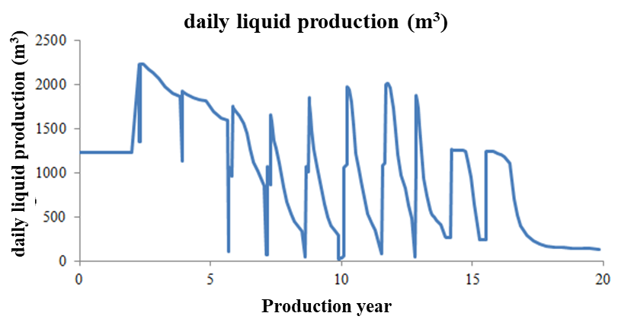
The overall output of area A is shown in Figure 2.1.4-Figure 2.1.6, the regional production data of each year is shown in Table 2.1.3 and the maximum production data in Table 2.1.4.

Figure 2.1.4 Changes in daily fluid production in area A
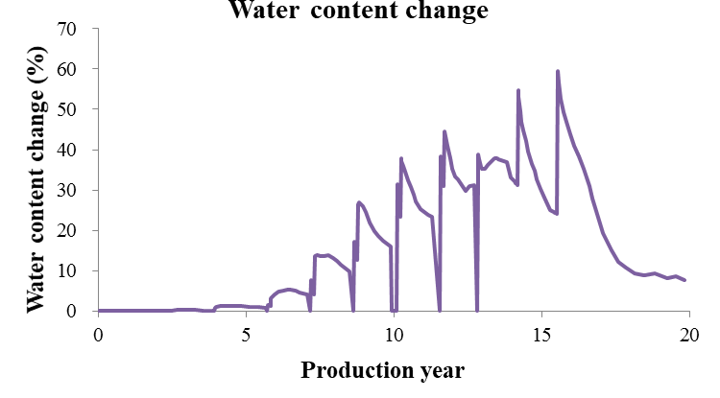
Figure 2.1.5 Change of total water content in area A (Note: Due to the braising plan, the water cut per day will fluctuate)

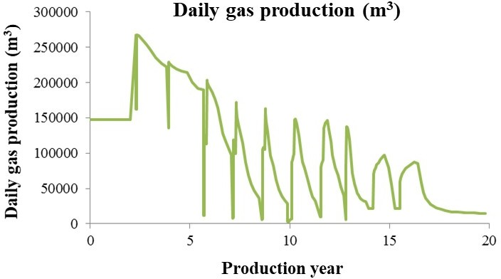

Figure 2.1.6 Changes in daily gas production in area A Table 2.1.3 Production data in each year
Production  year | Daily oil production  (m3) | Daily fluid production  (m3) | Daily gas production  (m3) | Wellhead  pressure (MPa)
1 | 1230 | 1230 | 147600 | 4
2 | 1230 | 1230 | 147600 | 4
3 | 2057 | 2064 | 246947 | 4
4 | 1860 | 1882 | 223270 | 4
5 | 1675 | 1695 | 201051 | 4
6 | 1558 | 1636 | 186987 | 4
7 | 813 | 848 | 97561 | 4
8 | 1134.259 | 1134.259 | 110359.2 | 4
9 | 641.5561 | 641.5561 | 62182.96 | 4
10 | 377.0353 | 377.0353 | 36238.1 | 4
11 | 282.0535 | 282.0535 | 19009.27 | 4
12 | 256.0271 | 256.0271 | 13884.14 | 4
13 | 262.0571 | 262.0571 | 13297.91 | 4
14 | 343.9455 | 343.9455 | 16574.81 | 4
15 | 372.3046 | 372.3046 | 18572.9 | 4

Table 2.1.4 Maximum production data
Maximum daily oil  production (m3) | Maximum daily fluid  production (m3) | Maximum daily gas  production (m3) | Maximum water  content (%)
2057 | 2064 | 246947 | 0.62
It can be seen from the above table that with the implementation of the water injection development plan, the single-day liquid production and water content fluctuate greatly. This requires the oil and gas treatment process to consider the gradual increase in the water content of the combined station, and the processing capacity can meet The processing demand when the liquid volume is the largest and the moisture content is the highest.

Crude oil evaluation
According to the data provided, the properties of surface crude oil are shown in Table 2.1.5.

Table 2.1.5 Statistics of surface crude oil properties
 | Surface crude oil  density (g/cm3) | Viscosity(mPa  ‧s) (60℃) | Freezing  point (℃) | Sulfur  content (%) | Gum &  Asphaltene | Wax content  (%)
Range | 0.7931~0.8092 | 1.678~2.887 | -30~-4 | 0.139~0.302 | 0.06~1.24 | 4.2~13
Average | 0.8032 | 1.96 | -17 | 0.19 | 0.39 | 8.87
The composition analysis of degassed crude oil in area A is shown in Table 2.1.6. Degassed crude oil refers to the composition of oil well fluid after degassing once on the ground. The components of the bottom-hole oil stream are not accurately provided, and the components of the ground degassed crude oil in adjacent areas can be calculated as the stable feed components of crude oil.

Table 2.1.6 Component analysis of ground degassed crude oil adjacent to area A
Component | Formation oil (Mol%)
CO2 | 0.307
N2 | 0.697
C1 | 9.911
C2 | 1.379
C3 | 0.613
nC4 | 1.631
C6 | 1.872
C7 | 2.474
C8 | 3.868
C9 | 3.316
C10 | 2.741
C11 | 4.347
C12 | 7.826
C13 | 6.966
C14 | 8.694
C16 | 13.271
C16+ | 30.200
total | 100
Crude oil in Area A has the characteristics of "light weight, low viscosity, sulfur, less gum & asphaltene, and high wax content". In combination with the analysis of crude oil components and related specifications, the following treatments should be done in the process of crude oil gathering and transportation:
      - Although crude oil is sour crude, it contains less sulfur, and most of the active sulfur can be removed in conventional crude oil processing procedures, such as oil-gas separation, crude oil dehydration, and crude oil stabilization. The desulfurization industry is combined with the above process.
      - The crude oil is high waxy crude oil, so wax prevention measures must be taken to prevent pipeline blockage caused by wax scaling.
      - Crude oil has the characteristics of "low density, low viscosity, and low condensation" and good flow characteristics. The pressure energy of the wellhead oil flow should be fully

utilized to appropriately increase the pressure of the gathering and transportation system.

Nature of natural gas
The proportion of dissolved gas in area A is 0.6103~0.9030, and the average value is 0.7601.
The statistics of natural gas properties are shown in Table 2.1.7.

Table 2.1.7 Statistics of natural gas properties
 | Relative density | Methane  （%） | Ethane  （%） | CO2  （%） | N2  （%） | H2S  （mg/m3）
Range | 0.6103~0.9030 | 61.1~89.6 | 6.41~16.9 | 0.03~10.9 | 1.26~12.4 | 0~26800
Average | 0.7601 | 72.16 | 8.6 | 3.77 | 6.82 | 7466
Area A is methane gas with medium carbon dioxide, medium nitrogen, and medium sulfur. The analysis of the given components shows that the sum of the molar components of the above components is not 100%. It can be seen that the natural gas in area A contains approximately average 8.27% (mole fraction) of C3+ component.
The presence of H2S and CO2 in natural gas will cause corrosion of equipment and pipelines, and the combustion of sulfides will pollute the atmosphere. Therefore, natural gas without removal of these impurities cannot be used as commercial gas, and acid gas in natural gas must be removed.
For qualified commercial natural gas, its gas quality should meet the gas quality index requirements in the national standard GB17820-2012 "Natural Gas" [12], see Table 2.1.8.
Project | Class One | Class Two | Class three
High heat① (MJ/m3) | ≥36 | ≥31.4
Total sulfur①(mg/m3) | ≤60 | ≤200 | ≤360
Hydrogen sulfide①  (mg/m3) | ≤6 | ≤20 | ≤360
Carbon dioxide%（V/V） | ≤2.0 | ≤3.0 | —
Water dew point②③，℃ | Under the pressure of the junction point, the water dew point should be 6℃ lower  than the lowest ambient temperature under the conveying conditions
①The standard reference condition of gas volume in this standard is 101.326KPa, 20℃.
②Under transportation conditions, when the buried temperature of the pipe top is 0℃, the water dew point should not be higher than -6℃.
③ For natural gas entering the gas pipeline, the pressure of the water dew point should be the highest transmission pressure.

Formation water properties
Area A is methane gas containing carbon dioxide, nitrogen and sulfur. The presence of H2S and CO2 will cause corrosion of equipment and pipelines, and the formation water contains Cl-. The co-existence of the three will aggravate the gathering and transportation pipelines. Corrosion conditions, and different H2S and CO2 corrosion environments, the selection of pipeline materials will also be affected, and the corrosion environment needs to be judged first.
In an environment where CO2 and H2S coexist, the partial pressure ratio ( pCO / pH S ) of the
2 2
two is usually used to determine the corrosion mode: when / is less than 20, it is the H2S corrosion
2
2

zone; when
pCO
/ pH S
is between 20 and 600, it is the H2S and CO2 mixed corrosion zone;

When
pCO / pH S
is greater than 600, it is a CO2 corrosion zone.

2 2

The calculation shows that the main corrosion type of gathering and transportation pipelines is H2S corrosion, and sulfur-resistant pipelines are mainly considered when selecting pipeline materials.

Overall design plan
The surface of area A is covered by yellow sand, and the main landforms are dunes and depressions between dunes. The climate is arid, with little rain and windy sand, and belongs to a typical warm-temperate continental extreme arid desert climate. Oilfield development is carried out in the desert hinterland because of its extremely harsh natural environment, no social support, long transportation distance, and large investment, it is a challenge to the surface technology. Under these conditions, it will be difficult to meet the needs of desert oil field development by adopting the conventional construction mode in the mainland. Therefore, it is necessary to fully rely on Area A The oilfield road network and pipelines built within.
Since the data does not clearly indicate the type and purpose of the pipeline that has been built, combined with the current gathering and transportation status of the Tarim Oilfield and the Tahe Oilfield and other desert oilfields, assumptions are made about the type of pipeline, and the pipeline is assumed to be a crude oil export pipeline. Natural gas transmission pipeline. (Even if it is assumed to be a natural gas pipeline, a new crude oil pipeline is required, which is equivalent to the same assumption, so we will not discuss it again)
Based on this assumption, the overall regional process design adheres to the design concept of "environmental protection, efficiency, and innovation", strictly follows the relevant design specifications, and combines reservoir engineering and oil production engineering programs, oil and gas physical properties and chemical composition, product programs, and ground natural conditions Through the technical and economic analysis and comparison of multiple schemes, a closed process flow of oil and gas gathering and processing suitable for Area A was developed.
    - The overall flow of gathering and transportation technology
In general, the first-level and half-distributed oil and gas mixed transportation technology is adopted, and based on the three low and one high characteristics of "low density, low viscosity, low condensation, and high wax content" of regional crude oil, in order to make full use of oil well fluid pressure energy and heat energy, Naturally no heating (no heat preservation) and oil collection method of wellhead throwing and wax removal.
    - Gathering pipeline network layout
In view of the small area under regional jurisdiction, relatively concentrated wellhead locations, fewer wellheads, and large production and pressure fluctuations, the first-level and half-station deployment method where oil from a single well enters the station directly is used, and the production distance and minimum are the goal Function, using the ant colony algorithm to optimize the joint station site selection and well group division, and finally adopt a valve group division method that is convenient for management and reduces investment.
    - Piping design
In terms of pipeline design, from the perspective of controlling the influence of slug flow, rationally utilizing the pressure energy of oil well fluids and controlling the average flow rate of the liquid, a suitable end point of the pipeline is obtained to calculate the pressure, and then the pipe diameter and hydraulic calculation of the pipeline are inversely calculated to try to make the later stage simmered When the well plan is implemented, the pipeline will not have bad hydraulic

conditions, and the pressure of the gathering and transportation system will be appropriately increased. At the same time, it also considers the flow guarantee measures along the oil and gas mixed transportation, such as natural gas hydrate prediction, pipeline wax removal, slug flow control and erosion control.
    - Oil and gas treatment technology
The design of the oil and gas processing technology has always been centered on the construction principles of adapting to the water content of crude oil and adapting to the reservoir development plan, closely combining the physical properties of the oil and gas of the block, and taking into account various process flows.
Crude oil processing unit: Make full use of the characteristics of "low density, low viscosity, and low condensation" of crude oil, combine oil and gas separation with crude oil dehydration, and adopt a dehydration process of one-stage thermochemical precipitation during stable production period + two-stage thermochemical precipitation during water injection period; The crude oil stabilization process of negative pressure flash evaporation + steam stripping desulfurization is adopted to shorten the process and reduce investment.
Natural gas processing unit: In view of the characteristics of natural gas containing H2S and CO2 and low water content during stable production period, the purification process of first MDEA desulfurization followed by TEG dehydration is adopted. The subsequent sulfur recovery process is suitable for medium sulfur recovery and also has tail gas treatment. Low-temperature Claus process; the use of shallow cooling process natural gas condensate recovery process for calorific value verification.
    - Joint station yard design and supporting engineering
Strictly following the current national regulations, taking into account environmental protection and energy saving, the process flow and layout of the joint station were designed, and the area's supporting sewage treatment, fire safety, power supply system, communication system and other parts were designed in detail.

Ground process
  - Ground production scale
The scale of ground construction should match the reservoir development plan and the production allocation plan, and generally follow the design principles that adapt to the changes in the water content of the oilfield and the development plan. It is proposed to build a joint station to process crude oil and natural gas. The corresponding production capacity scale is shown in Table
3.1. 1.

Table 3.1.1 Designed production scale
Crude oil processing capacity | 2050m3/d
Natural gas processing capacity | 246947 m3/d
Adaptation principle | Adapt to changes in moisture content
Years of stable production | 7~8 a
Design life | 20 a

  - Overall layout of gathering and transportation technology
    - Basis for the overall layout
      - The selection of the gathering and transportation process should be based on the determined oil and gas reserves, reservoir engineering and oil production engineering schemes, and full consideration should be given to the area of the oil field, the type of reservoir structure, the oil and gas reserves, the scale of production, and the expected changes in the water cut of the oil field. Well oil production, single well gas production, well oil pressure and oil temperature, etc.
      - Petroleum physical properties. Crude oil physical properties include crude oil components, wax content, glue content, impurity content, density, pour point and viscosity-temperature relationship, etc.; natural gas physical properties include natural gas components and the content of acid gases such as H2S and CO2.
      - Well layout methods, oil displacement methods and oil production methods of the oilfield, as well as expected well pattern adjustments and changes in oil displacement methods and oil production processes during development.
      - The geographical location of the oil field, natural conditions such as meteorology, hydrology, engineering geology, seismic intensity, and the industrial and agricultural development of the oil field, transportation, power, communications, distribution of residential areas and supporting facilities, and other social conditions.
(6) The successful experience and failure lessons of similar oil fields have been developed.

Principles of overall layout
      - to meet the requirements of oilfield development and exploitation. The oil and gas gathering and transportation process should be based on the requirements of reservoir engineering and oil production engineering to ensure the safety and reliability of oilfield development and production, and coordinate production and transportation, and produce qualified oil and gas products according to quality and quantity.
      - to meet the requirements of oilfield development and development design adjustments, and adapt to the requirements of dynamic changes in oilfield production. The selected gathering and transportation process should have strong adaptability and flexibility to make adjustments, and minimize the workload of the reconstruction of the gathering and transportation process. When the gathering and transportation process is partially adjusted, try not to affect the normal production of the oil field. It should be able to collect various production information of the oil gathering system in time so that the operator can take corresponding measures.
      - to carry out the principle of energy conservation. The gathering and transportation process should reasonably utilize the pressure energy of the oil and gas well fluid, reduce the midway transfer of oil and gas, and reduce the power consumption. At the same time, the heat energy of the well flow should be used reasonably, and the equipment and pipelines should be well insulated , Reduce the temperature of oil and gas processing and transportation. Pay attention to the use of high-efficiency energy-saving equipment and energy-saving technology to minimize the energy consumption and production costs per unit of production.
      - to make full use of oil and gas resources to increase the degree of airtightness from the wellhead to the mine oil depot or user, so as to minimize the oil and gas loss during the gathering and transportation process.
(6) to implement the principle of "less input, more output" and increase economic efficiency. The oil and gas gathering, and transportation process design of an oil field should be closely

integrated with reservoir engineering, drilling engineering, and oil production engineering. Overall consideration should be given to the specific requirements of oilfield development in stages. Comprehensive planning, implementation in phases, combining the above ground and underground, unified demonstration and optimization, and ensuring good overall economic benefits for oilfield development and construction. At the same time, various safety production regulations and design regulations stipulated by the state and industry should be observed.
(6) to pay attention to protecting the ecological environment. When determining the oil and gas gathering and transportation process plan, engineering measures to eliminate pollution and protect the environment must be considered. In the feasibility study section of major projects, an evaluation report on the environmental impact of the project must be submitted to the relevant state department Approval.

Overall process design of gathering and transportation
    - Gathering and transportation process layout
In order to concentrate the oil and gas from each single well in the oil field for transportation, measurement and purification, it is necessary to adopt different crude oil gathering and transportation processes according to the actual conditions of each block and the nature of the oil product to achieve full utilization of oil and gas data, formation pressure, and energy saving. Consumption and the purpose of convenient management. There are many kinds of oil and gas gathering and transportation process. According to the form of oil and gas gathering and transportation system, it can be divided into first-level (or first-level and half), second-level and third-level station gathering and transportation processes.
According to GB 50350-2015 "Oil Field Oil and Gas Gathering and Transportation Design Code", the oil and gas gathering and transportation design should be based on the technical and economic comparison to determine the station deployment method [11]. The specific situation can also adopt the half-level arrangement method.
Due to the small scale of area A, it is not suitable for the three-level deployment of stations, and mainly considers the first-level (first-and-a-half) or second-level deployment of stations.
      - First-level half-distribution station process
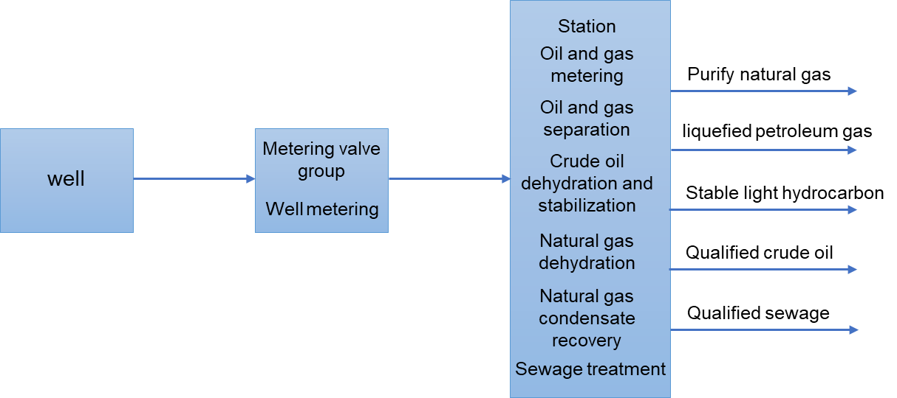
The gathering and transportation process of the first-level semi-distributed station is "wellhead→metering station→joint station", and the flow chart is shown in Figure 3.3.1.

Figure 3.3.1 The flow chart of the first-level station
Generally, one metering station is set up for every 8-12 oil wells. If the metering period of oil wells is appropriately extended to shorten the time for metering without a well, the use range of the metering device can be increased. The use range of each metering device can be according to formula (3.2. 1):

nm =
W
24T

t
(3.2. 1)

Where
nm is the number of metering devices to be installed in the development oil area; W is total

number of oil wells in development oil area; T is oil well metering cycle, that is, how many days are required to measure once; t is the time of continuous measurement for each oil well in hours.
The value of the above formula is the number of oil wells that can be measured by each
metering transposition. According to this metering range, one metering device can be shared for several metering valve groups. A metering device is set to form the gathering and transportation process of the first-level and semi-distributed station; there is no need to design a metering valve group, and each oil well is directly set up in the metering device of the joint station for measurement, forming an oil area and measuring at the joint station to form a deployment process.
      - Secondary cloth station
The secondary station deployment process refers to the station deployment form consisting of "wellhead→metering station→combined station". According to the different transportation modes, it can be divided into the oil and gas distribution process of the secondary station and the oil and gas mixed transportation of the secondary station. Process.
- The oil and gas distribution process of the secondary station
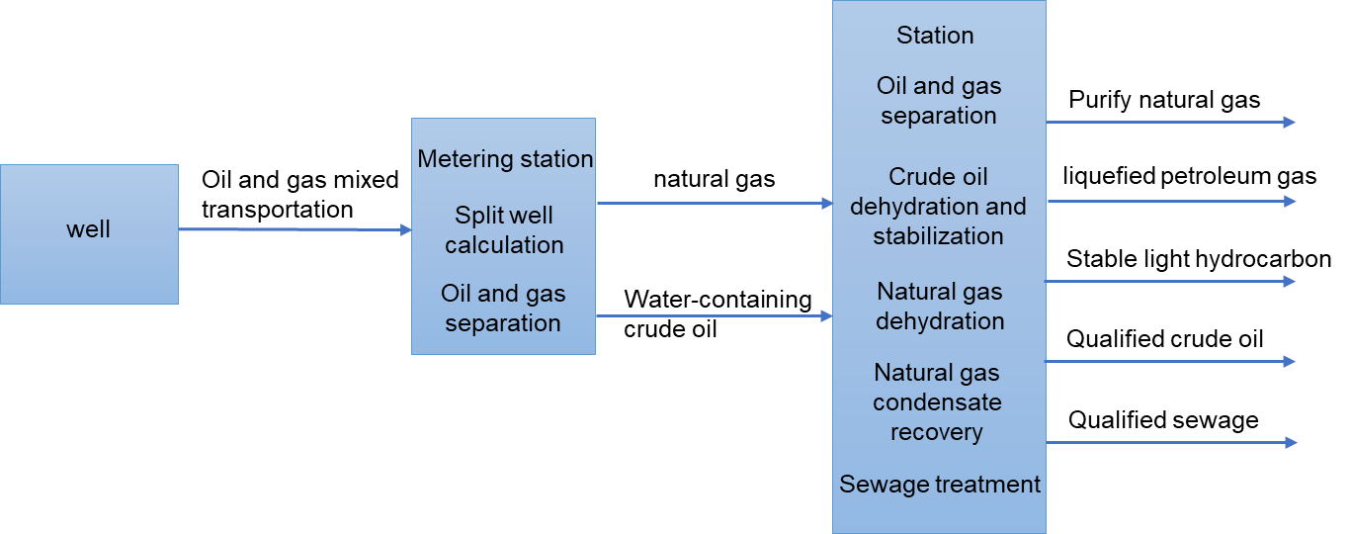
Oil well products are transported to the sub-well metering station through pipelines. After gas-liquid separation, the output values of single well oil, gas and water are measured respectively. After the oil-gas-water separator exits, the oil and gas are respectively transported to the joint station. Water-containing crude oil enters the crude dehydration device and crude oil stabilization device perform dehydration and stabilization. The petroleum vapor flashed from the natural gas and the stabilization tower enters the natural gas dehydration device and the natural gas condensate recovery device for processing to produce qualified oil and gas products. The effluent and oily sewage are treated on-site. The flow diagram of the oil and gas separation process is shown in Figure 3.3.2.

Figure 3.3.2 The diagram of the oil and gas separation process

- The oil and gas mixed transportation process of the secondary station
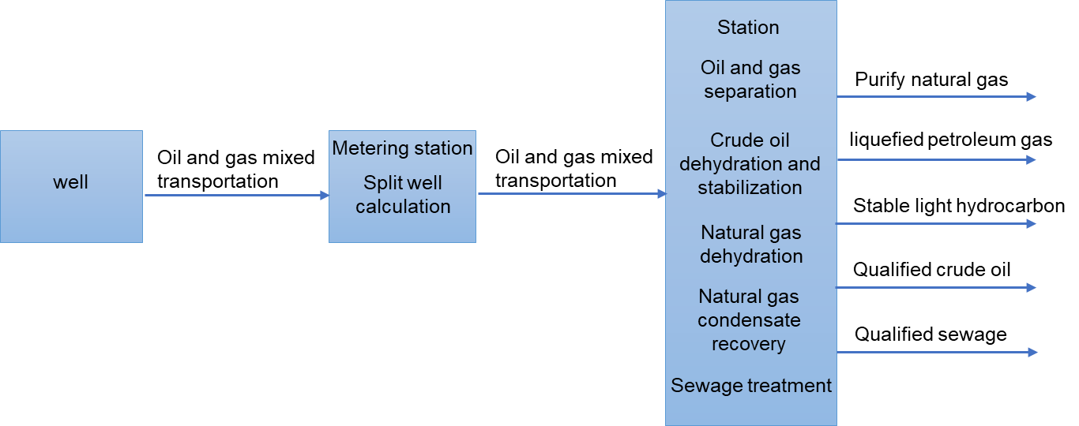
After the output value of oil, gas, and water is measured separately at the sub-well metering station, the product of a single well is mixed with the gas and liquid and then enters the centralized processing station through the oil gathering pipeline for centralized oil and gas separation, crude oil dehydration, crude oil stabilization, natural gas dehydration, and natural gas condensate recovery Wait for the treatment process to obtain qualified oil and gas products, and the produced water will be reinjected after centralized treatment. The oil and gas mixed transportation process block diagram of the secondary distribution station is shown in Figure 3.3.3.

Figure 3.3.3 The diagram of oil and gas mixed transportation process
According to the application situation of the current domestic oilfield gathering and transportation layout methods, the three layout methods to be adopted have their own technological characteristics and applicable occasions, see Table 3.3.1.

Table 3.3.1 Process characteristics and applicable occasions of the three layout methods
Layout | Process characteristics | Applications
First-level | Since most metering stations are simplified to metering valve groups, and the metering valve group to the metering device is connected by metering pipelines, the gathering and transportation process is greatly simplified. Compared with the second-level deployment station process, this kind of first-level and half-distribution station process engineering The amount is greatly reduced, and its engineering  investment is significantly reduced. | Many oilfields at home and abroad, especially those developed in recent years, including oilfields in desert areas, all adopt the first, half or first level station gathering and transportation process, thus simplifying the process and reducing investment.
Two-level (oil & gas separation) | The specificity of this process is single well entry, centralized periodic metering in sub-wells, which simplifies well site facilities, separate treatment of oil and gas. Different delivery processes are used for oil output, oil gathering, and gas gathering pipelines. The disadvantage is oil. Gas separation and transmission and gas gathering systems are complex, and dew point treatments need to be dispersed at multiple locations. The amount of engineering is large, equipment, steel,  and investment consumption are large. | This process is suitable for oil fields with relatively large gas and oil but not high wellhead pressure. Using this separation process can reduce wellhead back pressure and increase the transmission capacity from the metering station to the joint station.

Two-level (oil & gas mixed) | This process can make full use of the formation energy, no pump connection is needed from the wellhead to the joint station, which simplifies the gas gathering system, is easy to manage, and saves a lot of investment. It is currently widely used in various domestic oil fields. | This process is suitable for oil fields with low gas-oil ratio and small gathering and transportation radius, but the crude oil is stable and the natural gas condensate recovery device has poor adaptability when  the processing volume varies greatly.

When considering the layout of the gathering and transportation process, the size of area A, the location of wellheads, and production changes should be considered comprehensively, and each single well in the block has the characteristics of higher wellhead pressure (4MPa) and faster production decline after stable production period. , In order to make full use of the formation energy to ensure the relative stability of the total output of the oil-gathering pipeline in the later stage, it is advisable to adopt the transportation method of mixed oil and gas.
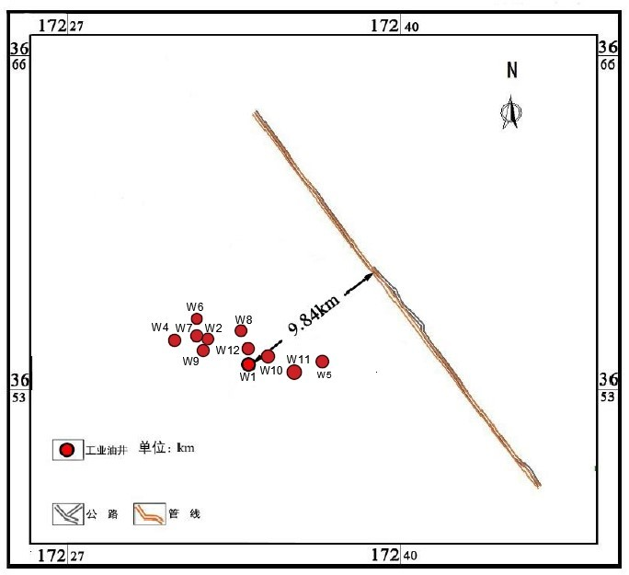
The wellhead layout of the production well in area A is shown in Figure 3.3.4.

Figure 3.3.4 Wellhead layout of area A
It can be seen from the above figure that the area of the pipeline in area A is small and the location of the wellhead is relatively concentrated. In order to facilitate centralized management, simplify the process and reduce the project investment, it can be simplified to the first-level and half-distributed station based on the mixed oil and gas transmission at the second-level station. In the end, the overall gathering and transportation process of the first-level and half-station oil and gas mixed transportation is adopted.

Comparison and selection of oil collection technology
In order to facilitate the collection and transportation of oil fields, the process measures taken to complete the task of collecting and transporting oil and gas are called oil gathering processes. Because of the large differences in the physical properties of crude oil in many oil fields in my country, even in different areas of the same oil field, the nature of the crude oil is not the same Therefore, oil collection methods are also diverse. To sum up, the oil field collection technology mainly includes heating oil collection, liquid oil collection technology, heat source accompanied by heat preservation oil collection technology, non-heating oil collection technology, etc.

According to GB 50350-2015 "Oil Field Oil and Gas Gathering and Transportation Design Specification", the basic process of oil field oil and gas collection should adopt the wellhead unheated single pipe process, wellhead heating single pipe process, double pipe liquid mixing process, single pipe loop water mixing process [11]. Each The selection of the typical process should be combined with the industry standard "Oilfield Surface Engineering Construction Planning and Design Code" SY/T 0049 [13].
Because the crude oil in area A has the characteristics of light weight, low viscosity, low condensation, good fluidity, and high wellhead temperature (56℃), the main consideration is the wellhead heating single-tube oil collection technology and the wellhead unheated single-tube collection technology. Oil craft.
      - Single tube heating oil collection process
Heating and heat preservation to reduce the viscosity of crude oil is an oil gathering process widely used in various oil fields in our country. The single pipe heating oil gathering process refers to wellhead heating, a gathering pipeline, and oil gathering technology for mixed oil and gas transportation. The metering station is arranged at 8~10 At the appropriate position of the well, the oil and gas mixture from each single well is first heated by a water jacket heating furnace, and a single pipeline is used to concentrate the mixed oil and gas into the metering station, and then enter the metering separator to measure the oil and gas respectively to complete the metering. After the oil and gas are mixed again into the oil gathering pipeline and exit the station. The oil wells that are not used for single well metering are generally mixed with oil and gas to the metering station, and switched directly into the outbound oil gathering pipeline through the valve group of the main office. Before the station enters the production separator, the total amount of oil and gas are respectively measured, and then mixed again into the oil gathering pipeline out of the station, and transported to the centralized processing station or the joint station. Figure 3.3.5 shows the heating and thermal insulation oil collection of the secondary distribution station flow chart.

Figure 3.3.5 Flow chart of heating, heat preservation and oil collection at the secondary distribution station
The technical characteristics of the oil collection process are:
- There is generally a water jacket heating furnace on the well site. In addition to heating the oil well products, it can also be used to achieve hot oil circulation and wax removal. The metering station has simple equipment, only one oil collection pipeline, saving steel, and complicated geological conditions The oil well is more adaptable.
- The water jacket heating furnace on the well site brings inconvenience to management and it is difficult to realize automation; the pipeline needs to be cleaned when the well is stopped or in operation, otherwise the pipeline will be blocked; for the gasless or less gas oil well, sometimes the well site water jacket furnace Need to lay another gas supply pipeline.
The wellhead heating single-tube oil gathering process is mainly suitable for crude oil whose freezing point is higher than the temperature of the oil and gas gathering and transportation environment. The single well crude oil production is greater than 10t/d, the production gas-oil ratio is greater than 30m3/t, and the oil production well can produce continuously.

The water jacket heating furnace is an indirect heating furnace. During normal operation, the water in the water jacket occupies 1/2 to 1/3 of its volume. Natural gas is sprayed into the fire tube through the burner to burn, and the heat is transferred to the water and steam. Then transfer the heat to the crude oil in the coil to increase the temperature, reduce the viscosity, and increase the fluidity. The water jacket heating furnace has a finalized product. When selecting, first calculate the heat load required to heat the oil and gas product, and then Some products are selected. In order to improve the level of assembly and speed up oilfield construction, the separator and the water jacket heating furnace have been combined together, called the metering separator-water jacket heating furnace combined device.
The heating furnaces of the metering station and the crude oil centralized processing station are also selected according to the heat load, but the heating furnaces of the centralized processing station have a larger load, and tube heating furnaces are generally used. However, the number of heating furnaces should be determined according to the temperature drop along the line. Normal When the amount of heat dissipation along the line is the smallest, the heating furnace bears the smallest heat load, and one unit should be allowed to shut down for maintenance; when the amount of heat dissipation along the line is the largest, the heat load borne by the heating furnace can also meet the requirements. Consider from the aspects of operation management and convenient maintenance. The number of heating furnaces is best not less than 2, but not more than 4.
      - Naturally does not heat the oil collection
Naturally non-heating oil collection is a method that does not take any measures to stop heat tracing or heating and carry out non-heating transportation. Generally used in oil fields with good crude oil properties, high oil temperature, and high-water content crude oil production periods.
The main feature is good fluidity ､ The thermal and hydraulic conditions of the oil-gathering
pipeline are relatively good. Basically, the gathering and transportation without heating can be realized without additional measures.
Naturally unheated gathering and transportation can be realized for oil wells under the following conditions:
- The wellhead temperature of light and medium crude oil and the end temperature of pipeline transportation are higher than the wax precipitation temperature of crude oil.
- The wellhead temperature of light and medium crude oil and the end temperature of pipeline transportation are lower than the wax precipitation temperature, but higher than the degassed crude oil freezing point and wax prevention temperature. When the ground temperature along the line is lower than the crude oil freezing point, measures to remove blockage are still needed.
- For light and medium crude oil under the condition of transportation temperature, the viscosity of degassed crude oil is low, the gas-oil ratio is high, or the oil is produced mechanically, measures for wax removal, wax prevention, and electrothermal blocking removal are required.
- The natural water content of the water-bearing crude oil is higher than 60%, and the oil output temperature at the wellhead is higher than the minimum allowable gathering and transportation temperature.
Considering that the crude oil in area A is low-viscosity and low-condensing light crude oil, and the temperature of a single well is relatively high (56°C), if the end temperature of the

pipeline transportation can be higher than the waxing temperature of the crude oil, the natural non-heating oil collection process can be used.
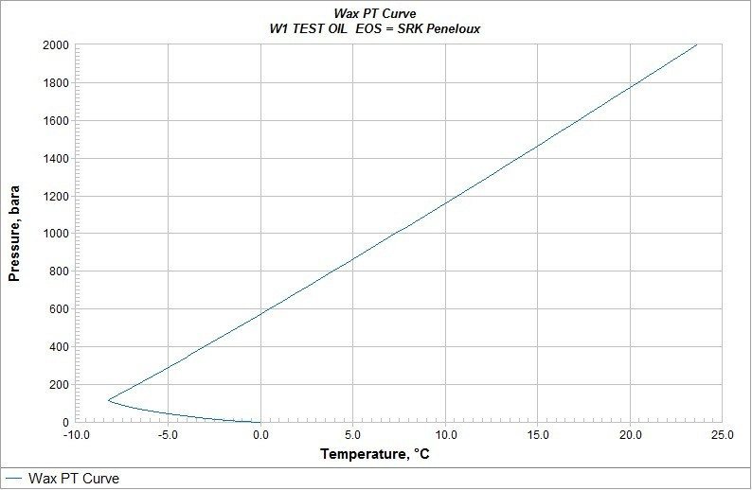
Since the wax precipitation point of crude oil is not given, referring to the temperature relationship between wax precipitation point and freezing point in high wax content oilfields in China, combined with the wax content in area A, the wax deposition curve of formation oil is simulated using PVTsim software, as shown in Figure 3.3. 6. The wax deposition temperature of the formation oil under the conveying pressure is -5°C (12°C above the freezing point).

Figure 3.3.6 Wax deposition curve of formation oil
After determining the wax precipitation point, use the OLGA software to perform thermal calculations on the delivery pipeline and the collection pipeline without the insulation layer. The temperature drop along each pipeline is shown in Figure 3.3.7-3.3.8, and the calculation results are shown in Figure 3.3.7-3.3.8. Table 3.3.2.
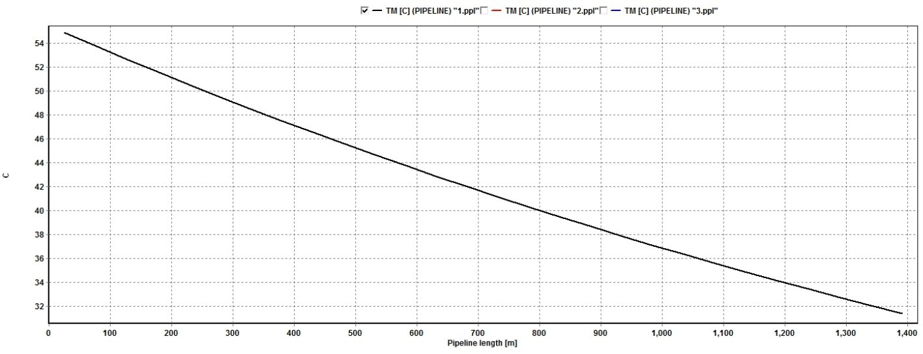

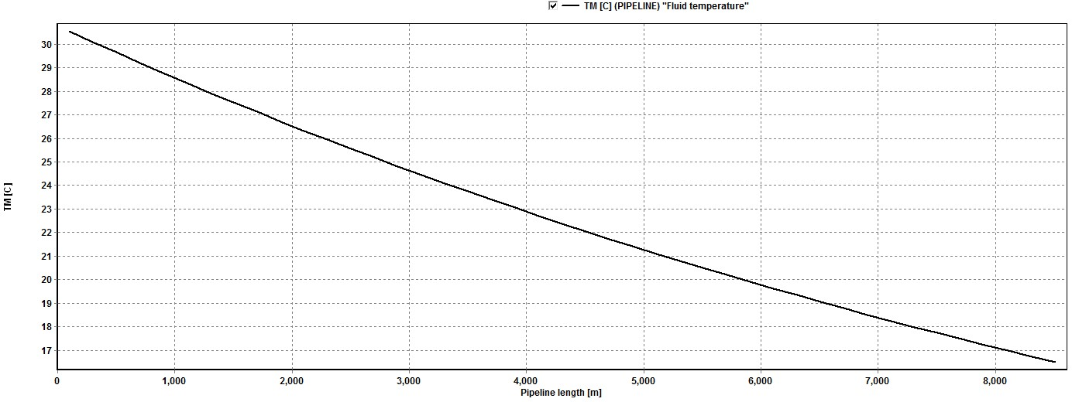
Figure 3.3.7 Temperature drop along the outlet pipeline

Figure 3.3.8 Temperature drop along the oil gathering pipeline Table 3.3.2 Thermal calculation results
Pipeline type | Starting temperature | End temperature | Insulation thickness | greater than the wax precipitation point
Outlet pipeline | 56℃ | 31℃ | 0 mm | yes
Gathering  pipeline | 31℃ | 16.7℃ | 0 mm | yes
It can be seen from the above table that without the insulation layer, the oil product has good flow performance and the oil collection pipeline has better thermal and hydraulic conditions. The natural non-heating process can fully meet the transportation requirements. Therefore, the overall area is adopted the mixed transportation of oil and gas in the first-level station + natural non-heating overall gathering and transportation technology.

Wellsite process
Area A generally adopts the integrated gathering and transportation process of first-level mixed oil and gas transportation + natural non-heating at the half cloth station. In addition to the valve block metering function, the well site does not require heating process design. Combining the nature of crude oil and oil products and the corrosion of the transport medium, The well site also needs to design the process of throwing wax and adding corrosion inhibitors.
- Valve group metering
In order to reduce equipment investment, the valve group metering uses a three-phase separation metering device to separate gas, liquid (emulsified oil) and free water, and then measure the amount of gas, liquid and free water, and the water content of the emulsified oil.
Especially after the oil field enters the water injection development stage, the water cut in the produced fluid increases. Under such conditions, the use of a three-phase metering device is an effective means to ensure the accurate metering of oil wells.
- Throw the ball to remove wax
The crude oil transported by the pipeline belongs to the high waxy crude oil. Although the pipeline terminal temperature is greater than the wax precipitation temperature under the condition of the designed delivery volume and the annual average ground temperature. However, when the pipeline is in a situation where the delivery volume fluctuates greatly (especially the later delivery attenuation) and the outside world Under extreme temperatures, the thermal condition of the pipeline will change, and it is even possible that the end temperature is lower than the wax precipitation temperature, so that the oil will be waxed. With the deposition of wax crystals in the pipeline, the effective flow area of the pipeline will be reduced. Even blockage occurs, so it is necessary to set up a pitching ball to remove wax at the wellhead.
Regularly throw balls (usually reusable plastic balls or disposable chemical balls) from the wellhead to the oil gathering line to remove part of the wax on the pipe wall and maintain the normal flow of crude oil. The ball cleaning is usually determined according to the degree of wax accumulation Wax cycle. Balls from the wellhead to the metering valve group are put in from the wellhead, and the metering valve group is taken out; from the metering valve group to the joint station, the ball is put in by the metering station, and the joint station is taken out. The ball can be pitched with automatic ball throwing device or manual device.
This method requires the wellhead to have a ball-balling device, the metering valve group has

a ball-receiving or ball-balling device, rationally use the formation energy, and use the ball-through method to remove the wax and debris on the pipe wall to ensure the smooth flow of the pipeline and safe production. The wax removal ball generally has Steel balls, rubber balls and chemical balls. The ball diameter is generally 2~3mm less than the inner diameter of the pipeline. The automatic ball throwing device and electromagnetic heating ball receiving device have been manufactured.
- Addition of corrosion inhibitor
In order to alleviate the corrosion of pipelines and equipment caused by H2S and CO2 dissolved in water, a certain amount of corrosion inhibitor must be added to the wellhead. Corrosion inhibitor means that metal corrosion can be significantly slowed down when it exists in a very low concentration in the environmental medium. The rate is to prevent metal corrosion. According to the influence of corrosion inhibitors on the electrode process, the corrosion inhibitors can be divided into anode corrosion inhibitors, cathodic corrosion inhibitors and mixed corrosion inhibitors. Anode corrosion inhibitors have effects on the anode process. Retarding effect, such as complex salts, nitrite, sodium benzoate, etc.; cathodic corrosion inhibitors have a retarding effect on the cathode, such as polyphosphate, zinc salt, arsenic ion, etc.; mixed corrosion inhibitors on the cathode and anode processes All have blocking effects, such as silicates, alkaloids, etc.
According to GBT 23258-2009 "Code for Corrosion Control in Steel Pipelines", anode corrosion inhibitors can be used to slow down the corrosion of media containing low concentrations of oxygen [14]. Cathodic corrosion inhibitors can be used to slow down the corrosion of H2S and CO2, so the cathode type is selected Corrosion inhibitor.
①Adding method
The corrosion inhibitor for gathering pipelines can be continuously injected, intermittently injected, or combined with intermittent injection. Considering the corrosion and management of the pipeline, the continuous injection method is adopted, and the continuous injection device adopts gravity. Type filling device.
②Filling amount
The amount of corrosion inhibitor that is continuously injected is usually determined by the water content in the conveying fluid and is generally determined by the concentration of the corrosion inhibitor of 100 to 1000 ppm.
The corrosion inhibitor dose can be estimated by formula (3.4.1) when applying corrosion inhibitor to the pipeline:

W = 2.4DL
(3.4.1)

Where W is processing capacity in liter; D is pipeline diameter in cm; L is pipeline length in km.
According to the wellhead production, the corrosion inhibitor dosage is 0.245mL/d, and the daily injection volume per well is 0.020mL.

Ground process summary
The overall regional process design adheres to the design concept of "environmental protection, efficiency and innovation", strictly follows the design specifications, and combines reservoir engineering and oil production engineering schemes, oil and gas physical properties and chemical composition, product schemes, ground natural conditions, etc., through multiple schemes According to the technical and economic analysis and comparison, we have worked out a closed

process flow for oil and gas gathering, transportation and processing suitable for Area A.
- The overall flow of gathering and transportation technology
In general, the first-level and half-distributed oil and gas mixed transportation process is adopted, and based on the three low and one high characteristics of "low density, low viscosity, low condensation, and high wax content" of block crude oil, in order to make full use of oil well fluid pressure energy and heat energy Adopt the oil collection method of natural non-heating and wellhead throwing to remove wax.
- Gathering pipeline network layout
In view of the small area under the jurisdiction of the block, the relatively concentrated location of wellheads, the small number of wellheads, and the large fluctuations in production and pressure, the first-level and half-station deployment method is adopted in which oil from a single well enters the station directly, and the production distance and minimum The objective function is to use ant colony algorithm to optimize the joint station location and well group division, and finally adopt a valve group division method that is convenient for management and reduces investment.

Pipeline design and flow assurance
  - Gathering pipeline network layout
    - Principles of oil and gas pipeline selection
The design of oil and gas gathering and transportation pipelines should comply with the current national standard "Code for Fire Protection Design of Oil and Natural Gas Engineering" GB 50183[15]. The selection of oil and gas gathering and transportation pipelines should meet the following requirements:
      - It is advisable to take it straight, not to damage the existing structures along the line, and occupy less cultivated land;
      - It should form a corridor belt with other production pipelines, roads, power supply lines and communication lines in the oil field;
      - Pipelines of the same nature and similar buried depths should be radiated in the same trench;
      - It is advisable to choose favorable terrain for laying, and avoid low-lying water accumulation zones, local saline-alkali zones and other highly corrosive zones and low sections with poor engineering geology.
The altitude of area A is between 1040m~1070m, and the terrain is gentle, which is conducive to the laying of oil and gas pipelines. The surface of area A is covered by yellow sand, and the main landform is dunes and depressions between dunes. There are no built structures and cultivated land, which is good for pipeline selection. A The line selection of the block gathering and transportation network should take into account many factors such as the layout of the pipe network, the site selection, etc., take direct wiring, conduct technical and economic comparisons, and select the best plan.

Layout of the outlet pipeline network
The oil pipeline mainly has a single well direct entry, cluster well entry, single well series connection, and valve group entry and other layout methods.
Combining the layout of the oil wells in area A and the layout of the gathering and transportation process, the layout of the oil pipeline can choose to directly enter the station from a

single well or to enter the station in series with a single well. It is advisable to conduct a technical and economic comparison to repeatedly demonstrate the specific layout method.
      - Single well comes into the station
A single well comes into the station with a typical radial pipe network, which simplifies the well site facilities, see Figure 4.1.1.
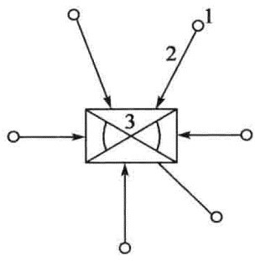

Figure 4.1.1 Schematic diagram of the structure of a single well with oil directly entering the station
1- Wellhead; 2- Output pipeline; 3- Gathering station or joint station
      - Series connection between wells
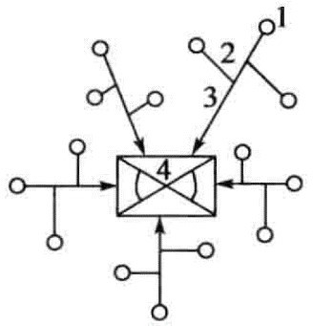
The single well oil pipeline is connected to the nearest oil well site, and the gas coming from the related well sites is connected in sequence. According to the layout of the oil well, the oil gathering trunk line enters the gathering station radially in different directions. The structure diagram is shown in Figure 4.1.2.

Figure 4.1.2 Schematic diagram of single well series connection structure
1- Wellhead; 2- Output pipeline; 3- Oil gathering trunk line; 4- Oil gathering station or joint station
The advantage of this form is that the construction of the connection between the pipeline and the trunk line of the newly-built well can be carried out at the well site, without the need for air defense and replacement of the original trunk line. The reason is that two gate valves have been set up between the built single well gas production pipeline and the trunk line. When the oil coming from a new well is entered, the two gate valves can be closed, the pipeline between the two valves can be removed, and the straight pipe section can be replaced with a tee. In this way, the oil from the new well can be connected from the tee between the two gate valves to ensure The wellhead of a single well is built without fire, the trunk line is not vented, and the normal operation of the gas production trunk line will not be affected when the oil is connected to the newly-built well. In addition, the construction access or inspection road of the production pipeline in series can make full use of the front of the single well station Road, the disadvantage of this form is that the pipeline is slightly longer.
However, with the development of oilfields, the pressure of oil wells has continued to drop,

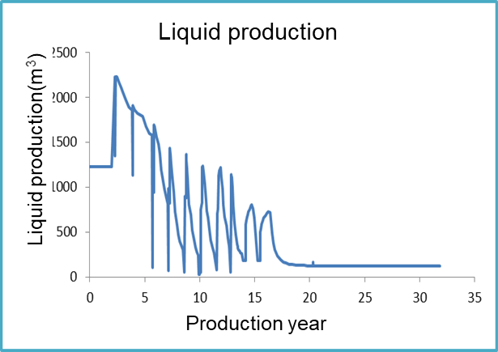
and there is a problem that the pressure drop rate of a single well at a later stage does not match the pressure system of the oil pipeline. When the shut-in pressure cannot reach the pressure of the oil pipeline system, the oil pipeline The natural gas will be transported back to low-pressure wells, forming a phenomenon of "backflow" in the low-pressure wells, resulting in a significant reduction in the limited delivery capacity of the main oil pipeline.

Figure 4.1.3 Liquid production in area A
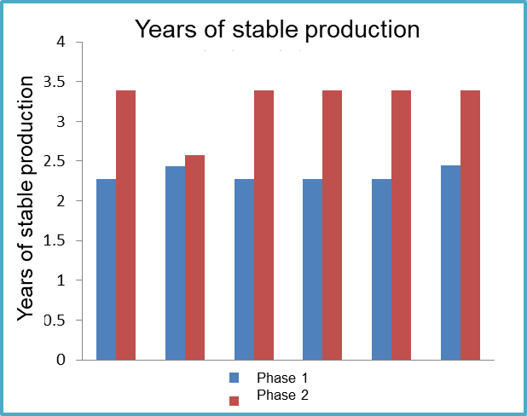
Figure 4.1.4 Years of stable production of a single well
Area A is a carbonate oil field, with large production fluctuations (Figure 4.1.3), rapid pressure decay, and rolling development in the area, with different stable production years of single wells (Figure 4.1.4), in order to adapt to the efficient development process of Area A For the production and pressure fluctuations, it is not advisable to adopt the layout of single wells in series, and finally adopt the layout of the output pipeline of single wells directly into the station.

Gathering pipeline network layout
Gathering pipeline network layout can be roughly divided into the following three categories and combined pipeline network:
      - Radial gathering and transportation network
The flow of the radial gathering pipeline network system is centered on a metering station (metering valve group) or a joint station, and the pipeline is connected to multiple well stations in a radial form. This type of pipeline network is suitable for relatively concentrated wellheads or small areas. The oil field can also be used as a basic unit in the multi-well oil gathering process. Oil and gas are produced from the wellhead and transported to the metering station (metering valve group) or joint station after the wellhead is throttled. The basic form of the pipeline network

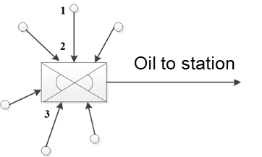
is shown in Figure 4.1.5.

Figure 4.1.5 Schematic diagram of the system flow of radial gathering and transportation network
1- Wellhead; 2- Output pipeline; 3- Gathering station; 4- Gathering pipeline
      - Gathering system process of branched gathering and transportation network
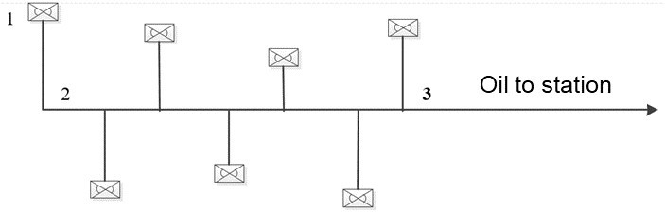
The branch-shaped gathering pipeline network is in the same shape as branches, and an oil gathering trunk line is arranged along the long axis of the structure. The oil and gas collected from the oil wells on both sides of the trunk line are integrated into the gathering trunk line and transported to the destination. The characteristics of the pipeline network. The oil gathering branch line is relatively short, which is convenient for the nearby oil and gas input of oil wells to be watched. It is suitable for oil fields with long and narrow oil and gas reservoirs and large well pattern distances. It can meet the needs of rolling development and phased construction of oil fields. However, the pipeline network is usually single well Combining the oil gathering process flow, so there are many stations. After the oil and gas are produced from the well, they are choked, heated, separated and metered at the well site and then enter the gathering pipeline and sent to the metering station or joint station. The processed oil and gas are transported outside. The flow chart of the simple branch-shaped gathering and transportation network system is shown in Figure 4.1.6.

Figure 4.1.6 Schematic diagram of the gathering and transportation system of branched gathering and transportation network
1- Single Well Station (Oil Gathering Station); 2- Oil Gathering Branch Line; 3- Oil
Gathering Trunk Line
      - Gathering system flow of ring-shaped gathering and transportation network
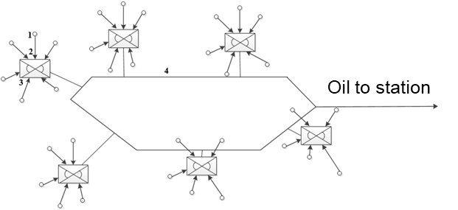
The loop-shaped gathering and transportation pipeline network gathering, and transportation system process is suitable for large square, round or oval oil fields. Oil fields with the above conditions are not suitable for use if the terrain conditions are complex and in deep mountainous areas. The pipeline network gathering and transportation system process is shown in Figure 4.1.7.

Figure 4.1.7 Schematic diagram of the gathering and transportation system of the ring-shaped gathering and transportation network

1- Wellsite; 2- Oil Gathering Trunk Line; 3- Oil Gathering Station; 4- Oil Gathering Trunk Line
The advantage of the flow of the gathering and transportation system of the ring-shaped gathering and transportation network is that the gathering stations in the oil field can be connected to the downstream purification plant or the first station of the export through the nearest oil gathering trunk line after gathering oil from the surrounding oil wells, which has certain flexibility; The total investment of the project is relatively large, which is only suitable for the development of large oil fields with large area and scattered oil wells.
      - Process of combined gathering and transportation pipeline network gathering and transportation system
Various pipe network structures have their own advantages and disadvantages and are suitable for different specific use occasions. Due to the relatively large oil production area, the distribution of gas wells, single well production and topography, and road traffic conditions are very different. Therefore, most gas gathering pipe networks can only adopt a mixed structure including branched, radial and ring structures, especially the combination of the previous two structures is the most common.
Because the area under jurisdiction of A is small and the number of single wells is small, there is no need to adopt a combined method for pipeline network layout. The selection of the gathering and transportation pipeline network layout should be based on the specific conditions of the A area and the application of the three basic pipeline network layouts Circumstances, the advantages and disadvantages of the three basic pipe network layout methods are shown in Table 4.1.1.

Table 4.1.1 Advantages and disadvantages of the three basic network management layout methods
Pipe network  layout | Advantage | Disadvantage
Radial pipe network | - The single well device is simplified, unattended can be considered, and the production and management costs are low;  - In the later stage of oilfield development, booster units can be centrally located on stations and used together, with relatively low production costs and convenient management. | - The oil production pipeline adopts the oil and gas mixed transportation method, and the pipeline pressure loss is relatively high;  - When the conveying medium is acid medium, the corrosion in the pipe is serious and the safety is poor;  - The total length of the gathering and transportation pipeline is longer than that of the branch-shaped gathering and transportation network, and the steel  consumption is more.
Branch pipe network | - Separating air and night in a single well is beneficial to reduce pipeline pressure loss and slow down corrosion;  - The oil-gathering branch line can be connected to the nearest oil-gathering trunk line, which is conducive to shortening the  length of the pipeline and saving steel and | - Because single crystals need to be equipped with gas-liquid separation and metering devices, there are many production personnel, it is inconvenient to focus on management, and the investment in single well stations is relatively large;  - When boosting is required in the later

 | line investment. | stage of oilfield development, the booster unit can only be installed at the well site, and each well is boosted separately, which is  difficult to use collectively.
Loop pipe network | After collecting oil from the surrounding oil wells, the oil gathering stations can be connected to the downstream purification plant or the first export station through the nearest oil gathering trunk line, which has a  certain degree of flexibility. | The total investment of the project is relatively large, which is only suitable for the development of large oil fields with large area and scattered oil wells.

According to the specific conditions of the oil field, combined with the corresponding oil gathering process, comprehensive comparison is made from the aspects of technical reliability, safety of gathering and transportation system, and ground engineering investment, and adopts radioactive pipeline network layout.

Principles for station selection
The site of the oil and gas gathering and transportation station should be determined in accordance with the overall surface planning of the oilfield and the local town planning, taking into account the direction of the gathering and transportation pipeline. The selection of the site should comply with the current industry standard "Oil and Natural Gas Engineering General Drawing Design Code" SY/T 0048 [16].
According to GB 50350-2015 "Oilfield Oil and Gas Gathering and Transportation Design Code" [11], the selection of station site should follow the following principles:
      - The area of the station site should meet the requirements of the general layout, and the land should be economized. It is not suitable to occupy cultivated land in areas where wasteland is available.
      - Station sites in desert areas should avoid wind vents and mobile desert areas, and sand prevention measures should be taken.
      - The layout of various stations with different functions should be comprehensively considered. Metering stations and oil collection valve groups should be jointly constructed with gas distribution stations and water injection stations; oil, gas, and water treatment stations that are related to each other in technology should be combined Construction; the mine oil depot should be built in a suitable location on the edge of the oil field; the railway outbound oil depot should be close to the railway station or railway line to facilitate connection.
      - The fire separation distance between the station yard and the surrounding facilities, noise control and environmental protection should comply with the advanced national standard "Code for Fire Protection Design of Petroleum and Natural Gas Engineering" GB 50183 [15], "Code for Design of Noise Control in Industrial Enterprises" GB/T 50087 [17]and "Industrial relevant regulations of "Enterprise Design Sanitary Standard" GBZ 1 [18].
The surface of area A is covered by yellow sand, there is no arable land, and wasteland can be fully utilized, but it should be in a desert area, and the station should take measures to prevent sand. The contest question does not indicate whether area A is in a windy or mobile desert area. Suppose area A Stations can be built at a suitable location in area A that is neither in a vent or in a mobile desert area. Since the area is in the internal road system of the oilfield, it is advisable to give priority to relying on existing roads in order to facilitate transportation.

In terms of station function, combining the overall gathering and transportation process technology of area A, the construction scale of area A and the area of area A, and following the principle that oil, gas, and water treatment stations should be jointly constructed in terms of technology, they should be built with both oil and gas. A joint station with water treatment function can be constructed only one.

Optimization of Gathering Pipeline Network Layout
In order to reasonably determine the structural layout of the oil and gas gathering and transportation pipeline network, with the output distance between well stations as the objective function, the connection relationship between well stations and the joint station site as optimization variables, a well group optimization model was established. Small window ant colony algorithm was used to solve , Convert the well-station connection relationship into path selection, calculate the heuristic factor according to the corresponding output and distance of different pipe sections, use the total output distance under different path schemes as the evaluation index of information accumulation, and ensure the well-type and integration by controlling the ant state transfer process Constraints such as the output radius and the processing capacity of the metering station effectively avoid the generation of infeasible solutions.
The objective functions often used in well group division include the shortest pipeline length, the minimum output distance and the smallest pipeline network construction investment. Among them, the lowest construction investment is the objective function to best reflect the economics of the pipeline network, but when calculating pipeline parameters and construction costs. More production data are required and the process is complicated. Here, the output distance and the objective function closely related to the pipeline construction cost are used to optimize the well group, and a better grouping scheme can be obtained through the ant colony algorithm.

Objective function
After the number of gathering and transportation stations such as station is determined, the well-station connection relationship and the metering station site are used as optimization variables, and the well group division model is established with the objective function of the production distance between wells and stations and the minimum:

NS Nw
(4.1.1)

min F (U ,V ) = ∑∑ij Qij Lij
i=1 j=1

ij
= ⎧⎪1 ,wellj ∈stationi
0 ,well ∉station
⎨
(i = 1, 2,L NS ; j = 1, 2L , NW )
(4.1.2)

⎩⎪ j i
F is the objective function, that is, the sum of the production distances between well stations; U is the station site; V is the grouping relationship variable; Ns and Nw are the number of joint stations and the number of wellheads respectively; δij is the decision variable for the connection relationship; Qij is the joint station stationi to the wellhead Transmission volume of pipeline between wellj, t/d; Lij is the length of pipeline between stationi of the joint station and wellhead wellj, km.

Constraints
Each well site can only belong to one metering station (valve group) or joint station, namely:
N s

∑  ij = 1
i =1
(4.1.3)

Well type constraint, that is, the number of well sites under the jurisdiction of each metering station cannot exceed the maximum value P, the expression is as follows:

Nw
∑
ij = 1
j =1
The expression of the processing capacity of the metering station:
Nw
(4.1.4)

QL ≤ ∑ Q ≤ QH
(4.1.5)

i ij ij i j =1
Where QiL and Q ^{H} are the minimum and maximum processing capacity, t/d. Gathering and transportation radius constraints of the measuring station:
i
ij Lij ≤ R

(4.1.6)

Where R is gathering radius, km.
The feasible domain of site optimization:

U ⊂ UD

(4.1.7)

Where UD is the area range of the gathering well site, that is, the coordinate range of the optimized search.

Layout optimization
The ant colony algorithm was first used to solve the traveling salesman (TSP) problem. The calculation results of some classic TSP examples show that it has better optimization performance than other intelligent algorithms. Well group division and pipeline network layout are used as optimization problems of discrete variables. After proper transformation, it can be transformed into a path search problem, which can be solved by ant colony algorithm. The main steps are as follows:
Step1 Establish a production distance data table. According to the number of designated stations, the initial station location is generated by a random function in the well site area, and the distance from each well site to different metering stations is calculated based on the well site data, and then the total production distance matrix is obtained.
Step2 Establish a window array. In the total solution space of the ant's path search, inferior solutions account for a large proportion. In order to narrow the search range of the solution space, reduce the possibility of inferior solutions, and speed up the algorithm convergence speed, it is for each metering station Set up window arrays respectively, and place all well sites within the gathering and transportation radius in the corresponding window arrays. Randomly generate the sequence of each ant visiting the metering station to reduce the interference of the window array on the natural optimization process of the ant population. The starting point is determined by the state transition function.
Step3 Define the heuristic function. The heuristic function represents the a priori and deterministic factors on the path when the ant is searching for optimization. It is a measure of the visibility of each well site when the ant is transferring from the metering station, and it should be directly related to the objective function. Here, the heuristic information between nodes is defined as the reciprocal of the production distance of the pipe section, namely θij, so that the wellsite corresponding to the pipe section with a small production distance value has the opportunity to be selected first.

ij =
1
Qij Lij
(4.1.8)

Step4 Pheromone update rules. Pheromone changes on the path include the accumulation of

new information and the volatilization of existing information, so that the optimization process can not only make full use of the searched path information, but also provide for the generation of new paths. Opportunity. A cycle period is for all ants to complete the site sequence visits. The calculation formula for the volatilization and accumulation of pheromone after one cycle is:

⧫ ij (t +1) = (1 −  )ij (t) + Δij (t)
(4.1.9)

m
(t) = ∑Δ (t)
Δ
k
ij ij
k =1
(4.1.10)

Where
ij (t)
is the amount of pheromone on the path between two nodes;  is the

pheromone volatilization coefficient;
Δij (t)
is the pheromone increment on the path from node

i to node j in the cycle at time t, and its value is proportional to the solution containing the path The quality is positively correlated, which is the cumulative effect of all ants; m is the total number of ants; k is the kth ant.
In order to make full use of the overall information of each feasible solution and improve the
global convergence of the optimization process, the accumulation rule of path pheromone by each ant is calculated according to the Ant-Circle model:

⎧ Q
Δ k (t) = ⎪ F
including（i, j ）

(4.1.11)

ij ⎨ k

Where

Δ k (t)
⎪⎩0 without（i, j ）
is the pheromone increment of the kth ant on the path from node i to node j

in the cycle at time t; Q is the pheromone intensity, where 1 is taken; Fk is the kth ant in this cycle The objective function value corresponding to the feasible solution, that is, the sum of the pipe network output distances, is calculated by formula (4.1.3).
ij
Step5 State transition function. Each ant is constantly moving between different nodes. The
state transition probability from the current node i to the next node j is the result of the combined effect of the pheromone and the heuristic function on the path connecting the two nodes. The state transition probability calculation formula for:

⎧ [ (t)] [ (t)]
ij ij
⎪

(4.1.12)

Pk (t) = ⎪
∑ [
(t)] [ (t)]
, j ∈ allowed

ij ⎨
⎪ S∈allowedk
⎪⎩
is is k
0

where α､β is the importance factor of the pheromone and the heuristic function respectively;

allowedk
is the set of nodes that the kth ant is allowed to visit at the current moment;
is (t) is

the pheromone value on the path between node i and node s at time t; Heuristic function on the path between node i and node s.
is (t)
is at time t

The control of the state transition process is the key to ensuring that the constraints are met. The taboo table of each ant is dynamically updated with the optimization process to ensure the uniqueness of the membership. Each ant is from the intersection of the window array and the non-taboo elements Select a feasible solution; if the intersection is empty, it means that there is no feasible solution within the gathering and transportation radius. Stop the optimization calculation of the station. Every time the next well number to be transferred is obtained based on the roulette method, it is judged whether the well meets the measurement. The processing capacity constraint

of the station. If it is satisfied, add the well number to the solution set that the ant has constructed; if not, discard the well number. When the number of wellsites belonging to the station reaches the well-type constraint value after optimization also stop the optimization calculation of this station.
Step6 Optimize the station site. After completing the well group division, take each metering station and its well-sites as the research object to optimize the station site. Taking the distance and minimum pipeline output between the well stations as the objective function, the optimal station is calculated by the variable scale method Site. The optimized site site is re-used as the initial site site of the well group division program. Return to Step 1, and terminate the calculation when the quality of the pipeline network layout is no longer improved or the number of cycles reaches the upper limit.
- Process station
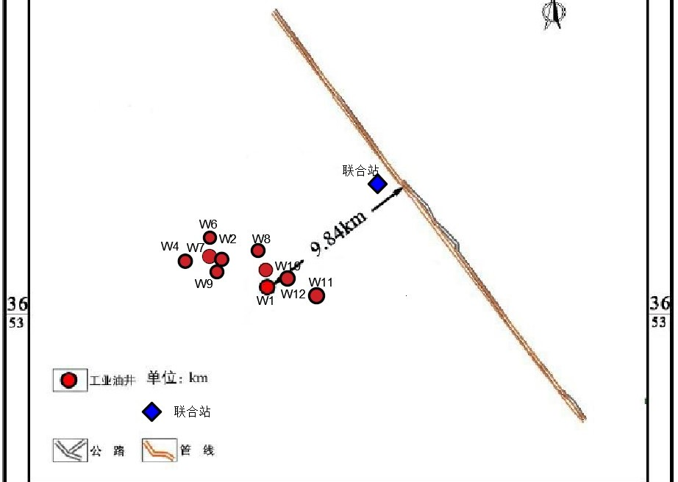
According to the data provided, area A is within the range of the oilfield highway network and the transportation is convenient. In this case, the joint site selection should be based on the existing traffic conditions, combined with the location of the wellhead, and the joint station calculated by the ant colony algorithm The relative inner position of the block road network is shown in Figure 4.1.8.

Figure 4.1.8 The relative position of the process station in the area road network
- Division of well groups
According to the size of area A and the number of wellheads, one valve group or two valve groups can be set. Because the number of wellheads is small and relatively concentrated, there is no need to set up three valve groups.
Use ant colony algorithm to divide one metering valve group and two metering valve groups into well groups:
- Layout of a valve group

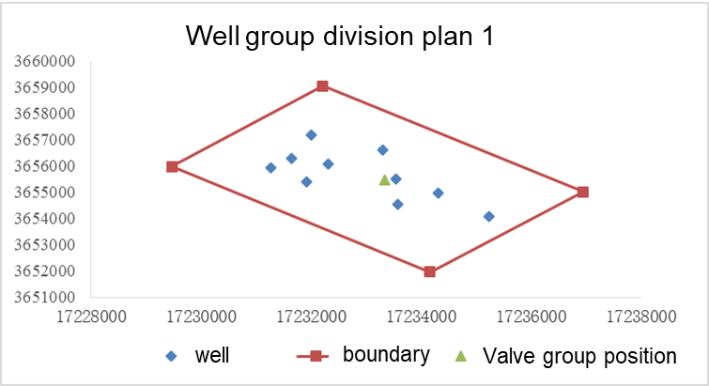

Figure 4.1.9 The layout of a metering valve group
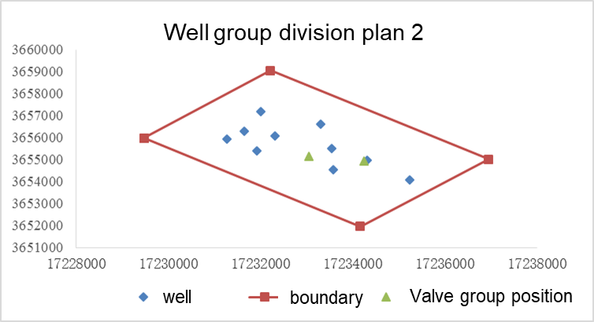
- The layout of the two valve groups

Figure 4.1.10 Layout of the two valve groups
Table 4.1.3 Comparison results of two valve group division methods
Well group division  method | Length of oil  outlet pipeline | Oil collection  line length | Sum of output times  distance | Recommend
Plan 1 | 16.01 km | 8.61 km | 24.98 ×105 m⋅t / d | Yes
Plan 2 | 14.21 km | 10.79 km | 29.22 ×105 m⋅t / d | no
It can be seen from the above table that the division method of one valve group is adopted. Although the oil outlet pipeline is relatively long, the distance between the oil collection pipeline and the output is smaller. In the division method of two valve groups, the investment of the pipeline and valve group is relative to one valve. The group situation is relatively large, and area A has the characteristics of rolling development, large output fluctuations, and stepped decline in output. Setting a valve group is more suitable for the needs of rolling development, and can better take into account the phased layout of the first and second phases, and comprehensive technical and economic comparisons. Choose a valve group to divide the wells. The overall layout of the gathering pipeline network is shown in Figure 4.1.11 and the relative position in the highway network is shown in Figure 4.1.12. The distance from each wellhead to the valve group is shown in Table 4.1.3.

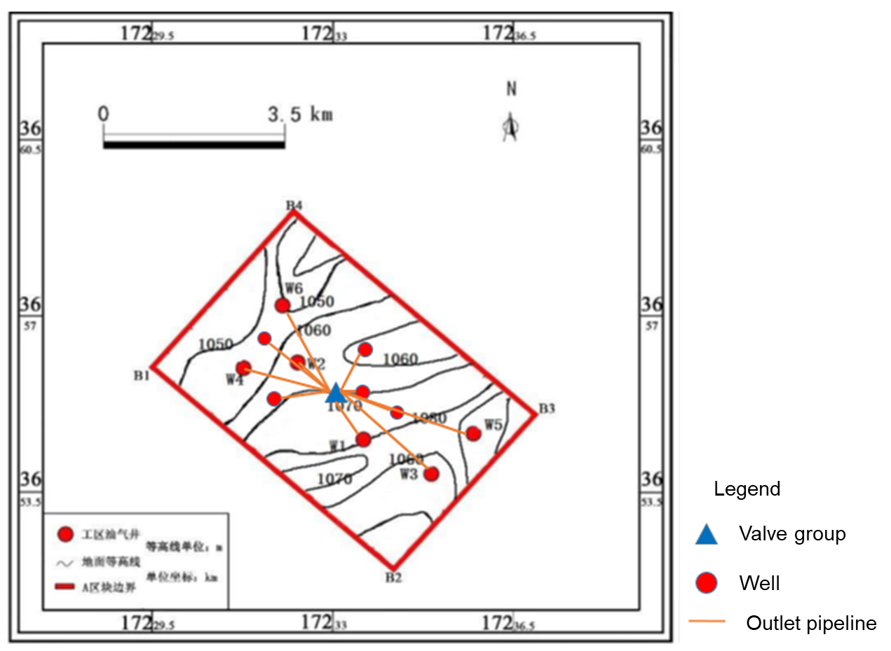

Figure 4.1.11 The overall layout of the gathering and transportation network
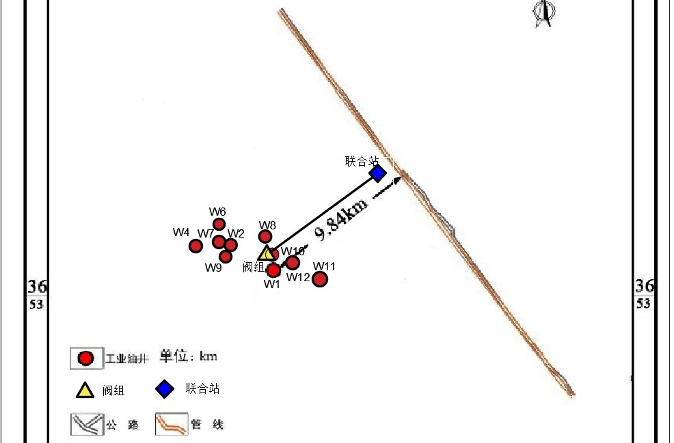
Figure 4.1.12 The relative position of the gathering and transportation network in the road network
Table 4.1.3 The length of the pipeline from each wellhead to the valve group
Pipeline name | Pipeline length | Pipeline name | Pipeline length
W1-Valve group | 969.97 m | W7- Valve group | 2536.59 m
W2- Valve group | 1189.65 m | W8- Valve group | 2174.39 m
W3- Valve group | 2227.08 | W9- Valve group | 1872.69 m
W4- Valve group | 2270.57 m | W10- Valve group | 1154.98 m
W5- Valve group | 2517.67 | W11- Valve group | 1416.48 m
W6- Valve group | 2116.34 m | W12- Valve group4 | 224.81 m
      - Layout phase
After determining the overall well division plan using a valve group, in order to meet the needs of the rolling development of the oilfield, the pipeline network needs to be constructed in stages. The rolling development plan is shown in Table 2.1.2.
        - Layout of the first-phase gathering and transportation network

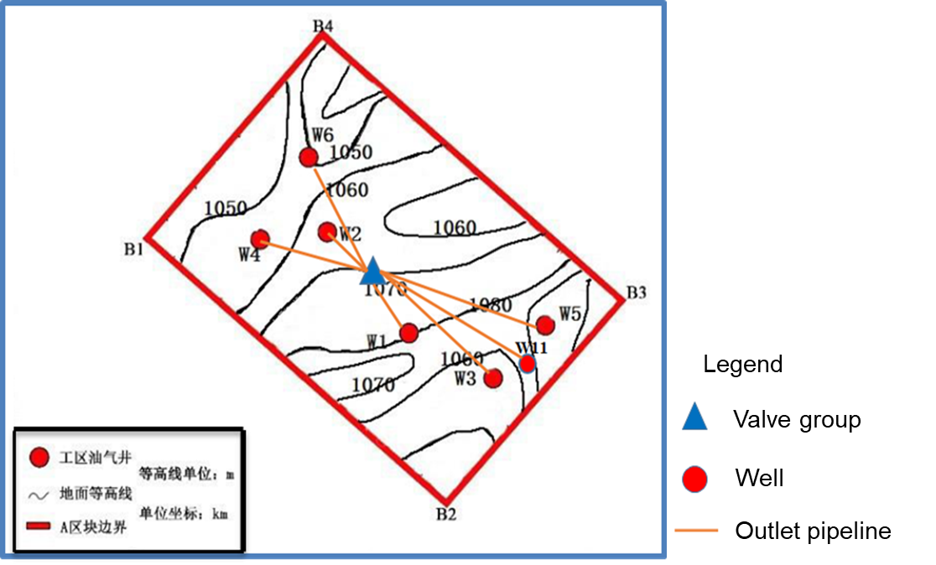

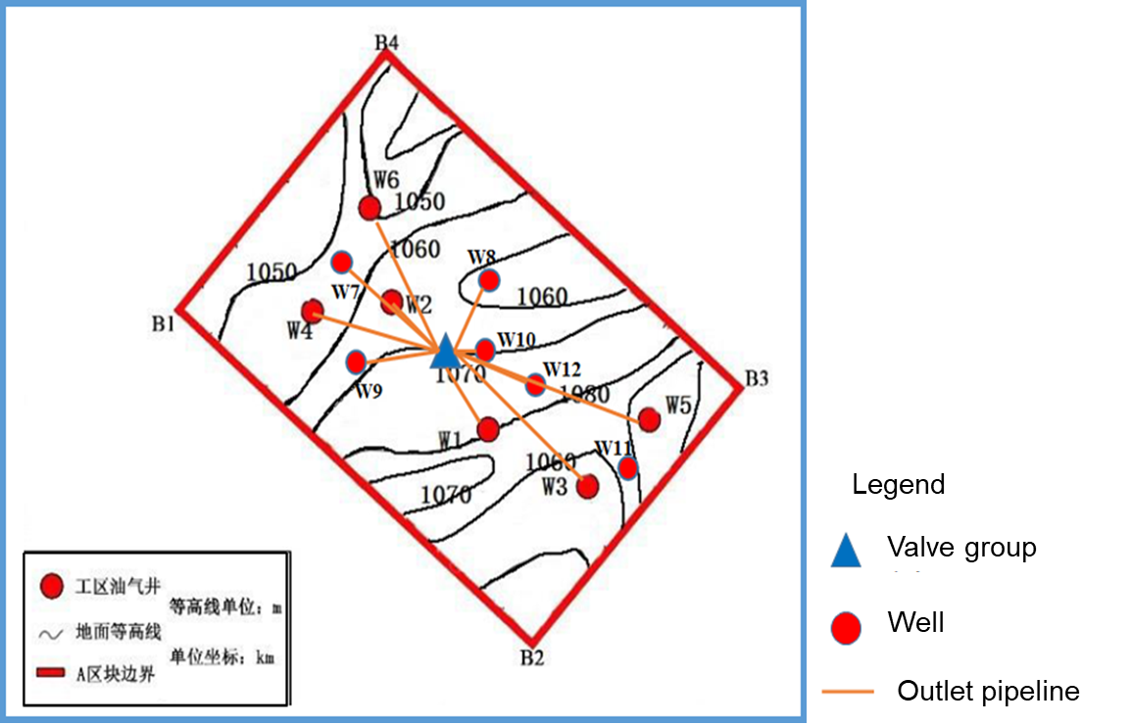
Figure 4.1.13 Phase I Gathering and Transportation Pipeline Network Layout
Figure 4.1.14 Phase II Gathering and Transportation Pipeline Network Layout

  - Gathering pipeline design
    - Material selection for gathering and transportation pipelines
The selection of materials for the pipes and accessories of the oil and gas gathering and transportation pipelines should be determined after technical and economic comparisons based on the design pressure, design temperature, medium characteristics, and application areas. The steel pipes and steel used should have good toughness and weldability.
The natural gas in area A is methane gas containing H2S and CO2. H2S in natural gas gathering and transportation chemical pipelines and equipment will cause metal hydrogen-induced cracking (HIC) and sulfide stress cracking (SSC). Due to hydrogen atoms Existence causes the fracture toughness of the pipeline, the physical, chemical, and mechanical properties of the material to decrease, and it is easy to cause pipeline damage during operation, thereby destroying the safety of the pipeline and affecting the service life of the pipeline. The CO2 in the medium will cause metal to the material Weightless corrosion, that is, general electrochemical corrosion, the general corrosion resistance and stress corrosion resistance of the pipe must be considered when selecting the pipe material.
Based on the previously calculated H2S and CO2 partial pressure ratio, it can be determined that the corrosion environment in the pipeline is mainly H2S playing a leading role. Therefore, when considering the selection of pipeline materials, it should be considered as sulfur-resistant pipes.

Principles for selecting materials for sulfur-resistant pipelines and equipment
        - Principle of safety and reliability
In general, the sulfur content and acid value (pH value) in the feed gas under normal operating conditions of the pipeline should be used as the basis for the design and selection of materials, and the combination of the maximum sulfur content and the highest acid value that may be achieved under the most severe operating conditions For the corrosion caused by the metal at the time, the appropriate material should be selected from the aspect of safety and reliability. For a uniform corrosive environment, it is necessary to avoid the emergence of the "material-medium environment combination" where the wall thickness of the pipeline components is sharply reduced. The corrosion rate should not be greater than 0.26 mm/a. The occurrence of "material-medium environment combination" with severe local corrosion should be avoided, such as pitting, crevice corrosion, scouring corrosion, abrasion corrosion, etc. When it is unavoidable, other effective methods should be adopted. Preventive measures. For stress corrosion environments, the occurrence of "material-medium environment combination" of stress corrosion cracking should be avoided as much as possible. When selecting low-grade materials due to the high uniform corrosion rate, and changing to high-grade materials, consider the possibility of occurrence Other more dangerous types of corrosion, such as localized corrosion or stress corrosion cracking. The components of each pipeline with the same operating conditions should be selected from the same or equivalent materials. The branch pipeline connected to the main pipe, the purge steam pipeline, etc. A valve and the pipeline before the valve should be made of materials with the same or equivalent performance as the main pipe, and the same corrosion allowance should be taken.
        - Economic principle
When designing and selecting materials, comprehensively consider the service life of pipeline components, costs, construction and normal maintenance costs, so that the comprehensive economic indicators are reasonable. Under normal circumstances, standardization and serialization of materials are preferred. For uniform corrosion environments, if the selection is low Grade materials will produce a larger corrosion rate; when selecting high-grade materials, it can be determined through comprehensive economic evaluation.
        - Consider the influence of pipeline structure
Fully consider the influence of factors such as the velocity of the medium in the pipeline, flow pattern, phase change and other factors on material corrosion. When serious erosion and corrosion are foreseeable, effective measures such as increasing the flow area, reducing the flow rate, and upgrading local materials should be taken. For directly welded pipelines, equipment and components, avoid using dissimilar steels, especially in environments that may cause serious galvanic corrosion, dissimilar steels should not be used.
        - Combining equipment components
When designing and selecting materials, fully consider the supply situation of the market, especially the supporting supply of pipeline components. The use of new materials and new products, and fully understand its usability, reliability, manufacturing performance, (welding) construction performance and related. The supporting supply of pipeline components and the cost are determined on the basis of other aspects. In principle, new materials should be appraised by a qualified organization and have successful industrial application experience.
(6) Combined pipeline construction
Consider the feasibility of pipeline component construction. For pipelines that require

post-weld heat treatment, the effect of heat treatment on the performance of pipeline components should be considered.

Material selection for gathering and transportation pipelines
        - Selection of anti-SCC carbon steel
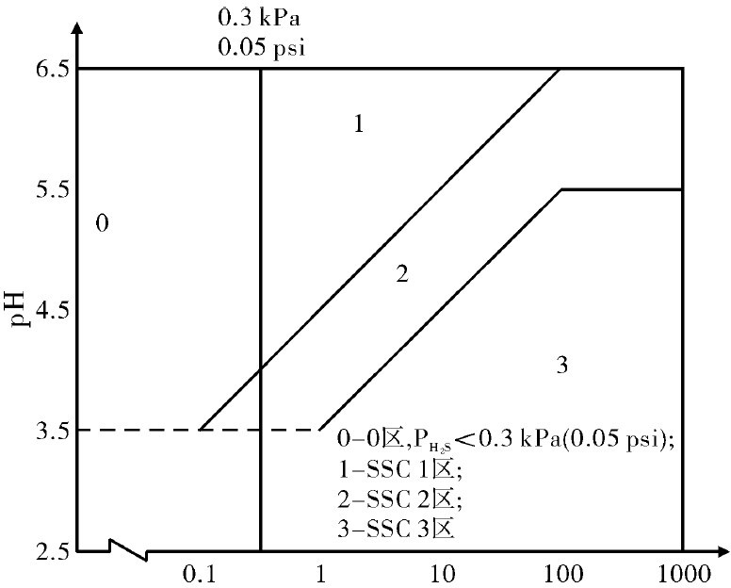
When selecting materials for anti-SCC carbon steel, the H2S partial pressure of the block should be combined with the PH value of the conveying medium.

Figure 4.2.1 Division of SCC environmental severity
The discontinuity of H2S partial pressure lower than 0.3kPa (0.06 psi) and higher than 1 MPa (160 psi) in Figure 4.2.1 reflects the uncertainty when measuring low H2S partial pressure and beyond the range of H2S partial pressure (including low and high H2S) uncertainty of steel performance.
According to the "Requirements for Anti-sulfide Stress Cracking Metal Materials for Natural Gas Ground Facilities" (SY/T0699-2006) [19], the implementation standards for pipes used in acid environments are shown in Table 4.2.1:

Table 4.2.1 Pipes used in acidic environment
Material  category | Standard | Grade | Environmental restrictions | use
Carbon steel | GB 3087 | 10，20 | SCC | Equipment shell,  takeover, collection pipeline, pipe fittings, etc.
 | GB 6479 | 20，20
 | GB 6310 | 20G
Carbon steel and  Low-alloy steel | GB/T9711 | S L246､L290､L360 steel | SCC 3 zone | Equipment tube bundle, collection gas pipeline, pipe fittings, etc.
 |  | S L416､L460 steel | SCC 1 area SCC2 zone
 | API Spec 6I | B steel, X-42  To X-62 steel | SCC zone 3 product  specification level is PSL2
 |  | X-6 to X-66 steel | SSC 1､SSC 2 zone
Corrosion resistant alloy | SY /T6601 | LC30-2242( N08826) | Used as any equipment and parts, there is no restriction on the temperature, PH2S, chloride concentration in the  mining environment, any | Collection gas pipeline, pipe fittings, etc.

combination of original pH
value and elemental sulfur

In terms of strength, the use of high-strength grade steel can save steel. However, excessive emphasis on high-strength thin-walled pipes will bring unfavorable factors such as pipeline instability, poor fracture resistance and poor seismic resistance. SSC 3 zone recommends L246, L290, L360 steel Grade, L416, L460 steel grade is recommended for SSC Zone 2.
At present, the selection of pipeline materials for typical domestic sulfur-bearing oil and gas fields is shown in Table 3.2.2.

Table 4.2.2 Selection of pipeline materials for some domestic sulfur-bearing oil (gas) fields[20-22]
Oil (gas) field name | H2S content | CO2 content | Pipe material selection
Puguang | Up to 17% | 10.6% | Gas production pipeline Nickel-based alloy 826  Gas gathering line L360 QCS
Jingbian | 1489. 67mg /m3 | 6.12% | L360 NCS
Tarim Middle Ancient Block | 0.69% | 4.69% | Gas gathering pipeline L360 NCS
The average content of H2S in area A is 0.49%, the average content of CO2 is 3.77%, and crude oil contains 0.19% sulfur. Considering the relevant specifications and the current application status of sulfur-resistant oil (gas) fields at home and abroad, see the pipeline steel grade and material selection Table 4.2.3.

Table 4.2.3 Pipeline steel grade and material selection
Pipeline name | Steel grade and material selection
Oil collection line | L360 NCS
Outlet pipeline | L245 NCS
    - Gathering pipeline design
      - Phase state judgment
Before carrying out gathering and transportation pipeline design, hydraulic calculation, and thermal calculation, the phase state of the conveying medium in the pipeline should be judged to determine single-phase gathering and transportation or multi-phase gathering and transportation, and the pipeline design and hydraulic power should be carried out according to the corresponding phase state calculation method and thermal calculation.
Use HYSYS software to judge the fluid phase state at the wellhead at 4 MPa and 56°C. The phase state diagram is shown in Figure 4.2.2.

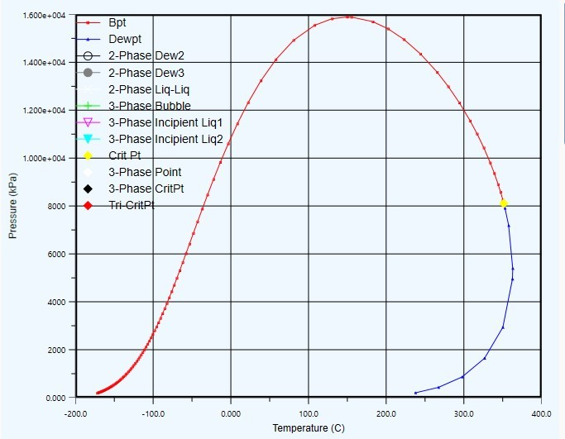

Figure 4.2.2 Phase diagram of conveying fluid
      - Design output
Considering the fluctuations in the delivery volume during the oil delivery process from the oilfield, a certain margin should be left when determining the pipeline design delivery volume. The designed delivery volume of the oil outlet pipeline should be 1.1 times the oil delivery volume during normal operation, corresponding to each designed output capacity of the single well oil pipeline is shown in Table 4.2.4.

Table 4.2.4 Designed output capacity of each oil pipeline
Well | Design output (t/d) | Well | Design output (t/d)
W1 | 147.64 | W8 | 98.43
W2 | 199.90 | W9 | 157.48
W4 | 98.43 | W10 | 196.85
W6 | 196.85 | W11 | 196.85
W7 | 157.48 | W12 | 196.85
      - Design pressure
When determining the design pressure of each production pipeline, the wellhead pressure and the annual pressure attenuation should be combined to meet the delivery pressure requirements under the design delivery volume. After OLGA hydraulic calculations and demonstrations, the design pressures of the delivery and collection pipelines seen in table 4.2.5.

Table 4.2.5 Design pressure of pipeline
Pipeline type | Design pressure
Outlet pipe | 4.2 MPa
Gathering pipe | 3.7 MPa
      - Buried depth of pipeline
Oil and gas gathering and transportation pipelines should be laid in the ground. The laying depth of buried pipelines should be determined comprehensively according to the terrain along the line, ground load conditions, thermal conditions and stability requirements. The minimum thickness of the buried pipeline should meet the current national standard "Gas Pipelines". The relevant provisions of the Engineering Design Code GB 50251 [23] are shown in Table 4.2.6. The purpose of the minimum buried depth of the pipeline is to prevent the pipeline from being damaged by external machinery. It is the minimum requirement from a safety perspective.

Table 4.2.6 Minimum covering thickness (m)
District level
Rocks
Soil

 | Dry land | Paddy field
First level | 0.6 | 0.8 | 0.5
Level 2 | 0.8 | 0.8 | 0.5
Level 3 | 0.8 | 0.8 | 0.5
Level 4 | 0.8 | 0.8 | 0.5

Area A is located in an arid area with yellow sand on the surface, and at the same time is a first-class area with no people around. The minimum covering thickness of the oil and gas gathering pipeline is 0.6m.
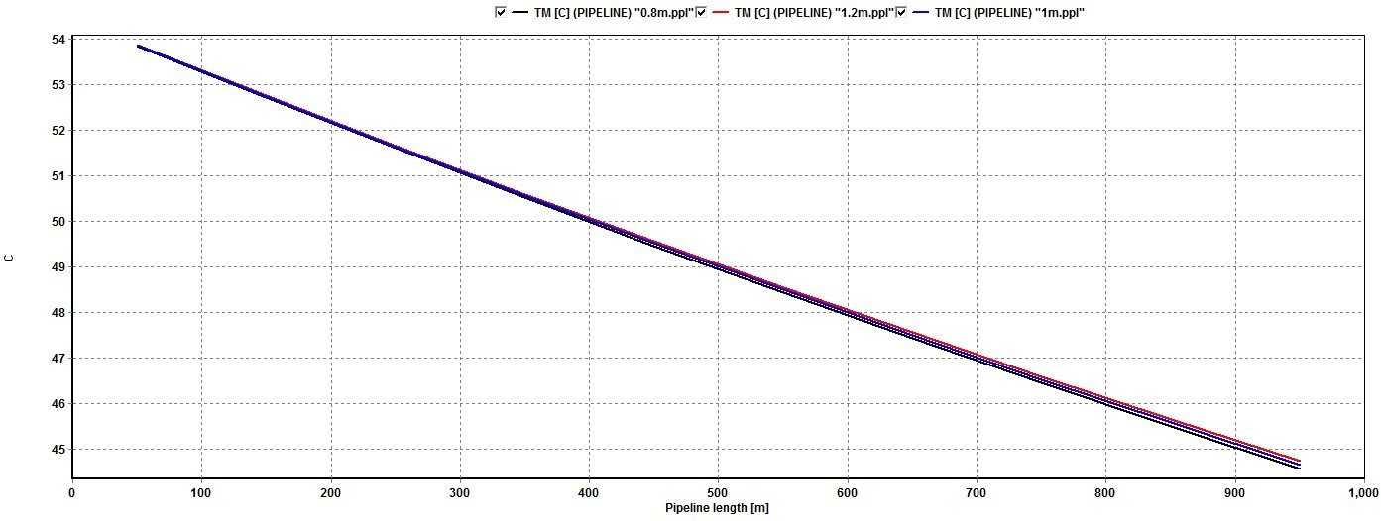
Use the OLGA software to test the temperature drop of the pipeline with a buried depth of 0.8m, 1m, and 1.2m (Figure 4.2.3). From the figure, it can be found that the temperature drop curves of the three different buried depths are almost the same. All the buried depths can meet the requirements of pipeline insulation and transportation technology.

Figure 4.2.3 Three types of buried depth pipeline temperature drop curves
According to the process requirements of the pipeline and combined with the transportation economy, the reasonable buried depth is 1m.

Pipeline anti-corrosion coating
Applying a protective coating on the surface of the pipeline is an important method to prevent metal corrosion. Its function is to isolate the metal construction surface from the soil medium, and increase the corrosion battery circuit to hinder the corrosion effect, thereby slowing the metal corrosion rate.
Existing anti-corrosion layer materials, such as petroleum asphalt, coal tar enamel, polyethylene adhesive tape, fusion bonded epoxy powder, three-layer composite structure PE, etc., have different performances and advantages and disadvantages in long-term use. The structure, advantages and disadvantages and applicable temperature of the anti-corrosion layer are shown in Table 4.2.7.

Table 4.2.7 The structure and service conditions of the outer anti-corrosion layer
 | Asphalt | Coal tar enamel | Polyethylene Adhesive tape | Three-layer composite structure  PE | Fused epoxy powder
Primer material | Asphalt primer | Coal tar primer | Pressure sensitive  adhesive or butyl rubber | Epoxy powder primer | —
Anti-corrosion  layer material | Petroleum bitumen,  with glass mesh | Coal tar enamel,  use glass mesh | Anticorrosive  adhesive tape | Epoxy powder +  copolymer + | Epoxy powder

 | cloth as the middle strengthening layer, and plastic cloth outside | cloth or glass felt as the middle strengthening layer, and wrap  the glass felt | (inner tape), protective adhesive tape | polyethylene
Anti-corrosion layer structure | 3~5 layers of asphalt, total thickness 4~7mm | 1~3 layers of enamel paint, total thickness 3~5mm | One layer of primer, one layer of inner belt, and one layer of outer belt, total  thickness  1.8~3.7mm | One layer of primer, hot extruded or wrapped, with a total thickness of 1.8~3.7mm | The paint is fused on the pipe wall to form a thin film with a thickness of 0.3~0.5mm
Applicable temperature  (℃) | -20~70 | -20~70 | -30~60 | -40~70 | -30~110
Mouth method | Pour bitumen on site or heat shrinkable sleeve | Coal tar primer thermal wrap tape or thermal  shrink sleeve | Polyethylene fused sleeve or heat shrink sleeve | Polyethylene fused sleeve or heat shrink sleeve | Epoxy powder electrostatic or ion spraying heat  shrinkable sleeve
Advantage | Low price and wide sources | Low water absorption, penetrating rhizome, resistant to bacterial corrosion | Good electrical insulation, high mechanical strength, low water absorption | Mechanical properties, low temperature resistance and electrical insulation | Strong mechanical properties and bonding properties, good resistance to cathodic disbondment and temperature  resistance
Disadvantage | Low mechanical strength, poor low-temperature toughness, high water absorption,  easy to be corroded by bacteria, and easy to age | Mechanical degree and low temperature toughness are poor, and environmental pollution is great | Poor adhesion, easy to age in the sun | High quality requirements for steel pipe surface treatment, painting and on-site patching, and higher prices | Poor toughness and impact resistance, sensitive to water absorption, strict requirements for construction  quality

Considering the corrosion of the pipeline transportation medium, the cost of the external anti-corrosion layer, the difficulty of construction, and the operating temperature of the pipeline, a 3-layer PE external anti-corrosion layer is adopted.

Pipe diameter and wall thickness
        - Pipe diameter
Under the specified delivery volume, increasing the pipe diameter can reduce the pressure

required for oil delivery and reduce the oil delivery power, but the pipeline construction cost and heat energy consumption increase. Under a certain delivery volume, only for a certain range of flow rates It is the most economical.
There are many factors that affect the economic flow rate of the pipeline, such as the size of the flow, the transportation distance, the nature of the crude oil, the price of fuel and power, the estimated indicators of materials and equipment, and the investment in infrastructure. According to GB50350-2015 "Oilfield Oil and Gas Gathering and Transportation Design Code" [11], the liquid velocity of the gathering pipeline should be 0.8m/s~2m/s.
Considering the fluid transportation requirements, design pressure, pressure drop size, liquid economic flow rate and other factors, three groups of pipe diameters are selected for preliminary selection of the oil outlet pipeline and the oil gathering pipeline.
The optimization process is illustrated by taking W1-valve group as an example, and the primary pipe diameter is shown in Table 4.2.8.

Table 4.2.8 Primary selection pipe diameter table
W1-Vavle group | Case 1 | Case 2 | Case 3
Outer diameter of pipe | D68 | D70 | D73
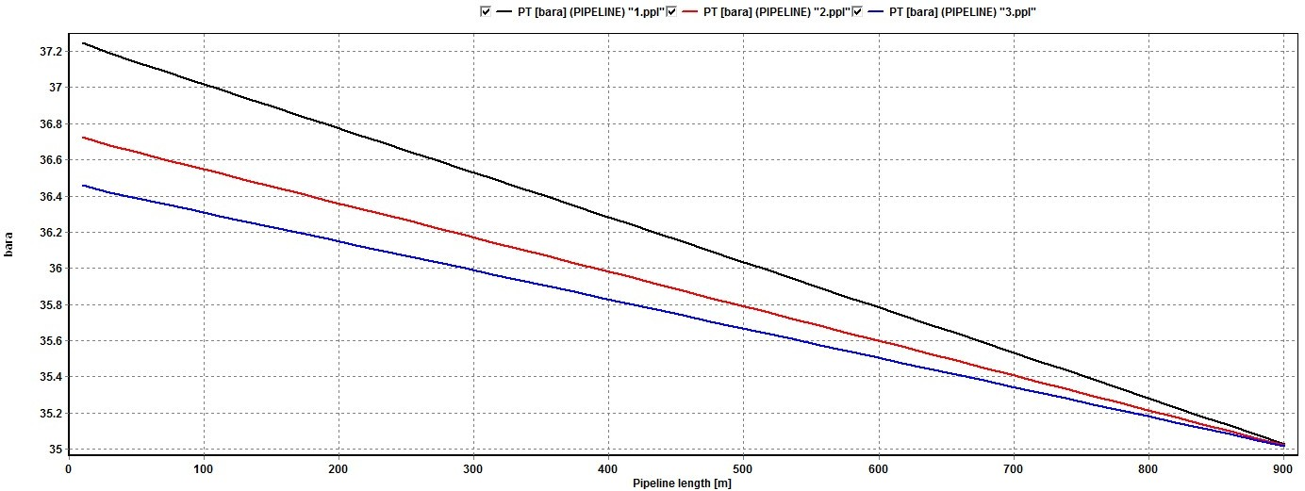
The OLGA software is used to perform hydraulic calculation and economic flow rate verification of the above three groups of pipe diameters to select the best pipe diameter. The hydraulic calculation results are shown in Figure 4.2.4, the average flow velocity is shown in Figure 4.2.5, and the verification results are shown in Table 4.2.9.

Figure 4.2.4 Pressure drop along the path under three groups of pipe diameters
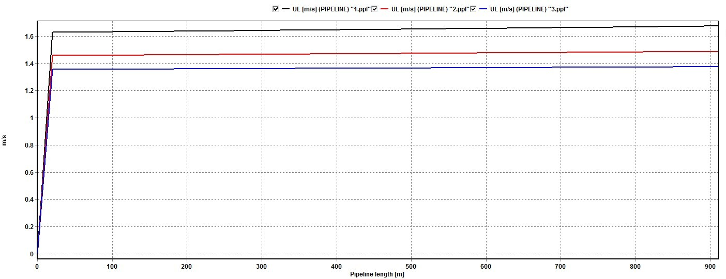
Figure 4.2.5 Average flow velocity of liquid under three groups of pipe diameters Table 4.2.9 Trial calculation results of three groups of pipe diameters
Pipe diameter | Gathering pressure | Start and end pressure drop | Average liquid velocity
D68 | 3.73 MPa | 0.222 MPa | 1.63 m/s

D70 | 3.67 MPa | 0.17 MPa | 1.46 m/s
D73 | 3.64 MPa | 0.144 MPa | 1.36 m/s

Because the crude oil in area A has the characteristics of low viscosity and the pipeline length is short, the pressure drop of the three-phase mixed transportation of oil, gas and water is small, and the pressure drops of the three sets of pipe diameters are all in line with the requirements; and the average liquid velocity is 0.8m/s ~2m/s is in line with the economic flow rate requirements. In this case, in order to make full use of the wellhead oil flow pressure (4MPa), the pressure of the gathering and transportation system can be appropriately increased, so the D68 pipe diameter is selected.
After repeated trial calculations and demonstrations by OLGA software, the outer diameter parameters of the oil gathering pipeline and the oil outlet pipeline are shown in Table 4.2.10.

Pipeline type | Outer diameter of pipe (mm) | Pipeline type | Outer diameter of pipe (mm)
Oil collection line | 219 | W7- Valve group | 73
W1-Valve group | 68 | W8- Valve group | 63
W2- Valve group | 73 | W9- Valve group | 73
W3- Valve group | 77 | W10- Valve group | 73
W4- Valve group | 63 | W11- Valve group | 73
W5- Valve group | 77 | W12- Valve group | 73
W6- Valve group | 77
        - Pipe wall thickness
The wall thickness of the steel pipe of the straight section of the oil and gas gathering pipeline should be rounded up to the standard wall thickness of the steel pipe. The calculated wall thickness of the pipeline should be calculated according to formula (4.2.1):

 = pD + C
2S Ft
(4.2.1)

Where  is pipeline calculation wall thickness in mm; p is pipeline design pressure in MPa; D is

outer diameter of pipe in mm; F is strength design factor in dimensionless;
⬧ s is minimum yield

strength of steel pipe in MPa; C is corrosion margin added value in mm; t is temperature reduction factor, t=1.
①Design factor
According to GB50350-2015 "Code for Design of Oil and Gas Gathering and Transportation in Oilfields", when the pipeline transports sulfuric acid natural gas, the value of the design coefficient F should not be lower than that of the secondary area, and F is 0.6.
②Corrosion allowance C
According to the relevant specifications, the selection of the corrosion allowance C: For slight corrosion, it should not be greater than 1mm; when the pipeline contains acidic media such as water, hydrogen sulfide, carbon dioxide, etc., it should be determined according to the degree of corrosion and the anti-corrosion measures taken, preferably 1mm~4mm ; In other cases, the corrosion allowance should not be calculated.
Block A adopts the method of oil and gas mixed transportation to collect oil. The oil production pipeline transports a mixture of oil and gas, and the natural gas contains hydrogen

sulfide and carbon dioxide. During the development period, the water content is 0.016~0.62, especially the water injection development stage. High, the corrosion is more serious, the corrosion allowance can be 3mm.
The design wall thickness results based on formula (4.2.1) are shown in Table 4.2.11.

Table 4.2.11 Wall thickness parameter table of oil collecting pipeline and oil outlet pipeline
Pipeline name | Design wall thickness  (mm) | Pipeline name | Design wall thickness  （mm）
Gathering pipeline | 5.5 | W7- Valve group | 4
W1-Valve group | 4 | W8- Valve group | 4
W2- Valve group | 4 | W9- Valve group | 4
W3- Valve group | 4 | W10- Valve group | 4
W4- Valve group | 4 | W11- Valve group | 4
W5- Valve group | 4 | W12- Valve group | 4
W6- Valve group | 4
      - Hydraulic and thermal calculation
The hydraulic and thermal calculation of the pipeline is mainly based on the block's gathering and transportation technology and the control of the average liquid velocity of the gathering pipeline in the corresponding specifications. The OLGA software was used to calculate the hydraulic and thermal power of the pipeline.
        - Gathering and transportation technology: the overall gathering and transportation technology in area A is natural non-heating and non-insulated oil and gas mixed transportation technology
        - Flow velocity control: According to GB50350-2015 "Code for Design of Oil and Gas Gathering and Transportation in Oilfields", the liquid velocity of crude oil gathering and transportation pipelines inside the oilfield should be 0.8m/s~2m/s.

Table 4.2.12 Hydraulic and thermal calculation results of each pipeline
Pipe number | Temperature (℃) |  | Pressure (MPa) |  | Velocity (m/s)
 | Starting temperature | End temperature | Starting pressure | End pressure | Average liquid velocity
Gathering pipe | 31 | 21.45 | 3.52 | 3.0 | 1.34
W1-Valve group | 55.5 | 37.97 | 3.73 | 3.504 | 1.63
W2-Valve group | 55.6 | 38.59 | 3.84 | 3.503 | 1.87
W3-Valve group | 55.5 | 29.75 | 3.88 | 3.504 | 1.53
W4-Valve group | 55.34 | 20.2 | 3.89 | 3.502 | 1.25
W5-Valve group | 55.4 | 29.65 | 3.89 | 3.503 | 1.53
W6-Valve group | 55.2 | 29.45 | 3.88 | 3.504 | 1.52
W7-Valve group | 55.88 | 24.38 | 3.92 | 3.503 | 1.42
W8-Valve group | 55.8 | 20.85 | 3.87 | 3.504 | 1.27
W9-Valve group | 55.86 | 28.66 | 3.82 | 3.504 | 1.85
W10-Valve group | 55.9 | 39.19 | 3.82 | 3.506 | 1.83
W11- Valve group | 55.77 | 36.26 | 3.86 | 3.505 | 1.83
W12- Valve group | 55.9 | 51.9 | 3.57 | 3.5 | 1.93

  - Gathering pipeline flow guarantee
    - Natural gas hydrate prediction
Because of the three-phase mixed transportation of oil, gas and water in area A, natural gas and water are present in the pipeline at the same time during the transportation process. When the water content of natural gas is saturated, liquid water is often present. It must be above 0℃. Under the conditions of temperature and the presence of liquid water, certain components in natural gas can form a white crystalline solid with liquid water, which looks like loose ice, which is natural gas hydrate.
The existence of natural gas hydrate will reduce the effective flow area of the pipeline, reduce the transportation capacity of the pipeline, and even cause ice blockage, making the pipeline unable to transport normally. Therefore, it is necessary to predict the formation conditions of natural gas hydrate and control the transportation temperature and transportation of the transportation medium. Pressure to avoid the formation of hydrates.
Combined with the overall oil and gas gathering and transportation and oil and gas processing processes in the region, there are two places where natural gas hydrates are easy to form. One is the process of fluid transport from the wellhead to the joint station, and the other is the process of throttling and pressure reduction of incoming liquid through the control valve In these two points, the prediction of natural gas hydrate should be done, and antifreeze should be added when necessary.
      - Hydrate prediction during transportation
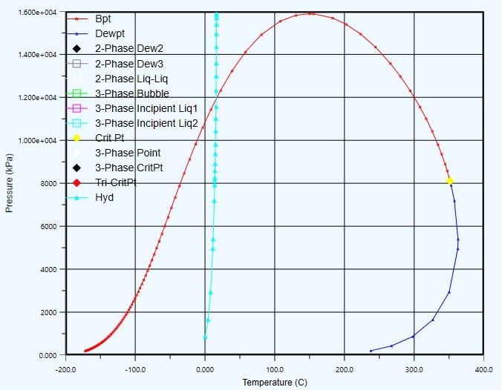
Use HYSYS software to simulate and predict the conditions for the formation of hydrates in the oil gathering pipeline during the stable production period. The prediction results are shown in Figure 4.3.1.

Figure 4.3.1 Natural gas hydrate formation curve of oil gathering pipeline
The delivery pressure of the entire oil outlet pipeline and the collection pipeline is in the range of 3~4MPa, and the delivery temperature is in the range of 21.5~56 ℃ . From the above figure, we can see that in this temperature and pressure range, no hydrate is formed during pipeline transportation. There is no need to add antifreeze at the wellhead.
      - Prediction of inbound throttling and pressure reduction

Use HYSYS software to simulate the inbound throttling process. The calculation results are shown in Table 4.3.1.

Table 4.3.1 Incoming liquid throttling calculation
 | Pressure | Temperature
Before throttling | 3000 kPa | 21.5 ℃
After throttling | 600 kPa | 17.73 ℃
According to the simulation calculation results, after the incoming liquid is throttled, the temperature is 17.3°C and the pressure is 0.6MPa (which is consistent with the design pressure of the first-stage thermochemical sedimentation dehydrator). It can be seen from Figure 4.3.1 that the temperature and No hydrate is formed under pressure, and anti-freezing measures may not be taken, except when the external environment encounters extreme temperatures.

Wax prevention measures
According to the calculation results of the pipeline's hydraulic and thermal power, during the stable production stage, there is no wax crystal precipitation in the pipeline under normal transportation conditions, but when the block enters the water injection development, the output will follow the opening and closing of the well (determined by the braising well plan). The output changes greatly, and the overall output shows a decreasing trend. The pipeline is very likely to be in a poor operating state with low throughput for a certain period of time, which will inevitably affect the thermal condition of the pipeline, and extreme temperature conditions in the external environment cannot be ruled out. It is necessary to take certain measures to prevent wax deposition from affecting the operation of the pipeline after the block enters the water injection development stage.
      - Wax deposition control measures
The wax deposition control mainly adopts four methods: heat preservation/heating, reagent injection, thermochemical wax removal and mechanical pigging. Since the block gathering and transportation process adopts the natural non-heating oil gathering method, the main consideration is to inject reagents, thermochemical wax removal and mechanical pigging to control the waxing of the pipeline [24].
① Inject reagent method. By injecting chemical agents (solvents, dispersants, crystal modifiers) to change the aggregation characteristics or thermodynamic boundaries of wax crystals and hydrates, wax precipitation can be prevented. Thermodynamic inhibitors can reduce the activation energy to form hydrates and wax molecules. If there is no accident as the premise, the fluid temperature can be allowed to be lower, but the amount of inhibitors (such as ethylene glycol and ethanol) used is larger.
② Thermochemical wax removal method (NG, Nitrogen Generating System) NGS (nitrogen generation) method is to melt the wax crystals on the pipe wall through the exothermic heat during the nitrogen generation reaction to achieve the purpose of wax removal. Petrobras used NGS to achieve good anti-condensation effects in the oil pipeline in the Campos Basin.
③ Mechanical pigging method. At present, the most commonly used method is to directly use a pipe cleaner to remove wax on the pipe wall by sweeping and scraping.
Taking into account the wax deposition that may occur in the pipeline flow process, combined with economy and technology, the mechanical pigging method is adopted, and a ball throwing wax removal device is installed at the wellhead.

      - Throw the ball to remove wax [25]
Crude oil flows at low temperatures, and the precipitated paraffin is easily deposited on the pipe wall. The deposition of paraffin makes the actual flow diameter of the pipeline smaller, and the resistance increases rapidly, and finally causes the pipe to block. Regularly throws balls from the wellhead to the oil gathering pipeline (usually repeatable The use of plastic balls or disposable soluble chemical balls) to remove part of the wax on the pipe wall and maintain the normal flow of crude oil. Usually according to the degree of wax deposition to determine the throwing wax removal cycle. From the wellhead to the metering station from the wellhead, Take out the metering station; between the metering station and the joint station, the metering station is used for input, and the joint station is taken out. The automatic pitching device or manual device can be used for pitching.
This method generally requires a ball delivery device at the wellhead, a ball receiving or delivery device at the metering station or metering transfer station, pipeline insulation, rational use of formation energy, and the same ball method to remove wax and debris on the pipe wall to ensure smooth and smooth pipelines. Safe production. The wax removal balls generally include steel balls, rubber balls and chemical balls. The ball diameter is generally less than the inner diameter of the pipeline 2~3mm. The automatic ball throwing device and the induction heating ball receiving device have been manufactured.

Slug flow control

Slug flow control measures
Slug is a typical unstable working condition often encountered in gas-liquid mixed transportation pipelines, especially oil-gas-water mixed transportation pipelines. It is manifested by periodic pressure fluctuations and intermittent liquid plugs, which are often given to the design of gathering and transportation systems. And operation management caused huge suffering and safety hazards. Block A adopts the gathering and transportation technology of mixed transportation of oil, gas and water. During the transportation process, slug flow is extremely likely to occur. In order to minimize the harm of slug flow, combined with the specific process conditions, there are two main aspects. Control the slug flow[26]:
①In the pipeline design calculation, increase the terminal entry pressure and set the terminal entry pressure to 3MPa;
② When the incoming liquid enters the station, the slug flow catcher is used to capture the slug flow.
        - End point pressure
Generally speaking, 0.5 MPa is sufficient for the subsequent process when the oil comes to the joint station, but the end pressure is set to 3 MPa in the pipeline calculation, which is mainly based on the following three factors:
- In consideration of the hazard of slug flow, in order to give certain control to the slug situation, reduce the influence of slug flow on pipeline flow, and ensure the safe and stable transportation of oil-gas-water mixture;
- The pipeline design is carried out under the condition that the wellhead pressure (starting pressure) is 4MPa and the end pressure is 3MPa. On the one hand, the oil flow can make full use of the formation energy. On the other hand, the pipeline may be possible during the implementation of the later simmering plan. When the thermal and hydraulic conditions become bad due to the low capacity, it is not advisable to design the pipeline pressure drop too much from

the beginning.
- For the consideration of controlling the average liquid velocity within the economic velocity range.
This section mainly explains the reason for setting the calculated pressure at the end of the pipeline to 3MPa from the perspective of controlling slug flow, and it is also a measure to minimize the harm of slug flow.

Selection of Slug Catcher
In the gathering and transportation process of oil and gas fields at home and abroad, the common slug flow traps can generally be divided into container type and multi-tube (finger type) slug flow traps. These two types of traps are different in structure. Larger, but each has its own advantages in actual use.
        - Positive displacement slug catcher
The usual types of container slug traps are horizontal and vertical. The horizontal type of container-type slug flow trap is more common, consisting of a single tank or multiple tanks, a buffer plate, a mist trap and a vortex preventer.
        - Multi-tube slug catcher
Multi-tube slug flow traps are generally composed of a diverter, a slug separation section, a slug collection section and a slug storage section, a riser, a sinking pipe, and a balance tube bundle. Each of the multi-tube traps.The pipe sections are different in slope and length. Under certain circumstances, a non-slope effusion pipe section will be set for liquid-liquid stratification and liquid storage.
Internationally, it is generally recommended to use container-type slug traps for slugs below 100m3. For larger slugs, pipe-type slug traps are often used. In actual projects, performance and equipment investment, transportation, installation, and technical risks.
Catcher type | Features
Container slug catcher | - High gas-liquid separation efficiency;  - Generally used to deal with small slugs;  - In the case of processing the same slug volume (small slug volume), the container-type slug flow trap has a higher investment and a smaller footprint;  - The container-type slug trap can be prefabricated and skid-mounted in the factory, and the installation time on site is short;  - In the case of dealing with small slugs generated by onshore gas-liquid mixed  pipelines, container-type slug traps are preferred
Tubular slug catcher | - Low gas-liquid separation efficiency;  - It can handle thousands of cubic meters of slug;  - The multi-tube slug catcher is relatively cheap and covers a large area;  - The workload of welding and installation of multi-tube slug trap is large
As far as the two types of slug traps are concerned, the technology is relatively mature, low-risk, and long-term procurement equipment. In summary, because the volumetric slug catcher can be prefabricated and skid-mounted in the factory and has a small footprint, the volumetric slug catcher is selected for this design.

Pipeline design summary
The overall regional process design adheres to the design concept of "environmental

protection, efficiency and innovation", strictly follows the design specifications, and combines reservoir engineering and oil production engineering schemes, oil and gas physical properties and chemical composition, product schemes, ground natural conditions, etc., through multiple schemes According to the technical and economic analysis and comparison, we have worked out a closed process flow for oil and gas gathering and processing in Area A. In terms of pipeline design, from the perspective of controlling the influence of slug flow, rational use of oil well fluid pressure energy and controlling the average flow rate of the liquid, a suitable end-point calculation pressure of the pipeline is obtained, and then the pipe diameter and hydraulic calculation of the pipeline are inversely calculated to try to make the late simmer When the well plan is implemented, the pipeline will not have bad hydraulic conditions, and the pressure of the gathering and transportation system is appropriately increased. At the same time, it also considers the flow guarantee measures along the oil and gas mixed transportation, such as gas hydrate prediction, pipeline wax removal, and slug flow control.

System supporting engineering and auxiliary facilities
  - Anticorrosion
Area A is naturally methane gas containing H2S and CO2, and the crude oil is sulfur-containing crude oil, and the oil and gas mixed transportation gathering and transportation process is adopted. When H2S and CO2 are dissolved in water, it will corrode pipelines and production equipment, so it is necessary Control the corrosion of pipelines and production equipment.
The internal and external anti-corrosion design of oil and gas gathering pipelines should comply with the current national standard "Code for Internal Corrosion Control of Steel Pipelines" GB/T 23258 [27], "Code for External Corrosion Control of Steel Pipelines" GB/T 21447[28], "Cathodic Protection of Buried Steel Pipelines" Relevant regulations of Technical Specification" GB/T 21448 [29].

Protection range
The corrosion protection scope of this project includes 10 single-well, 1 metering valve group, 1 combined processing station, 1 built pipeline, oil field gathering pipeline and pipeline in the joint station.

Internal corrosion protection
According to GB 23258-2009 "Code for Internal Corrosion Control of Steel Pipelines" [30] and the temperament condition of Block A and gathering and transportation technology, the following internal corrosion control measures are taken:
      - Pigging. Pipe pigs are used to remove dirt and deposits in the pipes, and regular pipe cleaning is combined with the addition of corrosion inhibitors and dehydration processes.
      - Dehydration and removal of acid gas. The free water and acid gas are removed from the pipeline medium at the joint station.
      - Add corrosion inhibitor. Add a cathode type corrosion inhibitor at the wellhead, which can be fully dispersed in the liquid for transmission to ensure that the pipeline and production equipment can be protected during the transportation process.

External corrosion protection
The anti-corrosion layer is the basic barrier for pipeline protection. The selection of anti-corrosion layer should be based on the terrain and soil conditions of the specific pipeline

installation environment, combined with the use of domestic mature anti-corrosion layers, as well as reliable technology, reasonable economy, convenient management and maintenance, and strong on-site construction adaptability In order to select the principle, the outer anti-corrosion layer of the steel pipeline adopts three layers of PE, and the pipeline of the outdoor equipment adopts the polyurethane paint with good fire resistance.

Sand prevention
According to GB 50350-2015 "Oil Field Oil and Gas Gathering and Transportation Specifications", the design of oil and gas gathering and transportation projects in the desert and Gobi areas should be suitable for the harsh environmental conditions in the desert and Gobi areas, sand-fixing and other wind-sand prevention measures are an essential link in the construction of oil and gas gathering and transportation projects.

Comprehensive control of sandstorm
The comprehensive control of wind and sand includes engineering measures to prevent wind and sand, chemical sand fixation measures and plant sand fixation measures. The essence of these methods is to weaken the wind that causes wind and sand activities and reduce the amount of sand in the airflow to achieve the purpose of preventing wind and sand hazards.
      - Engineering sand control measures [33]
Engineering measures to prevent wind and sand refer to the method of setting up artificial structures or covering the sand surface to control the occurrence of wind erosion and change the conditions of sand transportation and accumulation to achieve the prevention and control of wind and sand hazards. There are many types and forms of engineering measures, according to their functions. And the nature can be divided into several measures: solid, resistance, transmission (guide).
Sand fixation measures are to use heavy materials to cover the surface of the dunes to isolate the contact between wind and sand, or to set up sand barriers to reduce the surface wind speed to inhibit wind and sand activities. The main measures are to cover the dunes with heavy materials and set up various sand barriers.
Sand blocking measures are to set up various artificial structures at an appropriate distance on both sides of the building (usually 100~200m) to block sand dunes and wind-sand flows from moving forward and make them stop near the structure, as the first front edge of the building There are many types of sand blocking measures for road defense lines, and they vary from place to place. Commonly used methods include high vertical sand barriers, sand blocking dikes and sand retaining walls.
Engineering sand control measures for stabilizing, blocking, and transporting (conducting) have their own conditions of use and scope. Comprehensive measures should be taken according to the natural conditions of the desert and the characteristics of wind and sand movement, such as erecting high-rise sand barriers on the outer edge of the sand-fixing belt , This kind of solid-resistance protection system is very effective. Block A can choose suitable engineering sand control measures according to the actual surface conditions and wind and sand environment.
      - Chemical sand fixation
Chemical sand fixation has made great progress abroad. A batch of chemical sand fixation materials with good effects have been selected, such as asphalt emulsion sand fixation, Nerosine sand fixation, oil-latex sand fixation and sand agglomeration fixation, etc., which have been

applied in production. Formula with bitumen emulsion, spraying process and planting sand plants, etc.
Emulsified asphalt sand fixation is to retain the diluted asphalt particles in the surface sand and cement the sand in a consolidation layer several centimeters thick to achieve the purpose of wind prevention and sand fixation. Because the consolidation layer has pores, it will not affect plant growth. It is easy to spray and quickly penetrate into the sand. It requires high dilution, dispersibility and stability of the emulsified asphalt. This property is due to the high dilution, dispersibility and stability of the asphalt. Determined by the nature and amount of emulsifier, bitumen emulsions are divided into two types: cationic and anionic according to their ion types.
According to the test data, 0.5kg of pitch black is used per square meter, and the storage life is 3~5a. Because the asphalt emulsion has strong adhesion to sand particles, it has low water quality requirements and low energy consumption. Although the cost is high, it is also effective The solid measures.
      - Plants fix sand [34]
Preventing the hazards of sandstorms, engineering control measures and chemical sand fixation measures can be effective immediately, but they require a lot of materials and labor, and the preservation period is not long. Frequent maintenance and maintenance of science and engineering are usually regarded as a temporary protective measure. Plant sand fixation can not only weaken wind speed, change the nature of quicksand, and achieve the purpose of long-term sand fixation, but also adjust the climate and beautify the environment. It has many functions; but plant sand fixation is also a difficult and complex task that needs to be synchronized with engineering Before afforestation, a detailed survey and design should be carried out to determine the type of production conditions, tree species selection, forest belt planning and afforestation technical measures to ensure the survival and growth of the forest.
Block A can appropriately combine engineering sand fixation, chemical sand fixation, and plant sand fixation according to the actual surface conditions and wind-sand environment to fully realize sand control for oil and gas gathering and transportation projects.
Refer to the Tazhong 4 Oilfield Joint Station, which adopts multi-level and multi-variety sand-prevention and sand-fixing measures. First, a 1.2m high steel plate mesh and nylon mesh sand blocking wall are set around the joint station; 30m wide shrubs are arranged on the northeast and southeast sides of the main wind direction. Forest belt, dominated by drought-tolerant trees such as Haloxylon ammodendron, Saguaro jujube, and tamarisk; within the shrub belt is a 50m-wide grass grid sand-fixing belt; inside the grass-square sand-fixing belt is a 3m wide concrete pavement sand-fixing belt, which doubles as a fire belt and sidewalk There is also a 20m wide wind-proof green forest belt, among which shrubs are 15m wide, and trees are 5m wide. The trees are dominated by sand jujube, white elm, Populus euphratica, poplar tree, Xinjiang poplar, etc.; in the sand-blocking forest belt on the northwest side of the joint station, It is an experimental area for plant, flower and grass selection and open-field vegetable cultivation, as well as a greenhouse for soil-free vegetable cultivation experiment area; build concrete roads and grounds in some parts of the production plant area, and cover some places with concrete road slabs, and some places use concrete slats Surround the sand in a grid.

Sand prevention in pipeline construction
In order to effectively prevent sandstorms, pipeline construction in desert areas should comply with the following requirements:

      - Spoil and filling should be limited to the leeward side of the pipeline;
      - The pipeline construction should be carried out simultaneously with the sand prevention and sand fixation project, and the engineering measures and biological measures should be combined;
      - To prevent wind erosion of pipelines, fill soil and damaged ground should be covered with clay and stones, sprayed with asphalt sand fixation agent or protected by grass sand barriers, and plants can be planted in the sand barriers when conditions permit;
      - Shorten the construction period and adopt the flow operation construction of excavation, pipe laying, backfilling, protection and planting at the same time;
      - Minimize the width of the construction work zone as much as possible. Do not damage the surface and vegetation during the construction. The construction is completed in sections. Generally, the section is 3-5km. If the excavation line is too long at one time, the pipe trench is easily buried by wind and sand, causing rework waste.

Wind and sand prevention of communication lines
Communication and transmission line settings:
      - Communication and power transmission lines should not pass through tall moving sand dunes and severe wind erosion zones;
      - The buried depth of the electric pole is 1.5~2.0m. When backfilling, place a layer of grass or branches with an interval of 30~40cm, and ram it in layers;
      - Along the range of 2~3m around the pole, a high ring-shaped cone shall be built to connect gently to the ground and covered with stones or clay;
      - Comprehensive reinforcement should be carried out within the range of electric poles and cable poles;
      - Electrical equipment (transformers, power distribution panels, etc.) should strengthen outdoor dust, wind and heat protection measures.

Communication Engineering
The communication system should meet the needs of oilfield production management for communication services and should be able to provide a reliable communication channel for data transmission.
The construction of the communication system of this project is to provide a bearer network for the SCADA data, voice and video transmission of the crude oil long-distance transportation related process stations. At the same time, the video surveillance camera front-end and amplifying broadcast telephone terminals are set up for each process station. The communication system design should be adequate Make use of established resources, and should take into account the needs of short-term and long-term communications services.
According to GB50350-2015 "Oil Field Oil and Gas Gathering and Transportation Design Code", the determination of the communication mode of the oil field gathering and transportation station should meet the following requirements:
- The communication between stations and posts in the more concentrated areas of the oilfield should be mainly wired communication, and wireless communication is supplemented. The direct telephone between oil and gas gathering stations should use direct dedicated lines, oilfield private communication networks or public telecommunications network hotlines Function realization.

- For areas where the oil field is relatively dispersed and the marginal area is relatively independent, the communication between stations should mainly be wireless communication, and wired communication is the supplement. Large oil and gas stations in the oil field block, according to the geographical location and The communication requirements should be wired communication access or wireless communication access, and single-user stations should use wireless communication access.
- The voice communication of single well and measuring station should adopt wireless walkie-talkie mode.
The area of Block A is relatively small, and the oil wells and stations are more concentrated. Wired communication should be the main method, and wireless communication should be supplemented. Single wells should use wireless walkie-talkies.
At present, the commonly used transmission methods at home and abroad are optical fiber communication, wireless broadband communication and satellite communication.
The selection of the system technical scheme of this project should save investment as much as possible on the premise of meeting the technical requirements, and the satellite communication method has a large investment, the capacity is small compared to the optical fiber communication, and the performance-price ratio is at a disadvantage. Therefore, the satellite communication method is not suitable for this project. No further discussion in this design. Optical fiber communication method has large transmission capacity, long relay distance, stable transmission quality, and no interference from external factors. The wireless broadband communication method has flexible networking, high transmission rate and convenient expansion.
According to the actual needs of this project, the communication system must not only be safe and reliable, but also save investment as much as possible. Therefore, a comprehensive analysis takes into account the actual situation of the project, but requires high transmission quality, and optical cable communication can be convenient and direct in the formal development stage. Incorporate into the newly-built optical fiber communication transmission network. Considering all aspects, the design recommends the use of optical fiber transmission communication as the communication transmission scheme of this project.
Taking into account the actual situation of the project, the optical fiber transmission system considers the use of multi-service uncompressed video optical transmission equipment networking. Install optical receiving equipment at the installation station, and install optical transmission equipment at the remaining stations. The system carries between the well site and the joint station. SCS data, video and control signal and voice transmission services.

Automatic control
    - Automatic control system
The production and operation management in this project area adopts the SCADA system. In order to ensure safe production and improve the management level, this project has set up a production monitoring system (ie SACDA system) for the entire block. The production monitoring system (SACDA system) is logically structured Divided into three layers:
The first layer is the production management, decision-making, and dispatch command system, which is a production monitoring system with the SCADA central control system as the core; the second layer is the monitoring system located in each station, which is the control and management of each production area; The third floor is a small station control system located in

each intermediate station and valve room.
The central control system of the SCADA system (that is, the management, dispatch, and decision-making system of the central processing plant) is set up in the production dispatching command center of the loading station, and a complete and unified production database and application database are set up to conduct centralized production monitoring of each station under its jurisdiction, scheduling and management.
The station control system of the SCADA system is a monitoring system installed in the stations along the line. It is responsible for the data collection of the production process, processing and automatic control of the production process, and process management; and collects and monitors the production operation to realize the concentration of the production operation area Scheduling and management. At the same time, the production data and production information are uploaded to the central control system, and the production command and scheduling instructions from the control center are accepted to complete the concrete realization of the production plan.

Industrial automation system in oil storage area
The automation of the production process is an important technical means to improve working conditions, ensure quality, increase labor productivity, and reduce consumption. It is the core part of overall automated production and management, and an indispensable measure to realize modernization of oil depot operations and management.
      - Classification of automatic control systems
The production automation system of the oil depot includes a wide range of contents, the main part of which is the automatic control system. At present, the most common automatic control system is divided into two categories, one is open-loop control, and the other is closed-loop control.
- Open loop control system
The output of the control system does not affect the control effect of the system is called an open-loop control system. In an open-loop control system, there is no need to feed back the output to the input of the system for comparison with the input. There is a corresponding working status corresponding to it.
- Closed loop control system
Any system whose output signal can directly affect the control function is called a closed-loop control system. The output quantity is sent back to the input end and the output quantity through a certain link for comparison. The system whose deviation acts on the controller to produce a control effect is also called a feedback control system.
The closed-loop control system is widely used in the petrochemical production process. Its advantage is that it has little effect on the response of the system when external disturbances or slight changes in the internal parameters of the system are caused by feedback, so it can be used with less precision and cost The low-level components constitute a precise control system, but the open-loop control system cannot. When external disturbance occurs or the parameters that control the remaining control objects change, the open-loop control system cannot complete the original control task, and its output is Can not maintain the original fixed corresponding relationship with the output. But from the perspective of stability, the open-loop system is easy to solve, and the closed-loop system will be unstable if the design is improper or the entire parameter setting is improper.

      - Basic tasks of automatic control
The basic tasks of station automation are mainly to realize automatic control tasks such as office automation, industrial automation, fire automation, safety monitoring automation, data acquisition automation, and industrial closed-circuit television monitoring. The oil tank area automation system uses modern information and automation technology, which is convenient and fast. To understand the real-time operation of field equipment and historical production information, provide reliable data basis for production scheduling decision; at the same time, it can also quickly and timely effectively control the field equipment, so as to realize the efficient and safe operation of the oil depot.
- Office automation uses computers to handle daily business operations, gradually realizing paperless office, and updating management methods and management models.
- The industrial automation site is unattended, and the loading and unloading and receiving and dispatching of oil products are automatically completed by the computer in the remote (operation area or oil depot master control room). The storage and transportation of oil products and operation tickets can be generated and issued on the computer. Tracking on the computer at any time and inquiring about the progress of a certain operation. On-site problems can be reported to relevant management personnel in real time to solve them immediately. Administrative and business management personnel on the operation of the oil depot and the status of various resources (people, finances, materials) Can be remotely controlled at any time.
- Automatic fire alarm for fire hazards. Once a fire hazard occurs, the computer will start the fire-fighting facility to extinguish the fire and give an alarm at the same time.
- Safety monitoring, automatic flammable gas automatic alarm, automatic patrol on duty personnel. When a dangerous situation occurs, the "emergency stop" system can be automatically activated, cut off the oil circuit and circuit connected to the dangerous part, and stop all related facilities.
- Data acquisition automation real-time automatic acquisition of oil tank level, temperature, density, oil-water interface, pipeline flow, pressure, and converted to volume or weight by the computer, so that the oil depot at any time in and out and oil volume at a glance.
- Industrial closed-circuit television visually monitors the situation in each key position and area of the entire oil depot in the operation area and the general control room of the warehouse, and video conferences can also be conducted.
      - Industrial automation system structure
The design principle of industrial automation system is considered from the aspects of function, reliability, human-machine dialogue, performance ratio, etc. It is formed by connecting the acquisition control layer and the monitoring measurement layer through the field bus. The monitoring and measurement layer is connected to the ethernet through the server.
The acquisition control layer is mainly composed of on-site process equipment, instrumentation, programmable logic controller and field bus to realize the measurement and control of the process and resources of the tank farm in the oil depot.
The process equipment of the oil tank farm is composed of two parts: oil tank and pipeline. The oil tank involves instruments such as light-conducting level gauge, Ptl00 and pressure sensor, and the pipeline involves instruments such as mass flowmeter, temperature sensor and pressure sensor, which are used together to collect the scene Data. At the same time, actuators such as pumps and valves are installed on the pipeline for process control. The measurement and control

scheme based on programmable logic controller (PLC) is adopted to ensure the high reliability of the system. The PLC uses a programmable controller and is controlled by the CPU. The DP port is connected to the distributed station ET200 to expand the system. There are two distributed racks. The data on the tank is connected to the main rack, and the pipeline signal is connected to the expansion rack.
In order to enhance the communication ability with the operating station computer, a communication processor is inserted in the acquisition control layer, and a network card is inserted in the monitoring and measurement layer computer, and the two are connected through a field bus to form a network. The monitoring and measurement layer is monitored by two Metering operation station composition. It has the functions of process monitoring, resource data supervision, data calculation, trend chart query, system alarm and user management. At the same time, due to the use of accurate metering algorithms (precision less than two ten thousandths) for data processing, the operation station The measurement accuracy is very high. The two monitoring and measurement operation stations are mutually backup to monitor the on-site process of the oil tank farm and measure the on-site data.
      - Monitoring and measurement software structure
The monitoring and measurement layer has functions such as process monitoring, resource data supervision, data calculation, trend chart query, alarm and user management. Under the oil depot local area network environment, it obtains the data structure and information composition of each automated monitoring system, and designs and collects various types of monitoring Information database, providing data conversion interface, providing unified query and monitoring interface, realizing the unification and integration of oil depot automatic monitoring data information, forming an oil depot automated management system. The developed oil depot automated management system is convenient for centralized monitoring of oil depots and convenient online monitoring and query , And also provide support for the development of other management information systems.
      - Automatic control function
The main functions of the control system are: data collection and processing, dispatch and execution of scheduling and operating commands, display of dynamic process flow, alarm and event management, real-time curve display, historical data collection, archiving and trend display, report generation and printing, Execution of standard configuration application software and user-generated application software, network communication monitoring and management, and trade settlement management.
- Process monitoring
The process flow chart shows the distribution of oil in the tank area, the process flow direction and the operating status of the equipment, the liquid flow direction in the pipeline, the temperature, the pressure, and the working status of the pumps and valves. In addition, the process flow screen can also be effective in accordance with the process requirements Control. The resource data includes a single tank map in the reservoir area, an inspection map and overall resources. The single tank map shows the detailed information of each oil tank. The inspection map shows several main parameters of the tank from an overall perspective. The overall resource map follows Different standards (such as oil type, tank type, etc.) for overall parameter statistics and display.
Instrument measurement can only get oil level height and temperature, and actual production

needs to calculate the volume and quality of oil products and other related data based on these data. This requires data calculation and processing based on high-precision measurement algorithms, and the calculation results are passed Real-time images, historical curves and other methods are vividly displayed.
- CCTV monitoring system
The oil depot closed-circuit television monitoring system plays a role in the safety of the reservoir area, assisting leadership decision-making, inquiry of accident responsibility, and historical record preservation. The realization functions are: each reservoir area establishes an independent monitoring system, and places several monitors in the duty room. View the situation of each monitoring point, can freeze frame, focus, zoom in, multi-screen split, etc. It can be considered to realize the linkage function with the fire protection system, the oil distribution system, etc. The video data of each warehouse area can be transmitted to the central control located in the office building via optical fiber Indoors, the central control room can view the situation of any monitoring point as needed. A large TV wall is set up in the central control room to fully understand the situation of the entire storage area, and the oil depot leader can issue corresponding instructions in time according to the specific situation.
- Security monitoring and alarm automation system
Install temperature detectors on each oil tank in the tank farm, and install combustible gas detectors in the fire dike of the tank farm. Once these detectors send out an alarm signal, the operator can use the TV monitoring system in the station control room or after confirmation on site. Start the foam fire extinguishing system and the cooling water sprinkler system to quickly extinguish the fire. Set up combustible gas detectors in important places such as the oil pump room, metering device area, and wharf, and install smoke detectors in the station control room and engine room. In the event of a fire, Sound and light alarm signals are issued immediately so that the staff on duty can take timely measures.
Safe production is the primary task of oil depots, and regular patrols are an important means to ensure safe production. In order to effectively manage patrols, a patrol system can be used.
The automatic emergency shutdown system is designed to immediately stop the related power equipment to block the flow of oil when an abnormal situation occurs in the oil depot. It is a highly reliable independent control system. The system can automatically or according to the abnormal area or location. Perform the following functions manually:
① Alarm to the district control room and the central control room of the oil depot, display strong flashing information, turn on the alarm bell at the same time, and output the alarm print (time query, alarm nature, alarm location information);
② Immediately stop operation and block the oil pump unit;
③ Close the inlet and outlet valves of related pumps and the inlet and outlet valves of related oil tanks;
④ Change the relevant oil sending and receiving operation process;
⑤ Before restarting, all locking equipment is reset.
In order to ensure the safe production of the oilfield and realize the centralized monitoring, control and management of the oilfield gathering and transportation network and station yard, this project has set up a set of supervisory control and data acquisition (SCADA system). This area The block automatic control system is divided into three layers from the logical structure: The first layer is the block management center system, which is set in the central processing station. The

main function is data acquisition and analysis, remote control and dispatching command; the second layer is the station control system, Set in the central processing station, mainly for data collection, monitoring and control and chain protection of the process variables and equipment operating status in the station, and transmit data to the management center system and receive scheduling commands; the third layer is the field data acquisition system, which is set in The well site is responsible for data collection, monitoring and data upload of the production and operation status of each well site. According to the automatic control system in this project, it has high integration (that is, high level of automatic control). The control center can automatically control the control station and reduce it. The characteristics of station yard personnel and convenient operation and maintenance are very suitable for the system station yard with simple technology, fewer and scattered stations, and investment in target blocks that do not increase too much.

Power supply and distribution system
The power load level of the oilfield station shall comply with the relevant regulations of the current national standard "Code for Design of Power Supply and Distribution System" GB 50052
- and the current industry standard "Code for Design of Oil and Gas Field Transformation and Distribution" SY/T 0033 [32], and shall be combined with oilfield oil and gas gathering and transportation engineering The characteristics of the production process and the loss and impact caused by interruption of power supply are divided into Chengdu. The power load level of the oilfield station should meet the following requirements:
  - Electricity load such as oil depot (pipeline transmission) and light hydrocarbon storage depot should be level one;
  - The electric load of the mine oil depot (transport by railway), crude oil stabilization station, transfer station, water discharge station, dehydration station, booster station, gas injection station, mechanical oil well row, etc. should be Class II;
  - For stations dealing with natural gas condensate, when the design capacity is greater than or equal to m3/d, the power load should be level II;
  - When the design capacity of the booster station is greater than or equal to m3/d, the prime mover of the compressor is an electric motor, or when the prime mover adopts a gas engine, and the unit's lubrication and cooling equipment and meters are powered by an external power source Second level
  - The electrical load of self-injection wells, mechanical oil production wells (including cluster wells), metering stations, and oil collecting valve groups should be level three.
According to relevant regulations, the joint station in Block A should belong to the second-level power load station, and the second-level compliance should adopt two-circuit power supply.

Power supply system
      - Engineering power supply
The project relies on the local power grid for power supply. All single well stations and joint stations are within the economic power supply radius of the local 10KV overhead power grid, so 10KV overhead lines are used for power supply. Each station is equipped with box-type substations according to load levels. Each station is equipped with integrated UPS power supplies ， Provide automatic control and communication system power supply, provided by the electric power professional.

      - Laying method of distribution lines
The power distribution adopts copper core insulated cables, the indoor part is buried in the ground through steel pipes, and the outdoor part is directly buried in the ground using armored cables.
The lighting circuit adopts copper core insulated wires that pass through steel pipes and is darkly distributed along the walls and in the roof insulation layer. The lighting circuits of explosion and fire hazard places adopt steel pipes.
      - Electric lighting distribution design
Install emergency lighting for accidents in the transformer and distribution rooms of each station.
The electrical lighting of explosion and fire hazardous locations should meet the explosion-proof requirements.
The illuminance standard is in accordance with the "Code for Architectural Lighting Design" GB50034-2004. According to the different lighting requirements, the lighting source should be selected from equipment products that meet the relevant national standards. The road lighting in the station is planned to use sodium-mercury mixed light source, and the light pole uses steel column and polychloride. Ethylene power cable is buried in the ground, photoelectric automatic control and manual control.
      - Distribution of communication and instrument automation system
Communication and instrument automation do not allow intermittent power supply, so the uninterrupted power supply device (UPS) is used. For the UPS power supply device, see the communication and automatic control section.

Lightning protection for buildings
Make full use of the steel bars of the buildings as lightning protection devices. The steel bars of the column foundation are connected to each other through steel columns, steel roof trusses, reinforced concrete columns, roof trusses, roof slabs, crane beams and other components or lightning protection devices to form a whole; The main metal objects that do not take cathodic protection, such as equipment, pipelines, and frameworks in buildings, should be connected to the grounding device for direct lightning protection or the protective grounding device of electrical equipment.

Anti-static measures
Outdoor overhead process metal pipelines shall be equipped with anti-static grounding devices at the entry and exit devices or facilities, the boundary of the explosion danger zone and the tank body of the tank area. All pipelines, equipment, and metal conductors that may generate static electricity during the production and storage process should be used Anti-static grounding.

Grounding
According to the requirements of "Code for Lightning Protection Design of Buildings" (GB50057) and "Code for Grounding Design of Industrial and Civil Power Installations" (GBJ65), all buildings, stations and process pipelines shall be provided with necessary lightning protection and anti-static grounding according to the requirements of the regulations. , Working grounding and protective grounding.
A ring-shaped closed shared grounding grid is installed outside the substation and distribution room of each station, and the grounding resistance is less than 1Ω. The metal shells and process equipment of all live equipment are protected by grounding.

Buildings that need protection from direct lightning strikes use Ф10 galvanized round steel as lightning protection strips, and Ф10 galvanized round steel as down conductors. Metal pipes protruding from the roof and reliable connection between components and roof lightning protection devices.
There are no less than 2 connection points between the lightning protection induction grounding trunk line and the grounding device in all buildings. The metal pipes leading into and out of the building should be connected to the lightning protection grounding device at the entrance and exit. The building is grounded once at about 25m, and its impact ground resistance is not more than 100Ω.
Indoor equipment, structures, pipes and other major metal objects should be connected to the lightning protection grounding device or the protective grounding device of electrical equipment nearby. All pipes and equipment installed outdoors that may cause electrostatic hazards should be connected into a continuous electrical path and Grounding. Grounding resistance is not more than 30Ω.
A bare metal bracket shall be provided on the outside of the entrance of an explosive
environment as an anti-static facility and shall have obvious signs. The metal bracket shall be grounded. In the production process, use anti-static shoes, anti-static work clothes, anti-static gloves and other personal electrostatic protection facilities; There should be an electrostatic testing instrument, so as to know the amount of static electricity carried by oneself before entering the explosion-proof place in order to take measures. The anti-static grounding resistance is not more than 100Ω.
The grounding device preferentially uses the foundation steel bars of the building as a natural grounding body, and the artificial grounding grid uses hot-dip galvanized flat steel.

Fuel gas system
According to GB50350-2015 "Oilfield Oil and Gas Gathering and Transportation Design Code", the fuel used in oilfield stations should be natural gas as fuel gas. When fuel gas is used as fuel, the fuel gas system should meet the following requirements:
- The hydrogen sulfide content in the fuel gas should not be higher than the current national standard "Natural Gas" GB 17820 [12] for the three types of gas quality requirements;
- The gas supply pipeline of the heating furnace and boiler should be equipped with a gas-liquid separator, and pipeline heating measures should be taken when necessary;
- When the pressure of the fuel gas is too high or unstable to meet the requirements of the burner, a voltage stabilizing device should be installed. The fuel gas stabilization device should not be connected to life or other gas pipelines;
- The fuel gas pipeline before entering the burner should be equipped with a quick shutoff valve, a vent valve and a regulating valve.
The block fuel gas system uses the wet gas flashed during the treatment process, and the HYSYS process simulation calculation shows that the fuel gas flashed during the process treatment meets the requirements for three types of gas in the "Natural Gas" GB 17820 and can be used.

Building structure
In order to improve the seismic level, the designed seismic intensity is 7 degrees, and the

basic seismic acceleration value is 0.1g. Generally, buildings and structures shall adopt seismic fortification measures according to the corresponding fortification intensity. First, select a structural system that meets the requirements of seismic fortification intensity. Layout, modeling treatment, etc. try to avoid and reduce weak links in earthquake resistance. The structural layout of the structure is conducive to the formation of an effective energy-absorbing and dissipating structure. According to the "Classification Standard for Seismic Protection of Construction Engineering" (GB50223-2008) [35], according to the "Building "Code for Seismic Design" (GB50011-2010) [36] is in accordance with the requirements for seismic fortification intensity of the region to be increased by one degree. Seismic measures are taken. Except for the control center building, compressor room, and flare tower, the seismic fortification category is Category B. Other buildings and structures are in accordance with Category C considerations.
The surface of Block A is covered by yellow sand, and the main landforms are dunes and depressions between dunes. The climate is arid, rainless and windy and sandy. The annual average temperature is 10.1°C, the highest temperature is 41.3°C, and the lowest temperature is -26.4°C. There is very little precipitation in this area. The amount of evaporation is large, the annual average precipitation is 24.6mm, and the evaporation is 2606.9mm. It belongs to a typical warm temperate continental extreme drought desert climate. Architectural design focuses on heat insulation in summer and heat insulation in winter. According to the "Code for Thermal Design of Civil Buildings" (GB50176-93) [37], the building should have an orientation, shape coefficient, flat elevation not to be too convex, and building exterior window area not to be too large. Large, using double-layer windows, painting thermal insulation coatings and other aspects to consider building thermal insulation.

Water supply and drainage system
    - Water supply
The well station is an unattended station, and its effluent can be intermittent equipment, site washing and mining area greening. The water produced at the wellhead is stored on-site and transported to the water treatment plant in a centralized manner. The central treatment station is a manned station and the source of water for production in the station can rely on the nearby river water source, drinking bottled water for drinking water.

Drainage
The rainwater and production and domestic sewage of each station are discharged by a split system, and the rainwater is drained naturally on a vertical slope. The well station is mainly used for washing wastewater, which contains only mechanical impurities such as sediment, and is discharged on the spot; the water produced by the well station is a small amount of sewage for maintenance Sewage storage tanks are used for storage, and are regularly transported by sewage tank trucks to the central treatment station to be treated together with the sewage production in the station. The sewage in the central treatment station is discharged into the sewage tank after treatment, and transported to the sewage treatment system by the tanker for treatment.

Firefighting system
The fire protection design of this project follows the principle of "prevention first, combining prevention and fire protection", strictly implements relevant regulations and specifications, and achieves safe production, reliable technology, convenient and practical, economical and

reasonable. The process equipment of each well station and central processing station is fully considered. Reliability and flexibility of the measures to cut off the gas source. According to the "Code for Fire Protection Design of Petroleum and Natural Gas Engineering" (GB60183-2004) [38], each well station in this project belongs to the five-level station, and the fire water supply system may not be installed, and each station is configured separately A certain number of different types and different specifications of mobile fire extinguishing equipment.
The central processing station is a three-level station, with a fire-fighting water supply system and mobile fire-fighting appliances. In addition, two heavy-duty fire trucks are installed in the living base as the fire-fighting cooperation force of the processing plant. A fire occurred in one place. According to a fire occurred at the same time and the facilities with the largest water demand were designed. Fire control system: independent fire water supply system pipe network, manual fire alarm button in the production area. When a fire occurs, manually after confirmation Start the fire pump and open the fire hydrant to put out the fire.

Heating and HVAC
- Design principles
Strictly follow the current national standards of thermal engineering and HVAC, compromise documents formed by the current national standards, and design based on the principles of practical, advanced, and economical. Use high-efficiency, low-consumption, and low-pollution equipment to implement "safety and reliability" "The guiding ideology of ", simplify the process, achieve the purpose of saving investment and reducing operating costs. Full consideration of environmental protection, soil and water conservation and energy saving.
- Heating
According to the requirements for heat parameters such as the production heat load of the process equipment of each station in the block, the winter heating heat load of each building in the plant area, the heat load of the process heat tracing, etc. Heating. The scale of the heating station is 2 fully automatic heat-conducting oil furnaces, a single heat load is 8000kW, and the operation mode is 1 use and 1 standby; according to the heat load of the domestic hot water of the operation base and the heating load of the building unit in winter According to the requirements of the parameters, it is proposed to use a hot water boiler to heat the operation base. The design scale of the boiler room is 2 hot water boilers, a single heat load is 1.4MW, and the operation mode is 1 use and 1 set.
- Keep the room warm
The control room uses a heat pump type cabinet air conditioner with auxiliary electric heating to meet the requirements of cooling in summer and heating in winter. In the duty room, in order to meet the requirements of process equipment and instruments for ambient temperature and humidity, air conditioners and electric heating devices are installed.
- Ventilation
The plant ventilation adopts a combination of mechanical ventilation and natural ventilation. Some production plants emit toxic gases during production and operation. In order to reduce the concentration of toxic gases to the range allowed by sanitary requirements or to eliminate indoor waste heat, natural air intake can be used. The forced ventilation method of mechanical exhaust set up an axial fan or roof fan for full ventilation to remove harmful gases and indoor waste heat.

HSE risk management
"HSE" is the abbreviation of Health, Safety and Environmental Management System. H is Health, S is Safety, E is Environment, and HSE management system is a common management method in the international petroleum industry.

HSE management of long-distance pipeline
    - Analysis of hazardous factors for long-distance pipelines
      - Long-distance crude oil pipelines are transported by surface, buried, etc. In the season of heavy precipitation, natural geological disasters such as mudslides, landslides, landslides caused by flash floods and floods caused by river floods often occur in the region. These disasters may cause damage to the pipeline.
      - Factors such as poor pipeline anti-corrosion quality, mechanical damage to the anti-corrosion layer caused by pipeline construction, soil moisture, salt, alkali, and underground stray current will cause pipeline corrosion, and in serious cases, cause pipe perforation and cause accidents.
      - When the pipeline is cleared during the operation period of the external pipeline, there may be too many corrosion products in the pipeline, which will cause the pig to be stuck, thereby forming an overpressure pig, which will cause the risk of pipeline and equipment holding back and rupture.
      - Due to the incomplete purge and replacement of the device before it is shut down for maintenance, or the maintenance site is not well separated from the toxic medium, the maintenance personnel may be in a limited space during the process of disassembly, knocking, hot work, dynamic welding, etc. Poisoning or suffocation.

Safety protection measures of pipeline system
The safety of pipeline system engineering generally includes the safety of design, construction, operation management, external transportation, etc. There are many emergencies on pipelines and gathering and transportation facilities, such as pipeline leaks and fires. First of all, different measures should be taken according to different emergencies to ensure that the damage and impact of the emergencies on the public, environment, and property are minimized. Considering the safety during the design, construction and operation of the project, it should meet the relevant regulations in SY618-1996 "Safety Regulations for Oil and Gas Pipelines".
      - Security measures
Reasonable use of advanced and mature design technologies and products at home and abroad; follow national safety production regulations, design documents comply with standards; strictly divide the scope of hazardous areas, and propose corresponding technical requirements, measures, supporting settings and operating points during design, and implement hazardous Provisions for grade division; fully consider the integrity and reliability of the oil pipeline safety system. Carry out hierarchical management on the safe operation of pipelines. Responsibility is assigned to people. Production management and operation personnel should have a strict job responsibility system; prepare safety management regulations and regular inspection plans; formulate and enforce safety training plans for all employees; establish engineering technology Files and records of accidents; establish a complete system of line inspection, maintenance, and transformation; formulate and strictly implement regulations on labor safety and health.
      - Environmental protection measures

- Influencing factors of engineering environment
The environmental impact of the project during the construction period mainly comes from the construction of station yards, construction access roads and pile yards, leveling construction belts, excavation of pipe trenches, construction machinery, vehicles, and trampling of soil, etc. Impact on land use types and agricultural production. In addition, the exhaust and noise emitted by various machinery and vehicles during construction, the amount of solid waste discarded during construction, and the wastewater generated by pipeline pressure testing will also have a certain impact on the environment. However, such impacts caused by the construction are temporary, and will disappear within a short period of time after the construction is completed (Table 5.1). The specific construction measures should be worked out according to the surrounding soil, vegetation, and environmental characteristics of the block, and a reasonable construction site and access road should be designed to isolate the agricultural block as much as possible, protect the vegetation, and control the waste and noise generated by the construction operation Within a reasonable range to minimize the impact on the environment.
Table 5.1 Environmental impact analysis of engineering construction team
Construction type | environmental impacts
Construction site and construction access road | Destruction of surface vegetation and soil structure
Pipe trench excavation | Change soil, affect vegetation growth and development
Construction transportation and photo album work | Produce multi-phase pollutants, exhaust gas, exhaust gas
- Environmental impact during operation
The impact of various stations and pipelines on the environment during operation is relatively small, mainly air pollution and water pollution. The air pollution mainly comes from the discharge of pollutants from various stations. This kind of discharge is mainly the CO2 produced by burning natural gas or crude oil during the operation of the equipment into the atmosphere; in the event of an accident, the crude oil in the system must be emptied for inspection and repair work ; The period of pigging operations varies from 10d to 30d, each time the crude oil is discharged from several cubic meters to tens of cubic meters; the overpressure of the system in the first station and the loading station of the outbound transportation will empty the crude oil, and the probability of this situation is small. According to relevant information, compared with the analog survey, the frequency of occurrence is 1-2 times/year, and the duration of each time is 2-5min. The water pollutants discharged from the first station and the loading station are mainly domestic sewage. In addition, there is a small amount of wastewater discharged during the pigging operations at each station.
In addition to domestic garbage, solid waste discharged from the first station and the loading
station of the outbound transportation will also generate a small amount of solid waste during dust removal and pigging operations. The main components are dust, welding slag and iron oxide powder. Through the above comprehensive analysis, the corresponding pollutant control system was worked out (Table 5.2).

Table 5.2 Pollutant control measures
Type
pollutant
of
Treatment measures

Water pollutant | The sewage discharged from the plant, the sewage from the pipe cleaning, and the clean water from the device maintenance are collected and collected into the sewage tank and then loaded and transported to the central treatment plant for treatment; the domestic sewage treatment is discharged after  reaching the standard.
Waste residue | The waste generated during the short-term pigging operation enters the sewage tank, and a small amount of domestic garbage is regularly sent to the  garbage treatment plant.
Noise control | Choose throttling, blowout prevention devices and metering equipment that  meet noise standards.
      - Energy-saving measures
Crude oil can not only transport large amounts of energy, but also consume energy. Therefore, conscientiously implementing the relevant energy-saving technology policies of the state and group companies, actively adopting energy-saving technologies and equipment, using energy reasonably, striving to reduce energy consumption, doing a good job in energy conservation, and economically and rationally delivering crude oil are important goals of the project design. According to the characteristics of well site and pipeline operation, the energy consumption of this project mainly includes the following aspects: fuel gas consumption of self-provided small generator set; fuel gas consumption of heating furnace; fuel consumption of external pumps and loading pumps; production water, Electricity; Consumption in the event of an accident in the pipe network system or policy maintenance. From the perspective of energy saving, the following measures have been formulated:
- Set up pipeline cut-off valves to divide the pipeline into several small sections to reduce the crude oil loss of the oil pipeline;
- Imported products such as high-efficiency energy pumps and other energy-saving equipment and pipeline shut-off valves are used.

HSE management of station
    - Analysis of hazardous factors in stations
      - The main accident hidden points of the station are pressure vessels such as external pumps and oil storage tanks. The low-carbon steel inner tube with a certain corrosion resistance is selected for the heating furnace in this design station. From the perspective of its working environment, there is a large range of fluid disturbances, and the change of crude oil composition affects its working life under certain conditions. At present, there is no full-scale monitoring means, so it should pay special attention in the production operation. If periodic inspection or replacement measures are not adopted, it is easy to cause corrosion, hydrogen embrittlement, explosion, fire and other major accidents [39].
The working conditions of the oil storage tank are also more complicated. Although internal anti-corrosion measures are adopted, they may also cause leakage or burst due to factors such as blockage, local pitting corrosion and valve failure, and cause major fire accidents. In addition, arcs and electric sparks caused by short circuit, grounding of the shell, and separation of contacts of the electrical equipment in the station may cause fire and explosion.
      - Hidden dangers in station yards are the most prone events, mainly the hazards of crude oil leakage. Often caused by corrosion of pipes and devices and seal failure, or incomplete cleaning

before maintenance.
      - Hidden danger of emergency overpressure system. Generally, emergency shut-off valves are used to limit crude oil emissions during system process design, but when a certain emergency situation occurs in the treatment plant, only full venting measures can be taken, resulting in short-term excessive leakage, which is easy to produce pollution and cause human and animal environments. influences.

Security measures for stations and yards
      - Safety precautions
Strict implementation of the "Design Standards for Industrial Enterprises" (GBZ1-2002). Conscientiously implement the principle of "safety first, prevention first", and implement the current standard specifications in the design, so that the joint station, the first station of overseas transmission, and the loading station can meet the safety and health requirements, and all devices achieve long-term and stable production. The safety and health of employees in the process are not compromised. Therefore, the following protection work should be done:
- Explosion-proof
The focus of explosion protection is on piping systems, pressure vessels and electrical installations. For the former, inspection and regular maintenance should be strengthened, and for the latter, it should be carried out in strict accordance with the "Code for Design of Electrical Devices for Explosive and Fire Hazardous Environments" (GB50058-92).
① Safe and reliable process equipment that is not easy to leak and low noise is used in the station.
② Seriously check the quality of equipment, materials and construction and installation quality, and minimize the unsafe factors; all pipes are made of seamless steel tubes that meet the standards, have good processing performance and good weldability; the welders must be qualified Certified welder; construction personnel should operate in strict accordance with relevant specifications to ensure the quality of the project.
③ The overall layout of the station is in accordance with the design specifications to ensure the safe distance of each area.
④ Lightning and anti-static measures are taken at the station, lightning protection belts are installed, and the process equipment and pipelines are grounded to avoid possible natural gas leakage and fire or explosion due to lightning strikes or static sparks.
⑤ All pressure vessels in the station comply with the design, manufacture and safety management regulations of pressure vessels.
- Fire protection
Strictly implement the "Code for Fire Protection of Petroleum and Natural Gas Engineering Design" (GB50183-2004) and set up a water fire protection system throughout the site; the safety emergency rescue station shall be on duty 24 hours to meet the fire protection requirements.
① Process fire protection. The process design adopts safe and reliable equipment materials, strict construction quality requirements to ensure the quality of the project; formulate strict and correct fire protection measures for repairs, be equipped with corresponding firefighting facilities, and have full-time and part-time firefighting supervisors on-site supervision.
② Prevention of fire and explosion. Provide employees with safety and fire prevention education and training so that employees can grasp the correct knowledge and skills of fire prevention and fire extinguishing, set up safety fire prevention supervision posts, and implement

fire prevention policies that focus on prevention and combining prevention and control.
- Anti-noise
① Select low-noise equipment, and pay attention to control the speed of fluid entering and exiting the separator in the design of the separator. The flow rate of fluid entering and leaving the separator can also be controlled by adjusting the opening of the valve during production.
② Reduce or limit the working and staying time of staff under high-decibel noise, and conduct regular medical examinations for staff who often work in noisy environments.
      - Environmental protection and pollution prevention
This project fully considers the requirements of environmental protection in the design, strictly in accordance with environmental protection standards, and has adopted effective treatment measures for wastewater, waste gas, waste residue, noise and other pollution sources discharged during the production process.
① Sewage treatment
According to the requirements of the State Administration of Work Safety and the State Environmental Protection Administration, all water that may cause pollution to the environment will be monitored and discharged after passing and discharged into the sewage treatment plant if it fails. The volume of the accident pool takes into account the collection of fire water, rainwater and possible leaking liquids, which can ensure the pollution of the army’s water environment in the event of an accident. The project wastewater mainly comes from the production wastewater discharged intermittently by the process equipment such as tail gas treatment, the initial rainwater in the plant area, the wastewater from the engineering shutdown and maintenance of the equipment, domestic sewage, etc. Sewage treatment and drainage shall implement the first-level discharge standard of the Comprehensive Wastewater Discharge Standard (GB8978-1996).
② Waste disposal
The wastes generated in this project mainly include waste residue and waste gas. Waste residues need to be transported to the garbage disposal station for treatment. The waste gas can be burned as fuel or directly emptied.
      - Energy-saving measures
In order to reduce the energy consumption of the station, such as the combined station, the first station of overseas transmission, and the loading station, the following energy-saving measures have been adopted:
① Select energy-efficient electrical equipment with advanced technology to increase the power factor of the power supply network and reduce the energy consumption of the power grid and electrical equipment itself.
② Adopt high-efficiency heat-insulating material, perfect heat preservation structure, reduce heat loss of equipment and pipeline.
③ Recover steam condensate as much as possible to improve the recovery rate.

HSE management system construction and operation
    - HSE system construction
Combined with the characteristics of the block, on the basis of extensive research on domestic and foreign safety management experience and lessons, combined with the understanding of previous field practice, a series of related systems have been formulated to form a complete HSE management system.

      - Regulations on safety management of construction engineering
Strengthened the supervision and management of the safety production of the construction teams of construction projects. The safety and environmental protection department of the block construction project headquarters is fully responsible for the work safety supervision and assessment of each unit, and formulates corresponding safety and environmental protection measures for the construction unit, and strictly implements the pre-construction acceptance regulations according to the construction characteristics of the block.
      - Work area safety and environmental protection training and education management system
Strengthen the safety and environmental protection training and education of the participants in the work area. All management and technical personnel in the work area should be considered: safety management, HSE and other qualification certificates.
      - Notification of safety management of contractors in the work area
The project contractor is required to apply for safety construction qualification review to the safety and environmental protection department after obtaining the construction project contractor's construction qualification issued by the project management department. The project contractor must conduct HSE training and issue an HSE certificate after being evaluated by the safety and environmental protection department.
      - Regulations on traffic safety management in construction area
According to the climate and road conditions of the work area, please refer to the unit insisting on carrying out traffic safety education for all personnel and regularly carrying out team safety activities. The vehicle must strictly control the speed of the vehicle according to the road signs; it must master the changes in the rainy season and the river; check the braking system after the vehicle passes the water, drive at a low speed for a distance, and wait until the braking performance is restored before driving at normal speed.

HSE system implementation
In order to ensure the effective implementation and operation of the above-mentioned HSE safety system, in line with the principle of "focusing on management outside and promoting learning internally", the following work is carried out to connect and promote each other to ensure that the HSE system penetrates into all links.
      - Implement graded safety supervision and management system
Established a unit supervision system and strengthened safety supervision and management responsibilities, and each grassroots unit of Party A and B is the grassroots execution unit of enterprise safety management as shown. The headquarters set up a safety and environmental protection department, and all participating units set up safety and environmental protection supervision agencies; each grassroots department is equipped with a full-time safety and environmental protection supervisor.
      - Improve the grade requirements of engineering design and construction operations
The engineering design shall be carried out in strict accordance with the geological design, and the security measures for the inspection of engineering gathering and transportation shall be inspected. The Safety and Environmental Protection Department of the headquarters took the lead in organizing an expert group to carry out risk identification and risk assessment on key risk wells.
      - Organize safety education and training for all employees
Pre-job training and education strictly follow the requirements. All staff who enter the area,

no matter what position they have been engaged in or what professional training they have received, must strictly follow the principle of "training before going to work" and receive special training in safety and environmental protection projects to ensure that they have Improve the safety and environmental awareness and skills of the specific situation of the block.

Emergency Support System
In order to fully standardize emergency management work, establish and improve the emergency response mechanism of the region, quickly, orderly and efficiently organize various emergency response operations, rescue people in distress, and minimize the casualties and property caused by emergencies For loss and environmental damage, according to relevant national regulations, emergency plans for various accidents have been specially formulated.

Classification and classification of emergencies
      - Classification of emergencies
According to the occurrence process, nature and mechanism of emergency events, through hazard identification and risk assessment, the block emergency events are divided into several aspects as shown in Table 9.3, so that different emergency treatments can be carried out for different emergency events. And the implementation of measures.
      - Classification of emergencies
In order to effectively deal with all kinds of emergencies, according to the nature of the emergencies, the degree of harm, the scope of impact, the size of influence, casualties and property losses, it is divided into four levels from high to low: I (group company) level , II (headquarters) level, III (participation unit) level, IV (basic unit) level. The participating units shall classify the determined emergency events according to the nature, severity, controllability, impact range and other factors of the emergency event, and according to the setting of the organization.

Principles of emergency work
      - Safety first, prevention first, all hands-on, comprehensive management, ecological protection, and pollution prevention
Emergency rescue work should follow the principle of prevention first and unremitting standing, strengthen the awareness of prevention, strive to reduce the occurrence of attempted incidents, make unremitting efforts to prevent accidents, and make all preparations for responding to emergencies to ensure the normal progress of all production .
      - Putting people first, reducing harm, focusing on prevention, combining prevention with prevention
Effectively perform the management, supervision, coordination, and service functions of the functional departments of the headquarters and take the protection of employees' life and health as the primary task. The headquarters and all participating units should make full use of the rescue forces of the enterprise, unit and nearby society, and establish an emergency rescue system with clear responsibilities, rapid response, powerful command and effective measures. Use the required resources and take necessary measures to minimize emergencies and the resulting casualties, hazards and environmental pollution.
      - Integrate resources and coordinate responses
Integrate the existing emergency resources within the enterprise, make full use of social emergency resources, realize the organic integration of organization, resources, and information,

and form an emergency management mechanism with unified command, responsiveness, complete functions, coordinated order, and efficient operation.
      - Rely on technology to improve quality
Strengthen scientific research and the development of emergency technology, use advanced monitoring, monitoring, early warning, prevention and emergency response technologies and equipment to give full play to the role of experts, provide scientific and technological content and command level for handling emergencies, and avoid the occurrence of times Health, derivative incidents; strengthen publicity and education to improve the overall quality of employees’ self-rescue, mutual rescue, and emergency response to various emergencies.

Reference
- JIANG H Y，SONG X M，WANG Y J，et al. Current situation and forecast of the world’s carbonate oil and gas exploration and development. Offshore Oil, 2008, 28 (4): 6-13. Doi: 10.3969/j.issn.1008-2336.2008.04.002
- LI Yang, KANG Zhijiang, XUE Zhaojie, ZHENG Songqing. Theories and practices of carbonate reservoirs development in China. Petroleum Exploration & Development, 2018,45(4): 669-678. Doi: 10.11698/PED.2018.04.12
- ZHANG L. China’s construction project management model to explore the current. Science and Technology & Innovation ， 2014 (19): 105. Doi: 10.3969/j.issn.2095-6835.2014.19.071
- Dou Z. On Rolling Development of Fractured⁃Vuggy Carbonate Reservoirs. Xinjiang Petroleum Geology, 2013, 34 (3): 300-302. Doi: CNKI:SUN:XJSD.0.2013-03-017
- Li Y. The theory and method for the development of carbonate fractured-cavity reservoirs in Tahe oilfield. Acta Petroleum sinica, 2013, 34 (1), 115-121. Doi: 10.7623/syxb201301013
- Jiao F. Practice and knowledge of volumetric development of deep fractured-vuggy carbonate reservoirs in Tarim Basin, NW China. Petroleum exploration and development, 2019, 46 (3): 552- 558. Doi: 0.11698/PED.2019.03.13
- Lu X., Cai Z. A study of the paleo-cavern system in fractured-vuggy carbonate reservoirs and oil/gas development: Taking the reservoirs in Tahe oilfield as an example. Oil & Gas Geology, 2010, 31(1): 22-27. Doi: 10.1016/S1876-3804(11)60008-6
- Lu X., Hu W., Wang Y., et al. Characteristics and development practice of fault-karst carbonate reservoirs in Tahe area, Tarim Basin. Oil & gas geology, 2015, 36(3): 347-356. Doi: 10.11743/ogg20150301
- Zhang X. The characteristics of Lower Ordovician fissure-vug carbonate oil and gas pools in Tahe oil field, Xinjiang. Petroleum exploration and development, 2001, 28(5): 17-22. Doi: 10.3321/j.issn:1000-0747.2001.05.005
- Zhou X., Yang H. Practice and Effectiveness of Carbonate Oil-Gas Reservoir Exploration-Development Integration in Tarim Oilfield. Petroleum geology, 2012, 17(5):1-9. Doi: 10.3969/j.issn.1672-7703.2012.05.001
- China National Standard. GB 50350-2015 “Oil Field Oil and Gas Gathering and Transportation Specifications”.
- China National Standard. GB17820-2012 "Natural Gas".
- China Industry Standard. SY/T 0049 "Oilfield Surface Engineering Construction Planning and Design Code".

- China National Standard. GBT 23258-2009 "Code for Corrosion Control in Steel Pipelines".
- China National Standard. GB 50183 "Code for Fire Protection Design of Oil and Natural Gas Engineering".
- China Industry Standard. SY/T 0048 "Oil and Natural Gas Engineering General Drawing Design Code".
- China National Standard. GB/T 50087 "Code for Design of Noise Control in Industrial Enterprises".
- China National Standard. GBZ 1 "Enterprise Design Sanitary Standard".
- China Industry Standard. SY/T0699-2006. "Requirements for Anti-sulfide Stress Cracking Metal Materials for Natural Gas Ground Facilities".
- Xue L., Zhou X., Yan Y., et al. Material selection of the production casing in high ‐
temperature sour gas reservoirs in the Changxing Formation, Yuanba Gas Field, northeastern Sichuan Basin. Natural gas industry, 2013, 33(1): 1-5. Doi: 10.3787/j.issn.1000-0976.2013.01.014
- Chi K., Zhou Y., Chen L., et al. A Study on the Selection of Sulfide Resistant Pipes for Gathering System of Jingbian Gas Field. Inner Mongolia Petrochemical Industry, 2013, (1): 53—55. Doi: 10.3969/j.issn.1006-7981.2013.01.023
- Sun F., Ma Z., Song X., et al. Research Progress of Material Selection and Protection Technology on Oil and Gas Pipeline. Hot Working Technology, 2013, 42(6): 34-37. Doi:
CNKI:SUN:SJGY.0.2013-06-011
- China National Standard. GB 50251-2015 “Code for Design of Gas Pipeline Engineering”.
- Zhou H., Liu M. Research on Wax Control Technology for Oil Field Gathering Pipeline.
Chemical Enterprise Management, 2014, (2): 1-3. Doi: 10.3969/j.issn.1008-4800.2014.02.080
- Li Y., Kou J., Tang J. et al. Experiment study of pigging technology for multiphase flow in pipelines. Acta petrolei sinica, 2002, 23(5): 101-104. Doi: 10.3321/j.issn:0253-2697.2002.05.021
- Wang C., ZHU L. Measures of Controlling Plug Flow in the Pipeline Transporting natural gas and condensate fluids. Natural gas industry, 2008, 28(11): 106-108. Doi: 10.3787/j.issn.1000-0976.2008.11.032
- China National Standard. GB/T 23258 "Code for Internal Corrosion Control of Steel Pipelines".
- China National Standard. GB/T 21447 "Code for External Corrosion Control of Steel Pipelines".
- China National Standard. GB/T 21448 "Cathodic Protection of Buried Steel Pipelines" Relevant regulations of Technical Specification".
- China National Standard. GB 23258-2009 "Code for Internal Corrosion Control of Steel Pipelines.
- China National Standard. GB 50052 "Code for Design of Power Supply and Distribution System"
- China Industry Standard. SY/T 0033 "Code for Design of Oil and Gas Field Transformation and Distribution".
- Yang T. Oilfield Road Sand Prevention Design. Oil-gasfield Surface Engineering, 2007, 26(7): 40-41. Doi: 10.3969/j.issn.1006-6896.2007.07.027

- Zhou H., Liu J., Xu X., et al. Analysis on the Growth Status of the Shrubs along the Biological Sand-control Experimental Section of the Oil Base Road in the Hinterland of Taklamakan Desert. Arid Zone Research, 2002, 19(4): 25-27. Doi:
CNKI:SUN:GHQJ.0.2002-04-005
- China National Standard. GB50223-2008 "Classification Standard for Seismic Protection of Construction Engineering".
- China National Standard. GB50011-2010 "Building "Code for Seismic Design".
- China National Standard. GB50176-93 "Code for Thermal Design of Civil Buildings".
- China National Standard. GB60183-2004 "Code for Fire Protection Design of Petroleum and Natural Gas Engineering".
- Li J. Environment Risk Evaluation and Management of HSE System in Oilfield Production. Drilling & Production Technology, 2008 31(4), 135-138. DOI: 10.3969/j.issn.1006-768X.2008.04.045

