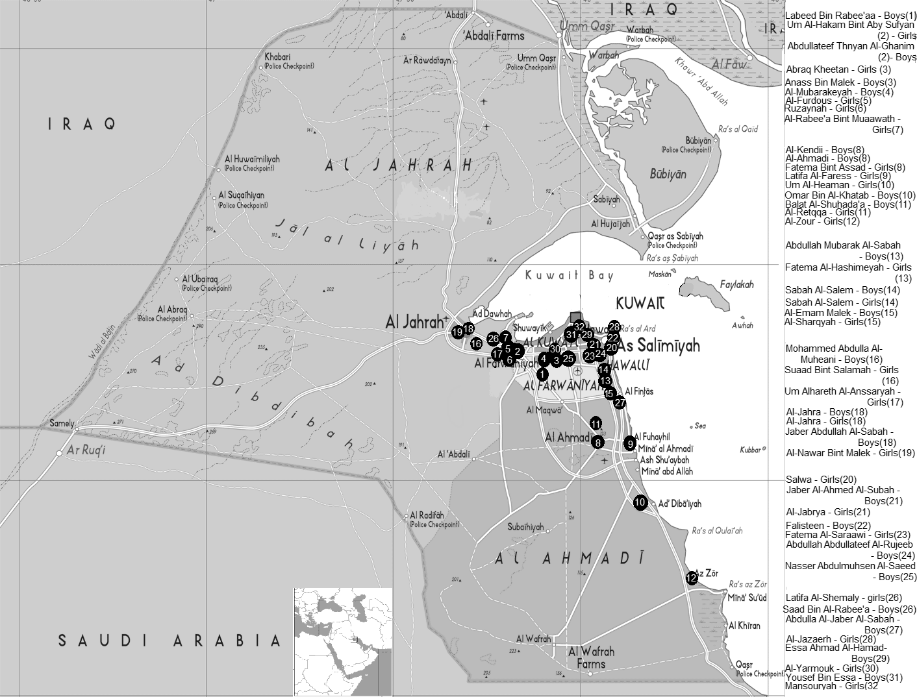

Fig. 1. The locations of the 46 schools in Kuwait selected in this study are shown.

