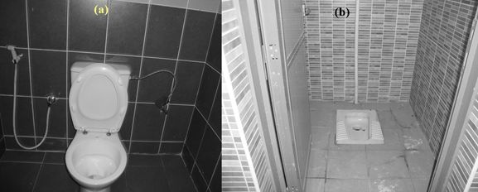

Fig. 1. A typical European seat style toilet (a) and an Asian squat style toilet (b) found in one of the schools.

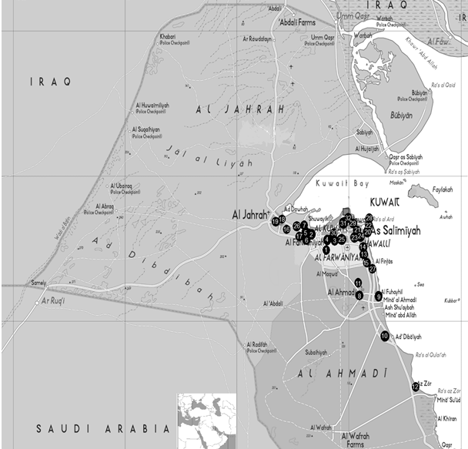
‎ (1) Labeed Iben Rabeea'a (2) Um Al-Hakam Bent Aby Sufyan, (3) Abdulateef Thnyan Al-Ghanim, (4) Anas Iben Malek, (5) Abraq Kheetan, ‎‎(6) Ruzainah,(7) Al-Rabee'a bent Mua'aawath, (8) Al-Kendy, (10) Al-Ahmadi, (11) Al-Retqqa, (12) Al-Zoor, (13) Fatema Al-Hashemyah, (14) ‎Sabah Al-Salem, (15) Sabah Al-Salem, (16) Mohammed AL-Meheani. (17) Al-Jahra, (18) Um Al-Hareth Al-Anssaryah, (19) Al-Nawar Bent ‎Malek, (20) Salwa, (21) Al-Jabryah, (22) Jaber Al-Ahmad Al-Sabah, (23) Abdullah Abdulateef Al-Rejeeb, (24) Fatema Al-Sara'awy, (25) ‎Nasser Abdul. AL-Saeed (26) Saad Ben Rabeea' (27) Abdullah Al-Jaber Al-Sabah, (28) Lateefa Al-Shemali, (29) Suaad Bent Salamh, (30) ‎Yousef Ben Essa, (31) Al-Jazae'r, (32) Al-Mansouryah, (33) Al-Yarmouk, (34) Sabah Al-Salem, (35) Jahra, (36) Al-Emam Malek, (37) Al-‎Mubarakeyah, (39) Balat Al-Shuhada'a (40) Fatema Bent Asad (41) Omar Ben Al-Khata (42) Al-Shargeyah, (43) Falasteen, (44) Al-Furdous, ‎‎(45) Um Al-Heaman, (46) Al-Jazae'r Fig. 2. The localities of the 46 schools in Kuwait employed in the present research are shown with chosen schools are limited to urbanized areas (about 11% of the country).
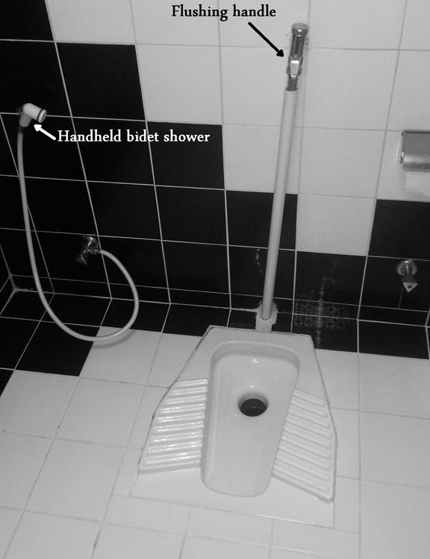

Fig. 3. An Asian style toilet indicating where the swab samples were taken.

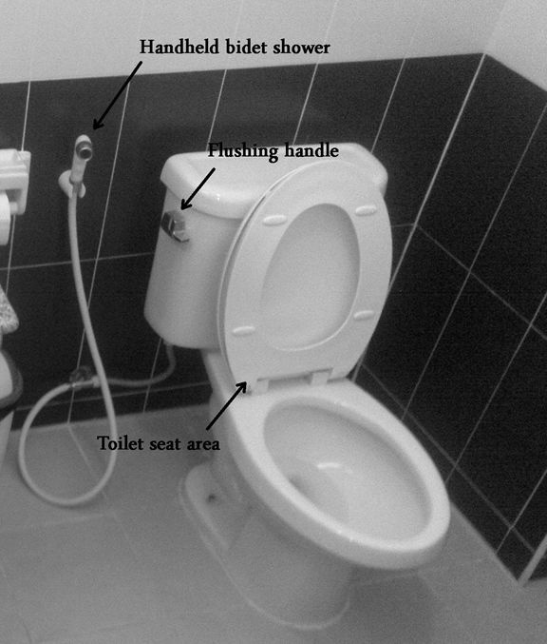

Fig. 4. A seat style toilet showing the three locations where swab samples were taken.

Fig. 5. E. coli bacteria results of three sampling contact points (flush handle, shower bidet, and seat) in RLU units for 7 schools (representing about 15%) out of 46 schools.

