EVALUATION AND EFFECTIVENESS OF REALLOCATING TRAFFIC SIGNAL TIMING AT CORRIDORS WITH
HIGH FREIGHT VOLUME

Ijeoma Ihuoma-Walter, Ph.D. (corresponding author)
Civil Engineering Department
Morgan State University
1700 East Cold Spring Lane, Baltimore, MD 21251
Email: ijmarian@yahoo.com; ijihu1@morgan.edu
ORCiD :0000-0002-5076-010X

Celeste Chavis, Ph.D. (coauthor)
Transportation and Urban Infrastructure Studies
Morgan State University
1700 East Cold Spring Lane, Baltimore, MD 21251
Email : celeste.chavis@morgan.edu
ORCiD : 0000-0002-3737-2364

Adewole Oladele, Ph.D.(coauthor)
Civil Engineering Department
Morgan State University
1700 East Cold Spring Lane, Baltimore, MD 21251
Email : adewolesimon.oladele@morgan.edu
ORCiD: 0000-0003-3588-4312

Abstract
The COVID-19 pandemic drastically altered traffic patterns across the globe. With more people staying at home and relying on delivery services, there was a reduction in passenger car traffic but an increase in freight traffic. This study investigates the changes in traffic volume and mode splits during the COVID-19 pandemic at the intersection of Broening Highway and Holabird Avenues and investigates traffic signal reallocation strategies that account for the changes in traffic. This study considers morning peak traffic volumes before and during COVID. A methodology was developed to evaluate and measure freight volumes and emissions. From the literature, the cost per kilogram of CO, VOC, and NOx was $5.85, $3,37, and $12.53, respectively.
The intersection operated at a level of service (LOS) of C both pre-COVID and during COVID. Traffic volume decreased by 24.3% during COVID at the study location; car volumes declined by 50%, and truck volumes increased by 130%. The total rate of emissions decreased by 22.6%.

Keywords: Multi-modal transportation, Signalized Intersection, Freight, Vehicle and persons delay, COVID, Value of time.

introduction
The United States is currently experiencing a rise in emerging technology advancement and a shift of businesses to e-commerce. Densely populated urban areas are suddenly becoming aware of these changes and are adopting emerging technology advancements into their daily lives and increasing their inventory of goods online and demanding quick delivery of goods ordered online, often within 24 hours. The COVID-19 pandemic has further fueled e-commerce industries to change their distribution model to support these improvements suddenly. The distribution model improvements are causing an increase in heavy-duty freight trucks on the roadways. Hence, the inclusion of heavy-duty freight truck in traffic signal allocation at intersections to reduce delay is paramount because the exhaust emission released is higher for freight truck during signal delay at the intersection. Conversely, the demand for transportation and logistics in certain sectors such as e-commerce has surged ^{[1]} . Hence, the COVID-19 pandemic has dramatically illustrated the need for transportation professionals to prepare for future disruptions ^{[1]}. This research used traffic volumes to evaluate the disruption in traffic volumes and surge in freight traffic volumes and suggest the need to reallocate signal timing in corridors with high volumes of freight truck to reflect changes in COVID and post COVID volumes at intersection due to the surge in heavy-duty freight trucks.

The solution seeks to minimize delay and analyze performance measures for reducing emission at the intersection through traffic signal reallocation. This research focused on the need to reallocate traffic signals that can be applied to any intersection corridor with a high volume of freight truck traffic. Existing data from Maryland State Highway Administration, Maryland Ports Administration and Maryland Transportation Authority. The study area is located at the intersection of Broening Highway and Holabird Avenue in Baltimore, Maryland. An Amazon facility is located along this corridor, contributing to the volume of heavy-duty freight truck traffic.

Study Area
The study area is at the intersection of Holabird Avenue and Broening Highway, located in Baltimore City. The Amazon Fulfilment Center is located along Holabird Avenue and Broening Highway, as well as other industries. This intersection is one mile from the Port of Baltimore. Figure 1 shows the study area Holabird Avenue and Broening Highway. The traffic data showed a significant increase of vehicle and truck traffic from 2008-2011 to 2012-2016. The Amazon Fulfillment Center, which opened in 2012, is located on Holabird Avenue in Baltimore, and it operates a 24 hours’ freight services. Prior to 2012, the AADT for Holabird Avenue-.10 MI W of Broening Hwy traffic volume is 12,911 in 2008 and increase to 14,898 in 2011. After 2011, the AADT traffic data increased from 14,772 in 2012 to 17,330 in 2016, while the truck traffic data for this location is 3781. The significant traffic increase from 2008 to 2016 is due to the opening of the Amazon Fulfillment Center in 2012. Figure 2 and Figure 3 show stacked bar charts by vehicle class volume for the years 2010 and 2016.

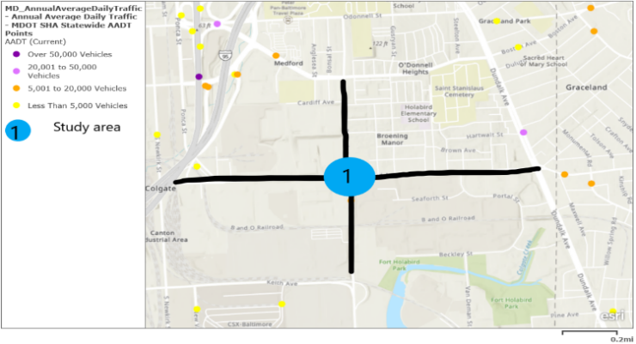
FIGURE 1. Study Area

FIGURE 2. Class Volume Data for 2010

FIGURE 3. Class Volume Data for 2016

Research Objective
The purpose of this research is to analyze the change in traffic volume and modal splits during the COVID-19 pandemic using existing traffic data and signal timing at an intersection located along a multimodal corridor with a heavy volume of truck traffic. Specifically, the COVID-19 pandemic has caused an increase in e-commerce, thereby increasing the number of freight truck traffic on the road and decreasing passenger car volumes as a lot of employers are demanding their employees telework due to the COVID-19 pandemic. This study will aim at analyzing pre-COVID traffic data and COVID data to see the need to reallocate traffic signal as a result of the sudden change. This research used existing traffic data from bus and freight truck transit agencies such as the MDOT SHA Traffic AADT Monitoring System to analyze freight truck service performance during pre-COVID and COVID.

The research object will take the following form:
- Evaluate the current traffic situation pre-COVID and COVID at the Holabird Avenue and Broening Highway Intersection near the Amazon Fulfillment Center.
- Measure the effectiveness of reallocating traffic signal timing to meet the surge in freight truck volumes under mixed traffic conditions during current COVID-19 and pre-pandemic conditions.

Literature REVIEW

Traffic Emissions at Intersection and Air Quality Models
^{[2]} suggested that the operational performance at a signalized intersection could be assessed using various traffic performance measures of effectiveness (MOEs) for evaluating the intersection level of service such as average vehicle delays, number of stops, travel time, throughput and traffic capacity, queue length, average fuel consumption, and total vehicle emissions (CO, NOx, HC), etc. The emissions produced are proportional to fuel consumption, and emissions are usually higher near intersections compared to other street segments ^{[2]} .Studies have shown that fuel economy and emissions could be significantly reduced by improving vehicle standards as well as the optimization of traffic management systems ^{[2]} . Finally, the author concluded that the optimum MOE estimates along the Pareto front were obtained by optimizing green splits in response to dynamic traffic demand ^{[2]} . The proposed algorithm yielded a 22.5 % reduction in average fuel consumption and about a 17% decrease in total vehicle emissions.

COVID-19 and Transportation
The demand for movement is directly related to participation in other economic activities such as work and shopping; the COVID-19 pandemic has demonstrated this fact on a global scale ^{[3]} . Transport operations dependent on revenue from reliable travel volumes experienced significant revenue declines, including fare, fuel tax, and toll revenues ^{[3]} . Conversely, the demand for transportation and logistics in certain sectors such as e-commerce has surged ^{[3]} . Hence, the COVID-19 pandemic has dramatically illustrated the need for transportation professionals to prepare for future disruptions ^{[3]} .

In Minneapolis, COVID-19 related shut down reduced traffic volume on average throughout the city by 50% ^{[4]} . However, the effects proved to be only temporary, after which the traffic volume began to recover at a slow but steady pace ^{[4]} . Although passenger vehicle volumes decrease, it is not known how the increase in trucking during the COVID-19 pandemic influenced these traffic counts ^{[4]} .
In summary, past research has been carried out on signal control strategies pertaining to vehicle delay at a signalized intersection, persons delay on bus transit, and optimization of signal control for multimodal traffic. This study aims to evaluate the pre-COVID and COVID traffic volumes with the existing traffic signal timing and develop a monetized equation based on persons’ time, the value of goods for freight trucks, and exhaust emissions. The goal of this research is to look at multiple parameters in one equation at six different scenarios in order to recommend a traffic signal reallocation strategy for an intersection with high volumes of freight trucks before and during the COVID-19 pandemic, thus capturing the shift to teleworking and surge in e-commerce during due to the pandemic.

Methodology

Data Collection
As previously mentioned, this study investigates traffic flow at Holabird Ave and Broening Highway in Baltimore, MD. The traffic data was collected on Wednesday, October 2, 2019 (Pre-COVID). The morning peak period 6:00 AM to 9:00 AM, with the peak hour ranging from 7:00-8:00 AM. The author returned to the site on Wednesday, March 3, 2021 (COVID), to collect traffic data via video recording from 7:00 AM to 8:00 AM to align with the SHA peak hour. The existing signal timing for all approaches was also collected in the field on March 3, 2021.

Figure 4 and Figure 5 show the existing lane configuration and phase diagram for Holabird Avenue and Broening Highway. The EB and WB direction has two through lanes, and EB has an exclusive permissive left-turn lane onto Broening Highway NB. The WB has one exclusive permissive left-turn lane onto Broening Highway SB and a shared right turn lane to Broening Highway NB.

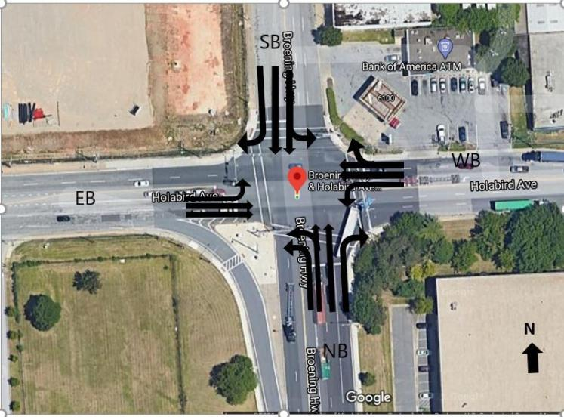

FIGURE 4. Lane Configuration at Holabird Ave & Broening Hwy
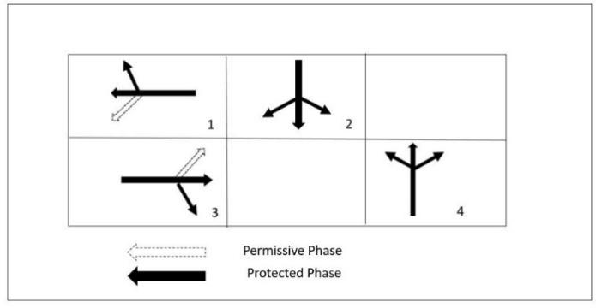
FIGURE 5. Exiting 3-Phase Diagram at Holabird Ave & Broening Hwy

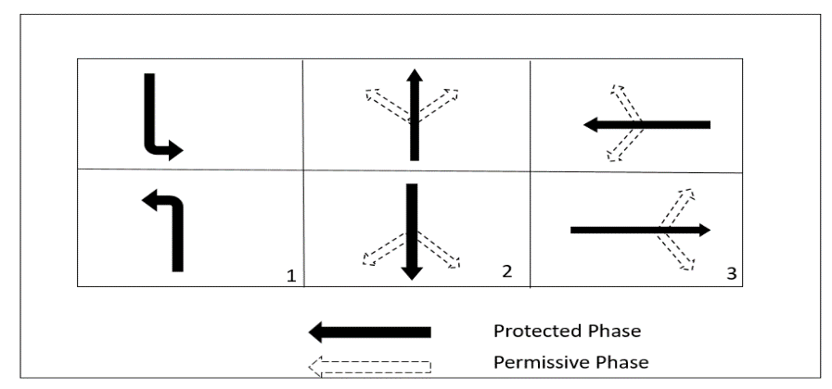
FIGURE 6. New 3-Phase Diagram at Holabird Ave & Broening Hwy

Step 2 will run six scenarios in SYNCHRO to obtain the delay, emissions, and in some scenarios, signal timing. There were three scenarios with pre-COVID volumes and three scenarios with COVID volumes. Additionally, a new 3-phase signal phasing scheme was tested.

The field observed COVID data shows that the westbound (WB) approach has the highest traffic volumes for cars during the morning peak (304), while the northbound (NB) approach has the lowest traffic volumes for cars (126). For trucks, the eastbound (EB) and WB approaches have the highest volumes of heavy vehicles (196 and 195, respectively). The NB and southbound (SB) approaches have the lowest volume of heavy vehicles (145 and 129). The number 65 bus runs along this corridor; one bus runs along the EB right (EBR) direction, and two buses in the NB left (NBL) direction. The Peak Hour Factor (PHF) calculated in each direction of approach shows a bit of variability, from 0.80 to 0.93. Traditionally, it is not usually below 0.80 for an urban environment.
TABLE 1. Pre-COVID Volumes and COVID Volumes.

 |  |  |  | Pre-COVID Volumes (10/02/2019)
Vehicle Type | EBL | EBT | EBR | WBL | WBT | WBR | NBL | NBT | NBR | SBL | SBT | SBR | Total
Cars | 43 | 321 | 79 | 146 | 469 | 101 | 69 | 55 | 41 | 94 | 191 | 113 | 1722
 | 443 |  |  | 716 |  |  | 165 |  |  | 398
Trucks | 4 | 14 | 19 | 32 | 30 | 10 | 37 | 13 | 28 | 28 | 49 | 23 | 287
 | 37 |  |  | 72 |  |  | 78 |  |  | 100
Buses | 0 | 0 | 3 | 2 | 4 | 2 | 2 | 0 | 0 | 2 | 3 | 2 | 20
 | 3 |  |  | 8 |  |  | 2 |  |  | 7
Total | 47 | 335 | 101 | 180 | 503 | 113 | 108 | 68 | 69 | 124 | 243 | 138 | 2029
 | 483 |  |  | 796 |  |  | 245 |  |  | 505
%HV | 9% | 4% | 22% | 19% | 7% | 11% | 36% | 19% | 41% | 24% | 21% | 18%
PHF | 0.92 | 0.92 | 0.92 | 0.92 | 0.92 | 0.92 | 0.92 | 0.92 | 0.92 | 0.92 | 0.92 | 0.92
 |  |  |  | COVID Volumes (03/03/2021)
Vehicle Type | EBL | EBT | EBR | WBL | WBT | WBR | NBL | NBT | NBR | SBL | SBT | SBR | Total
Cars | 26 | 191 | 47 | 62 | 199 | 43 | 53 | 42 | 31 | 41 | 83 | 49 | 867
 | 264 |  |  | 304 |  |  | 126 |  |  | 173
Trucks | 21 | 74 | 101 | 87 | 80 | 28 | 68 | 25 | 52 | 36 | 63 | 30 | 665
 | 196 |  |  | 195 |  |  | 145 |  |  | 129
Buses | 0 | 0 | 1 | 0 | 0 | 0 | 2 | 0 | 0 | 0 | 0 | 0 | 3
 | 1 |  |  | 0 |  |  | 2 |  |  | 0
Total | 47 | 265 | 149 | 149 | 279 | 71 | 123 | 67 | 83 | 77 | 146 | 79 | 1535
 | 461 |  |  | 499 |  |  | 273 |  |  | 302
% HV | 45% | 28% | 68% | 58% | 29% | 39% | 57% | 37% | 63% | 47% | 43% | 38%
PHF | 0.8 | 0.88 | 0.8 | 0.93 | 0.8 | 0.8 | 0.89 | 0.8 | 0.8 | 0.84 | 0.87 | 0.8

TABLE 1 shows the pre-COVID data on October 2, 2019, from 7:00 to 8:00 A.M. Similar to the COVID data, the data is classified into cars, buses, and trucks. The overall peak hour factor (PHF) of 0.92 provided by SHA was used in all directions. Since the SHA data was presented by approach and not by movement, the authors assumed that the proportion of vehicles turning left, turning right, and proceeding straight for a particular movement remains the same pre-COVID as it was during COVID for each mode though the total number of vehicles varied.

The pre-COVID data shows that the WB approach has the highest total volume of cars (716) while the NB approach has the lowest volume of cars (165). For trucks, the WB, NB, and SB have the highest volumes of heavy vehicles, 72, 78, 100, respectively. The EB approach has the lowest volume of heavy vehicles with a total of 37. The assumption for the number of buses per hour is one on the EBR and two on the NBL. The existing bus schedule also shows that one bus per hour runs on the EBR and two buses per hour NBL direction. The number of buses per hour is two on the NBL movement. While the magnitude of the volumes differed in the pre-COVID and COVID cases, in both the WB approach had the largest volume followed by EB, NB, and SB. Traffic volumes changed between the two data sets. TABLE 1 shows traffic volumes by the movement for cars, trucks, and buses. As shown in TABLE 1 the traffic volume of cars pre-COVID was higher than during COVID. However, for trucks, the volume of trucks increased during COVID.

MTA Bus Ridership Data
Table 2 provides ridership data for Route 65 for Fall 2017. The data counts are from onboard Automatic Passenger Counting (APC) system data; it shows average daily weekday and weekend bus stop ridership (boarding, alighting). This ridership data shows bus 65 has a stop located on Holabird Avenue EB by Amazon Fulfilment Center.
Table 2. MTA Average Daily Ridership for Route 65 in Fall 2017 and Maximum Load
Service Type | Avg. Number of Riders per Trip | Sampled Round Trip Revenue Hours | Avg. Passenger per Revenue Hour | Sampled Riders | Average Passengers per Mile | Load Factor (% of Seats Filled)
WEEKDAY | 20.46 | 65.2 | 25.4 | 744.16 | 2.260 | 0.255
SAT | 18.93 | 29.9 | 23.4 | 354.20 | 2.063 | 0.239
SUN | 17.49 | 36.7 | 31.7 | 445.84 | 1.943 | 0.226
 | Maximum Loads for #65 Stops Serving Holabird Ave and Broening Hwy
 | Maximum Load [pax] |  | Value of Time [$/hr]
 | East Bound | Northbound | Eastbound | Northbound
Pre-COVID (Feb 2020) | 26 | 35 | $292.61 | $382.34
COVID (Oct 2020) | 21 | 29 | $242.76 | $322.52

A Freedom of Information Act (FOIA) request was conducted to obtain ridership data for the MTA transit system for February 2020 (pre-COVID) and October 2020 (COVID). Since we are analyzing the morning peak period, the maximum load is used for the analysis. The maximum load data was provided at the stop level, while this may slightly overestimate the number of bus riders, the 2017 average weekday ridership numbers shown in Table 2 provide further evidence that the numbers provided in Table 2 are realistic for the weekday morning peak.

Emission Cost
SYNCHRO provides three measures of tailpipe emissions: carbon monoxide (CO), nitrogen oxides (NOx), and volatile oxygen compounds (VOC) in units of grams based on fuel consumption which is a function of speed, vehicle miles traveled, and the number of stops. Given fuel consumption ($F$) in gallons, the amount of CO, NOx, and VOC, respectively, is given as:

CO= F x 69.9g/gal | (7)
NOx= F x 13.6 g/gal | (8)
VOC=F x 16.2 g/gal | (9)
(DelDOT, 2014) ^{[5]} .
TABLE 3 illustrates the estimated cost of emissions developed in past studies. The cost estimates in TABLE 3 were adjusted to 2020 dollars using the United States Bureau of Labor Statistics Inflation Calculator. Additionally, tons were converted to kg use the conversion that 1 ton = 907.185 kg. Thus for this study, we assume that the value of emissions for carbon monoxide, $VOE_{CO}$, is $5.85/kg, the value of VOCs, $VOE_{VOC}$, is $3.36/kg, and the value of NOx, ${VOE}_{NOx}$, is averaged to $12.53/kg.

TABLE 3. Value of Emissions Estimates (Victoria Transport Policy Institute (2011) (6)

Publication | Costs | Cost Value | 2020 USD/ton | 2020 USD/kg
AEA Technology Environment (2005) (7) | NOx | 2005 €19,7750 | $13,293 | $14.65
 | VOCs | €1,813 | $3,049 | $3.36
Wang et al. (1994) | NOx | 1989 $/ton $4,430 | $9,437 | $10.40
 | CO | 2,490 | $5,304 | $5.85

Analysis/Result

Synchro Delay Result
TABLE 4 shows the summary of Synchro results for scenarios one to scenario six. Comparing the cycle length of the Pre-COVID scenarios (scenarios 1-3), scenario one has the highest at 118 sec compared to 75 secs for scenarios two and three. For intersection delay, scenario one has the highest delay at 32.0 sec compared to scenario two and scenario three, which experienced a delay of 23.2 secs and 18.7 secs, respectively. Scenario three, pre-COVID volumes with new phasing and optimal signal timing, has the lowest intersection delay (18.7 sec) and operates at a LOS B compared to scenarios one and 2, which have a LOS C. The CO, NOx, and VOC emissions are the highest in scenario one. The CO, NOx, and VOC emissions are significantly lower in scenario three compared to scenarios one and scenario three. In summary, scenario three has the lowest values for all output for the pre-COVID scenarios, as shown in TABLE 4.

Similarly, TABLE 4 summarizes Synchro results for the COVID scenarios (scenarios 4-6). The cycle length in scenario one is the highest at 118 sec, followed by 75 secs for scenario five and 65 secs in scenario six. For intersection delay, scenario four has the highest delay, 31.6 sec, compared to scenario five and scenario six at 26.5 sec and 20.3 sec, respectively. While all three COVID scenarios are operating a LOS C, scenario six, COVID volumes with new phasing and optimal delay, has the lowest intersection delay. The CO, NOx, and VOC emission is the highest in scenario four and the lowest in scenario six. Similar to the Pre-COVID scenarios, the lowest values of all output during COVID occurred in the new phasing and optimal signal timing scenario (scenario 6); see TABLE 4.

TABLE 4. Summary of Synchro Results
Scenario | Cycle Length (s) | Intersection Delay (s/veh) | LOS | CO (g/hr.) | NOx (g/hr.) | VOC (g/hr.)
1: Pre-COVID, Existing phase & timing | 118 | 32.0 | C | 2916 | 567 | 676
2: Pre-COVID, Existing phase, Optimal timing | 75 | 23.2 | C | 2663 | 518 | 617
3:Pre-COVID,New Phasing,Optimal Timing | 75 | 18.7 | B | 2436 | 474 | 564
4:COVID,Existing phase & timing | 118 | 31.6 | C | 2256 | 438 | 523
5:COVID,Existing phase, Optimal timing | 70 | 26.5 | C | 2155 | 419 | 499
6:COVID,Newphasing, Optimal timing | 65 | 20.3 | C | 1948 | 377 | 452

Discussion of Results

Impact of COVID
The COVID-19 pandemic significantly changed traffic flows across the world. This study looked at an intersection with high freight volume in Baltimore, MD. The Holabird Ave and Broening Highway intersection serves an Amazon Fulfillment Center and the Port of Baltimore. This research collected traffic volumes during COVID (10/12/2019) and compared them with pre-COVID (10/02/2019) traffic volumes. The analysis presented in this research considered six different scenarios measures of performance. Table 1. Pre-COVID Volumes and COVID Volumes. Pre-COVID volumes show a significant change in traffic volumes and further illustrate the impact of COVID on modes of traffic and delay experienced at the intersection. Overall, the percentage change in total volume was -4.5%, -37.3%, +11.4%, -40.2% along the EB, WB, NB, and SB approaches, respectively. In the study period, car volumes declined by 50%, and truck volumes increased by 130%. This resulted in a high heavy vehicle percentage during COVID. Specifically, the heavy vehicle percentage in EBL, EBT, EBR, WBL, WBT, WBR, NBL, NBT, NBR, SBL, SBT, SBR lanes increased by 36%, 24%, 46%, 39%, 22%, 28%, 21%, 18%, 22%, 23%, +2%, +0%, respectively.

This change in traffic volume and the percentage of heavy vehicles resulted in delay and a need for signal optimization. Using the volume data in Volumes, and signal timing data observed in the field, delay and level of service (LOS) were calculated in Synchro for six scenarios. Comparing the two existing scenarios, Scenario 1: Pre-COVID Existing and Scenario 4: COVID Existing, the LOS remained C, and the overall intersection with delay was 32.0 sec/veh Pre-COVID and 31.6 sec/veh during COVID; see TABLE 4.

Summary of Contribution
The research contributed to two main areas: (1) increase the understanding of how the COVID-19 pandemic impacted areas with high freight volumes, and (2) provided a methodology for combining multiple performance metrics into a single objective. A methodology was developed to calculate the delay and the cost of carbon monoxide (CO), volatile organic compounds (VOCs), and nitrogen oxide (NOx) emissions.
The COVID analysis showed that the shift to teleworking and reliance on e-commerce impacted the volume and modal split of traffic and demonstrated the need for signal adaption during disruptive events. The findings of this study could provide useful guidance to traffic engineering professionals and policymakers to prepare for a future crisis that can disrupt the traffic system. Future research could focus on more efficient computational algorithm techniques to solve traffic signal optimization during disruptive events.

author contributions
All authors contributed to all sections of this report and have reviewed the results and approved the final version of the manuscript.

REFERENCES
1. Hendrickson, C., & Rilett, L. R. (2020). The COVID-19 pandemic and transportation engineering. American Society of Civil Engineers. https://ascelibrary.org/doi/full/10.1061/JTEPBS.0000418.AEA Technology Environment. (2005). Damages per tonne emission of PM2.5, NH3, SO2, NOx and VOCs from each EU25 Member State (excluding Cyprus) and surrounding seas.
2. Al-Turki, M., Jamal, A., Al-Ahmadi, H. M., Al-Sughaiyer, M. A., & Zahid, M. (2020). On the potential impacts of smart traffic control for delay, fuel energy consumption, and emissions: An NSGA-II-based optimization case study from Dhahran, Saudi Arabia. Sustainability, 12(18), 7394. https://doi.org/10.3390/su12187394.
3. Hendrickson, C., & Rilett, L. R. (2020). The COVID-19 pandemic and transportation engineering. American Society of Civil Engineers. https://ascelibrary.org/doi/full/10.1061/JTEPBS.0000418.AEA Technology Environment. (2005). Damages per tonne emission of PM2.5, NH3, SO2, NOx and VOCs from each EU25 Member State (excluding Cyprus) and surrounding seas.
4. Liu, Z., & Stern, R. (2021). Quantifying the traffic impacts of the COVID-19 shutdown. Journal of Transportation Engineering, Part A: Systems, 147(5), 04021014. https://ascelibrary.org/doi/10.1061/JTEPBS.0000527.
5. DelDot. (2014). Estimating Vehicle Emissions in Signalized Networks with Synchro/SimTraffic.
6. Victoria Transport Policy Institute. (2011). Transportation cost and benefit analysis II – air pollution costs. Victoria Transport Policy Institute.
7. AEA Technology Environment. (2005). Damages per tonne emission of PM2.5, NH3, SO2, NOx and VOCs from each EU25 Member State (excluding Cyprus) and surrounding seas.

https://www.bls.gov/data/inflation_calculator.htm

