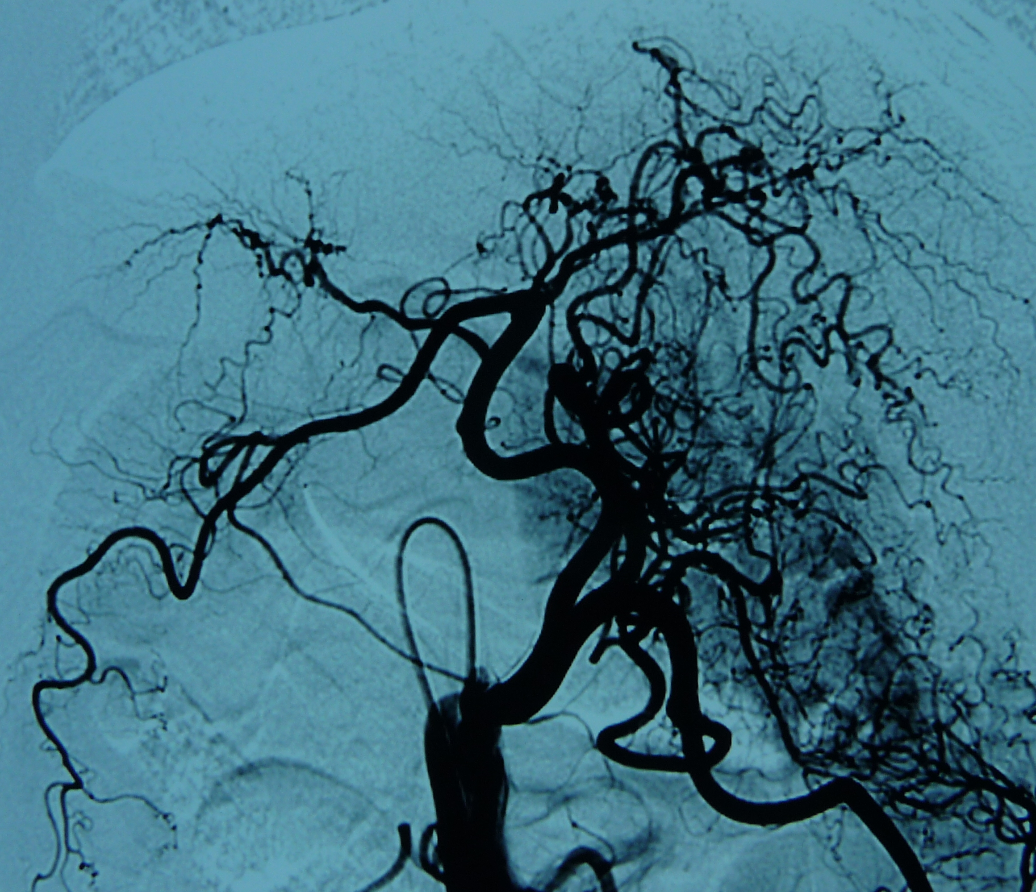
Fig. A: Canine Celiac Arteriography Show: proper hepatic artery (→) and right hepatic artery (↑) and left hepatic artery (←).
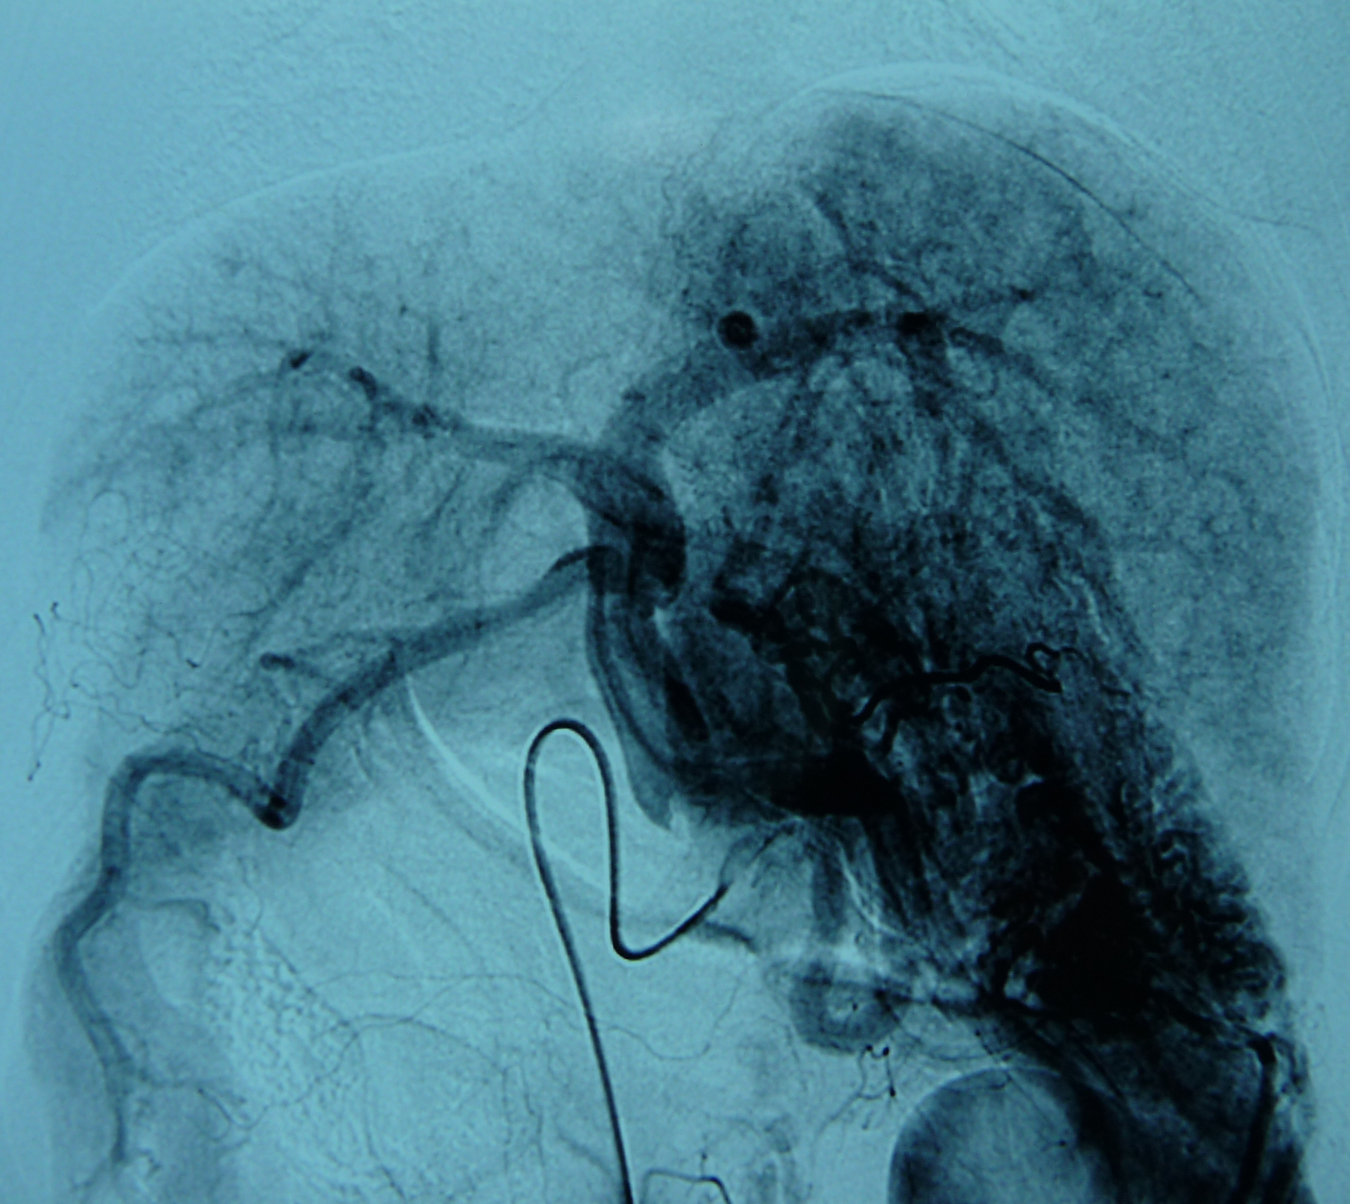
Fig. B: Angiography of the canine celiac artery show: development of the trunk (←) and left branch (←) and right branch (→) in the portal vein phase.

