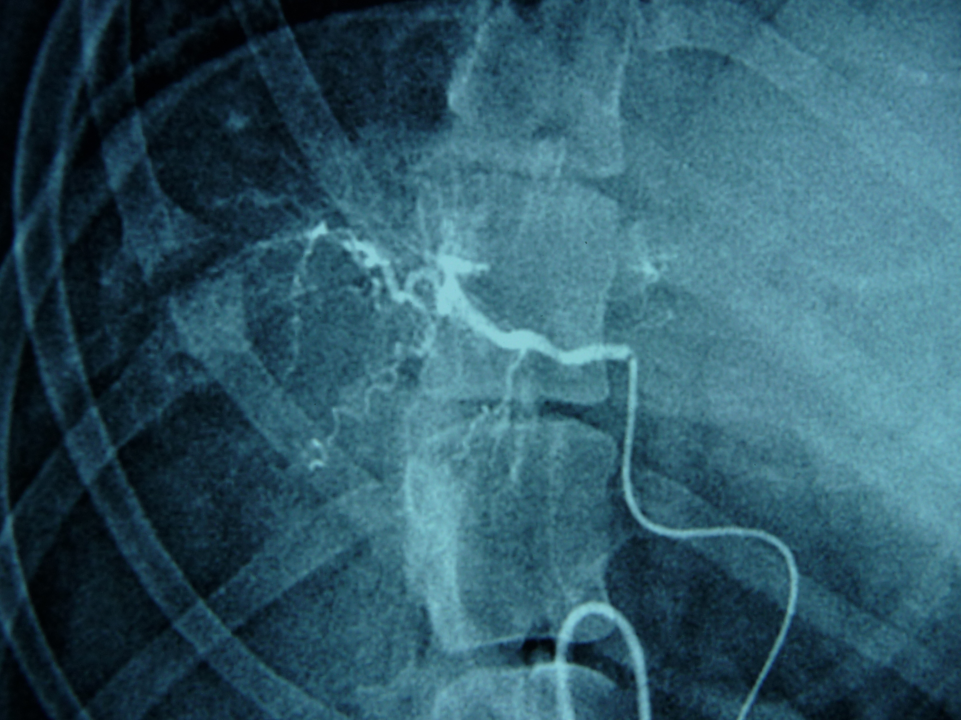
Fig. C: Superselective right hepatic artery embolization with DC-bead-- Sorafenib (←).
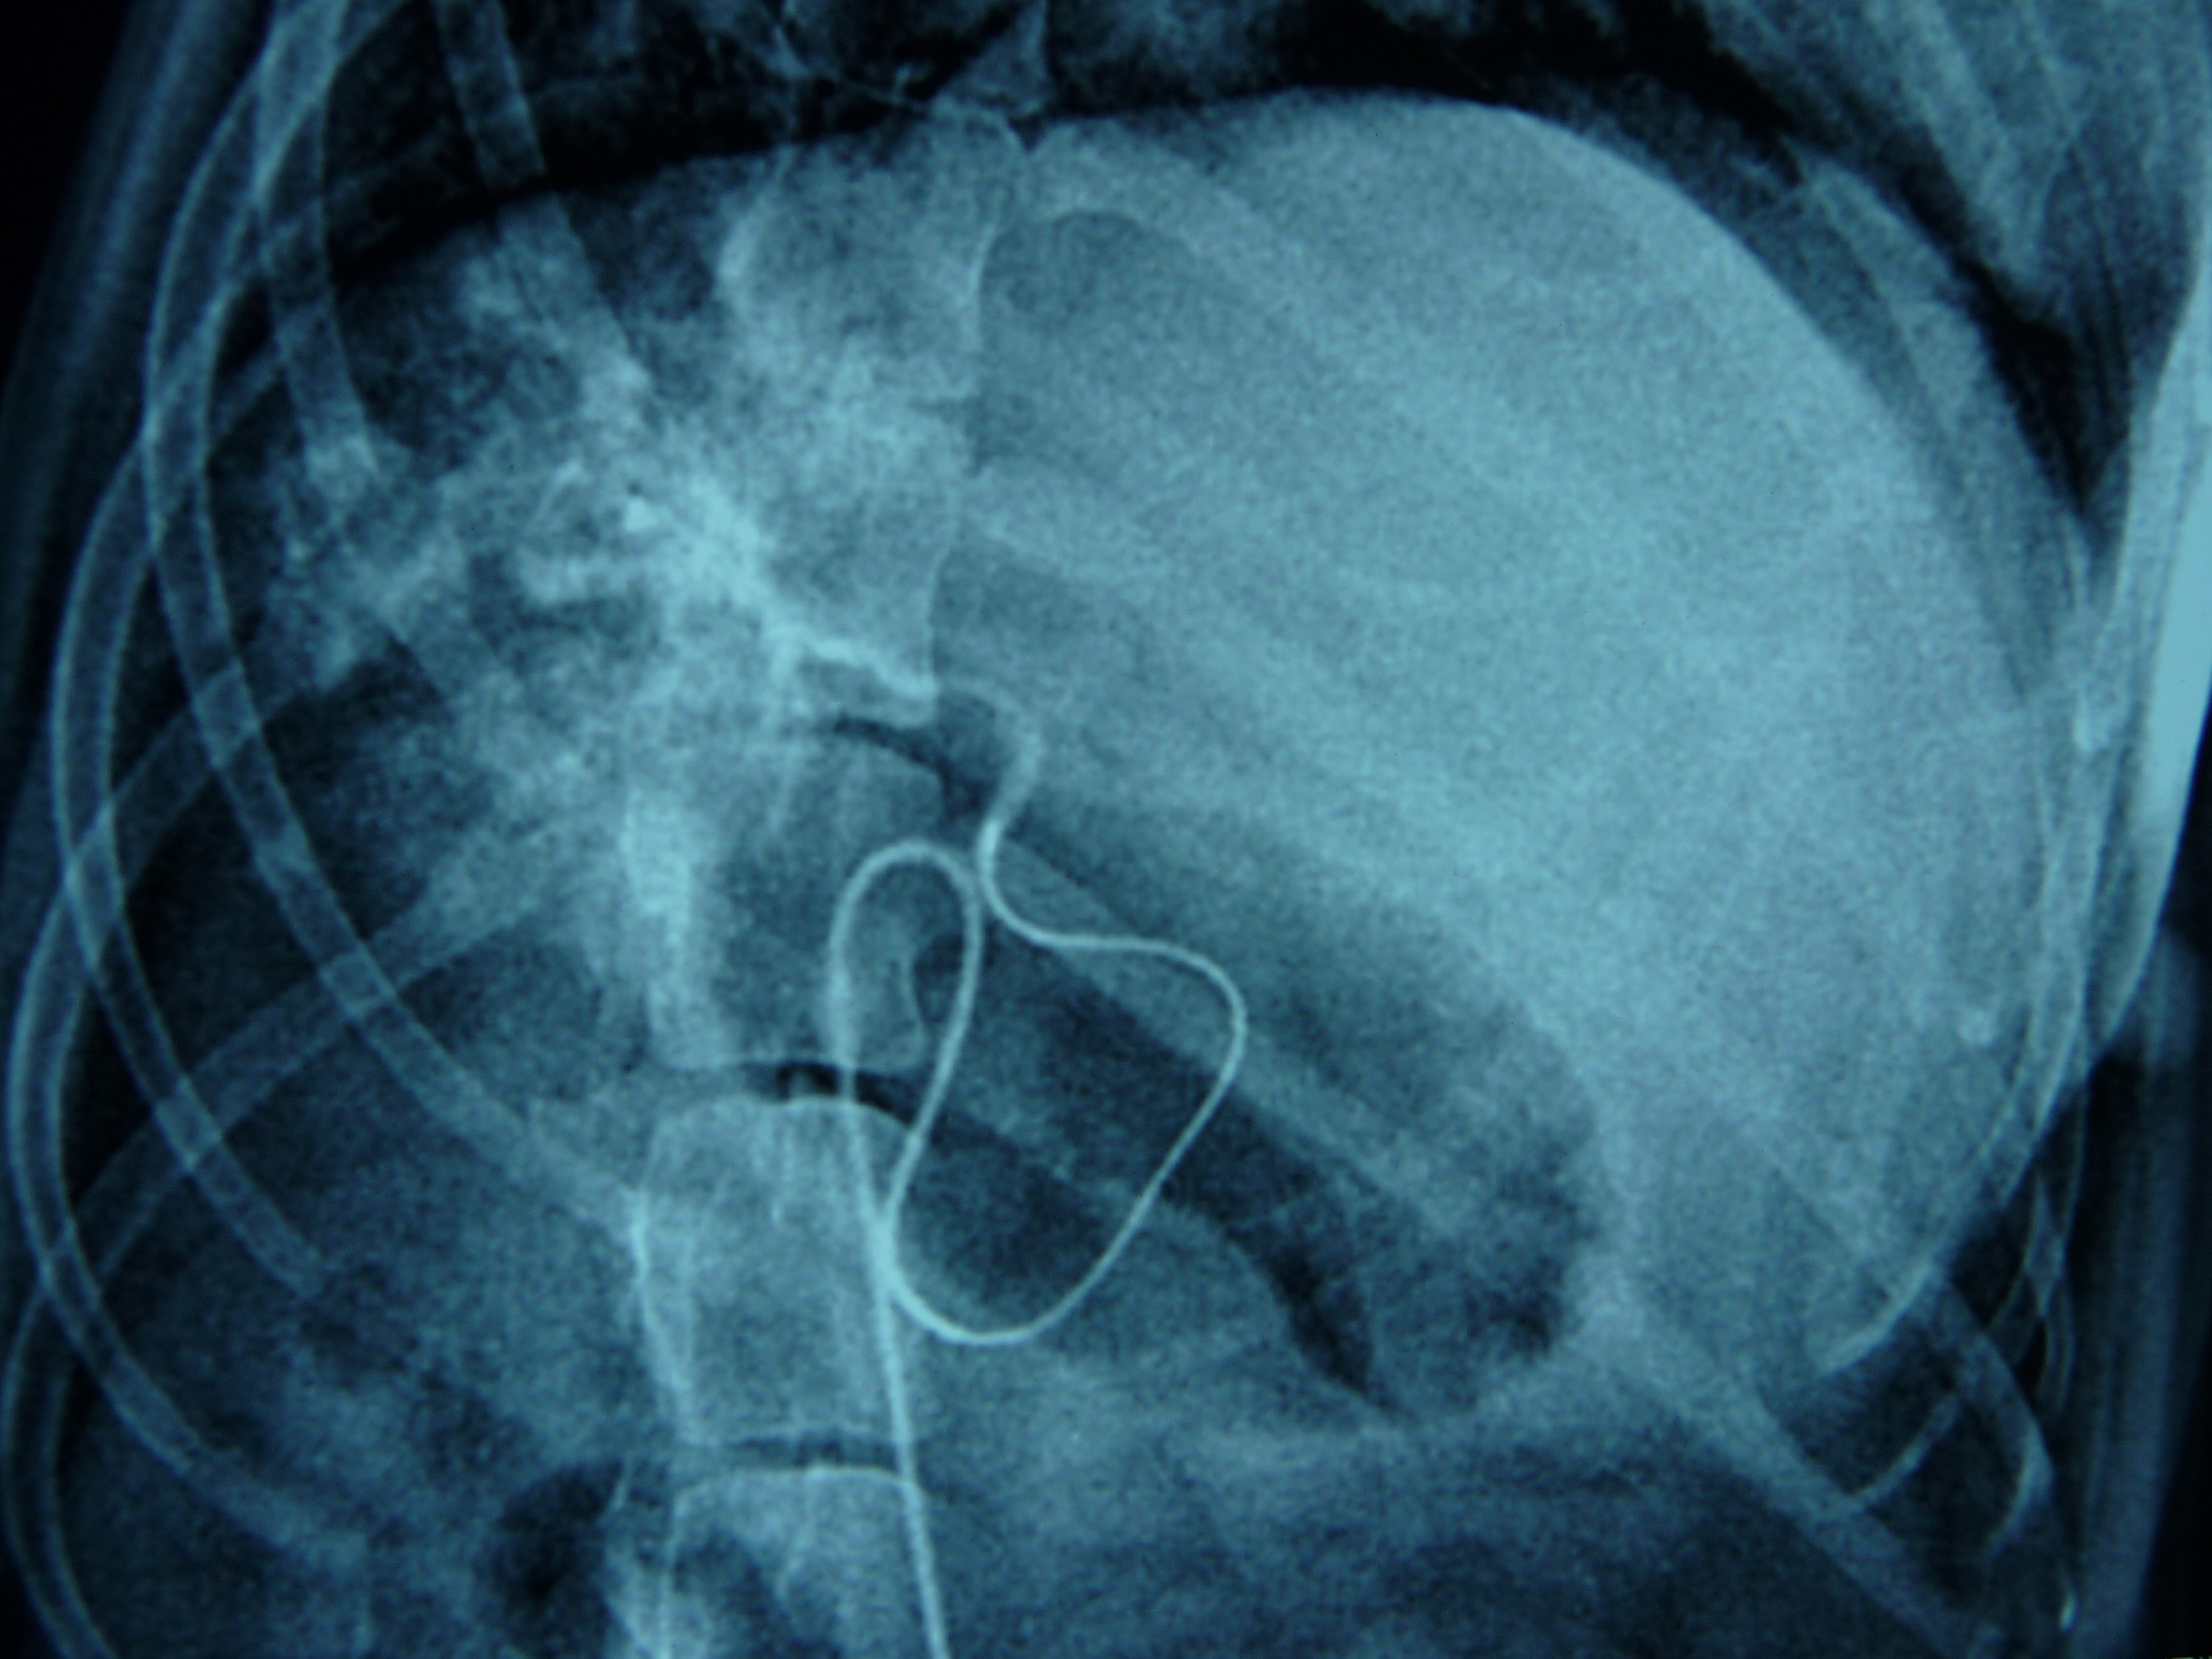
Fig. D: The visible deposition of embolism in the right lobe of the liver (←) after embolization of the right hepatic artery.

2.3.3 collection of samples: observe the peripheral blood drug concentration of experimental animals in different periods of 0 hour (before administration) and 10min, 30min, 1h, 4h, 16h, 1day, 2days, 4days, 7days, 10days, 14 days after operati

