FOXM1 and UBE2C are distinct biomarkers for Non-small Cell Lung Cancer Survival Prediction：Data-mining based on ONCOMINE
Ya WANG¹, Jiang ZHU²
1. Clinical Medical College of Sichuan University, Chengdu 610041, China
2. Department of Thoracic Oncology, West China Hospital, Sichuan University, Chengdu 610041, China
Corresponding author: Jiang Zhu
D第一作者通讯地址：四川省成都市武侯区四川大学华西临床医学院，电话 18349304937，邮编610041，
邮箱 1258703499@qq.com
ABSTRACT
Non-small cell lung cancer (NSCLC) remains to be primary reason of tumor deaths in the past few decades. The mortality of this malignancy could be reduced by developing new prognostic biomarkers and discovering novel therapeutic biological target. Here, we studied the mRNA expression of FOX gene family and UBE2C in different types of cancer compared with normal tissue through ONCOMINE differential analysis. CCLE analysis was mined to explore the expression profiles of target genes in different tumor cells. GEPIA was used to discover the expression of target genes in different subtypes and the correlation with lung cancer stage. The prognostic values of FOXM1 and UBE2C were further investigated through Kaplan-Meier plotter analysis. It showed that FOXA1, FOXD1 and FOXM1 were dramatically high expressed in NSCLC comparing with normal lung tissues. Besides, the expression of FOXM1 was significantly associated with UBE2C. Furthermore, the overexpression of FOXM1 and UBE2C were correlated to shorter survival in lung adenocarcinoma (LAC) instead of lung squamous cell carcinoma(LSCC).
Hence, we could draw a conclusion that FOXM1 and UBE2C are distinguished biomarkers and crucial prognostic indicators for lung adenocarcinoma patients.

KEYWORDS: FOXM1, FOX gene family, UBE2C, Biomarkers, non-small cell lung cancer, lung cancer，prognosis

INTRODUCTION
Carcinoma of the lungs is the leading cause of tumor mortality around the world and about 80–85% of lung cancers are NSCLC consisted of large-cell carcinoma, lung adenocarcinoma (LAC) and lung squamous cell carcinoma (LSCC) [1]. It is notable that the 5-year survival rate has remained at ~17% over previous decades [2]. Moreover, as the symptoms associated with lung cancer are often non-specific, it is frequently diagnosed in the advanced stages[3]. Therefore, it is required to develop new prognostic biomarkers and discovering novel therapeutic biological target.

The human FOX (Forkhead box) gene family is a key regulatory transcription factor family, composed of 19 subgroups and 50 members, named from FOXA1 to FOXS1 [4]. Fox family genes control the expression of other genes by regulating the activity of transcription factors, regulating the growth, differentiation, apoptosis, proliferation, migration, invasion and angiogenesis of tumor cells [5]. FOXM1, as one of the most widely investigated gene from the FOX gene family, is a transcription factor overexpressed in various of tumor cells such as breast carcinoma, ovarian cancer, gastric and other cancers[6, 7]. It plays a vital role on stimulating cell proliferation through cell cycle progression and transcriptional regulation of important genes for G1/S and G2/M phase transition and M phase progression[8]. It is reported that the poor prognosis in glioblastoma patients was related to FOXM1 gene overexpression[9]. Therefore, FOXM1 is likely to be an important prognostic biomarker in NSCLC patients.

Recently, it was shown that UBE2C expression was transcriptionally regulates by FOXM1 in esophageal squamous cell cancer and the regulation may be a widespread phenomenon in human tumor[10]. UBE2C/UBCH10, as an E2 ubiquitin-conjugating enzyme, plays an important role on regulation mitosis and cell cycle [11]. It has been indicated that UBE2C was overexpressed in a range of tumor and associated with poor prognosis in several types of cancer including ESCC and colorectal cancer[12, 13]. These findings revealed that UBE2C is likely to be oncogene in lung cancer.

In the current study, we examined the expression of FOX gene family and UBE2C in different types of cancer compared with normal tissue, with purpose of determining the expression levels of FOXM1 and UBE2C and the correlations between FOXM1 and UBE2C, along with their corresponding prognostic significance in NSCLC.

MATERIAL and METHODS
ONCOMINE Databases
ONCOMINE database (www.oncomine.org), an open and convenient online cancer microarray database, integrated 715 datasets and 86,733 sample. It is a powerful web application through which mRNA expression levels of FOXM1 and UBE2C in a large volume of cancer types, subtypes, and experiments were explored. Significant correlation between gene and cancer can be show in a special figure. Co-expressed disease-related genes can also be mined through this database.

CCLE (Cancer Cell Line Encyclopedia) Analysis
The Cancer Cell Line Encyclopedia (CCLE) (https://portals.broadinstitute.org/ccle/home), as a newly developed website, provides analysis tools including integrative genomics viewer (IGV), differential expression analysis, gene co-expression, gene set enrichment analysis (GSEA). The CCLE enables public access to genomic data, analysis and visualization for about 1000 cell lines.

GEPIA (Gene Expression Profiling Interactive Analysis)
Gene expression profiling interactive analysis (http://gepia.cancer-pku.cn/), an open interactive web server, provides customized functions such as tumor/normal differential expression analysis, profiling plotting according to cancer types or pathological stages, patient survival analysis and so on. This is a time-saving and intuitive tool integrated approximately 9,736 tumors and 8,587 normal samples from the TCGA and the GTEx projects[14].

The Kaplan-Meier plotter
The Kaplan Meier plotter (http:// kmplot.com/analysis/), an online database including 2,437 lung cancer patients and 54,675 genes from GEO, EGA and TCGA, is capable to assess relapse free and overall survival[15]. Patients were split into two cohorts by gene expression and were compared by a Kaplan-Meier survival plot, through which prognostic values of FOXM1 and UBE2C expressions were estimated. The hazard ratio with 95% confidence intervals and logrank P value are calculated. The difference was statistically significant in P-value < 0.01.
RESULTS
FOXM1, FOXA1, FOXD1 and UBE2C were significantly overexpressed in lung cancer
To examine the transcription level of all the members in FOX gene family in lung cancer, we performed concept analysis through ONCOMINE databases, which revealed that FOXA1, FOXD1, FOXM1, FOXK2 and FOXC1 were overexpressed in lung cancer in a database with 203 samples. FOXA1 transcripts were 7.19 fold elevated in lung adenocarcinoma comparing with normal lung tissue (p=2.55e-7). FOXD1 transcripts were 2.22 fold elevated in comparing with normal lung tissue (p=0.003). FOXM1, FOXK2 and FOXC1 were also distinctively overexpressed in lung cancer contrasting with normal lung in a database with 203 samples. (Figure 1 A)

Additionally, the expression of FOXA1, FOXD1, FOXM1, FOXK2, FOXC1 and UBE2C in a range of cancers were further explored through ONCOMINE analysis. It was found out that FOXM1 and UBE2C were significantly high expressed in a variety including brain and CNS cancer, breast cancer, colorectal cancer, sarcoma and especially lung cancer. FOXA1 and FOXD1 were comparatively high expressed in lung cancer. However, FOXK2 and FOXC1 had no significant different expression in lung cancer. (Figure 1 B)
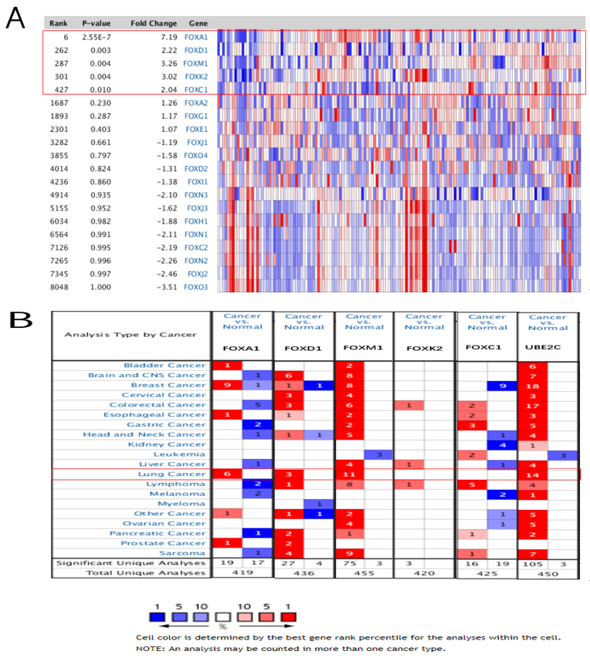
Figure 1 A: A: The transcription level of all the members in FOX gene family in lung cancer.
The top highly expressed FOX family members in lung cancer in a research including 203 samples was showed in this figure.
Figure 1 B: The expression level of FOXA1, FOXD1, FOXM1, FOXK2 and FOXC1 in diverse cancers versus normal tissue. Overexpressed was in red, while low expressed was in blue. The number represents the number of studies meet the threshold in the ONCOMINE database.

The overexpression of UBE2C was distinctly associated with FOXM1 expression
Since it was found out that FOXM1 was distinctively overexpressed in lung carcinoma and a variety of other cancers, we next carried out further exploration on the co-expression gene of FOXM1 through ONCOMINE database, which indicated that the expression of UBE2C was significantly related to FOXM1(r=0.789). (Figure 2 A) The result was demonstrated through CCLE analysis that FOXM1 and UBE2C were significantly high expressed in lung carcinoma cell comparing with other tumor cell lines. (Figure 2 B)
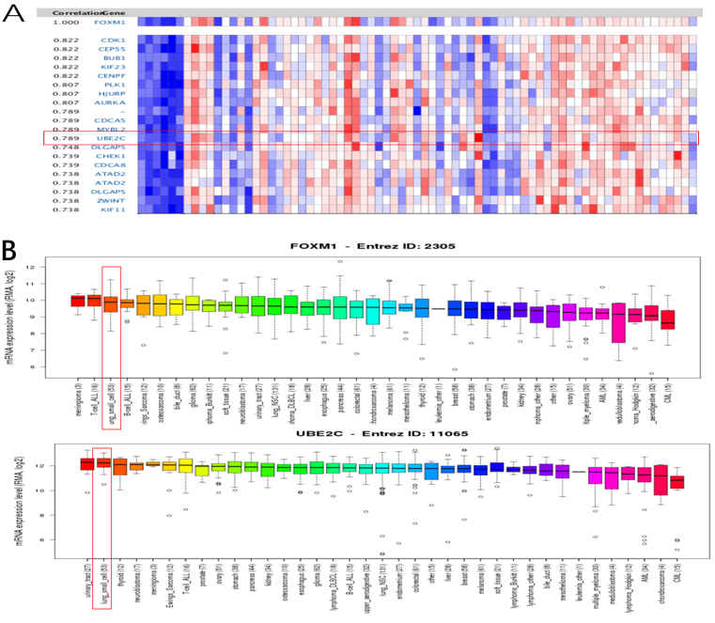
Figure 2 A: The co-expression analysis of FOXM1 and UBE2C
In ONCOMINE database, the co-expression genes of FOXM1 in lung cancer within a database including 73 samples was shown in this figure.
Figure 2 B：The expression level of FOXM1 and UBE2C in a variety of cancer cell lines through CCLE analysis
FOXM1 was the 3rd highest overexpressed in lung cell line behind meningioma and T-cell-ALL, while UBE2C was 2nd highest overexpressed in lung cancer cell behind urinary tract in different types of cancer cell lines.

The expression level of FOXA1, FOXD1, FOXM1 and UBE2C in lung adenocarcinoma and lung squamous carcinoma
We compared the expression level of FOXA1, FOXD1, FOXM1 and UBE2C in lung adenocarcinoma and lung squamous carcinoma through GEPIA dataset, which indicated that FOXA1 was overexpressed in lung adenocarcinoma(LUAD) instead of lung squamous carcinoma(LUSC), whereas FOXD1 was high expressed in squamous cell lung carcinoma(LUSC) tissues instead of LUAD. The expression level of FOXM1 and UBE2C were significantly high in both LUAD and LUSC.(Figure 3A, Figure 3B) 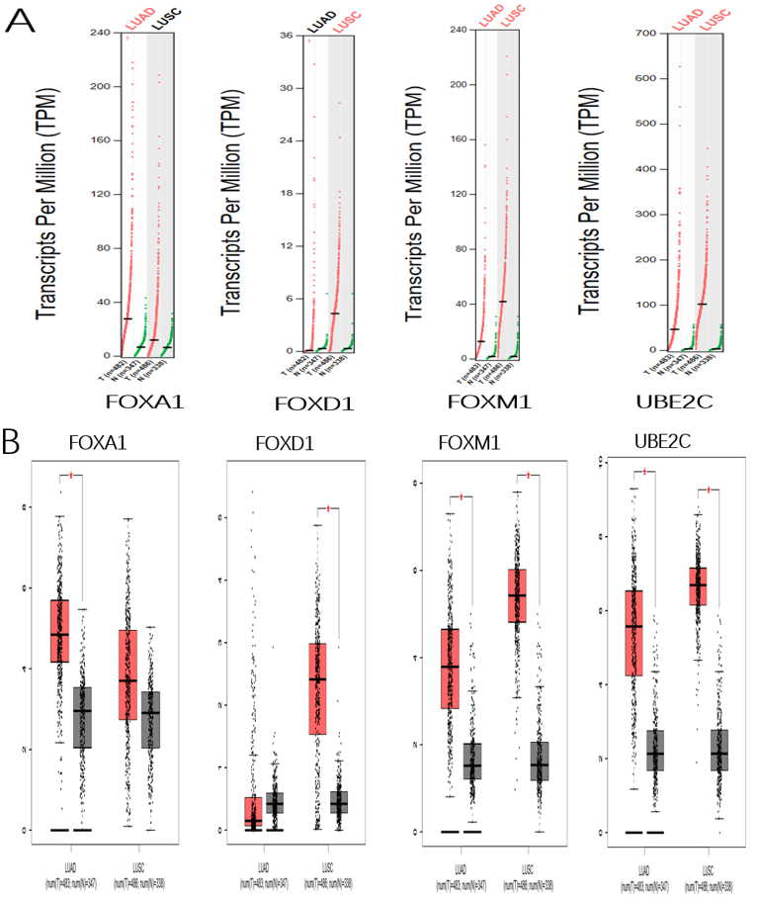
Figure 3A, Figure 3B The expression level of FOXA1, FOXD1, FOXM1 and UBE2C in lung adenocarcinoma and lung squamous carcinoma
Figure 3A： The chromosomal distribution of over-red or under-green expressed genes was plotted through GEPIA analysis.
Figure 3B：The expression of FOXA1, FOXD1, FOXM1 and UBE2C in LUAD and LUSC was plotted by Boxplot through GEPIA analysis.

Correlation between FOXA1, FOXD1, FOXM1 and UBE2C expression and tumor stage in lung cancer patients
We also further analyzed the expression of FOXA1, FOXD1, FOXM1 and UBE2C with tumor stage for lung adenocarcinoma(LAC) and squamous cell lung carcinoma(LSCC). It was found out that FOXM1 and UBE2C were distinctively varied from different stages in all lung cancer. The later was the clinical stage, the higher were FOXM1 and UBE2C expression levels. However, FOXA1 and FOXD1 did not significantly differ(p>0.05). (Figure 4)
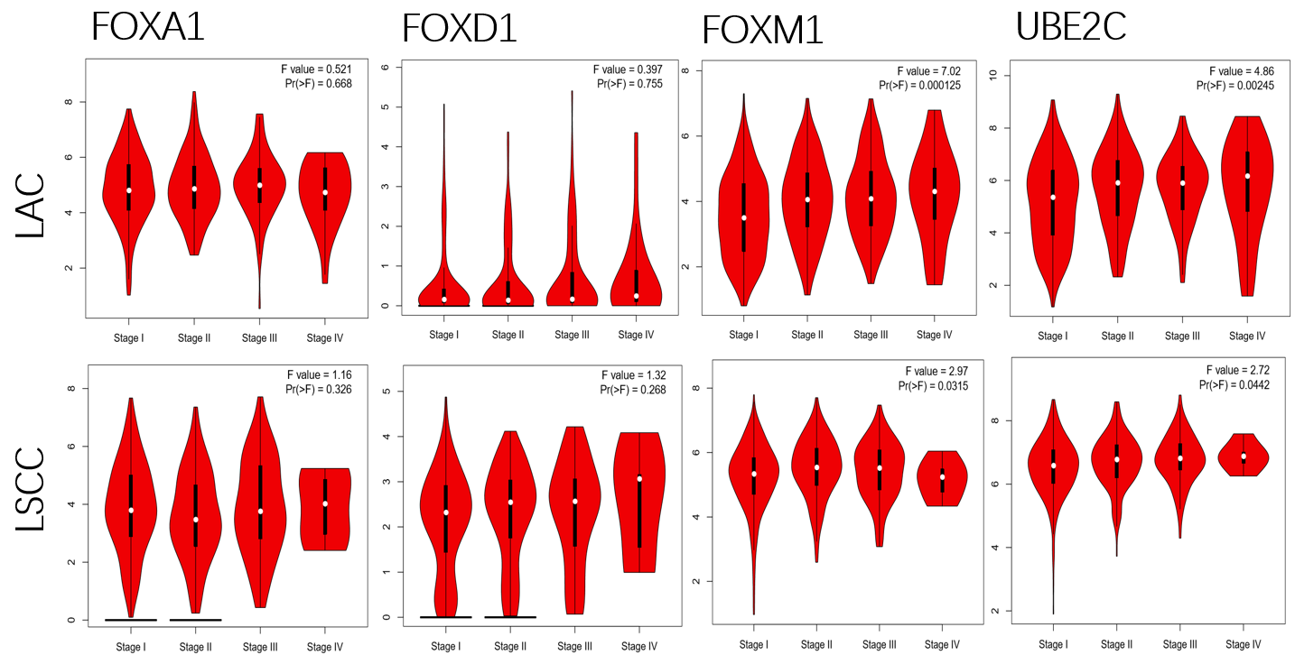
Figure 4 Association of FOXA1, FOXD1, FOXM1 and UBE2C expression with tumor stage in LC patients
In GEPIA analysis, association of the target gene in lung adenocarcinoma(LAC) and squamous cell lung carcinoma(LSCC) stage was achieved.

The prognostic values of mRNA level of FOXA1, FOXD1, FOXM1 and UBE2C in NSCLC patients
We further explored the prognosis of FOXA1, FOXD1, FOXM1 and UBE2C expression of patients with NSCLC. In Kaplan–Meier Plotter analysis, the correlation between the mRNA expression levels of the FOXA1, FOXD1, FOXM1 and UBE2C and the survival of patients with in LAC and LSCC was explored. Kaplan–Meier survival curve revealed that the expression level of FOXA1and FOXD1 were not associated with the overall survival (OS), progression-free survival (FP) and post-progression survival (PPS) in all NSCLC patients (p > 0.05).

The significance of FOXM1 in the prognosis of NSCLC was explored through Kaplan–Meier Plotter analysis. The results revealed that high expression level of FOXM1 was associated with shorter overall survival(OS) in NSCLC patients. It was founded that high expression level of FOXM1 was distinctly related to shorter overall survival(OS) (HR=1.7, p=0.0011) in NSCLC. (Figure 5 A).

The prognostic value of UBE2C was explored through the Kaplan-Meier plotter. In figure 5B, UBE2C high mRNA expression was distinctly associated with shorter OS (HR=1.4, p=0.021) in NSCLC. (Figure 5 B)
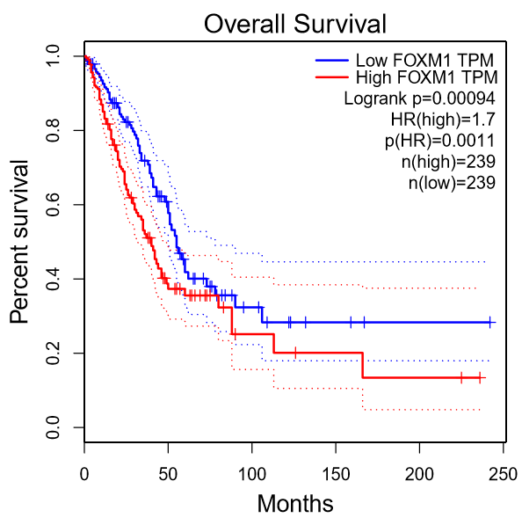 Figure 5A: The prognostic values of mRNA expression level of FOXM1 in NSCLC patients

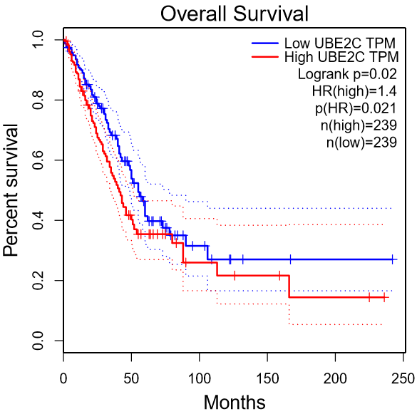
Figure 5B: The prognostic values of mRNA expression level of UBE2C in NSCLC patients

DISCUSSION
Lung cancer, mainly developing from bronchogenic cell, is not only the highest prevalence, but also the cancer of supreme cancer-related mortality among all malignant tumor in the United States [16]. Despite great progress in diagnostic and treatment technology has been made in recent years, the 5-year overall survival rate of lung carcinoma remains less than 15% primarily contributing to resistance to conventional therapies, as well as distant metastasis [17, 18] . It is rewarding to illustrate the oncogenesis of lung cancer and develop new prognostic biomarkers.

It is reported that FOX gene family plays an important role on regulating the growth, differentiation, apoptosis, proliferation, migration, invasion and angiogenesis of tumor cells [5]. ONCOMINE analysis revealed that, in the FOX gene family, FOXA1, FOXD1 and FOXM1 were significantly high expressed in NSCLC, implying their unique roles in NSCLC. The prognostic significance of FOXA1, FOXD1 and FOXM1 was further explored through Kaplan–Meier Plotter, revealing that FOXA1 and FOXD1 were not associated with prognosis in NSCLC, while FOXM1 was a vital prognostic biomarker for NSCLC patients especially for lung adenocarcinoma patients.

FOXA1 (forkhead box A1) or HNF3α (hepatocyte nuclear factor 3α), is a major regulatory transcription factor regulating and controlling a range of tumors including breast, prostate and liver cancer[19, 20]. It was found that FOXD1, up-regulated in different types of cancer including prostate cancer, ovarian cancer and breast cancer, was associated with cancer proliferation and resistance to chemotherapy[21-23]. As a study reported that FOXD1 was overexpressed in NSCLC and associated with poor prognosis[24]. However, in our current study, FOXA1 and FOXD1 were overexpressed in lung cancer. FOXA1 was especially high expressed in lung adenocarcinoma(LAC), while FOXD1 was in squamous cell lung carcinoma(LSCC). They didn’t vary from lung cancer stage and were not associated with prognosis of NSCLC.

FOXM1, which is essential for multi-organ cell proliferation, differentiation and especially for cell apoptosis, was critical for the development and progression of a great deal of types of cancer [25]. ONCOMINE analysis revealed that FOXM1 was overexpressed in lots of tumors including brain and CNS cancer, breast cancer, colorectal cancer, sarcoma and especially lung cancer. The results are in good agreement with the results of previous studies [24]. In GEPIA analysis, FOXM1 was furtherly demonstrated to overexpress in LAC and LSCC. Additonally, higher expression of FOXM1 was associated with later lung cancer stage. A study by Milewski et al. indicated overexpression of FOXM1 in LAC may associated with shorter OS or FP [26]. Similar results were indicated by Kaplan-Meier plotter survival analysis in the present study that a high level of FOXM1 overexpression was related to shorter survival in LC patients, espicially in patients with LAC.

FOXM1 was positively associated with the expression of UBE2C, demonstrated by ONCOMINE co-expression analysis. The results were consistent with a study by Nicolau-Neto Palumbo et al. revealing that FOXM1 and UBE2C are co-expressed in esophageal squamous cell carcinoma and other types of cancer [10, 27].

UBE2C, as a transcription factor, plays an important role on the progression and prognosis of a variety of cancers including gastric carcinoma, rectal carcinoma and esophageal squamous cell carcinoma[28-30]. However, the significnce of UBE2C in the prognosis of LC patients remains deeply unknown. In the present study, ONCOMINE analysis revealed that UBE2C was highly expressed both in NSCLC patients and lung cancer cell lines. What is more，a high level of UBE2C expression was significantly associated with later LC stage and shorter survival in LAC. The results were consistent with a study by Zhang et al. demonstrated that overexpression of UBE2C in NSCLC was correlated with poor prognosis [31].

In summary, FOXA1，FOXD1 and FOXM1 were overexpressed in LC among FOX gene family. FOXM1 is positively associated with UBE2C, and they are distinctive biomarkers and predicts shorter survival in LAC.

CONFLICT OF INTEREST
All author of the paper have read and understood the author agreement of CANCER BIOLOGY & MEDICINE, and we declare that we have no conflict of interest and agree with the journal ’s copyright policy.

REFERENCE:
1 Yokota J, Kohno T: Molecular footprints of human lung cancer progression. Cancer Sci 2004;95:197-204.
2 DeSantis CE, Lin CC, Mariotto AB, et al.: Cancer treatment and survivorship statistics, 2014. CA Cancer J Clin 2014;64:252-271.
3 Wei S, Tian J, Song X, et al.: Causes of death and competing risk analysis of the associated factors for non-small cell lung cancer using the Surveillance, Epidemiology, and End Results database. J Cancer Res Clin Oncol 2018;144:145-155.
4 Jackson BC, Carpenter C, Nebert DW, et al.: Update of human and mouse forkhead box (FOX) gene families. Hum Genomics 2010;4:345-352.
5 Hannenhalli S, Kaestner KH: The evolution of Fox genes and their role in development and disease. Nat Rev Genet 2009;10:233-240.
6 Miao L, Xiong X, Lin Y, et al.: Down-regulation of FoxM1 leads to the inhibition of the epithelial-mesenchymal transition in gastric cancer cells. Cancer Genet 2014;207:75-82.
7 Wang M, Gartel AL: The suppression of FOXM1 and its targets in breast cancer xenograft tumors by siRNA. Oncotarget 2011;2:1218-1226.
8 Koo CY, Muir KW, Lam EW: FOXM1: From cancer initiation to progression and treatment. Biochim Biophys Acta 2012;1819:28-37.
9 Maachani UB, Shankavaram U, Kramp T, et al.: FOXM1 and STAT3 interaction confers radioresistance in glioblastoma cells. Oncotarget 2016;7:77365-77377.
10 Nicolau-Neto P, Palumbo A, De Martino M, et al.: UBE2C Is a Transcriptional Target of the Cell Cycle Regulator FOXM1. Genes (Basel) 2018;9:
11 Townsley FM, Aristarkhov A, Beck S, et al.: Dominant-negative cyclin-selective ubiquitin carrier protein E2-C/UbcH10 blocks cells in metaphase. Proc Natl Acad Sci U S A 1997;94:2362-2367.
12 Hao Z, Zhang H, Cowell J: Ubiquitin-conjugating enzyme UBE2C: molecular biology, role in tumorigenesis, and potential as a biomarker. Tumour Biol 2012;33:723-730.
13 Bavi P, Uddin S, Ahmed M, et al.: Bortezomib stabilizes mitotic cyclins and prevents cell cycle progression via inhibition of UBE2C in colorectal carcinoma. Am J Pathol 2011;178:2109-2120.
14 Tang Z, Li C, Kang B, et al.: GEPIA: a web server for cancer and normal gene expression profiling and interactive analyses. Nucleic Acids Res 2017;45:W98-W102.
15 Gyorffy B, Surowiak P, Budczies J, et al.: Online survival analysis software to assess the prognostic value of biomarkers using transcriptomic data in non-small-cell lung cancer. PLoS One 2013;8:e82241.
16 Siegel RL, Miller KD, Jemal A: Cancer Statistics, 2017. CA Cancer J Clin 2017;67:7-30.
17 Sun C, Liu Z, Li S, et al.: Down-regulation of c-Met and Bcl2 by microRNA-206, activates apoptosis, and inhibits tumor cell proliferation, migration and colony formation. Oncotarget 2015;6:25533-25574.
18 Sun C, Sang M, Li S, et al.: Hsa-miR-139-5p inhibits proliferation and causes apoptosis associated with down-regulation of c-Met. Oncotarget 2015;6:39756-39792.
19 Gan HY, Li N, Zhang Q, et al.: Silencing FOXA1 gene regulates liver cancer cell apoptosis and cell proliferation. Eur Rev Med Pharmacol Sci 2018;22:397-404.
20 Bernardo GM, Keri RA: FOXA1: a transcription factor with parallel functions in development and cancer. Biosci Rep 2012;32:113-130.
21 Zhao YF, Zhao JY, Yue H, et al.: FOXD1 promotes breast cancer proliferation and chemotherapeutic drug resistance by targeting p27. Biochem Biophys Res Commun 2015;456:232-237.
22 van der Heul-Nieuwenhuijsen L, Dits NF, Jenster G: Gene expression of forkhead transcription factors in the normal and diseased human prostate. BJU Int 2009;103:1574-1580.
23 Ju W, Yoo BC, Kim IJ, et al.: Identification of genes with differential expression in chemoresistant epithelial ovarian cancer using high-density oligonucleotide microarrays. Oncol Res 2009;18:47-56.
24 Nakayama S, Soejima K, Yasuda H, et al.: FOXD1 Expression Is Associated with Poor Prognosis in Non-small Cell Lung Cancer. Anticancer Research 2015;35:261-268.
25 Ahmed M, Uddin S, Hussain AR, et al.: FoxM1 and its association with matrix metalloproteinases (MMP) signaling pathway in papillary thyroid carcinoma. J Clin Endocrinol Metab 2012;97:E1-E13.
26 Milewski D, Balli D, Ustiyan V, et al.: FOXM1 activates AGR2 and causes progression of lung adenomas into invasive mucinous adenocarcinomas. PLoS Genet 2017;13:e1007097.
27 Guo L, Ding Z, Huang N, et al.: Forkhead Box M1 positively regulates UBE2C and protects glioma cells from autophagic death. Cell Cycle 2017;16:1705-1718.
28 Zhang Y, Tian S, Li X, et al.: UBE2C promotes rectal carcinoma via miR-381. Cancer Biol Ther 2018;19:230-238.
29 Zhang HQ, Zhao G, Ke B, et al.: Overexpression of UBE2C correlates with poor prognosis in gastric cancer patients. Eur Rev Med Pharmacol Sci 2018;22:1665-1671.
30 Li L, Li X, Wang W, et al.: UBE2C is involved in the functions of ECRG4 on esophageal squamous cell carcinoma. Biomed Pharmacother 2018;98:201-206.
31 Zhang Z, Liu P, Wang J, et al.: Ubiquitin-conjugating enzyme E2C regulates apoptosis-dependent tumor progression of non-small cell lung cancer via ERK pathway. Med Oncol 2015;32:149.

