Comparison and correlation study of polar biomarkers of CKD patients in saliva and serum by UPLC-ESI-MS

Jielian Yanª, Li Zhou^{b}, XiaohongTang^{b}, Yong Liuª, YixiangDuan^{a,d,*}

^{a,}Research Center of Analytical Instrumentation, Analytical & Testing Center, Sichuan University, Chengdu, China
^{b,c}Department of Nephrology, West China Hospital, Sichuan University, Chengdu 610064, PR China
^{d}Research Center of Analytical Instrumentation, Key Laboratory of Bio-resource and Eco-environment, Ministry of Education, College of Life Science, Sichuan University, Chengdu, China
Abstract:
There are abundant reports on the use of aromatic amino acids and creatinineas biomarkers in serum and urine forCKD(chronic kidney disease). However, investigationsinto these bio-species in bio-fluids, such as saliva and sweat, are rarely reported. Increasing interest in non-invasive methods for medical diagnosis advocates for the testing of these bio-fluidstoidentify potential biomarkers for prompt clinical andpreliminary screening using advanced analytical equipment.
Unstimulated whole saliva samples were obtained from twenty-seven CKD patients and an equivalent number of healthy individuals. Saliva was assayed with ultra-performance liquid chromatography coupled with electro-spray ionization tandem mass spectrometry (UPLC-ESI-MS) in hydrophilic interaction chromatography mode. The data were analyzed using a student’s t test and receiver operatingcharacteristic(ROC) to evaluate the predictive power of several potential biomarkers (P<0.01) in saliva for preliminary CKD screening. Through testing of salivary samples between CKD patients and healthy individuals, we found three possible salivary biomarkers that demonstrated significant differences(P<0.01) from the nine reported species in serum and/or urine. The area under the curve (AUC) values for control vs CKDpatientsfor on L-phenylalanine, L- tryptophan, and creatinine were 0.863, 0.834, and 0.916, respectively. This is the first report to compare serum and urine biomarkers in saliva between CKD patients and healthy people. This study explores the potential of CKD diagnosis by saliva, and demonstrates a positive correlation between salivary and serum creatinine.
1 Introduction
Chronic kidney disease (CKD) is considered to be a part of the rising non-communicable disease burden worldwide. Prevalence of CKD is estimated to be 8-16% world-wide^{[1]}. Important risk factors for CKD include hypertension, diabetes mellitus, and obesity. Treatment of CKD is often neglected by patients because of a delay in diagnosing indicators in common clinical experiments when compared totheprogression of the actual pathological process. Recently, a comparison between control group and healthy group has becomeanincreasingly attractive and important goal.
Currently, biomarkers for CKD are often detected in serum and/or urine using various types of equipment, but this is not ideal becausethereisdiminishedcompliance of patients for these methods of sample collection. Moreover, frequent collection of blood during dialysis is particularly adverse for the elderly and infants. Thus,it is advantageous for investigators to developadditional means of a non-invasivemethod.One such method that should be tested for potential diagnostic ability is the use of biofluidssuch as saliva and sweat. Undoubtedly, saliva is the best option for a diagnostic alternative because of its safety and comfort in collection process. Sincemany compounds in blood make their way into saliva,it is a suitable indicator of the current state of the blood. A number of biomarkers that are used as indicators of pathophysiological states to differentiate between patients and healthy people can be readily found in saliva^{[2]}.For example, decreased eGFR (estimated glomerular filtration rate) indicates a reduction in renal clearance of a variety of proteins and nitrogenous byproducts that could be detrimental to the vascular system^{[3]}.
Upon activation of apoptosis, the endothelium sheds micro-particlesthat are regarded asbiomarkers of endothelial dysfunction^{[4]} and are believed to behave as bioactive vectors^{[5]}. The metabolism of amino acids is related to the function of kidney, therefore regarding abnormalities of amino acids discovered in CRF can show the loss of renal function ^{[6]}.Therefore, we can compare biomarkers identified byultraperformance liquid chromatography coupled to a electrospray ionization mass spectrometry(UPLC-ESI-MS) with diagnostic standard compounds and determine whether saliva could be an alternative medium to serum and urine for patients with CKD. The components of blood that are exchanged in the kidney can also be exchanged in salivary glands, so the concentrations of biomarkers in blood and urine may correlate with those in saliva. Furthermore, it would be a quicker, easier, and cheaper alternative for medical testing and diagnosis. However, factors such as the collection method, collection time, sex, body mass index, weight, and smoking can affect the global metabolite profiles of patients^{[7]}.Diseases that have been previously reported to benefit from the application of saliva as a diagnostic tool range from cancer to other metabolic diseases, including periodontal disease^{[8]}, oral and breast cancers^{[9-12]}, and Sjögren’s syndrome^{[13]}.
Nevertheless, salivary biomarkers of CKD certainly need to be compared with those discovered in serum and urine samples although saliva seems to have an attractive future in clinical research, pathology, and therapy. Since most of the compounds of these biomarkers are hydrophilic, we utilized UPLC-ESI-MS to focus on these compounds with a metabolic approach.
UPLC which uses high pressure and small diameter porous particles and is combined with electrospray ionization time-​of flight mass spec​trometry enables us to obtain the properties of compounds with a higher peak capacity, better resolution, increased sensitivity, and greater selectivity at a high acquisition rate. This detection method is especially advantageous for detecting accurate molecules of polar compounds.
While genomics, transcriptomics, and proteomics can provide diagnostic support for various diseases, metabolomics can generate the greatest differentiation of compounds. Currently, there are few investigations reporting metabolites of saliva from CKD patients using UPLC-ESI-MS. Therefore, in this study, we aimed to validate salivary biomarkers of CKD patients using UPLC-ESI-MS for a general screening of CKD biomarkers currently utilized in serum and urine samples, and thus, confirm the potential of saliva for CKD diagnosis.

2 Materials and Method
2.1 Materials
Acetonitrile (HPLC grade) was provided by Burdick & Jackson (USA). Distilled water was produced“in-house”utilizing an ULUPURE system (Chengdu Ultrapure Technology Co., Ltd, Chengdu, China). Ammonium formate was UPLC grade obtained from Adamas (Switzerland). Creatinine was from CNW(Shanghai).

L-phenylalanine and L-tryptophan were bought from Sangon(Sangon Biotech Co., Ltd, Shanghai, China). The stock standard solutions 0.2mg/mL of L-phenylalanine, L-tryptophan, and creatinine were prepared by dissolving L-phenylalanine, L-tryptophan, and creatinine in acetonitrile/water with 0.05% formic acid, respectively. These solutions were stored at 2-8 ℃ and the mix solvents acetonitrile/water prior to use were employed through diluting the stock solutions to obtain the respective concentrations with.
2.2 Subjects
Patients suffered from CKD were foundin the West China Hospital of Nephrology. All the volunteers included 27 CKD patients and 27healthy volunteers. Patients(nonsmokers) who have cancer, cardiac insufficiency, alimentary tract hemorrhage, respiratory failure or other diseases are excluded due to the fact that may have an impact on the biological indicators and clinical observations. The Ethics Committee of Sichuan University approved the study protocol which was carried out according to the Helsinki Declaration of 1975. All patients are Chinese, and a consent form was obtained and concurred to be responsible as the saliva donors of the experiments.
For patients with CKD without dialysis, participation was allowed if the serum creatinine clearance was below than 59 mL/min/1.73m² (measured directly by clearance technique). Twenty-seven healthy adults without history of diabetes mellitus, kidney disease or other diseases consisted of subjects, and were tested clinically at recruitment.

2.3 saliva collection and sample preparation
After fasting overnight, all the subjects were required to avoid eating, drinking, smoking, and oral hygiene procedures for at least several hours before sample’s collection.
We obtained 2-4 mL of clear un-stimulated whole saliva between 9:00 and 11:00 a.m. Venous blood samples were drawn from all patients from the antecubital vein (for CKD patients). Saliva was then sent to the laboratory for isolation. We added 400μL of the processed saliva to a mixture of methanol/ acetonitrile (1:3 v/v, 800 μL) to precipitate the proteins, before vigorous shaking for about 60s. Samples were then vortexed for at 13500 rpm for 21 min at 4 ℃. After allowing samples to stand at the same temperature for 10 min, the supernatant was taken for UPLC-ESI-MS’ analysis.
2.4 UPLC-ESI-MS analysis
The identifications were performed on the UPLC-ESI-MS system consisting of a Waters ACQUITYTM Ultra Performance Liquid Chromatography system and a MicromassLCT Premier TM orthogonal accelerated time of flight mass spectrometer (Waters, Milford, USA).
The chromatographic separation was achieved with an ACQUITY UPLC BEH Amide column (100mm*2.1mm i.d, 1.7um, Waters, Milford, USA) with the sample temperature set to 8℃.
The column is eluted utilizing with the solvent system as below with the flow rate as 0.15mL/min: (A) 95:5 acetonitrile-aqueous ammonium acetate (10mmol/L), (B) 50:50 acetonitrile-aqueous ammonium acetate (2mmol/l). After every injection, the auto-sampler was cleaned with a strong/weak wash cycle to remove residue. Each run took 20 minutes.

TOF/MS was performed using an ESI source, operating in positive ion mode. The data profile of positive ions ranges from m/z 50-1000. The capillary voltage was 3.2 kV in positive mode; the cone voltage was 30 V. The desolvation gas flow was set to 650 L/h at a temperature at 350 ℃. The cone gas flow was obtained as 30L/h, and the source temperature was 110 ℃.
In the recent study, intact mass data can be acquired using the TOF mass spectrometer fitted with alock spray enabled Z-spray ion source. A lock mass of leucine enkephalin (Sigma-Aldrich, L9133, lot 095K5109, Steinheim,Germany, [LE+ H]+, m /z, 556.2771) for positive ion mode was utilized to correct lock mass. The solution of LE was ivia a lock spray interface at the flow rate of 0.05 mL/min with the help of a second LC pump (Waters).
2.5 Data processing and analysis.
A multivariate data can be identified by integrating and deconvoluting the mass spectral data matrix incorporating an integrated peak area for measured features (unique mass-retention time pair) by alignment, peak picking and deisotoping employing MassLynx 4.1 (WatersCorp, Milford, MA).The raw data were found correspounding to a multivariate matrix containing aligned peak areas with matched retention times and mass-to-charge ratios (m/z). The distinctions of metabolites in both saliva biomarkers’ intensity in two groups were analyzed with the Students’ T test.
The Students’ T test was utilized to examine vital distinctions in the distributions between control group and CKD group. Then to estimate the diagnostic effectiveness of both possible biomarkers such as L-phenylalanine, L-tryptophan and creatinine with 95% confidence interval (CI) for CKD recognition and to find out a best cut-off based on the maximum corresponding specificity and sensitivity receiver operating characteristic (ROC) curves were also used. Two-tailed p<0.01 was taken to be remarkably significant.
This equipment’s relative standard deviations (RSD) of peak areas and retention times about the sample of saliva were qualified, and so were the standard materials. The system stability is shown from the predicting data of QC sample. It proved that the developed method had good repeatability and stability. The healthy group was comprised of 27 healthy volunteers.Therewere17 males and 10 females. Patient group comprised 27 CKD patients,andthere were 16 males and 11 females.
3 Results and discussions
3.1 Patients descriptions
All 27 patients recruited in this research were pathologically and clinically diagnosed with CKD. No significant distinctions between CKD patientsand the control group can be seen in measurements of 7-ketolithocholic acid, choline, creatine, adenine, guanine, and betaine(7-ketolithocholic acid: P=0.022; choline: P=0.036; creatine: P=0.229; adenine: P=0.010; guanine: P=0.427; betaine: P=0.012). SIM (selected ion monitoring) showed that accurate molecular weights were provided for the 9 salivary biomarkersfound in serum and urine and were fully separated with the correct gradient program.
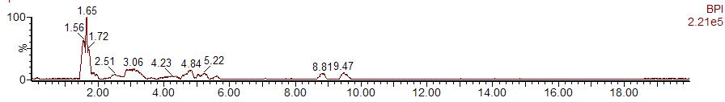

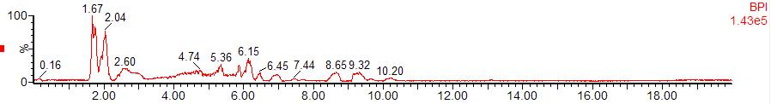

Figure1. Raw BPI of UPLC-MS data obtained from the saliva sample of health and CKDgroup at positive ESI mode

3.2 Linearity and limit of quantitation
In order to accurately evaluate the linearity of L-phenylalanine, L-tryptophan, and creatinine, each type of them was added to salivary sample at the concentrations of 0, 10, 30, 50, 150, 200, 300 ng/mL. The calibration profile was established by endogenous L-phenylalanine, L-tryptophan, and creatinine levels’ subtraction from added saliva specimen. This assay was found to be linear up to 1000 ng/mL for all three biomarkers. The linear equations of calibration curves of L-phenylalanine, L-tryptophan, and creatinine in human saliva were y=2.003*x+555.367 with r²=0.990,y=0.482*x+19.358 with r²=0.999, andy=0.835*x-31.094 with r²=0.994, respectively (y, peak area; x, concentration (ng/mL) of L-phenylalanine, L-tryptophan and creatinine; r, correlation coefficient). Under our UPLC-ESI-MS conditions, the limits of detection (LOD, S/N=3) of L-phenylalanine, L-tryptophan, and creatinine were 3.39, 15.54, and13.32ng/mL, respectively. The limit of quantification (LOQ) was explained as the level when the S/N ratio is 10. Therefore, LOQ was 11.31, 51.78 and 44.40 ng/mL for L-phenylalanine, L-tryptophan, and creatinine, respectively.
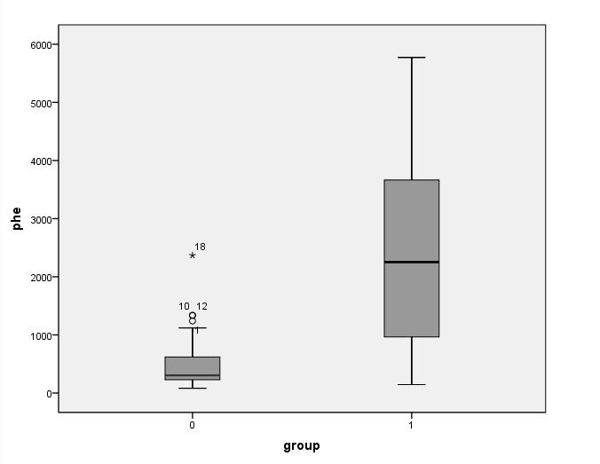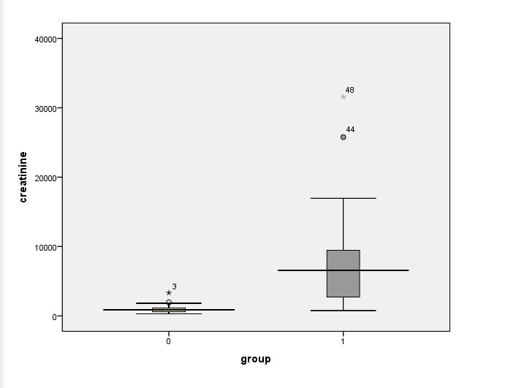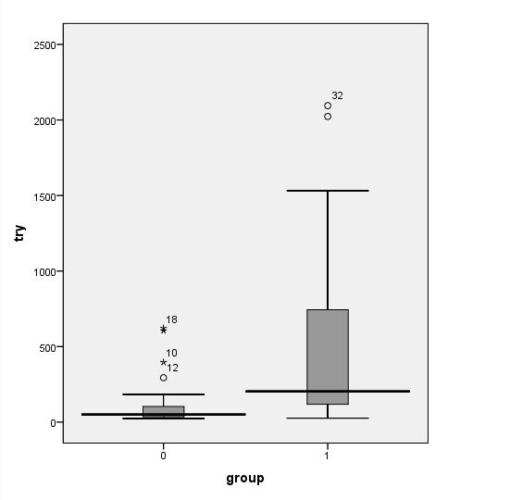
P<0.001

P<0.001

p=0.001

C. Creatinine
B. L-tryptophan
A. L-phenylalanine

Figure2. Box plots of the three biomarkers in differentiating CKD group from healthy group. The P values of the comparing of CKD with control were marked.

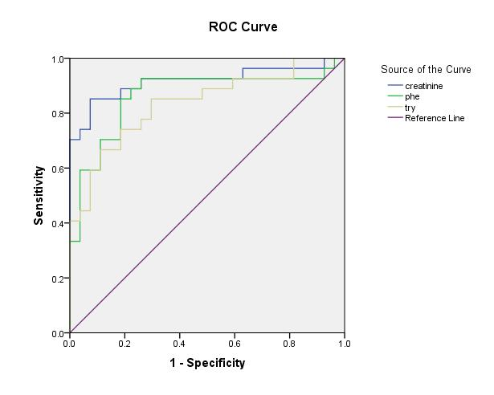
Figure 3.ROC analysis for three biomarkers in diagnosis of CKD.

Table 1. Identification and Quantification of biomarkers of CKD patients found in saliva and reported[23] in serum and/or urine
Name | Retention time | Pattern [M+H] | Actual mass | Exact mass | Mass error | p
7-Ketolithocholic acid | 1.56 | C24H39O4 | 391.2884 | 391.2848 | 3.6 | 0.022
Phenylalanine | 7.54 | C9H12NO2 | 166.0860 | 166.0868 | -0.8 | <0.001
Tryptophan | 7.21 | C11H13N2O2 | 205.0966 | 205.0977 | -1.1 | 0.001
Choline | 7.02 | C5H15NOd | 104.1060d | 104.1061 | 0.7 | 0.036
Creatine | 9.11 | C4H10N3O2 | 132.0761 | 132.0767 | -0.6 | 0.229
Creatinine | 4.33 | C4H8N3O | 114.0667 | 114.0660 | -1.6 | <0.001
Adenine | 6.23 | C5H6N5 | 136.0607 | 136.0623 | 0.1 | 0.010
Guanine | 10.71 | C5H6N5O | 152.0573 | 152.0572 | -0.5 | 0.427
Betaine | 4.84 | C5H12NO2 | 118.0863 | 118.0868 | -0.7 | 0.012
ªSelected peak [M-H₂O+H]
Table 2. Remarkable salivary biomarkers’ ROC curve analysis
Metabolites | AUCs | 95%Confidence interval | Sensitivity | Specificity | Std. errorª
Phe | 0.863 | 0.725-0.970 | 0.926 | 0.741 | 0.055
Trp | 0.861 | 0.762-0.961 | 0.815 | 0.815 | 0.051
Creatinine | 0.916 | 0.832-1.000 | 0.926 | 0.741 | 0.056
LR model | 0.936 | 0.856-1.015 | 0.889 | 0.926 | 0.040
aUnder the nonparametric assumption

3.3 Human saliva analysis
Saliva samples from 27 healthy individuals and 27 CKD patients were analyzed. We first measured the levels of the three metabolite biomarkers used to distinguish CKD from control. Figure 1 shows a typical BPI (base peak ion) of a saliva sample from both a healthy individual and a CKD patient（T_{RA}=7.86min;T_{RB}=7.35min; T_{RC}=4.63min). Figure 2 demonstrates that the concentrations of these 3 biomarkers in CKD subjects were significantly higher than that of healthy individuals. Students’ t-Test was employed to study the distinctions’ statistical significance in the distributions between the control group and CKD group and P<0.01 was thought to be remarkably significant (two-sided).The Student's t-Test is a parametric method and the p-values of these independent groups were marked in the figures. As the result of the p-values in Figure 2, we discovered that the distributions of L-phenylalanine, L-tryptophan, and creatinine in saliva samples were all significantly different (p<0.01). However, we found that the p-values of 7-ketolithocholic acid, choline, adenine, and betaine were all in the range of 0.01 to 0.05. In addition, the p values of creatine and guanine were larger than 0.05 in these two groups. Therefore, the differentiation power of creatine and guanine is weakest among all the biomarkers, and L-phenylalanine, L-tryptophan, and creatinine were the most promising biomarkers using this analytical technology. We will get further diagnostic power for the most prominent three to compare their ability in discriminating two groups.
To further investigate the diagnostic power of these 3 biomarkers, their ROC curves were evaluated. The ROC curves were constructed using SPSS and can indicate a diagnostic test’s overall accuracy. In a excellent test, the relevant AUC value is 1.0 and with the angle’s top at the apex left of panel the ROC curve is a right angle.
When AUC ranges from 0.5 to 0.7, that shows a relatively low diagnostic value. An AUC above 0.9 is considered to be highly accurate. Figure 3 shows the curve of the remarkably significant salivary biomarkers, and a detailed AUC (95%CI), cutoff values, sensitivity and specificity are illustrated in Table 2. We found that L-phenylalanine, L-tryptophan, and creatinine have sensitivities and specificities of 0.926 and 0.815, 0.92 and 0.741, and 0.815 and 0.741, respectively. Furthermore, the AUC values for L-phenylalanine, L-tryptophan, and creatinine were 0.863, 0.861, and 0.916, respectively. These results indicate that amino acids including L-phenylalanine, L-tryptophan have a similar efficiency as a biomarker as creatinine in the diagnosis of CKD. The AUC value for these 3 significant biomarkers in combination were 0.936 (sensitivity=0.889, specificity=0.926).

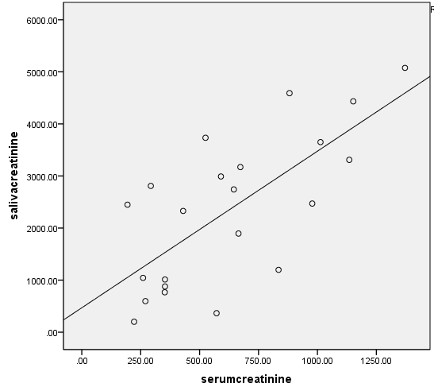
R² linear=0.507
Figure 4. Correlation between saliva creatinine and serum creatinine

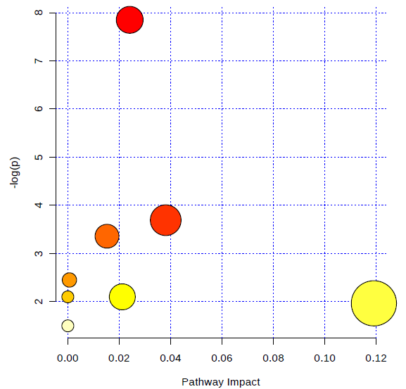
Figure 6.Summary of pathway analysis with MetPA.
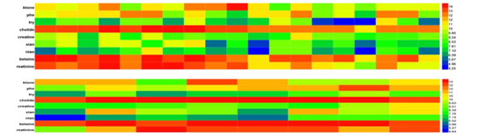
Figure 7. Hierarchical clustering analysis of metabolites identified by standard substances between males and females

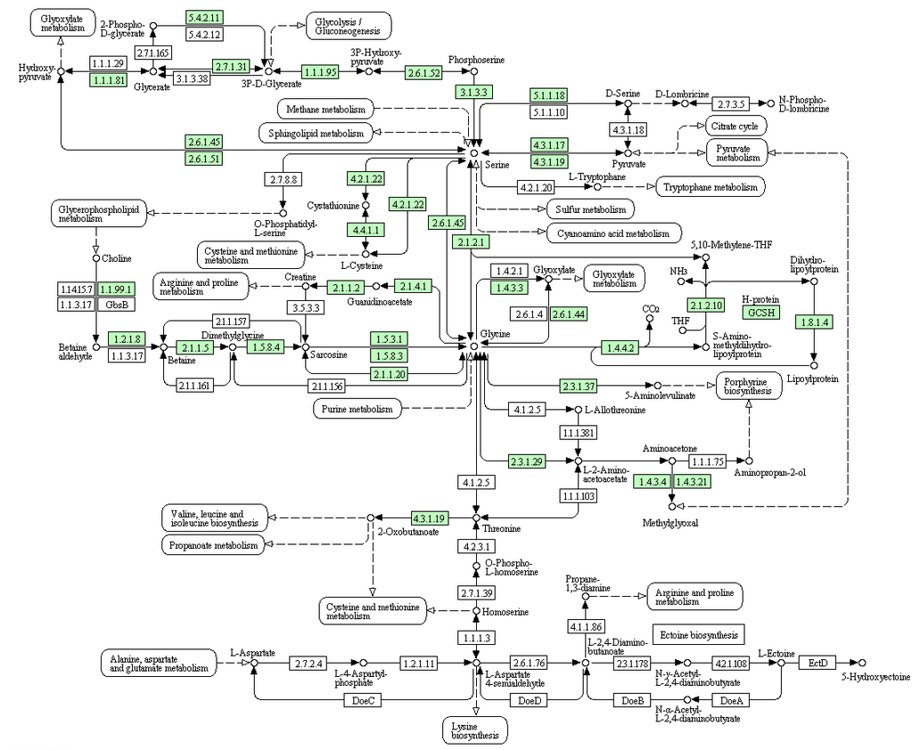
Figure 8. Construction of Glycine, serine and threonine metabolismmetabolism pathways in human CKD disease generated by KEGG.

3.4. Correlation between saliva creatinine and serum creatinine
To understand the relationship between serum and salivary creatinine and how to change it, we conducted a correlation analysis of the case groups. As shown in Figure 4, a significant correlation was indicated between serum creatinine levels and salivary creatinine concentrations(r=0.433, p<0.05). Low levels of salivary creatinine are associated with a high serum creatinine levels. Additionally, the mean serum and the salivary creatinine concentration were discovered to be significantly higher in CKD subjects in comparison with those in the controls. Serum creatinine is positively correlated with that of saliva in CKD patients with r = 0.507 (Figure 4).

3.5. Heatmap analysis
Heatmap(Figure 7) directly observed the variation in men and women which reflects some biomarkers induced by the sex. Further evaluation is needed to validate the compound in these group to provide a better diagnosis approach in patients.

3.6. Biochemical analysis
Chenodeoxycholic acid is the main bile acid, and 7-ketolithocholic acid is regarded as the main intermediate in the intestinal bacterial transforming from chenodeoxycholic acid to ursodeoxycholicacid^{[14]}. Zhao^{[15]} et al found that in adenine-induced CRF(chronic renal failure) rats, the down-regulation of the 7-ketolithocholic acid is mostly based on the overgrowth of small-intestinal bacteria which causes deconjugation of bile acids and less efficient absorption.
Choline is a quaternary amino cationic alcohol that can be oxidized to betaine in the mitochondria of kidney cells. However, betaine might play a role reducing the risk of atherosclerosis in patients with CRF by decreasing the post methionine load hyper homocysteinemia^{[16]}. Henricus^{[17]} et al discovered the level of betaine’s oxide was elevated in stage 3–4 CKD patients.

For phenylalanine and tryptophan, daily diet can be the only way because these two necessary amino acids cannot be synthesized in vivo. LewenJia^{[18]} et al demonstrated that and phenylalanine and tryptophan’s concentrations of CRF patients altered dramatically when compared with the control group due to the pathophysiology of CRF disease^{[19]}.

Slominska^{[20]} et al indicated a close correlation between anincrease of adenine concentration in plasma from CRF patients and the adenine incorporation rate into erythrocyte adenine nucleotide pool. Furthermore, plasma adenine concentration and its erythrocyte incorporation rate had a strong correlation with erythrocytes’ ATP levels. Moreover, Hayashie^{[21]} et al found that guanine levels were decreased in both serum and urine of patients among the serum and urine biomarkers of CKD individuals. In addition to phenylalanine, tryptophan and creatinine are also found in rats^{[22-24]}. Thus, Larsen^{[25]} et al even investigated phenylalanine in dogs and rats with CKD. As shown in Table 1, previous research^{[26]} about the biomarkers are included. The distribution of creatinine(P=0.229) and guanine(P=0.427) were not significantly different.
Other compounds that are important for the pathways of metabolomics include phenylalanine metabolism, glycine, serine and threonine metabolism, arginine and proline metabolism, purine metabolism except 7-Ketolithocholic acid (P=0.022). Both choline and betaine generate glycine, serine, and threonine metabolism. In serum andurine they are statistically significant, and thus, are possible surrogate biomarkers for subjects with CKD. Phenylalanine belongs to necessary amino acids, and phenylalanine hydroxylation activity in the kidney appears to be similar or even greater than that across the splanchnic area. In addition, phenylalanine hydroxylation of the whole body rates also markedly decreased in renal patients^{[27, 28]}.
Tryptophan is different from other amino acids because it is largely protein bound. The mechanisms for abnormalities in tryptophan metabolism in kidney disease remain complex, but decreased absorption of intestine and increased catabolism of liver have been suggested^{[29]}. Tryptophan metabolism may act significantly in the progression of CKD except nutritional consequences because changes of tryptophan level are potentially vital ^{[30]}.
Tryptophan and phenylalanine can be absorbed only from diet. Our results illustrates that the significant level changes in both phenylalanin and tryptophan compared with the controls.
It reported that this had relation to CRF disease’s pathophysiology ^{[19]}.The kidney is included in tryptophan metabolism in these ways:1) tryptophan derivatives is eliminated by it and 2) numerous enzymes involved in tryptophan metabolism mainly through the kynurenine pathway are produced by it ^{[31]}. Thus it is unknown whether tryptophan exchange in organs involves bound or free tryptophan. However, the uptake of the brain’s tryptophan originated from blood seems to be dependent on bound ones^{[29]}. When a meal containing meat or when a large amount of tryptophan is administered, the total concentration of blood tryptophan do not rise as high as that in normal condition ^{[32]}. Uremia is another important bio-fluid and altering in tryptophan metabolism appearing in uremia may be considered as several causes: 1)Tryptophan play a critical role in the protein turnover’s regulation as it is an essential amino acid which has to be synthesized by absorbing protein; 2) The formation of neurotoxins may be included in tryptophan metabolism (i.e., quinolinic acid); and 3) It has been concluded that, except nutritional results tryptophan, tryptophan metabolism may be a vital part in the progression of CKD.^{[30]}Furthermore, other amino acids such histidine, arginine, taurine and valine are also required ^{[33-35]}. In contrast, our results differ from other serum and urine studies, which demonstrate growing levels of L-phenylalanine^{[36]}.Recently, Jie Wei^{[37]} et al showed that this discrepancy between saliva and serum may originate from different metabolite speeds in different biological compartments. Each biomarker has a specific abundance concentration in a given compartment that is affected by both in-vivo and in vitro patho-physiological stimuli. Despite the fact that these markers are from different metabolic pathways, they are able to share certain metabolites with the same path of perturbation partly because they have similar metabolic enzymes that associated with the development of kidney disease. There may also be other causes that this type of instrumentation is highly sensitive and various factors may affect the performance of the apparatus and he sensitivity^{[38]}.
Therefore, abnormalities in amino acids of uremia caused by CRF have been ascribed to toxic effects of uremia on the amino acids’ intermediary metabolism, low protein intake, deficient renal excretory and metabolic functions, loss of protein and amino acids by the dialysis procedure and changing distribution of some amino acids between the extra- and intra-cellular compartments^{[39]}.
These data in this essay may be valuable in understanding the mechanism(s) of the changes in phenylalanine and tryptophan metabolism occurring in disease state. It may also provides a possible cause for poor nutritional status and reduced blood flow that is often observed in uremia.
Creatinine’s lipid solubility is very low excreted by the kidney and it is a waste product of metabolism^{[40]} although its molecular mass is large. Virtually all the creatinine that is filtered at the glomerulus is excreted without reabsorption in the tubules. Thus, the level creatinine in the blood is used as an index of renal function^{[41]}. To determine if there is an association between serum and salivary creatinine, a correlation analysis of the case groups were performed. We observed a positive correlation between serum and salivary creatinine in CKD patients (r=0.507). A positive correlation can be explained by the permeability of salivary gland cells between the membranes^{[42]}, CKD patients have increased serum creatinine levels, which creates a concentration gradient that facilitates increased diffusion of creatinine from serum to saliva^{[43]}. In fact,Xia^{[44]} et al found a similar positive correlation in both their cases (r=0.971). Our investigation demonstrates that the level of salivary creatinine correlates with that of serum creatinine. As this may be due to different sources, the results of the present study imply a correlated relationship between serum creatinine and saliva creatinine rather than a causation^{[37]}.
The basic measurements of diagnostic test accuracy are sensitivity and specificity. Hence, ROC analysis was produced to determine the diagnostic potential of saliva as an alternative medium (Fig. 3).Accuracy is measured by the area under the ROC curve. The highest area under the curve (0.916) got in our study was for salivary creatinine. This suggests that the screening of salivary creatinine is a good alternative diagnostic test to discriminate CKD patients from healthy individuals.
To the best of our knowledge, it is firstly to investigate creatinine(P<0.01) and adenine(P=0.01) in saliva detected by UPLC-MS. This novel method of detecting metabolite salivary biomarkers of CKD is noninvasive, simple, fast, and comfortable.
These results advise that the results of salivary biomarkers of CKD has the possibility to contribute to ground breaking advancements in molecule-oriented monitoring and screening of CKD since its accuracy seems similar to traditional approaches. Thus, the proposed approach could complement conventional diagnostic method in preliminary screening. Moreover it may assist a quick, early and noninvasive diagnosis of CKD. However, obstacles still remain, as age, sex of the samples and collection time might contribute to changes in the markers measured.

Reference
[1] VivekanandJha, Guillermo Garcia-Garcia, Kunitoshi Iseki, et al. Chronic kidney disease: global dimension and perspectives. Lancet.2013, 382: 260-272.
[2] Linden Heflin, Sarah Walsh, Miguel Bagajewicz. Design of medical diagnostics products: A case-study of a saliva diagnostics kit. Computers and Chemical Engineering. 2009, 33(5): 1067-1076.
[3] Yerkey MW, Kernis SJ, Franklin BA, et al. Renal dysfunction and acceleration of coronary disease. Heart.2004, 90: 961-966.
[4] Mohamad A. El Sawy, Mona M. Zaki, Ihab Z. EL-Hakim, et al. Serum amino acid abnormalities in pediatric patients with chronic renal failure with and without history of thromboembolic manifestations. Egyptian Journal of Medical Human Genetics. 2012, 13(1): 73-80.
[5] V. Faure, L. Dou, F. Sabatier, et al. Elevation of circulating endothelial microparticles in patients with chronic renal failure. Journal of Thrombosis and Haemostasis.2006, 4: 566-573.
[6] GiacomoGaribotto. Muscle amino acid metabolism and the control of muscle protein turnover in patients with chronic renal failure. Nutrition. 1999, 15(2): 145-155.

[7] Masahiro Sugimoto, Juri Saruta, ChisaMatsuki, et al. Physiological and environmental arameters associated with mass spectrometry-based salivary metabolomic profiles. Metabolomics. 2013, 9(2): 454-463.
[8] Yoshiaki Nomura, Yoh Tamaki, Akiko Eto, et al. Screening for periodontal diseases using salivary lactate dehydrogenase, hemoglobin level, and statistical modeling. Journal of Dental Sciences. 2012, 7(4): 379-383.
[9] Akira Katakura, Nobuharu Yamamoto, Takumi Sakuma, et al. A screening test for oral cancer using saliva samples: Proteomic analysis ofbiomarkers in whole saliva. Journal of Oral and Maxillofacial Surgery, Medicine, and Pathology. 2015, 27(1): 1-5.
[10] C. Streckfus, L. Bigler, W. Dubinsky. Using LC-MS/MS mass spectrometry to identify breast cancer biomarkers in saliva.Oral Surgery, Oral Medicine, Oral Pathology, Oral Radiology, and Endodontology. 2006, 102(3): 337-338.
[11]Qihui Wang, Qiaoling Yu, Qingyu Lin, et al. Emerging salivary biomarkers by mass spectrometry. ClinicaChimicaActa.2015, 438: 214-221.
[12]Jie Li, YulanPeng, YixiangDuan. Diagnosis of breast cancer based on breath analysis: An emerging method. Critical Reviews in Oncology/Hematology.2013, 87: 28-40.
[13] Makio Mogi, Toshitaka Kage, Takehiro Chino, et al. Increased β2-microglobulin in both parotid and submandibular/sublingual saliva from patients with Sjögren's syndrome. Archives of Oral Biology. 1994, 39(10): 913-915.
[14] Satoru Fukiya , Miki Arata , Hiroko Kawashima, et al. Conversion of cholic acid and chenodeoxycholic acid intotheir 7-oxo derivatives by Bacteroidesintestinalis AM-1 isolatedfrom human feces. FEMS Microbiology Letters.2009, 293: 263-270.
[15] Yingyong Zhao, Xianlong Cheng, Feng Wei, et al. Application of faecalmetabonomics on an experimental
model of tubulointerstitial fibrosis by ultra performance liquid chromatography/high-sensitivity mass spectrometry with MSE data collection technique. Biomarkers. 2012, 17(8): 721-729.
[16] David O Mcgregor, Warwick J Dellow, Richard A Robson, et al. Betaine supplementation decreases post-methionine hyperhomocysteinemia in chronic renal failure. Kidney International.2002, 61: 1040-1046.
[17] Henricus A. M. Mutsaers, Udo F. H. Engelke, Martijn J. G. Wilmer, et al. Optimized Metabolomic Approach to Identify Uremic Solutes in Plasma of Stage 3–4 Chronic Kidney Disease Patients. Plos one. 2013, 8(8): e71199.
[18] LewenJia, Jing Chen, Peiyuan Yin et al. Serum metabonomics study of chronic renal failure by ultra performance liquid chromatography coupled with Q-TOF mass spectrometry. Metabolomics. 2008, 4(2): 183-189.
[19] Jonas Bergström, Anders Alvestrand and Peter Fürst. Plasma and muscle free amino acid in maintenance hemodialysis patients without protein malnutrition. Kidney International. 1990, 38(1): 108-114.
[20] Ewa M. Slominska, MarekSzolkiewicz, Ryszard T. Smolenski, et al. High Plasma Adenine Concentration in
Chronic Renal Failure and Its Relation to Erythrocyte ATP.Nephron.2002, 91: 286-291.
[21] Kaori Hayashi, Hiroyuki Sasamura, TakakoHishiki, et al. Use of serum and urine metabolome analysis for the detection of metabolic changes in patients with stage 1-2 chronic kidney disease. Nephro-Urology Monthly. 2011, 3(3): 164-171.
[22] Marian Wang, Irma, Vyhmeister, Marian E. Swendseid, et al. Phenylalanine hydroxylase and tyrosine aminotransferase activities in chronically uremic rats. The Journal of Nutrition. 1975, 105(1): 122-127.
[23] Anna Tankiewicz, DariuszPawlak, Joanna Topczewska-Bruns, et al. Kidney and liver kynurenine pathway enzymes in chronic renal failure. Advances in experimental medicine and biology.2003, 527: 409-14.
[24] Vishal Diwan, David Small, Kate Kauter, et al. Gender differences in adenine-induced chronic kidney disease and cardiovascular complications in rats. American Journal of Physiology. 2014, 307(11): 1169-1178.
[25] Jennifer A. Larsen, Elizabeth M. Parks, Cailin R. Heinze, et al. Evaluation of recipes for home-​prepared diets for dogs and cats with chronic kidney disease. Journal of the American Veterinary Medical Association. 2012, 240(5): 532-538.
[26] Yingyongzhao. Metabolomics in chronic kidney disease.Clinica Chimica Acta.2013, 422: 59-69.
[27] Tessari P, Deferrari G, Robaudo C, et al. Phenylalanine hydroxylation across the kidney in humans Rapid Communication. Kidney International. 1999, 56(6): 2168-2172.
[28] Niels Moller, Shon Meek, Maureen Bigelow, et al. The kidney is an important site for in vivo phenylalanine-to-tyrosine conversion in adult humans:a metabolic role of the kidney. Proceedings of the National Academy of Sciences. 2000, 97(3): 1242-1246.
[29] GiacomoGaribotto, GiacomoDeferrari, Cristina Robaudo, et al. Effects of a protein meal on blood amino acid profile in patients with chronic renal failure. Nephron.1993, 64: 216-225.
[30] Mackenzie Walser, Sylvia B Hill. Free and protein-bound tryptophan in serum of untreated patients with chronic renal failure.Kidney International.1993, 44: 1366-1371.
[31] D. Pawlak, A. Tankiewicz, P. Myslwiec, et al. Tryptophan metabolism via the kynurenine pathway in experi-mental chronic renal failure. Nephron.2002, 90: 328-335.
[32] Hirschberg P, Kopple JD. Protein calories and fat in the predialysis patients. In: Mitch WE, Klahr S, eds. Nutrition and the kidney. Boston: Little, Brown. 1988: 131.
[33] Mohamed E Suliman, Björn Anderstam, Jonas Bergström. Evidence of taurinedeple-tion and accumulation of cysteinesulfinic acid in chronic dialysis patients.Kidney International.1996, 50: 1713-1717.
[34] William M. Pardridge, Elliot M. Landaw. Tracer kinetic model of blood-brain barrier transport of plasma protein-boundligands.The Journal of Clinical Investigation. 1984, 74(3): 745-752.
[35] Tizianello A, Deferrari G, Garibotto G, et al. Abnormalities in amino acid metabolism in chronic renal failure. Contribtuion to Nephrol.1990, 81: 169-180.
[36] Manuel Hidalgo. Pancreatic Cancer.New England Journal of Medicine.2010, 362: 1605-1617.
[37] Jie Wei, GuoxiangXie, Zengtong Zhou, et al. Salivary metabolite signatures of oral cancer and leukoplakia .International Journal of Cancer. 2011, 129(9): 2207-2217.
[38] W.A. HuubWaterval, Jean L.J.M. Scheijen, Marjon M.J.C. Ortmans-Ploemen, et al. Quantitative UPLC-MS/MS analysis of underivatised amino acids in body fluids is a reliable tool for the diagnosis and follow-up of patients with inborn errors of metabolism. ClinicaChimicaActa.2009, 407: 36-42.
[39] Keitaro Yokoyama, Masamich Tajima, Hiraku, et al. Plasma pteridine concentrations in patients with chronic renal failure. Nephrology Dialysis Transplantion. 2002, 17(6): 1032-1036.
[40] Ramesh Venkatapathy, VasupradhaGovindarajan, NirimaOza, et al. Salivary creatinine estimation as an alternative to serum creatinine in chronic kidney disease patients. International Journal of Nephrology. 2014, 2014: 1-6.
[41] A. C. Guyton and J. E. Hall, “The body fluids and kidneys,” in Textbook of Medical Physiology. Elsevier Saunders. 2006, 11: 291-415.
[42] Ivanovski K, Naumovski V, Kostadinova M, et al. Xerostomia and salivary levels of glucose and urea in patients with diabetes. Prilozi. 2012, 33(2): 219-229.
[43] T. Nakahari,H. Yoshida, Y. Imai. Transepithelial fluid shift generated by osmolarity gradients in unstimulated perfused rat submandibular glands.Experimental Physiology. 1996, 81(5): 767-779.
[44] Yuncheng Xia, CanhuiPeng, Zhifang Zhou, et al. Clinical significance of saliva urea, creatinine, and uric acid levels in patients with chronic kidney disease. Journal of Central South University.Medical sciences. 2012, 37(11): 1171-1176.

