Design Scheme of Electric Lifting Workbench for Maintenance of Aerometer in Observation Field
Hai Tao Yan
(People's Republic of China, Meteorological Bureau of Tai'an City, Shandong Province, Tai'an, 271000)
Abstract：The wind speed and wind direction meter of meteorological station is installed on the wind meter pole 10 meters high from the observation site, which also causes some difficulties for the maintenance of the wind speed and wind direction meter in the later period. Based on this situation, an electric lifting worktable (referred to as the electric lifting worktable) is specially designed for the maintenance of wind meters in meteorological observation sites. It can lift the maintenance personnel and equipment and tools to a height convenient for work, and then grasp the wind meter pole through the mechanical arm. It can be operated by a single person, thus getting rid of the traditional dimension by climbing the wind meter pole or releasing the wind meter pole. The present situation of repairing has the characteristics of saving manpower and easy operation, which is conducive to improving work efficiency and reducing work intensity. It also greatly guarantees the safety of maintenance personnel, and has good practicability and extensive popularization value.
Key word：Observation field; Wind maintenance; Electric lifting table; Design scheme
Classification Number of Chinese Map:P414

1 Introduction
The induction part of the wind meter in the meteorological station is installed on the wind meter pole 10 meters above the ground. Nowadays, most of the wind meter sensors are replaced or repaired by putting the wind meter pole upside down. The labor intensity is high, and it is impossible for a single person to carry out maintenance operation, so it is inconvenient to carry out emergency repair, which brings many difficulties to the maintenance work. In view of this situation, an electric lifting worktable for maintenance of wind meters in meteorological observation sites is designed. The worktable is safe and reliable. It can raise the maintenance worktable to a height convenient for maintenance work under the condition of full relaxation of hands, feet and body. It can be operated by a single person, which is convenient for timely repair of wind meters and can relieve the general meteorology. The difficulties in maintaining wind meters at stations are

- Reasons for inconvenience in maintenance of wind meters
There are two main reasons for the difficulty in the maintenance of wind meters.

2.1 The wind sensor of meteorological station is installed at a height of 10 meters in the observation field, which is far beyond the height range of people's convenient work. Only by means of other devices can the wind sensor be approached for maintenance work.

2.2 At present, most meteorological stations have no pedals and top platforms. Therefore, only by putting down the wind lever to maintain it, it will cause a long maintenance process, heavy labor intensity, unable to operate by one person, which is not conducive to the timely repair of faults.
- Solutions to the Problem of Aerometer Sensor Maintenance
To solve the difficulties caused by the installation height of the wind meter sensor, we can make a wheeled electric lifting table, which requires simple and convenient movement and lifting operation, safe and fast, and can operate by one person for the maintenance of the wind meter.
3.1 Design Scheme of Electric Lifting Workbench
In order to meet the above requirements and objectives, an electric lifting table for maintenance of wind meters in meteorological observation field is specially designed, which mainly includes worktable, electric lifting mechanism, grasping manipulator, control panel, base and fixed support foot mechanism.
3.2 worktable
The bottom frame of the working table is welded by 600 *600 mm square pipe. The thickness of the steel plate is 3 mm. The length and width of the steel plate are 600 mm and 400 mm. A guardrail is connected with the bottom frame of the working table. The guardrail is 1000mm higher than the countertop. The guardrail is welded by 50 mm diameter stainless steel pipe. A reinforcing bar is added between the longitudinal and horizontal grids of the guardrail. See figs 1 and 2. In order to facilitate the maintenance personnel to enter and leave the worktable, the upper door is installed at one end of the guardrail, and the guardrail bar is equipped with multiple hooks with buckles, so as to facilitate the suspension of toolkits and spare wind speed sensors.
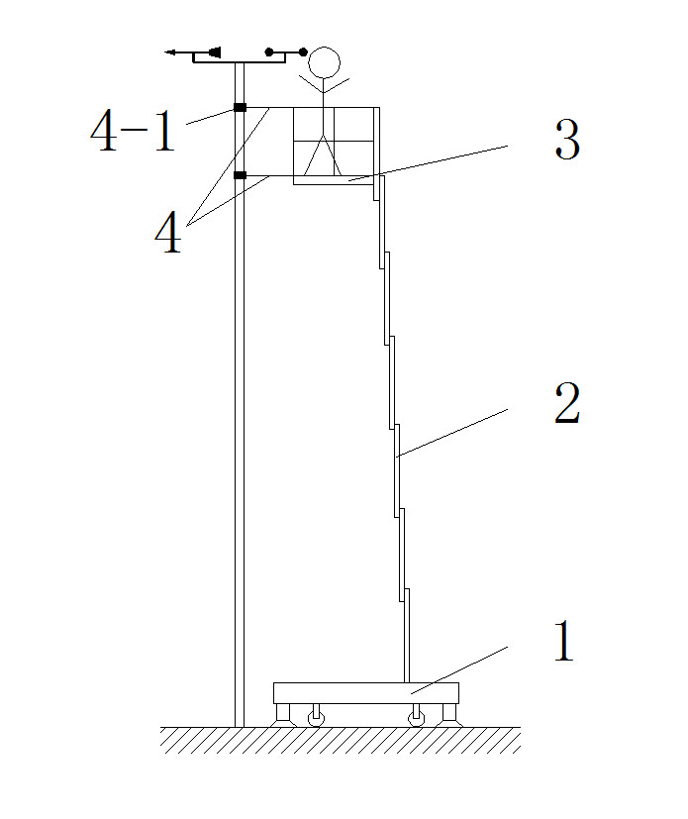

Figure 1 Schematic diagram of the observation field instrument maintenance for electric lifting table 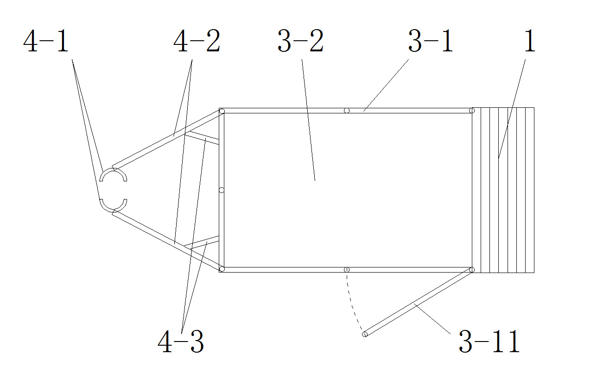

Figure 2 the overlook chart of the electric lifting table
3.3 Electric Lifting Mechanism
The electric lifting mechanism is a single mast type electric slide rail lifting mechanism, which is connected with one end of the upper worktable and the lower end with the base, as shown in Fig. 1. The single mast column adopts high strength aeronautical profile and new sliding track technology. The boom section is 200 x 95 x 6.5mm, the motor power is 1.0kw, the load is 130kg. The single mast column type electric sliding rail lifting mechanism can raise the working table to 10m height.
3.4 Grab Manipulator Arm
In order to facilitate the maintenance personnel to work steadily, two pairs of grasping manipulators are arranged at one end of the worktable far from the single mast type electric lifting mechanism. Each pair of grasping manipulators includes a pair of movable connecting rods distributed along the horizontal direction and a telescopic cylinder connected with them. The two pairs of grasping manipulators are vertically distributed along the side end of the worktable far from the single mast type lifting mechanism, and the two pairs of grasping manipulators are vertically distributed along the worktable. A pair of grasping manipulators are connected with the guardrail far from the grasping end, and a pair of grasping manipulators are connected with the worktable floor far from the grasping end, as shown in figs. 1 and 2. In order to grasp the wind meter rod conveniently, a telescopic cylinder is arranged on the movable connecting rod. The telescopic cylinder is located at the end of the convergence direction
3.5 Control Panel
The control panel connects and controls the electric lifting mechanism, the grasping manipulator and the supporting foot mechanism with wires.
3.6 Base and Fixed Support Foot
The base and the fixed support foot mechanism are the foundation of the whole electric lifting table. The base is made of 60*60 mm square pipe welded and laid with 3 mm thick steel plate. The length is 1450 mm and the width is 650 mm. In order to realize the convenient movement and safe and stable operation of the base, one wheel is installed in four directions below the base for easy movement. The bottom of the base is provided with a retractable fixed support foot mechanism and fixed support. The foot mechanism is located at four corners at the bottom of the base, as shown in figs. 3 and 4. The fixed support foot mechanism is equipped with shock absorber and support foot device. Each fixed support foot mechanism is connected with the lower end of the base through the hydraulic cylinder. The fixed support foot mechanism and the hydraulic cylinder are electrically connected with and controlled by the control panel. The shock absorber is equipped with springs and air pumps. When the wind outside causes the rod shaking, the electric lifting table is grasped by grasping the mechanical arm. The wind instrument pole will also be slightly swayed by the swaying of the wind instrument pole. Most of the influence of external wind force swaying on the lifting worktable can be offset by a shock absorber. The supporting foot device includes the first supporting foot and the second
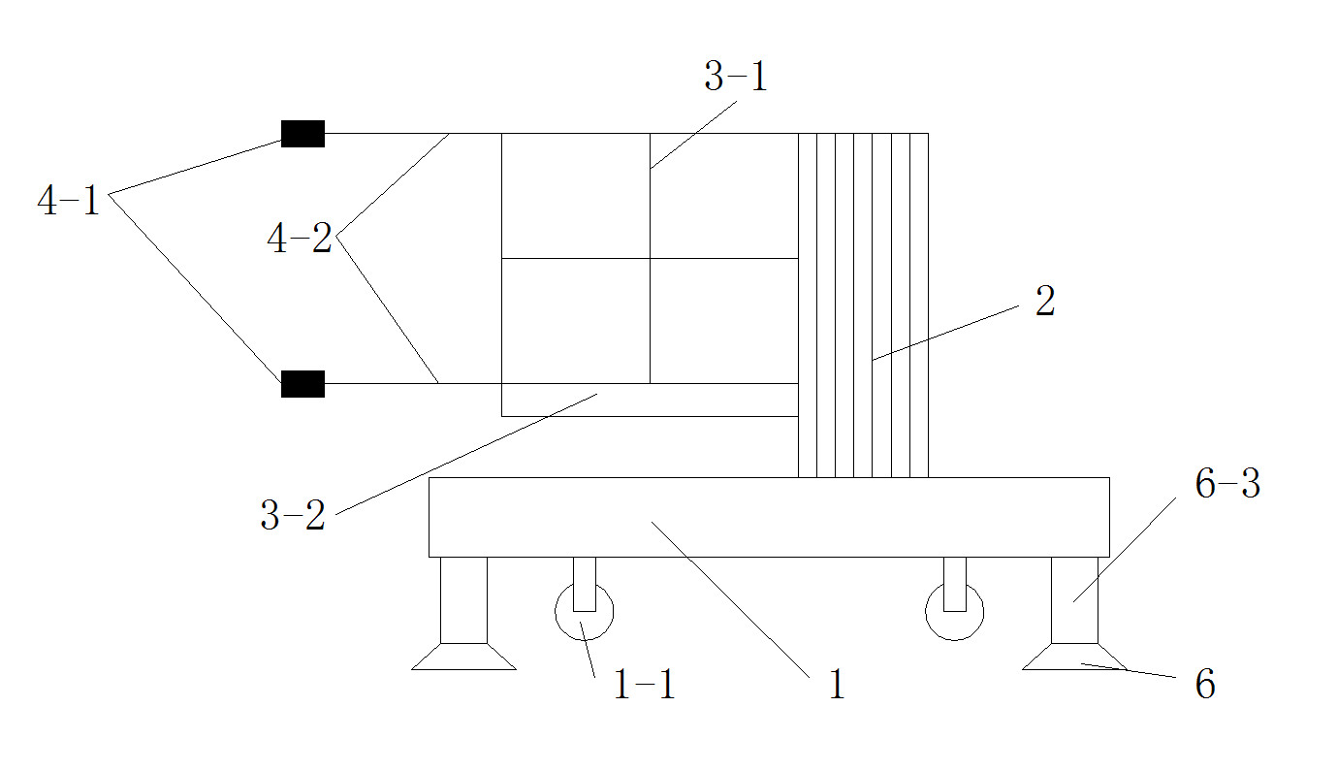

Figure 3 Schematic diagram of the structure of an electric lifting table
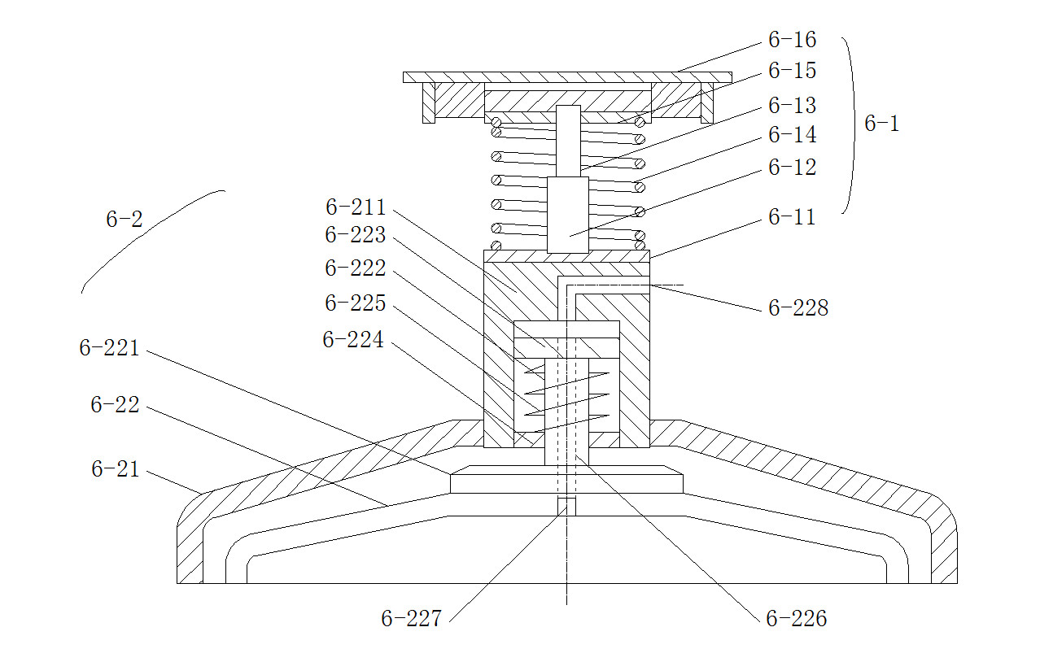

Figure 4 Schematic diagram of the structure of the supporting foot mechanism
Note: The labels in Fig. 1, Fig. 2, Fig. 3 and Fig. 4 are as follows: 1, base; 2, lifting mechanism; 3, worktable; 4, grasping manipulator arm; 5, control panel (sketch); 6, supporting foot mechanism; 3-1, guardrail; 3-2, workbench floor; 3-11. upper door; 4-1, grasp; 4-2, movable connecting rod; 4-3, telescopic cylinder; 6-1, shock absorber; 6-11, lower mounting plate; 6-12, shock absorber; 6-13, connecting rod; 6-14, first spring; 6-15, spring seat; 6-16, upper mounting plate; 6-2, supporting foot device; 6-21, first supporting foot; 6-22, second supporting foot; 6-211, cover; 6-221, connecting seat; 6-222, guide rod; 6-223, plug; 6-224, clasp; 6-225, second spring; 6-226, exhaust pipe; 6-227, relief valve, 6-228, opening.
- The Use Method of Electric Lifting Workbench
Use Method of Electric Lifting Workbench: When it is necessary to maintain the windmill, push the electric lifting workbench to the windmill pole of the meteorological observation field. Maintenance personnel can determine the appropriate distance between the windmill pole and the windmill pole by grasping the mechanical arm through the control panel, so as to ensure that the grasping mechanical arm can still grasp the windmill pole after the workbench is raised and determine the appropriate distance. After loosening the manipulator arm and using the control panel to control the fixed support foot mechanism, the rollers are adjusted to the position after lifting off the ground with the base. After checking the loading situation of the toolkit and the necessary wind instruments, the guard door is opened to enter the workbench, and the control panel is used to control the electric lifting mechanism to raise the workbench to a height convenient to work (according to the height of each person, it is convenient to work). The height is also different). Manipulate and grasp the manipulator arm to grasp the wind instrument pole, remove the toolkit from the guardrail hook of the worktable and replace or repair the spare wind instrument. After the repair, hang the toolkit and the changed wind instrument onto the hook, control the grasping manipulator arm by the control panel, then let the

5 Conclusion
The electric lifting worktable for maintenance of wind meters in observation sites designed in this scheme has the advantages of simple movement, easy lifting, safety and reliability, and can be operated by single person, which is convenient for timely repair of wind meters'faults. It can save trouble in the maintenance of wind meters by putting down wind meters, reduce labor intensity, improve work efficiency, achieve the purpose of saving time and labor, and ensure safety. It can well solve the problem of wind meters' transmission in meteorological stations. The difficulty of overhaul caused by too high installation of sensors can make the hands, feet and bodies of maintenance personnel work in a state of overall relaxation. Its popularization and use will have a good role in promoting the modernization of meteorological equipment.
Reference:
[1] Drawn up by the Central Meteorological Bureau. Ground Meteorological Observation Norms [M]. Published by Meteorological Press, Beijing, 1979, 12, 1st Edition.

[2] Xu Shufeng, He Chun. Electric Lifting Workbench [J]. Mechanical Engineer, 2009, (5): 82-83.

[3] Chen Jun, Chen Zhenhua, Li Suping, etc. Design and control method of wheeled mobile worktable for greeting robot [J]. Machinery Manufacturing, 2009, (11): 24-26.

[4] Xu Benlian, Hou Baolin, Chen Qinglan, et al. Design and dynamics simulation of manipulator [J]. Lifting and transporting machinery, 2003, (10): 26-28.

[5] Ye Zengji, Xu Zili, Zhang Xin. Design and optimization of greeting manipulator with connecting rod transmission structure [J]. Machinery Manufacturing, 2011, (05): 11-13.

[6] Pan Jin, Xu Fengren and Shen Zhao. Study on Static Characteristics of Self-priming Gas Supports [J]. Special Equipment for Electronic Industry, 1990, (02): 31-34+39.

[7] Yan Haitao, lifting platform for maintenance of wind meters at observation sites [P]. China: ZL 2018 2 0325 866.3, 2018-11-16.

