**Analysis on the structural type of large-span steel truss bridge specially designed for cables**

Gao Xipeng1, He Xiwei1

1. Shandong Electric Power Engineering Consulting Institute Corp., Ltd., Jinan, Shandong, China 250013)

**Abstract:** When the installation of cables and pipelines needs to go across rivers, bridges are usually adopted to support the cables and pipelines for crossing the rivers. The measure can make full use of the space resources and have no effect on the flow pattern of rivers. For this reason, analysis on the structural-type design of a large-span steel truss bridge specially used for cables has been performed. The numerical results indicate that the stayed-cable bridge with steel truss beam and concrete main tower has better performance and improved structural type caparisoned with that of the beam and arch bridges, and the construction of the major beam can be without the temporary support.

**Keywords:** large span, steel truss, cable, pipe bridge, design

**Introduction**

With the rapid growth of the national economy, the demand for power supply is further improved. However, due to the large-scale development of land and the construction of heavy industrial parks, it is often difficult to select the transmission line path, and high voltage power cables crossing rivers are frequently encountered. When crossing a wide river, more cable bridge structures are used, among which steel bridge structures are the most common.

There are many structural systems suitable for long-span structures. As for cable bridge structure across rivers, it can be selected from beam structure, truss structure, rigid frame structure and arch structure in plane bar system structure, or the combination of the above structure and prestressed technology[1-3]. The research on mechanical properties and structural design of truss cable pipe bridge has made some achievements. Zhang Zhen[4] discussed and analyzed the key points of structure design of 55m steel truss bridge and believed that welded I-beam and H-beam could better adapt to the connection design of steel truss structural members. Wang Chun-cai et al.[5] used TDAP III nonlinear structural analysis software to analyze the nonlinear dynamic characteristics of a large-span steel truss rail-road dual purpose bridge, which consisted of three continuous steel truss Bridges with a main span of 168.85m. The research shows that the safety reserve of the bearing capacity of the bridge is insufficient, and there are certain safety risks. Jiang Li-mei et al.[6] based on ANSYS finite element analysis software,  carry out static and dynamic analysis of a steel truss railway bridge. The maximum span of the bridge is 126m+196m+126m continuous steel truss bridge. The research shows that the static and overall modal analysis of steel truss bridge has a good guiding significance for the design of this kind of structure. Hassen et al.[7] take a steel truss bridge as the research object, using ANSYS modal analysis, get the natural vibration period and vibration mode diagram. It provides parameters and basis for further structural dynamic analysis. Hao Tian-tian[8] used finite element analysis software MIDAS / CIVIL 2010 to analyze the dynamic characteristics of a continuous steel truss bridge in Nanchang. The analysis of the structure shows that the torsional stiffness of the truss bridge is large, and the superstructure has a great influence on the transverse stiffness. Zhang Yuan-liang et al.[9] conducted a preliminary standardized design and construction technology research on 30m, 40m, 50m three large span high voltage cable across the river bridge structure. Based on the reliability theory, Li[10] analyzed the optimal design of a 64 m simply supported steel truss bridge. It is considered that the contradiction between economy and safety can be solved to a certain extent by optimizing the design based on reliability and strengthening the bearing capacity of composite materials, and the unity of economy and safety can be realized. Tan Jinhua[11] analyzed the fine fracture mechanics of simply supported steel truss bridge by ANSYS software, which provided the premise for further analysis of crack propagation and fatigue life evaluation. Zhang Chenglong[12] carried out the numerical simulation of the three-component force coefficient of an assembled steel truss bridge, which provided direct data support for the analysis of the wind resistance of the bridge and provided reference for the optimization of the bridge structure.

More detailed studies on long-span continuous steel truss bridge have been carried out in the literature[13,14], but they are mainly the railway bridges or the highway-railway bridges in transportation. There are few reports on the mechanical characteristics analysis and structural design of cable pipe bridges with a span of more than 100 m. There are great differences between long-span steel truss cable pipe bridge and truss bridge with highway, railway and other traffic functions. And the current codes and regulations do not give clear calculation methods, design concepts and corresponding design standards. According to the requirements of structural functions, more stiff supporting skeletons are added inside the cable pipe bridge structure, and the load transfer path is also complex. If designed in accordance with the current specification, there will be a large deviation, making the structure have greater security risks.

In view of this, based on a cable transmission project, this paper puts forward a special type of long-span steel truss cable pipe bridge. Through the mechanical characteristics analysis of long-span steel truss cable pipe bridge, the structural stress characteristics are understood, and the internal force distribution law of the structure is mastered, which has guiding significance for controlling the key stress parts of the structure and clarifying the structural optimization design idea.

**1 Section form of cable pipe bridge**

The cable pipe bridge needs to lay multiple cables with different voltage levels, and meets the needs of personnel maintenance. The section form is generally single cabin or multi cabin rectangular section, as shown in Figure 1.

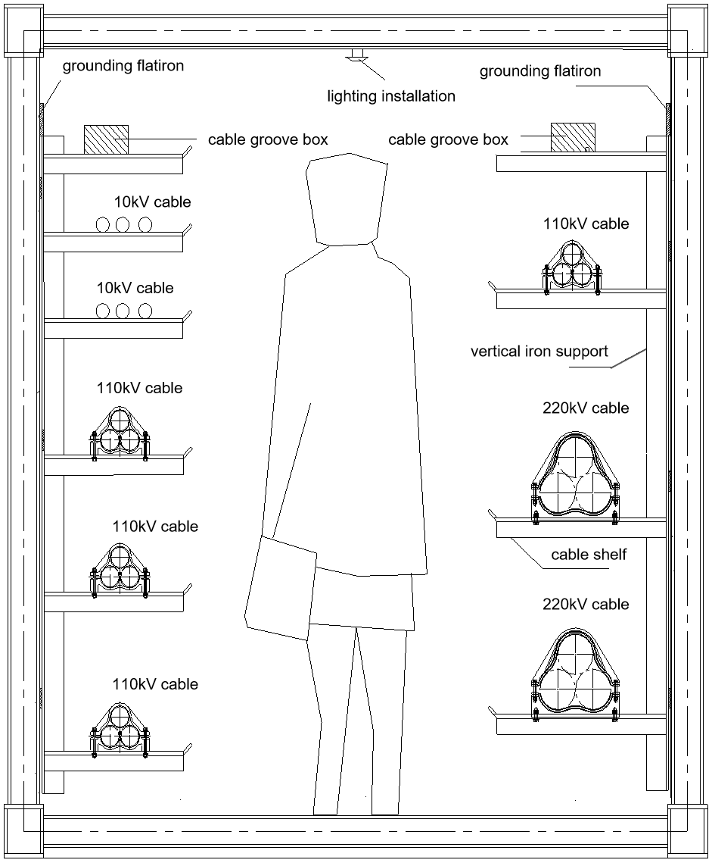

Fig.1 Section form of single cabin cable pipe bridge

**2 Structural type of large-span steel truss cable-stayed bridge designed for cables and pipelines**

Large-span steel truss cable-stayed bridge designed for cables and pipelines adopts the bridge scheme of cable-stayed bridge without backstays. The main structure of the bridge is the Warren-type steel truss structure with double truss and vertical bar, and the bridge tower is the reinforced concrete structure without backstays and the H-type tower with variable width. The bridge pylon cap and abutment adopt reinforced concrete prism structure, and the bridge pylon cap and abutment all adopt cast-in-place pile foundation. Schematic diagram of cable-stayed bridge designed for cables and pipelines is shown in Figure 2.



Fig. 2 Schematic diagram of large-span steel truss bridge

**3 Design example of large-span steel truss cable-stayed bridge designed for cables and pipelines**

3.1 Project overview

A cable transmission project is a lifeline engineering for a large coastal super quality iron and steel products base. Due to the restrictions of terrain and local site conditions, a large-span bridge designed for cables with a length of 150m needs to be built to cross a navigable river along the line. The whole project is located in a coastal city with good traffic conditions. After the completion of the pipe bridge，the bridge will be used for laying double circuit 220KV cable, multiple circuit 220KV cable and power line inspection personnel access.

3.2 Design standards

The baseline period for structural design is 100 years and the security level is one. The peak ground motion acceleration is 0.1 g ( basic intensity is 7 degrees ), the bridge type is A, and the earthquake type is E2. The environmental category was Class II, and the design reference temperature was 20°C[].

3.3 Main bridge design

3.3.1 Design load

(1) Permanent load

The dead load includes the dead weight of the main truss structure,cable and accessory structure. The bulk density of the main truss structure steel is calculated according to 78.5kN/m3. The 220kV cable specification is 3x38.5kg/m, and the 110kV cable specification is 3x13.5kg/m. The 10kV specification can be approximately regarded as the same as 110kV.

(2) Live load

The wind load is calculated according to the relevant provisions of *Wind-resistant design speciation for highway bridges* and the snow load is calculated according to the relevant provisions of *Load code for the design of building structures* [15,16].

3.3.2 Main design materials

Concrete: C40 (Standard value of compressive strength of cube is 40MPa); Reinforcement: HPB300, HRB400; Stay cable: low relaxation steel strand , HDPE sheath is arranged outside the cable; Steel: Q345qE(Steel for bridge and its’ yield strength is 345MPa); Bolts: 10.9s high strength bolts; Bearing: GPZ (II) uniaxial movable, fixed pot rubber bearing.

3.3.3 Main truss structure design

In this design, the bridge span scheme of cable-stayed bridge without backstay is adopted. The total length of the whole bridge is 150m and the height of the tower is 50m. The main bridge structure adopts the Warren-type steel truss structure with flat chord double truss and vertical bar. The chord center spacing is 5 m, the truss height is 4 m, and the internode spacing is 5 m. The upper and lower chords of the truss adopt 200mmx266mm welded box section, the web member and the flat coupling beam adopt 150mmx150mm welded H-section, and the lower flat joint adopts 150mmx150mm welded H-section and the lower flat joint at both ends of the beam adopts 250mmx208mm box section for strengthening.

3.3.4 Design of bridge tower

The bridge tower adopts reinforced concrete structure, H-shaped tower with variable width without backstays. The thickness of the tower column in the transverse direction is 1.2 m, and the distance between the outer edge of the bottom of the tower column in the transverse direction is 8.525 m. The distance between the inner edge of the transverse girder tower column and the top of the tower is 5.852m and 5.925m. There are horizontal beams at vertical distances of 5m, 42.5m and 47.4m from the bottom of the tower. Respectively for the erection of the main beam, improve the lateral stiffness and stability of the bridge tower. The Angle between the vertical column of the vertical bridge and the horizontal plane is 73°. The section of the vertical tower wall thickness of the vertical bridge is a variable section. The horizontal distance of the bottom wall thickness is 3m, and the horizontal distance of the top wall thickness is 2.4m.

3.3.5 Design substructure of bridge pylon

The bridge pylon cap adopts reinforced concrete prism structure, the size is 18x18x3m. 36 cast-in-place piles with a diameter of 1.2m and a length of 25m for each pile are set under the cap.

3.3.6 Abutment design

Because the abutment elevation is higher, the double-column reinforced concrete abutment is used, the pier column diameter is 1.2m, and the pier height is 7.1m.

3.4 Structure calculation

3.4.1 Working condition combination

(1) Dead load + cable force

(2) Dead load + cable force + wind load + snow load + overall temperature drop

(3) Dead load + cable force + wind load + overall temperature rise

3.4.2 Main calculation contents

Midas Civil /2015 was used for simulation calculation of the following contents:

(1) Check the strength, stability and deformation of the main truss structure in the ultimate state of bearing capacity.

(2) Check the strength and stability of local bar.

(3) Check the bending and shear resistance of the concrete structure of the bridge tower under the state of bearing capacity.

3.4.3 Finite element module method

The overall calculation of the main bridge adopts the plane bar element model, the truss beam, tower and pillar adopt the beam element, and all the beam elements of the truss girder structure adopt the rigid connection form. cable adopts two-force bar unit; bridge pier adopts prefect rigidity restraint, and restraint between master and slave nodes is used between the truss beam and pillar and the tower. The vertical and horizontal master-slave rigid restraints between tower and beam. The calculation model is shown in the following figure.

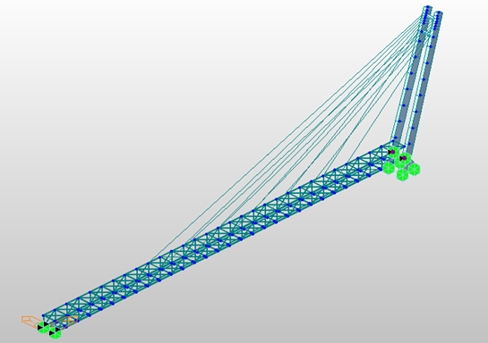

Fig. 3 overall calculation model

In order to reflect actual stress state of the main bridge, in addition to the finite element model analysis of the bridge state, the finite element analysis of the construction stage of the main bridge is also needed, this ensures that the main bridge from construction to completion to the operation stage of the force situation is within the design requirements.

3.4.4 Calculation

（1）Vertical displacement of main bridge

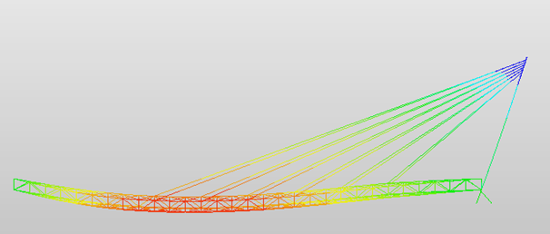

Fig. 4 dead load+cable force+wind load+snow load vertical maximum displacement ( cm）

Calculation by working condition, the maximum displacement of the main bridge under ' dead load + cable force + wind load + snow load ' is 24. 82 cm, which is less than the vertical deflection limit L / 400 = 37. 5 cm[17].

（2）Tower top displacement

According to the above four load combinations, longitudinal and transverse bridge direction of the tower top are obtained in the following table: (Unit: cm)

|  |  |  |  |  |
| --- | --- | --- | --- | --- |
| Load | dead load+cable force | dead load+cable force+wind load+snow load | dead load+cable force+wind load+snow load+temperature drop | dead load+cable force+wind load+temperature rise |
| transverse direction | 0 | 8.92 | 9 | 8.18 |
| longitudinal direction | 26.09 | 29.12 | 29.28 | 28.55 |

(3)Bearing reaction force of main bridge

By calculation, the vertical maximum reaction force at tower bottom is 11621.9kN, the vertical maximum reaction force of the tower and the support is 514.6kN, and the vertical maximum reaction force of the abutment support is 370.4kN.The maximum reaction force at the bottom of the tower in the transverse direction is 603.1 KN, the maximum reaction force at tower and bracket in the transverse direction is 1086.7KN, and the maximum reaction force at bridge abutment bracket in the transverse direction is 1005.4KN;The maximum reaction force of tower bottom in longitudinal direction is 4598.1 KN, and the maximum reaction force of tower and bracket in longitudinal direction is 2263.3KN.

3.4.5 Structure checking calculation

Structure checking shall cover all the following contents:

Fig. 5 Flow chart of pipe bridge checking calculation

structure checking

calculation

calculation of anti-bending at bridge tower root

calculation of local compression in anchorage zone

checking calculation of cross beam at tower bracket

checking calculation of resistance to shearing resistance of pile cap

checking calculation of vertical ultimate bearing capacity of pile foundation

checking calculation of anti-bending on abutment cap

checking calculation of anti-shear checkout on abutment cap

checking calculation of punching shear of bridge cap

checking calculation of bearing capacity of abutment pile

strength checking calculation

stability checking calculation

bridge tower

checking calculation

bridge abutment checking calculation

Main truss checking calculation

chord rod, end cross beam

end tilted belly poles, end vertical

tilted belly poles, beams

cross linked, vertical beam, direct abdomen rod

After checking calculation, the above checking calculation contents meet the requirements.

**4 Conclusion**

In this paper, based on a cable transmission engineering, a large-span steel truss bridge specially used for cables is firstly proposed, and analysis on mechanical characteristics of large-span steel truss cable pipe bridge. In this process, the following conclusions are drawn:

(1) Adopt a steel truss girder cable-stayed bridge with isolated inclined tower. Compared with the beam and arch style of the same span, the major beam steel quantity is small, the major beam erection construction does not need temporary auxiliary measures ( auxiliary pillar, temporary steel tower );The inclined main tower resists the horizontal action torque of the stay cable through the weight of the main tower relative to the bending moment of the tower root; The major beam is made of light and high strength steel, which not only satisfies the vertical stiffness of the major beam, but also reduces the force of stay cable.

(2)Under the most unfavorable load combination, the vertical maximum deflection of the major beam is 24.8<L/400=37.5cm.Vertical displacement meets the requirements of the specification. The horizontal offset displacement at top of main tower is 29.28cm<L/300=50cm.Meet the specification requirements. The maximum axial tension of main truss member is 938.2kN, the maximum axial tensile stress is 151.3MPa, the maximum axial pressure is 1459.2kN, and the maximum axial compressive stress is -139.7MPa, all of which meet the requirements of the design code.

(3) Because it is a cable-stayed bridge with one side stay cable floating system across single tower, the horizontal component force of the support at the tower beam under the action of stay cable reaches 2263.69kN, then the tower crossbeam adopts the "L" shaped reinforced concrete beam, and the bracket resist the horizontal component force here.

(4) The abutment, tower and foundation are all made of reinforced concrete structure, and the bearing capacity of each part meets the requirements of the design code.

**References:**

[1]Wang Weilai, Wang Wenxing. Numerical Analysis of Large-Span Truss Beams[J]. Low Temperature Architecture Technology，2014,（1）：52-53.

[2]Zhao Jianqiang. Design And Analysis Of Large-Span Steel Structure Of The Yantai Railway Station[J]. Jinan: Shandong University, 2012.

[3] Lu Cilin, Yin Siming. Prestressed Steel Structure Space Structure System[J]. Steel Structure,2000,15(3):64-67

[4] Zhang zhen. Discussion on Structural Design Essentials of Steel Truss Bridge in City Bridge[J]. Guangdong Science and Technology，2007,（10）：105-106.

[5]WANG Chun-cai, LI Jun, LI Qiang. An Analysis of Nonlinear Dynamic Characteristics for Long-Span steel Truss Bridges. Journal of Qingdao Technological University，2012，33（1）:24-29.

[6]JIANG Li-mei， JIANG A-lan. Static And Dynamic Analysis Of Steel Truss Bridge Based On ANSYS[J]. Low Temperature Architecture Technology, 2013, 35(1): 40-42.

[7] Ha Sen, Lei Youkun. Analysis Of Steel Truss Bridge Based On ANSYS[J]. Guangdong Building Materials,2017,33(3):32-33

[8] HAO Tian-tian, JIANG A-lan. Research On Dynamic Characteristics Of Through Truss Steel Bridge[J]. Low Temperature Architecture Technology, 2012, 34(12):37-39.

[9] ZHANG Yuan-liang, HE Jian, LIANG Pei-xin and so on. Design and Standardization Study of the Long-span Cable Bridge across Rivers[J]. Jiangsu Construction,2015,(6):26-29

[10]Li Xinkui. The Method of Optimization for Design of Simply Supported Steel Truss Bridge Based on Reliability Theory[D]. Dalian Maritime University, 2008.

[11] Tan Jinhua. Numerical Simulation of Three-Dimensional Crack Propagation in Steel Truss Bridges[J]. Sichuan Construction,2008,28(3):164-165.

[12] Zhang Chenglong, Wang Qiang, He Xiaohui, Mao Di. Numerical simulation of tre-component force coefficient of fabricated steel truss bridge[J]. Ordnance Industry Automation, 2014, 33(04): 88-91.

[13] Huaping Wang, Yi-Qing Ni, Jian-Guo Dai, Maodan Yuan. Interfacial debonding detection of strengthened steel structures by using smart CFRP-FBG composites. Smart Materials and Structures, 2019, 28-115001-1-13.

[14] Huaping Wang, Jian-Guo Dai. Strain transfer analysis of fiber Bragg grating sensor assembled composite structures subjected to thermal loading. Composites Part B: Engineering, 2019, 162, 303-313.

[15] JTG/T 3360-01-2018, Wind-resistant design speciation for highway bridges[S]. China Communications’ Press Co., Ltd, 2019.

[16] GB 50009-2012, Load code for the design of building structures[S]. Beijing: China Architecture & Building Press, 2012.

[17] GB50017-2017，Steel Structure Design Code[S]. Beijing: China Planning Publishing House, 2018.