HEMP CONCRETE: A Sustainable Green Material for Conventional Concrete
Dr. Sudarshan D. Kore ª, Dr. J. S. Sudarsan^{b}
Assistant Professor, School of Construction Management,
National Institute of Construction Management and Research (NICMAR) Pune, INDIA.
skore@nicmar.ac.inª, ssudarsan@nicmar.ac.in^{b}
Corresponding author: Dr. Sudarshan D. Koreª
Corresponding Author’s Email: skore@nicmar.ac.inª
Alternate Email: sudarshankore123@gmail.com

Abstract
Concrete one of the important building material and day by day the utilization of concrete increasing to meet the infrastructure development requirement. On one hand it is unavoidable but some alternative to be explored to reduce the global environmental impact caused by the concrete. To overcome this from the last decade the world is looking towards the fact of sustainability due to rapid industrialization. The growth in the construction industry increased the demand of concrete as construction material. This concrete produces significant amount of greenhouse emission in the environment. There is a need to find an alternative solution to minimize the greenhouse emission emitted from the concrete manufacturing plant.
Hempcrete is a building material prepared from hemp yarns, lime and water. This composite material have several beneficial properties like low in cost, easily available, thermal and acoustic insulation, low density and sustainable cause of no adverse impact of carbon footprint on production. In this study the properties and several benefits of the hempcrete were discussed in detail.

Keywords: Hemp, Hempshiv, concrete, sustainability

- Introduction
Rapid growth in the urbanization, industrialization and infrastructure activities in the word increased the demand of the amenities in the developed and undeveloped countries. The increased demand in the infrastructure amenities by people of the society is much more in later 1990’S. To meet this demand the construction industry uses concrete as construction material which is one of the popular material in the world. The concrete is prepared by cement, fine aggregate, coarse aggregate and water. In today’s scenario approximately 25 billion tons per year of concrete is being produced globally ^{[18]}. For production of concrete the main ingredient is cement. For production one ton of cement approximately 0.98 tons of carbon di oxide is emitted in the environment ^{[2]}. The emission of this gas lead to be the one of the major cause for global warming. The issue of global warming attracts the researchers to find a suitable alternative material as binder for construction industry which makes it economical and sustainable ^{[3]}. There are various other materials found by the researchers like waste from thermal power plant (Ash) metakaoline, Ground Granulated Blast furnace Slag (GGBS), silica fume etc. ^{[17] [15] [10]}. For sustainable development need to find some materials which does not have any impact on the greenhouse gas emissions.
The recent advancement in the construction industry developed some new innovative materials which may be called as ecofriendly, sustainable or green construction materials. The various studies conducted by the past researchers explored the use of plant fibers and byproducts in concrete as constriction material for sustainable developments for example wood, hemp, sunflower, flax, sisal ^{[1]}.

- Emerging Trends On A New Challenge:
Hemp is grown in the tropical regions of the world as one of the popular crop in those regions. The biological name of this plant is Cannabis Sativa as shown in Figure 1. The fibers generated form the hemp stack is used as a building product along with lime and cement ^{[12]}.
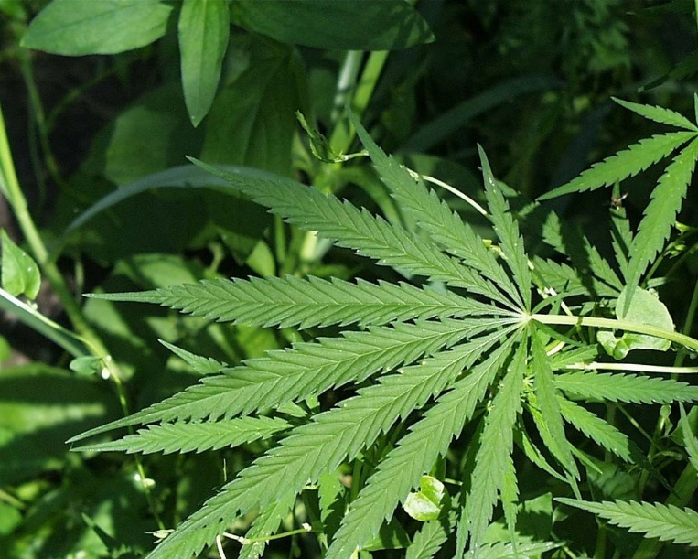
Figure 1 Hemp Plant
Hemp is a quickly developing yearly yield (1.5 - 4m tallness) which is mostly developed for its high rigidity common fiber which develops in the shoot nearby the timbered center of the plant ^{[27]}. This timbered center of the plant is slashed up into little sizes (5-25mm) (hurd/shive) and blended in with lime, water and a little amount of concrete (to speed up setting time) to shape of composite blend called hempcrete ^{[7]}. The use of hemp fibers was first trialed by France in 1990. The hemp fibers were used for production of less weight concrete, making of protection boards, mass-spraying of hempcrete respectively for the production of lightweight composites ^{[15]}. Hempcrete is obtained by adding the hemp shives or fibers along with cement or lime in presence of water. It is having several benefits such as low density, and acoustic protection properties, and can passively regulate humidity in a built environment ^{[29]}. Due to low strength and modulus elasticity it cannot be used as structural concrete. It can be used as filling material for construction of ecofriendly and sustainable strictures ^{[3]}. Pores in hempcrete can create a respiratory structure that absorbs and desorbs moisture from its environment and controls sudden tempering and humidity changes in its environment. This ability of the hempcrete allows the users to use to maintain healthy environment in arid regions ^{[8]}. Hemp is an agriculture product cause of this it is a carbon negative martial which doesn’t emit any carbon emission during the production process ^{[21]}. The researchers claimed that per kilogram of hemp shiv sequesters about 1.6 to 1.8 kg of CO₂ ^{[14] [25]}.
From the past fifteen years the hemp is termed as green building material which was seen from the previous studies. Hemp had significant papers as a fibre plant in the past, and already processed into cord and fabric in Egypt's in the past dynasty 3500 years ago ^{[24]}. Hemp's potential for green growth in Europe has been rediscovered around 25 years ago ^{[13]}. Several European countries have changed their laws to enable the production and processing of manufacturing hemp ranges with a content of less than 0.2% in the higher part of the plant. Recent policy reforms in favor of cannabis farming and manufacturing on a global scale are only viable if they are combined with the use of hemp.
Building is known to consume approximately 40% of the total energy production, 25% of the world's water, and 40% of the world's resources (UN Environment Program, 2016). By substituting plant aggregates for mineral aggregates, this consumption can be greatly reduced ^{[6]}.This calculation not only locks CO₂ within the building envelope, but it also lowers operating energy such as air conditioning, makes insulating hemp concrete a very promising choice for fighting global warming ^{[5]}. Currently, about 5,000 tonnes of hemp material are used for construction purposes in France, the country that pioneered the use of hemp-based insulating construction materials in the early 1990s, followed by other European countries, and has increased in popularity in the last 15 years as a result of growing research in this area ^{[4]}.

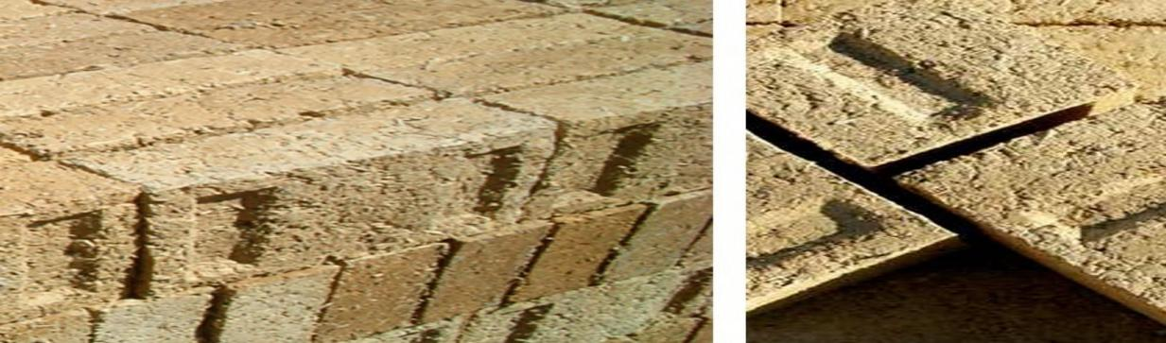
Figure 2 Brick made from Hempcrete ^{[16]}

Hempcrete's Characteristics

Capabilities for dealing with moisture
  - Hempcrete's vapor permeable walls enable dampness to naturally move starved of the risk of condensation and water harm ^{[28]}.
  - It has a large potential for retaining moisture. With permeable skins on both sides of the wall, moisture-related problems are significantly reduced in any area.
  - It hurd contains a lot of silica, because when it's combined with lime, the hurd begins to mineralize.

Compressive Strength (CS)
  - According to Elfordy et al., ^{[11]} compressive strength of hempcrete blocks varies from 14.5 psi (1.02 kg/cm²) to 420 psi (29.5 kg/cm²).
  - It helps to stabilize or harden lightweight partition framing members. Hempcrete's density ranges from 93.6 to 136.4 kg/m3. As a result, it is bright.

Thermal Efficiency
  - Hempcrete has exceptional thermal properties.
  - Hemp concrete has a R value of 1.5 to 2.0 per inch in its steady state ^{[26]}.
  - The density obtained in the combination, as well as the binder/Hemp ratio, will affect the values.
  - It also passed the European burn exam, which is a 75-minute test ^{[9]}.

Sustainable Building Material
- It can raise up to four meters tall in three months without pesticides or herbicides, and hemp cultivation is quickly growing around the world ^{[7]}.
- The recent growth in this sector is due to several reasons, not the least of which is our collective sense that what we are doing with our world isn't quite working out.
- This sensation is growing in intensity, but it is at odds with our normal way of life. Hemp is a green building material with a wide range of applications, and it is expected to become a valuable crop in the future ^{[28]}.
- One of the most interesting the components of this hemp renaissance is the slow growth in the use of hemp as a building fabric ^{[7]}.
- Hempcrete consists of hemp ‘shiv’, the woody middle of the hemp plant broken up into something as nice wooden chips, that's then mixed with a lime-based complete binder and water.
- This arrangement sets hard to become an exceptional padding for walls, floors, or roofs. It has numerous benefits over supplementary building materials, including being fireproof, non-toxic, sustainable, breathable, and highly isolative.
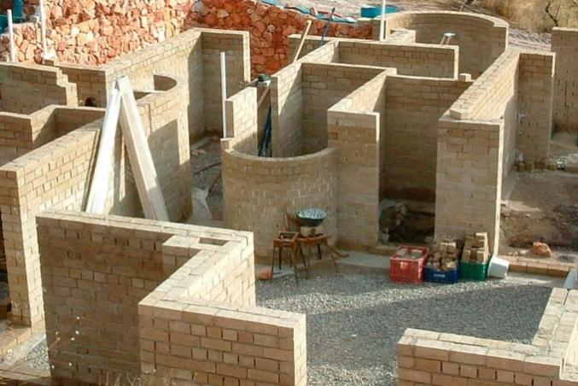 | 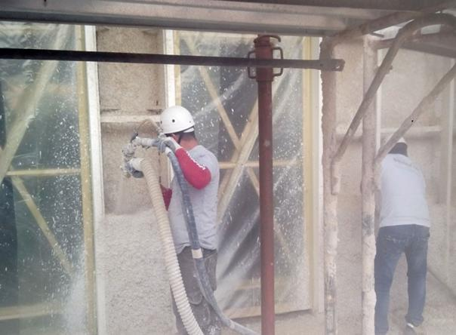
Figure 3 W alls with hemp clay bricks | Figure 4 Hemp lime concrete sprayed application

Environmentally Friendly Construction Material
- It's probably safe to say that climate change poses the biggest threat to our future survival, and buildings account for roughly half of all greenhouse gas emissions, both during construction and in heating, cooling, and maintenance demands after they've been occupied.
- At any of these points, it has the ability to minimize emissions, making it a genuinely green building material.
- Plants engross carbon from the air as they grow, and hemp is able to lock up more carbon per hectare than almost every other plant, including trees, due to its rapid growth rate ^{[19]}.
- Once this biomass is processed, mixed with lime, and incorporated into a structure, the carbon is locked up for the life of the structure. Lime also balances the energy used in its production by removing CO₂ from the air as it sets.
- Most traditional construction materials have a high embodied carbon content, which means they release large amounts of CO₂ into the environment during their manufacture.
- It typically absorbs more carbon than it emits during production, rendering it a carbon-neutral material. To set that into perception, m³ of hempcrete will restore around 110kg of CO₂ ^{[17]}. For the walls, an average sized house will use about 50 cubic meters of hempcrete, resulting in 5.5 tons of carbon being locked up over the course of the building's lifespan ^{[10] [19]}.
- In contrast, a typical new house of comparable size will likely release 48 tons of carbon into the atmosphere through its walls. This equates to a carbon reduction of 53.5 tons per house constructed ^{[5]}. It's clear that the carbon balance isn't even near, and that, despite minor differences in measurement methods, building with hempcrete will save you money.
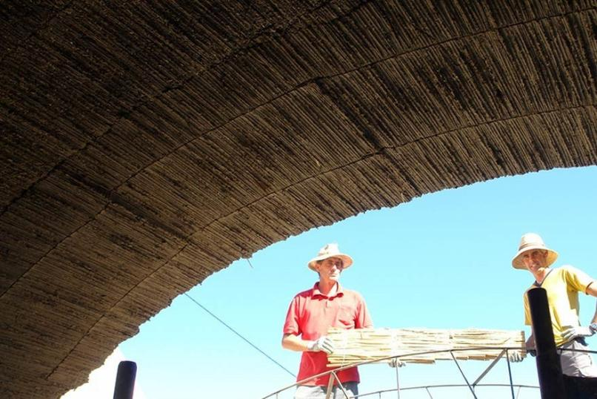
Figure 5 Structural vault of hemp concrete

Insulation
- The potential of this green material is to save carbon and to act as an insulating enclosing material with two main properties that help it minimize carbon emissions and save money on energy bills: moisture management and thermal mass. These features, which are often ignored by building codes, mean that hempcrete buildings use less energy to have inhabitants warm and happy.
- Its ability to absorb and desorb moisture helps it to control humidity in the house, allowing for greater comfort at lower temperatures and lower energy bills.
- Hempcrete's thermally massive properties cause the building's fabric to warm up and remain warm even when the weather is modified ^{[9]}. This is in contrast to most modern houses, where the lining layer in the partition is placed so close to the inner surface that the only thing that keeps the space warm.
- The biggest downside is that when there is some kind of aeration or draught, the room heat drops rapidly, forcing the regulator to cut in and reheat the room on a consistent basis. This, too, has strong negative effects for energy bills. Anyone who lives in a modern home and has observed how easily the room temperature drops when the heating is switched off is frustrated ^{[20]}.

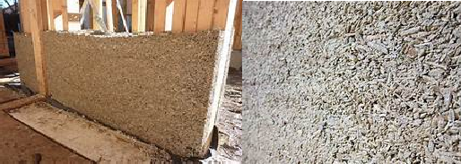
Figure 6 Hemp Concrete as insulating material

Expertise and Experience
- There is a shortage of knowledge and experience within the hempcrete industry, if there is one at all. There are a few businesses that are successfully constructing and renovating, but the majority of the structures are one-off projects. The experience and skills needed for these one-off projects are similar to, but not equal to, those required for large-scale construction.
- Hempcrete buildings, like any other building, may benefit from economies of scale, but scale necessitates investment, and investment necessitates confidence.
- At the moment, the numerous yet effective hempcrete builders are not banding together to provide this evidence in a crime manner.

Potential Future
- The raw material for hempcrete will become more readily available as hemp cultivation spreads around the world and processing plants made easy ^{[20]}. If textile manufacturers can shift away from cotton and toward hemp, the hemp market can grow quickly, allowing the price of hemp shiv to remain steady.
- The emerging infrastructure material manufacturing industry has attracted a lot of investment, But due to outdated laws that make hemp farming difficult.

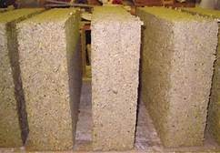 | 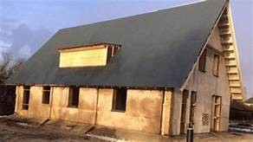
Figure 7 Construction with Hempcrete

- Any hempcrete building offers evidence for how we need to design, and if we look hard enough, we will find proof that existing standard building strategies are failing us. More concrete structures are quietly underperforming, dumping even more carbon into the atmosphere.
- Hempcrete isn't a commodity through a lot of unanswered questions. It's a sustianble material of future age, and it has the potential to help us develop in a more ecological way, resulting in better building results.

Applications Of Hempcrete ^{[22]}

Plastering
  - Painted on the building's interior or exterior surfaces.
  - Ideal for places that are prone to cracking and knocks.
  - Better for filling in and repairing holes in existing plaster.
  - Spray applications save time and money by eliminating the need for formwork.
  - The most popular approach is to add lime plaster directly to hempcrete.

9.2 Form Packing
  - To maximize the insulating potential, it is tightly filled near the surfaces and loosely in the middle.
  - The frame may be balanced or bent to one side. The exterior is also finished with cladding.
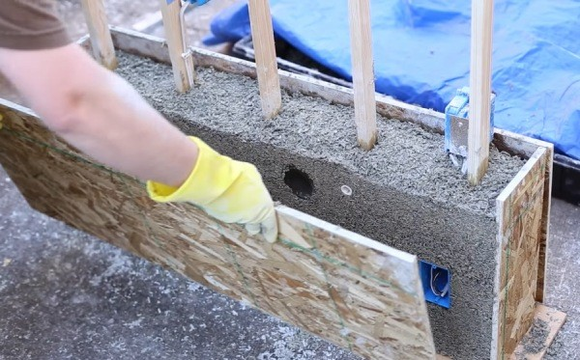
Figure 8 Form packing of hempcrete

9.3 Precast Insulation Panels
  - Hemp concrete construction utilizes precast panels for large structures.
  - Individually built residences that are assembled on site may also benefit from precast panels.
  - The British Science Museum cast-off hempcrete boards in an artefact storage room.

Hempcrete Vs. Concrete ^{[23]}
- In terms of design, concrete has a distinct benefit over hempcrete in that it can be used to create load-bearing structures.
- Hempcrete, on the other hand, has obvious benefits in its ability to withstand mould, bacteria, and damp, which are common problems for homeowners in older buildings and can cause severe respiratory problems.
- Concrete and hempcrete are both fire-resistant, maintain heat well, and are effective sound-proofing materials. The initial cost of the materials, as well as their suitability for a variety of large-scale construction projects, would likely determine any change in industry between widespread acceptances of concrete as a building material versus hempcrete.

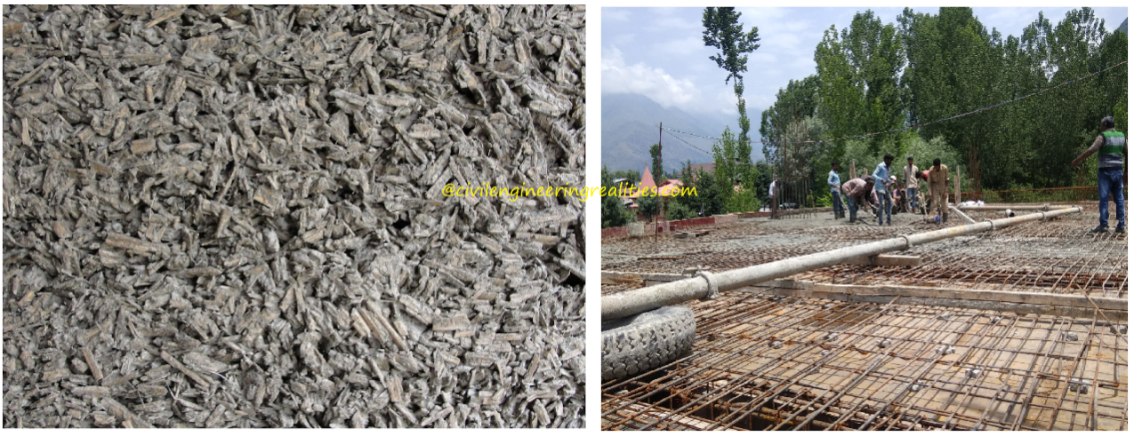
Hempcrete | Concrete
Figure 9 Comparison of Hemcrete with Concrete ^{[23]}

Conclusions
- Hempcrete has not only a helpful in protecting the environment, global warming and climate change; it also provides comfort in the structures.
- Its hygrometric behavior leads to indoor air quality and a relaxed indoor microclimate condition.
- It displays low thermal conductivity, low density, low strength, high absorptivity and high moisture buffer capacity.
- It is ensuring a building envelope, which can be used in the wall, roof and floor. The mixture proportions should be calculated properly according to the application area, so as to evade unforeseen effects.
- It is a appropriate plant for growing in environments other than extreme desert climates and high mountain regions.
- Guidelines must be formed to endorse hempcrete usage in the building's assembly.
- The researches related to hemp must be encouraged it will rise in the coming years and it will indirectly help in producing green building products and technologies.

References
[1] S. Amziane (2016), Overview on biobased building material made with plant aggregate, Sustain. Constr. Mater. Technol. 2016-Augus 31–38.
[2] E. Awwad, D. Choueiter, H. Khatib (2020), Concrete Masonry Blocks Reinforced with Local Industrial Hemp Fibers and Hurds Third International Conference on Sustainable Construction Materials and, Sustain. Constr. Mater. Technol. -Augus 1–11.
[3] G. Balčiunas, S. Vejelis, S. Vaitkus, A. Kairyte 2013), Physical properties and structure of composite made by using hemp hurds and different binding materials, Procedia Eng. 57 (159–166.
[4] H. Bedlivá, N. Isaacs, (2014), Hempcrete – An environmentally friendly material?, Adv. Mater. Res. 1041 83–86.
[5] T. Bejat, Hygrothermal Behaviour of a Hemp Concrete Wall :, in: 13th Conf. Int. Build. Perform. Simul. Assoc., Chambery France, 2013.
[6] T. Bejat, A. Piot, A. Jay, L. Bessette (2015), Study of two hemp concrete walls in real weather conditions, Energy Procedia. 78 1605–1610.
[7] R. Brencis, S. Pleiksnis, J. Skujans, A. Adamovics, U. Gross (2017), Lightweight composite building materials with hemp (Cannabis sativa L.) additives, Chem. Eng. Trans. 57 1375–1380.
[8] P. de Bruijn (2008), Hemp Concretes Hemp Concretes, Swedish University of Agricultural Sciences,.
[9] F. Delhomme, A. Hajimohammadi, A. Almeida, C. Jiang, D. Moreau, Y. Gan, X. Wang, A. Castel (2020), Physical properties of Australian hurd used as aggregate for hemp concrete, Mater. Today Commun. 24 ,100986.
[10] T.M. Dinh, C. Magniont, M. Coutand (2012), Hemp concrete using innovative pozzolanic binder, First Int. Conf. Bio-Based Build. Mater. 33, 265–270.
[11] S. Elfordy, F. Lucas, F. Tancret, Y. Scudeller, L. Goudet (2008), Mechanical and thermal properties of lime and hemp concrete (“hempcrete”) manufactured by a projection process, Constr. Build. Mater. 22 , 2116–2123.
[12] J.C. van Empelen (2018), A study into more sustainable, alternative building materials as a substitute for concrete in tropical climates, 1–26.
[13] R. Hornby (2020), A Review of Alternative Building Materials in comparison to CMU : Hempcrete , Woodcrete , Papercrete, Univ. Arizona. 1–16.
[14] T. Jami, S.R. Karade, L.P. Singh (2018), Hemp Concrete - A Traditional and Novel Green Building Material, Proc. Int. Conf. Adv. Constr. Mater. Struct. .
[15] M. Jothilingam, P. Paul (2019), Study on strength and microstructure of hempcrete, AIP Conf. Proc. 2117.
[16] N.M.T. K, H.G. Sunil, D. Rani, A. Kumar (2016), Manufacturing of building blocks using Hempcrete, 02 62–73.
[17] J.K. Kana (2020), Experimental investigation on the physical properties of hemp concrete on addition of low carbon material, Int. Res. J. Eng. Technol. 7 2360–2364.
[18] H. Klee, Briefing (2004): The cement sustainability initiative, Proc. Inst. Civ. Eng. Eng. Sustain. 157 9–11.
[19] C. Magniont, G. Escadeillas, M. Coutand, C. Oms-Multon (2012), Use of plant aggregates in building ecomaterials, Eur. J. Environ. Civ. Eng. 16.
[20] A. Mukherjee, C. MacDougall (2013), Structural benefits of hempcrete infill in timber stud walls, Int. J. Sustain. Build. Technol. Urban Dev. 4 295–305.
[21] P. Novakova, J. Sal (2019), Use of technical hemp for concrete-Hempcrete, IOP Conf. Ser. Mater. Sci. Eng. 603.
[22] E. Ob (2021), Hempcrete , or concrete made of hemp in architectural engineering, Ecoreactor. 1–11.
[23] K. Rajput 2021), Hempcrete Vs Concrete | What Is Hempcrete | What Is Concrete, (1–11.
[24] R. Rhydwen (2010), Building with Hemp and Binder,.
[25] A.N.G. Shi, Y. Isebelle, K.O.H.S. Hwee, T.A.Y.W.E.N. Lin, N.G. Shi, H.U.I. Jolyn, O.N.G.T. Dee, C.A.I. Yufeng, I. Nabilah, L.O.W. Kerling, K. Teck, Y. Melvin, L.I.N.J.U.N. Liang, G.O.H.J. Garvin (2015), Hemp concrete, National University of Singapore,.
[26] M. Sinka, L. Radina, G. Sahmenko, A. Korjakins, D. Bajare (2015), Enhancement of lime-hemp concrete properties using different manufacturing technologies, First Int. Conf. Bio-Based Build. Mater..
[27] A. Sutton, D. Black, P. Walker (2011), BRE, IME An introduction to low-impact building materials, BRE. 1–6.
[28] J. and T.F. Updike (2016), Hempcrete as a Sustainable Building Material Joseph Updike South Dakota School of Mines and Technology ASCE Student Member 7296671 501 E . Saint Joseph St . Rapid City , SD 57701 Joseph.Updike@mines.sdsmt.edu, ASCE, Rapid,.
[29] T. Woods (2021), Hemp MythBusters — Can hempcrete replace concrete?, Medium. 1–10.

