Influence of Pre-Saturation of Gravel on the Mechanical Properties of Concrete
Authors:
Habeeb Solihuª
Abdulwasiu Abdulkadirª
Affiliation:
ª Institute of Technology, Kwara State Polytechnic, Ilorin, Kwara State, Nigeria
Corresponding Author’s Email: abdulkadir.a@kwarastatepolytechnic.edu.ng
Corresponding Author’s Phone Number: +2347038949144

Abstract
In this study, the laboratory tests on the influence of pre-saturation of gravel on the mechanical properties of concrete were carried out. The study accessed the specific gravity, water absorption capacity, the impact and the crushing values of the coarse aggregates. Also, this study determined and compared the compressive strengths of concrete produced with the pre-saturated gravel and the dry natural gravel. The results of the compressive strength comparisons have revealed that about 10.8%, 5.6%, 9.4%, and 28.4% reductions in compressive strengths when the samples prepared with pre-saturated and natural aggregates were crushed at 7days, 14days, 21days, and 28days curing periods respectively. Thus, pre-saturation of aggregate has a negative impact on the strength of the concrete. This study, recommends that the pre-saturated aggregate be avoided/treated as much as possible in concrete production because it has negative impact on the compressive strength of the concrete. That is, it reduces the compressive strength at different curing periods.
Key words: Natural Aggregate; Pre-saturated Aggregate; Compressive Strength; Mechanical Properties

1.0 Background of the Study
Concrete is a commonly used important materials in modern civil engineering structures [1]. It is a world’s most frequently utilized building materials, significantly more than any other material in the construction industry. Concrete when compared to other form of materials used in construction, it is a commonly and predominantly used constructional materials [2]. Besides meeting the requirement of high compression and tension-resistances, concrete is easy to construct, and its high strength, toughness and impermeability can be maintained for a long time [1].
Pre-saturation methods of coarse aggregate intend to minimize as much as possible the exchange of water between the cement paste and the aggregate. Authors such as Hansen [3] observed that aggregate should be saturated completely to stop any water transfer into the aggregates. However, Barra et al., [4] suggest that saturation point should not reached because of the risk of bleeding i.e. the transfer of water from within the aggregates to the cement paste, which could impact the water/cement ratio in the interfacial transition zone (ITZ) between the coarse aggregate and the cement paste, affecting the bond strength. The influence of the microstructure of ITZ in concrete mechanical behavior, depending on surface properties and pore structure of coarse aggregate has been pointed out by [5].
Concrete is a brittle material with low tensile and high compressive strengths. Thus, to handle the tensile stresses, reinforcement in forms of steel bars is imperative in concrete. Steel is one of the most vital and indispensable material in construction activity [2]. Over 3 million scientific papers are written every year and more than 5 thousand are involved with concrete [6]. Concrete is the most widely used construction material due to its high stability, availability and low cost. Structural properties of concrete such as strength, ductility, elasticity, creep resistance, and durability, have been intensively-studied [7].
Traditionally, other materials are also being used as major building materials in construction sector [8]. However, in recent years, alternative and sustainable cement based materials have attracted serious attention both in the industry and the academic rim [9] & [10]. The effect of the pre-saturation of the recycled coarse concrete aggregate (RCCA) on concrete’s fresh and hardened properties produced using the mixing water compensation method was investigated and compared with a conventional concrete. Both methods can be easily adopted at concrete plants or construction sites [11].
According to [12], concrete, the most widely used construction material, is evolving. Modern concrete is more than just a mixture of cement, fine, and coarse aggregates; modern concrete contains more of superplasticizers (SP), chemical admixtures, fibers, and etc. The development of these smart concretes results from the use of sophisticated scientific apparatus and the emergence of a new science of concrete to observe concrete microstructure and even nanostructure.
Also, Cartuxo et al., [13], investigated the influence of two SPs on the rheological behaviour of concrete made with fine recycled concrete aggregates (FRCA). Three families of concrete were tested. Five replacement ratios (0%, 10%, 30%, 50% and 100%) of natural sand by FRCA were tested. The results show that the incorporation of FRCA significantly increased the shrinkage and creep deformation.
According to a study by [10], with the demand for environmental sustainability, and for producing more durable and sustainable concrete, attention is paid to the production of concrete with Portland cement substituted by alternative binder materials. Recently, the continuously depletion of the ozone layer and global warming issue have increased the awareness of the construction industries in using more eco-friendly construction materials. Geo-polymer concrete has started to gain significant attention in research community, due to its benefits in using by-product waste to replace cement and reducing greenhouse gas emission during its production. It also possesses better mechanical properties and durability compared to conventional concrete [14].
Barra et al., [4] tested several concrete with different incorporation ratio of gravel at an oven dried (OD), air dried (AD) (approximately 90% of water content) and saturated surface dried (SSD) moisture state to compressive strength, flexural strength and freeze-thaw resistance and using super plasticizes to maintain workability, verified that concrete with air dried gravel presented the best results. These authors obtained the air after saturation. Later, [5] also, tested several concrete with aggregate at oven dried (OD), air dried (AD), and saturate surface dried (SSD) states but without the use of plasticizers and maintain the effective water cement ratio in mixes by adding extra water in order to reach aggregate saturation. Test performed on slump and compressive strength and concrete with air dried aggregates had no preparation and were used as received in laboratory (at about 50% of potential water content).
Again, [15] opined that, the use of construction and demolition waste in concrete manufacture allows the concept of sustainability to be included in the construction industry and helps to alleviate both the large consumption of natural resources and the high generation of waste. The secondary material characterization shows that, despite presenting promising properties in terms of granulometry, particle size, density and shape, the recycled aggregates (RA) should be pretreated to comply with the quality of fineness and water absorption, and their resistance to fragmentation limits their application in concrete mixes with a strength grade below 30 MPa. The results on the hardened concrete revealed that the use of mixed RA is feasible, but at the expense of minor losses of the mechanical characteristics.
Also, [16] by experimenting a two stage mixing against traditional mixing induced a pre-saturation to the coarse aggregate which result in higher compressive strength concretes. The results were explained by the authors as the consequence of a better interfacial transition zone caused by the filling of coarse aggregate surface pores with a denser cement paste.
Etxeberria et al., [17], therefore, recommend an 80% pre-saturation of the potential water content in coarse aggregate. Coarse aggregate can be pre-saturated by immersion in the water for a determined period of time. The aggregate surface should however, be dry because any surface water could increase the water cement ratio. The challenges with guaranteeing this condition on a large scale suggested the use of sprinklers in aggregate piles in the plant. Meanwhile Lima, [18] opined that there would be issues of homogeneity and the possibility of smaller particles being washed away.
Therefore, investigating the laboratory influence of pre-saturation of gravel on the mechanical properties of concrete is the rationale for this study. The study determined the specific gravity, water absorption capacity, the impact value and the crushing value of the gravel. The properties of fresh concrete such as the workability of concrete is an important factor contributing to the strength of concrete. This workability can be altered by the amount of water absorbed by the gravel during pre-saturation. This study determined and compared the compressive strengths of concrete produced with pre-saturated gravel and dry natural gravel. Thus, in order not to negatively affect the characteristics of both fresh and hardened concrete when pre-saturated aggregate is being used, carrying out this project is justified.
2.0 MATERIALS AND METHODS
2.1 Materials Used
Natural gravel was used as the coarse aggregate. Sharp sand was used as the fine aggregate while Dangote Ordinary Portland cement was used as the concrete binder. Potable water was used for concrete mixing during production and for concrete curing.
Material Quantification
Bill of quantity is defined as the means of estimating the quantities of the individual components of concrete such as the cement, water, fine, coarse aggregates in accordance with the chosen design mix ration. This study estimated the quantities of the materials needed before batching. Batching by weight is a method of batching where the individual concrete components was measured relative to their weights for a chosen mix ratio. So, for this study, batching by weight was used because it is believed to be more accurate relative to the other method of batching (batching by volume).

2.2 Sieve Analysis
Sieve analysis is a laboratory test commonly used to determine the particle size distributions for the fine and the coarse aggregates components of concrete. The apparatus and the procedures followed are described as follows.
Apparatus:
- Fine aggregate
- Coarse aggregate
- Set of sieves of different sizes as shown in Plate 3-1
Procedure:
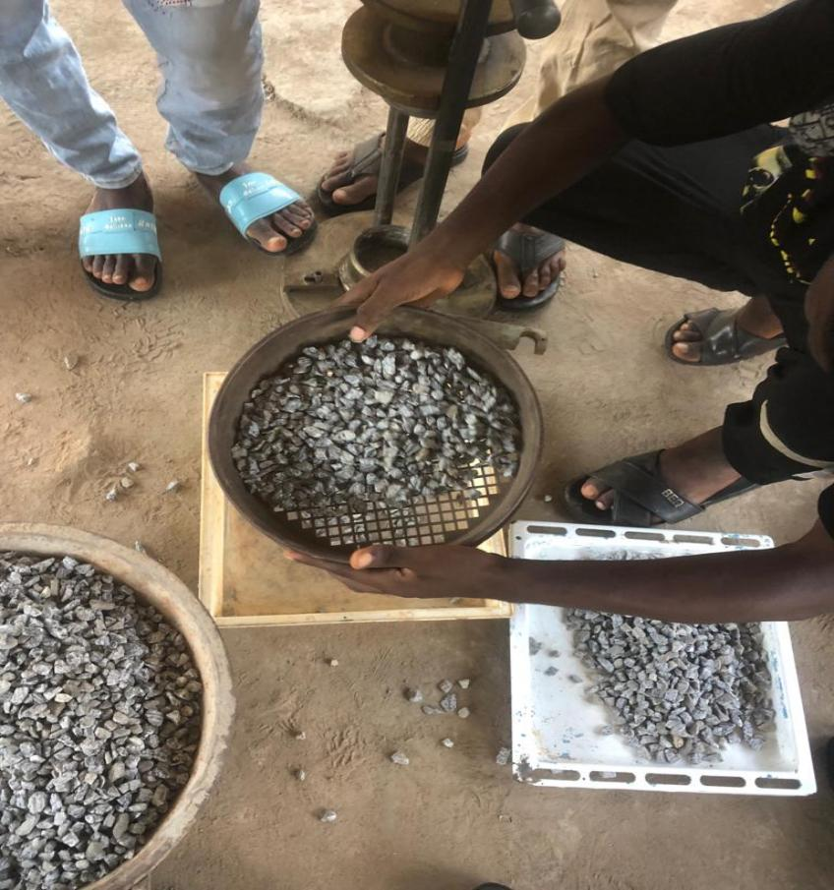
A dry sample of about 500g was prepared and weighed on a digital weighing balance. The sample was sieved through an already arranged set of sieves of different sizes. The samples retained on each sieve set was weighed and the value was recorded. The required calculations were performed and plotted accordingly.

Plate 3-1: Set of Sieve Sizes Arranged Plate 3-2: Impact Value Test
In Descending Order

2.3 Impact Value Test (IV)
Impact value test was carried out to determine the toughness of the aggregate used. This is shown in Plate 3-2.
Procedure:
Dry sample of aggregate passing 14 mm and retained on 10 mm BS sieve was used. An empty cylinder was weighed and recorded as (M₂). This sample was placed in three layers into the empty cylinder with each layer receiving 25 blows. Excess aggregate was removed from the top of the cup and the weight of the cylinder + sample was determined and recorded as (M₁). The compacted sample was placed in a mould directly on the base and placed in the impact machine. The placed sample was subjected to 25 blows. The crushed aggregate were sieved through a 2.36 mm sieve and the mass passing sample was weighed and recorded as (M₃). The weight of the compacted sample was recorded as (M₄).
The Impact Value was estimated using the expression in Equation 3-1
$IV \left(\%\right)=\frac{M4}{M3}∗100………………………Eqn. 3−$1
2.4 Specific Gravity Test (Gs)
Specific gravity is defined as the ratio of the weight in air of a given vol. of material or sample at a temperature to the weight in air of an equal volume of distilled water at the same temperature. This is used to determine various properties of aggregate.
Procedure:
The gas jar and the glass plate were weighed on a digital weighing balance (M₁). 300g of dry sample was placed on the gas jar + plate and weighed as (M₂). Water was then added to the gas jar containing the sample and the entrapped air was expelled. Also, water was later added to the gas jar to the same level with the sample and recorded as (M₃). An empty gar jar was later filled with water and the weight was recorded as (M₄). The specific gravity was calculated using the expression in Equation 3-2:
$$Gs=\frac{M2−M1}{\left(M4−M1\right)−(M3−M2)}……………………Eqn. 3−2$$
2.5 Compressive Strength Test
The quantities of cement, aggregates, and water were mixed together using the manual mixing method.
Procedure:
The values calculated in mix design were measured with the aid of a weighing balance. Slump test was carried out to determine the workability of the concrete prior to casting of 24 cubes of 150 mm x 150 mm x 150 mm. These concrete cubes were place under laboratory condition of temperature for setting. The cubes were demoulded and immersed under water for curing for different curing periods (7days, 14days, 21days, and 28days). At the end of each curing period, 6 cubes were removed, air-dried and subject to a predetermined load to measure their compressive strength. These values were recorded, tabulated and presented in graphical forms to compare the strength at different curing periods. Some of the pictures captured during the compressive strength test are shown in Plates 3-3 & 3-4. The compressive strength is thus, estimated using the expression in Equation 3-3:
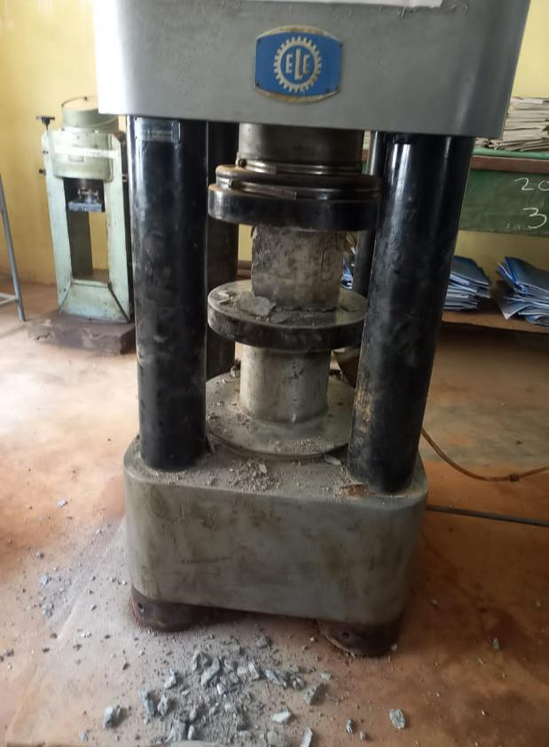
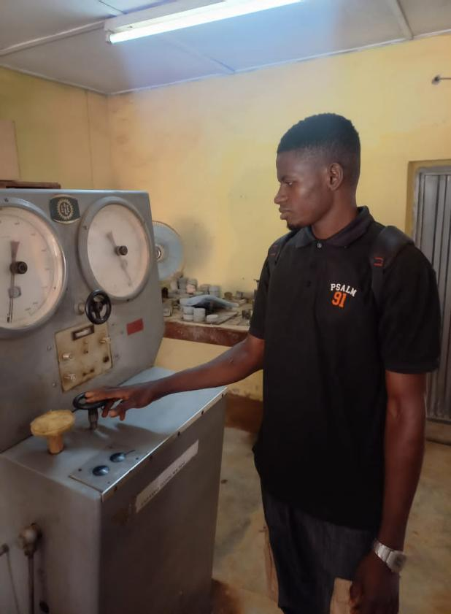

Plate 3-3: Compressive Testing Machine Plate 3-4: Compressive Testing Machine during Crushing

$$Compressive Strength= \frac{crushingload (N)}{effectivearea (mm^{2})}N/{mm^{2}}………….. Eqn. 3−3$$

3.0 RESULTS AND DISCUSSIONS
This section highlights the results of the various laboratory tests and their discussions.
3.1 Material Quantity Estimation
Batching by weight method was used for all the 24 cubes produced for this study. Therefore, the results of the material quantities as estimated above are summarized in Table 4-1.

Table 4-1: Bill of Quantity Prepared for the Materials
S/N | Description | Quantity | Unit
1. | Quantity of cement in 1m³ of concrete | 316 | kg
2. | Volume of a concrete cube | 0.003375 | m³
3. | Volume of 24 cubes concrete | 0.0972 | m³
4. | Weight of cement required for a 24 cubes of concrete | 31 | kg
5. | Weight of water in 24 cubes | 15 | kg
6. | Weight of fine aggregate in 24 cubes | 62 | kg
7. | Weight of coarse aggregate in 24 cubes | 124 | kg

3.2 Sieve Analysis Test Result
The results of the sieve analysis test is divided into two parts; the part for the fine aggregate and the part for the natural gravel. The result of sieve analysis for the fine aggregate is tabulated in Table 4-2 while the particle size distribution curve is plotted in Figure 4-1. Similarly, for the natural gravel, the result of sieve analysis is tabulated in Table 4-3 while the particle size distribution curve is plotted in Figure 4-2.
Table 4-2: Sieve Analysis Test Result for the fine aggregate
Sieve size (mm) | wt. of Sample retained (g) | % Retained (%) | Cum. % retained | % Total Passing
4.75 | 6.00 | 1.20 | 1.20 | 98.24
2.36 | 16.00 | 3.20 | 4.40 | 95.04
1.18 | 70.00 | 14.00 | 18.40 | 81.04
0.60 | 186.00 | 37.20 | 55.60 | 43.84
0.30 | 170.00 | 34.00 | 89.60 | 9.84
0.15 | 44.00 | 8.80 | 98.40 | 1.04
0.08 | 4.20 | 0.84 | 99.24 | 0.20
Pan | 1.00 | 0.20 | 99.44

Figure 4-1: Particle Size Distribution Curve for the fine aggregate

Table 4-3: Sieve Analysis Test Result for the Natural Gravel
Sieve size (mm) | wt. of Sample retained (g) | % retained (%) | Cum % retained | % total Passing
20.00 | 150.00 | 15.00 | 15.00 | 47.70
13.20 | 39.00 | 3.90 | 18.90 | 43.80
10.00 | 200.00 | 20.00 | 38.90 | 23.80
4.75 | 152.00 | 15.20 | 54.10 | 8.60
2.36 | 73.00 | 7.30 | 61.40 | 1.30
0.60 | 12.00 | 1.20 | 62.60 | 0.10
0.30 | 1.00 | 0.10 | 62.70 | 0.00
Pan | 0.10 | 0.20

Figure 4-2: Particle Size Distribution Curve for the Natural Gravel
Coefficient of Curvature Determination
$$Cc=\frac{{D30}^{2}}{D60∗D10}$$
$Cc=\frac{0.5^{2}}{0.8∗0.3}$ = 1.04, approx. 1
Coefficient of Uniformity Determination
$$Cu=\frac{D60}{D10}$$
$$Cu=\frac{0.8}{0.3}=2.7 <4.0$$
Thus, both the coefficient of curvature and coefficient of uniformity are approximately 1, it revealed that the fine aggregate material used is UNIFORMLY GRADED SOIL.

Coefficient of Curvature Determination
$$Cc=\frac{{D30}^{2}}{D60∗D10}$$
$Cc=\frac{{11}^{2}}{70∗5}$ = 0.35, < 1
Coefficient of Uniformity Determination

$$Cu=\frac{D60}{D10}$$
$$Cu=\frac{70}{5}=14, >4.0$$
Thus, both the coefficient of curvature and coefficient of uniformity are approximately 1.0, it revealed that the fine aggregate material used is WELL GRADED GRAVEL.
3.3 Impact Value Test Result
The result of Impact Value Test is tabulated in Table 4-3 while the bar chart showing the comparison between the two experimental trials is plotted in Figure 4-3. From Figure 4-3, it can be concluded that the results are relatively closed with each other. The average Impact Value for the natural gravel is estimated as 38.6.
Table 4-3: Impact Value Test for the Natural Gravel
Experimental trial | A | B
wt of mould + comp. sample (m₁) | 1140.4 | 1145.2
wt of mould (m₂) | 720.0 | 720.0
wt of comp. sample (m₁-m₂) | 420.4 | 425.2
wt of fraction passing 2.36 mm sieve (m₄) | 158.5 | 168.0
Impact Value = (m₄/m₃)*100 | 37.7 | 39.5
IV | 38.6

Figure 4-3: Impact Values for the two Experimental Trials
3.4 Specific Gravity Test Result
The result of Specific Gravity Test is tabulated in Table 4-4 while the bar chart showing the comparison between the specific gravity values for the fine and natural gravel aggregates are plotted in Figure 4-4. From Figure 4-4, it can be concluded that the specific gravity for sharp sand is higher than that for natural gravel. The average specific gravity for the natural gravel and fine aggregates are estimated as 2.62 and 2.64 respectively.
Table 4-4: Specific Gravity Test Results
Aggregate Type | Gravel |  | Sharp Sand
Exp. Trials | A | B | A | B
wt of gas jar (m₁), (g) | 102.20 | 101.10 | 103.50 | 103.50
wt of gas jar + plate + sample (m₂) | 302.50 | 302.00 | 303.50 | 303.50
wt of gas jar + plate (m₃) | 533.00 | 533.50 | 535.50 | 534.70
wt of gas jar + plate + water (m₄) | 408.50 | 409.80 | 410.80 | 410.20
(m₂-m₁) | 200.30 | 200.90 | 200.00 | 200.00
(m₄-m₁)-(m₃-m₂) | 75.80 | 77.20 | 75.30 | 75.50
Specific Gravity (Gs) = (m₂-m₁)/[(m₄-m₁)-(m₃-m₂) | 2.60 | 2.60 | 2.65 | 2.64
Average Gs | 2.62 |  | 2.64

Figure 4-4: Specific Gravity Plots for both fine and coarse aggregates

3.5 Bulk Density Test Result
The bulk density test results for the fine aggregate and coarse aggregate are tabulated in Tables 4-5 and 4-6 respectively. A bar chart showing the comparison between the bulk density values for the fine and natural gravel aggregates are plotted in Figure 4-5 for the two test types (loose and compacted).

Table 4-5: Bulk Density Test Results for Fine Aggregate
Sample | Fine Aggregate |  | Fine Aggregate
Test Type | Loose |  | Compacted
Exp. Trials | A | B | A | B
wt of comp. sample + mould (W₁) kg | 0.758 | 0.765 | 0.81 | 0.803
wt of mould (W2) kg | 0.025 | 0.025 | 0.025 | 0.025
wt of comp. sample (W₁ -W₂) kg | 0.733 | 0.74 | 0.785 | 0.778
Volume of mould (V) (m³) | 0.000535 | 0.000535 | 0.000535 | 0.000535
Bulk density = [(W1-W²)/V] | 1370.1 | 1383.2 | 1467.3 | 1454.2
Avg. Bulk Density | 1376.65 |  | 1460.75

Table 4-6: Bulk Density Test Results for Natural Gravel
Sample | Natural Gravel |  | Natural Gravel
Test Type | Loose |  | Compacted
Exp. Trials | A | B | A | B
wt of comp. sample + mould (W₁) kg | 0.762 | 0.758 | 0.858 | 0.863
wt of mould (W₂) kg | 0.027 | 0.027 | 0.028 | 0.028
wt of comp. sample (W₁-W₂) kg | 0.735 | 0.731 | 0.83 | 0.835
Vol. of mould (V) (m³) | 0.000535 | 0.000535 | 0.000535 | 0.000535
Bulk density = [(W₁-W₂)/V] | 1373.8 | 1366.4 | 1551.4 | 1560.7
Avg. Bulk Density | 1370.1 |  | 1556.05

It can be noted the natural gravel bulk density is higher than that for the fine aggregate when the compacted test type was used while the reverse is the case for when the loose test type was used.

Figure 4-5: Bulk Density Plots for the Natural Gravel & Fine Aggregate
3.6 Slump/Compacting Factor Determination

The slump and compacting factor for both the dry and pre-saturated gravel are summarized in Table 4-9 and pictorially shown in Figures 4-7 and 5-8.
Table 4-9: Compressive Strength Result for the Pre-Saturated Coarse Aggregate
Mix Proportion |  | 1:2:4 | w/c | 0.48
Sample | Aggregate Nature | Slump (mm) | Compaction Factor | Degree of work
 | Dry | 32 | 0.80 | Low
 | Pre-saturated | 52 | 0.85 | Medium

As shown in Figures 4-7 and 4-8, at the same conditions of mix-design ratio and water content, both the workability and the compaction factor for the pre-saturated aggregate are higher relatively to that for the natural dry aggregate. Thus, for the degree of work for the dry aggregate is low while that for the pre-saturated aggregate is medium.

Figure 4-7: A Bar Chart Showing the Comparison between the Workability of the
Dry and Pre-Saturated Coarse Concrete

Figure 4-8: A Bar Chart Showing the Comparison between

3.7 Compressive Strength Result
The compressive strength test results for when the dry aggregate and pre-saturated aggregate were independently used for concrete are tabulated in Tables 4-7 and 4-8 respectively. A clustered bar chart comparing these strengths at different curing periods (i.e. 7days, 14days, 21days, and 28days) is shown in Figure 4-6.
Table 4-7: Compressive Strength Result for the Dry Aggregate
w/c |  | Area of mould (mm²) |  | vol. of mould (mm³)
0.48 |  | 22500 |  | 3375000
Age (days) | weight of cube (g) | Density of cube (g/mm³) | Load at Failure (kN) | Comp. Strength (N/mm²) | Avg. Strength (N/mm²)
7 | 8200 | 0.0024 | 385 | 17.20 | 16.91
 | 8140 | 0.0024 | 329 | 15.80
 | 8140 | 0.0024 | 389 | 17.75
14 | 8160 | 0.0024 | 400 | 18.15 | 18.48
 | 8120 | 0.0024 | 390 | 19.80
 | 8150 | 0.0024 | 410 | 17.50
21 | 8140 | 0.0024 | 450 | 20.20 | 20.36
 | 8160 | 0.0024 | 470 | 20.00
 | 8200 | 0.0024 | 490 | 20.90
28 | 8180 | 0.0024 | 600 | 26.50 | 26.60
 | 8140 | 0.0024 | 590 | 26.50
 | 8100 | 0.0024 | 600 | 26.85

Table 4-8: Compressive Strength Result for the Pre-Saturated Coarse Aggregate
w/c |  | Area of mould (mm²) |  | vol. of mould (mm³)
0.48 |  | 22500 |  | 3375000
Age (days) | weight of cube (g) | Density of cube (g/mm³) | Load at Failure (kN) | Comp. Strength (N/mm²) | Avg. Strength (N/mm²)
7 | 8170 | 0.0024 | 350 | 15.50 | 15.08
 | 8200 | 0.0024 | 340 | 14.75
 | 8170 | 0.0024 | 320 | 15.00
14 | 8150 | 0.0024 | 290 | 17.11 | 17.45
 | 8200 | 0.0024 | 300 | 18.00
 | 8100 | 0.0024 | 425 | 17.25
21 | 8200 | 0.0024 | 300 | 18.11 | 18.45
 | 8150 | 0.0024 | 290 | 19.00
 | 8000 | 0.0024 | 270 | 18.25
28 | 8000 | 0.0024 | 390 | 17.25 | 19.05
 | 8150 | 0.0024 | 400 | 18.95
 | 8100 | 0.0024 | 329 | 20.95

Figure 4-6: A Clustered Bar Chart Showing the Comparison between
The Compressive Strengths of Dry and Pre-Saturated Coarse Aggregate

From Figure 4-6, it can be inferred that the compressive strengths at different curing periods for the pre-saturated aggregates were lower than those recorded at different curing periods for the dry aggregate. Thus, pre-saturation of aggregate has a negative impact on the strength of the concrete.

Table 4-9: Compressive Strength Result Summary
Age (days) | Dry Avg. Strength (N/mm²) | Pre-Saturated Avg. Strength (N/mm²) | Change in Strength (N/mm²) | % Increment
7 days | 16.91 | 15.08 | 1.83 | 10.8
14 days | 18.48 | 17.45 | 1.03 | 5.6
21 days | 20.36 | 18.45 | 1.91 | 9.4
28 days | 26.60 | 19.05 | 7.55 | 28.4

4.0 CONCLUSIONS
It can be concluded that the bulk density of the dry gravel is higher than that for the fine aggregate when the compacted test type was used while the reverse is the case for when the loose test type was used. Also, the average specific gravity for the natural gravel and fine aggregates are estimated as 2.62 and 2.64 respectively. Also, the average Impact Value for the natural gravel is estimated at 38.6
Also, the study conclude that at the same conditions of mix-design ratio and water content, both the workability and the compaction factor for the pre-saturated aggregate are higher relatively to that for the natural dry aggregate. Thus, for the degree of work for the dry aggregate is low while that for the pre-saturated aggregate is medium.
Finally, it can be concluded that the compressive strengths at different curing periods for the pre-saturated aggregates were lower than those recorded at different curing periods for the dry aggregate. Thus, pre-saturation of aggregate has a negative impact on the strength of the concrete. This study, thus, recommends that the pre-saturated aggregate be avoided/treated as much as possible in concrete production because it has negative impact on the compressive strength of the concrete. That is, it reduces the compressive strength at different curing periods.
Acknowledgment
The authors acknowledge the Lab Attendants, Institute of Technology, Kwara State Polytechnic, Ilorin, Nigeria, for providing us with the lab machinery used for this study.
Data Availability
The datasets analyzed during the current study are part of this submission
Funding
This research did not receive any specific grant from funding agencies in the public, commercial or not-for-profit sectors.
Conflict of Interest
The authors declare no competing interest in this research paper.

References

[1] | Z. Chenglong and C. Yu, "The effect of nano-SiO2 on concrete properties: a review," Nanotechnol Rev, vol. 8, pp. 562-572, 2019.
[2] | N. Venkat Rao, M. Rajasekhar, K. Vijayalakshmi and M. Vamshykrishna, "The future of civil engineering with the influence and impact of nanotechnology on properties of materials," in 2nd International Conference on Nanomaterials and Technologies (CNT 2014), 2015.
[3] | T. C. Hansen, "Recycled aggregates and recycled aggregate concrete, recycling of demolished concrete and masonry," RILEM (International Union of Laboratories and Experts in Construction Materials, Systems and Structures), p. 6, 1992.
[4] | Barra et al., "The influence of retained moisture in aggregates from recycling on the properties of new hardened concrete," Waste management, vol. 16, no. 1-3, pp. 113-117, 1996.
[5] | Poon et al., "Influence of moisture states of natural and recycled aggregates on the slump and compressive strength of concrete," Cement and concrete research, vol. 34, no. 1, pp. 31-36, 2012.
[6] | L. Czarnecki, "Sustainable Concrete; Is Nanotechnology the future of concrete polymer composites?," Advanced Materials Research, vol. 687, pp. 3-11, 2013.
[7] | Y. Feng, Y. Su, N. Lu and S. Shah, "Meta Concrete: Exploring Novel Functionality of Concrete Using Nanotechnology," Engineered Science, vol. 8, pp. 1-10, 2019.
[8] | P. Asokan, S. Mohini and A. R. Shyam, "Solid wastes generation in India and their recycling potential in building materials," Building and Environment, vol. 42, pp. 2311-2320, 2007.
[9] | V. Letelier, J. M. Ortega, E. Tarela, P. Muñoz, B. L. Henríquez-Jara and G. Moriconi, "Mechanical performance of eco-friendly concretes with volcanic powder and recycled concrete aggregates," Sustainability, vol. 10, pp. 30-36, 2018.
[10] | H. Md. Uzzal, C. Rongjin, S. Thomas Ng, X. Dongxing and Y. Hailong, "Sustainable natural pozzolana concrete - A comparative study on its environmental performance against concretes with other industrial by-products," Construction and Building Materials, pp. 1-10, 2020.
[11] | F. Lius, J. de Brito and M. Barra, "Influence of the pre-saturation of recycled coarse concrete aggregates on concrete properties," Magazine of Concrete Research, vol. 63, no. B, pp. 617-627, 2011.
[12] | A. Pierre-Claude , "Cements of yesterday and today: Concrete of tomorrow," Cement and Concrete Research, vol. 30, no. 9, pp. 1349-1359, 2000.
[13] | F. Cartuxo, J. de Brito, L. Evangelista, J. R. Jiménez and E. F. Ledesma, "Rheological behaviour of concrete made with fine recycled concrete aggregates - Influence of the superplasticizer," Construction and Building Materials, vol. 89, pp. 38-47, 2015.
[14] | M. Chau-Khun, Z. A. Abdullah and O. Wahid , "Structural and material performance of geopolymer concrete: A review," Construction and Building Materials, vol. 186, pp. 90-102, 2018.
[15] | D. Rodrı ´guez-Robles, J. Garcı ´a-Gonza´lez, A. Juan-Valde´s, J. M. Mora´n-del Pozo and I. M. Guerra-Romero, "Effect of mixed recycled aggregates on mechanical properties of recycled concrete," Magazine of concrete research, vol. 67, no. 5, pp. 247-256, 2015.
[16] | V. W. Y. Tam, X. F. Gao and C. M. Tam, "Microstructural analysis of recycled aggregate concrete produced from two-stage mixing approach," Cement and concrete research, vol. 35, no. 6, pp. 1195-1203, 2005.
[17] | M. Etxeberria, E. Va´zquez , A. Marı and M. Barra, "Influence of the amount of recycled coarse aggregates and production process on properties of recycled aggregate concrete," Cement and concrete research, vol. 37, no. 5, pp. 735-742, 2007.
[18] | J. Lima, "Proposition of guidelines for production and standardization of construction and demolition waste and of its application in mortars and concrete (in portuguese) Masters dissertation in Architecture and Urbanism,," School of Engineering of Sao Carlos of the University of Sao Paulo, Sao Carlos, 1999.

