C M RAVI KUMAR

YAJNODBHAVI H M PRUTHVI RAJ S R MARUTHI T
RAGHAVENDRA S
1.

2.

3.

4.

5.
Author names:
The authors whose names are listed immediately below report the following details of affiliation or involvement in an
organization or entity with a financial or non-financial interest in the subject matter or materials discussed in this manuscript. Please specify the nature of the conflict on a separate sheet of paper if the space below is inadequate.
C M RAVI KUMAR

YAJNODBHAVI H M PRUTHVI RAJ S R MARUTHI T
RAGHAVENDRA S
1.

2.

3.

4.

5.
Author names:
The authors whose names are listed immediately below certify that they have NO affiliations with or involvement in any
Organization or entity with any financial interest (such as honoraria; educational grants; participation in speakers' bureaus; membership, employment, consultancies, stock ownership, or other equity interest; and expert testimony or patent-licensing arrangements), or non-financial interest (such as personal or professional relationships, affiliations, knowledge or beliefs) in the subject matter or materials discussed in this manuscript.

Conflicts of Interest Statement

Manuscript Title: Compressive and Flexural Strength Property Enhancement for Fibre Reinforced Standard Concrete (FRSC), High Strength Concrete (FRHSC) and High Performance Concrete (FRHPC) using Foundry Sand (FS) and Crushed Concrete Waste (CCW)

Ravi Kumar C M *¹, Yajnodbhavi H M*², Pruthviraj S R*³, Maruthi T*⁴, Raghavendra S*⁵

¹ Associate Professor, Department of Studies in Civil Engineering, University B. D.T College of Engineering ( A Constituent College of Visvesvaraya Technological University), Davangere-577004 Karnataka, India
² Assistant Professor, Department of Civil Engineering, PES Institute of Technology and Management, Shivamogga 577204 ,Karnataka, India
^{3,4 & 5} PG Students, Department of Studies in Civil Engineering, University B. D.T College of Engineering ( A Constituent College of Visvesvaraya Technological University), Davangere-577004 Karnataka, India
∗E-mail:cmravibdt@gmail.com,yagna.hm@pestrust.edu.in,pruthvi960637@gmail.com, maruthimanoj3@gmail.com, raghush96@gmail,com.

Declaration of interests

☐ The authors declare that they have no known competing financial interests or personal relationships that could have appeared to influence the work reported in this paper.

☐The authors declare the following financial interests/personal relationships which may be considered as potential competing interests:
We hereby declare that the contribution of this paper is based on combined effort of the authors research work done at University B D T College of Engineering, Davanagere.

We acknowledge that the support extended by Visvesvaraya Technological University and provided all facilities to do the work within the stipulated time.

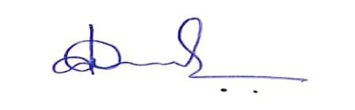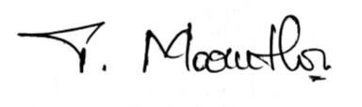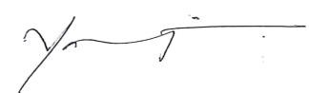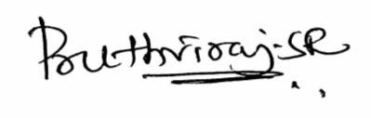

23-07-2020
RAGHAVENDRA S
23-07-2020
MARUTHI T
23-07-2020
PRUTHVI RAJ S R
23-07-2020
YAJNODBHAVI H M
23-07-2020
C M RAVI KUMAR
Date
Author's signature
Author's name (typed)
This statement is signed by all the authors to indicate agreement that the above information is true and cor-
rect (a photocopy of this form may be used if there are more than 10 authors):

