Extended Reality in Quantity Surveying
Tarun Kumar Makkenaª, VPS Nihar Nanyam ^{b*}
ªStudent, RICS School of Built Environment, Amity University, India
*^{b}Asst. Professor, RICS School of Built Environment, Amity University, India
Corresponding Author’s email id : nnanyam@ricssbe.edu.in
Abstract
Purpose – It is possible for cost professionals to prepare an informed and compendious cost plan by identifying all the factors that cause cost overruns, variations, safety hazards and others without having a significant prior experience. The implementation of Extended Reality can address this phenomenon. The paper aims to introduce the concept of Extended Reality in the field of quantity surveying by exploring its untapped potential and also looks to identify critical barriers in implementing this technology.
Methodology/approach –A detailed review of literature study produced eight critical factors acting as barriers in successful implementation. With the suggestions from the industry professionals, the inter-relationship among these factors were established and prioritised using Interpretative Structural Modelling (ISM) tool. Further, these factors were categorised using MICMAC (Cross-Impact Matrix Multiplication Applied to Classification) analysis.
Findings – This study identifies, Lack of expertise and Lack of suitable software as the key driving factors in successful implementation and all the remaining factors are directly or indirectly influenced by them.
Research limitations –The sample size considered in building the ISM network is limited to the Indian construction industry. The disadvantages of Extended Reality have not been covered in the study. There may be several negative repercussions to human health due to this technology.
Practical implications – This study can be used by industry professionals in understanding how advance technology like this can overcome many challenges pertinent to cost planning and estimation.
Originality/value – This study stands out among the few research topics which contribute to reducing the knowledge gap among the cost professionals irrespective of their experience.
Keywords – Augmented Reality, Extended Reality, Mixed Reality, Virtual Reality.

1. Introduction

1.1 Background
The engineering and construction industry plays a vital role in building the future of the modern world. The real estate and construction together are the second largest employment provider in India after the agriculture industry, according to the economic survey 2017-2018. Since decades being the largest employment provider, the industry faces many obstacles such as material price sensitivity, shortage of talent, the rapid pace of technology changes and so on.

Quantity surveying is an integral part of the construction activities which govern the three critical variables in the construction, namely the cost, quality, and time. The various activities involved in this field are as follows,
- Quantity take-off  - Conceptual to Detailed estimates  - Preparation of Bill of Quantities  - Cash flow projections | - Cost and Quantity reconciliation  - Cost planning  - Life cycle costing and Value engineering, etc.

1.2 Problem Identification
Quantity surveying, the most significant part of the construction, has been facing many challenges from decades which lead to cost overrun, delay of activities, variations, safety issues, etc. Few of them are listed as follows,
- Lack of understanding capabilities: In the process of preparation of a cost plan the cost planner should have a logical insight of the scope of the project so that the cost arrived at the end will cover all the works and items in the project. These understanding capabilities are limited to highly experienced professionals in the industry, which are in shortage.
- Human error: During various activities like quantity take-off, quantity reconciliation, detailed estimate, etc., we tend to overlook or misinterpret many items which will have a direct impact on the cost and time of the project.
- Risk management: In the case of risk management, quantity surveyors play a vital role in allocating the contingency reserves for the project, which is essential in unplanned situations. This allocation depends on how well the quantity surveyor understands and forecasts the risks in the project. For instance, a construction project in the earthquake zone or a terrain with a sloppy surface will have a high contingency reserve allocated as a proactive measure.
- Paper-based communication: The traditional way of communication, i.e. through the paper is being practised widely across the industry, is a time-consuming and unsecured process. This way of communication produces many files which further will require physical space to store, and also the auditing process is complicated and time-consuming.
Statistical facts of the construction industry:
- 32% of the construction productivity software users saved at least over 5 hours each week^{[1]}.
- 30% of the construction work performed by the companies are reworking^{[2]}.
- 1% reduction in the cost of construction could save $100 billion globally^{[3]}.
- 52% of rework happening is caused because of sparse project data and miscommunication^{[1]}.

1.3 Motivation
In today's world because of the advancement and exploration of human intelligence many revolutionary technologies such as Excel, MS Project, BIM, Cost X and others has transformed and is transforming the construction activities in a customised and flexible way to the users. Even though BIM took the industry to the next level of visualisation, the only lacking feature is "the experience of the user to feel the visualisation". It is said that "knowledge is information gained through experience" and the use of Extended Reality technology overcomes this limitation.
As we all are familiar with words like Virtual reality, Augmented reality, etc. in the industry of entertainment like gaming, cinemas, etc. There are instances around the world, showing the usage of these technologies enhancing the user experience.
Unprecedented pandemic situation accelerates the need to adapt technologies for collecting, processing, managing, and remotely visualising data.
Therefore, the exploration of such technologies and its implementation in the built environment makes the activities more flexible and intractable.

1.4 Objective of the research study
- Listing the available technologies on extended reality and explaining their potential in the field of quantity surveying.
- Identifying the critical barriers and key benefits in the adoption of this technology in the industry.
- Finding out the interrelationship between these barriers using "Interpretive Structural Modelling" and categorising them by "MICMAC" Analysis.

1.5 Outline of the research
This study introduces the concept of "Extended reality in the field of quantity surveying" by exploring its potential and benefits. Also, identifying the critical barriers in implementing such technologies through a detailed study of previously published literature. The inter-relationship between the barriers are established through a qualitative approach to identify the highest influential barriers in implementing this technology to focus on such factors can bring a significant change in the industry.

1.6 Section summary
This section introduces the importance of quantity surveying in the construction industry, along with various activities involved in it, such as quantity take-off, all types of estimate preparation, cash flow projections, and others. The challenges pertinent to quantity surveying in the field of construction industry are described, and critical statistical data published by standard organisation is quoted to provide a better understanding of the current industry needs.
Further, some key features like virtual user experience lacking in the existing technologies like BIM, CostX, Candy CCS and others are identified, and the gaps have been fulfilled by using a new-age technology called Extended Reality. This feature is an advancement to BIM.

2.Extended Reality

2.1 Introduction
Extended reality (XR) is a broad term which describes the wide spectrum of real-world to virtual world interactions between human and machines, generated by computers and wearable technologies. It comprises three key technologies, namely Virtual Reality (VR), Augmented Reality (AR) and Mixed Reality (MR) and everything in between them, as shown in figure 1 below.
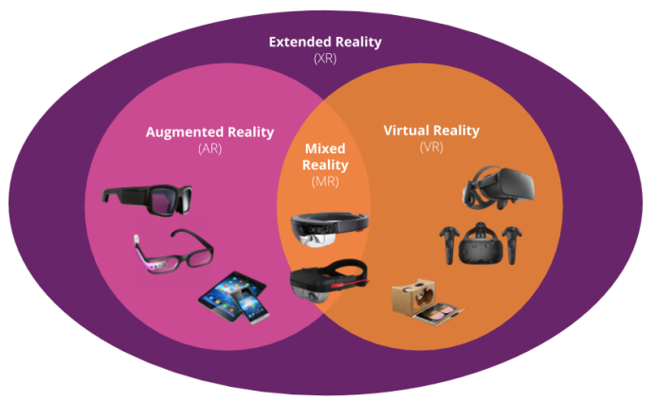
Figure 1 Spectrum of Extended Reality^{[4]}

Virtual Reality (VR) is a technology which immerses the human into a virtual environment generated by the computer. It also involves an interaction between human and the virtual elements in the background to make it feel real.
Augmented Reality (AR) is a technology in which it augments the view of the actual world with virtual content. It overlaps the virtual models to the real physical environment, which gives a better understanding experience to the user. It does not involve any interaction of the human with the virtual content.
Mixed Reality (MR) is an advancement of augmented reality, bringing up the flexibility to interact on a real-time basis with the virtual content superimposed on the actual world. "Flexibility" is the critical attribute of this technology.

2.1.1 Existing available technology
The major available technologies working on the concept of extended reality are as follows.

Virtual Reality |  | Augmented Reality/Mixed Reality
- Oculus Rift  - PrioVR  - Unity | - Unreal  - HTC Vive | - Google HoloLens  - Vuforia  - Easy AR | - AR Toolkit  - Kundan

2.1.2 Forecasted Market Size of AR and VR.
The forecasted market size - Augmented reality and Virtual reality in Billion US dollars from 2016 to 2022.

Figure 2 Forecasted market size of AR and VR^{[5].}

2.2 The core elements of XR.
It comprises of three core elements as follows:
1. Data collection: The process begins with collecting the real-time on-site data through multiple means like sensors, cameras and processors. This data is then connected to an ecosystem called IoT (Internet of Things), where the data is analysed and processed.
2. Presentation: The data should neither be excessive nor insufficient. It should be as per the requirement to not cause any complexity in comprehending the data.
3. Interaction: Finally, the Extended Reality not only enables the virtual displayed information but also allows the user to interact with the data naturally, which is shown in figure 3.

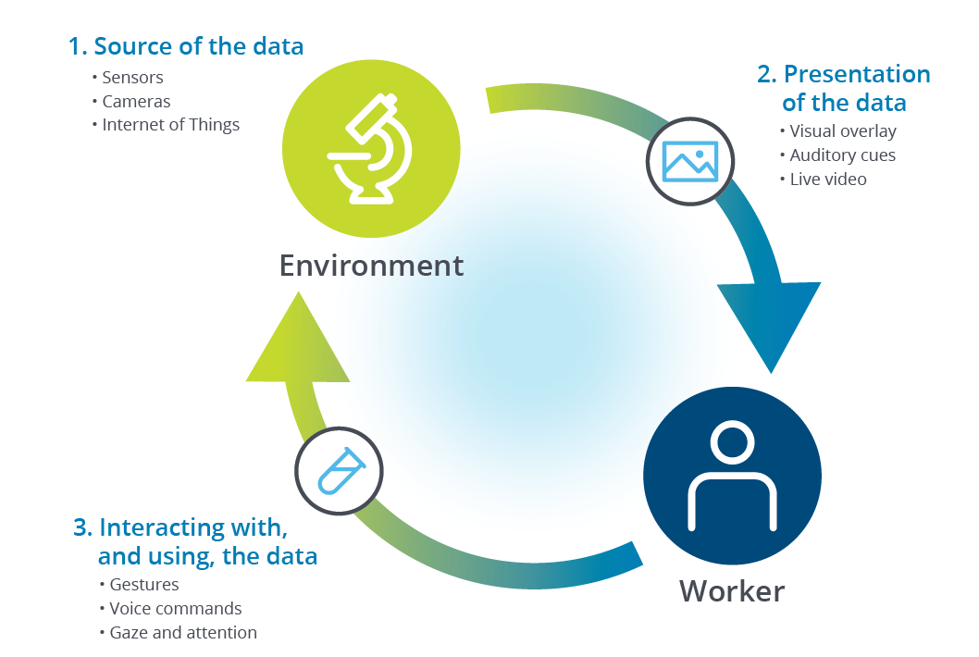
Figure 3 Core Elements of XR^{[6]}

2.3 The Impact of XR on various activities in QS.

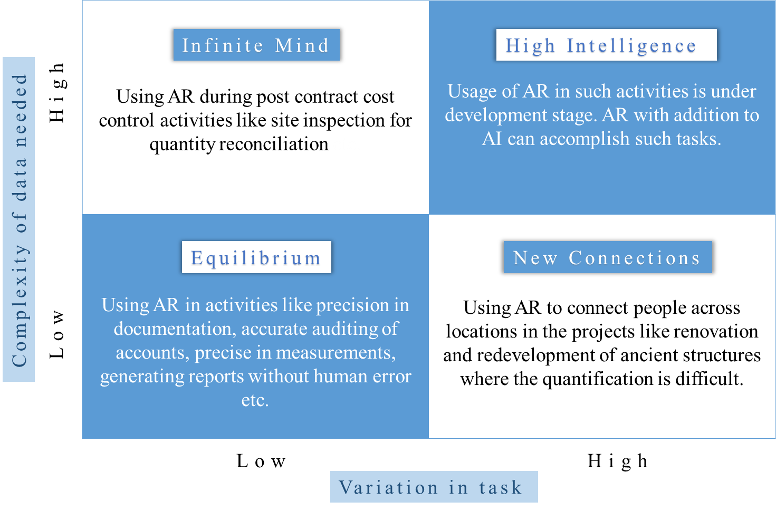
Figure 4 The Impact of XR on various activities in QS
Source: Author’s compilation

Category 1: Equilibrium
This category focuses on the activities which deal with data of low complexities needed and small variation in work. Here AR has been used by the employee only to do the work that has been told to him, but more efficiently. Example, such as enhancing the visualisation of the model, precision in document preparation, tracking the physical movements and helping in increasing the labour productivity, accurate auditing of accounts without human errors, etc.

Category 2: Infinite Mind
This category focuses on the activities which deal with high complexities in data needed and low variation in work. Quantity surveyors by default handle high volumes of data during the entire project life cycle as they are responsible for planning, record, monitor and maintain positive cash flow so that the project gets completed within the budget.
For example, during the post-contract stage, the quantity surveyor doing the site inspection work for quantity reconciliation carries high volumes of data such as drawings, receipts, etc. in case of HVAC measurements the complexity of understanding data increases. In such cases, AR makes it flexible by storing, superimposing and documenting the data on-site with wearable technologies.

Category 3: New Connections
This category focuses on works which deal with low complexities in data needed and high variation in practice. For example, in the projects like renovation or redevelopment of ancient historic structures, the quantification and material selection process is a strenuous task which requires professionals of high competencies. In such a scenario, AR technology is used to establish connections between professionals across different locations. The unique attribute is that the view of the angle can be kept the same for the people connected so that the person can see what you see. Thus, the communication is on a real-time basis.

Category 4: Full Symbiosis
This category focuses on works which deal with high complexity in data needed and high variation in the task. It refers to the usage of AR at its highest point, which is in the under-development stage. Here the complexity of data needed and variation of the task is high, and an interface is required, which brings the best of both humans and machines together. Augmented reality, in addition to Artificial intelligence (AI), can accomplish tasks of such a category effectively.

2.4 Traditional approach vs Modern Approach
Comparing the traditional approach of 'issuing a variation order to the contractor' with the modern approach:
The detail pictorial representation of the process is presented as follows:

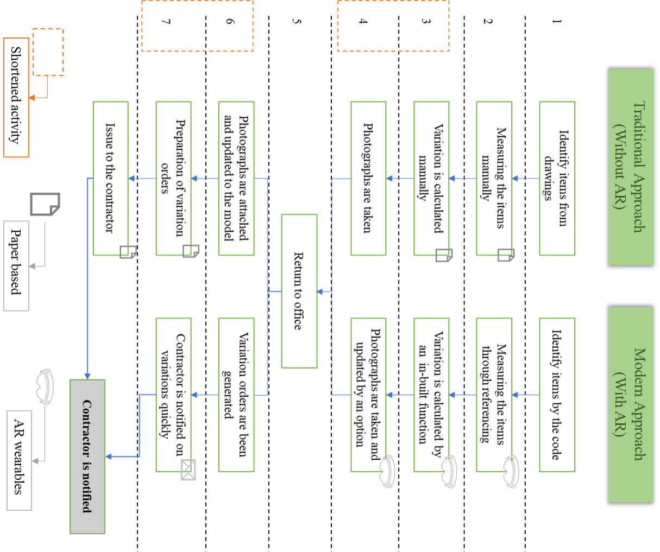

Figure 5 Traditional approach vs Modern Approach
Source: Author’s Compilation

2.4.1 Pictorial representation
The process as mentioned earlier is represented in sequential numerical order from 1 to 12.

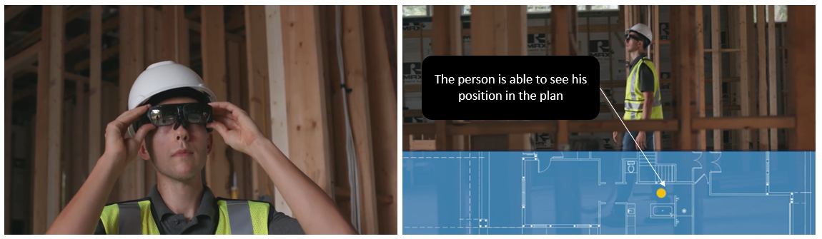
2. Tracking the position on the plan
1. Wearing the head-mounted A.R. device

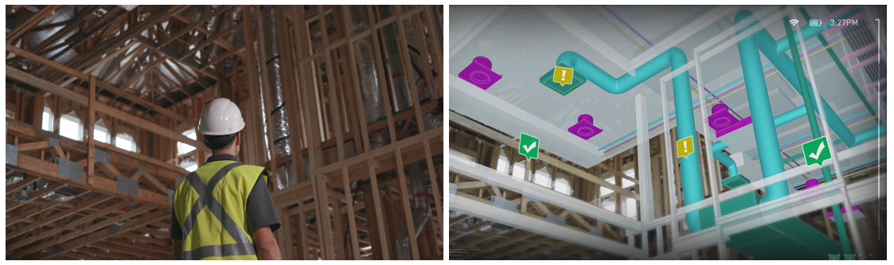
4. Augmented-view of the surrounding position
3. Real-view of the surrounding position

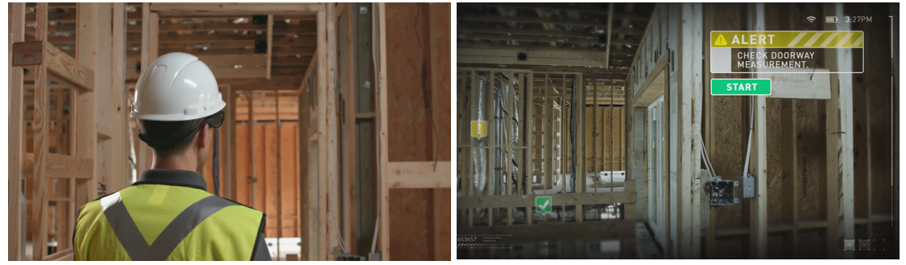
6. Augmented-view of the doorway before measuring,
with an option to measure the length of the doorway.
5. Real-view of the doorway before measuring.

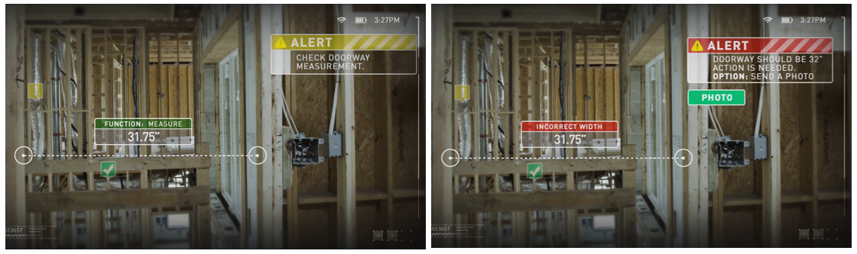
8. Indicating that the measurement of the doorway is not the same as per the drawings.
7. The augmented view of measuring the width of the doorway.
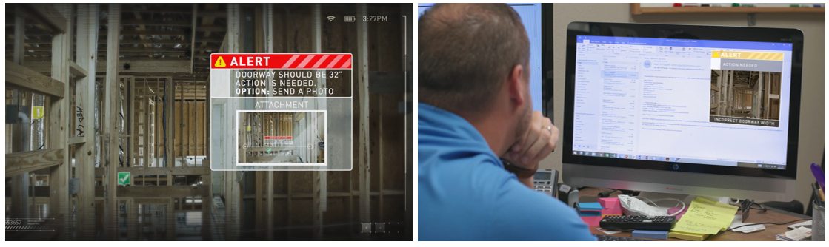
10. Off-site team receiving the update instantly on a real-time basis.
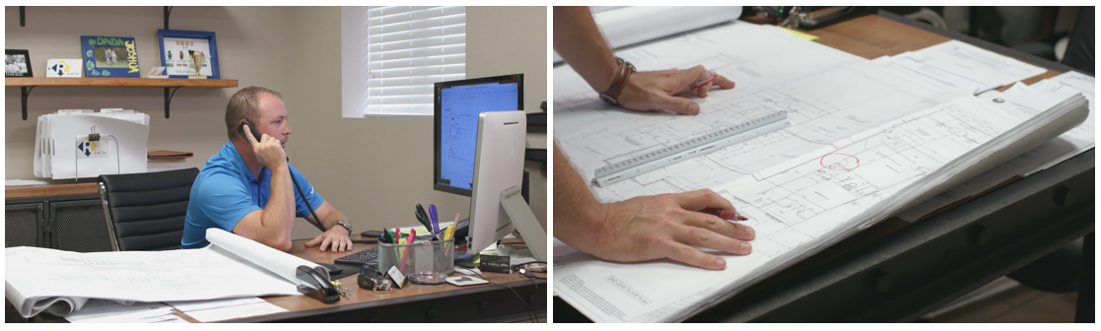
9. Augmented-view of attaching and sending a photo pertinent to the doorway measurement.
12. Necessary corrections and measures are taken pertinent to the input on real-time basis.
11. Getting insight of the update from the on-site team.
Source: ^{[7]}

2.4.2 Section Summary
From the above figure, it has been identified that the modern approach eliminates many activities such as 3,4,6 & 7 from the former approach. Therefore, the total time for the specific activity, i.e. issuing a change order is reduced.
In the traditional approach, the means of communication will be either in written format or through emails which again consume time and effort. The data recording process in the conventional method involves large volumes of data files which further require a physical space to store. In the modern approach, the means of communication is instant, and the data recording process is quick, which also includes a facility to attach photos for a logical record of data. Once the message is sent to the head office, necessary corrections and measures are done. The quantity surveyor in the traditional approach needs to carry and have a better understanding of the drawings to inspect the work and variations. But, with the contemporary approach, the quantity surveyor need not take any drawings to the site as all the data is embedded in the wearables he wears. He can locate the point where he is in the plan, which is shown in the pictorial representation above.

3. Literature Review

3.1 Introduction
Many literature documents have been published on the applications of virtual reality and augmented reality in the field of construction, logistics, and safety. There are a limited number of papers published on the forms of Virtual Reality and Augmented Reality in Quantity Surveying. For this research paper, 15 literature documents were studied to understand the potential of these technologies and to identify the critical barriers in the implementation.

3.2 Studies done on Augmented reality
Bademosi and Issa ^{[8]} discussed the untapped potential of AR technology in each phase of the project life-cycle such as Conceptual planning, Design, and Pre-construction, Construction, Operation and Maintenance by conducting a content analysis-based review method.
Future Scope: The authors recommended research and development on the possible applications of AR in the deconstruction phase and material disposal management.
Suk et al.^{[9]} discussed how 3D models make the Quantity Take-off easy and more accurate. This study was conducted on 22 sophomore construction management students taking a course on estimation. Comparative performance analysis of these students in quantity take-off between 2D and 3D models were done. The results revealed that students were able to perform and gain accurate results with the 3D models than 2D drawings comparatively.
Future Scope: The authors recommend more research and development in simplifying the processes to create input data, i.e. from 2D or BIM to AR interface.
Behzadi^{[10]} discussed the potential of VR/AR technologies in various activities such as Scheduling, Communication/Information Retrieval, Man-Labour Hours and Safety in the construction site as it gives a real-time view of multiple ongoing situations. The author states that "AR technology has a higher benefit than VR technology" comparatively.
Future Scope: The authors recommend further study to identify the critical barriers and drawbacks for these technologies.
Kirchbach and Runde^{[11]} discussed the potential of VR and AR in effective construction site control using software named "A4CC (Architecture for construction control)". A comparative experimental study was done on two distinct cases namely "Control centre case" and "On-site case" where the AR and VR were used to simulate various situations in the site to an output understandable to the user without any computer knowledge.
Zaher et al.^{[12]} discussed how the handheld mobile devices, when combining with the technologies like AR and BIM, provides a powerful platform for construction progress monitoring by developing a new technology named "BIM-U" and "BIM Phase". This technology not only tracks the progress and does 5D modelling but also adds various essential cost parameters to the models for effective monitoring on a real-time basis.
Future Scope: The author recommends further research and development of software's which determines the variation from the planned and actual model. Also improvising the proposed system using technology like "HoloLens" and then conducting user feedback studies.
Stoltz et al.^{[13]} discussed the potential of AR in various activities of Warehouse such as receiving, storing, packing and shipping. The author further discusses the barriers in implementing this technology through multiple interviews and by conducting an experimental study. In this experiment, AR has been used through a head-mounted wearable which made most of the practitioners satisfied over AR on mobile devices in terms of faster performance, user-friendly and time-saving.
Future Scope: The author recommends further enhancement in the hardware and software based on the user experience.
Agarwal^{[14]} defines AR as a "Mediated Reality" and discusses the benefits, need of AR technology in the AEC industry and the technologies available such as Integrated AR applications, Immersive AR applications, Mobile AR application, and others. Challenges in implementation in terms of cost, spatial alignment and development, etc. are also discussed.
Future Scope: The author recommends further research and development of a streamlined software.
Woodward et al ^{[15]} discussed how V.R./A.R. technologies are used in the planning and construction phase of VTT's new head office in Finland such as radiosity rendering, mobile outdoors augmentation, augmented scale model/web camera, etc.
Future Scope: The author recommends future development on the responsiveness of 3D CAD modelling systems and mobile augmented building visualisation applications.

3.3 Studies done on Virtual Reality
Olatunji^{[16]} discussed and categorised all the existing software applications for estimating practice such as Quantification applications, Data Extraction programs, Pricing applications, and Resource and Planning programs. The author also mentions that regular updates of this software will only sustain in long-run.
Future Scope: The author recommends research and development of a standardised framework for selecting a suitable software of estimating purpose.
Bellos ^{[17]} discussed how VR technology plays a vital role in critical decision making using an "interactive step optimisation method" with an example consisting of a "continuous column in a three-storeyed building" subjected to changes in length. The author also mentions that the absence of VR in complex projects will make the decision-making process more sensitive.
Haggard ^{[18]} discussed the potential of VR technology with a case study. In this study, a company named BNBuilders implemented VR technology in their project, which in return made them save money, limit rework and improve communication. All the information presented has been cumulated through a phone call from the client (Vertex Pharmaceuticals) and the contractor (BNBuilders).
Future Scope: The author recommends further research and development of a streamlined software.
Avhad and Hinge^{[19]} discussed the changes in the construction industry due to the advancement of information and technology, specifically focusing on VR and AR technologies. The paper also described the uses of VR in the real-estate business in terms of marketing, visualisation, customisation, etc. therefore increasing its efficiency in satisfying the end-users.
Future Scope: The author recommends further study in the role of VR Material management, Inspection and Maintenance, Safety training and Skill Development, Project planning and monitoring.
Jain and Kokate^{[20]} discussed the applications of VR technology in the field of Real-Estate such as transparency on product/services offered, Virtual touring for homes, More customer reach, Mobility, Improved Brand Image, etc. Thus, enhancing the experience of customers will increase the brand of the organisation.
Holt et al.^{[21]} discussed the need of educators to be aware of the emerging technologies in the construction industry by conducting a survey across the US Construction industry which gathered more than 1000 responses. The authors further discuss the changes to be done in construction higher education which will have a high impact on the industry.
Future Scope: The author recommends research and development in finding cost-effective ways of implementing these technologies.

3.4 Barriers identified from the literature review
High initial cost, lack of expertise, lack of interoperability, Lack of suitable software, Resistance to organisational change, Lack of industry standards and data preparation, Lack of support from the management, Lack of technical support, Lack of knowledge and training were the key barriers identified from the literature review.
From the study done by Holt et al.^{[21]} shows that most of the professionals from the construction industry responded that the key barriers are High initial cost, Lack of expertise, Lack of knowledge and training for the implementation of the technology.
As the models in construction involve high data rendering processes and appropriate hardware requirements, which further needs the expertise to operate, makes the initial installation cost high.
From the study done by Abboud ^{[22]} and Carlsen^{[23]} shows that lack of support from the management, Resistance to organisational change, lack of industry standards and data preparation are one of their limiting factors for the implementation of these technologies. There are many A.R./V.R. platforms on which the designers work with no standard platform causing delays in purchasing decisions, and also restricts the user to work on limited platforms for the development of multiple AR apps.
In the research done by Whyte el al. ^{[24]}, the limiting factor identified for the use of these technologies is the 'lack of interoperability'. Due to 'lack of industry formats', the data/model that has been operated in one interface cannot be performed in other platforms. The data modification should be done in both the platform which is a time-consuming process.
In the study done by Olatunji ^{[16]} and Piroozfar et al.^{[25]} the barriers identified were 'Lack of technical support' and the 'Lack of suitable software' for these technologies. In brief, they can be inferred as the 'lack of professional staff' required for the software and hardware development. There are many platforms with no standardisation processes and techniques to select suitable software because of their principal motive behind their origin. For instance, VR was introduced primarily in the entertainment industry to enhance user experience.
Table 1 Critical Barriers identified
S.No. | Barriers | Literature Support
1 | High Initial Cost | Holt et al.^{[21]}
2 | Lack of Expertise | Holt et al.^{[21]}, Carlsen^{[23]}
3 | Lack of interoperability | Whyte el al. ^{[24]}
4 | Lack of suitable software | Olatunji ^{[16]}
5 | Resistance to Organisational change | Abboud ^{[22]}, Holt et al.^{[21]}
6 | Lack of industry standards and data preparation | Abboud ^{[22]}
7 | Lack of Technical Support | Piroozfar et al.^{[25]}
8 | Lack of Knowledge and Training | Holt et al.^{[21]}

3.5 Research Gap
Most of the researchers who worked on virtual and augmented reality were primarily focussed in the field of real estate, architecture, engineering and construction. From the research conducted so far, there is no publication focused on identifying the potential of 'Extended Reality' in Quantity Surveying, which is a significant part of the construction industry.

4.Benefits of Extended Reality

4.1 Benefits identified from case studies
The following is the tabulated form of 10 case studies identified across the world on the usage of virtual and augmented reality in various activities in their objectives. These cases are studied, and key benefits are identified with the source and are included in the table.

Table 2 Key benefits identified
S. No | Source | Key benefits identified | Application
1 | Woodward et al.^{[15]} | 1. Improved understanding and visualisation  2. Ease in interior design and material selection | A wide range of VR/AR applications was used in the planning and construction phase such as immersive virtual reality visualisation, augmented scale model, augmented web camera, etc. for better visualisation and communication of the project.
2 | Pejic et al.^{[26]} | 1. Improved understanding and visualisation  2. Ease of access | The three-dimensional model of the residential complex has been presented using VR and AR technologies for better visualisation instead of printing the 3D rendered model on a brochure.
3 | Guo-Cheng Li ^{[27]} | 1. Reduction in construction time  2. Reduction in construction cost  3. Effective resource management  4. Effective risk management  5. Effective safety management  6. Effective decision making | The VR concept was used to develop an interface named "VCPCS (Virtual Construction Project Control System)" through which an optimal construction plan was obtained to prevent multiple unfavourable construction intents.
4 | Lorentzen et al. ^{[28]} | 1. Effective risk management  2. Effective Safety management | The VR technology is used in simulating the real environment, which includes road alignment, placement of road signs, etc. and was tested virtually for efficiency and safety purpose.
5 | Woksepp ^{[29]} | 1. Reduction in construction time  2. Effective communication  3. Effective resource management  4. Effective risk management  5. Effective safety management  6. Effective decision making | The construction of a new pelletising plant had many constraints such as time, cost and complexity, which were overcome by developing various VR and 4D models in the planning and design phase.
6 | Haggard ^{[18]} | 1. Reduction in errors  2. Reduction in construction time  3. Reduction of construction cost | The BNBuilders being the contractor implemented VR for visualising the project (including core and shell) which gave them the benefit of reducing clashes, cost and time of construction.
7 | Baydoğan ^{[30]} | 1. Effective decision making  2. Ease of evaluating material | The Swedish company developed a mobile application on AR through which the customer can choose the right furniture for their homes from anywhere.
8 | Whyte et al. ^{[24]} | 1. Improved understanding and visualisation  2. Ease in interior design and material selection  3. Effective decision making  4. Customer satisfaction | Research is done at Loughborough University on the implementation of VR in new residential projects during the design, construction and marketing phases to improve the quality, performance and customer satisfaction.
9 | Pejić et al ^{[31]} | 1. Improved understanding and visualisation  2. Ease of access | The three-dimensional model of the single storey house has been presented using VR and AR technologies for better visualisation instead of printing the 3D rendered model on a brochure.
10 | Autodesk^{[32]} | 1. Reduction in errors  2. Reduction in construction time  3. Ease in inspection and reporting  4. Effective communication  5. Effective decision making | Due to an aggressive deadline to complete a new building in Boston, Gilbane takes advantage of VR to validate the prefabrication work, to build faster.

5.Research Methodology

5.1 Introduction
The tool used in this study is "Interpretive Structural Modelling (ISM)". It is used to find the interrelationship between various barriers/factors identified in the problem. The barriers are categorised in multiple levels through multiple iterations to establish a clear relationship; further, the barriers are categorised based on their driving and dependence powers.

5.2 Key Objectives
- To identify the critical variables of the problem and rank them accordingly.
- To identify the inter-relationship among the variables identified.
- To classify the variables based on their driving and dependency powers obtained.

5.3 Methodology adopted
A detailed review of literature study produced eight critical factors acting as barriers in successful implementation. With the suggestions from the industry professionals, the inter-relationship among these factors were established and prioritised using Interpretative Structural Modelling (ISM) tool. Further, these factors were categorised using MICMAC (Cross-Impact Matrix Multiplication Applied to Classification) analysis. The detailed step-by-step procedure is mentioned in figure 6 and figure 7.

5.3.1 Part 1 – ISM tool
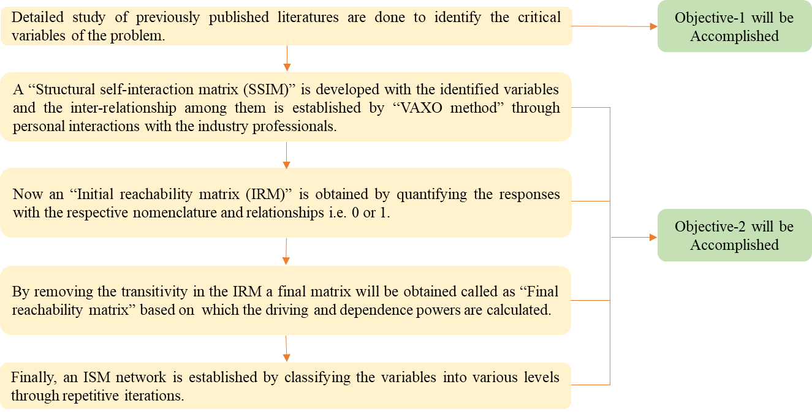
Figure 6 Methodology of ISM tool

5.3.2 Part 2 – "MICMAC Analysis."

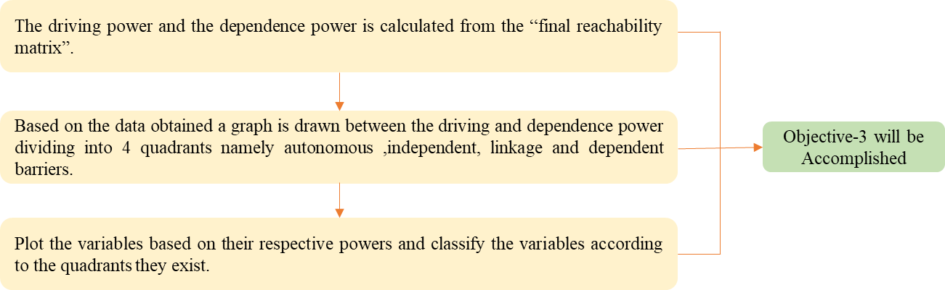
Figure 7 Methodology of "MICMAC" analysis

6. Data Analysis
"Structural self-interaction matrix (SSIM)":

In this step, we try to establish relationships between the barriers identified from the literature review. The following denotations are used to build the relationship.
V – "Barrier i drives barrier j."
A – "Barrier j drives barrier i."
X – "Barrier i and j are interrelated to each other"
O – "Barrier i and j are not related to each other"
The interrelationship between the barriers identified is established by acquiring data from the industry professionals through personal interactions. The professionals are from reputed organisations like AECOM, WSP, and Arcadis. The professionals interacted are aware and updated on the potentials of the emerging technologies in the construction industry. The respondents feel that this technology is in the initial stage, which is only used by big players in the construction industry, and there is a lot to improve.

6.1 "Structural Self-Interaction Matrix (SSIM)"

 |  | Lack of Knowledge and Training | Lack of Technical Support | Lack of industry standards and data preparation | Resistance to organisational change | Lack of suitable software | Lack of interoperability | Lack of Expertise | High Initial Cost
 |  | 8 | 7 | 6 | 5 | 4 | 3 | 2 | 1
High Initial Cost | 1 | V | A | A | V | A | A | O
Lack of Expertise | 2 | A | V | V | V | V | V
Lack of interoperability | 3 | O | A | V | V | A
Lack of suitable software | 4 | V | V | V | V
Resistance to organisational change | 5 | V | O | O
Lack of industry standards and data preparation | 6 | O | V
Lack of Technical Support | 7 | A
Lack of Knowledge and Training | 8

6.2 "Initial Reachability Matrix."
In this step, an "Initial reachability matrix" is developed by replacing the denotations used in the previous step as follows,
- If the entry is V for (i,j), then the entry in IRM will be 1 for (i,j) and 0 for (j,i).
- If the entry is A for (i,j) then the entry in IRM will be 0 for (i,j) and 1 for (j,i).
- If the entry is X for (i,j) then the entry in IRM will be 1 for (i,j) and 1 for (j,i).
- If the entry is O for (i,j) then the entry in IRM will be 0 for (i,j) and 0 for (j,i).
Table 3 "Initial Reachability Matrix"
 | 1 | 2 | 3 | 4 | 5 | 6 | 7 | 8
1 | 1 | 0 | 0 | 0 | 1 | 0 | 0 | 1
2 | 0 | 1 | 1 | 1 | 1 | 1 | 1 | 0
3 | 1 | 0 | 1 | 0 | 1 | 1 | 0 | 0
4 | 1 | 0 | 1 | 1 | 1 | 1 | 1 | 1
5 | 0 | 0 | 0 | 0 | 1 | 0 | 0 | 1
6 | 1 | 0 | 0 | 0 | 0 | 1 | 1 | 0
7 | 1 | 0 | 1 | 0 | 0 | 0 | 1 | 0
8 | 0 | 1 | 0 | 0 | 0 | 0 | 1 | 1

6.3 "Final Reachability Matrix."
In this step, the 'final reachability matrix' is obtained by removing the transitivity from the 'initial reachability matrix' by following the basic principles as listed below:
From the initial reachability matrix if i is related to j and j is related to k then i also related to k. Now if the entry in the cell of (i,k) is 0, then it should be replaced as 1 to remove the complexities due to multiple links in the ISM network to be obtained.
Table 4 "Final Reachability Matrix"
 | 1 | 2 | 3 | 4 | 5 | 6 | 7 | 8 | Driving Power
1 | 1 | 1 | 0 | 0 | 1 | 0 | 1 | 1 | 5
2 | 1 | 1 | 1 | 1 | 1 | 1 | 1 | 1 | 8
3 | 1 | 0 | 1 | 0 | 1 | 1 | 1 | 1 | 6
4 | 1 | 1 | 1 | 1 | 1 | 1 | 1 | 1 | 8
5 | 0 | 1 | 0 | 0 | 1 | 0 | 1 | 1 | 4
6 | 1 | 0 | 1 | 0 | 1 | 1 | 1 | 1 | 6
7 | 1 | 0 | 1 | 0 | 1 | 1 | 1 | 1 | 6
8 | 1 | 1 | 1 | 1 | 1 | 1 | 1 | 1 | 8
Dependence Power | 7 | 5 | 6 | 3 | 8 | 6 | 8 | 8

6.4 Level Partition
Now to obtain an ISM network, the barriers are being categorised into various levels through repeated iterations, which consists of a reachability set, antecedent set, and intersection set tabulated. The level is decided when the reachability set and the intersection set are the same. This process continues until a similar set does not coincide.

Iteration 1:
Variables | Reachability Set | Antecedent Set | Intersection Set | Level
V1 | 1,2,5,7,8 | 1,2,3,4,6,7,8 | 1,2,7,8
V2 | 1,2,3,4,5,6,7,8 | 1,2,4,5,8 | 1,2,4,5,8
V3 | 1,3,5,6,7,8 | 2,3,4,6,7,8 | 3,6,7,8
V4 | 1,2,3,4,5,6,7,8 | 2,4,8 | 2,4,8
V5 | 2,5,7,8 | 1,2,3,4,5,6,7,8 | 2,5,7,8 | 1
V6 | 1,3,5,6,7,8 | 2,3,4,6,7,8 | 3,6,7,8
V7 | 1,3,5,6,7,8 | 1,2,3,4,5,6,7,8 | 1,3,5,6,7,8 | 1
V8 | 1,2,3,4,5,6,7,8 | 1,2,3,4,5,6,7,8 | 1,2,3,4,5,6,7,8 | 1

Iteration 2:
Variables | Reachability Set | Antecedent Set | Intersection Set | Level
V1 | 1,2 | 1,2,3,4,6 | 1,2 | 2
V2 | 1,2,3,4,6 | 1,2,4 | 1,2,4
V3 | 1,3,6 | 2,3,4,6 | 3,6
V4 | 1,2,3,4,6 | 2,4 | 2,4
V5 | 2,5,7,8 | 1,2,3,4,5,6,7,8 | 2,5,7,8 | 1
V6 | 1,3,6 | 2,3,4,6 | 3,6
V7 | 1,3,5,6,7,8 | 1,2,3,4,5,6,7,8 | 1,3,5,6,7,8 | 1
V8 | 1,2,3,4,5,6,7,8 | 1,2,3,4,5,6,7,8 | 1,2,3,4,5,6,7,8 | 1

Iteration 3:
Variables | Reachability Set | Antecedent Set | Intersection Set | Level
V1 | 1,2 | 1,2,3,4,6 | 1,2 | 2
V2 | 2,3,4,6 | 2,4 | 2,4
V3 | 3,6 | 2,3,4,6 | 3,6 | 3
V4 | 2,3,4,6 | 2,4 | 2,4
V5 | 2,5,7,8 | 1,2,3,4,5,6,7,8 | 2,5,7,8 | 1
V6 | 3,6 | 2,3,4,6 | 3,6 | 3
V7 | 1,3,5,6,7,8 | 1,2,3,4,5,6,7,8 | 1,3,5,6,7,8 | 1
V8 | 1,2,3,4,5,6,7,8 | 1,2,3,4,5,6,7,8 | 1,2,3,4,5,6,7,8 | 1
Iteration 4:
Variables | Reachability Set | Antecedent Set | Intersection Set | Level
V1 | 1,2 | 1,2,3,4,6 | 1,2 | 2
V2 | 2,4 | 2,4 | 2,4 | 4
V3 | 3,6 | 2,3,4,6 | 3,6 | 3
V4 | 2,4 | 2,4 | 2,4 | 4
V5 | 2,5,7,8 | 1,2,3,4,5,6,7,8 | 2,5,7,8 | 1
V6 | 3,6 | 2,3,4,6 | 3,6 | 3
V7 | 1,3,5,6,7,8 | 1,2,3,4,5,6,7,8 | 1,3,5,6,7,8 | 1
V8 | 1,2,3,4,5,6,7,8 | 1,2,3,4,5,6,7,8 | 1,2,3,4,5,6,7,8 | 1

Final representation:
Variables | Level
Resistance to organisational change | 1
Lack of technical support | 1
Lack of knowledge and training | 1
High initial cost | 2
Lack of interoperability | 3
Lack of industry standards and data preparation | 3
Lack of expertise | 4
Lack of suitable software | 4
Table 5 Final Variables and Levels

6.5 ISM Network

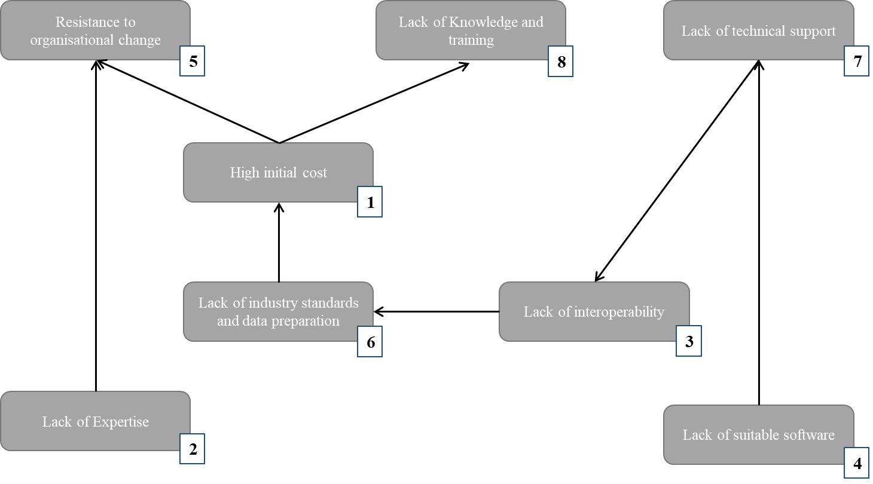
Figure 8 ISM Network

6.6 MICMAC Analysis
The barriers are classified into four categories depending on their driving power and dependence power. The first category is "autonomous barriers" having low dependence and low driving power. These barriers are weak and have few links in the network. The second category is "Dependent barriers" having high dependence power and low driving power. The third category is "Linkage barriers" having high driving power and high dependence power. Any action on these barriers is very sensitive to the whole network. The fourth category is "Independent barriers" having high driving power and low dependence power.

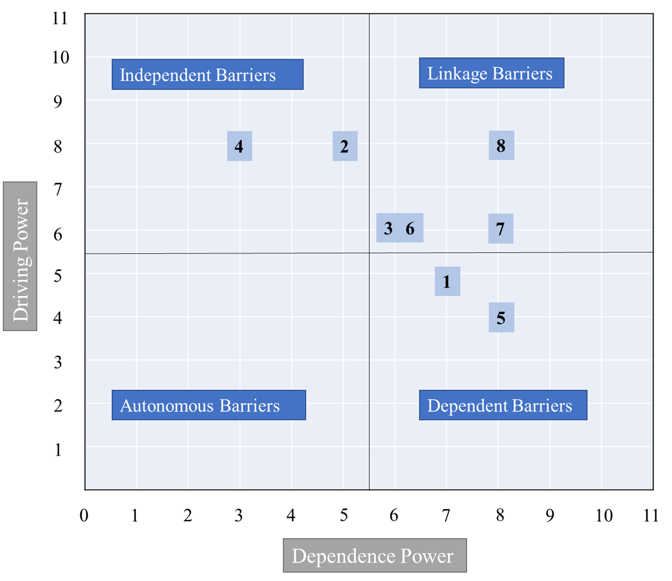

Figure 9 "MICMAC" analysis

7. Analysis of results
From the ISM network obtained, it can be interpreted that, 'lack of expertise' and 'lack of suitable softwares' are present at the bottom level which affects the other barriers in the top level which further affect the implementation of the technology.
From the "MICMAC analysis" approach it has been observed that V4-Lack of suitable software and V2-Lack of expertise fall in the quadrant of independent barriers, having high driving power and low dependence power. V3-Lack of interoperability, V6-Lack of industry standards and data preparation, V7-Lack of technical support and V8-Lack of knowledge and training falls in the quadrant of linkage barriers. These barriers have high dependence power and high driving power. Hence these barriers are considered as the most vital barriers because they can easily affect other barriers. V1-High initial cost and V5-Resistance to organisational change are the dependent barriers with high dependency power and low driving power.

8. Conclusion
From this study, the critical barriers for the implementation of extended reality in the field of QS are identified and tabulated. It has been observed that ‘Lack of expertise’ and ‘Lack of suitable softwares’ are the barriers with high driving power. Therefore, more research and development towards these barriers can have a positive impact on the other barriers favourably allowing the quantity surveyors to leverage the benefits of this technology.
From the global pandemic of 2020, it can be inferred that there is an immediate need for the construction industry to adopt newer technologies for collecting, processing, monitoring, and remotely visualising data. By such technology, more data can be captured from on-site for the off-site review, enabling us to fill the gaps that were filled previously by making assumptions.
The sample size considered in building the ISM network is limited to the Indian construction industry. The ISM method used in this study is highly based on individual perception, and the sample size involved. The disadvantages of Extended Reality have not been covered in the study. There may be several negative repercussions to human health due to this technology.

9. Future Scope
The extended reality, being an extension of the existing tool belt in the construction industry, will have a significant contribution in the coming years. There are numerous possibilities to be explored in this technology in the field of Data security, Effect on human health, Artificial intelligence, Blockchain technology and others. Extensive research should be done in developing a standardised platform to create XR models and interact with it.

11. References

[1] PlanGrid, “New Research from PlanGrid and FMI Identifies Factors Costing the Construction Industry More Than $177 Billion Annually,” 2018. https://www.plangrid.com/press/fmi/ (accessed Mar. 04, 2019).
[2] M. Miri and M. Khaksefidi, “Cost Management in Construction Projects: Rework and Its Effects,” Mediterr. J. Soc. Sci., vol. 6, no. 6, pp. 209–215, 2016, doi: 10.5901/mjss.2015.v6n6s6p209.
[3] S. C. C. R. and A. R. Philipp Gerbert, “Shaping the Future of Construction A Breakthrough in Mindset and Technology,” World Econ. Forum, no. May, pp. 1–64, 2016, [Online]. Available: https://www.bcgperspectives.com/Images/Shaping_the_Future_of_Construction_may_2016.pdf.
[4] Thoughtworks, “eXtending reality with AR and VR - Part I | ThoughtWorks,” 2020. https://www.thoughtworks.com/insights/blog/extending-reality-ar-and-vr-part-i (accessed May 15, 2020).
[5] Global augmented/virtual reality market size 2016-2022 | Statistic.” https://www.statista.com/statistics/591181/global-augmented-virtual-reality-market-size/ (accessed Mar. 04, 2019).
[6] Deloitte Insights, “Digital reality,A technical primer,” Deloitte University Press, 2017.
[7] SRI International, “Augmented Reality Solutions for Construction Inspection - YouTube,” 2017. https://www.youtube.com/watch?v=8lY4qaVvR8c (accessed May 15, 2020).
[8] F. Bademosi and R. R. A. Issa, “Implementation of Augmented Reality Throughout the Lifecycle of Construction Projects,” in Advances in Informatics and Computing in Civil and Construction Engineering, Cham: Springer International Publishing, 2019, pp. 307–313.
[9] S. J. Suk, G. Ford, Y. Kang, and Y. H. Ahn, “A Study on the Effect of the Use of Augmented Reality on Students’ Quantity Take-off Performance,” 2017. Accessed: Mar. 05, 2019. [Online]. Available: https://www.iaarc.org/publications/fulltext/ISARC2017-Paper025.pdf.
[10] A. Behzadi, “American Journal of Engineering Research ( AJER ) Open Access Using Augmented and Virtual Reality Technology in the Construction Industry Ajang Behzadi,” Am. J. Eng. Res., no. January, pp. 350–353, 2017.
[11] K. Kirchbach and C. Runde, “Augmented reality for construction control,” Proc. Int. Conf. Inf. Vis., pp. 440–444, 2012, doi: 10.1109/IV.2012.76.
[12] M. Zaher, D. Greenwood, and M. Marzouk, “Mobile augmented reality applications for construction projects,” Constr. Innov., vol. 18, no. 2, pp. 152–166, 2018, doi: 10.1108/CI-02-2017-0013.
[13] M. H. Stoltz, V. Giannikas, D. McFarlane, J. Strachan, J. Um, and R. Srinivasan, “Augmented Reality in Warehouse Operations: Opportunities and Barriers,” IFAC-PapersOnLine, vol. 50, no. 1, pp. 12979–12984, 2017, doi: 10.1016/j.ifacol.2017.08.1807.
[14] S. Agarwal, “Review on Application of Augmented Reality in Civil Engineering,” Int. Conf. Inter Discip. Res. Eng. Technol., pp. 68–71, 2016.
[15] C. Woodward et al., “Case Digitalo-A Range of Virtual and Augmented Reality Solutions in Construction Application,” 2017. Accessed: Mar. 05, 2019. [Online]. Available: http://virtual.vtt.fi/virtual/proj2/multimedia_old/publications/casedigitalo-maribor2007-old.pdf.
[16] O. A. Olatunji, “Virtual Reality and Estimating Practice: A Software Selection Model for Estimating,” 28th Int. Symp. Autom. Robot. Constr. (ISARC 2011), no. June 2011, 2017, doi: 10.22260/isarc2011/0133.
[17] J. Bellos, “Virtual Reality as a Decision Making Tool in Construction Management,” Eur. Conf. Manag. Leadersh. Gov., no. November 2012, pp. 30–IX, 2012, doi: 10.13140/RG.2.1.1168.4007.
[18] K. E. Haggard, “Case Study on Virtual Reality in Construction.” Accessed: Mar. 05, 2019. [Online]. Available: https://digitalcommons.calpoly.edu/cgi/viewcontent.cgi?referer=https://www.google.com/&httpsredir=1&article=1041&context=cmsp.
[19] A. A. Avhad and G. A. Hinge, “Implementation of Virtual Reality in Construction Industry,” Int. J. Innov. Res. Sci., vol. 6, no. 6, pp. 67–69, 2017, doi: 10.15680/IJIRSET.2017.0606276.
[20] R. Jain and P. Kokate, “Implementation of Virtual Reality in Construction Industry,” 2017. Accessed: Mar. 05, 2019. [Online]. Available: http://ijses.com/.
[21] E. Holt, J. Benham, and B. Bigelow, “Emerging Technology in the Construction Industry: Perceptions from Construction Industry Professionals,” pp. 26.595.1-26.595.10, 2015, doi: 10.18260/p.23933.
[22] R. Abboud and R. Abboud, “Architecture in an Age of Augmented Reality: Opportunities and Obstacles for Mobile AR in Design, Construction, and Post-Completion,” 2014. Accessed: Mar. 02, 2019. [Online]. Available: https://www.inglobetechnologies.com/wp-content/uploads/2014/06/IWDS2013-AR-PAPER-R-ABBOUD-MARCH.pdf.
[23] A. Carlsén, “Augmented Construction,” 2018.
[24] J. Whyte and D. Bouchlaghem, “THE PROMISE AND PROBLEMS OF IMPLEMENTING VIRTUAL Differences between CAD and VR .,” p. 8, 1998, Accessed: Mar. 02, 2019. [Online]. Available: http://itc.scix.net/.
[25] P. Piroozfar, A. Essa, S. Boseley, E. R. P. Farr, and R. Jin, “Augmented Reality ( AR ) and Virtual Reality ( VR ) in construction industry : An experiential development workflow,” Tenth Int. Conf. Constr. 21st Century, no. July, 2018, [Online]. Available: http://ascpro.ascweb.org/chair/paper/CPRT195002016.pdf.
[26] P. Pejic, M. Lakicevic, S. Krasic, and P. Sidjanin, “Application of Augmented and Virtual Reality in Residential Complex Presentation , Case Study : Energoprojekt Sunnyville,” vol. 12, no. 1, pp. 127–133, 2017.
[27] L.-Y. D. and J.-T. W. Guo-Cheng Li, “Construction project control in Virtual reality: A case study,” J. Appl. Sci., 2006.
[28] T. Lorentzen, Y. Kobayashi, and Y. Ito, “Virtual reality for consensus building: Case studies,” Lect. Notes Comput. Sci. (including Subser. Lect. Notes Artif. Intell. Lect. Notes Bioinformatics), vol. 5531 LNCS, pp. 295–298, 2009, doi: 10.1007/978-3-642-02115-2_29.
[29] S. Woksepp, “Virtual Reality in Construction Tools , Methods and Processes,” Constr. Innov., p. 191, 2007.
[30] F. A. and M. Ç. Baydoğan, “Evaluation of Augmented Reality in Architecture Through Sample Applications,” Eurasian J. Civ. Eng. Archit., vol. 1, no. 1, 2017.
[31] P. Pejić, S. Krasić, M. Veljković, S. Sakan, and T. Rizov, “Augmented and virtual reality application in traditional architectural project presentation - Case study of ‘MH Petra’ house,” FME Trans., vol. 45, no. 2, pp. 227–231, 2017, doi: 10.5937/fmet1702227P.
[32] Autodesk, “Prefabricated Construction - How Gilbane Uses VR to Validate [Video],” 2018. https://www.autodesk.com/redshift/prefabricated-construction/ (accessed Mar. 05, 2019).

