**Calculation of the Efficiency of**

**Regenerative Air Heat Exchanger with**

**Intermediate Heat Carrier**

V.Yu. Borodulin and M.I. Nizovtsev*

Kutateladze Institute of Thermophysics SB RAS, 630090, Novosibirsk, Russia

ABSTRACT

The study deals with a new regenerative air heat exchanger with an intermediate heat carrier used in the systems of room ventilation. A physical and mathematical model of the heat transfer process is proposed. The influence of design and operating parameters on the temperature efficiency of the heat exchanger is analyzed. The possibility of a significant increase in its efficiency with a decrease in the packing diameter is shown. As a result of calculations, it was found that with a decrease in the filling height, the maximum temperature efficiency shifted towards a decrease in the air flow rate from its value determined from the equality of water equivalents of liquid and air.

*Key words: Ventilation, Heat exchanger with intermediate heat carrier, Packed column, Computational model, Temperature efficiency.*

**1. Introduction**

Today the relevance of solving the issues of controlled ventilation of rooms with heat recovery from ventilated air is becoming especially acute, since on the one hand, prices for energy carriers are growing, and on the other hand, new energy-efficient designs of walls and windows with low air permeability are being widely used [1].

During building operation, energy consumption for ventilation air heating and cooling can reach 50% in the total energy balance [2]. Up to 90% of these energy costs can be saved using recuperative and regenerative heat exchangers [3, 4].

Plate recuperators with metal [5, 6] or plastic heat exchange surfaces [7] are the most widespread. The disadvantage of plate heat exchangers is freezing at low outside temperatures. Various measures are being developed to combat freezing [8]. Recovery wheels with porous discs or mini-channels show high efficiency [9, 10]. However, these apparatuses as well as regenerators of periodic action [11, 12] have the disadvantage of partial mixing of air flows despite their high efficiency.

The complexity of solving the issues of air regenerative ventilation is caused by low heat transfer coefficients between the air medium and the solid body surface, which requires extended heat exchange surfaces and significant dimensions of heat exchangers. Another problem that has to be solved is the removal of moisture condensing from the indoor air as it cools in the heat exchanger.

The efficiency of the used designs of air heat regenerators is not high enough; in addition, a significant drawback of the known devices is that they operate reliably only at relatively high outside temperatures. At low temperatures, their heat exchange surfaces freeze over, and the devices cease to perform their functions. This necessitates R&D studies to find new technical solutions [13–17].

When choosing a heat exchanger for heat recovery from ventilation emissions, it is necessary to take into account the peculiarities of its operation. The main purpose of the ventilation system is to provide the required amount of fresh air and to remove harmful substances, bacteria, moisture and dust from the room. Usually, the main requirements for such a device are as follows: high efficiency, design simplicity, ability to remove condensed moisture from the heat exchanger, and reliable operation under the conditions of negative outside air temperatures. Regenerators using an intermediate heat carrier largely meet these requirements.

A schematic diagram of the studied heat exchanger is shown in Figure 1. The main structural elements of a recuperator with an intermediate heat carrier are scrubbers (columns with packing). Columns with packing are a widespread type of technological equipment and are used in various fields of industry. They are also used to humidify gases in air conditioning units, to heat or cool gas when contacting with a liquid. Despite a widespread use, the scrubber processes remain insufficiently studied. By combining two columns with a packing for heating and cooling ventilation air, a heat exchange unit with an intermediate heat carrier can be obtained. The advantages of this type of regenerators are the absence of freezing, small losses of air pressure and ability to separate the air ventilation input and output, which increases the efficiency of their operation. These heat recuperators are new, and therefore there is limited information in the literature about such devices [18, 19]. The paper presents a computational model of heat transfer in the air heat regenerator with an intermediate heat carrier; the influence of various parameters of such a recuperator on the efficiency of its operation is analyzed.

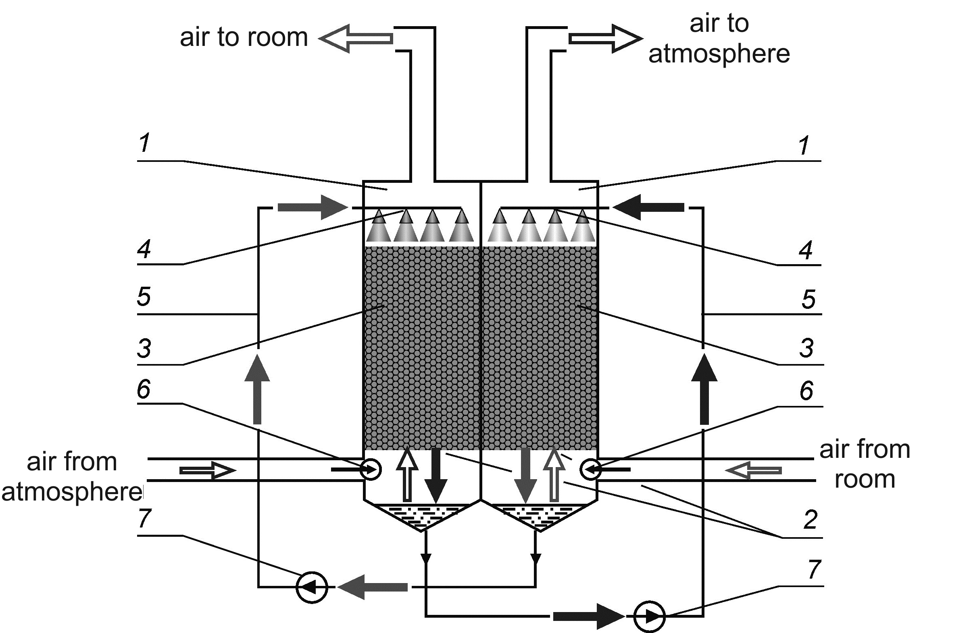

**Figure 1.** Scheme of air heat regenerator with intermediate heat carrier: 1 - column body, 2 - grate, 3 - packing, 4 - sprinkler, 5 - pipeline, 6 - air ventilator, 7 - water pump.

**2. Calculation model**

Let us consider the process of heat exchange in one packed column with countercurrent movement of liquid and gas phases (Figure 2). The packing in the column is irrigated from above with liquid, which serves as an intermediate heat carrier between the columns. The liquid flows down the packing surface under the action of gravity from top to bottom. Air is supplied to the heat exchange column to organize its movement through the packing from bottom to top, i.e., countercurrent to the liquid flow.

The calculation model is based on the idea of ​​two countercurrent interpenetrating continua of liquid and gaseous phases, which pass through each other without mixing, exchanging heat through some fixed interface. At that, the interface is formed on a rigid base, which is the packing surface. Let us consider the balance of thermal energy for air and liquid participating in heat transfer, while we assume that convective heat transfer prevails over conductive heat transfer and the latter can be neglected.

For an arbitrarily chosen volume of the packing, the balance will consist in the fact that a change in the internal energy of liquid or air in it is the sum of the energy entered through the interface and the energy transferred through the external boundary of the volume.

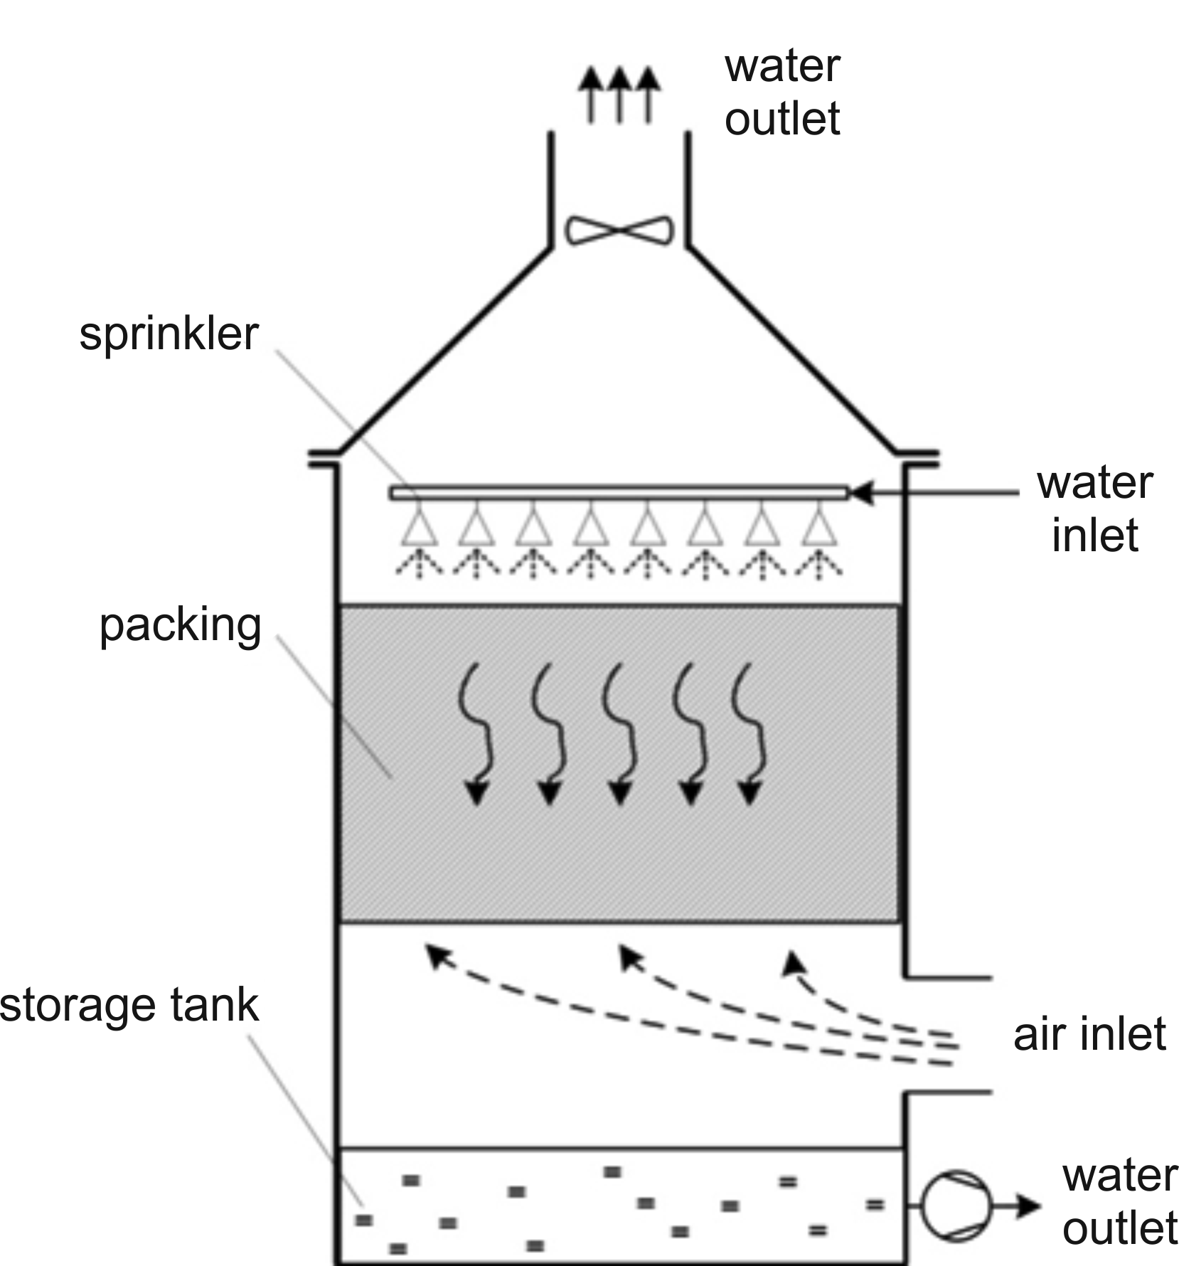

Figure 2. Counterflow packed column.

When constructing the model, the heat absorbed or released during possible phase transformations was not taken into account.

Let the packing material has density  and heat capacity . The sectional area of the packing is indicated by, and its volumetric-geometric characteristics will be described by the porosity value  and specific surface area . A change in the internal energy of air in the packing layer with thicknessdepends on the rate of change in the air temperature and its mass. If we assume that the entire volume of free space in the packing is filled with air, then its mass in a layer of thicknesscan be expressed as , where is the air density. Therefore, will take the form:

,

where is specific heat capacity, and is the air temperature. Let us take for the positive direction of the  axis the direction which coincides with the direction of air movement through the packing. Then, the convective heat flux  through the boundaries of the packing layer with a thickness  can be expressed through the temperature gradient and the mass flow rate of air :

.

We will assume that heat transfer between liquid and air occurs at the boundary of the liquid film, which covers the packing material as a thin layer. If we assume that the entire packing surface is involved in heat transfer, then the heat transfer area will be equal to the surface area of the packing. For a layer with thickness, it will be . As a result, the amount of heat  transferred to air through the interface per unit of time can be written:

,

where  is the heat transfer coefficient, is the temperature of water. Balance of thermal energy for air is:

.

Substituting the corresponding expressions, we obtain the inhomogeneous differential equation:

. (1)

Let us consider the balance relations of thermal energy for the liquid phase. The amount of water in the packing layer depends on the regime of its flow. Under the assumption of its film-like nature, the mass of water in the packing layer with thickness of can be written in the form , where  is the density of water, and  is the thickness of the film on the surface of the wetted packing. Then, a change in the internal energy of liquid in the packing layer will take the form:

,

where is specific heat capacity of water. The resultant heat flux , transferred through the boundaries of the packing layer by convection, considering the direction of water motion can be written as:

,

where  is the mass flow rate of liquid. The amount of heat , transferred through the interface per unit of time is equal to heat with the opposite sign ; therefore, in the final form, the balance equation for a liquid can be written as:

 (2)

Water film thickness  on the surface of packing material, velocity of the film flow of liquid and mass flow rate are mutually connected by equation:

. (3)

To take into account the effect of the amount of heat that can accumulate in the packing and increase the thermal inertia of the layer, instead of equation (2), we can write:



A flowchart of a regenerator with heating and cooling columns, as well as two storage tanks is shown in Figure 3.

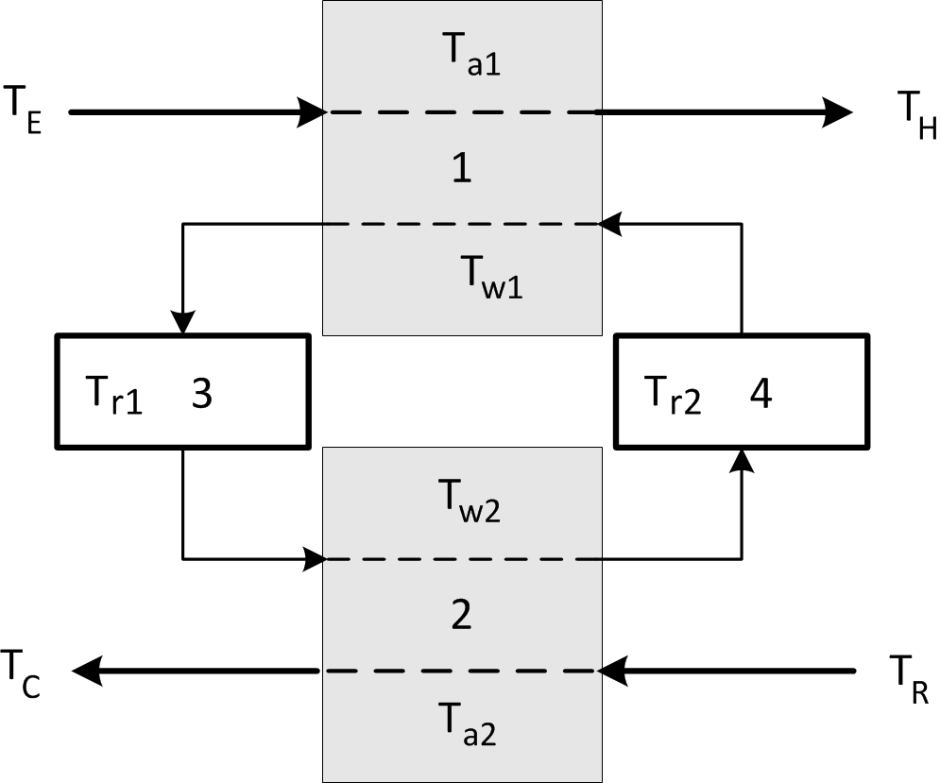

**Figure 3.** Flowchart of a regenerator with intermediate heat carrier: 1 – heating column;

2 – cooling column; TE – outdoor air temperature; TH – temperature of air, entering the room; TC – temperature of air, removed from the room; TR – air temperature in the room; Tr1 and Tr2 – temperature of liquid in intermediate storage tanks 3, 4.

According to this flowchart, liquid at the column outlet first enters the storage tanks, where the temperature of liquid may differ from the temperature of incoming liquid and the ambient temperature. Mixing occurs in tanks; as a result, the temperature of liquid there changes until certain equilibrium is established. If we assume that the liquid level is kept constant, and the temperature of liquid in the tank equalizes quickly, when a small portion of liquid arrives, then the current temperature in the storage tank can be determined using an ordinary differential equation:

 , (4)

where  is the mass of liquid and  is its temperature in the storage tank.

Let us assume that air from the outside enters the heating column 1 at temperature , and air from the room enters the cooling column 2 at temperature .

The temperature of air flowing from the columns to the room and outside will be  and , respectively. The liquid leaving heating column 1 enters storage tank 3, from which it, in turn, is fed to cooling column 2. Liquid movement from column 2 through storage tank 4 to column 1 occurs similarly.

Let the initial temperature of liquid in the columns and tanks is the same and it coincides with air temperature in the room.

When modeling the heat transfer process, we will assume that there is no additional heat loss when liquid moves between the columns and stays in the storage tanks.

Let us write down the system of equations of heat transfer in the regenerator, supplementing equations (1), (2), (4) for each of the columns with the corresponding initial and boundary conditions:

,

,

,

,

 at ,

 at ,

 at ,

 at ,

 at ,

 at ,

 at ,

,

,

.

Here is the intensity of packing irrigation, is the height of packing in the columns.

**3. Discussion of calculation results**

Let us analyze the influence of various parameters of the regenerator based on the results of numerical calculations. Keramzite gravel with a fraction (packing) diameter of 0.0125 m is used as a filling material in the columns, and a water solution of calcium chloride is an intermediate heat carrier. At that, for the initial parameters, we choose the following: kg/m3,  kg/m3,  kg/m3, J/(kg·К),  J/(kg·К),  J/(kg·К), , m2, m, m, , m3/h,  m3/h, µm, Вт/(m2·К), °C, °C,  kg.

The efficiency of heat transfer processes in each of the heat exchange columns can be characterized by temperature efficiency , which is determined by the ratio of the absolute value of the air temperature difference at the column inlet and outlet to the air temperature difference between the inlets of the heating and cooling columns:

, .

Let us determine the influence of various regenerator parameters on the temperature efficiency. It should be noted that in the considered air regenerator, the equilibrium temperature efficiency for both columns is the same with the same column design, equal flow rates of liquid and air, and without taking into account the processes of liquid evaporation. A typical way how the temperature efficiencies of regenerator columns achieve their equilibrium values over time is shown in Figure 4 according to the results of calculations. Under the temperature efficiency, we will further mean the equilibrium temperature efficiency of the regenerator .

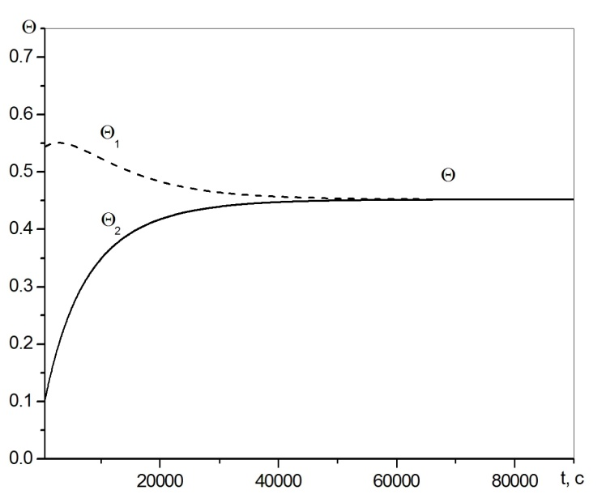

**Figure 4.** A change in the temperature efficiency of the heating and cooling columns

over time.

Let us consider the influence of filling height on the temperature efficiency. According to calculations, an increase in led to an increase in efficiency (Figure 5).

This is caused by an increase in the area of the heat exchange surface, which depends on the filling height in accordance with expression . Obviously, regenerator dimensions act as the natural limiter of the filling height.

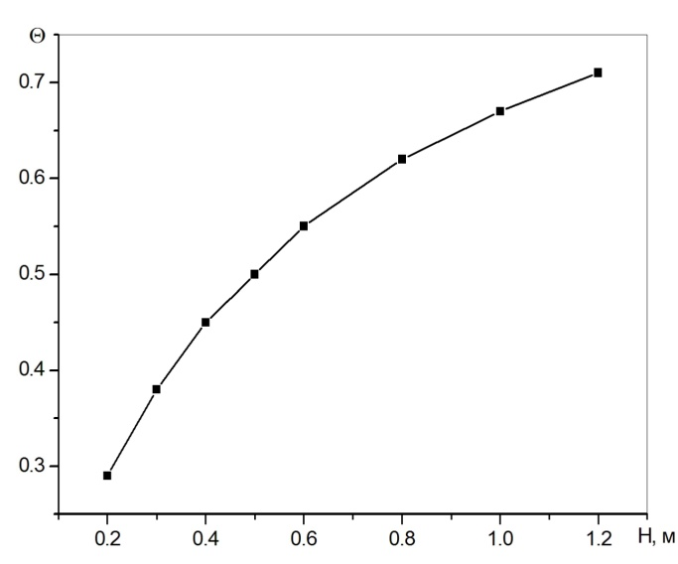

**Figure 5**. Temperature efficiency versus filling height.

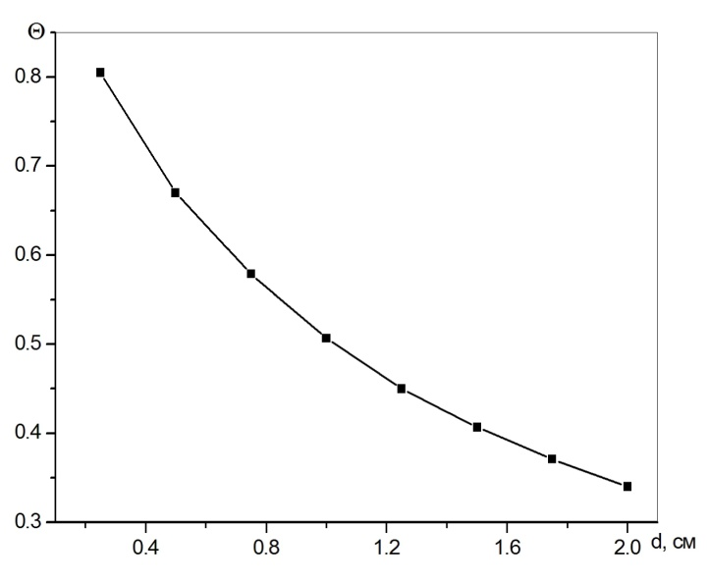

**Figure 6.** Temperature efficiency versus packing diameter.

With a decrease in the packing diameter and retention of all other parameters, an increase in the temperature efficiency took place (Figure 6), and the rate of its growth increased with a decrease in the diameter. This dependence of temperature efficiency is associated with an increase in the specific surface of the filling with a decrease in the packing diameter, according to:

,

where Ф is the shape factor, and ε is porosity.

With an increase in the temperature efficiency of the regenerator with an increase in the filling height or a decrease in the size of the packing, an increase in hydraulic losses should be taken into account.

Calculations showed that it is possible to increase the temperature efficiency of the recuperator due to the intensification of heat transfer processes between liquid and air. The calculated dependence of the temperature efficiency on the heat transfer coefficient on the contact surface is presented in Figure 7.

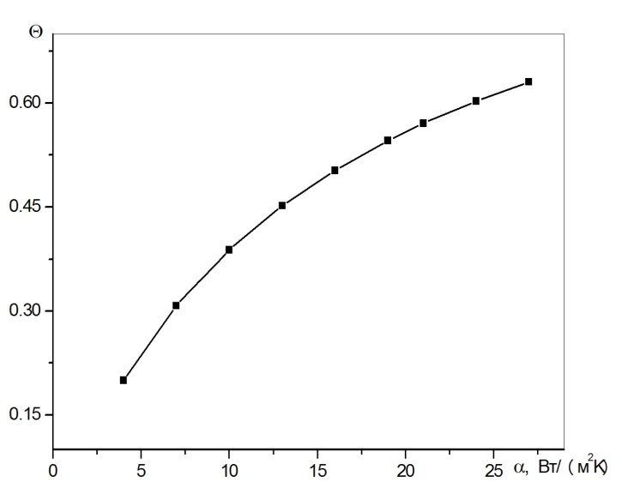

**Figure 7.** Temperature efficiency versus heat transfer coefficient.

Let us consider the influence of the flow characteristics of air and liquid heat carrier on the temperature efficiency of the regenerator. The influence of the liquid flow rate on the efficiency at a constant air flow rate through the columns of 110 m3/h and a column height of 0.4 m is shown in Figure 8.

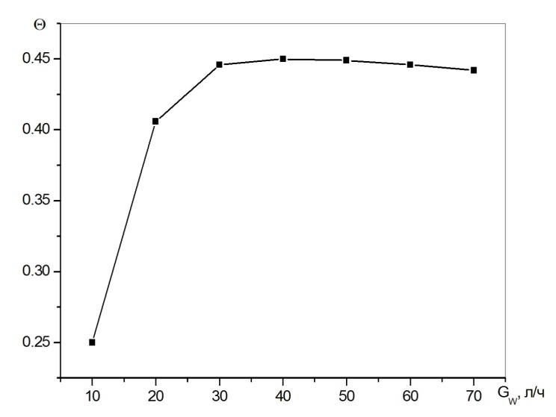

**Figure 8.** Temperature efficiency versus water flow rate.

In the studied range of liquid flow rates, the temperature efficiency increased to the maximum value, and with a further increase in the flow rate, its slight decrease occurred. The maximum value of efficiency was observed at liquid flow rate *Gw* ≈ 40 l/h, which corresponded to the equality of water equivalents:

 . (5)

The calculated dependences of the temperature efficiency of regenerator on the air flow through the columns for liquid flow rate of 40 l/h at different heights of filling in the columns are shown in Figure 9.

The dependence of efficiency at each filling height had a maximum, and with an increase in the height, the value of maximum efficiency increased, and the position of maximum approached its value at the air flow rate obtained from the equality of the water equivalents of air and water (5). With a decrease in the filling height, the heat transfer surface decreased, the value of maximum decreased and its position shifted towards the lower air flow rates through the columns.

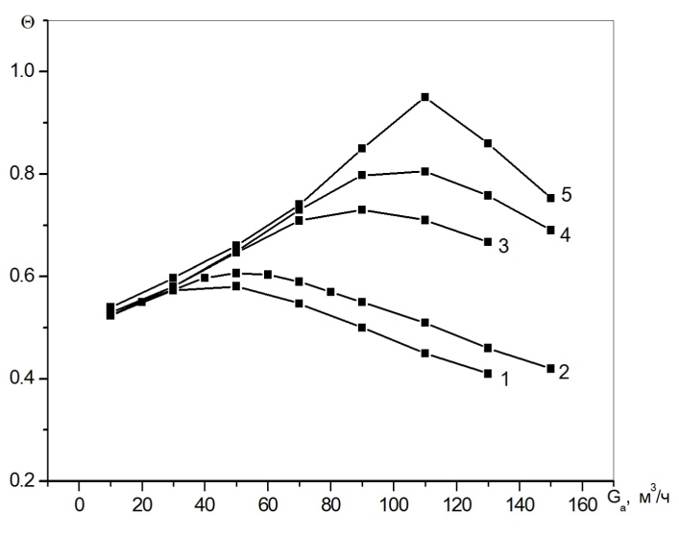

**Figure 9.** Temperature efficiency versus air flow rate for filling height:

1 - H=0.4 m, 2 - 0.5 m, 3 -1.2 m, 4 - 2 m; 5 - 10 m.

**4. Main conclusions**

A computational model of heat transfer of a new air-to-air regenerative heat exchanger with an intermediate liquid heat carrier for room ventilation is proposed and tested in this work.

When analyzing the influence of various factors on the temperature efficiency of regenerator, the possibility of a significant increase in its efficiency with a decrease in the packing diameter is shown.

As a result of calculations, it was found that with a decrease in the filling height, the maximum temperature efficiency shifted towards a decrease in the air flow rate from its value determined from the equality of water equivalents of liquid and air.

**Acknowledgement**

This work was supported by a state contract with the IT SB RAS № 121031800217-8.

**References**

[1] Fernandez-Seara J., Diz R., Uhia F.J., Dopazo A., Ferro J.M. (2011). Experimental analysis of an air-to-air heat recovery unit for balanced ventilation systems in residential buildings. *Energy Conversion and Management*, 52, p. 635-640. (doi:10.1016/j.enconman.2010.07.040).

[2] Rezaie B., Esmailzadeh E., Dincer I. (2011). Renewable energy options for buildings: Case studies. *Energy and Buildings*, 43, p. 56-65.

(doi: 10.1016/j.enbuild.2010.08.013).

[3] Mardiana A., Riffat S.B. (2013). Review on physical and performance parameters of heat recovery systems for building applications. *Renewable and Sustainable Energy reviews*, 28, p. 174–190.

(doi: 10.1016/j.rser.2013.07.016).

[4] Dodoo A., Gustavsson L., Sathre R. (2011). Primary energy implications of ventilation heat recovery in residential buildings. *Energy and Buildings,* 43 p. 1566–1572.

(doi: 10.1016/j.enbuild.2011.02.019).

[5] Mota F.A.S., Ravagnani M.A.S.S., Carvalho E.P. (2014). Optimal design of plate heat exchangers. *Applied Thermal Engineering*, 63, p. 33-39.

(doi: 10.5772/60885).

[6] Amin M.R., Lindstrom J.D. (2012). Transient thermal simulation of counter flow compact recuperator partition plates. *Applied Thermal Engineering*, 48, р. 11-17. (doi: 10.1016/j.applthermaleng.2012.04.030)

[7] Joen C. T., Park Y., Wang Q., Sommers A., Han X., Jacobi A. A. (2009) А review on polymer heat exchangers for HVAC & R applications. *Int. J. Refrig,* 32 p. 763–79.

(doi:10.1016/j.ijrefrig.2008.11.008).

[8] Nasr M.R., Fauchoux M., Besant R. W., Simonson C.J. (2014). A review of frosting in air-to-air energy exchangers. *Renewable and Sustainable Energy Reviews*, 30, p. 538-554.

(doi: 10.1016/j.rser.2013.10.038).

[9] Ruan W., Qu M., Horton W.T. (2012). Modeling analysis of an enthalpy recovery wheel with purge air*. Int. J. Heat and Mass Transfer*, 55, p. 4665–4672. (doi: 10.1016/j.ijheatmasstransfer.2012.04.025)

[10] Smith K. M., Svendsen S. (2015). Development of a plastic rotary heat exchanger for room-based ventilation in existing apartments. *Energy and Buildings*, 107, p. 1–10.

(doi: 10.1016/j.enbuild.2015.12.025).

[11] Manz H., Huber H., Schalin A., Weber A., Ferrazzini M., Studer M. (2000). Performance of single room ventilation units with recuperative or regenerative heat recovery. *Energy and Buildings*, 31(1), p. 37–47.

(doi:10.1016/S0378-7788(98)00077-2)

[12] Nizovtsev M.I., Borodulin V. Yu, Letushko V.N. (2017). Influence of condensation on the efficiency of regenerative heat exchanger for ventilation. *Applied Thermal Engineering*, 111, p. 997–1007. (doi: 10.1016/j.applthermaleng.2016.10.016)

[13] Kragh J., Rose J., Nielsen T.R., Svendsen S. (2007). New counter flow heat exchanger designed for ventilation systems in cold climates. *Energy and Buildings*, 39(11), p. 1151–1158.

(doi:10.1016/j.enbuild.2006.12.008).

[14] Cerrah Ecem, McCague Claire, Bahrami Majid. (2020). Sorbent based enthalpy recovery ventilator. *Energy and Buildings,* 211, 109755.

(doi:10.1016/j.enbuild.2020.109755).

[15] Ephraim M. Sparrow, Jimmy Tong C.K., Mark R. Johnson and Gerry P. Martin. (2007). Heat and Mass transfer characteristics of rotating regenerative total energy wheel. *International Journal of Heat and Mass Transfer*, 50, p. 1631–1636. (doi: 10.1016/j.ijheatmasstransfer.2006.07.035)

[16] Nizovtsev M.I., Terekhov V.I., Yavorskiy A.I. Disc heat exchanger // Invention patent No. 2255282 of June 27, 2005.

[17] Nizovtsev M.I. (2007). Experimental study of the dynamic and thermal characteristics of a disc fan-regenerator of heat of ventilated air. *News of higher educational institutions. Construction*, 10, p. 46–50.

[18] Yavorskiy A.I. Ventilation heat recovery method// Application for invention No. 2010121465/06 of 26.05.2010.

[19] Nizovtsev M.I., Yavorskiy A.I., Letushko V.N., Borodulin V.Yu. (2013). Experimental study of an air-to-air heat exchanger with an intermediate heat carrier for heat recovery from ventilation air. **Energy and Resource Efficiency of Low-Rise Residential Buildings: Proc. Scientific - Practical. Conf., - Novosibirsk**: IT SB RAS, p**. 43-49.**