Image Segmentation Based on Intuitionistic Type-2 FCM Algorithm
Zhong-qiang PAN1, Xiang-jian CHEN^{1,*}
1Jiangsu University of Science and Technology, School of Computer Science and Engineering, ZhenJiang, China, ironming_qiang@qq.com, 212003
*Corresponding author

Keywords: Image segmentation, Rough sets, Intuitionistic type-2 fuzzy c-means clustering.

Abstract. Due to using the fuzzy clustering algorithm, the accuracy of image segmentation is not high enough. So one hybrid clustering algorithm combined with intuitionistic fuzzy factor and local spatial information is proposed. Experimental results show that the proposed algorithm is superior to other methods in image segmentation accuracy and improves the robustness of the algorithm.

Introduction
Image segmentation[1,2] is based on dividing the image into regions with different features. Common Image segmentation methods include threshold selection based on region characteristics[3], edge detection[4] based on specific theory. With the development of science and technology in recent years, many researchers combine the special theory with the existing image segmentation technology and propose many new segmentation algorithms[5,6,7]. Ren Mingwu[8] et al used edge pattern histogram to reduce the noise and the threshold effect of Edge on image segmentation.
The structure of this paper is organized as: Part 2 described the proposed method; Part 3 provides the experimental results; Finally, the conclusion is given in the Part 4.

Rough Intuitionistic Type-2 fuzzy c-means Clustering Algorithm
In this paper, a hybrid clustering algorithm combined with a new intuitionistic fuzzy factor and local spatial information is proposed. The proposed algorithm is listed in the following three subsections:

Initialization of Cluster Centroids by IT2F Roughness
If the upper and lower approximation of an image I (m, n) can be described as Qi (k) and qi (k) , then the IT2F roughness at the kth intensity can be given by:
$$ρ_{i}\left(k\right)=1-\frac{\left|q_{i}\left(k\right)\right|}{\left|Q_{i}\left(k\right)\right|},0≤k≤L-1$$
Where the qi (k) and Qi (k) can be given as following equation:
$$q_{i}\left(k\right)=\left|u_{1}\left(x_{ij}\right)\right|,0≤i≤M-1,0≤j≤N-1$$
$$Q_{i}\left(k\right)=\sum_{m=1}^{M}{\sum_{n=1}^{N}{(1+u(m,n)δ(\left\lfloor \left(2^{\left(bit\right)}-1\right)*u_{I}(x_{ij})\right\rfloor -k))}}$$
where $u\left(m,n\right)=\exp\left(1-\frac{1}{2}{\left(\frac{d\left(m,n\right)}{σ}\right)}^{2}\right)$ means the the Gaussian MF used as type-2 fuzzy memberships, so the total distance of all the pixels can be given as:
$$d\left(m,n\right)=\sum_{r∈R}{\sum_{t∈T}{d\left(I\left(m,n\right),I\left(r,t\right)\right)}}$$
$$=\{\frac{1}{2}{((μ\left(I\left(m,n\right)\right)-μ(I(r,t)))}^{2}$$
$$+{(v\left(I\left(m,n\right)\right)-π(I(r,t)))}^{2 }$$
$$+{(π\left(I\left(m,n\right)\right)-π(I(r,t)))}^{2}\}$$

The Intuitionistic Fuzzy Factor
The proposed novel IT2FCM algorithm includes one important factor, this factor is composed of similarity and local spatial information, the defination of the local spatial information can be described as:
$$G_{ij}=\sum_{\begin{aligned}k∈N_{j} \\ k≠j\end{aligned}}{\frac{[{\left(1-\hat{u_{ik}}\right)}^{m}{x||x_{k}-v_{i}||}^{2}+{(s_{ik})}^{m}]}{d_{jk}+1}}$$
Where uik is the membership degree between the pixels, sik represents the similarity between the

pixel and cluster center, information.

Experimental Results
In order to compare the rough intuitionistic type 2 fuzzy clustering algorithm with the other methods, one synthetic test image has been given in Fig.1a. From the comparison results, we can see that the proposed method is better than the other four ones but slower than the other methods.
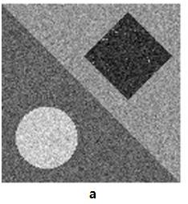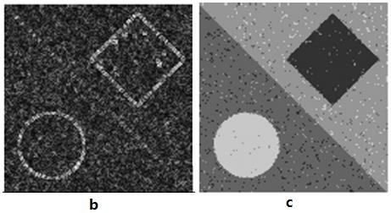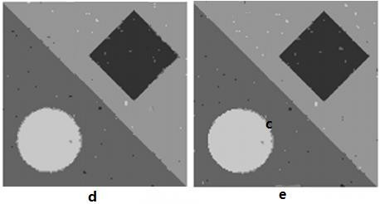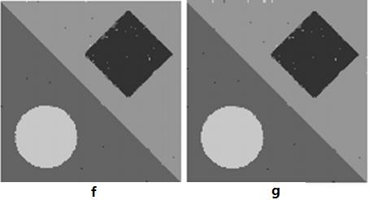
Figure 1. Comparison approaches on a synthetic image: (a) original synthetic image, (b) RIT2FCM (c) RFCM, (d) IIFCM, (e) T2FCM, (f) ASFIC, and (g) RIT2FCM.

Table 1. SA values of five methods for the synthetic image.

Noise levels | RFCM | IIFCM | T2FCM | ASIFC | RIT2FCM
(%) | (%) | (%) | (%) | (%) | (%)
Gaussian 5 | 0.05 | 0.03 | 0.02 | 0.02 | 0.02
Gaussian 10 | 0.31 | 0.02 | 0.22 | 0.22 | 0.21
Gaussian 20 | 6.18 | 0.85 | 0.73 | 0.64 | 0.62

Table 2. Average computational time for five methods.

Noise levels | RFCM | IIFCM | T2FCM | ASIFC | RIT2FCM
(%) | (s) | (s) | (s) | (s) | (s)
Gaussian 5 | 0.4672 | 0.3132 | 2.4823 | 1.3463 | 1.3672
Gaussian 10 | 0.5672 | 0.3125 | 2.5371 | 1.6491 | 1.6236
Gaussian 20 | 0.8672 | 0.3835 | 3.5172 | 2.5276 | 2.3512

Conclusion
One hybrid cluster algorithm is proposed to handle the uncertaity in image segmentation, which combined the adavantages of rough sets theory, type-2 fuzzy sets theory, and intuitionistic fuzzy sets theory. From the simulation results, we can see that the proposed method could handle the randomness, vagueness, and external noises better than other methods.

References
- Wang, L., Shi, F., Gao, et.al. Integration of sparse multi-modality representation and anatomical constraint for isointense infant brain MR image segmentation. NeuroImage, 89, 152-164, 2014.
- C. Panagiotakis, H. Papadakis, E. Grinias, et.al. Interactive Image Segmentation Based on Synthetic Graph Coordinates, Pattern Recognition, 46 (11), 2940–2952, 2013.
- P. Liu, L. D. Wu. Comparison of I value selection methods in image segmentation. Pattern recognition and artificial intelligence, 3:271-277, 1997.
- X. L. Zhang. A survey of image edge detection technology. High Energy density physics, 1:37- 40, 2007.
- K. J. Cheng. Nice ride. Research on Modulus and clustering algorithm based on kernel function. University of Electronic Science and Technology, 2009.
- Zadeh L A. Fuzzy sets, information and control. Information Control, 8(3):338-353, 1965.
- Ruspini E H. A new approach to clustering. Information Control, 15(1):22-32, 1969.
- Q. Yan, X. Q. Ye, J. L. Liu, etc. Maximum entropy threshold processing algorithm based on quantized image histogram. Pattern recognition and artificial intelligence, 3:352-358, 1998.
- Yu, P. F. Shi, L. C. Zhao. Image segmentation method based on minimum energy. Infrared and laser engineering, 284:21-24, 1999.

