**Сomputational experience optimization of colors in complex fractal images in carpet design using the simplex method**

**Fakhriddin Nuraliev1, Oybek Narzulloyev2 and Saida Tastanova3**

1 Tashkent University of Information Technologies Named after Muhammad

Al-Khwarizimi, Amir Temur street 108,Tashkent 100084, Uzbekistan

nuraliev2001@mail.ru

2 Tashkent University of Information Technologies Named after Muhammad

Al-Khwarizimi, Amir Temur street 108,Tashkent 100084, Uzbekistan

[oybek.88.13@gmail.com](mailto:oybek.88.13@gmail.com)

ORCID:

1. [0000-0002-0574-9278]

2. [0000-0002-2762-0432]

3. [0000-0001-5948-8205]

**Abstract.** This article proposes a new approach based on linear programming optimization to solve the problem of determining the color of a complex fractal carpet pattern. The principle is aimed at finding suitable dyes for mixing and their exact concentrations, which, when applied correctly, give the desired color. The objective function and all constraints of the model are expressed linearly according to the solution variables. Carpet design has become an emerging technological field known for its creativity, science and technology. Many carpet design concepts have been analyzed in terms of color, contrast, brightness, as well as other mathematical concepts such as geometric changes and formulas. These concepts represent a common process in the carpet industry. This article discusses the use of complex fractal images in carpet design and simplex optimization in color selection.

**Keywords:** fractal, optimization methods, simplex-method, geometric transformations, computer graphics, Pascal's triangle.

**1. Introduction**

At present, special attention is paid to the study of the mathematical aspects of the theory of fractals, as well as methods for describing natural processes and phenomena using the ideas of the theory of fractals. Especially when constructing fractal equations, fractal theories, methods and systems of computer graphics are widely used. Therefore, one of the important tasks is the development of geometric models and algorithms for objects with a fractal structure, as well as methods for their implementation. Much attention is paid to solving theoretical and practical problems in the development of technologies for the use of fractal geometric shapes in the design of urban planning and light industry.

The development and development of technologies for applying fractal geometric shapes in the field, creating textures and design remains one of the most important problems. In particular, interest in studying the processes that serve the fractal geometry of nature has led to the emergence of new scientific areas in biology, physics, mathematics, computer graphics, light industry, electronics, radio engineering, astrophysics, materials science, medicine and other sciences. As you know, the development of pattern design is carried out mainly by hand, including fractal patterns, which are quite difficult or impossible to draw by hand, are drawn using computer graphics technologies.

The main attention is paid to new areas of application of fractal analysis in engineering problems. This work is devoted to collecting new results on the application of fractals in technology, both from a theoretical and numerical point of view.

A number of monographs and scientific articles are devoted to the problems of geometric modeling of objects with a fractal structure using analytical methods. B. B. Mandelbrot, G. M. Julia, G. O. Peitgen, R. P. Tylor, B., B.A.Bondarenko, Sh.A.Nazirov [1, 2] and other scientists are striving to expand the scope of fractal geometry, including all over the world, by applying them in practice, in the fields of radio engineering and radar, from predicting the value of securities in the market to new discoveries in theoretical physics. In the Republic, Academician B.A. Bondarenko [1,2] contributed to the construction of generalized Pascal triangles, Pascal pyramids and equations of their fractals based on the theory of binomial basic polynomials with arithmetic properties [5].

In 1980, the famous researcher Benoit Mandelbrot discovered the principle according to which the whole world of such structures is formed in some unexpected way, and in 1984 he developed the concept of a fractal [3].

The science of fractals is very young, as they began to emerge with the development of computer technology. So much remains to be learned and so much remains to be explored.

The main reason why fractals are used in various sciences is that they sometimes represent the real world better than traditional physics or mathematics [4].

The study of fractals has expanded in such a short space of time that it is applied to over 200 fields of art and design. In industry, fractals are used to compress images by reducing data redundancy, creating an ideal platform for textile design [1]

The monograph [6] states that fractal structures or geometry currently play a key role in all models of natural and industrial processes that demonstrate the formation of rough surfaces and interfaces. It is noted that computer modeling, analytical theories and experiments have led to significant progress in modeling these phenomena in the wild. In particular, many problems originating in engineering, physics or biology are characterized both by the presence of different time and space scales, and by the presence of contacts between different components through (irregular) interfaces that often connect media with different characteristics. Thus, this work is devoted to collecting new results on the application of fractals in technology, both from a theoretical and numerical point of view.

Methods for determining the optimal sequence of technological operations belong to the category of problems that can be solved by objectively placing binary decisions about the analysis or synthesis of processes, taking into account certain optimization criteria, as well as the corresponding conditions and accuracy requirements or the capabilities available in the production process.

The charm of similarity inherent in fractal elements is associated with many textile patterns. The little subtleties that lead to the decorative variability these designs create is the design. Jane Barnes was the first woman to use fractals. She redefined the fashion textile trend and defined the use of textile software to create designer fabrics [7].

Another of the most important stages of carpet production continues to introduce advanced technologies and new stages of carpet production. One important process takes center stage in carpet design: dyeing to add color and beauty to patterns produced for contemporary carpets. Carpets and fibers are dyed in many different processes at different stages of production, from fibre, yarn or carpet, depending on the use of the product, the economics of the process and the market demand for the color. In this paper, which discusses the technology of carpet dyeing has evolved into advanced processes in the carpet industry [8].

In the carpet industry, carpet and its design are of great importance. Design and production represent the history and experience of generations, changing from culture to culture, from artist to artist. In the modern technological world, fractal design carpets have become another wave of new ideas in design.

The quality of the performance and environmental friendliness of paint in the production of carpets and textiles is one of the important stages in the carpet industry. The use of non-toxic and environmentally friendly natural dyes for textiles has received much attention due to the strengthening of environmental protection to avoid some dangerous synthetic dyes. Therefore, we used natural dyes for flowers in the production of carpets [14]. Natural dyes and their extraction methods have been the subject of several recent studies. Natural dyes are renewable, biodegradable, and they can replace synthetic dyes already used in the textile industry, as they will lead to cleaner and more sustainable processes.

At the present time, also special attention to the carpet production plays an important role in the optimal choice of colors, taking into account the cost of production.

The carpet industry research partnership involved 13 & 9 Design, a Fractals Research consulting firm founded by the Mohawk Group and Taylor. Two of Richard Taylor's graduate students, Julian Smith and Conor Rowland, worked on the project. At the end of this project, the global flooring and carpet market is expected to reach $450 billion by 2025 [9].

**2. Research methods**

1. A method for constructing images of a fractal form, taking into account the theory of algebraic structures and prime numbers based on Pascal's triangle and geometric transformations.

Using the method of the theory of binomial polynomials, methods and algorithms for visualizing images in a fractal form have been developed, taking into account algebraic structures based on Pascal's triangle and the theory of prime numbers based on Mod *p* [15]*.*

Binomial coefficients are the simplest combinatorial objects and are defined as the number of separate combinations of m elements, except for k [16]:

 ( 1)

The general formula for the degree x of a generalized Pascal triangle of the sth order is written as follows:

 ( 2)

for s=2, the binomial coefficient will be as follows:

  ( 3)

Pascal's triangle has many interesting properties, and one of them follows from considering two of all modules. The elements in Pascal's triangle can be colored by marking them as follows, as shown in Figure 1, all odd numbers are yellow, all even numbers are red.

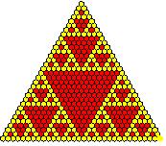

**Figure 1. Fractal based on Pascal's triangle Mod=2.**

The points of the sides of the triangle in the initial element of Pascal's triangle are located in the first quadrant in the coordinate system. In this case, the following relationship is established between the point located in the coordinate system and the elements of Pascal's triangle:

 ( 4)

where

In the coordinate system, the recurrent relation between geometric shapes (triangle, quadrilateral, hexagon) in the elements of Pascal's triangle is written as follows:

 (5)

The formula for determining the elements of Pascal's triangle when dividing it by Mod *p* is written as follows:

 (6)

When reducing the elements of Pascal's triangle to prime numbers, when in particular Mod *p* consists of prime numbers, the appearance of Pascal's triangle changes by coloring depending on its division into prime numbers (Fig. 2).

Further, based on the method of binomial polynomials, an object with a complex fractal structure was created, taking into account algebraic structures and the theory of prime numbers based on Pascal's triangle. At the first step, we used a transformation in the form of a reflection of computer graphics. Using the geometric reflection transformation, we have:

,  (7)

Using this formula, the corresponding results are obtained. Applying the geometric transformation of reflection and displacement, the fractal has the form shown in Figure 3, a).

Taking into account the geometric transformation of displacement, we have:

 (8)

Using the formula for the geometric transformation of reflection and displacement, it can obtain the following result (Fig. 3, b) and c)). Also using the rotation (rotation) geometric transformation formula:

 (9)

as well as scaling (if necessary):

 (10)

It can get the following result attached in figure 3, d).

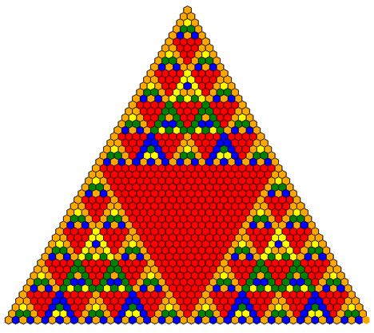

**Figure. 2. Fractal based on Pascal's triangle Mod=5.**

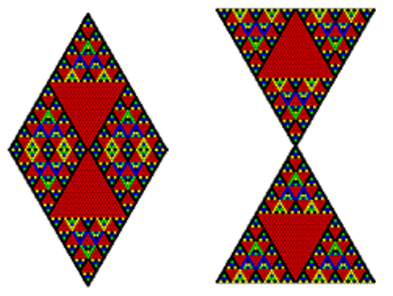

a)

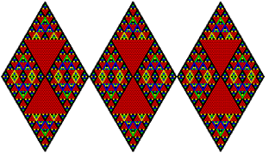

b)

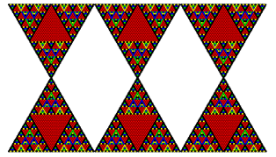

c)

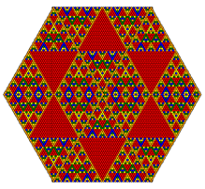

d)

**Figure 3. Images of complex fractal structures based on Pascal's triangle according to Mod=5.**

**3 . Method for optimizing the color of fractal structure images**

The choice of color variants of paints for the manufacture of a particular carpet product is a complex issue, since it is necessary, on the one hand, to ensure the specified accuracy of dyeing, on the other hand, to be able to produce carpets at the lowest cost and at the same time maintain the highest productivity. To solve these problems, in general, methods of mathematical programming and optimization are used.

In real problems, connections inevitably arise between objective functions, criteria:

1. Criteria can be consistent with each other;

2. Criteria may conflict with each other;

3. Criteria can be independent.

Preliminary expert evaluation of selected criteria [10] will allow solving the problem of multicriteria optimization in the simplest, but sometimes most effective ways.

Methods for determining the optimal sequence of technological operations belong to the category of problems that can be solved by objectively placing binary decisions about the analysis or synthesis of processes, taking into account certain optimization criteria, as well as the corresponding conditions and accuracy requirements or the capabilities available in the production process.

In the carpet and textile industry, Pascal's triangle and formulas is used to create patterns, optimization methods for choosing colors and estimating the cost of a product, calculating its cost.

Therefore, it is necessary to develop procedures and algorithms aimed at finding the optimal structure of the synthesized object. These procedures are usually based on the use of mathematical programming methods (mainly discrete programming), sequential and iterative synthesis algorithms, network and graphical design models, as well as heuristic methods of decision theory.

One of the optimization methods is the genetic method [13]. This method has also been considered in the textile industry. This article discusses the genetic algorithm in the textile industry. The genetic algorithm can contain a large number of answers and find the best of them by getting feedback from the tasks. In the jacquard knitting system, several designs of different colors can be made. However, many patterns can be unattractive and lack beauty. According to the customer, it is not easy to choose interesting and stylish models from such a variety of designs. An interactive genetic algorithm can be used to optimize colors for price and select ideal patterns based on desired user feedback. We can use it to optimize color when producing rugs with complex designs.

At present, technology, considered as the science of methods and means of converting materials, or in general the production processes used to produce a product, has evolved recently thanks to approaches aimed at systematizing scientific knowledge, developing strictly reasoned methods capable of developing rational solutions for building modern technological systems. Now, in many areas of industry, the technological preparation of the manufacturing industry is forced to solve many problems and complications in a short time, a situation that often requires summing up decisions in project activities that are aimed only at execution with obviously unfavorable results [11].

Finding the optimal solution in many important tasks involves the analysis and selection of an element in a certain set of feasible solutions, in which the enterprise will receive the maximum profit. Here, “tolerable plan” means a plan that can realistically be carried out taking into account all the capabilities of the enterprise, i.e. subject to restrictions on material, energy, human and similar resources. In this case, the optimality criterion is the achievement of the maximum objective function - income. Thus, the problem under consideration is the problem of finding the maximum of the objective function on the set of feasible solutions. The latter is determined by a number of restrictions on the variables of the problem, which are given in the form of inequalities and equalities. Problems of this kind are usually called resource allocation problems.

In carpet design, it is formed using complex fractal images and parameters. The fractal image uses  types of colors, of which . Natural colors are used in the production of carpets. Natural colors have  prices, . the number of pieces in the price set of natural color (Table 1). The buyer offers  and  prices for the carpet and can choose  color in the fractal image, when choosing .  values of  and  are recalculated using the following formulas.

, (11)

. (12)

Here - the price of recognition of colors chosen by the customer and natural colors are excluded from the price list, - indicates how many times the selected colors are used in the fractal image. The carpet manufacturer must find a way to keep costs to a minimum with , . This optimization problem can be solved by the simplex method, for which the objective function and conditions are written as follows.

 . (13)

Computational algorithm.

Step 1: the values  and  are given instead;

Step 2: the  value is set;

Step 3: the values and  are given;

Step 4: Found ;

Step 5: k colors are selected. , then  will be. ( and are found by formulas (11) and (12));

Step 6: According to the formula (13) the values of  are found;

Step 7: If there are equal cases in , the first value is the current value and the second value is the price of the next color that is more expensive.

**4.** **Computational experiment**

Carpet company manufactures and sells carpet products. For the production of carpets, natural dyes are used.

A fractal pattern with 7 colors of a certain size was chosen and the cost of painting the carpet was calculated. The number of each color in Pascal's triangle, consisting of seven colors, taken for example 489, 263, 66, 140, 97, 84 and 136. Let's imagine that the client chose the main 2 colors and the number of 489 and 263. And he designated an intermediate amount for the carpet, this is ours there will be a maximum and a minimum.  and

,

.

In the process of solving the problem, we use the values given in Table 1 for each color [12].

**Table 1.**

**Prices for natural dyes**

|  |  |  |  |
| --- | --- | --- | --- |
| S. NO | Product | ENGLISH NAME/COMMO | Prices/Kg/c.u. |
| 1 | MICHIGAN BROWN EXTRACT | Black Catechu/Kattha | 11 |
| 2 | CEDAR YELLOW EXTRACT | Myrobalan | 24 |
| 3 | MALLOW GOLD EXTRACT | Pomegranate Peel | 26.5 |
| 4 | GARNET BROWN EXTRACT | Bark of Acacia | 35 |
| 5 | GALLNUT EXTRACT Tannin Grade | Aleppo Oak/Oak | 37 |
| 6 | CEDAR GRAY EXTRACT | Myrobalan | 37 |
| 7 | GALLNUT EXTRACT Dyeing Grade | Aleppo Oak/Oak | 39 |
| 8 | ESTEBIO INDIGO | Indigo | 40 |
| 9 | NUT BROWN | Areca Nut | 42 |
| 10 | CANDY ORANGE EXTRACT | Annatto | 47 |
| 11 | WINE RED EXTRACT 4001 | Lac | 50 |
| 12 | APSRA YELLOW EXTRACT | Himalayan Rhubarb | 50.5 |
| 13 | TURKEY RED EXTRACT RT | Madder | 61 |
| 14 | ONION PEEL EXTRACT | Onion Skin | 78 |
| 15 | SUN YELLOW EXTRACT | Marigold | 85 |

Let's select 7 colors from the preset paints CEDAR YELLOW EXTRACT Myrobalan, MALLOW GOLD EXTRACT Pomegranate Peel, ESTEBIO INDIGO Indigo, CANDY ORANGE EXTRACT Annatto, WINE RED EXTRACT 4001 Lac, ONION PEEL EXTRACT Onion Skin, SUN YELLOW EXTRACT Marigold) from the table 1 [12].

c.u. and c.u.

Let’s denote the corresponding amount of paint for carpets

1. Constraints that task variables must satisfy:



line

fuzzy numbers

Next, we solve the optimization problem for the remaining three colors for . The remaining colors are selected by the simplex optimization method from the remaining colors of the tables remaining by 13 colors.

Then calculate the maximum and minimum

,



We select Indigo Blue (ESTEBIO INDIGO) and Wine Red (WINE RED EXTRACT 4001, Lac) from the color table as preset colors.

Target function of the task.



Denote - income from the sale of carpets, then the objective function of the problem is written as follows:

.

Thus, the task is to find , under the constraints:

.

Using the simplex method to solve this optimization problem, it get the following results:



.

So, the cost of the flowers that used for the carpet, if it is equal to  c.u.; c.u.;  c.u.; c.u,  c.u,  c.u ; carpet c.u. equal to the total cost of production.

Below is Pascal's triangle and hexagon for the design of the carpet, obtained from the simplex by optimization at the best prices of the 7 color paints that we used for the carpet (Fig. 4, 5)

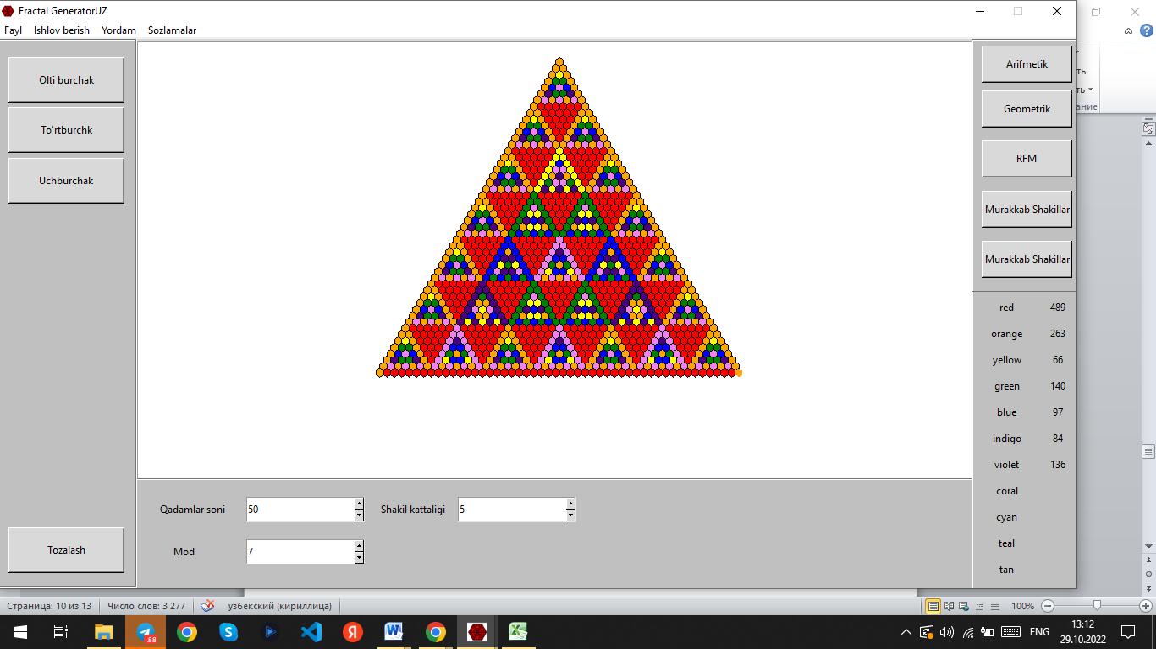

**Figure. 4. Images of complex fractal structures based on Pascal's triangle by Mod=7 for a carpet obtained from a simplex by the optimization method.**

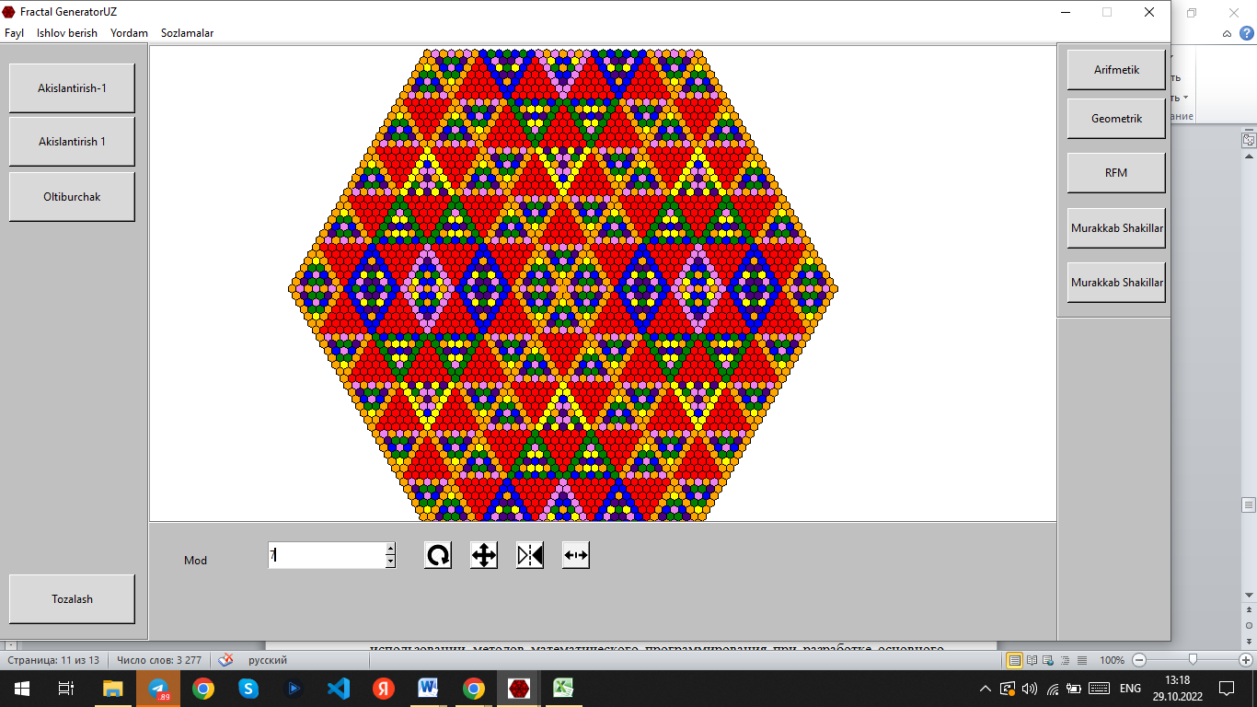

**Figure 5. Images of complex fractal structures based on Pascal's triangle by Mod=7 for a carpet obtained from a simplex by the optimization method.**

**5. Discussion**

It has found that fractals can only be used in the exact sciences, carpet design and much more.

Nowadays, a great potential for increasing the level of profitability and profitability of industrial enterprises producing carpets lies in the use of mathematical programming methods in the development of the main production plan of the factory. At the same time, the profit of the enterprise can be increased not only from the sold carpets, but also by reducing costs as a result of a more rational mixing of individual components and color dyes in the manufacture of carpet products.

Therefore, in the production of carpet products of a given size, it is advisable to use mathematical programming methods to select the optimal set of colors, which can be done at the lowest cost and maximum benefit.

A great potential for increasing the level of profitability and profitability of industrial enterprises producing carpets lies in the use of mathematical programming methods in the development of the main production plan of the factory. At the same time, the profit of the enterprise can be increased not only from the sold carpets, but also by reducing costs as a result of a more rational mixing of individual components and color dyes in the manufacture of carpet products.

**Conclusion**

Using the method of the theory of binomial polynomials with arithmetic properties, an algorithm for the method of visualizing images in fractal form has been developed, taking into account the theory of algebraic structures and prime numbers based on Pascal's triangle. This method and algorithm made it possible to visualize fractal shapes based on Pascal's triangle.

An algorithm for constructing complex images of a fractal structure using two-dimensional geometric transformations in the space of computer graphics were developed. Based on this method and algorithm, triangular, square and hexagonal spiral fractals, as well as complex fractal shapes based on Pascal's triangle, were created.

The current widespread use of complex fractal shapes in the carpet industry, the creation of its mathematical model, as well as the use of linear programming methods and optimization methods, can move to a new innovative modern stage in the carpet industry by evaluating the cost of production and creating cost optimization.

Therefore, in the production of carpet products of a given size, it is advisable to use mathematical programming methods to select the optimal set of colors, which can be done at the lowest cost and maximum benefit.

Based on this, an algorithm was developed to improve the efficiency of the carpet factory using complex fractal image forms and the simplex method was applied. In addition, natural colors were used for carpets of a certain size, and prices were taken from India. The optimal price of carpet colors selected on the basis of this algorithm is determined at the request of the customer. As an example, 50 rows and 7 color numbers from Pascal's 7-color triangle were used. We had 5 colors and let the buyer choose 2 colors so that we can find the most optimal price using the maximum and minimum amounts set by the buyer to the best of their opportunities.

One of the optimization methods is the genetic method [13]. This method has also been considered in the textile industry. This article discusses the genetic algorithm in the textile industry. The genetic algorithm can contain a large number of answers and find the best of them by getting feedback from the tasks. In the jacquard knitting system, several designs of different colors can be made. However, many patterns can be unattractive and lack beauty. According to the customer, it is not easy to choose interesting and stylish models from such a variety of designs. An interactive genetic algorithm can be used to optimize colors for price and select ideal patterns based on desired user feedback. We can use it to optimize color when producing rugs with complex designs.

# References

[1] Bondarenko B.A. Generalized Pascal Triangles and Pyramids, their Fractals, Graphs, and Applications – USA, Santa Clara: Fibonacci Associations, The Third Edition. – 2010. – 296 pp.

[2] Bondarenko B.A. “Generalized triangles and Pascal pyramids, their fractals, graphs and applications”, Discrete Math. Mat., 1991, volume 3, issue 3, 159–160 pp.

[3] Mandelbrot B. Fractal geometry of nature. - Moscow: Institute of Computer Research, 2002, 656 pages.

[4] Anarova Sh.A., Nuraliev F.M., Narzulloev O.M. Construction of the equation of fractals structure based on the rvachev r-functions theories. 2019 J. Phys.: Conf. Ser. 1260 072001. pp. 1-9.

[5] Nazirov Sh.A., Anarova Sh.A., Nuraliyev F.M. Fundamentals of Fractal Theory, - Tashkent: Navruz. Monograph. 2017. - 128 pp.

[6] Nikolaev E.V. Fractal Manifesto. Collection of articles / Per. From English, French - St. Petersburg: "Strata", 2016. - 156 pp.

[7] Ponder, Celia & Gregory, Bill & Griffing, Evan & Li, Yong & Overcash, Michael. (2019). Life Cycle Comparison of Carpet Dyeing Processes. Journal of Advanced Manufacturing and Processing. 1. e10012. 10.1002/amp2.10012. pp.1-6.

[8] Smith, J. H.; Rowland, K.; Moslehi, S.; Taylor, R.P.; Lesyak, A.; Lesyak, M.; Stadlober, S.; Lee, L.; Dettmar, J.; Page, M.; other. Relaxing Floors: The Fractal Fluency of the Built Environment. J. Nonlinear dynamics. Psych. Life of Sciences. 2020 , 24 , 127–141pp.

[9] Zak Yu.A. Applied problems of multiobjective optimization. — M.: Economics, 2014 — 455 pp.

[10] Malea C.I., Nitu E.L. Optimization of the technological process and equipment of complex profiled parts. 2020 IOP Conf. Ser.: Mater. Sci. Eng. 916 012058. pp. 1-13.

[11] Alevras D., Padberg M.W. Linear Optimization and Extensions: Problems and Solutions PDF. New York: Springer, 2001. — 451 p.

[12] <https://www.naturaldyes.io/>.

[13] Dariush S., Mehdi H., Hamed A., and Mohammad Sh. Jacquard pattern optimizing in weft knitted fabrics via interactive genetic algorithm. Fashion and Textiles 2014. pp.1-9.

[14]. Seyyed Majid Ghoreyshyan, Lale Maleknia, Hamid Mirzapour and Mohammad Noruzi. Antibacterial properties and color fastness of silk fabric dyed with turmeric extract.Iran. 2013.pp. 201-207.

[15] Nuraliev F.M., Anarova Sh.A, Narzulloev O.M ,"Mathematical and software of fractal structures from combinatorial numbers," 2019 International Conference on Information Science and Communications Technologies (ICISCT), Tashkent, Uzbekistan, 2019, pp. 1-4.