Factor effecting Ion thruster’s performance
刘景文
Author: Yuzhe Liu, Lidong Lin, Han Dong

1. Abstract
In this project, we investigated how ion thrusters produce propulsion and how the design of ion thrusters affects the performance of the thruster. In the experiment, we build a high voltage power supply (0- 50KV) and foil rings to produce ion wind. When considering the design of the thruster, we focus on three variables: the volume of the space where ions are produces and the electric field intensity. Thus, to investigate the first variable we made foil rings with different radius and change the distance between the ring and positive cathode. To determine the propulsion produced we use a speed sensor to determine the magnitude of the wind produced.

Keywords: Ion thruster, Ion engine, Ion propulsion

2. Introduction

The ion thruster is a kind of propeller that uses ion wind to accelerate. By producing accelerating ions, the propeller can get thrust. The thruster initially ionizes gays by depriving electrons of the gas molecules and therefore creating a group of positive ions. Due to Coulomb force which states that “the magnitude of the electrostatic force of attraction or repulsion between two point charges is directly proportional to the product of the magnitudes of charges and inversely proportional to the square of the distance between them” the ions are repelled by each other and then accelerate in one direction.

Nowadays, there are already spacecraft such as “Deep Space 1” and “Dawn” that use ion thruster as their propeller. The characteristic of ion thruster made it suitable for space transportation. Firstly, ion thruster needs less fuel to achieve a certain speed than conventional chemical fuel. Secondly, even though, ion thruster is not widely used on earth, since its minuscule thrust can’t overcome air resistance, this disadvantage can be minimized since there is no air resistance in the vacuum space.

To investigate more about the characteristics of ion thruster, our group conducted an experiment. There are two stages to the experiment. During the first stage, we will test that are we able to produce ion wind by just employing a high-voltage electric field. After confirming the result, in the second stage, we will design and make the test equipment. We will look at four variables: ring size, number of nails, distance, voltage, and how they account for the variations of the ion wind speed.

During the first stage of the experiment, we build a small piece of equipment that mimics the ion thruster. Firstly, we used aluminum-foil paper to build the middle part of the thruster, this part is connected to the cathode. And on top of this part, there is a round of copper wire which is connected to the anode of the power supply. We use these materials because they are good conductors of electricity. The layout of the equipment helps to create an electromagnetic field and therefore deprives electrons of air molecules. Therefore, produces ions and ion wind.

During the test period, we saw the thruster (equipment mentioned above) lift up from the ground. This shows the thruster is creating ion wind that causes uplift force. This proved what we thought previously. Additionally, we also smelled ozone during the experiment. This is the evidence that the oxygen molecules were ionized and then after being propelled from the thruster, the ions formed ozone.
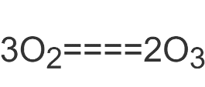
After confirming the design, we built our test equipment. The equipment is composed of a power supply, test track, two sets of rings, and a speed sensor. This equipment will help us to find the relationship between the four variables (mentioned above) and the speed of the ion wind. To test the speed of the wind we used the wind speed sensor, which will tell us how fast the wind is by calculating the speed of its rotation. In different trials, we changed the variables and compared the speed.

- Experiment

Question
How does setting of ion engine equipment affects its performance?
Hypothesis
- Number of nails will affect the performance of ion engine: the more the nails are the greater impulse it could produce.
- Distance affects the impulse available to run the rotor. The closer the engine to, the greater the impulse available.
- The size of the ring affects the impulse generated, the greater the ring is the greater the impulse could be generated
- Voltage will affect the impulse generated, the greater the voltage is the greater the impulse could be generated
Material
A roll of Tin foil paper | Glue gun | pencil
Thin wood plates | Three Copper nails | ruler
Copper wire | Speed sensor | Cotton thread
Potential transformer (220V to 50kV | Switcher | tape
Small PE tube (1.5cm of diameter) | cutter | 502 glue

Procedure
- Set up the power supply which include a switcher and a voltage transformer as figure 1 shows
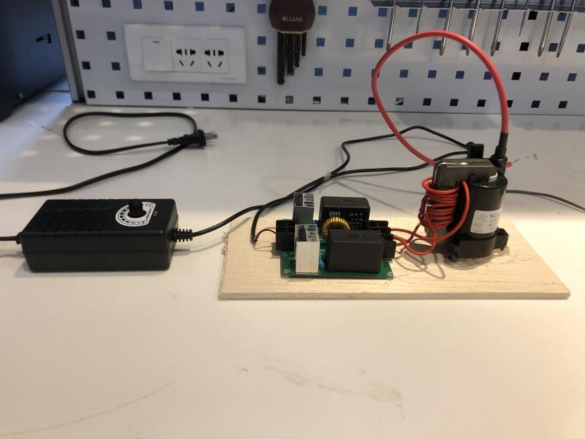
Figure 1 power supply
- set up the test track with foil paper, wood plates, copper nails and mark the scale on the plate using the pencil and ruler in order to clarify the distance. The fixation process is supported by glue gun.
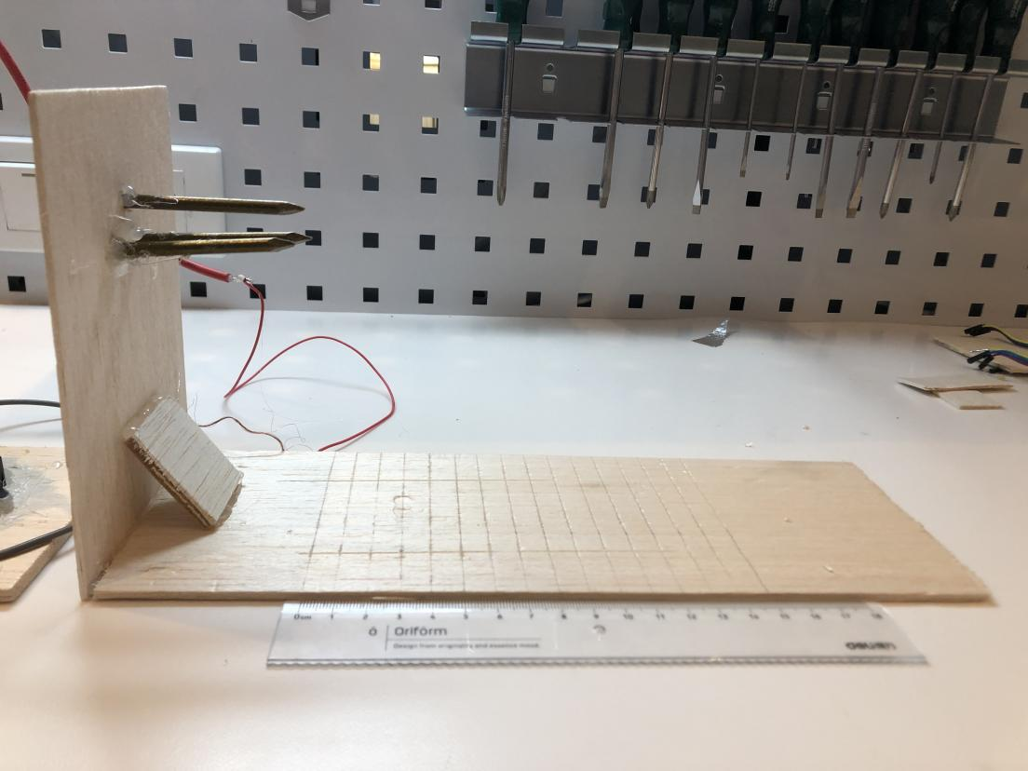
Figure 2 test track
- roll the foil paper around the PE tube and fix three of them in shape of pyramid by using glue gun.
- Made another foil tube without inner structure with diameter of 6.5cm.
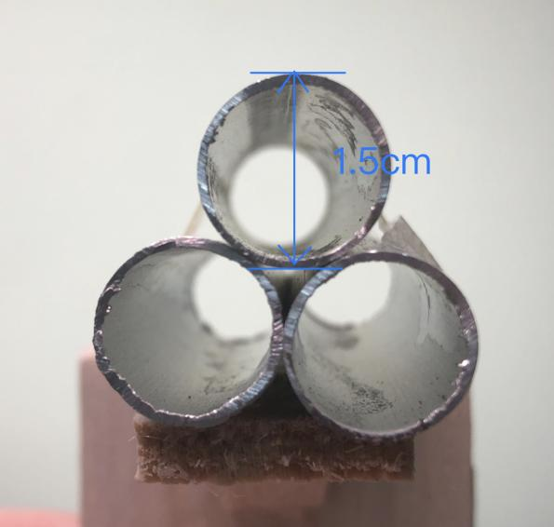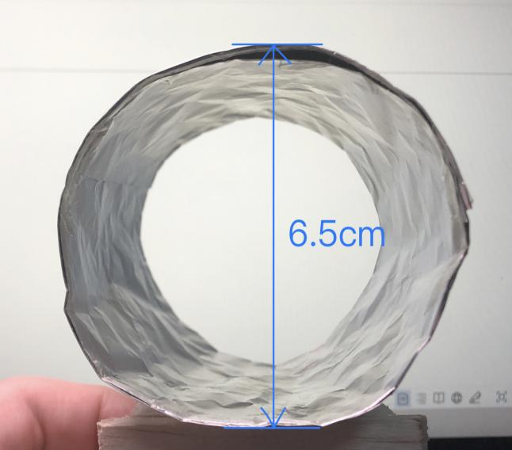
Figure 3 foil tubes
- Connect the all three nails to the transformer by copper wires, place the experiment tubes with three tubes based on the scale marked on the plate, place the wind speed sensor at the position that the blades of the sensor are just apart from the tube. Then open the power supply and take note of the wind speed data produced by the ion engine.
- Repeat the experiment by adjusting the separation of nails and tubes with distance of 1cm 2cm, and 3cm, record the data.
- Disconnect one of the nails and repeat the procedure described in step 5 and 6. The disconnect two of them and repeat the experiment.
- Lessen the voltage at the condition of 3 nails 2cm distance and repeat the experiment.
- Replace the three tubes system with the larger tube and repeat all of the procedures described in step 5, 6 and 7.
- In order to avoid the error as much as possible, all of the experiment described above will be repeated for three times.

- Data and result
Trial | Ring Size | Number of Nails | Distance | Voltage | Wind speed  (round 1) (RPM) | Wind speed  (round 2) (RPM) | Wind speed  (round 3) (RPM) | AVG wind speed (RPM)
1 | Small | 3 | 1cm | 50KV | N. A | N. A | N. A | N. A
2 | Small | 3 | 2cm | 50KV | 18 | 20 | 19 | 19
3 | Small | 3 | 3cm | 50KV | 0 | 0 | 0 | 0
4 | Small | 2 | 1cm | 50KV | 16 | 19 | 16.5 | 17.17
5 | Small | 2 | 2cm | 50KV | 0 | 0.333 | 0.5 | 0.28
6 | Small | 1 | 1cm | 50KV | 0 | 0 | 0 | 0
7 | Small | 3 | 2cm | 25KV | 0 | 0 | 0 | 0
8 | Large | 1 | 1cm | 50KV | 10 | 11.5 | 9.5 | 10.333
9 | Large | 1 | 2cm | 50KV | 0 | 0 | 0 | 0
10 | Large | 2 | 1cm | 50KV | 15 | 12 | 16 | 14.33
11 | Large | 3 | 1cm | 50KV | 17 | 17.5 | 16 | 16.83
12 | Large | 3 | 2cm | 50KV | 0 | 0 | 0 | 0
table 1 data collected from the experiment

Figure 4

- Discussion of result
in the first three trials and last two trials of the experiment, we tested separately how the distance affects the impulse available with three nails. For the small rings group, the result is only available for a distance of 2cm which is 18, 19, and 20RPM respectively. While there is no wind speed detected when the distance increased to 3cm, the experiment for a distance of 1cm failed to give data because our tubes are too close to the nails, which lead to electric ace being generated between nails and tube so we have to stop the experiment to prevent an accident. This series of trials indicate that the closer the nails are to the tubes the greater the impulse is. However, it is not enough to conduct this barely based on one data available, other trails with larger tubes further solidify the result that the wind speed could be only detected when the distance is 1cm. In the whole picture we could infer that when the distance is too far from the nail to the tubes, the ionized performance will be too weak that although there is a wind-generated, its speed is too slow to be detected. And with too close a distance, the ionized performance is too great that causes the electric ace.

In the trial 4 and 5, when the number of nails connected to the power supply decrease to 2, our ion engine generated the wind speed with the same pattern of decreasing with distance. It averages 17.17 when distanced 1cm and 0.28 when distanced 2cm. comparing the data of 2cm distance with trial 2, we could find that with two nails the wind speed generated (avg 0.28 RPM) is much less than the test with 3 nails (avg 19 RPM), it is nearly not detectable for the test with two trails.

When we tested the one with only one nail available, even with the distance of 1cm there is nothing detected from the wind speed sensor, while the test with two nails at this distance generated a pretty fast wind speed avg 17.17 RPM.

The lower voltage is tested under the condition of trial 2 except the voltage is decreased to half of the original value. There is no wind detected.

The data collected from the large tube group though is out of our expectations. With three nails connected there is only wind available when the distance is 1cm which gives an avg 16.83 RPM, which is even then the result from two nails connected when we use the small tubes. And when we repeat the experiment with 2 and 1 nails connected there is no that significant decrease in wind speed happens as the test group with small tubes. At a distance of 1 cm, the numbers given by three different nails groups are avg 16.83RPM, 14.33 RPM, and 10.33 RPM. Unlike the small tubes that generated their own ionized gas separately in one of the three tubes, a large tube is likely to provide a larger space for gas to defuse. So, when we remove one of the nails from the connection, we lose one-third of the ionized gas completely because the small tube only allows them to ionize part of the gas passing through them. The situation is different with large tube, since all three nails are within the range of a large tube, although one of them or two of them could not provide power, the rest of them could still ionized and make a great portion of gas passing through the tube due to the diffusion of a gas. Therefore, this result makes sense for us finally. Another thing to be noticed is that the large tube group all avg a lower wind speed when the remaining conditions are the same as the smaller tube group, which is opposite to our hypothesis. This could be explained by the efficiency of ionization performed by the foil paper. the effective ionized range may be too small for larger rings to ionize all of the gas inside the tube, larger inside surface area helps smaller tube groups to generate more impulse inversely.

6. Conclusion
In this experiment, all of our hypothesis is expected except the one about tube side. In conclusion: the closer the distance between nails and tubes is the greater the impulse could be generated; the greater the number of nails is connected the greater the impulse could be generated; the higher the voltage the greater the impulse could be generated and lastly the three small tube system could generate more impulse compared to the large tube. The amount of ionized gas is the key to understanding all of those conclusions: that is the more the gas is ionized within the range of the tube, the more wind ion engine could blow which means more impulses are generated.

Reference
- “Coulomb’s Law.” Wikipedia, 12 Mar. 2021, en.wikipedia.org/wiki/Coulomb_force. Accessed 21 Mar. 2021.
- “Ion Thruster.” Wikipedia, 16 Aug. 2020, en.wikipedia.org/wiki/Ion_thruster.
- “Dawn (Spacecraft).” Wikipedia, 26 Apr. 2020, en.wikipedia.org/wiki/Dawn_(spacecraft).
- Wilbur, P.J., et al. “Space Electric Propulsion Plasmas.” IEEE Transactions on Plasma Science, vol. 19, no. 6, 1991, pp. 1167–1179, alfven.princeton.edu/publications/ep-encyclopedia-2001, 10.1109/27.125039. Accessed 11 Dec. 2019.
- Choueiri, E. Y. “A Critical History of Electric Propulsion: The First 50 Years (1906-1956).” Journal of Propulsion and Power, vol. 20, no. 2, Mar. 2004, pp. 193–203, 10.2514/1.9245.

