“URINARY C-PEPTIDE CREATININE RATIO AND ITS CORRELATION WITH PARAMETERS OF METABOLIC SYNDROME”
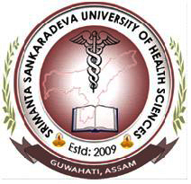

A THESIS SUBMITTED TO SRIMANTA SANKARADEVA UNIVERSITY OF
HEALTH SCIENCES FOR THE DEGREE
DOCTORATE OF MEDICINE (DM) ENDOCRINOLOGY
2020
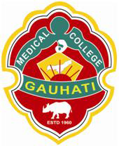

Dr. MANOJ GEDAM
DEPARTMENT OF ENDOCRINOLOGY
GAUHATI MEDICAL COLLEGE AND HOSPITAL,
GUWAHATI, ASSAM, INDIA

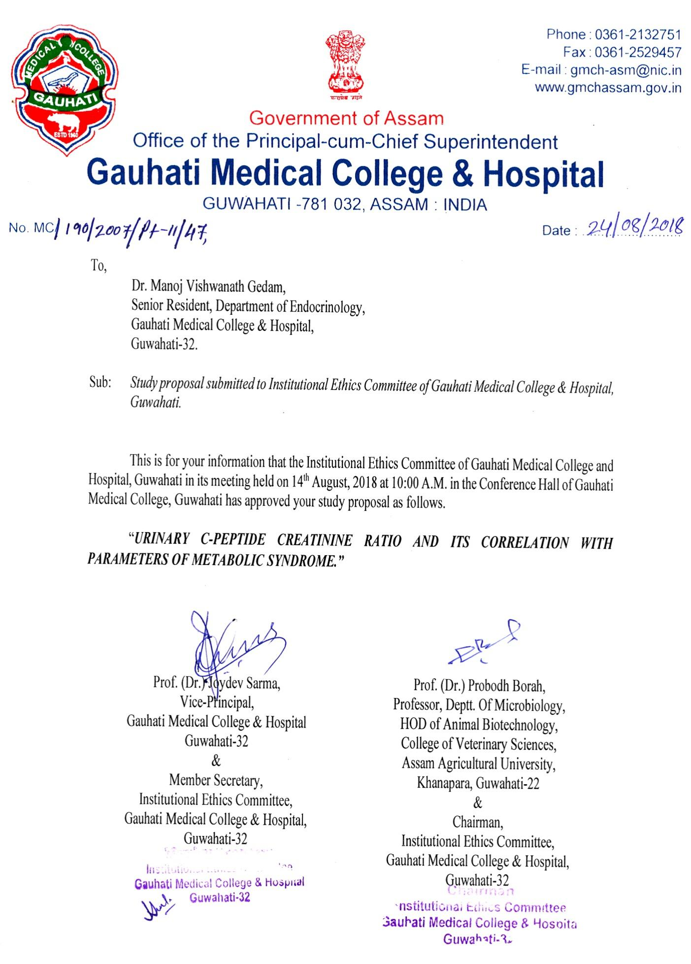
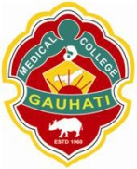
OFFICE OF THE PRINCIPAL
GAUHATI MEDICAL COLLEGE & HOSPITAL
GUWAHATI, ASSAM

Prof.(DR) RK Talukdar
Principal-cum-Chief Superintendent
Gauhati Medical College & Hospital
Guwahati, Assam

CERTIFICATE
This is to certify that the dissertation entitled “URINARY C-PEPTIDE CREATININE RATIO AND ITS CORRELATION WITH PARAMETERS OF METABOLIC SYNDROME” is a bonafide research work done by Dr. Manoj Gedam in the Department of Endocrinology, Guwahati Medical College & Hospital, Guwahati, Assam, under the guidance of Prof.(Dr) Dipti Sarma, Head of Department of Endocrinology and co-guidance of Dr. Bipul Kumar Choudhury, Associate Professor, Department of Endocrinology, Guwahati Medical College, Guwahati. No part of this dissertation work was earlier published or submitted to any other university or institute.
Dr. Manoj Gedam has fulfilled the necessary requisite of regulation of Srimanta Sankaradeva University of Health Sciences, Guwahati for preparing a thesis, as a preliminary to appear in the examinations leading to the degree of DM (Endocrinology).

Dated …………… Prof.(Dr) RK Talukdar
Place: Guwahati

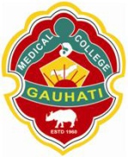
DEPARTMENT OF ENDOCRINOLOGY
GAUHATI MEDICAL COLLEGE & HOSPITAL
GUWAHATI, ASSAM

DR. DIPTI SARMA
Professor and Head of department
Department of Endocrinology
Gauhati Medical College & Hospital
Guwahati, Assam

CERTIFICATE
This is to certify that the dissertation entitled “URINARY C-PEPTIDE CREATININE RATIO AND ITS CORRELATION WITH PARAMETERS OF METABOLIC SYNDROME” is a bonafide research work done by Dr. Manoj Gedam in the Department of Endocrinology, Guwahati Medical College & Hospital, Guwahati, Assam, under the guidance of Prof.(Dr) Dipti Sarma, Head of Department, Department of Endocrinology and co-guidance of Dr. Bipul Kumar Choudhury, Associate Professor, Department of Endocrinology, Guwahati Medical College, Guwahati.No part of this dissertation work was earlier published or submitted to any other university or institute.
Dr. Manoj Gedam has fulfilled the necessary requisite of regulation of Srimanta Sankaradeva University of Health Sciences, Guwahati for preparing a thesis, as a preliminary to appear in the examinations leading to the degree of DM (Endocrinology).

Dated: Prof.(Dr.) Dipti Sarma
Place: Guwahati

DEPARTMENT OF ENDOCRINOLOGY
GAUHATI MEDICAL COLLEGE & HOSPITAL
GUWAHATI, ASSAM

DR. DIPTI SARMA
Professor & Head
Department of Endocrinology
Gauhati Medical College & Hospital
Guwahati, Assam

CERTIFICATE
This is to certify that the dissertation entitled “URINARY C-PEPTIDE CREATININE RATIO AND ITS CORRELATION WITH PARAMETERS OF METABOLIC SYNDROME” is a bonafide research work done by Dr Manoj Gedam in the Department of Endocrinology, Guwahati Medical College & Hospital, Guwahati, Assam, under the guidance of Prof.(Dr) Dipti Sarma,, Head of Department, Department of Endocrinology and co-guidance of Dr. Bipul Kumar Choudhury, Associate Professor, Department of Endocrinology, Guwahati Medical College, Guwahati.. No part of this dissertation work was earlier published or submitted to any other university or institute.
Dr.Manoj Gedam has fulfilled the necessary requisite of regulation of Srimanta Sankaradeva University of Health Sciences, Guwahati for preparing a thesis, as a preliminary to appear in the examinations leading to the degree of DM (Endocrinology).

Dated ………….. Prof. (Dr.) Dipti Sarma
Place: Guwahati

DEPARTMENT OF ENDOCRINOLOGY
GAUHATI MEDICAL COLLEGE & HOSPITAL
GUWAHATI, ASSAM

DR. BIPUL KUMAR CHOUDHURY
Associate Professor
Department of Endocrinology
Guwahati Medical College & Hospital
Guwahati, Assam

CERTIFICATE
This is to certify that the dissertation entitled “URINARY C-PEPTIDE CREATININE RATIO AND ITS CORRELATION WITH PARAMETERS OF METABOLIC SYNDROME” is a bonafide research work done by Dr Manoj Gedam in the Department of Endocrinology, Guwahati Medical College & Hospital, Guwahati, Assam, under the guidance of Prof.(Dr) Dipti Sarma,, Head of Department, Department of Endocrinology and co-guidance of Dr. Bipul Kumar Choudhury, Associate Professor, Department of Endocrinology, Guwahati Medical College, Guwahati.. No part of this dissertation work was earlier published or submitted to any other university or institute.
Dr.Manoj Gedam has fulfilled the necessary requisite of regulation of Srimanta Sankaradeva University of Health Sciences, Guwahati for preparing a thesis, as a preliminary to appear in the examinations leading to the degree of DM (Endocrinology).

Dated ………….. DR Bipul Kumar Choudhury
Place: Guwahati

ACKNOWLEDGEMENT
It is indeed a privilege for me to able to appreciate all those far and near, whose help, encouragement, suggestions as well as constructive criticism helped me in completing this phenomenal task of preparing a thesis.
At the very onset I convey gratefulness to the Principal-Cum-Chief Superintendent of my institution Prof.(Dr.) RK Talukdar for allowing me to carry out my thesis work.
I convey my most sincere gratitude to my guide Prof. Dipti Sarma, Head of Department of Endocrinology for her valuable suggestions throughout the period of the study and untiring support. I shall forever remain indebted to her for her keen interest, constant inspiration and meticulous supervisions in every step while preparing this piece of work. Her fine clinical acumen and confidence in diagnostic skill have paved the way to build up my personality.
I consider myself extremely privileged to have Dr. Bipul Kumar Choudhury, Associate Professor, Department of Endocrinology, as my teacher and co-guide for my dissertation. I shall always remain indebted to him for his support and guidance during the course of my post-graduation. He will always be fondly remembered as an affectionate teacher who is a constant source of inspiration and guiding light.
I offer my sincere gratitude to my respected teacher Dr. Uma Kaimal Saikia, Associate Professor, Department of Endocrinology for her invaluable guidance and inspiration during the course of my post-graduation.
I convey my sincere gratitude to my respected teacher Dr. Ashok Krishna Bhuyan, Assistant Professor, Department of Endocrinology for his support and guidance in times of need.
I am highly grateful to my seniors and colleagues Dr. Samiran Das, Dr. Sonali Appaiah, Dr. Manjari Dwivedi, Dr Akash, Dr Susheel, Dr Surendra, Dr Angad of the Department of Endocrinology for their constant support and help offered to me during my thesis work.
I shall remain ever grateful to my wife Dr. Aditi Kakodia, my parents, sisters and brother who has always been by my side and has helped and encouraged me throughout.
I am also greatful to Mr Nayan and Mrs. Parnati and all the laboratory staff of the Metabolic Laboratory Department of Endocrinology for their help.
I would also like to pay my gratitude & tender my apology to all those who have helped me in some way or the other, but remain undocumented.

Date:
Place: Guwahati Dr. Manoj Gedam
CONTENTS

CHAPTER |  | PAGE NO
Chapter – 1 | INTRODUCTION | 1-3
Chapter – 2 | AIMS AND OBJECTIVES | 4
Chapter – 3 | REVIEW OF LITERATURE | 5-36
Chapter - 4 | MATERIALS AND METHODS | 37-44
Chapter – 5 | RESULTS AND OBSERVATIONS | 45-65
Chapter – 6 | DISCUSSION | 66-73
Chapter – 7 | SUMMARY | 74-76
Chapter – 8 | CONCLUSION | 77-78
 | BIBLIOGRAPHY | 79-92
 | ANNEXURES | i-vii
 | - PROFORMA
 | - CONSENT FORM
 | - ABBREVIATIONS
 | - MASTER CHART

