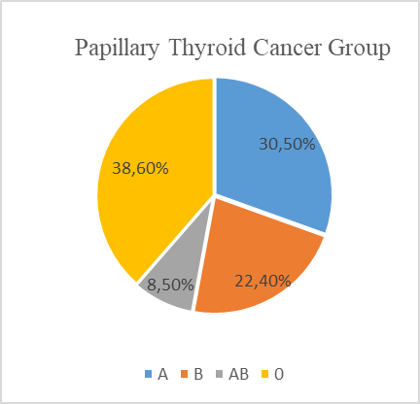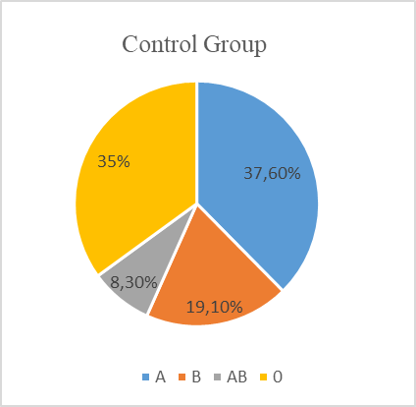

Figure 1: Schematic distribution of ABO blood types

Figure 2: Occurrence rates of ABO blood types and Rh factor in the thyroid papillary cancer and control groups (in percentages)

Table 1: Distribution of ABO blood types and Rh factor in the control and papillary thyroid cancer groups
 | PTC  n = 223(%) | Control  n = 1040(%) | p value
Age (years)* | 43 (16 ̶86) | 43 (16 ̶90)
Sex  Female  Male | 163 (73.1%)  60 (26.9%) | 547 (52.6%)  493 (47.4%) | <0.001  <0.001
ABO  A Positive  A Negative  B Positive  B Negative  AB Positive  AB Negative  O Positive  O Negative | 58 (26%)  10 (4.5%)  40 (17.9%)  10 (4.5%)  16 (7.2%)  3 (1.3%)  78 (35%)  8 (3.6%) | 349 (33.6%)  42 (4%)  172 (16.5%)  27 (2.6%)  74 (7.1%)  12 (1.2%)  334 (32.1%)  30 (2.9%) | 0.029  0.761  0.612  0.129  0.975  0.811  0.408  0.577
Rh factor  Rh Positive  Rh Negative | 192 (86.1%)  31 (13.9%) | 929 (89.3%)  111 (10.7%) | 0.229  0.575
PTC: Papillary thyroid cancer; p < 0.05 was considered statistically significant. * Median (minimum–maximum)

