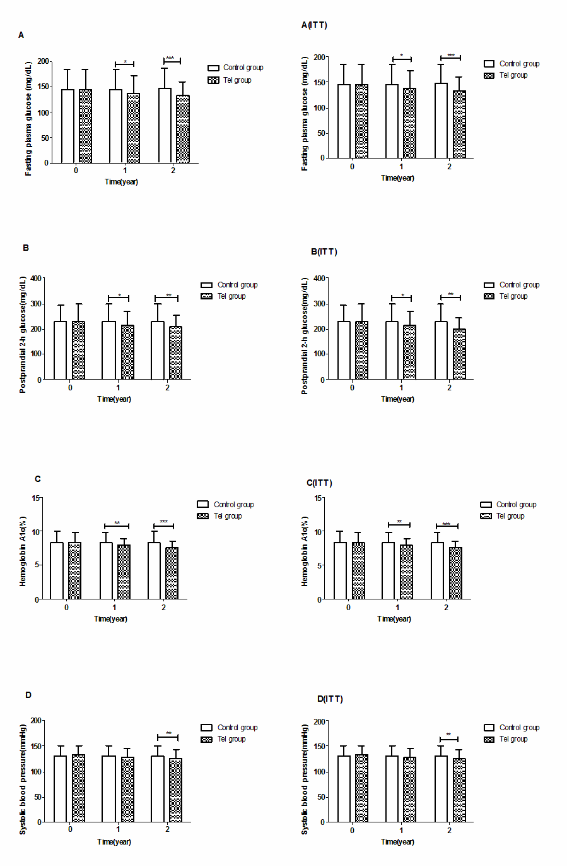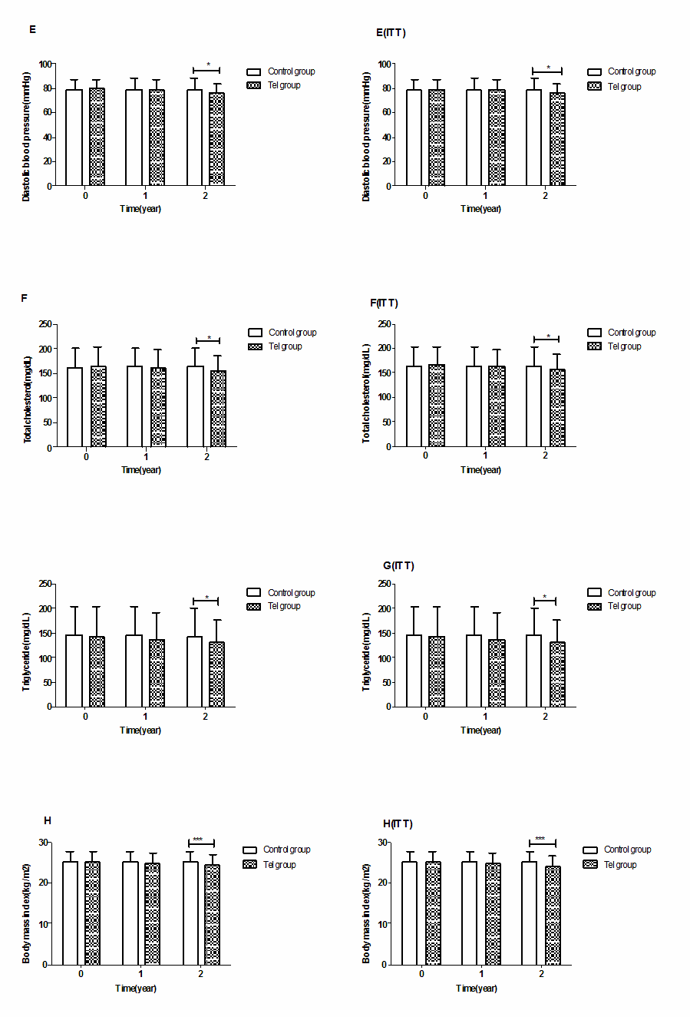
Fig. 3 Inter-group comparison of same follow-up times. A: FPG levels of four groups at same follow-up times; B: 2HPG levels of four groups at same follow-up times; C: HbA1c levels of four groups at same follow-up times; D: SBP levels of four groups at same follow-up times; E: DBP levels of four groups at same follow-up times; F: TC levels of four groups at same follow-up times; G: TG levels of four groups at same follow-up times; H: BMI levels of four groups at same follow-up times. A(ITT), B(ITT), C(ITT), D(ITT), E(ITT), F(ITT), G(ITT), and H(ITT): Corresponding index levels of four groups at same follow-up times by ITT. ITT-LOCF: intention to treat analysis-last observation carried forward. Results ara expressed as the mean ± SD. ＊P<0.05, **P<0.01, ***P<0.001 for comparisons between conditions.

