About the author: Liu Xue Ying, Femal (1983.04- ), Han nationality, master degree, lives in the city of TianJin. She is a lecture in Cabin Attendant College at Civil Aviation University of China. Her main research interest focuses on hospitality management and cabin service and management. Email: eleanor_ryuu@qq.com.
Predicting on Chinese consumers' organic wine purchase intention
Liu XueYing

Civil Aviation University of China, TianJin, China, Zip Code:300300
Abtract:
There is very little research on the perception and willingness of Chinese consumers to purchase organic wine.The research aims to understand the factors which influence Chinese consumers’ willingness on organic wine purchase. Based on the TRA and TPB, combine with SCT, a conceptual model is established to solve research problems.
Keywords: Chinese consumer: organic wine: purchase intention: TRA: TPB: SCT

1.0 Introduction
The Chinese people's consumption of wine is increasing, and now it already become as the fifth largest wine consumer market in the world. According to relevant international grape and wine-related organizations, China's wine production has reached 2.92 billion liters in 2018; wine consumption reached about twenty liters, it has almost become the fastest growing market in the world.

1.1 The organic wine market
IWSR's 2018 report shows that the share of global organic wine has risen to 2.4%, which is equivalent to nearly 690 million bottles of wine. As consumers become more environmentally aware, the market share of organic wine has huge growth potential. However, there is very little research on the perception and willingness of Chinese consumers to purchase organic wine and imported organic wine^{[6].}

1.2 Purpose
The research aims to understand the factors which influence Chinese consumers’ willingness on organic wine purchase. Based on the theory of rational action(TRA) and the theory of planned behavior(TPB), combine with status consumption theory(SCT), a conceptual model is established to solve research problems.

2.0 Literature review and hypothesis
In 1975, Ajzen and Fishbein put forward the TRA to clarify the reason behind decision making through psychological theory and whether a particular behavior is adopted or not. The theory has widely explained some behavioral and psychological research work in the marketing section, and also applied to organic food marketing in many environments.

Likewise the perceived behavioral control variable has been includes into the TPB, for better explaining individual decision behavior. The theory is widely applied on energy saving, green consumption and intentions to organic food purchasing.

Furthermore SCT refers to the consumption of status goods by consumers in order to maintain or improve their social status and thereby express their desired social status and social level to themselves or other important people around them ^{[1].} At social events, wine consumption reflects the drinker's social status, lifestyle and personality.

The researcher believes that environmental concern is the essential prerequisite for perceiving the value of organic food ^{[2]}. At the same time, research has proved that consumers' concern for ecology and the environment has led to the continuous growth of global organic food and beverages ^{[4]}.
H1. China Consumers’ environmental awareness has a significant effect on the Chinese consumer’s attitude toward organic wine.

Mei et al. (2012)^{[5]} believe that knowledge and beliefs affect all stages of decision-making. Research shows that environmental knowledge significantly affects attitudes towards green purchases. When people understand or master some knowledge about organic wine, they may change their buying attitude.
H2. Knowledge of organic wine has a significant effect on the China consumer’s attitude toward organic wine

In China, consumers are beginning to pay more attention to topics related to health and their dietary habits, such as choosing healthy foods in their daily life. The focus on chemical residues in food has led to the notion of healthier organic food, which has increased the purchase intention of organic food. Positive attitudes and beliefs about healthier organic foods may enhance individuals' willingness to purchase organic wine. Therefore, the following assumptions are made ^{[8]}.
H3. The health concern of Chinese consumehas a significant effect on the China consumer’s attitude toward organic wine.

Organic food is considered high-quality food because of its high-standard planting requirements and production methods, making it healthier. At the same time, certification and verification from an authoritative organization or government can ensure its quality and safety. The quality assurance of organic food is easier to win the trust of consumers and promote consumer purchase behavior.
H4. The quality of organic wine has a significant effect on China consumer's attitude toward organic wine

Organic food’s price needs to be seriously considered as well. Its price is an important aspect when consumers making purchasing decisions process, because the price of organic food is directly related to purchasing power. The price of organic food is often more expensive than that of non-organic food ^{[3]}. The high price of organic food in the literature is one of the biggest obstacles to its consumption. If the price of organic food is too over, consumers will not have the ability to purchase it.
H5. The price of organic wine has a negative effect on the China consumer's attitude toward organic wine.

The researcher considered the social norms as an imperative driving force for consumption of the organic food ^{[2]}. For example, if buying organic food is considered a socially recognized behavior, then individuals are more likely to buy organic food for themselves or their family members.
H6. The subjective norm has a positive impact on the China consumers intention to purchase the organic wine.

The TPB explained the behavior lies on the willingness to process the act considered with perceived behavior control. Perceived behavioral control is the degree to which an individual believes that people can control their behavior. According to the study, consumers’ green purchase behavior in European Union countries was well explained by the TPB. Researcher also applied the TPB to evaluate the intention of consumer to purchase organic food.
H7. Perceived behaviour control has a significant effect on the China consumers purchase intention toward the organic wine.

Organic food consumption is also considered as a luxury fashion purchase, which is beyond the basic needs, likewise represents symbolic meanings. According to Sector Trend Analysis (2016) report, wine, especially imported wine, in China is considered a status symbol and is mainly used in social interactions such as business and other important occasions. Furthermore Chinese wine purchase behaviour reflects the symbolic and social value of wine.
H8. The status consumption has a significant impact on the intention to purchase the organic wine.

The organic food product does not have any chemicals or pesticides, thereby enhancing consumers' positive attitudes towards organic food. In terms of personal behavior, the more positive the consumer's attitude towards food, the more likely it is that consumers will purchase the food. In accordance with the TRA theory, this research gave us a framework of basic psychological concepts, because the behavior is directly affected by the intention, that why the intention is also called behavioral intention ^{[8]}.
H9. The positive attitude of China consumers toward organic wine has a significant effect on the purchase intention of the organic wine.

H10. The China consumers’ positive purchase intention of the organic wine has a significant influence on the China consumers purchasing behavior of organic wine.

3.0 The model and framework
Based on relevant information, the conceptual model is proposed to analyze purchase behavior of Chinese consumers' organic wine.
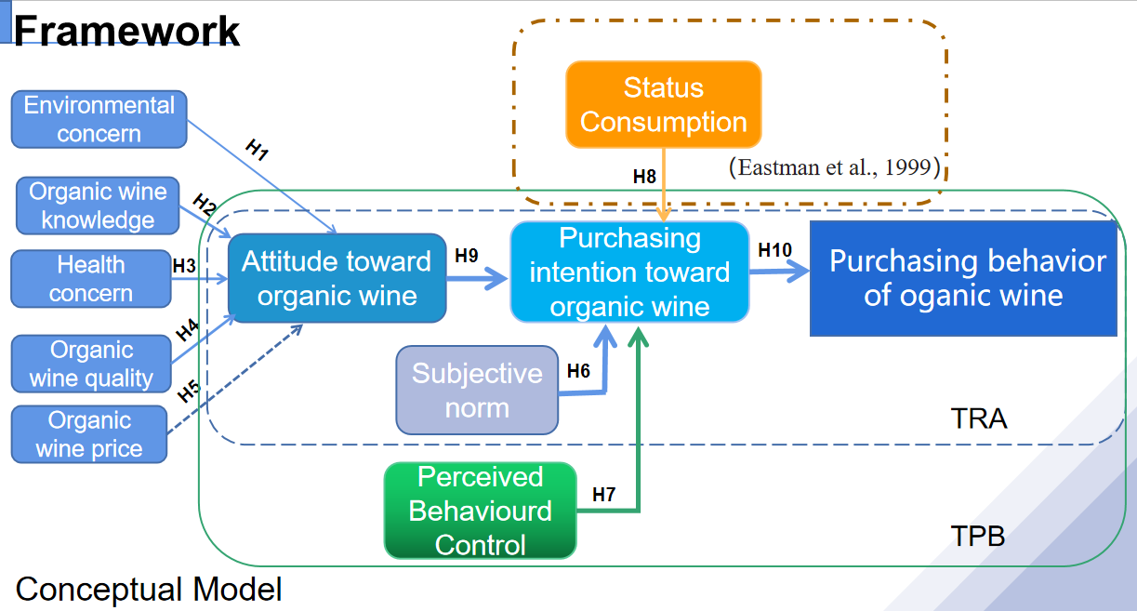

4.0 Methodology
Questionnaire survey was used for the research’s data collection, which was filled out online by scanning the code. The respondent need to be a consumer who is over 18 years old, lives in Beijing and has an awareness of buying organic wine. The survey method was to ask consumers before the exit of the largest organic food supermarket in the center of Beijing. The simply size was decided by running G.Power software, all the collected survey data was going to be entered by using SPSS for final analysis. The measurement model.will be tested by using Smart PLS.

5.0 Conclusions
Establish a conceptual model by studying all direct and indirect variables to predict the purchase behavior of Chinese consumers for organic wine. This study shows that the most important predictive attitude factor is health concern. Meanwhile the subjective norms are the most important factor affecting attitudes, organic wine knowledge is the most important personal factor that affects people's attitudes towards organic wine purchases.

References
[1] Eastman, J.K., R.E. Goldsmith, L.R. Flynn (1999), “Status Consumption in Consumer Behavior: Scale Development and Validation,” Journal of Marketing Theory and Practice, 7, 41-52.
[2] Groening, C., Sarkis, J. and Zhu, Q. (2018), “Green marketing consumer-level theory review: a compendium of applied theories and further research directions”, Journal of Cleaner Production, Vol. 172 No. 2, pp. 1848-1866.
[3] Lea, E. and Worsley, T. (2005), “Australians’ organic food beliefs, demographics and values”, British Food Journal, Vol. 107 No. 10, pp. 855-869.
[4] McCarthy, B., Liu, H.B. and Chen, T. (2016), “Innovations in the agro-food system: adoption of certified organic food and green food by Chinese consumers”, British Food Journal, Vol. 118 No. 6, pp. 1334-1349.
[5] Mei, O.J., Ling, K.C. and Piew, T.H. (2012), “The antecedents of green purchase intention among Malaysian consumers”, Asian Social Science, Vol. 8 No. 13, pp. 248-263.Organic Trade Association (2016), available at: www.ota.com/resources/market-analysis
[6] Rana, J. and Paul, J. (2017), “Consumer behavior and purchase intention for organic food: a review and research agenda”, Journal of Retailing and Consumer Services, Vol. 38, pp. 157-165.
[7] Thøgersen, J., de Barcellos, M.D., Perin, M.G. and Zhou, Y. (2015), “Consumer buying motives and attitudes towards organic food in two emerging markets: China and Brazil”, International Marketing Review, Vol. 32 Nos 3/4, pp. 389-413
[8] Zhang, K.Z. and Benyoucef, M. (2016), “Consumer behavior in social commerce: a literature review”, Decision Support Systems, Vol. 86 No. 1, pp. 95-108.

