**Supply and demand, tax, income, profit and proof of Goldbach's conjecture**

**——Logic is the basis of correct mathematical measurement**

Wang Zhaocheng[1]

1400203697@qq.com

**Abstract:** This paper demonstrates that Marshall's logic on the supply and demand curve is not rigorous enough, that Coase's theorem is flawed, and that the" Okishio Theorem" and Sweezy s logic are inadequate through empirical proof. By the way, the Goldbach conjecture is proved through clever mathematical proof. It shows that beautiful curves and mathematical formulas cannot be separated from reality and logic, and correct logic can play a correct role in market theory. In this paper, the analysis of the actual supply and demand curve, as well as the concepts and models of tax, profit rate and income, have positive practical significance for economic depression and stagflation.

**Keywords:** supply and demand, income, tax, profit rate, Goldbach conjecture

**1、 Logical Defects of Marshall's Supply Demand Curve Theory**

Adam Smith pointed out that there is an invisible hand in the market to adjust the price of goods, which can achieve Pareto optimality without government intervention, that is, to achieve maximum utility. However, in the early 21st century, under the explanation and proof of the game theory, in some cases, only relying on the spontaneous regulation of the market, and the government does not introduce policies or laws to restrain the situation, is unable to achieve the maximum effectiveness.

In western economics, Alfred Marshall put forward the supply and demand curve, which is the theoretical basis. However, the supply and demand curve is not logically rigorous. The conclusion derived on this basis is inconsistent with the experience and the fact.

The supply curve, in practice, because of the diminishing marginal utility, the number of goods successfully sold will not increase after consumers purchase a certain amount, even if the price drops again and consumer demand is met. Even if the price decreases, consumers will choose not to buy this product again because there is no place to store it or there is no utility increase. As shown in the figure, the actual demand curve. The dotted line indicates that as the commodity price decreases, the demander will not buy this commodity again. At this time, we call it "the time when the proposed value is 0"or"0 value to be brought".

In the demand curve, the intersection of the solid line and the dotted line also represents the "demand end point". This curve is applicable to microeconomics and macroeconomics.

In western traditional microeconomics and macroeconomics, Marshall's supply curve and demand curve were wrong and imprecise in counting unsalable unsold goods into the category of demand curve. Therefore, based on the above supply and demand curve in western microeconomics, the theorems deduced are imprecise or wrong conclusions. On this basis, the corresponding wrong conclusion of reasoning cannot judge the overproduction, and the perfect model that thinks the market can adjust automatically, but the conclusion of the model and calculation brings about unsalable goods and waste of resources. There are many such examples in reality, so I will not repeat them.

The same is true of the supply curve. In reality, although the capitalists see profits, in a numerical value, the purchasing power of consumers in the market is fully realized. When the consumer demand is at "0 value to be brought", the price changes immediately, and the consumer will not buy this product. Because the commodity cannot be traded, the capitalists in the market will not produce this commodity again. Even if the price of this commodity rises, the supplier will still choose not to enter this market to produce because it cannot be sold. At this time, the supply of this commodity will not increase.

As shown in the figure 1. The end point of the solid line is the time when consumers are expected to bring value. The dotted line indicates that the goods cannot be sold, and even if the price of the goods increases, the supply will not increase. The intersection point of solid line and dotted line is the manufacturer's stop entry point. The end point of the solid line of the supply curve or the intersection point of the realization and the dotted line indicates that " supply end point".



We put the actual supply and demand curves in a chart. Sometimes, the supply and demand curves do not intersect. (As shown in Figure 3, CD.) When the elasticity of the supply curve is different from that of the demand curve, that is, when the slope of the supply curve is different from that of the demand curve, and the length of the solid line is different, the two curves will not intersect. At this time, the product will be unsalable or the supply is less than the demand.

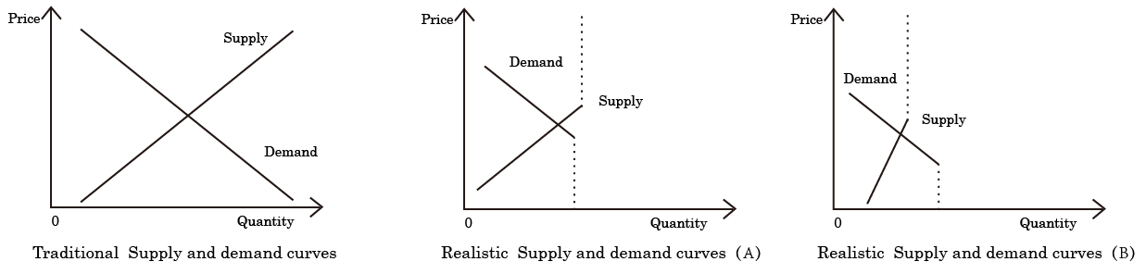

Figure 2 Equilibrium Price Point of Traditional and Actual Supply Demand Curves

Furthermore, in Marshall's western economic framework, the supply and demand curves would intersect. The intersection point is the equilibrium point or the maximum benefit point. As shown in the figure above, the actual supply and demand curves are A and B. When the solid lines intersect, the equilibrium price appears.

At the micro and macro levels, in practice, sometimes the supply and demand curves do not intersect. Figure 3 shows that there is a problem in the production and sales of goods. It indicates that there is a problem between supply and demand, which is in an unbalanced state, resulting in unsalable or insufficient supply. At this time, utility is not maximized. Consumers and manufacturers cannot obtain the maximum benefits.

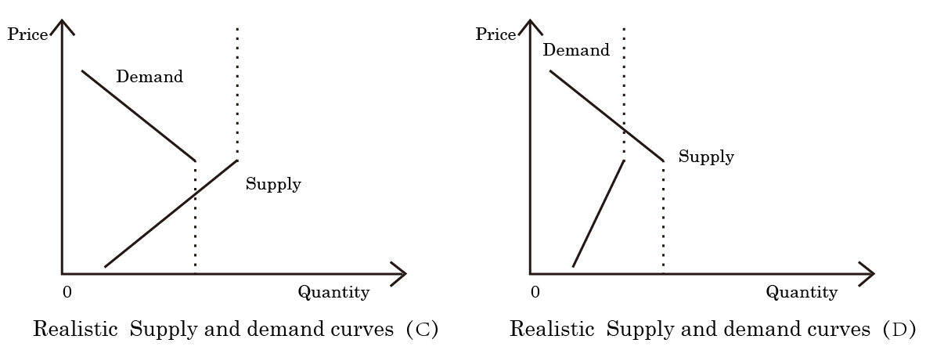

**Fig. 3 Supply and demand curve when the goods are unsalable or in short supply in practice**

On the micro level, there are situations of insufficient supply or unsalable sales. Using our model, we can judge whether the goods are under sold or unsalable in the actual production and market. Then we can get targeted and effective measures.

On the macro level, the solid lines of the supply and demand curve cannot intersect. At this time, there is no equilibrium price in the market. At this time, there will be an economic crisis in serious cases.

When the elasticity of the supply curve is compared with that of the demand curve, and in the comparison, the elasticity of the supply curve is relatively small, the supply is less than the demand. When the elasticity of the supply curve is relatively large compared with that of the demand curve, the situation of unsalable sales occurs. That is, when the supply end point is on the left of the demand end point, supply is less than demand; When the end point of supply satisfaction is on the right side of the end point of demand satisfaction, supply exceeds demand.

(In this paper, the supply demand curve is abbreviated as SD curve, the supply curve is abbreviated as s curve, and the demand curve is abbreviated as d curve.)

**practical application**

Explain why a new product will not be unsalable when it first appears. As shown in Figure 3.

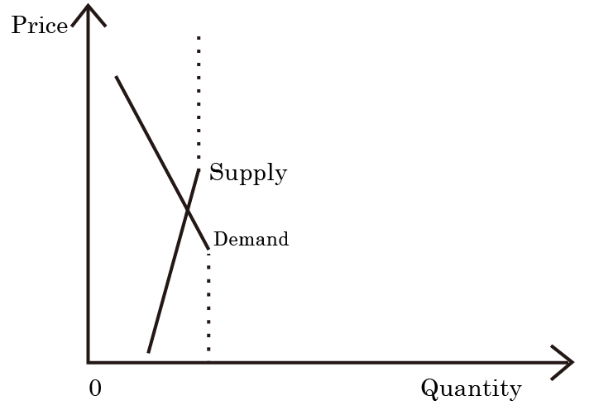

**Fig. 4 Supply and demand curve of new products in reality**

When new products appear, there are few manufacturers, and the elasticity of the supply curve S is small. As it is a new product, the user consumers have not experienced it before, so the consumer demand is strong. However, because of the new product, few people know about the product, or there is a wait and see for a better product to be updated. At this time, the elasticity of the demand curve is small. The slope of the two curves is small, so the SD curve is easy to intersect, and the equilibrium price is easy to be generated. Therefore, it is proved that when a new product appears in the market, it is easy to achieve balanced price, easy to sell, and maximize the interests of producers and consumers.

Later, with the emergence of "0 value to be brought " and " demand end point ", the purchasing power of consumers declines, and then two kinds of CD charts (as shown in Figure 3) appear. The SD curve cannot intersect and the equilibrium price cannot be achieved. At this time, there is a problem in commodity sales.

When more and more manufacturers enter this market, the s supply curve becomes not steep, but flat. At this time, the C figure appears. At this time, supply exceeds demand, and the goods are unsalable.

Similarly, in the other case, when the price changes a lot, the number in the market is small, indicating that the elasticity of supply is small or monopoly. When the elasticity of the demand curve is small, the D chart appears, and the solid lines of the SD curve do not intersect. At this time, supply is less than demand.

As can be seen in the figure, the maximization of social interests requires the intersection of solid lines of the SD curve. It has nothing to do with monopoly.

**2、 Taxes, Prices, Subsidies, Elasticity and Practical Countermeasures**

When the solid lines of the supply and demand curve do not intersect, there are problems in the market, problems in commodity sales, unsalable or insufficient supply, and failure to produce an equilibrium price. At this time, the overall utility cannot be maximized. On the basis of this theory, at the micro level and macro level, the solid line of the supply and demand curve is partially intersected to achieve equilibrium price and maximum utility. The following measures will be adopted. This strategy can deal with or prevent economic crisis.

(1) Only adjust the demand curve to move the d curve downward.

Increase the income of consumers. At this time, due to the increase of consumer income, the actual price of goods for consumers has decreased compared with the increased income in the past. If the demand curve moves downward, it will intersect the supply curve and form an equilibrium price.

In the form of non inflation, more monthly funds will be distributed to the people or consumers to increase the disposable income of consumers. In the form of more money from the government or big capitalists, the demand curve will move downward, making the SD curves intersect, forming a balanced price, and preventing the occurrence of economic crisis.

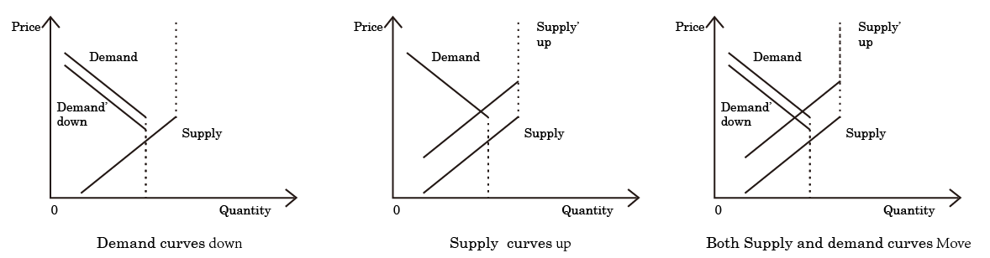

**Figure 5 Achieving Equilibrium Price after Moving the Supply Demand Curve**

(2) Turn the commodity into a hot commodity. After the commodity becomes a hot commodity, the slope increases and the elasticity decreases. When the commodities are popular, the slope of the D curve and the S curve becomes larger, and the solid line of the SD curves are easy to intersect.

(3) Through currency depreciation and inflation, the prices of commodities on the market will rise in a disguised way in a short time. At this point, the supply curve moves up. It is possible to intersect the demand curve in a short time.

Note that at this time, it refers to the situation where market commodity prices generally rise, but people's income and consumer income do not rise.

In addition, the method of issuing currency cannot be adopted, because issuing currency will make the SD curves move up as a whole, which is basically invalid in the long run.

(4) Currency appreciation

At this point, the demand curve moves down and the supply curve moves up. It is possible to intersect.

Therefore, the first insurance method is better.

Inflation and the government issuing more money will also reduce the elasticity of the d curve. Because the tax burden is in the two curves of the supply and demand curve, the relatively low elasticity curve. Therefore, when consumer elasticity is low, further increasing the burden on consumers when paying taxes will also cause the demand curve to move up. It is not conducive to the intersection of SD curves.

Macroscopically, the government controls and monitors the hot selling products. The products with low SD slope are hot selling products. Through intelligent data mining of production and sales data in various markets, it can find the products with low SD slope and intervene to reduce the risk of unsalable goods.

**Specific micro applications:**

How to improve long-term profits of famous brand enterprises.

For famous brand enterprises, in the long run, consumer demand has declined, and the elasticity of the d curve has increased. When increasing profits, they should:

1. Reduce the selling price of existing goods. Because the demand curve is about to terminate, it is not conducive to the intersection of the SD curves. Reducing the selling price makes the demand curve move downward.

2. Create a sub brand high-end brand, increase the price, and reduce the elasticity of the consumer demand curve of this high-end brand. Form a curve of scarce hot selling products. Create consumption hot spots and make consumers have new marginal utility.

The two steps are taken to improve enterprise profits.

For example, Rolex gold watch and diamond watch. Both gold watches and diamond watches have distinctive features. Although no separate trademark and brand have been established, the inherent attribute label has been equivalent to a new brand effect. The price of gold watches and diamond watches is obviously higher than that of ordinary Rolex steel band watches. It is equivalent to creating new products and brands, and the high-end price is high, which improves the total income and profit of the enterprise.

It has formed new scarce hot selling products and brought a low elastic demand curve. It also makes consumers have new marginal utility. As in step 2

At the same time, Rolex reduced the price of ordinary watches. As in step 1

Practice has proved that Rolex sales have grown steadily.

Similarly, Mercedes Benz has reduced the price of ordinary cars and increased maintenance costs. Increase the price of Mercedes Benz high-end car Maybach and customization, as well as luxury SUV.

Practice has proved that Mercedes Benz's sales have grown steadily.

The above practical examples also prove the scientificity and correctness of this theoretical model in reality.

**In terms of government regulation**

The specific scheme is as follows:

1. On the one hand, the minimum income will be increased and the funds will be distributed to consumers every month.

2. On the one hand, after the commodity price is formed, the national tax is used to subsidize the transaction price of commodities. At this time, the transaction price of the commodity p=consumer spending + national tax subsidies to consumers. (The demand curve moves down.)

1. 2 measures will move the demand curve downward.

3. On the one hand, the state tax is used to subsidize manufacturers and enterprises. In addition to the transaction price of the goods, additional subsidies are given to enterprises for each order. The enterprise's income from each commodity=the transaction price of the commodity + the cost of the national tax subsidy to the enterprise. (The supply curve moves up.)

123 Used together, it will make the d curve move down and the s curve move up. Making the SD curve easy to intersect, forming the equilibrium price, at this time, the market welfare is maximum and the utility is maximum.

4 .In addition, with the government's precise taxation, the SD curve will be easier to intersect.

The tax increase makes the SD curve more vertical, with a larger slope and more inelastic.

Because tax is included in the price at this time, the price reduction and increase of a unit of commodity at this time reflect less price changes than before.

So taxation makes the SD curve more vertical.

When collecting consumer tax and producer tax, it depends on the elasticity of the SD curve, and the party to be taxed according to the elasticity.

In the market, when collecting taxes, the SD curve will bear more taxes than the party with less elasticity.

Therefore, the government should tax the party with greater elasticity in the SD curve.

**Specific application:**

**Example 1: House price**

The elasticity of demand curve in SD curve is small

So,

1. A, the national tax supplementary sales price (excessive), (price=consumer spending + national tax supplementary sales price). (demand curve ) down

B. Tax supplementary enterprises (less), (the income of each commodity of the enterprise=the transaction price of the commodity + the cost of the state tax subsidy to the enterprise) ,(supply curve up)

2. In terms of taxation, there is little consumer tax and much enterprise tax. The slope of SD becomes vertical.

At this point, it is easy for the SD curve to intersect, the equilibrium price is easy to form, and the social welfare tends to be large.

**Example 2. Agricultural products**

1. A, the national tax supplementary sales price (less), (price=consumer spending + national tax supplementary sales price). (demand curve ) down

B. Tax supplementary enterprises (more), (supply curve up)

2. There are many taxes and consumer taxes (consumer taxes will be collected after every successful commodity transaction). Reduce enterprise tax payment. Taxes make the slope of SD vertical.

At this point, it is easy for the SD curves to intersect, the equilibrium price is easy to form, and the social welfare tends to be large.

In the above example, the tax collected in Scheme 2 is equivalent to the subsidy paid in Scheme 1, and the country does not lose.

**3、 Mistakes of Coase Theorem**

Coase theorem points out that market externalities can be solved without government. Coase theorem is wrong. Because patents will only increase costs, because the cost prices of consumers and producers are different in the supply and demand curve, resulting in different degrees of deviation of the SD curve, it will not fundamentally promote the intersection of the SD curve, that is, promote the formation of a balanced price grid. However, the increased patent costs did not feed back the society in the form of taxes or other forms, did not form a balanced price, and did not bring benefits to the whole society, that is, the whole social welfare did not change, because the capitalists would not volunteer money for public welfare.

Therefore, we still need to adopt tax or other methods to solve the market externalities. For example, as we proved above, the way to make the solid lines of the SD curve intersect is to increase or reduce the tax on producers or consumers through the government. Specifically, according to the elasticity of the supply and demand curve, we choose the detailed taxation method to collect tax on positive and negative externalities, and then move the Supply curve to make the solid lines of the SD curve intersect to achieve market equilibrium. At the same time, we make the whole society reach Pareto optimality and increase social welfare.

For example, the example of Coase theorem, if A wants to learn, but B wants to turn off the light. At this time, student A bought food for student B the next day in exchange for turning off the lights later. At this time, student A turns off the light at night, and student B realizes that someone brings meals. Seems to maximize benefits. However, some of them are ineffective effects, which bring about Involuntary utility and involuntary benefits . These Involuntary benefits should not be included in the total benefits. That is, the lost benefits should be included. B doesn't want to turn off the lights and immediately agrees to A's meal transaction. However, if the lights are turned off on time, it will bring more willing benefits. At this time, if there are involuntary transactions, involuntary benefits. Then B can't choose the service of taking meals with A, which will bring less effect than the light off that b originally chose. B chose to turn off the lights at first, which has a better effect and brings better benefits. B can also buy meals the next day. It's also normal for B to buy his own food. B usually buys his own food without any discomfort.

It seems that AB has reached a negotiation, and the total utility of AB in a market (a room) has been maximized after discussion. In fact, the effective utility is not even available, even if AB is in two separate rooms, A reads books and turns off the lights at night; B Go to bed early and buy meals the next day, which brings high practical benefits.

This proves that what Coase theorem says is not accurate. As the transaction process increases the patent cost, the total benefit will remain unchanged. Both sides are satisfied. In fact, both parties to the transaction are not fully satisfied.

The example of Coase theorem brings about the so-called involuntary transaction, that is, unwillingness. Coase did not consider it.

**4 " Okishio Theorem" and Sweezy 's one sidedness**

Among the economists who questioned Marx's general law of declining profit margins, the arguments of American economist Sweezie and Japanese economist Nobuo Nishiba are representative.

The " Okishio Theorem" was proposed by Okishio Naboo in 1961. In 1942, P. M. Sweezy believed that because there was an industrial reserve force in the capitalist economy, which played a role in reducing real wages and increasing the rate of surplus value, the growth rate of real wages could not be the same as that of labor productivity.

Next, we empirically prove the one sidedness of the above two views.

First of all, Okishio Naboo believes that capitalists adopt the "cost criterion" rather than the "productivity criterion". The logical starting point is not in line with the economic logic. It should be that productivity comes first, cost comes later, and not cost determines productivity.

He believes that without statistical research, it is impossible to answer "whether the production technology that improves labor productivity will improve the organic composition of capital" This problem. This paper gives an answer here, and uses empirical evidence to prove that in the traditional industrial society, the organic composition of capital has improved, and the profit rate has declined in the long run; In the era of digital weak AI, as the organic composition of capital increases, the profit margin will rise.

**Demonstration link**

**1. Sample selection**

This paper selects all A-share listed companies in Shanghai and Shenzhen from 2007 to 2021 as the initial research sample, and uses annual data for research. The initial study samples were screened according to the following conditions:

(1) Exclude the sample of financial industry. Because financial listed companies are subject to many government regulations.

(2) Exclude samples of ST, SST, * ST and PT. To reduce the possible deviation to the research results, this paper will eliminate such abnormal research samples;

(3) Remove the samples with missing values and abnormal values of related variables.

Finally, the unbalanced panel data consisting of 35559 "enterprise  year" observations was obtained, with a large sample size, ensuring the credibility of the research conclusions in this paper.

**2. Data source**

The relevant data used in this paper are all from the CSMAR database. Before the start of empirical analysis, this paper winsorize all continuous variables at the enterprise level by less than 1% and more than 99% annually to mitigate the possible impact of outliers on the regression results. Data analysis and processing This part of the work is mainly completed through the software Stata17.

1. The interpreted variable is employee salary.

2. Core explanatory variable, Digit

In order to obtain production efficiency, enterprises adopt digital technology to improve productivity. This paper uses ABCD digital technology to collect indicators and make quantitative analysis in the annual report. The "0-1" dummy variable of "whether to conduct digital transformation in the current year" is used to measure the digital transformation of enterprises. It is feasible and scientific to describe the transformation degree of "enterprise digital transformation" and other elements from the perspective of word frequency statistics, and extract the corresponding keyword word frequency measurement from the annual report as the proxy indicator of enterprise digital transformation degree.

From the perspective of technical realization of variable design, the annual reports of Chinese A-share and B-share listed companies were collected through Python crawler function, and all text content was extracted through Java PDFbox library. Then, word frequencies of key technical directions were classified and collected to form the final aggregated word frequency, and finally an indicator system for enterprise digital transformation was constructed. Because this type of data has a typical "right bias" feature, it will be digitally processed, and then the overall indicator variables showing the digital transformation of enterprises will be obtained.

**3. Model Settings**

For the data in this paper, the following models are used for analysis:



In the above model, subscript i and subscript t represent the enterprise individual and year respectively; β0 stands for intercept item, β1 represents the regression coefficient of the explanatory variable, φi represents the regression coefficient of the control variable; μindustry and μyear  represent fixed effects at the industry and year levels respectively; εi,t represents the residual term.

**4. Descriptive statistics**

In order to preliminarily understand the characteristics of variables, this section describes the sample size, mean value, standard deviation, minimum value, median value and maximum value of each variable in detail.

Table 1 Descriptive statistics of main variables

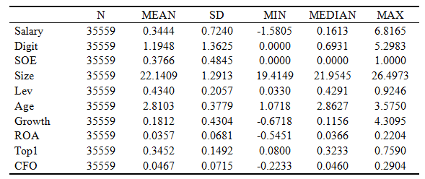

It can be seen from the descriptive statistical results that the statistical characteristics of each variable are within a reasonable range.

**5. Correlation analysis**

On the one hand, preliminarily judge the correlation between variables, and on the other hand, test whether there is an obvious multicollinearity problem between variables. In this section, Pearson coefficient and Spearman coefficient are used to test the correlation of each variable. The test results are shown in Table 3. The lower left corner is the test results of Pearson correlation coefficient, and the upper right corner is the test results of Spearman correlation coefficient.

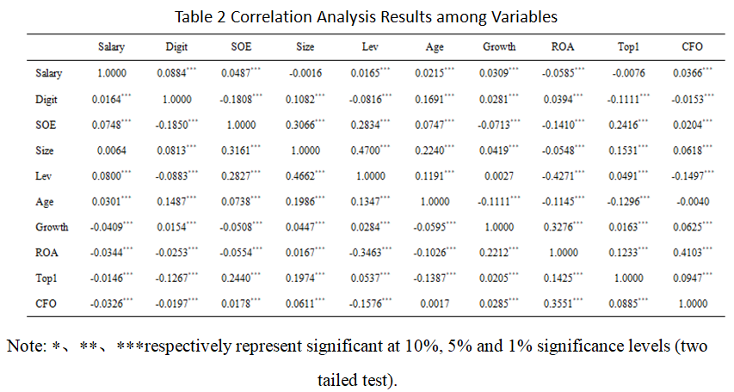

Generally, when the absolute value of the correlation coefficient between variables is greater than 0.75, it means that the multicollinearity problem is serious, which will lead to deviation of the results. From the correlation analysis, we can see that the absolute values of the correlation coefficients of the variables used (except for different explained variables) do not exceed 0.75, indicating that the empirical regression model in this paper is reliable.

**6. Regression analysis and hypothesis testing**

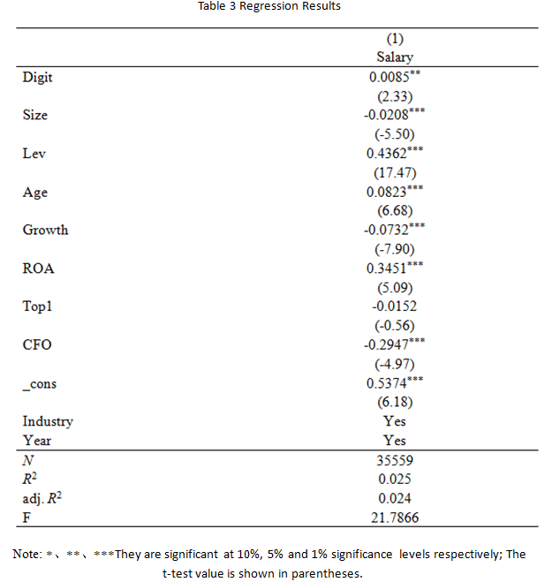

The panel data of listed companies can get accurate results by using the two-way fixed effect model regression of fixed industry and year. From the regression results, we can see that the core explanatory variable Digit will have a positive impact on Salary, and this impact is significant at the 5% level. That is, under the same other conditions, the higher the degree of digitalization of the enterprise, the higher the proportion of employee compensation in the total net profit of the enterprise.

**7. Heterogeneity test and further analysis**

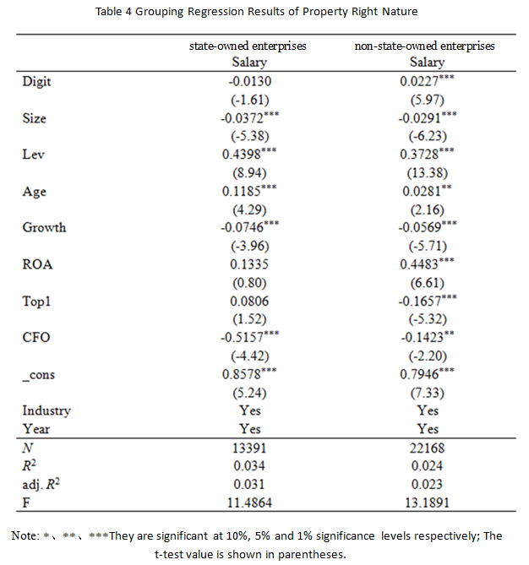

From the regression results of the two-way fixed effect model of fixed industries and years of the state-owned enterprise group, the core explanatory variable Digit will have a negative impact on Salary, but the impact is not obvious. This is also related to the nature of China's state-owned enterprises, the lagging policy of salary promotion, and the fact that it is not easy to raise the salaries of employees in state-owned enterprises.

From the perspective of non-state-owned enterprises, Digit will have a positive impact on Salary, and this impact is significant at the level of 1%. That is, under the same other conditions, the higher the degree of digitalization of the enterprise, the higher the proportion of employee compensation in the total net profit of the enterprise.

**8. Robustness test**

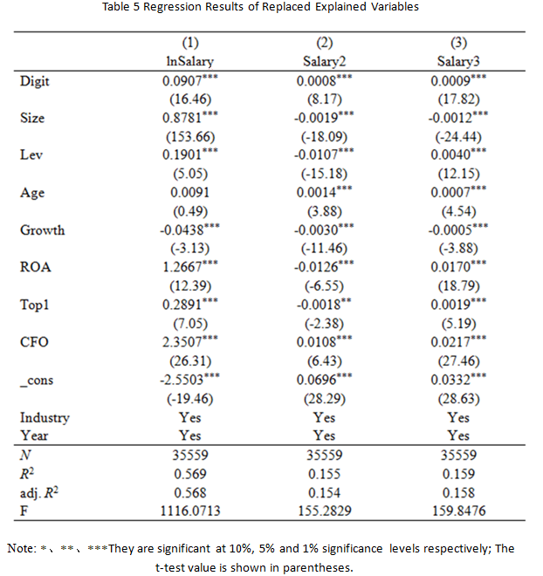

From the regression results of the two-way fixed effect model of fixed industries and years, we can see that the core explanatory variable Digit in this paper will have a positive impact on lnSalary, and this impact is significant at the level of 1%. The same is true for Salary2 and Salary3. It shows that under the same other conditions, the higher the degree of digitalization of the enterprise, the higher the absolute value of (lnSalary) employee compensation will be; Similarly, it will lead to (Salary2) an increase in the proportion of employee compensation in the total operating income of the enterprise; This will lead to (Salary3) an increase in the proportion of employee compensation in the total assets of the enterprise.

**Summary of demonstration:**

As shown in the figure above, the regression of revenue Salary to ROA profit margin shows that the result is significant in three stars. Therefore, it means that with the increase of workers' Salary, the profit margin increases significantly.

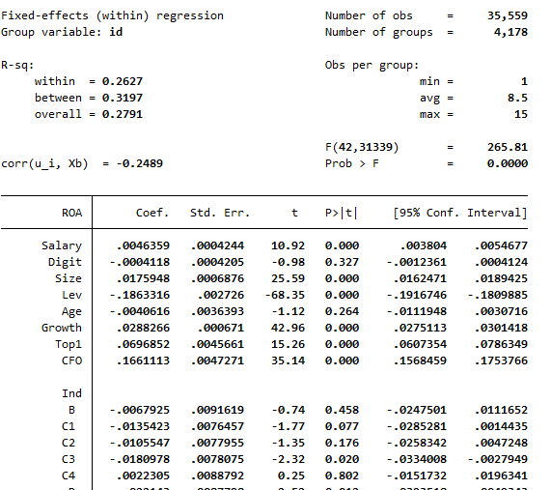

Figure 6 Regression Results

Okishio Nabuo proposed that "as long as the efforts of workers to increase wages fail, the bourgeoisie can improve the profit rate. Thus, the movement of profit rate is determined by class struggle." This is very one-sided, because we have proved through empirical evidence that under the digital condition, the degree of digitalization of enterprises has improved. At the same time, from the data of listed companies, wages have increased, and corporate profit margins have increased.

Similarly, Sweezy's discussion on profit margin is one-sided.

**Evidence from foreign countries**

From 1948 to 1982, the general profit margin of American private enterprises tended to decline in the 34 year period.

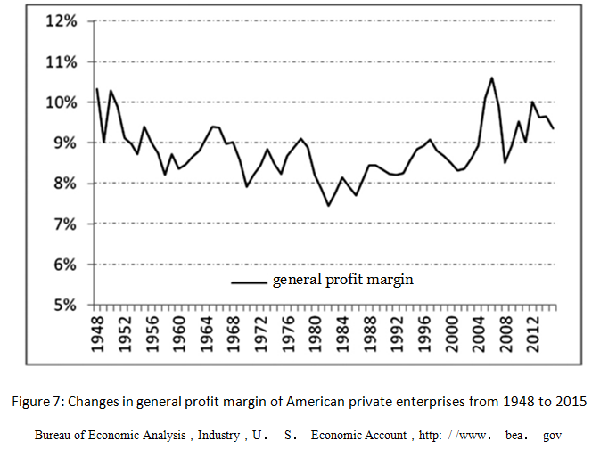

Combined with foreign empirical studies, we can see that the general profit margin did tend to decline in a long historical period from 1948 to 1980. During this period, the actual wage rate did not rise enough, and technological innovation brought about a decline in profit margins.

Therefore, the conclusion of " Okishio Theorem" ： "unless the real wage rate rises sufficiently, the technological innovation introduced by the capitalists will not reduce the general profit margin." It is also incorrect.

**5, Proof of goldbach conjecture**

In the above economics, no matter how beautiful the curve chart model is, but the logic is wrong or the starting conditions are wrong, the conclusion must be wrong, unscientific, and not practical.

Therefore, in practical application, we should first pay attention to the correctness of logic. The following is a clever mathematical proof of Goldbach's conjecture

The proof of Goldbach conjecture is to prove that： Any even number greater than 2 can be written as the sum of two prime numbers.

Prove Goldbach's conjecture skillfully:

We express and define all the numbers in the nature with cubic blocks. The prime number is represented by a cube block, as shown in the following figure. It is represented by a square with the smallest unit of non decomposable unit quantity. (It can be defined as a cube block with the smallest unit of non decomposable unit quantity.) For example, 2 represents the stack of two cubes.

Prime numbers are represented by prime number legends.

Among positive natural numbers above 1 in nature (except for the number 2), except for those that can be divided by a prime number to the second power or above (including the third, fourth, fifth, and so on), except for the number that is multiplied by an even number and an odd number, the number that is multiplied by two odd numbers, or the number that is multiplied by two prime numbers, the numbers are stacked and expressed in the unit of two squares on the bottom base, And those that cannot form the overall figure of a rectangle or square are prime numbers. We also refer to the prime number of this definition as prime number legend.

As shown in the figure below. This definition holds. The definition of prime number is valid. The graphical definition of prime number is valid.

(At this time, the numbers obtained by the product of all odd numbers cannot be stacked with squares with a bottom of 2 squares in the **Legend representation definition of prime number** and **Legend representation definition of even number** by default.)

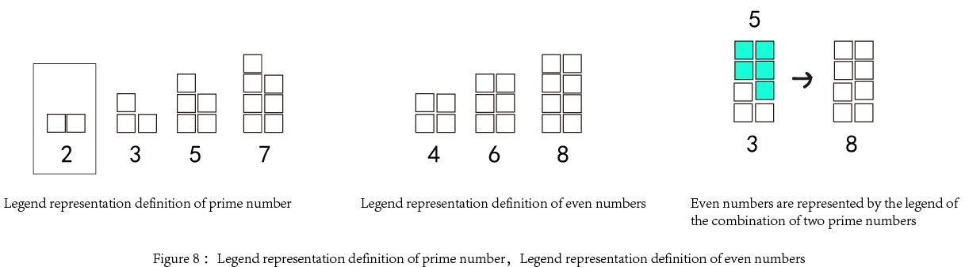

For the definition of even number: we express it as a stack (except for 2) with 2 basic square units as the bottom, which does not contain the number of odd product and forms a rectangle. At this time, the number is even. This is the definition of an even number legend.

It can be seen from the figure that even numbers can be represented by even number legends. Even number legends can be represented as the combination of two prime number legends, that is, the combination of two prime numbers.

**Certification process:**

Because all even numbers greater than 2 can be decomposed into at least one prime number in the even number legend, and the other, because of the axiom "odd number +odd number=even number", according to the **Legend representation definition of prime number** and **Legend representation definition of even number**, if the even number has only one other number besides the current prime number, then the other number must be a prime number, and must also be an odd prime number.

That is, Goldbach conjecture holds, that is, any even number greater than 2 can be written as the sum of two prime numbers.

Note: Even numbers above 6 can be formed by the combination of at least two prime numbers, and even numbers above 12 can be formed by the combination of two or more prime numbers. Because the axiom "odd number plus odd number=even number", at the same time, even numbers above 6 can at least be composed of an odd prime number, then, when one is an odd prime number, and the other number is an odd prime number, because the axiom "odd number and even number", and according to the definition of prime number legend and even number legend, according to the even number legend, when one is a prime number, the other cannot be an even number from the perspective of the legend. If another number is not a prime number, it will not exist after the prime number legend is subtracted from the even number legend. However, if you subtract the prime legend from the even legend, you can have a shape. This is not in line with the forecast. Therefore, the shape left after subtracting (although we don't know what number it is) must be a prime number, and it must also be a prime odd number. (Because, in the definition of prime number legend and even number legend, the number obtained by multiplying all odd numbers cannot be stacked with squares with a bottom of 2 squares by default.)

##### **References**

1. Dickinson. The Falling Ｒate of Profit in Marxian Economics［J］.Review Of Economic Studies，1956
2. Wang Zhaocheng. Political and economic analysis of commodity production and value realization in the context of digital economy [J] Successful Marketing, 2021 (12): 71-82
3. Wang Zhaocheng Commodity attribute analysis of blockchain based digital products in the context of the meta universe [J] Successful marketing, 2022 (5): 70-72
4. Foley，Duncan K. 1982. “The Value of Money，the Value of Labor Power and the Marxian Transformation Problem. ”Review of Radical Political Economics 14 ( 2) ,pp.37-47
5. HORAN, H.Will the growth of uber increase economic welfare[J].Transportation law journal,2017, 44(1):33-105

1. Wang Zhaocheng, Doctor ofEconomics,majoring in digital economy,School of Cyber Science and Engineering, Zhengzhou University, Zhengzhou,China,

   This work/research is supported by Collaborative Innovation Major Project of Zhengzhou (20XTZX06013)