Type of the article (Research Article)
Planktonic scenario of the river Ganga & Yamuna at Prayagraj in COVID- 19 lockdown: a case study

Kalpana Srivastava¹, Jitendra Kumar¹, Dharmnath Jha^{1*}, Venkatesh Ramrao Thakur¹, Vijay kumar¹, Basanta kumar Das ²
¹ICAR-Central Inland Fisheries Research Institute, Regional Centre, 24 Panna Lal Road, Prayagraj, Uttar Pradesh, India – 211002
²ICAR-Central Inland Fisheries Research Institute, Barrackpore, West Bengal 700 120
*Corresponding author: Dharmnath jha
Abstract: Ganga is the most prestigious river of India. The Covid 19 lockdown may have forced us to stay indoors, but it has been boon for pollution- ridden Ganga and Yamuna. Plankton is tiny organisms drifting with water current, influenced by river physical and chemical factors. During lockdown anthropogenic factors were reduced which affected water and plankton quality. Plankton samples were collected from the upstream of the river Ganga (Shankerghat, latitude 25⁰30’28” N and longitude, 81⁰52’10”E) and Yamuna (near boat club, latitude 25⁰24’29”N and longitude 81⁰54’50”E) at Prayagraj, during national lockdown. In the before lockdown period (2019), total 28 planktonic taxa were recorded from the river Ganga, among them 10 taxa from Bacillariophyceae, 15 from Chlorophyceae and 3 from Myxophyceae. While during LD period total 54 genera with 86 species was recorded (Bacillariophyceae 10 taxa, Chlorophyceae 23 taxa, Myxophyceae 9 taxa, Euglenophyceae 2 taxa, Dianophyceae, 1, Rotiferea 7 taxa, Protozoa 2 taxa). Various species of green algae were observed in this small period of lockdown, some species were not observed since a long, like Pediastrum tetras, Scenedesmus abundans, Ankistrodesmus fusiformis, and Brachionus angularis. Various species of phytoplankton and zooplankton were in reproductive phase because river was flowing silently, without any internal and external disturbance. Ganga was more affected by anthropogenic activity and factory discharge than Yamuna So lack of chemicals in the water and minimum human interference favoured auto rejuvenation of Ganga in terms of plankton quality, diversity and reproduction behaviour. Such type of environmental changes may stimulate for origin of new species and disappear or reappear of various aquatic species.
Key words: River Ganga and Yamuna; Plankton; Diversity; COVID-19; Lockdown & Prayagraj
1.Introduction
Phytoplankton are the base of aquatic food web and of global importance for ecosystem functioning and services as they account for 1% of the photosynthetic biomass on earth. The dynamics of these cells are linked to annual fluctuations of temperature, water column mixing resource (nutrients) availability and consumption. Climate can modify these environmental factors and alter phytoplankton structure, seasonal dynamics and taxonomic composition. These modifications affect various phytoplankton processes. Climate warming also affects phytoplankton species composition and favours species traits best adapted to changing conditions associated with climate change.

Due to the COVID-19 outbreak, India has declared country-wide lockdown in two phases from 25 March – 14 April 2020, and 15 April – 03 May 2020 ^{[1]}. Because of this, all the industrial activities other than essential were closed, and people asked to confine themselves in their houses. The lockdown resulted in minimum disturbance to the nature, especially, the Ganga River ^{[2]}. There was less industrial waste effluent in the water, minimum anthropogenic activities along its banks due to restricted pilgrim visits, and other activities along its course ^{[3]}. It was reported that the water quality, in terms of clarity or turbidity, of the river has improved at many places along its course during this short time period ^{[2,3]}. The corona virus lockdown may have forced us to stay indoors, but it has been boon for the environment and pollution- ridden Ganga and Yamuna. It is stated and proved in several studies that anthropogenic activities are considered as one of the key drivers of pollution in all spheres of the environment ^{[4]}. Domestic waste as well as industrial effluents from towns situated near these rivers are the main source of water pollution in the rivers near Prayagraj. With factories discharging toxic industrial waste into the river were closed, improvement in water quality of the river Ganga was observed ^{[5]} . This period can be considered as anthropause.
The Ganga river sustains a variety of aquatic biodiversity ^{[6]}.As aquatic organisms are very sensitive and important component of the ecosystem which response environmental disturbances ^{[7]}. Plankton, the tiny micro-organisms floating in water are important fish food and is in the base of food chain of aquatic ecosystem. Therefore any change in the water leads to the alteration in their groups in relations to tolerance, abundance, diversity and dominance in the environment ^{[8]}.
Plankton the tiny floating micro-organisms, being in the base of food chain of aquatic ecosystem are important fish food. They response to the surrounding water quality, climate, habitat, disturbance other ecological and anthropogenic factors. Therefore, in this backdrop present study were carried out to perceive the response of phytoplankton and zooplankton to COVID 19 lockdown in the river Ganga and Yamuna at Prayagraj during April 2020 and May 2020 and results were compared with those of before lockdown period. As algae were the primitive cell of evolution so these are the most important living organisms, and sensitive to the environment. Their quantitative structure and qualitative behaviour are some important tools for bio monitoring of the river Ganga
2. Materials and Methods
National Lockdown (LD) in India was started from 22 March and samples were collected during the month of April, May and June 2020, from the river Ganga and Yamuna at Prayagraj. Plankton samples were collected from the upstream of the river Ganga (Shankerghat, latitude 25⁰30’28” N and longitude, 81⁰52’10”E) and Yamuna (near boat club, latitude 25⁰24’29”N and longitude 81⁰54’50”E ), by filtering 50 litres of river water and fixed in 4 % formalin solution for qualitative and quantitative analysis in the laboratory under high power microscope ^{[9,10]}.
3. Results and Discussion
3.1 Planktonic scenario in river Ganga:
In the river Ganga plankton abundance recorded were 710 u/l( Ist LD),1130 u/l ( 2nd LD) and 1340 u/l ( 3rd LD). Plankton composition revealed all the major groups (Fig.1) as Bacillariophyceae ranged from 32.7-47.8 %, Chlorophyceae from 33.8-43.2 %, Myxophyceae from 5.3 to 18.3 %, Dianophyceae 2.6%, Rotifers from 7.5 to 23 %, and Protozoa 2.2 %. This can be observed from Fig 1 that in 1st and 3rd LD Chlorophyceae was dominant in the river Ganga, while in 2nd LD Bacillariophyceae. Contribution of 23% Rotifers in the river Ganga was striking feature; their sudden disappearance in 2nd LD and reappearance in 3rd LD was also noticeable phenomenon. In this period, in the river Ganga total numbers of taxa recorded were 40 among them 7 from Bacillariophyceae, 20 from Chlorophyceae, 3 from Myxophyceae, 1 from Euglenophyceae, 1 from Dianophyceae. 7 from Rotifera and 1 from Protozoa. Dominant taxa were Melosira, Synedra, and Nitzschia, (diatoms), Scenedesmus, Ankistrodesmus, and Coelestrum (green algae) , were Merismopedia and Microcystis, (blue green) Ceratium, (Dianophyceae) and Brachionus and Keratella (Rotifera). In before LD period Bacillariophyceae was 15%, Chlorophyceae 66%, and Myxophyceae 19% with dominance of Melosira sps and Asterionella sp(Diatoms), Chlorella and Elakatothrix (Green algae),and Merismopedia (blue green).Improvement in water quality was reflected by increase in Bacillariophyceae contribution from 15 % to 38% in LD period with presence of diversified 7 planktonic groups (Fig.1,2).

Fig.1.Plankton composition (%) in 1st,2nd and 3rd LD periods in the river Ganga
Comparative account of percentage contribution of various planktonic communities of the river Ganga and Yamuna before lockdown and in lockdown is presented in Fig.2 and 4.

Fig.2. Comparison of average plankton composition (%) in the river Ganga before and during LD period
In the before LD period, total 28 planktonic taxa were recorded from the river Ganga, among them 10 taxa from Bacillariophyceae, 15 from Chlorophyceae and 3 from Myxophyceae. While during LD period total 54 genera with 86 species was recorded (Bacil. 10, Chlorop. 23 Myxop. 9 Eug 2,Diano 1,Rotif 7 Proto 2). Various species of green algae were observed in this small period of LD (Plates 1-5). Some species were not observed since a long, like Pediastrum tetras, Scenedesmus abundans, Ankistrodesmus fusiformis, and Brachionus angularis. Various species of phytoplankton and zooplankton were in reproductive phase because rivers were flowing silently, without any internal and external disturbance. Most of the species of Brachionus was observed in reproductive phase and contributed more for zooplankton abundance. Although factories were closed but sewage channels were open in total lock down period as Rotifers were regarded as pollution or productivity indicator in the river Ganga ^{[11]}.
In the river Ganga, at higher TDS (257 ppm) Melosira sp (Bacillariophyceae) was dominant followed by Ankistrodesmus spp. (Chlorophyceae) and Microcystis sp.(Myxophyceae). Further at lower TDS (89 ppm Ganga), some morphological changes in Scenedesmus sp. were recorded as reduction in spines (1,3 instead of 2, 4,6,8). This may be regarded as adaptation for movement in stress free environment of river water, as the main function of the spines are to maintain buoyancy, reduced TDS may require less efforts for movement. As previously Scenedesmus sp with big spines (S. quardicauda.) was found dominated, but in lockdown period 90% Scenedesmus species were without spines.
3.2 Planktonic scenario in river Yamuna
Plankton population in the river Yamuna during lockdown period were 750 u/l (Ist LD), 610 u/l (2nd LD), 1200 u/l (3rd LD) with 15.8-21.3% Bacillariophyceae, 20-47.5% Chlorophyceae , 31.1-41.3 % Myxophyceae,4.2% Euglenophyceae, 10-22.6% Rotifera and 6.6% Protozoa (Fig.4).In 1st and 3rd LD phase Myxophyceae was dominant but in 2nd LD Chlorophyceae dominated. Total 23 taxa were recorded among them 4 from Bacillariophyceae, 8 from Chlorophyceae, 5 from Myxophyceae, 2 from Euglenophyceae 4 from Rotifera and 2 taxa from Protozoa. Dominant diatoms were Melosira, Synedra, and Nitzschia, green algae were Scenedesmus and Coelestrum, blue green were Merismopedia and Microcystis, and zooplankton were Brachionus and Keratella (Rotifer).If we compare present studies with that of April 2019, increase in plankton communities and diversity was recorded. Usually in the river Yamuna Rotifers were observed in winters but in LD period rotifers were noticed in April and May 2020. In case of river Yamuna Bacill, Chlorop and Myxop % contribution reduced, as compared to before LD data (Fig 5, 6) but other planktonic groups developed in LD period. Major dominant taxa were Nitzschia, Cyclotella, (Diatoms), Actinastrum, Coelestrum (Green algae), and Microcystis (Blue green).
Similar to the river Ganga, presence of 22.6% of Rotifers in 1st LD phase, sudden disappearance in 2nd LD and reappearance in 3rd LD was also noticeable phenomenon which may be correlated with high TDS values (Fig .6), as negative correlation of TDS and Rotifers was observed^{[12]}.

Fig.3. Plankton communities in 1st, 2nd and 3rd LD periods in the river Yamuna.

Fig 4. Comparison of average Plankton composition of the river Yamuna before and during LD period

Fig.5 Plankton abundance in Ganga and Yamuna during lockdown, Similar trend of plankton abundance in both the rivers

Fig. 6: Variation in TDS in Ganga and Yamuna in LD, maximum in LD

Disappearance of Rotifers in 2nd LD may be attributed to the higher ( TDS 257 ppm in Ganga and 430 ppm in Yamuna ) concentration of TDS as Rotifers were found negatively correlated with TDS in the river Ganga and Yamuna^{[12]}. Our previous studies revealed that, in the river Yamuna , Rotifers peak was recorded in winters ^{[13]} but in LD phase Rotifers was recorded in the month of April and May 2020. Although factories were closed but sewage channels were open in total lock down period. At highest TDS (430 ppm) in the river Yamuna Chlorophyceae ( Scenedesmus sp., and Chlorella sp) was dominant followed by Myxophyceae (Merismopedia sp.) and Bacillariophyceae (Melosira sp) .While in the river Ganga , at higher TDS (257 ppm ) Bacillariophyceae (Melosira sp) , was dominant followed by Chlorophyceae (Ankistrodesmus sp) and Myxophyceae (Microcystis sp.) . In this phase Melosira (Diatom) Scenedesmus sps, Chlorella (green algae) and Merismopedia (blue green)were found as salinity tolerant taxa in these rivers. Further at lower TDS (89ppm Ganga) , some morphological changes in Scenedesmus sp. were recorded as reduction in spines (1,3 instead of 2, 4,6,8). This may be regarded as adaptation towards free movement in river water, as the main function of the spines are to maintain buoyancy, reduced TDS may require less efforts for movement because dominant species of Scenedesmus was without spines as compared to previously recorded Scenedesmus with big spines ( S. quardicauda.). Therefore species with fewer spines/ no spines, or short spines was observed in water with reduced TDS.
Reduction in total plankton abundance, in comparison to before LD, but gradual increase from 1st to 3rd LD was may be attributed to the reduced eutrophic conditions due to factories shut down and minimum human interference. Yamuna, the big tributary of Ganga also followed the same trend for plankton abundance and composition, CPCB also found that water quality trends of tributaries were similar to the trend observed in the river Ganga during LD period ^{[14]}. These environmental conditions were also favourable for reproduction of phytoplankton and zooplankton as recorded in 1st LD. Presence of Ceratium in Ganga in the month of April 2020 was also a noticeable feature at the water temp ( 30.8 0C) and air temp (35.60C), as migration of this species has been impacted by global warming. When surface temp of the river water rises, these organisms move to deeper layer of water as they are temperature sensitive. Due to this behaviour species of Ceratium are used as bio indicator of global warming ^{[15]}. It appeared that this taxa is chemical pollution sensitive also, as during LD factories shut down provided comfortable aquatic environment, even at water temp of 30.8 0C. Similarly various sps of Ankistrodesmus, Elakatothrix, Scenedesmus, and Pediastrum etc were recorded in LD period which were not recorded previously. River Ganga revealed improved water quality in LD period, because of lack of anthropogenic activity and factory shut down but River Yamuna exhibited only a slight change in Rotifers contribution only.
These environmental conditions were also favourable for reproduction of phytoplankton and zooplankton as recorded in LD period. Presence of Ceratium sp. in Ganga in the month of April 2020 was also a noticeable feature at this water temp ( 30.8 ºC) and air temp (35.6ºC), as migration of this species has been impacted by global warming. When surface temperature of the river water rises, these organisms move to deeper layer of water as they are temperature sensitive. Due to this behaviour species of Ceratium are used as bio indicator of global warming ^{[15]}. It appeared that this taxa is chemical pollution sensitive also, as during LD factories shut down provided comfortable aquatic environment, even at water temp of 30.8 ºC. Similarly various sp of Ankistrodesmus, Elakatothrix, Scenedesmus, and Pediastrum etc were recorded in LD period which were not observed previously.
Ganga was much affected by anthropogenic influence, in comparison to river Yamuna, so by LD zero human interference and factory shut down, resulted in improved water quality which favoured increased diversity and reproduction of planktonic micro organisms in surface water of the river Ganga as compared to before LD period. Ganga was more affected by anthropogenic activity and factory discharge than Yamuna, so lack of chemicals in the water and minimum human interference favoured auto rejuvenation of Ganga in terms of plankton quality, diversity and reproduction behaviour. Increases in percentage contribution of Bacillariophyceae, Rotifera, reduction in Chlorophyceae, Myxophyceae, were recorded in LD period. Various new species of Chlorococcales (green algae) were observed in LD period which were not recorded previously at Prayagraj. Such type of environmental changes may stimulate for origin of new species and disappear or reappear of various aquatic species.
An improved understanding of the inherent natural variability of phytoplankton is therefore important for forecasting the extent of global change impact on aquatic ecosystem functioning. The extent of physical changes and potential for species to adapt to changing environmental conditions will greatly influence food web dynamics as the future climate warms and becomes more variable. Elevated temperature as a stress factor in aquatic environments has received increased attention recently. Population of blue green, green and bacteria, exists naturally at higher temperature, but diatoms cannot tolerate. Decreased temperature during LD improved water quality by increasing diversity and diatoms.
Before considering the effect which pollution may have on the qualities of natural waters, it is necessary to attempt to define just what we mean by natural waters. The change from oligotrophic to eutrophic involves a great increase in the amount of plankton. Oligotrophic water has sparse plant plankton, composed very largely of desmids, and correspondingly few planktonic animals. As fertility increases desmids are replaced by diatoms, and then by various flagellates and other green algae, finally blue green algae appear and these can become so abundant at some season as to form water blooms. The increase in tiny plants is followed by an increase in the small animals. Different species have different geographical distributions. The factors which control river animals are current speed, the type of substratum, the type of vegetation, the temperature, and the amount of oxygen in river, the hardness of the water and finally the geographic position of the river. All creatures have a limited geographical range so one cannot expect always to find the same set of species in the same type of environment/ microhabitat. Most of the above parameters are altered by most type of pollution.
In all rivers there are seasonal changes in abundance, there is a minimum algae in winters and maximum in spring and autumn, the 2 maximal caused by different species. There are different species in oligotrophic and eutrophic waters in the former especially near the source many sp are characteristics, although they may be scarce, but one nearly always finds the diatoms Eunotia spp, Achnanthes spp and Diatoma haemale and often Ceratoneis and Tabellaria spp and members of Chaetophorales. As one proceeds downstream the water becomes more eutrophic and the algal community changes until it becomes dominated by the diatom Cocconeis placentula, and the green algae Chamaesiphon. Several other species of diatom are also present. These include Synedra ulna, Navicula virdula, Surirella ovate, Cymbella ventricosa and Gomphonema olivaceum. In our present studies of lockdown, we also noticed presence of phytoplankton species which were noticed previously in the upper stretch of the river Ganga. The controlling factor seems to be the amount of nutrient salts.
Table-1 Planktonic taxa of river Ganga and Yamuna in lock down phase ( April – July 2020)
Plankton species | No.of Species | Plankton species | No.of Species
Bacillariophyceae |  | Myxophyceae
Melosira | 2 | Merismopedia | 2
Meridion | 1 | Microcystis | 2
Asterionella | 1 | Aphanothece | 1
Cyclotella | 2 | Aphanezomenon | 1
Tabellaria | 1 | Phormidium | 1
Synedra | 2 | Nodularia | 1
Nitzchia | 2 | Anabaena | 1
Navicula | 2 | Nostoc | 1
Stephnodiscuss | 1 | Lyngbya | 1
Epithemia | 1 | Dianophyceae
Chlorophyceae |  | Ceratium | 1
Scenedesmus | 6 | Euglenophyceae
Pediastrum | 3 | Euglena | 2
Ankistrodesmus | 5 | Lepocynclis | 1
Westella | 1 | Rotifera
Coelestrum | 1 | Brachionus | 4
Elakatothrix | 3 | Asplanchna | 1
Chlorella | 2 | Testudinella | 1
Actinastrum | 1 | Keratella | 1
Kirchneriella | 1 | Polyarthra | 1
Schroderia | 2 | platyias | 1
Oedogonium | 1 | Lecane | 1
Protococcus | 1 | Protozoa
Eudorina | 1 | Epistylish | 1
Cosmarium | 4 | Paramoecium | 1
Oocystis | 2
Staurastrum | 2
Micrasterias | 2
Desmatractum | 1
Dictyosphaerium | 1
Quadrigula | 1
Selenastrum | 1
Golenkinia | 1
Terubaria | 1

4 Conclusions
Ganga was much affected by anthropogenic influence so by lockdown zero human interference and factory shut down, resulted in improved water quality which favoured increased diversity and reproduction of planktonic micro organisms in surface water of the river Ganga as compared to before lockdown period. In the river Yamuna much improvement in water quality, plankton composition and algal diversity could not be recorded in lockdown period, because Ganga was more affected by anthropogenic activity and factory discharge than Yamuna So lack of chemicals in the water and minimum human interference favoured auto rejuvenation of Ganga in terms of plankton quality, diversity and reproduction behaviour. Increase in percentage contribution of Bacillariophyceae, Rotifera, and reduction in Chlorophyceae, Myxophyceae, and presence of 4 more planktonic groups were recorded in lockdown period. Various new species of Chlorococcales (green algae) were observed in lockdown period which were not recorded previously at Prayagraj. Various species of phytoplankton and zooplankton were in reproductive phase because rivers were flowing silently, without any internal and external disturbance. Palmer pollution index was 13 for Ganga and 17 for Yamuna indicating healthy water quality to support aquatic life.
Authors Contributions
KS drafted the manuscript and analysed the data, JK helped in the identification of the planktons, DNJ helped in statistical analysis, VRT Edited and revised the MS, VK collected and analysed water parameters and BKD overall supervision

Conflict of Interest
There is no conflict of interest
Acknowledgements
Authors are grateful to, the Director ICAR-CIFRI, Barrackpore and Head of ICAR-CIFRI, Allahabad for providing facilities and guidance, and thankful to the staff associated with sample collection.

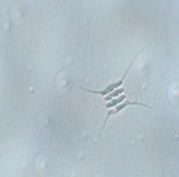 | 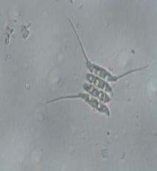 | 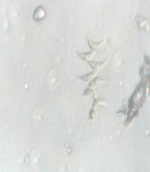
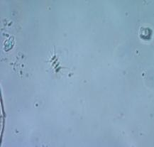 | 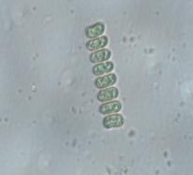 | 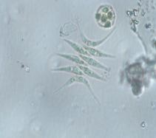

Plate1. Various sps of Scenedesmus with or without spines

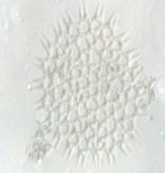 | 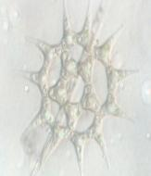 | 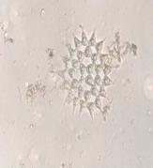 | 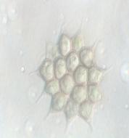
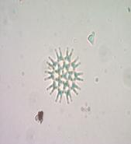 | 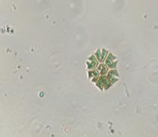 | 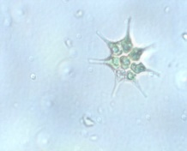
Plate 2. Various sps of Pediastrum

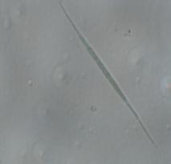 | 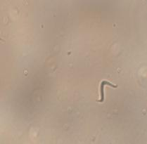 | 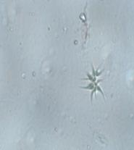
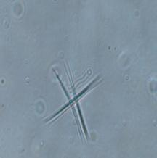 | 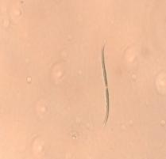 | 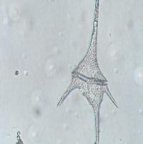

Plate 3. Various sps of Ankistrodesmus and rare Ceratium sp

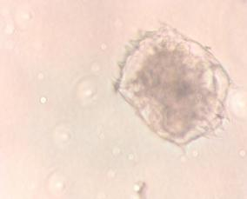 | 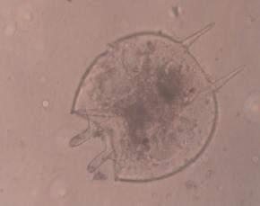
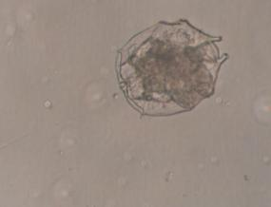 | 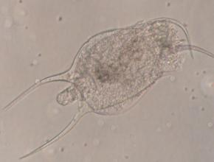

Plate 4. Various sps of Brachionus

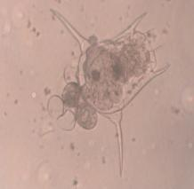 | 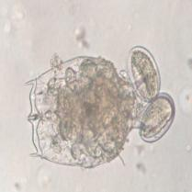 | 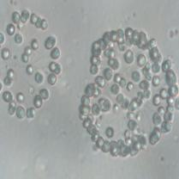
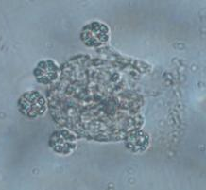 | 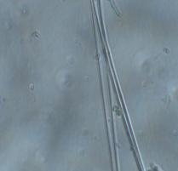 | 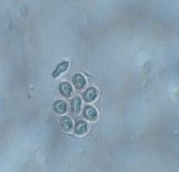

Plate 5. Zooplankton and phytoplankton in reproductive phase.

References
- MHA (Ministry of Home Affairs) 2020. Order: Extension of Lockdown. Order No. 40-3/2020-DM-I(A), MHA, Govt. of India. [accessed 2020 May 12].
- Yunus, A.P., Masago, Y., Hijioka, Y,. 2020. COVID-19 and surface water quality: improved lake water quality during lockdown. Sci Total Environ. 731:139012.
- CPCB (Central Pollution Control Board) 2020. Impact of lockdown on water quality of river Ganga. CPCB, Ministry of Environment, Forest and Climate Change, Govt. of India, New Delhi
- David, T and Clarence, L., 2001. Human-caused environmental change: Impacts on plant diversity and evolution PNAS , 98 (10) 5433-5440.
- Braga, F, Scarpa, G.M., Brando, V.E., Manfè, G, Zaggia, L., 2020. COVID-19 lockdown measures reveal human impact on water transparency in the Venice Lagoon. Sci Total Environ. 736: 139612.
- Sharma, A.K., D.S. Malik, & H. Bargali, 2018. Status of plankton diversity in relation to water quality of Bhagirathi riverine system in Garhwal Himalaya. International Journal of Advance Science Research 3:30–37.
- Carle, F.L., 1979. Environmental monitoring potential of the odonata with a list of rare and endangered anisoptera of Virginia, United States. Odontologia 8:319-323.
- Amarsinghe, B. P. & J. Viverberg, 2002. Primary production in a tropical reservoir in Sri-Lanka. Hydrobiologia 487: 85-93.
- APHA. 2005. Standard methods for the examination of water and wastewater, 21st edn. American Public Health Association.
- Welch, P. S. 1952. Limnological Methods. The Blakistan Company, Philadelphia.
- Laal, A. K. and Karthikeyan, M. 1993.Rotifers pollution or productivity indicators. Current science 65(11): 77-79.
- Abdul, G., S. Khan, Z. S. Mirza, A. Husain & N. Zafer, 2012. Community structure of epiphytic Rotifers of a floodplain. Biologia 58: 1-12.
- Ray, P. S. S. B. Singh and K. L. Sehgal 1966. A study of some aspects of ecology of the river Ganga and Jamuna at Allahabad in 58-59. Proc. Nat. Acad. Sci Ind.(B)vol 36 part 111 1966 pp 235-272
- Mohan Vishwa 2020. Cleaner Ganga: CPCB validates improvement in water quality, see bigger change in river stretch in U. P.,TNN April 28,13: 42 IST.
- Tunin-Ley, A.; Ibañez, F.; Labat, J.; Zingone, A.; Lemée, R. (2009). "Phytoplankton biodiversity and NW Mediterranean Sea warming: Changes in the Dianoflagellates genus Ceratium in the 20th century". Marine Ecology Progress Series. 375: 85–99.

