Isolation and Identification of Bacteria found in the milt of cultured Clarias gariepinus
Folalu Adekunle Awe¹, Ayofe Mutalib Hammed¹, Olamiwaye Akintade Adeboyejo¹ Olusegun Olufemi Whenu¹, Oluwatosin Modupe Olarinmoye, *Gabriel Olarinde Mekuleyi¹, Jesuyon Joseph Hungbo¹, Akanji Adeolu Akinyemi² and Olufunmilayo Adebimpe Olanloye³
- Department of Fisheries, Faculty of Science, Lagos State University, Ojo, Lagos State, Nigeria
- Department of Aquaculture and Fisheries Management, College of Environmental Resources Management, Federal University of Agriculture, Abeokuta, Nigeria
- Department of Pure and Applied Botany, College of Biosciences, Federal University of Agriculture, Abeokuta, Nigeria
*Corresponding author e-mail: gabrielmekuleyi@gmail.com
Abstracts
This study investigated bacteria that are associated with milt in cultured samples of African catfish- Clarias gariepinus. Male broodstocks of Clarias gariepinus were collected from private Fish Farm in Ogun State, Nigeria, while the fish’s milt was collected and analyzed for microbial load at laboratory of the Department of Microbiology, Federal University of Agriculture, Abeokuta, Ogun State. The molecular characterization of the amplicon was done at International Institute of Tropical Agriculture, Ibadan. Bio-edit was used for importing and mining nucleotide sequences into gene bank. As revealed by the results, bacterial organisms that were present in the milt of Clarias gariepinus are: Aeromonas caviae, Proteus mirabilis, Serratia rubidaea, Pseudomonas mosselii, Acinetobacter soli and Klebsiella variicola. The Basic Local Alignment Search Tools revealed the percentage similarity ranging from 86- 97.04% and their accession numbers. These bacteria indicated high levels of faecal contamination in the environment. In conclusion, bacteria were found in the milt of cultured catfish and are capable of being pathogenic to humans and may increase the vertical transfer to fry during breeding and rearing stage. Therefore, fish farmers should maintain a hygiene and serene environment during breeding and culturing of catfish.
Key words: Milt, Clarias gariepinus, bacteria, molecular method.
1.0 Introduction
One of the most common Nigerian fresh water fish species is Clarias gariepinus of the family Claridae. The development of catfish farming in Nigeria was driven by socioeconomic objectives which include generation of additional family income, nutrition improvement of rural community, as well as creation of employment [1]. Although aquaculture production in Nigeria has experience rapid growth in recent years, the industry is still constrained by some factors such as inadequate cooperative financial intervention on the growth of catfish aquaculture value chain, inadequate feed supply, and issues of fish diseases [2]. Studies have shown that tremendous high mortality rates and economic losses have been reported in catfish aquaculture due to infectious pathogens such as bacteria, viruses, fungi and parasites [3]. In the past, fish farming industry in Nigeria has been more focused towards the quality of eggs and larvae rather than that of sperm. However, in recent time, various authors, in an attempt to produce fingerlings of good quality, gave more attention towards obtaining fish milt with high quality [4]. Ultimately, the quality of milt is a measure of the ability of sperm to successfully fertilize an egg. Through the process of natural selection, the characteristics of sperm will be optimized so as to maximize the fitness of the individual male in relation with the specific reproductive strategy of each species [5]. Some findings have shown that milt of fish could be infected with a wide range of microbes present in the water body [6]. The microbes such as bacteria that are present on the body or internal organs of fish indicate the extent of pollution of the water environment [6]. However information on sperm-related microbiota might divulge the impacts of bacteria in the aggregation of sperm and sperm mortality. Such information might also be useful to identify probiotic bacteria for the improvement of sperm quality. Hence, this research work evaluates bacteria associated with milt in cultured samples of African catfish.
2. Materials and Methods
2.1 Sample collection and identification
A total number of eight (8) male broodstock were used. The cultured fish were purchased from the Broodstock Section of a private Fish Farm, Mowe, Ogun State of Nigeria. They were transported live to the laboratory in a large plastic container s filled up to half of its capacity with water and subjected to clinical examinations. Through the features of the redness of the genital papilla, the matured male samples were identified.
2.2 Milt collection
It is necessary to sacrifice male brood fish or surgically removed part of their testes in order to obtain the fish spermatozoa. Thus, male broodstocks of African Catfish, Clarias gariepinus collected for the study were dissected via the abdomen and the gonads were removed using standard laboratory method. However, blood clots and other tissues were rinsed away. The gonads were placed in the buffer solution prior to maceration to maintain its potency. Gonads were macerated in Petri dish and semen was transferred into freshly labeled sample bottles.
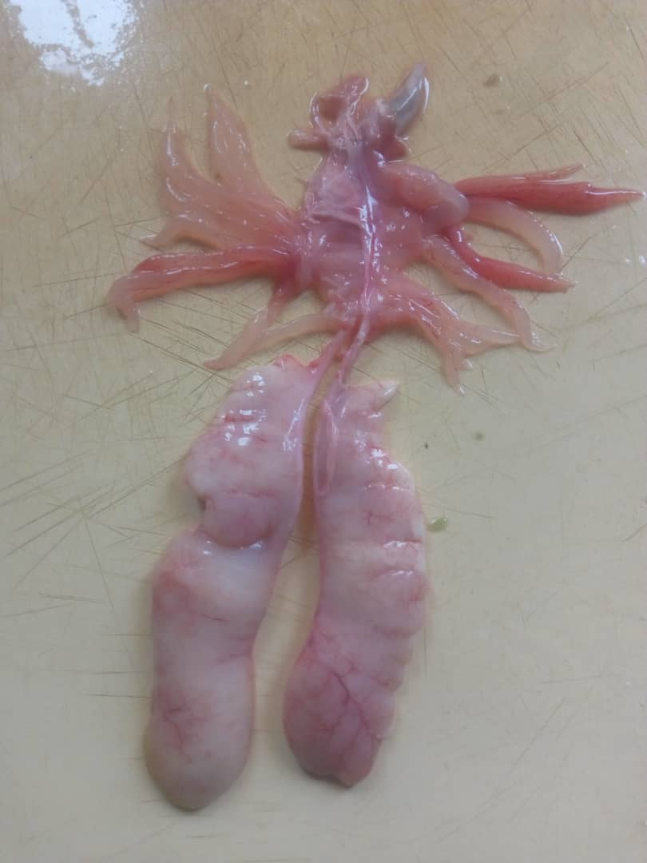
Plate 1: The milt or gonads of Clarias gariepinus
2.3 Isolation of bacteria and purification
Isolation of bacteria from the collected semen of the cultured broodstocks was carried out aseptically using different media. These media included tryptic soya broth at 25°C and at 37°C for 18-24hours, then followed by pouring it onto tryptic soya agar, blood agar, Rimler-Shoots agar, Thiosulfate Citrate Bilesalt Sucrose agar (TCBS), and finally incubate at the same time and temperature. The isolated bacterial strains were purified in accordance to the documented guideline in literature [7].
2.4 Characterization of bacterial isolates
Bacterial isolates were characterized by their morphological/macroscopic and microscopic characteristics and identification using molecular means.
2.5 RAPD-PCR analysis and DNA extraction
Isolation of DNA from broth culture of bacteria at log phase was done by following procedure described by Murray and Thompson [8] with little modifications. The modified protocol without the use of proteinase K has given good result, yielding quality DNA of approximately 20 µg from a 2 ml bacterial culture.
2.5.1 Primers and PCR amplification and resolution of RAPD markers
For PCR amplification of bacterial DNA template, a panel of 2 numbers of decamer random primers was used. The PCR cocktail mix consisted of 1ul of 25mM MgCl2, 1ul each of forward primer and reverse primer,2.5µl of 10x PCR buffer, 1µl of DMSO, 2µl of 2.5mMDNTPs, 0.1µl of 5u/µl Taq DNA polymerase, and 3µl of 10ng/µl DNA. However, using 13.4µl Nuclease free water, the total reaction volume was made up to 25µl.
2.5.2 Identification by 16S rRNA
Primers used in the present study targeted the variable regions of 16S rRNA of bacterial community. However, a pair of universal primers (17F and 1525R) succeeded to amplify the 16S rRNA gene in the PCR reaction and the resulting sequences covered variable regions 1(V1) to 7 (V7) of 16S rRNA in bacterial isolates in order to accurately identify the bacterial species. Comparing the nucleotide sequences of 16S rRNA gene using BLAST.
2.5.3 Polymerase chain reaction cycling parameter
Initial denaturation was done at 94ºC for 5mins. Immediately after the initial denature, 36 cycles of denaturation at 94ºC for 30 secs, annealing at 56ºC for 30secs and elongation at 72ºC for 45secs respectively the follows. Thereafter, a final elongation of step at 72ºC for 7 minutes and hold temperature at 10ºC forever was attained. Amplified fragment were observed on ethidium bromide-stained 1.5% agarose electrophoresis gels. The size of the amplicon is about 1500bp and the DNA ladder is 1kb from NEB. The sequencing was performed using genetic analyzer ABI 3500 from Thermo Fisher.
2.6 Statistical analyses of data
Data were analyzed using descriptive statistics. The bacteria nucleotides from sequencing were run using Bio-edit software on data base and were placed on National centre for Biotechnology information (NCBI) data base with the aid of Basic Local Alignment search Tools (BLAST).
3. Results
3.1 Molecular bacteria Isolates and their characterization
Table 1 depicts the molecular bacteria isolates and characterization. Bacteriological examination of the Milt of eight (8) broodstocks of Clarias gariepinus (African catfish) revealed the different bacteria with their accession number, number of nucleotide sequence, % similarity and the bacteria. The organisms were Aeromonas caviae,Proteus mirabilis, Serratia rubidaea, Acinetobacter soli, Pseudomonas mosselii, Klebsiella variicola and Acinetobacter gerneri. The lowest % similarity of 86% was found in Aeromonas caviae while the highest % similarity of 97.04% was associated with Klebsiella variicola.
Table 1: Molecular bacteria isolates and their characterization
Fish Samples | Accession number | Number of nucleotide sequence | %  similarity | Genomic identification
1 | MK598335.1 | 1383 | 86 | Aeromonas caviae strain ACDMC1235
2 | MH396745.1 | 1322 | 96.94 | Proteus mirabilis strain WWv278
3 | AB860302.1 | 1081 | 92.71 | Acinetobacter gerneri
4 | NA | NA | NA | NA
5 | LR590463.1 | 1337 | 96.78 | Serratia rubidaea strain NCTC12971
6 | MG757398.1 | 966 | 88.56 | Pseudomonas mosselii strain CIPMRG-3
7 | MT394056.1 | 1149 | 95.99 | Acinetobacter soli strain OsEp-Plm-30P2
8 | CP050958.1 | 1181 | 97.04 | Klebsiella variicola strain FDAARGOS-628
(NA: No nucleotide sequence found and it did not blast for molecular characterization)

3.2 Genomic DNA Band of the sequenced bacteria isolates
The amplification products of two Random Amplified Polymorphic DNA (RAPD), product in the isolates, types of amplified DNA bands and number of amplified DNA bands generated by these primers. Primers (27F and 1525R) were used. In plate 2 & 3, the molecular base pair of the PCR products generated by these primers ranged from 1500 to 300 bp. Fifty one polymorphic bands were generated by the two primers. The primer 1525R generated 26 unique bands while 27F produced 25 unique bands. The primer 27F divulged clear variations in RAPD products between the studied bacterial isolates.

Table 2: The primer code and its sequences
Primer code | Sequence
27F | AGAGTTTGATCMGGCTCAG
1525R | AAGGAGGTGWTCCARCCGCA
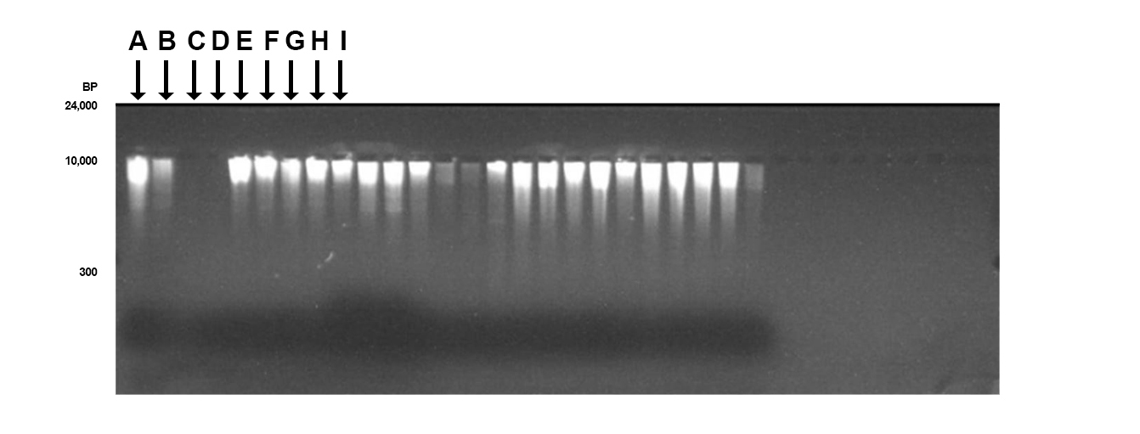Plate 2: Genomic DNA amplicon observed under ultraviolet light showing the bands
Index: A = Control Ladder; B= Sample 1; C= Sample 2; D= Sample 3; E= Sample 4; F= Sample 5; G= Sample 6; H= Sample 7, I= Sample 8.

4. Discussion
Microorganisms isolated in the Milts used for the study were Aeromonas caviae, Proteus mirabilis, Acinetobacter gerneri, Serratia rubidaea, Pseudomonas mosselii, Acinetobacter soli, and Klebsiella variicola species. According to Gennari and Dragotto [9], organisms isolated were classified into various forms; some are spoilage bacteria such as (Proteus mirabilis, Acinetobacter species and Pseudomonas mosselii), two enteric pathogenic organisms (Serratia rubidaea and Aeromonas caviae) and one opportunistic pathogen (Klebsiella pneumoniae).
The reasons for this loads of bacteria associated with C. gariepinuus from earthen pond may be due to contamination as a result of indiscriminate deposition of waste materials into the ponds through run offs, animal excreta and other environmental wastes. Free roaming animals can also contribute to faecal contamination of fish ponds.
Akinyemi [10] in his work isolated some bacteria from milt of broodstock in hatchery and these were Salmonella sp, Esherichia coli, Proteus sp, Staphylococcus aureus, Vibrio sp, Shigella sp, Providencia rettgeri and Staphylococcus epidermidis. Awe [11] isolated various bacteria from parts of African Catfish (Skin, gills and intestine). The bacteria isolated were Pseudomonas aeruginosa, Aeromonas veronii, Bacillus subtilis, Staphylococcus aureus and Enterococcus faecium. The bacteria found in the milt for this present were not similar to bacteria reported by [10-11] in the milt of Clarias gariepinus broodstocks in the hatchery of farms in Southwestern Nigeria.
The major pathogens associated with the degradation of milt quality as reported by Gram and Huss [12] indicated that bacteria observed in the present study were the major causes of microbial spoilage of fresh fish after capture and the microbial count on the different media. However the putative detrimental effect of bacteria on milt quality is still controversial while some studies has revealed that bacteria most frequently isolated from the milt or genitourinary tracts have no effect on semen quality [13].
Information on milt flora is not readily available and limited; studies involving the digestive system reported the influence of ingested food on bacteria community found in the alimentary canal. The mere presence of these bacteria in the milt of C. gariepinus broodstock is of potential pathogenicity. However, the presence of bacteria in fish milt may cause a transfer of these bacteria to the resulting fish seed via vertical transfer to the progeny. Microbial counts in the fish milt samples may also be attributable to transporting and quarantining as well as handling by fisheries personnel. Olufemi[14] reported that bacteria were responsible for many fish diseases especially those associated with environmental stress such as poor handling ad transferring. Bacteria Genera and species were aerobes or facultative anaerobes. This explain why they could be found in the spermatozoa of the broodstock fish which is also in agreement with Bairagi et al.[15] who isolated similar bacteria from fish gut. It also suggests that these bacteria are systemic. However, a similar work by the author on fish hematological bacteriology showed no significant difference in both infected and non-infected broodstock milt [10].
Although, the total bacterial count on fish milt could rarely indicates the quality of the semen, however, it could gives an indication of the risk of low capacitation[12]. These bacteria have the capability of reducing trimethylamine and produce hydrogen sulphide from sodium thiosulphate which represent a secondary metabolite that constitutes fresh fish spoilage. Klebsiella variicola being present in the milt of fish samples in this study indicated that the water used for culturing was faecally contaminated, and this may be due to the faecal waste from surrounding water through run-off.
Findings have shown that Pseudomonas mosselii was the sixth most common bacteria isolated however, the observed numbers of P. mosselii in the present study was low compared to previous reports [12]. The reason for low occurrence could be due to the fact that during storage at 0º C they had fewer isolates. Therefore, P.mosselii is the major pathogen associated with fresh fish spoilage during refrigeration as divulged by [12]. The genus Aeromonas observed in this study is known to contain a number of opportunistic pathogens causing diseases of aquatic and terrestrial animals, including human beings [16]. Herein, A. caviae bacterium was isolated from diseased C. gariepinus. The presence of Aeromonas spp. in fish milt may be due to environmental stress factors, such as high organic load, overcrowding, and sub-lethal oxygen levels, consequently causing infection after host injury or stress response [17]. Another bacteria recorded in this study is Proteus mirabilis which has been identified as commensal in warm bodied animals[18]. Therefore, its present in the milt of the sampled C. gariepinus might be due to faecal contamination released by the fishes in the pond. P. mirabilis is also an opportunistic pathogen that could primarily affect an individual whose immune system is compromised.
Presence of Serratia rubidaea in this study may be due to fish wound from peer bite in the pond which subsequently lead to an abscess in an open fracture. In addition, it is also possible that the bacteria were transmitted to the fish via water, since poor water quality condition may also affect the development of the disease. Serratia rubidaea is an enterobacterium described as a new species of Serratia and was first isolated from water and soil [19]. This bacterium was recognized to be a human pathogen. It was reported that S. rubidaea has an extensive distribution in aquatic environments but no report yet in fish [20].
Two different species of Acinetobacter were isolated in the Milt of Clarias gariepinus used in this present study. The isolation of these pathogens from the milt might be due to contamination coming from waste materials present in the pond. However, the role of A. baumanii for channel catfish, Channa striatus, Ictalurus punctatus, and snakehead, as the fish pathogen has been well documented but studies on A. gerneri and A. soli in fish milt are yet to be reported [21]. The potential spreading and persistence of Acinetobacter species in the environment are well known. It is obvious that Acinetobacter spp. are often isolated from healthy or diseased fish as the component of mixed bacterial flora because most bacteria prevailing in water environment colonize gills, skin and digestive tract of the aquatic animals.
5. Conclusion
This study has brought to light, the bacterial species associated with milt of Clarias gariepinus cultured in the pond. The presence of these microbes in large population indicates high levels of faecal contamination which might have been contracted from the pond and from the environment.

REFERENCES
[1]. FAO (2017).Fishery and Aquaculture Statistics.Global Aquaculture Production 1950-2015 (FishstatJ). In: FAO Fisheries and Aquaculture Department. Rome.
[2]. Udo, I. U. and Umanah, S. I.(2017). Current Status of the Nigerian Aqua Feeds Industry: A Review. International Journal of Innovative Studies in Aquatic Biology and Fisheries (IJISABF) 3(1): 14-22.
[3]. Adelakun, K.M., Oguniwin, D.I., Ajagbe, S.O. and Ijagbeni, A.B.(2012). Sustainable Aquaculture Practise: A Profitable Venture in Nigeria. In: Handzic, M., Subasi, A. and Goksu, A. (eds), Green Information Technologies and Strategies. Proceedings of the 3rd International Symposium on Sustainable Development, ISSD 2012, May 31 - June 01 2012, Sarajevo. Vol. 3 Part 1, 265 – 272.
[4]. Ochokwu, I.J., Apollos, T.G and Oshoke, J.O. (2015).Effect of Egg and Sperm Quality in Successful Fish Breeding. IOSR Journal of Agriculture and Veterinary Science (IOSRJAVS), 8(8V.II):48-57.
[5]. Taborsky, M. (2008). Sperm competition in fish: ‘bourgeois’ males and parasitic spawning. Trends Ecology Evolution. 13, 222 – 227.
[6]. Obiajuru, I.O.C. (1991). Intestinal microflora of tilapia and claria fishes in Ezere and Ekpe –Obia streams Orisuihiteukwa, Orlu, HND project, Federal Polytechnic, Nekede Owerri, Imo state, 59pp.
[7]. Austin, B. and Austin, D. A., (2007): “Bacterial fish pathogens . Disease of farmed and wild fish Praxis publishing, U. K; 2007; 581 pp.
[8]. Murray,M.G. & Thompson, W. F. (1980).Rapid Isolation of high Molecular Weight Plant DNA: Nucleic Acids Research.8 (19): 4321-4325.
[9].Gennari M., Dragotto, F.(1992): Isolation and characterization of Acinetobacter calcoacetisus from raw, washed and frozen vegetables, 37, 131–137.
[10]. Akinyemi, A.A.(2009): Microorganisms associated with fish hatchery systems and their effects on hematological parameters of cultured Clarias gariepinus (Burchell, 1822) broodstock PhD Fish pathology Thesis. University of Agriculture, Abeokuta. Nigeria. 221pp.
[11]. Awe, F.A; Hammed, A.M; Olarinmoye, O.M; Owodeinde, FG.Adeboyejo, O.A; Clake, E.O; Whenu, O.O. Akinyemi, A.A; Ezeri, G.N.O; Bankole, M.O. and Olanloye, A.O (2021). Isolation and characterization of Bacteria isolated from Sub-Adult African Mud-CatfishClarias gariepinus from selected fish farms in Ogun-state, Nigeria. Journal of Fisheries International. 16, Issue1, 1-8. 16(1): 1-8pp.
[12]. Gram, L. and Huss, H.H. (2000). Fresh and processed fish and shellfish, in: The microbiological safety and quality of foods. Lund, B.M. A.C. Baird Parker and G.W. Grould (Eds.) Champinan and Hall, London., pp. 472- 506.
[13]. Maciejewska R, Kchaou W, Chaari C, Znazen A, Keskes L, Rebai T, et al. 2005.Ureaplasma urealyticum, Ureaplasmaparvum, Mycoplasmahominis and Mycoplasmagenitalium infections and semen quality of infertile men. BMC Infect Dis. 7: 129. doi: 10.1186/1471-2334-7-129.
[14].Olufemi , A.A. (1998). Bacteriological studies and chemical analysis of public well water in Samaru and Zaria city in Northern Nigeria. Journal of Microbiology, 8 (1-2): 88- 98.
[15].Bairagi, V.; Ansede- Bermejo, J.; RodriguezCastro, A. and Urtaza- Martinez, J. (2002): Evaluation of different procedures for the optimized detection of Vibrio parahaemolyticus in mussels and environmental samples. International Journal of Food Microbiology, 129: 229-236.
[16].Van der Marel, M., Schroers, V., Neuhaus, H., and Steinhagen, D. (2008). Chemotaxis towards, adhesion to, and growth in carp gut mucus of two Aeromonashydrophila strains with different pathogenicity for common carp, Cyprinuscarpio L. Journal. Fish Disease. 31, 321–330.
[17]. Jeney, C., and Jeney, E. (1995). Influence of diseases on the wild eel stock: the case of Albufera Lake. Aquaculture 289, 143–149. doi: 10.1016/j. aquaculture. 2008.12.015
[18]. Markey, B., F. Leonard, M. Archambault, A. Cullinane, and D. Maguire. . 2013. Clinical Veterinary Microbiology, Oxford University Press, New York, NY, USA, 2nd edition.
[19]. Gavini F, Ferragut C, Izard D, Trinel PA, Leclerc H, Lefebvre B, Mossel DA. (1979) Serratia fonticola, a new species from water. Int J Syst Bacteriology, 29, 92- 101.
[20]. Farmer, J.J., Davis, B.R., Hickman-Brenner, F.W., McWhorter, A., Huntley-Carter, G.P., Asbury M.A., Riddle C, Wathen-Grady HG, Elias C, Fanning GR, Steigerwalt AG, O'Hara CM, Morris, G.K., Smith, P.B.and Brenner, D.J. (1985). Biochemical identification of new species and biogroups of Enterobacteriaceae isolated from clinical specimens. J ClinicalMicrobiology, 21,46-76.
[21]. Rauta P.R., Kumar K., Sahoo P.K.(2011). Emerging new multi–drug resistant bacteria pathogen, Acinetobacterbaumannii associated with snakehead Channa striatus eye infection. Science , 101, 548–553.

