Authors: Daniel Rittschof^{1*}, Sergey Dobretsov^{2, 3},

¹ Duke University Marine Laboratory, Nicholas School, Duke University, USA
² Centre of Excellence in Marine Biotechnology, Sultan Qaboos University, Muscat, Oman
³ Department of Marine Sciences, Sultan Qaboos University, Muscat, Oman
^{ritt@duke.edu}
^{sergey@squ.edu.om}

Title: Ecosystem Restoration: Enhancing Ecosystem Services with Floating Aquaculture

Abstract
Restoration ecologists recognize the need for restoring ecosystem services in sustainable ways that meet societal needs. In the UK, Ireland, Australia, and some US states the goal is restoring native oyster reefs. In other states, failures at restoration due to poor water quality and predation have focused restoration activities on techniques that work, restoring intertidal reefs and generating living shorelines that reduce or reverse erosion. In the United States, restoring water quality and reducing or reversing erosion are societally accepted entry points for repairing estuarine ecosystems. We provide an overview of the current status of oyster reef restoration and provide a novel restoration approach called “oyster reef in a bag”. Combining oyster reef restoration efforts with existing floating oyster aquaculture technology generates novel ecosystems that are a combination of biofouling and oyster reef communities. These novel ecosystems could be a practical beginning to improving water quality, mitigating erosion and restoring higher trophic level ecosystem services.

Running Head: Oyster Reef in a Bag

Keywords: oyster reefs, restoration ecology, aquaculture, restoration, management, novel ecosystems

INTRODUCTION

Perspective

This paper is a selective review and an opinion piece. Our main opinion is that in many regions of the world, oyster reef restoratoin to some former condition is untennable because of water quality and ecosystem changes. We suggest ways to enhance ecosystem services that include oyster reef restoration and that take advantage of the hybrid ecosystems that develop in floating bag oyster aquaculture. The hybrid system is s blend of a biofuling community and some aspects of oyster reef communities. New shellfish regulations in North Carolina, USA set the stage for testing this approach (N.C. Coastal Federation, 2021).

Some of us have lived long enough to watch environmental baselines shift sensu (Pauly, 1995). In only 70 years or so we’ve experienced coastal fisheries collapse, massive coastal development, sea level rise and climate change. New baselines ride atop a plethora of natural cycles we are beginning to understand. Although the fact statements we make are supported by science the concepts are controversial in the larger society making it hard to gain traction. Degraded water quality and erosion are issues where there is concensus among most stakeholders.Thus, restoring water quality and reducing or reversing erosion are accepted physical entry points for repairing estuarine ecosystems. Coincedentally this kind of restoration is central to developing sustainable alternative ecosystem services that support environmental and human health.

Globally, oysters are a popular aquaculture species. Because oysters are valuable in the restaurant trade, and have been of academic and mariculture interst since their populations began to decline. There are now well developed technologies for spawning, culturing oyster larve and settling them to the juvenile stage. Oysters, mussels, scallops and clams, consume so much plankton as food that practical grow-out is in sounds, estuaries and coastal oceans. Recent advances in oyster aquaculture reduce predation and the risk of smothering or anoxia with floating caging. This simple modification maximizes growth and survival through continuous submersion in the upper region of the water column and is sometimes complemented with use of triploid oysters.

Due to history, philosophy and politics, different regions of the world are taking different approaches to oyster reef restoration. Notable examples are the UK, Australia and the US. The UK and Australia national governments recognize the ecological and societal importance of restoring natural reefs. In the last decade their approach is comprehensive, collaborative, and embraces careful planning, permitting, measurement, comprehensive targeted approaches, monitoring, attention to biosecurity and to education and onboarding of stakeholders (Preston et al., 2020; TNC, 2021a). The basic approach is to maximize the probability of success by taking advantage of the known science, to provide hard substrate and to seed with living oysters to provide gregarious settlement cues.

In the United States researchers have decades of experience with oysters as subjects of restoration. In the US, it is states, not the US government, that regulate and often with NGO support fund restoration efforts. The politics and philosophies of each state determine the way forward. Thus, there is no comprehensive approach. Often there are extreme restrictions such as prohibition the use of living oysters, to protect food security and the fishers as eall as where and how restoration can be attempted. However, decades of funding and published studies provide a scientific and practical perspective for moving forward.

In addition to reef restoration efforts for shellfish harvesting, oyster reef restoration as living shorelines is accepted in coastal communities for erosion abatement. Living shore-lines in the form of restored oyster reefs are popular and are examples of effective restoration (Walters et al., 2017). Successes, where measured, include living oysters, physical increases in reef height that keep up with sea level rise (Rodriguez et al., 2014) and ecosystem services such as improved water clarity and quality, return of microbial activity and the return of biogeochemical ecosystem services (Garvis et al., 2015; Walters et al., 2017). With present it takes approximately 6 years to restore a reef in Indian River Lagoon, FL, USA.

In this review we provide an overview of the current status of conservation and restoration ecology. Additionally, we describe methods for restoration of polluted aquatic environments and, finally, we provide potetntial solutions for restoration of oyser reefs based on advances in aquaculture.

Conservation and Restoration Ecology

Over the last 6 or so decades conservation science was in a state of “passive monitoring of decline.” Passive monitoring of decline is being replaced by practitioners of restoration ecology who actively attempt to restore ecosystems. Many ecologists are hopeful that habitat distruction and biodiversity loss can be reversed. This hope is buoyed by positive restoration outcomes of individual species (whooping cranes, seals, otters, some sea turtles, some whales, bald eagles, turkeys, etc.). Jordan et al. (1987) coined the term restoration ecology when they published Restoration Ecology (1st Ed.) and transformed the journal Restoration & Management Notes to Ecological Restoration.

Zhang et al. (2018) provide a synopsis of the history of conceptual thinking about coastal conservation and restoration. Restoration ecology and theory began in terrestrial systems and considered physical and abiotic factors and addressed these in restoration efforts. Ecosystem services were first considered from the perspective of three fundamental tenets of ecology, predation, competition and disturbance. The next level of understanding is “facilitation” or the ways to group living components and mix different foundational species to enable restoration (Zhang et al., 2018). In the US facilitating restoration efforts is limited to physical grouping. However, as illustrated in by recent work in Australia (TNJ 2021b)chemical signals from biofilms and adult organisms can enhance recruitment of prapagules and restoration of ecosystems (Chambers et al., 2018; Cacabelos et al., 2020). The logical next step is facilitating the complex community relationships that are embodied in living reefs.

Restoration of polluted aquatic environments
Man has the ability to permanently alter and damage environments (Gittman et al., 2016b). A relatively new area is the restoration of chemically impaired environments (Farag et al., 2016). A major global problem in all human altered estuarine and coastal aquatic environments is nutrient pollution and the associated blooms of cyanobacteria, phytoplankton and harmful algae (Garvis et al., 2015) which destroy ecosystem services useful to society and replace them with phytoplankton based low biodiversity ecosystems, Often the change in the ecosystem is slow, but other times ecosystem changes can occur in just two or three years (Den Hartog and Polderman, 1975; Nienhuis and De Bree, 1977; Giesen et al., 1990; Moorman et al., 2017).

With environmental change due to human development came the concepts of hybrid and novel ecosystems. Studies of novel ecosystems in cities are represented by a new discipline, Urban Ecology (c.f. (Pickett et al., 1997)). Since about 2002, thought-leaders began to talk about designer communities (MacMahon and Holl, 2002; Hobbs et al., 2009). Novel and hybrid ecosystems can arise spontaneously as is the case for communities on marine debris (Póvoa et al., 2021; Rech et al., 2021) or can be intentionally established (Neely et al., 2021).

In addition to scientific and academic restoration activities is the generation of ecosystems comprised of non-indigenous plants or biologically active structures like plastics (Li et al., 2016; Qi et al., 2019). These new ecosystems are comprised of resilient often invasive organisms that provide robust ecosystem services. An example of a terrestrial and aquatic hybrid ecosystem is the award winning restoration of Kallang River in Ang Mo Kio Park, Singapore (Dreiseitl, 2016). The Kallang River ecosystem is comprised of tropical fishes from all over the globe including cichlids, carp, walking catfish and snake head, as well as apple snails, African land snails, and red eared sliders. The top predators are indigenous monitor lizzards and river otters that were displaced over the last decade by development in Maylaysia. The displaced otters replaced an extinct Singapore population (Barto, 2019; Turrel, 2020).

In coastal regions around the globe, huge areas are closed to shellfish collection and aquaculture because of human health concerns due to pathogens. Estuaries where shell fishing is closed but where the environmenta still supports shellfish are ideal places to restore shell fish populations. The restablished shellfish improve water quality and ecosystem services and support nearby harves fisheries by increasing larval supply. This type of restoration could address government mandates for water quality remediaiton.

In many countries the concept of restoration of estuarine ecosystems to historic conditions is ludicrous. In most cases the starting point is not known due to limited number of investigations. Often the historical condition cannot be reproduced due physical and chemical changes due to massive urban development, huge human populations, wide scale habitat destruction, industrial, agricultural and human waste pollution, changes in dominant land uses, siltation, climate change and sea level rise. For example, if one takes harbors as an example, even small harbors with minimal industrial development, then what is your restoration target? To return a harbor to the condition recorded would require elimination of anthropogenic input, capping toxic sediments, killing the existing communities and reintroducing what was in the harbor the centuary or two before. Additionally, as suggested by recent studies, to regenerate the fauna might require transplantation of the former “natural” biofilms to stimulate settlement of local species(Chambers et al., 2018; Cacabelos et al., 2020). One path is generation of a hybrid ecosystem that provides ecosystem services including improving water quality, reducing erosion and supporting higher trophic levels.

Our approach is similar to that of Vanderklift et al.(2020) who proposed and support the idea of using advances in aquaculture and genetics to augment natural systems. Exploiting genetic, biological, chemical, ecological, physical, and applied-technologies that impact the development, maintenance and monitoring of oyster reefs should all be considered. A multitrophic ecosystem seems preferable to one dominated by microbes.

Our place-based solution is designed for restoration of tide driven estuaries of the South East United States. These estuaries are warm, 20 to 30+ ºC waters, highly productive and eutrophic due upwelling as well as to agricultural and human derived nutrients. Siltation is a concern due to logging of pine plantations in the coastal plain. Subtidal oyster reefs are subjected to periodic anaerobiosis, smothering by silt and by predation from long lived persistent predators including predatory snails and decapod crustaceans. Environmental stress increases the prevalence of disease. A solution is floating aquaculture which confines oysters in floating mesh bags in aerobic surface waters, physically limits predation to small predators that can swim, minimizes siltation and maximizes energy intake with continuous submergence. However, oyster reefs don’t usually float and floating aquaculture provides a novel habitat that supports a novel hybrid ecosystem.

Restoration of Ecosystem Services: Baselines and Goals

Very difficult questions in restoration ecology that need to be carefully addressed are what is the baseline condition of the system to be restored, what is the restoration goal, what should be measured and what would be considered a success. The answers to these questions don’t need to be the same for each ecosystem to be restored. What should be the targets for restoration in developed areas? Hobbs et al.(2009) articulated our thoughts:
“Restoration in the future might need to aim more specifically at novel systems as a way of tackling the unprecedented era in which humans dominate all ecosystems.(Aronson and van Andel, 2006) Indeed, removing the requirement to aim for a historic ecosystem increases the range of options available and could enable reduced investment of effort and resources still to achieve valuable outcomes. However, caution is required: will we be capable of understanding what is best in a rapidly changing world? Will such activities be restoration or evolve into new types of intervention that respond to the rise of novel ecosystems? Restoration will involve a complicated set of decisions rooted in historical understanding and open to many potential trajectories. It will probably change its focus from damage control to ecosystem engineering or ‘designer ecosystems’.(MacMahon and Holl, 2002)”

Oysters and oyster reefs

The loss of intertidal oyster reefs is attributed to shell mining, harvesting, predation, disease and physical disruption due to waves from storms, winds and boat wakes (Garvis et al., 2015). Globally, about 85% of oyster reefs have been severely degraded in the last 200 years (Luckenbach et al., 1999; Kirby, 2004; Beck, 2009). Subtidal reefs are difficult to restore due to an overabundance of predators and due to degraded water quality, regions of periodic anoxia (Lenihan and Peterson, 1998; Powers et al., 2009). Intertidal reefs survive in a zone with reduced predation by snails and crabs that is above oyster lower temperature limit and below oyster upper lethal temperatures.

Oyster reefs are biodiversity hot spots. Oyster reef communities are organized and informed by the actions of symbiotic microbes and the actions of oyster hosts that manage their microbial communities (Dobretsov and Rittschof, 2020). The physical structure of living and dead shells alters flow, provides spaces for sedimentation and structural habitat for other organisms. Oysters initiate reef formation through aggregation pheromones and chemical cues that attract community members at many trophic levels. Once established, the entire community generates chemical signals that, structure and maintain it. Thus, oyster reefs are complex multispecies assemblages composed of primary consumers, grazers, and predators, as well as obligates, commensals and parasites. Oyster reefs provide structure and ecosystem services including habitat, pollution reduction, carbon and heavy metal sequestration in shell, storm protection, and food for humans.

Until recently, there has been little recognition of the importance of ecosystem services associated with oyster reefs (Luckenbach et al., 1999; Dunn et al., 2014). Australia and the the UK provided a big boost to the global interest in restoration ecology when they made shellfish reff restoration a national prioity (Preston et al., 2020; TNC 2021a, 2021b). Intertidal oyster reefs provide ecosystem services in lower energy sound and estuarine environments (Kennedy et al., 2009). Intertidal oyster reefs extend off the substrate and undergo succession. Many details of reef communities are well studied (Zhang et al., 2018). Restoration of oyster reefs has clear societal, economic and environmental benefits especially in mediating eutrophication and acidification from human activities (Meyer et al., 1997; Dame, 1999; Newell et al., 2002; Peterson et al., 2003; Coen et al., 2007; Grabowski et al., 2012; Kellogg et al., 2013; Chambers et al., 2018). Compared to subtidal reefs, intertidal oyster reefs thrive in low energy polluted environments such as in a small tidal creek about a kilometer downstream of a 6.8 million liter a day sewage treatment plant (figure 1). Food security is always a concern because pathogens, toxic metals or polychlorinated biphenyls in shellfish should not be ignored (Freitag et al., 2012).

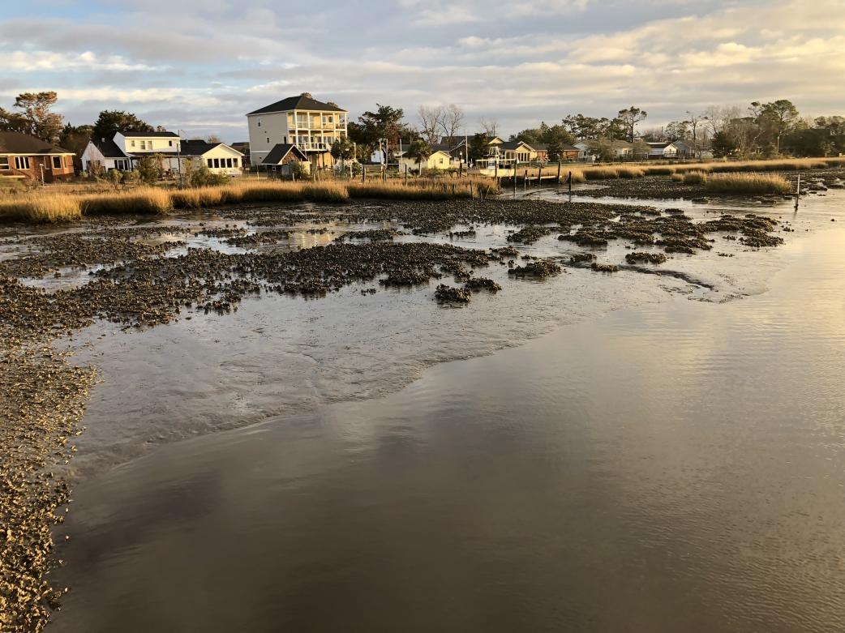
Figure 1. Crassostrea virginica, oyster reefs in a low energy stretch of Calico Creek, Newport Estuary Morehead City NC. These reefs have been undisturbed by harvest and damaged only by low frequency boat traffic, storms and runoff since 1964, about 55 years (Nierstedt et al., 1980). In the background and to the right are oysters reefs that have undergone succession to Sporobolus alterniflorus (=Spartina alterniflora ) by accreting sediments. (Photo, D. Rittschof).

Ecosystem in a Bag

On the North Carolina coast a floating aquaculture reef can be initiated in warm seasons with living oyster spat in floating mesh bags (Figure 2). In North Carolina, within days the biofouling community compoused of barnacles, sea squirts, hydroides and bryozoans forms on floats, bags and oysters (Roberts et al., 1991; Fitridge et al., 2012). Within months complex communities are found on and within the cages (Fitridge et al., 2012). This novel community (Figure 3) is dramatically different than either an intertidal or subtidal reef. In oyster aquaculture the bags are flipped every two weeks. Exposure to air kills the biofouling and reduces sediments within the bags. Biofouling provides it own ecosystem services and enhances water quality already improved by oyster filtration. Robust oyster rocks (clusters) are generated by natural set in less than a year in warm climats like those on the south east and Gulf of Mexico Coasts of the US. The communites provide prey and structure for fish that live and foage below the floating reefs (Muething et al., 2020).

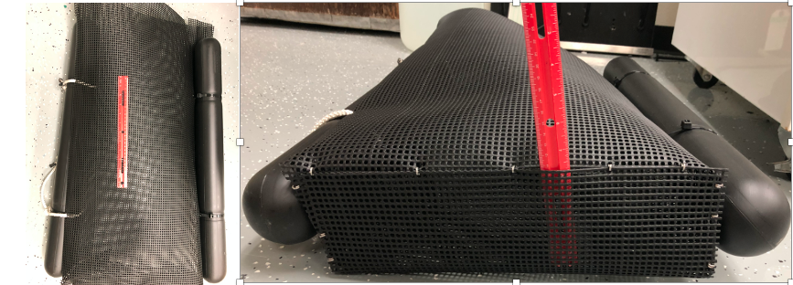

Figure 2. An example of a bag for floating aquaculture when filled to the right amount of oysters the bag floats in the top 10 cm of water. To keep biofouling at moderate levels, the bag is flipped over every two weeks. An anchor line is threaded through the white line attached to the left float. As they are flipped the bags alternate on the left and right ides of the line. (photo Daniel Rittschof)

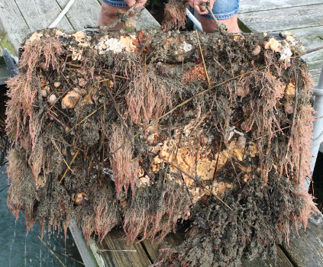

Figure 3. The robust biofouling community on the underside of an unflipped oyster bag. Oysters in the bag host oyster spat, mussels, barnacles, tube worms,ascidians, mud crabs and jingle shells and an algal turf. Growth on the outside is more extensive than on the inside. Individual oysters become clumps due to natural set in about 4 months. (Photo Lilia Moorman)

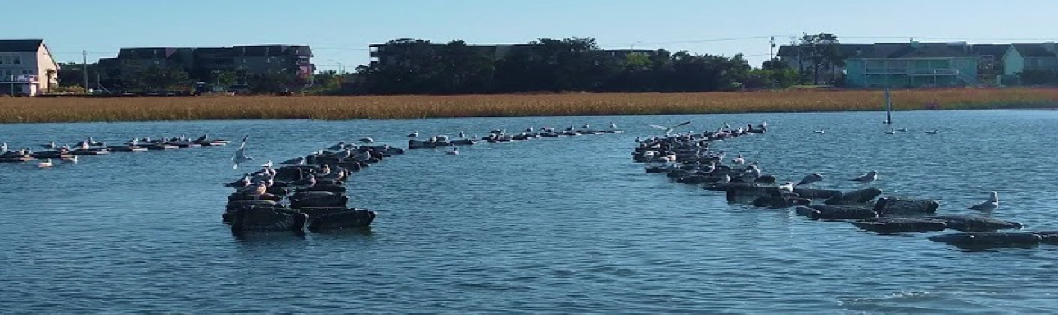

Figure 4. Floating Aquaculture on a lease in Atlantic Beach NC. Floating oyster Crasostrea virginica aquaculture provides a new hybrid ecosystem. Each floating bag contains 200 to 300 triploid or diploid oysters. Growth to market sized oysters from spat placed in bags in August is 6 to 8 months. (photo Thomas F. Schultz).
The “bag ecosystem” is truly novel. It is comprised of the biofouling community found in the top 30 cm growing on floating objects and a subset of natural reef community members that enter bags as propaguels or small swimming juveniles. In Beaufort NC and around the globe in temperate and tropical harbors about 95% of biofouling organisms are invasive species, many of which arrived with boats and trade before or with the first European settlers (Carlton, 202, (Rittschof, 2017b; Rittschof, 2017a). Though found in the immediate coastal ocean (Neely et al., 2021) biofouling communities are particularly adapted to live in polluted harbors (Dobretsov et al., 2019). The combined oyster reef community and biofuling community in a bag provides physical and biological ecosystem services.

Many estuarine areas that historically supported oyster reefs are now areas with high levels of boat traffic and boat wakes that destroy oyster reefs (Fitridge et al., 2012; Walters et al., 2017) and shorelines in general (Gittman et al., 2016a; Gittman et al., 2016b). There is a clear need to improve ecosystem services that mediate chronic human impacts on estuaries. This topic was the basis of a SEATAC workshop in 2015 which generated 6 papers (Farag et al., 2016) on mitigation and restoration of industrially contaminated areas. These papers illustrate what is a much larger issue and address what industrialized and developed countries could be targeting with respect to restoration.

With floating aquaculture technology hundreds of floating bags of oysters can be dragged behind a boat and anchored in a new location. We envision using multiple lines of floating oysters (Fig. 4) to dampen waves and wakes the way that lane floats dampen waves in swimming pools. If one makes analogies to the routine transport and use of honey bees for pollination, an intriguing option would be to regionally transport floating aquaculture to areas surrounding other habitats being restored like sea grasses where the floating oysters would improve water clarity by reducing particulates and phytoplankton shading the sea grass and dampen wave action. This approach might be costly in the short run, but could generate long-term benefits especially if the oysters can be commercially harvested or these areas can be used for recreational activities.

Climate change and oyster communities

The combined effect of climate change and pollution can affect, survival and functioning of oyster populations (Moreira et al., 2018a; Moreira et al., 2018b). Factors such as ocean acidification, increase of seawater temperatures, sea level rise and changes in ocean gyres and rainfall patterns, will significantly affect all marine ecosystems including Magellana (=Crasostrea) gigas oyster reefs (Ginger et al., 2013; Ko et al., 2014; Ekstrom et al., 2015; Wei et al., 2015; Dineshram et al., 2016). In contrast, oysters like C. virginica are resilient to pH changes. There is no significant effect of low pH on larval behavior activity and swimming velocity of pre-competent, competent, and post-competent larvae (Meyer-Kaiser et al., 2019). As temperatures increase, sea levels rise and storm and boat frequency increase wave action, intertidal oyster reefs decline. Regions which have lost most of their natural oyster reefs routinely also have high levels of nutrients from human waste, animal and plant agriculture. All native oysters appear to do less well in stressed environments and are more susceptible to diseases (Sprague, 1971; Pernet et al., 2016). Oysters reflect their historic environments. Their response to change is species-specific and depends upon the environmental history of the population.

Expanding oyster restoration and aquaculture would be one major way to stabilize estuaries and expand ecosystem services. Intentionally providing novel habitat through zoning of waterfront structures would be one passive way to augment ecosystem services in polluted environments. For example, requiring concrete building supports rather than toxic metal treated pilings as presented in the unplanned examples (Figure 5) is a passive tactic to enhance ecosystem services.

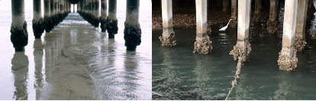
Figure 5. Concrete piling arrays providing habitat for rock oysters and barnacles (Hong Kong) and eastern oysters (North Carolina) expanding ecosystem services. Neither of these locations are recruitment limited. (Photo, Sergey Dobretsov and Daniel Rittschof).

CONCLUSIONS
Oyster reefs are important estuarine features whose structure and services are critical to estuarine cultural and societal function. Due to anthropogenic activity most oyster reefs have been lost or their former extent significantly reduced. Factors associated with climate change and pollution of coastal waters affect survival of oyster reefs and limit their restoration. Sea water temperature rise and acidification will have more devastating impacts on oyster reefs in the future. With advances in aquaculture and an understanding of ecological relationships, restoration of oyster reefs and their creative management can be used to improve ecosystem services. Combining our knowledge of reef development at the chemical level with genetic, biological, chemical, ecological and physical fundamentals already used in aquaculture provides a novel ecosystem with substantial ecosystem services.

Floating oyster aquaculture is a new tool in the toolbox and provides another way forward to provide stock for restoration of oyster reefs and can work synergistically with seagrass and fish stock restoration efforts. Though not quantified here, restoration of reefs could become an industry that supports fish stock restoration and provides jobs in restoration, monitoring and resource extraction. The next generation of environmental leaders around the world will be versed in hands on experience and theory (Figure 6).

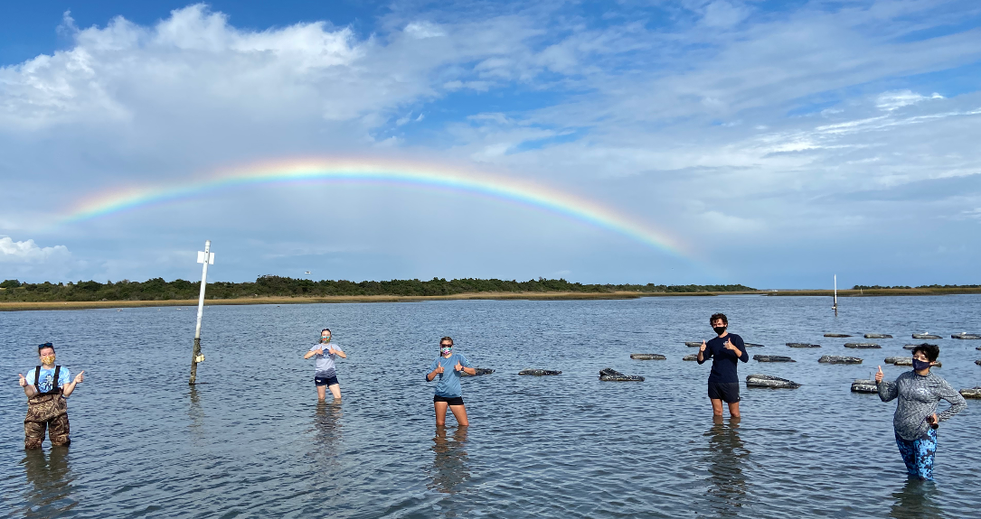 Figure 6. Part of the next generation of environmental scientists and restoration ecologists. The next cohort of environmental leaders is knowledgeable and dedicated and found all over the globe. They provide hope in turbulent times. (Photo Thomas Fred Schultz).

AUTHOR CONTRIBUTIONS
DR developed the idea and wrote the first draft. SD wrote different parts of the manuscript. All authors contributed to the manuscript writing and revision of the text.

ACKNOWLEDGEMENTS
Other than the coauthors, this work was stimulated by conversations with students MB, LH, DA, parasitologist JM, restoration ecologists TZ, BS, oyster aquaculturists (TS and JM), environmental chemists (PK, AL) mapping experts (DJ, JR, SD) and the Oak Foundation.

References

Aronson, J., and van Andel, J. (2006). Challenges for ecological theory. Blackwell Publishing: Oxford, UK.
Barto, P. (2019). The return of Singapore's urban otters. Jeepneyprojects.org [Online]. Available: Jeepneyprojects.org [Accessed 18Jan2021].
Beck, M.W. (2009). Shellfish reefs at risk: a global analysis of problems and solutions. Nature Conservancy.
Cacabelos, E., Ramalhosa, P., Canning-Clode, J., Troncoso, J.S., Olabarria, C., Delgado, C., et al. (2020). The Role of Biofilms Developed under Different Anthropogenic Pressure on Recruitment of Macro-Invertebrates. International journal of molecular sciences 21(6), 2030.
Carlton, J.T. (2021). RE: Personal communication regarding introduction of invasive species by boat.
Chambers, L.G., Gaspar, S.A., Pilato, C.J., Steinmuller, H.E., McCarthy, K.J., Sacks, P.E., et al. (2018). How Well Do Restored Intertidal Oyster Reefs Support Key Biogeochemical Properties in a Coastal Lagoon? Estuaries and Coasts 41(3), 784-799. doi: 10.1007/s12237-017-0311-5.
Coen, L.D., Brumbaugh, R.D., Bushek, D., Grizzle, R., Luckenbach, M.W., Posey, M.H., et al. (2007). Ecosystem services related to oyster restoration. Marine Ecology Progress Series 341, 303-307.
Dame, R.F. (Year). "Oyster reefs as components in estuarine nutrient cycling: Incidental or regulating", in: Oyster reef habitat restoration: a synopsis and synthesis of approaches. Edited by MW Luckenbach, R. Mann and JA Wesson. Virginia Institute of Marine Science Press, Gloucester Point, eds. M.W. Luckenbach, R. Mann & J.A. Wesson), 267-280.
Den Hartog, C., and Polderman, P.J.G. (1975). Changes in the seagrass populations of the Dutch Waddenzee. Aquatic Botany 1, 141-147. doi: https://doi.org/10.1016/0304-3770(75)90019-4.
Dineshram, R., Chandramouli, K., Ko, G.W.K., Zhang, H., Qian, P.-Y., Ravasi, T., et al. (2016). Quantitative analysis of oyster larval proteome provides new insights into the effects of multiple climate change stressors. Global Change Biology 22(6), 2054-2068. doi: 10.1111/gcb.13249.
Dobretsov, S., Coutinho, R., Rittschof, D., Salta, M., Ragazzola, F., and Hellio, C. (2019). The oceans are changing: impact of ocean warming and acidification on biofouling communities. Biofouling 35(5), 585-595. doi: 10.1080/08927014.2019.1624727.
Dobretsov, S., and Rittschof, D. (2020). Love at First Taste: Induction of Larval Settlement by Marine Microbes. International Journal of Molecular Sciences 21(3), 731.
Dreiseitl, R.S. (2016). American Society of Landscape Architects: 2016 ASLA Professional Awards [Online]. https://www.asla.org/2016awards/index.html. [Accessed 11May2020].
Dunn, R.P., Eggleston, D.B., and Lindquist, N. (2014). Oyster-sponge interactions and bioerosion of reef-building substrate materials: implications for oyster restoration. Journal of Shellfish Research 33(3), 727-738.
Ekstrom, J.A., Suatoni, L., Cooley, S.R., Pendleton, L.H., Waldbusser, G.G., Cinner, J.E., et al. (2015). Vulnerability and adaptation of US shellfisheries to ocean acidification. Nature climate change 5(3), 207-214.
Farag, A.M., Hull, R.N., Clements, W.H., Glomb, S., Larson, D.L., Stahl, R., et al. (2016). Restoration of impaired ecosystems: An ounce of prevention or a pound of cure? Introduction, overview, and key messages from a SETAC‐SER workshop. Integrated environmental assessment and management 12(2), 247-252.
Fitridge, I., Dempster, T., Guenther, J., and de Nys, R. (2012). The impact and control of biofouling in marine aquaculture: a review. Biofouling 28(7), 649-669. doi: 10.1080/08927014.2012.700478.
Freitag, A., Sohn, N., Hooper, M., and Rittschof, D. (2012). The geography of mercury and PCBs in North Carolina’s local seafood. Marine pollution bulletin 64(7), 1330-1338.
Garvis, S.K., Sacks, P.E., and Walters, L.J. (2015). Formation, movement, and restoration of dead intertidal oyster reefs in Canaveral National Seashore and Mosquito Lagoon, Florida. Journal of Shellfish Research 34(2), 251-258.
Giesen, W.B.J.T., van Katwijk, M.M., and den Hartog, C. (1990). Eelgrass condition and turbidity in the Dutch Wadden Sea. Aquatic Botany 37(1), 71-85. doi: https://doi.org/10.1016/0304-3770(90)90065-S.
Ginger, K.W., Vera, C.B., Dineshram, R., Dennis, C.K., Adela, L.J., Yu, Z., et al. (2013). Larval and post-larval stages of Pacific oyster (Crassostrea gigas) are resistant to elevated CO2. PLoS One 8(5).
Gittman, R.K., Peterson, C.H., Currin, C.A., Joel Fodrie, F., Piehler, M.F., and Bruno, J.F. (2016a). Living shorelines can enhance the nursery role of threatened estuarine habitats. Ecological Applications 26(1), 249-263.
Gittman, R.K., Scyphers, S.B., Smith, C.S., Neylan, I.P., and Grabowski, J.H. (2016b). Ecological consequences of shoreline hardening: a meta-analysis. BioScience 66(9), 763-773.
Grabowski, J.H., Brumbaugh, R.D., Conrad, R.F., Keeler, A.G., Opaluch, J.J., Peterson, C.H., et al. (2012). Economic valuation of ecosystem services provided by oyster reefs. Bioscience 62(10), 900-909.
Hobbs, R.J., Higgs, E., and Harris, J.A. (2009). Novel ecosystems: implications for conservation and restoration. Trends in ecology & evolution 24(11), 599-605.
Holm, E.R., Cannon, G., Roberts, D., Schmidt, A.R., Sutherland, J.P., and Rittschof, D. (1997). The influence of initial surface chemistry on development of the fouling community at Beaufort, North Carolina. Journal of Experimental Marine Biology and Ecology 215(2), 189-203. doi: https://doi.org/10.1016/S0022-0981(97)00040-3.
Jordan, W.R., Jordan III, W.R., Gilpin, M.E., and Aber, J.D. (1987). Restoration ecology. Cambridge ; New York: Cambridge University Press.
Kellogg, M.L., Cornwell, J.C., Owens, M.S., and Paynter, K.T. (2013). Denitrification and nutrient assimilation on a restored oyster reef. Marine Ecology Progress Series 480, 1-19.
Kennedy, V.S., Shaw, K.S., and Newell, R.I. (2009). Discriminatory predation by three invertebrates on eastern oysters (Crassostrea virginica) compared with non‐native Suminoe oysters (C. ariakensis). Invertebrate Biology 128(1), 16-25.
Kirby, M.X. (2004). Fishing down the coast: historical expansion and collapse of oyster fisheries along continental margins. Proceedings of the National Academy of Sciences 101(35), 13096-13099.
Ko, G.W., Dineshram, R., Campanati, C., Chan, V.B., Havenhand, J., and Thiyagarajan, V. (2014). Interactive effects of ocean acidification, elevated temperature, and reduced salinity on early-life stages of the Pacific oyster. Environmental science & technology 48(17), 10079-10088.
Lenihan, H.S., and Peterson, C.H. (1998). How habitat degradation through fishery disturbance enhances impacts of hypoxia on oyster reefs. Ecological Applications 8(1), 128-140. doi: https://doi.org/10.1890/1051-0761(1998)008[0128:HHDTFD]2.0.CO;2.
Li, H.-X., Orihuela, B., Zhu, M., and Rittschof, D. (2016). Recyclable plastics as substrata for settlement and growth of bryozoans Bugula neritina and barnacles Amphibalanus amphitrite. Environmental Pollution 218, 973-980.
Luckenbach, M.W., Mann, R., and Wesson, J.A. (1999). Oyster reef habitat restoration: a synopsis and synthesis of approaches; proceedings from the symposium, Williamsburg, Virginia, April 1995.
MacMahon, J.A., and Holl, K.D. (2002). Dsigner Communities. Conserv. Biol. Prac 3, 3-4.
Meyer-Kaiser, K.S., Houlihan, E.P., Wheeler, J.D., McCorkle, D.C., and Mullineaux, L.S. (2019). Behavioral response of eastern oyster Crassostrea virginica larvae to a chemical settlement cue is not impaired by low pH. Marine Ecology Progress Series 623, 13-24.
Meyer, D.L., Townsend, E.C., and Thayer, G.W. (1997). Stabilization and erosion control value of oyster cultch for intertidal marsh. Restoration Ecology 5(1), 93-99.
Moorman, M.C., Augspurger, T., Stanton, J.D., and Smith, A. (2017). Where's the Grass? Disappearing Submerged Aquatic Vegetation and Declining Water Quality in Lake Mattamuskeet. Journal of Fish and Wildlife Management 8(2), 401-417. doi: https://doi.org/10.3996/082016-jfwm-068.
Moreira, A., Figueira, E., Libralato, G., Soares, A., Guida, M., and Freitas, R. (2018a). Comparative sensitivity of Crassostrea angulata and Crassostrea gigas embryo-larval development to As under varying salinity and temperature. Mar Environ Res 140, 135-144. doi: https://doi.org/10.1016/j.marenvres.2018.06.003.
Moreira, A., Freitas, R., Figueira, E., Volpi Ghirardini, A., Soares, A., Radaelli, M., et al. (2018b). Combined effects of arsenic, salinity and temperature on Crassostrea gigas embryotoxicity. Ecotoxicol Environ Saf 147, 251-259. doi: 10.1016/j.ecoenv.2017.08.043.
Muething, K.A., Tomas, F., Waldbusser, G., and Dumbauld, B.R. (2020). On the edge: assessing fish habitat use across the boundary between Pacific oyster aquaculture and eelgrass in Willapa Bay, Washington, USA. Aquaculture Environment Interactions 12, 541-557.
N.C. Coastal Federation (2021). "Oyster Restoration and Protection Plan for North Carolina : A Blueprint for Action 2015-2020". (Newport, N.C.).
Neely, K.L., Ziegler, T.A., Peloso, M., Hooper, M., O’Briant, C., Wise, M., et al. (2021). Enhancing artificial reef fish populations by providing invertebrate prey refugia. Fisheries Research 241, 106003. doi: https://doi.org/10.1016/j.fishres.2021.106003.
Newell, R.I., Cornwell, J.C., and Owens, M.S. (2002). Influence of simulated bivalve biodeposition and microphytobenthos on sediment nitrogen dynamics: a laboratory study. Limnology and Oceanography 47(5), 1367-1379.
Nienhuis, P.H., and De Bree, B.H.H. (1977). Production and ecology of eelgrass (Zostera marinal L.) in the Grevelingen estuary, the Netherlands, before and after the closure. Hydrobiologia 52(1), 55-66. doi: 10.1007/BF02658082.
Nierstedt, R.J., Okun, D.A., O'Melia, C.R., Sherwani, J.K., Heath Jr, M.S., Wicker, W.J., et al. (1980). "Wastewater management in coastal North Carolina". Water Resources Research Institute of the University of North Carolina).
Pauly, D. (1995). Anecdotes and the shifting baseline syndrome of fisheries. Trends in Ecology & Evolution 10(10), 430. doi: https://doi.org/10.1016/S0169-5347(00)89171-5.
Pernet, F., Lupo, C., Bacher, C., and Whittington, R.J. (2016). Infectious diseases in oyster aquaculture require a new integrated approach. Philosophical Transactions of the Royal Society B: Biological Sciences 371(1689), 20150213.
Peterson, C.H., Grabowski, J.H., and Powers, S.P. (2003). Estimated enhancement of fish production resulting from restoring oyster reef habitat: quantitative valuation. Marine Ecology Progress Series 264, 249-264.
Pickett, S.T., Burch, W.R., Dalton, S.E., Foresman, T.W., Grove, J.M., and Rowntree, R. (1997). A conceptual framework for the study of human ecosystems in urban areas. Urban ecosystems 1(4), 185-199.
Póvoa, A.A., Skinner, L.F., and de Araújo, F.V. (2021). Fouling organisms in marine litter (rafting on abiogenic substrates): A global review of literature. Marine Pollution Bulletin 166, 112189. doi: https://doi.org/10.1016/j.marpolbul.2021.112189.
Powers, S.P., Peterson, C.H., Grabowski, J.H., and Lenihan, H.S. (2009). Success of constructed oyster reefs in no-harvest sanctuaries: implications for restoration. Marine Ecology Progress Series 389, 159-170.
Preston, J., Gamble, C., Debney, A., Helmer, L., Hancock P., and P. zu Ermgassen 2020. European native oyster habitat restoration handbook, UK and Ireland). 61 pp.
Qi, Y., Wu, Z., He, J., Rittschof, D., Su, P., Ke, C., et al. (2019). Conspecific cues that induce spore settlement in the biofouling and green tide-forming alga Ulva tepida provide a potential aggregation mechanism. International Biodeterioration & Biodegradation 145, 104807.
Rech, S., Gusmao, J.B., Kiessling, T., Hidalgo-Ruz, V., Meerhoff, E., Gatta-Rosemary, M., et al. (2021). A desert in the ocean – Depauperate fouling communities on marine litter in the hyper-oligotrophic South Pacific Subtropical Gyre. Science of The Total Environment 759, 143545. doi: https://doi.org/10.1016/j.scitotenv.2020.143545.
Rittschof, D. (2017a). Off the shelf fouling management. Marine drugs 15(6), 176.
Rittschof, D. (2017b). Trypsins: Keystone Enzymes in Estuarine Invertebrate Communities. JSM Enzymol. Protein Sci. 2(1).
Roberts, D., Rittschof, D., Holm, E., and Schmidt, A.R. (1991). Factors influencing initial larval settlement: temporal, spatial and surface molecular components. Journal of Experimental Marine Biology and Ecology 150(2), 203-221. doi: https://doi.org/10.1016/0022-0981(91)90068-8.
Rodriguez, A.B., Fodrie, F.J., Ridge, J.T., Lindquist, N.L., Theuerkauf, E.J., Coleman, S.E., et al. (2014). Oyster reefs can outpace sea-level rise. Nature climate change 4(6), 493-497.
Sprague, V. (1971). Diseases of oysters. Annu Rev Microbiol 25, 210-230. doi: 10.1146/annurev.mi.25.100171.001235.
The Nature Conservancy Australia (2021a). Rebuilding Australia’s lost shellfish reefs. 2021 Reef builders annual report. 17 pp.
The Nature Conservancy Australia (2021b). Victoria’s lost reefs rediscovered. Restoring shellfish reefs. 9 pp.
Turrel, C. (2020). Cheeky otters are thriving in Singapore—and adapting quickly to big city life. nationalgeographic.com [Online]. https://www.nationalgeographic.com/animals/2020/03/urban-otters-singapore-wildlife/. [Accessed].
Vanderklift, M.A., Doropoulos, C., Gorman, D., Leal, I., Minne, A.J.P., Statton, J., et al. (2020). Using Propagules to Restore Coastal Marine Ecosystems. Frontiers in Marine Science 7(724). doi: 10.3389/fmars.2020.00724.
Walters, L., Donnelly, M., Sacks, P., and Campbell, D. (2017). "Lessons learned from living shoreline stabilization in popular tourist areas: boat wakes, volunteer support, and protecting historic structures," in Living Shorelines. (Boca Raton, FL: CRC Press), 235-248.
Wei, L., Wang, Q., Wu, H., Ji, C., and Zhao, J. (2015). Proteomic and metabolomic responses of Pacific oyster Crassostrea gigas to elevated pCO2 exposure. Journal of proteomics 112, 83-94.
Werden, L.K., Alvarado J, P., Zarges, S., Calderón M, E., Schilling, E.M., Gutiérrez L, M., et al. (2018). Using soil amendments and plant functional traits to select native tropical dry forest species for the restoration of degraded Vertisols. Journal of Applied Ecology 55(2), 1019-1028.
Zhang, Y.S., Cioffi, W.R., Cope, R., Daleo, P., Heywood, E., Hoyt, C., et al. (2018). A global synthesis reveals gaps in coastal habitat restoration research. Sustainability 10(4), 1040.

