Figures coming from the dressing change through MLC
﻿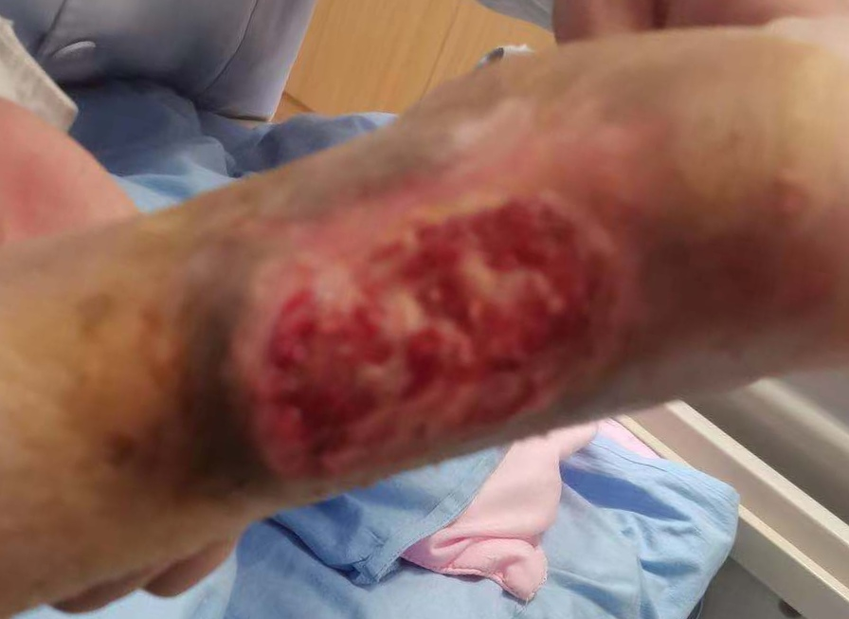﻿
Fig1 the skin ulcer on admission
﻿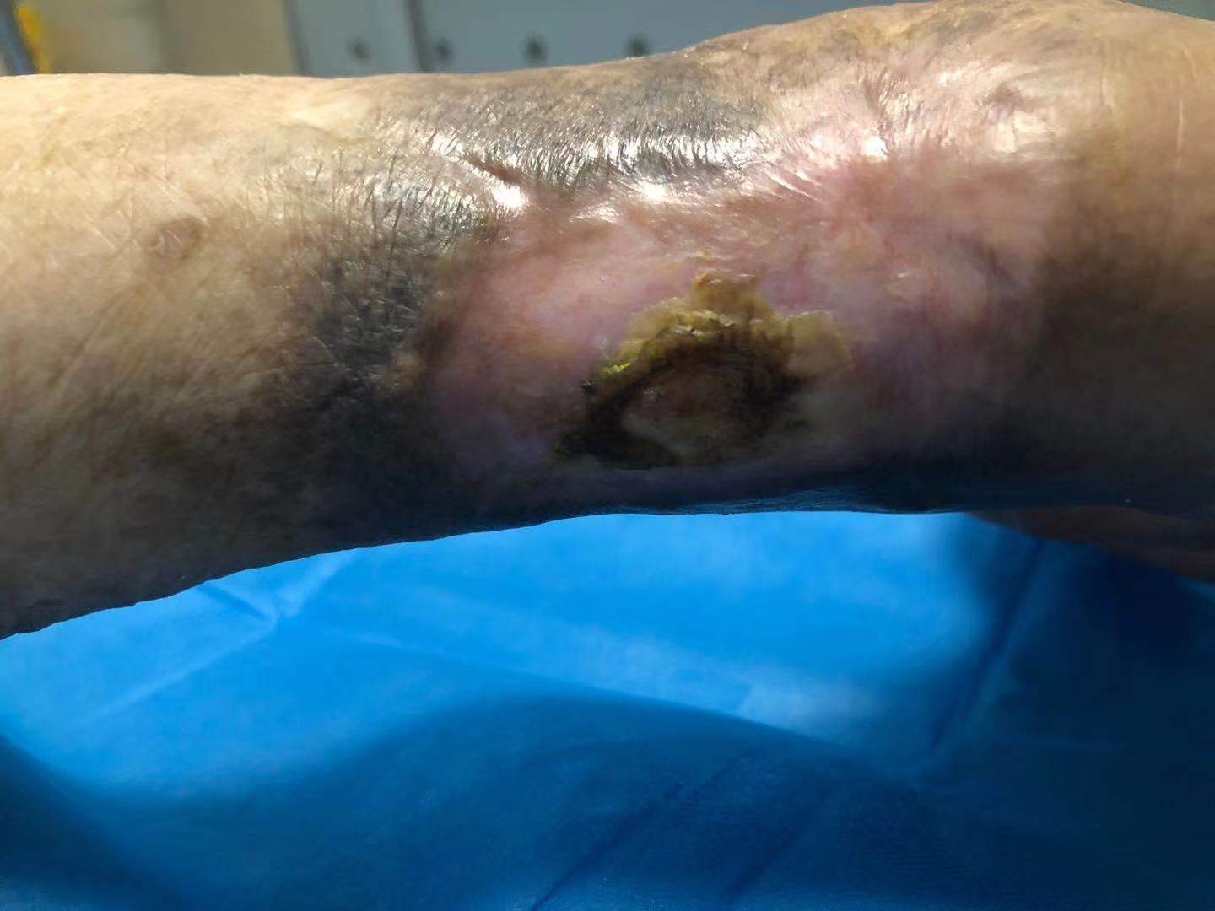﻿
Fig2 the wound healing through MLC
for 2 months

