﻿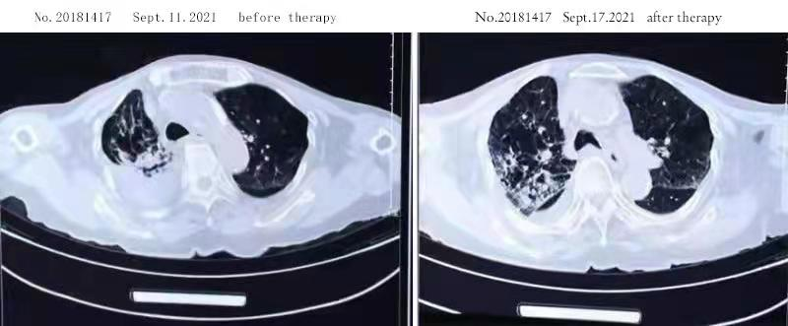﻿
Fig1 chest CT-scans before and after the vaporized therapy with TCM tea herb
﻿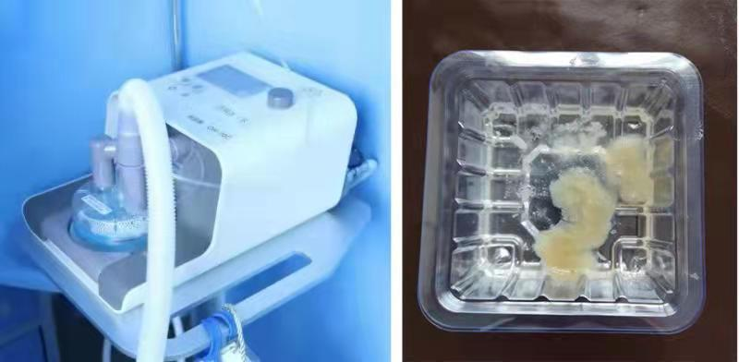﻿
Fig2 high-flow oxygenation device and the subsequent expectoration

