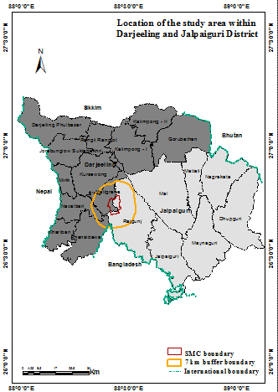

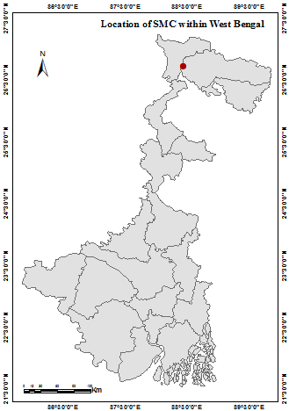

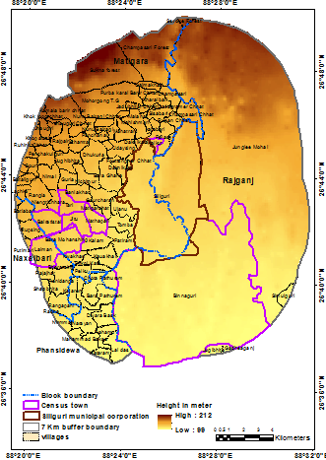

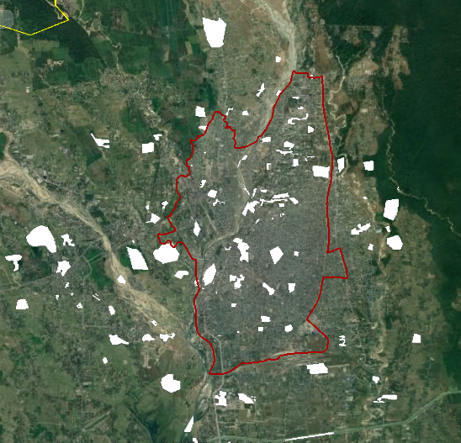

*Selected training samples in the study area.*

*Source: Google earth image*

**Figure 1.** Location map of the study area and selected training samples

Downloading LANDSAT 5 and 8 image of the selected study area

Digitizing the training areas of the city and its surrounding that typify LCZ types

SAGA software uses neighbourhoods as training areas to classify LANDSAT image into LCZ types

Review and mapping output of LCZs

**Figure 2.** Methodological steps of LCZ classification using WUDAPT method.

|  |  |  |  |  |  |  |  |  |
| --- | --- | --- | --- | --- | --- | --- | --- | --- |
| Built types LCZ | Description | Building stories | BY Stewart and Oke | | Real photograph | | | |
| Compact high rise LCZ 1 | Dense mix of tall buildings. Few/no trees. Mostly paved land cover. Concrete, steel, stone | |  | | --- | | > 9 | |  | |  | |  | |
|  | Construction materials. |  |  | |  | |  | |
|  |  |  |  | |  | |  | |
| Compact mid rise LCZ 2 | Dense mix of midrise buildings. Few/no trees. Mostly paved land cover with stone, brick, tile and concrete construction materials. | 3-9 |  | |  | |  | |
|  |  |  |  | |  | |  | |
|  |  |  | E:\A siliguri\Output maps\WhatsApp Image 2021-04-25 at 12.57.46 AM.jpeg | |  | |  | |
|  |  |  |  | |  | |  | |
| Compact low rise LCZ 3 | Dense mix of low rise buildings. Few/no trees. Mostly paved land cover. Stone, brick, tile and concrete construction materials. | 1-3 |  | |  | |  | |
|  |  |  |  | |  | |  | |
|  | Open arrangement of tall |  |  | |  | |  | |
| Open high rise LCZ 4 | buildings. Abundance of pervious land covers having low plants, scattered trees. Concrete, steel, stone and glass construction materials. | >9 |  | |  | |  | |
|  | . |  |  | |  | |  | |
|  | Open arrangement of mid rise buildings. Abundance of |  |  | |  | |  | |
| Open mid rise LCZ 5 | pervious land cover having low plants, scattered trees. Concrete, steel, stone and glass construction materials. | 3-9 |  | |  | |  | |
|  |  |  |  | |  | |  | |
|  | Open arrangement of mid rise buildings. Abundance of |  |  | |  | |  | |
| Open low rise LCZ 6 | pervious land cover having low plants, scattered trees. Wood, brick, stone, tile and concrete construction materials. | 1-3 |  | |  | |  | |
|  |  |  |  | |  | |  | |
|  | Dense mix of one story buildings. |  |  | |  | |  | |
| Light weight low rise LCZ 7 | Few/no trees. Mostly hard packed land cover. Lightweight construction materials e.g. Wood, thatch, corrugated metal. | 1 |  | |  | |  | |
|  |  |  |  | |  | |  | |
|  | Open arrangement of large low rise buildings. Few/no trees. |  |  | |  | |  | |
| Large low rise LCZ 8 | Land cover is mostly paved. Steel, concrete, metal and stone construction materials. | 1-3 |  | |  | |  | |
|  |  |  |  | |  | |  | |
|  |  |  |  | |  | |  | |
|  |  |  |  |  | |  | |
|  | Sparse arrangement of small or medium-sized buildings in |  |  | |  | |  | |
| Sparsely built LCZ 9 | natural settings. Abundance of Low plants, scattered trees. | 1-3 |  | |  | |  | |
|  |  |  |  | |  | |  | |
|  | Low rise and mid rise industrial |  |  | |  | |  | |
| Heavy industry | Structures. Few/no trees. Land cover is mostly paved or hard packed. Metal, steel and concrete construction materials. | 1-3 |  | |  | |  | |
| LCZ 10 | |  |  | |  | |  | |

**Figure 3.** Description of Local Climate Zones (after Stewart and Oke, 2012) identified in Siliguri Municipal Corporation.

A

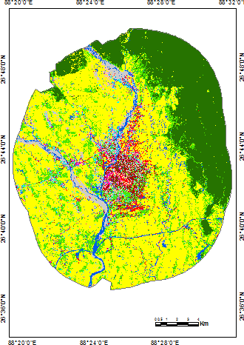



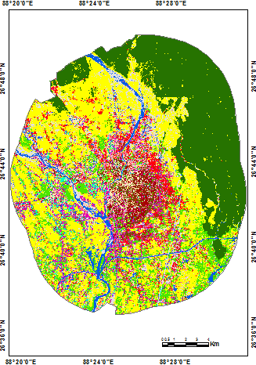

B



**LCZ, 2021**

**Figure 4.** Local Climate Zones map of SMC and its surrounding. (a) 2001 (b) 2021

B

B

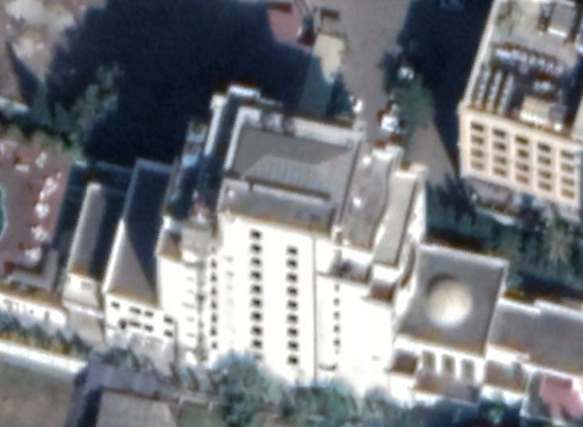

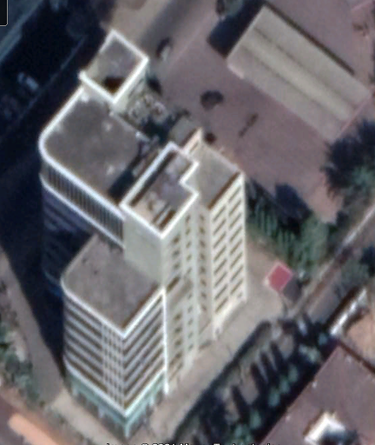

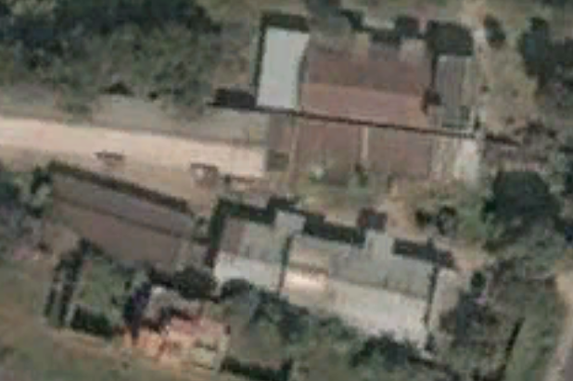

A

A

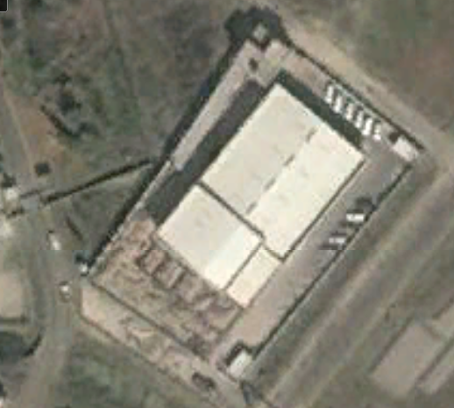

**Figure 5.** Examples of building conversion from A) low rise (2001) to B) high rise (2021) of same training samples. Captured from Google earth image.

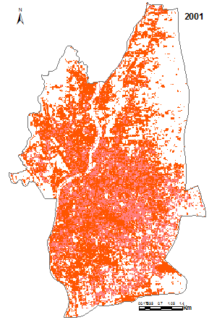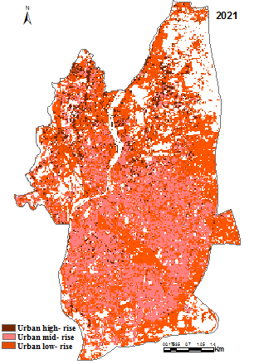

**Figure 6.** Spatial distribution of building states (low, moderate, high) of SMC in 2001 and 2021.

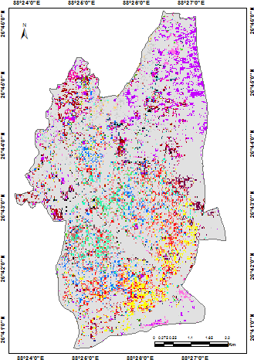









**to**



**to**



**to**



**to**



**to**



**Figure 7.** Conversion of land to mid rise and high rise in SMC.

**Table** **1.** Characteristic of Land sat Satellite Images used in the Study

|  |  |  |  |  |  |  |
| --- | --- | --- | --- | --- | --- | --- |
| Satellite | Sensor ID | Year | Acquisition  date | Resolution | Path/Row | Projection |
| LANDSAT 5 | TM | 2001 | 2001-01-19 | 30m | 139/41 | UTM-WGS1984 |
| LANDSAT-8 | OLI_TIRS | 2021 | 2021-01-11 | 30m | 139/41 | UTM-WGS1984 |

Source: earth explorer USGS

**Table 2.** Areal extension of the Local Climate Zones (LCZs) of the study area



**Table** **3.** Confusion matrix for classification accuracy assessment of LCZ, 2001.



**Table** **4.** Confusion matrix for classification accuracy assessment of LCZ, 2021



**Table 5.** Area (sq. Km) of each LCZ in SMC

|  |  |  |
| --- | --- | --- |
| LCZ types | 2001 | 2021 |
| Compact high rise | - | 0.8 | | |
| Compact mid rise | 1.61 | 5.26 | | |
| Compact low rise | 1.15 | 6.22 | | |
| Open high rise | - | 1.24 | | |
| Open mid rise | 5.97 | 6.38 | | |
| Open low rise | 4.89 | 3.59 | | |
| Light weight low rise | 4.75 | 4.76 | | |
| Large low rise | 2.22 | 2.71 | | |
| Sparsely built | 3.94 | 0.94 | | |
| Heavy industry | 0.03 | 0.77 | | |
| Scattered vegetation | 3.52 | 2.77 | | |
| Low plant | 11.89 | 2.68 | | |
| Waste land | 0.53 | 2.22 | | |
| Water | 1.29 | 1.44 | |

**Table 6.** Land transition to mid rise and high rise LCZ of SMC, from 2001 to 2021

|  |  |  |  |  |
| --- | --- | --- | --- | --- |
|  |  | LCZ types 2021 | (area in Sq. Km) |  |
| LCZ types (2001) | Compact high rise | Open high rise | Open mid rise | Compact mid rise |
| Compact low rise | 0.065(8.55) | 0.023(3.02) | 0.21(27.63) | 0.459(60.39) |
| Open low rise | 0.172(7.68) | 0.134(5.54) | 1.063(47.46) | 0.875(39.06) |
| Light weight low rise | 0.221(26.31) | 0.157(18.69) | 0.233(27.73) | 0.233(27.73) |
| Large low rise | 0.379(28.93) | 0.086(6.51) | 0.385(29.17) | 0.466(35.30) |
| Sparsely built | 0.126(10.24) | 0.163(13.25) | 0.873(70.97) | 0.071(5.77) |
| Low plant | 0.282(14.54) | 0.426(21.96) | 0.432(22.27) | 0.799(41.18) |
| Scattered tree | 1.323(55.82) | 0.017(7.17) | 0.977(41.22) | 0.05(2.11) |
| West land | 0.018(14.75) | 0.041(33.60) | 0.015(12.29) | 0.048(39.34) |

Computed by the author from image data extraction

Figures in the row cells depict the amount of former land cover contributed to the current land cover shows in columns. Values in parenthesis are the corresponding percentage values