March 10th, 2022
Editorial Department of Journal of Geographical Research

Title:
A Hybrid Geostatistical Method for Estimating Citywide Traffic Volumes – A Large-Scale Application

Dear Editor(s) of the Journal of Geographical Research,
I am submitting a manuscript for publication consideration in the Journal of Geographical Research. This manuscript has not been published elsewhere and it has not been submitted simultaneously for publication elsewhere.
The study presented in this manuscript implements a hybrid geostatistical interpolation framework for estimating city-wide traffic volumes by integrating linear regression models and kriging with network distances. A case study using 10-years of traffic volume data collected within the city of Edmonton, Alberta is used to demonstrate the robustness of the geostatistical models developed herein. The findings suggest that the proposed hybrid model significantly outperforms the traditional interpolation methods in terms of improved estimation accuracy, especially for a large-scale network. In addition, the study confirms that the stationarity assumption of kriging does not hold true for a large network whereby separate estimations for different road types perform significantly better than a general estimation for the overall network.
Thank you very much for your consideration, and please do not hesitate to contact the undersigned for any concerns and/or questions.

Yours Sincerely,
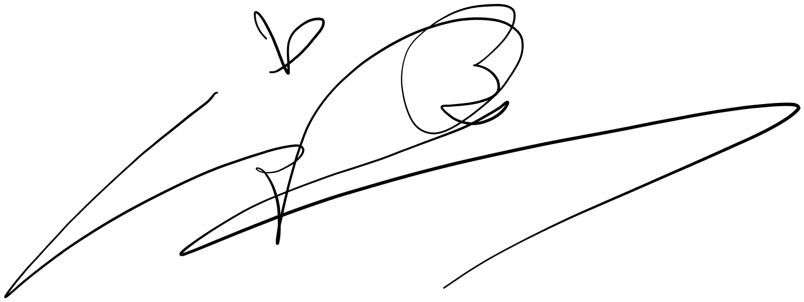
Mingjian Wu
Department of Civil and Environmental Engineering
University of Alberta
Edmonton, AB, Canada, T6G 2W2
Tel: 1-587-937-7024
Email: mingjian.wu@ualberta.ca

List of Authors:
Mingjian Wu, M.Sc. (Corresponding Author)
Graduate Research Student
Department of Civil and Environmental Engineering
University of Alberta
Edmonton, AB, Canada, T6G 2W2
Email: mingjian.wu@ualberta.ca

Tae J. Kwon, Ph.D., P.Eng.
Assistant Professor
Department of Civil and Environmental Engineering
University of Alberta
Edmonton, AB, Canada, T6G 2W2
Tel: +1(780) 492-6121
Email: tjkwon@ualberta.ca

Karim El-Basyouny, Ph.D., P.Eng.
Associate Professor and City of Edmonton’s Urban Traffic Safety Research Chair
Department of Civil and Environmental Engineering
University of Alberta
Edmonton, AB, Canada, T6G 2W2
Tel: +1(780) 492-9564
Email: basyouny@ualberta.ca

Conflict of Interest
All authors declare that they have no conflicts of interest.

Author Contributions
The authors confirm contribution to the paper as follows: study conception and design: Mingjian Wu, Tae J. Kwon, Karim EI-Basyouny; data collection and process: Mingjian Wu; analysis and interpretation of results: Mingjian Wu, Tae J. Kwon, Karim EI-Basyouny; draft manuscript preparation: Mingjian Wu, Tae J. Kwon, Karim EI-Basyouny. All authors reviewed the results and approved the final version of the manuscript.

