Articles

Analysis Study on Urban Vacant Land in Macau Peninsula
Ye Lin¹, Hanxi Li*
¹ Faculties of Innovation and Design , City University of Macau, City, Macau, China
*Corresponding Author: Hanxi Li, Faculties of Innovation and Design , City University of Macau, City, Macau, China; Email: 2320158858@qq.com
Abstract: With the development and construction of the city, the urban development of the Macau Peninsula has entered an era of stock development against the background of the limited scale of urban land. With the shortage of land resources, the problem of unused land on the Macau Peninsula is coming to the fore. This paper mainly studies the problem of idle land in the Macau Peninsula, based on the urban development and particular historical background of the region, investigates and elaborates on its complex formation causes through the literature research method, and analyzes the spatial distribution characteristics of idle land in the current situation of the Macau Peninsula by using GIS technology. Based on the above research, suggestions are put forward to prevent and manage the urban vacant land problem in the future urban management and development of Macau.

Keywords: Macau peninsula; urban vacant land; urban renewal

Introduction
Macau is one of the two particular administrative regions of the People's Republic of China. Including the Macau Peninsula and the outlying islands, the land area is 32.9 km2, and the total population is 679,600 (as of the third quarter of 2020). Fifty-seven percent of the population of Macau resides on the peninsula, which is only 9.1 square kilometers in size [1]. With urban construction, industrial restructuring, population migration, and deficiencies in land management policies, a large amount of idle land has been created in the peninsula of Macau, which hurts the urban environment, social security, and residents' health.
Idle land is usually defined as underutilized land, which many experts and scholars believe contains narrow and broad meanings. In a narrow sense, idle land refers to land that cannot be developed according to the time conditions specified by the original approval unit after the landowner has legally acquired the right to use the land. In a broad sense, idle land also includes land that has been approved by the relevant authorities for conversion from other land types to construction land but has not been constructed in time [2].
For the idle land in the city, the Macau government only defines the idle units in the completed buildings, and there is no clear definition for the idle land in the city. However, the problem of idle land resources has become a problem that cannot be ignored in Macau's urban construction and development. Idle land not only causes waste of resources but also has a severe impact on the healthy development of the city. on the one hand, it damages the image of the city. On the other hand, it fragments the ecological and social texture of the city, which seriously affects the land management system and economic and social development[3].
The problem of idle land in Macau has a long history, but relevant theoretical studies are in a blank stage. For example, the new Land Law passed in 2013 has improved the prevention of "idle land," In 2020, the Macau Urban Master Plan (2020-2040) was drafted for public consultation. After the public consultation of the Macao Urban Master Plan (2020-2040), the Macao government started to transform some unused land in Macao. These initiatives demonstrate the urgent relevance of the government's growing importance in analyzing and studying idle land.

Causes and Effects of Urban Vacant Land in the Macau Peninsula
2.1. Lack of land management and enforcement
Since 1987, Macau has granted more than 30 hectares of land every year in public auctions. In the 1960s, the rapid development of the Western economy led to the growth of Macau's tourism and export processing industries, and Macau's per capita income level rose sharply. In the late 1970s, thanks to the reform and opening-up policy of the Mainland, foreign capital poured into Macau, and a large number of immigrants from the Mainland created a good atmosphere of supply and demand for Macau's real estate industry. In 1992, the Macau government received close to 3 billion yuan from land sales and property revenues. While urban construction was in full swing, the corresponding construction management did not keep pace. The shortcomings of management defects began to emerge in 1993 when there was no more ready supply of land on the Macau Peninsula, most notably the generation of unused urban land [4]. However, the land grant contract and the law provide penalties and even conditions for the legal repossession of the granted land after the utilization period has expired. However, the relevant agencies did not enforce management, resulting in some land that was not started as planned initially being left idle for a long time.

2.2. Idle land due to land recycling policy
To prevent real estate developers from hoarding land for profit, the new Land Law was passed by the Legislative Assembly of the Macau SAR in 2013 and has been in effect since March 2014. Since it came into effect, the Macau government has vacated, relocated, and rehabilitated many projects in Macau that were not built during the lease period. By 2020, about 700,000 square meters and more than 80 pieces of land have been reclaimed [5]. Most of the reclaimed land is still in the urban environment of Macau in a new form. The government has fenced off the reclaimed land to prevent private encroachment, a move that has further reduced the utilization of the unused land.
The government reclaims this type of land because the planned construction is not completed within the lease period. However, many interest groups are involved, and due to imperfect laws and regulations, they are not adequately protected after the land is reclaimed. Moreover, due to the pull of interest issues, the recovered land needs to go through a rather long transition from recovery to rebuilding.

2.3. Environmental decay due to industrial and population shifts
Environmental decay has an indirect effect on the generation of unused urban land. Macau was once one of the most prosperous trading ports in the Far East, and the heyday of its entrepôt trade was from the late sixteenth century to the early seventeenth century, hundred years. However, after the Opium War, Hong Kong quickly replaced Macau as a prosperous entrepot in the Far East with the advantage of its natural harbor and other historical and economic reasons. In contrast, Macau's entrepot trade was drastically reduced in scale and scope due to the port's natural conditions, severe siltation, and especially the inconvenience of shipping from the era of sailing ships to the era of ships. The gaming and tourism industries overgrew in the middle of the twentieth century. They produced a one-of-a-kind phenomenon, which prompted the rapid shift of the city's population employment to the tertiary industry [6]. The original built environment has decayed due to population loss, and the land has been left unused.
Apart from state-owned land and industrial land, most of the other land in Macau belongs to private property rights. Smaller land areas, represented by residential land, where the property owners move out due to personal factors, lead to inefficient land use, building decay, and environmental degradation resulting in land idleness.
Urban vacant land due to environmental decay often has poor spatial quality, pollution, environmental problems, and a negative impact on the continuity of streets. According to the "street eye," theory in Jane Jacobs's "The Death and Life of Great American Cities," when enough residents surround a street, pedestrians walking on the street will be under the surveillance of the residents on both sides of the street. This model creates a lower-cost surveillance environment, which leads to higher crime costs. However, due to fragmented unused urban land, a large amount of unused land on the Macau Peninsula, especially in the Sha Lei Tou area, destroys the stability and continuity of the streets, resulting in unmonitored urban streets.

2.4. Investment transfer from reclamation projects
Macau's long-standing method of acquiring land for urban construction through reclamation has likewise resulted in the formation of urban open spaces. According to statistics, the area reclaimed in Macau from 1912 to 2018 reached 235,000 square kilometers [5]. Since 1993, Macau has relied on reclamation and the acquisition of old residential areas for redevelopment as the primary source of new land. From the investor's point of view, the land price on the Macau Peninsula is too high, and the urban environmental problems caused by high-density buildings are prominent. The return on investment for redevelopment after second-hand property acquisition is also not as good as investing in other areas. Therefore, it is often challenging to rebuild unused land on the Macau Peninsula under these circumstances. While environmental decay leads to empty urban land, which makes investment shifts and population migration increasingly evident, the idle land situated on the Macau Peninsula can easily fall into an undesirable cycle.

Status of unused land on the Macau Peninsula
3.1. Overview of Vacant Land in Macau
As of 2020, there are approximately 700 new sites in Macau, with approximately 1.2 million square meters. Seven hundred thousand square meters have come from land reclaimed by the government since 2014 under the new land law. Approximately 62% of the idle land belongs to private ownership or long-term leases.Most of the vacant land in Macau is small land with less than 100 square meters and is concentrated in the Sha Lei Tau area of the Macau Peninsula, which accounts for 55% of the total vacant land [5].

3.2. Types of idle land in the Macau Peninsula
According to the formation texture of idle land, it can be roughly divided into recycled land, abandoned land, and unused land. According to the original land use, abandoned land can be subdivided into industrial abandoned land and non-industrial abandoned land. Unused land is composed of long-term leased land and unused private land. According to Macau's current land law, land can be divided into private land and state-owned land, with state-owned land divided into private and public property. With the definition of unused land, the property rights of unused land in Macau belong to private land and state-owned private property. They can be divided into two categories: privately owned and government-owned. After a long period of urban development and land reclamation in Macau, the idle land in Macau has developed very distinctive physical characteristics with different property rights backgrounds. The characteristics of each type of idle land are shown in the following table (Table 1).

Table 1 Types and Characteristics of Vacant Land in the Macau Peninsula
Type of idle land |  | Ownership | Characteristics
Recycle Land |  | Government | The site area is large, surrounded by a fence barrier, the land is exposed after site leveling. There are some leftover building structures. With the time after recycling, there are different degrees of vegetation recovery. The degree of vegetation recovery is good.
Waste Land | Industrial waste land | Private | The site is extensive, mainly hard-paved, with legacy industrial buildings or illegal occupation and pollution problems.
 | Non-industrial waste land |  | The site area is small, mostly walled off, mainly hard paved, with legacy buildings or frames in the site, partly illegally occupied, with different degrees of vegetation recovery with the impact of abandonment time and human activities.
Unused land | Long-term land grant | Government | The site is regular in shape, with a large site area surrounded by a fence barrier, and the site is dominated by level grass.
 |  | Private | The site's shape is irregular. Those with a slightly larger site area are used mainly by residents as parking lots or warehouses on their initiative, with hard paved surfaces dominating the site. Sites with small areas mostly have a small amount of garbage piled up. With idle time there is part of vegetation restoration.

Since the new Land Law was implemented in 2014, the Macau government has reclaimed land that was not built according to the original plan and exceeded the lease term. Most of the government reclaimed land has been idle before reclaiming. The government has put fences around the reclaimed land after a simple cleanup of the environment and illegal occupation. Most of the government reclaimed land is significant. It retains remaining buildings or structures, with varying degrees of vegetation recovery over the time of inactivity. The degree of vegetation recovery is better due to less impact from human activities after the fence protection recovery.
Due to the transfer of population and industry, some privately owned land is abandoned. The industrial abandoned land, represented by the Inner Harbor Terminal, has a large site area, retains the original industrial buildings, and has illegal occupation has pollution problems. Most of the non-industrial abandoned sites were once used for residential or commercial purposes and were abandoned due to the relocation or bankruptcy of the property owner, most of them have been abandoned for a long time, and the buildings are seriously damaged or demolished.
Due to the problems of location, land prices, and high construction costs, some unused lands on the Macau Peninsula are in a long-term unused state. The long-term leased land has a large area, is surrounded by fences and blocked by human activities, and is less affected by human activities, and the site is mainly leveled lawn. Long-term unused land belonging to the private sector is irregular in shape. Those with a slightly larger site area are used mainly by nearby residents as parking lots or warehouses on their initiative, with complex paved areas dominating the site. Smaller sites are primarily in the form of building gaps, with walls blocking them, a small number of garbage piles, and with idle time some vegetation restoration.

3.3. Distribution of idle land on the Macau Peninsula
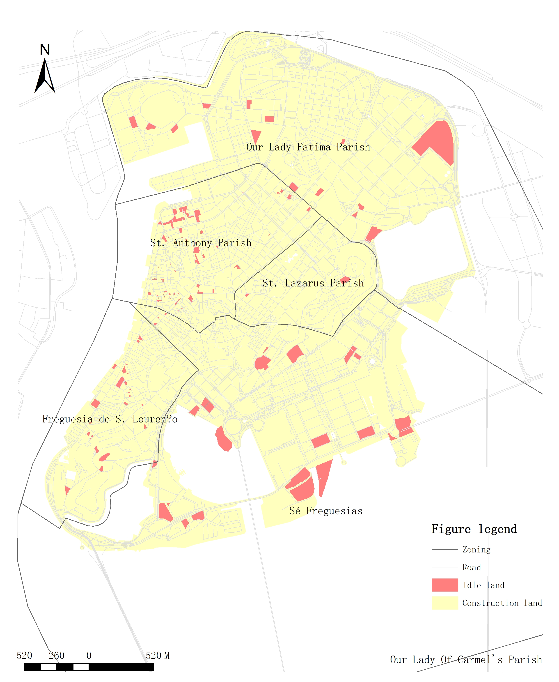
According to the meaning of idle land, the authors used GIS technology to make an essential identification of idle land in the Macau Peninsula and then adjusted the location and boundary through field research. A spatial distribution map of 121 idle lands in the Macau Peninsula was obtained (e.g. Figure 1). The spatial distribution of the obtained current idle land was then further classified according to different types of idle land (e.g. Figure 2).

Figure 1 Distribution of idle land on the Macau Peninsula

According to the distribution map of unused land in the Macau Peninsula, St. Anthony Parish has the largest unused land, accounting for 43.8% of the total unused land and 18.7% of the total unused land. Freguesia de S. Lourenço and Sé Freguesias have the same amount of unused land, accounting for 19.8% and 21.4% of the total unused land. 19.8% and 21.4%, respectively. However, Figure 1 shows that Sé Freguesias has a larger area of idle land, accounting for 42% of the total idle land. In comparison, Freguesia de S. Lourenço has a smaller area of idle land, accounting for 12.6% of the total idle land. Our Lady Fatima Parish has 11.5% of the total idle land and 11.5% of the total idle land. 11.5% of the total idle land and 26% of the total idle land area; St. Lazarus Parish has the least idle land, accounting for 3.3% of the total idle land and 0.3% of the total idle land area (Table 2).

Table2． The number and area of idle in different administrative regions
Administrative Zoning | Number of idle land | Area (m²)
Our Lady Fatima Parish | 14 | 41847
St. Anthony Parish | 53 | 30123
Freguesia de S．Lourenço | 24 | 20333
Sé Freguesias | 26 | 67647
St. Lazarus Parish | 4 | 626
Total | 121 | 160648
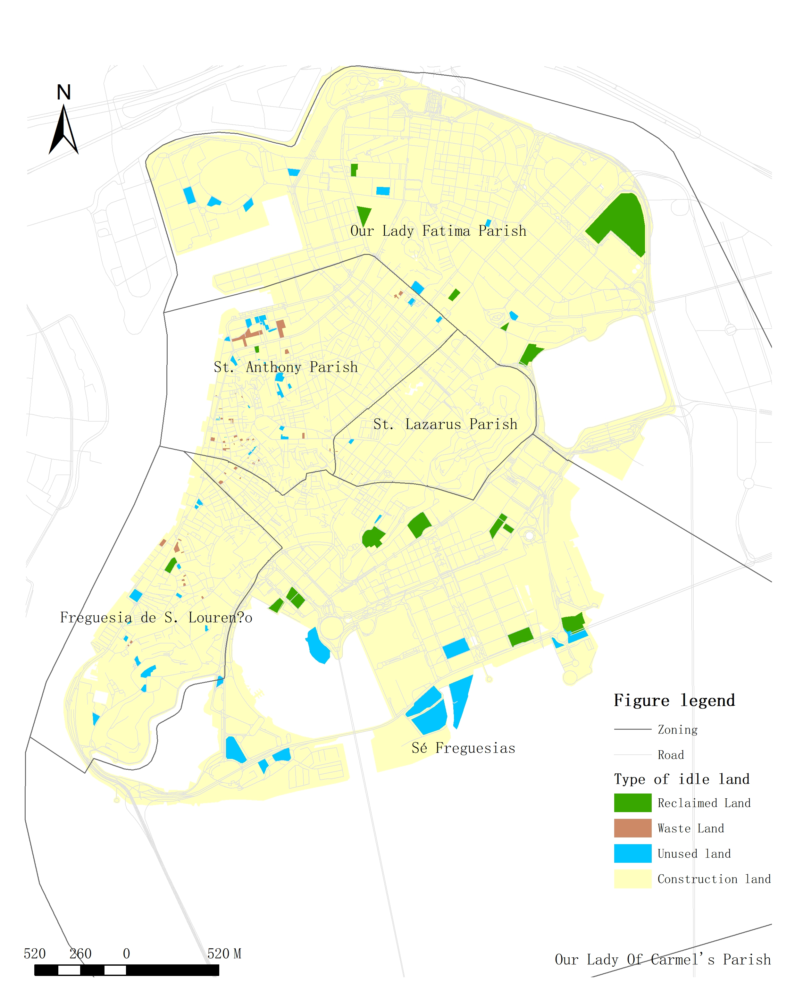
Figure 2 Distribution of different types of unused land on the Macau Peninsula

The distribution of unused land on the Macau Peninsula (e.g. Figure 2) shows that unused land is the most numerous, accounting for 48% of the total number of unused land. Furthermore, it is the most widely distributed, with scattered distribution in all five districts, with St. Anthony Parish having the most significant distribution. Idle land accounts for 38% of the total unused land, mainly in St. Anthony Parish and Freguesia de S. Lourenço; recycling accounts for 13% of the total number of unused land, mainly in Our Lady Fatima Parish and Sé Freguesias (Table 3).

Table 3 Number and area of different types of idle land
Type of idle land | Quantity | Area (m²)
Recycle Land | 16 | 55865
Waste Land | 46 | 18014
Unused land | 59 | 86769
Total | 121 | 160648

Our Lady Fatima Parish has 42.9% of the total amount of reclaimed land in its area and 47.6% of the total area of unused land in its area; the most significant amount of unused land, 57.1% of the total amount of unused land in its area, and the most significant area, 52.4% of the total area of unused land in its area.
St. Anthony Parish has 1.9% of the total amount of reclaimed land in its area and 3% of the total area of unused land in its area; the most significant amount of abandoned land, 66% of the total amount of unused land in its area, and the most significant area, 51% of the total area of unused land in its area; and 32.1% of the total amount of unused land in its area and 47% of the total area of unused land in its area. The number of unused land accounts for 32.1% of the total unused land in the region and 47% of the total unused land in the region.
Freguesia de S. Lourenço has 4.2% of the total number of reclaimed land and 16.4% of the total area of unused land in the region; 45.8% of the total number of unused land and 15.9% of the total area of unused land in the region; and the enormous amount of unused land, 50% of the total number of unused land and the largest area of the total area of unused land in the region. The most significant number of unused land, accounting for 50% of the total number of unused land in its area, and the most prominent area, accounting for 67.7% of the region's total area of unused land.
Sé Freguesias has 30.8% of the total amount of reclaimed land and 46.8% of the total area of unused land in its region; 15.4% of the total amount of abandoned land and 1.4% of the total area of unused land in its region; the immense amount of unused land, 53.8% of the total amount of unused land in its region, and the most significant area, 67.7% of the total area of unused land in its region. The most significant number of unused land, accounting for 53.8% of the total unused land in the region, and the most significant area, accounting for 67.8% of the total unused land in the region.
St. Lazarus Parish has 50% of the total amount of abandoned land in its area and 10.3% of the total area of unused land. The most considerable amount of unused land is 50% of the total amount of unused land in its area and 89.7% of the total area of unused land in its area (Table 4).

Table 4 Number and area of each idle land type in different administrative regions
Administrative Zoning | Type of idle land | Quantity | Area (m²)
Our Lady Fatima Parish | Recycle Land | 6 | 19929
 | Waste Land | 0 | 0
 | Unused land | 8 | 21918
 | Total | 14 | 41847
St. Anthony Parish | Recycle Land | 1 | 904
 | Waste Land | 35 | 15350
 | Unused land | 17 | 13869
 | Total | 53 | 30123
Freguesia de S．Lourenço | Recycle Land | 1 | 3342
 | Waste Land | 11 | 3231
 | Unused land | 12 | 13760
 | Total | 24 | 20333
Sé Freguesias | Recycle Land | 8 | 31690
 | Waste Land | 4 | 939
 | Unused land | 14 | 35018
 | Total | 26 | 67647
St. Lazarus Parish | Recycle Land | 0 | 0
 | Waste Land | 2 | 72
 | Unused land | 2 | 626
 | Total | 4 | 698

Utilization of Vacant Land in Macau Peninsula

4.1. Government rehabilitation measures
Macau's urban development did not consider the impact of development policies on the city's vacant land until the unprecedented growth of tourism after the handover when the damage to the cityscape caused by unused land began to be noticed. According to a web survey, in 2002, the Macau SAR government carried out a unified renovation of unused land in Macau. However, it mainly focused on unused land located in tourist hotspots, with improvements in temporary green open spaces or parking spots. The residents well received this project, but the related evaluation system was not established. After implementing the new Land Law in 2014, a series of social impacts caused by the government's land resumption brought the use of unused land back into the public eye. To " optimize the use of unused land and expand leisure and recreational space for the public," the Municipal Department of Macau has started to convert some unused land in Macau into leisure and recreational parks and temporary community services.

4.2 Informal use by residents
The long-term idleness of the land has also led to many everyday uses, with residents mainly using the unused land for parking, stacking debris, or farming. On larger plots of unused land, informal warehouses are built to store equipment and building materials and are even managed by "security guards." This spontaneous use of unused land by residents is considered a "disorderly space" in the city due to the lack of management and guidance, inefficient use, and poor spatial quality, which hurts the order and environment of the city and poses a threat to the physical and mental health of the city residents [7].
After implementing the new Land Law of the Macao SAR in 2014, the reclaimed land was fenced off, and all unpermitted people and activities were prohibited. Informal activities in some of the unused land were restricted. However, there is no regulation or restriction on informal activities for the unused land that has not been reclaimed. Due to the shortage of parking spaces and the inadequate supply of community services on the Macau Peninsula, unused urban land instead provides a solution. Although the public often has a negative attitude towards it, its existence cannot be denied.

Utilization of Vacant Land in Macau Peninsula

5.1. Reflections on the status of unused land in the Macau Peninsula
The urban idle land problem faced by the Macau Peninsula today is also manifested to varying degrees in the urban centers of the territory. However, the causes of the formation of idle land in the Macau Peninsula are somewhat unique due to its political and historical background. However, the characteristics and current use of idle land have similarities with other cities worldwide. However, the Macau government is aware of the impact of unused urban land and has developed prevention and utilization plans. However, due to the inherent complexity of urban idle land, fragmented and unregulated utilization is challenging to implement uniformly [8]. It is impossible to address the problem at its root. As a result, the problem of unused land on the Macau Peninsula and other urban problems arising from unused land has not been effectively solved so far. Some lessons can be learned from the causes and remedies of unused land in the Macau peninsula.
On the one hand, the problem of unused land in the city involves many factors, and it often takes a long time and is challenging to solve. Therefore, the best way to solve such problems is to prevent them before they arise and avoid creating large amounts of unused land. This requires urban planning managers to have a good understanding of urban idle land and to take responsibility for its prevention. On the other hand, the stable maintenance and regular operation of urban vitality is also an essential factor influencing the creation of idle land in cities. The stable existence of residents is the key. The reasonable development of urban industries guarantees residents to live and work in peace and happiness, ensuring the stability of human resources in cities to create lasting and sustainable urban development momentum.

5.2. Suggestions for the prevention and utilization of idle land on the Macau Peninsula
5.2.1. Improve relevant policies and systems to protect the interests of all parties
With the government as the leader, relevant policies are formulated and improved to prevent the generation of idle urban land, protect the interests of all parties, and encourage and guide the rebuilding of recovered land. Although the new Land Law of 2013 mentions the prevention of urban idle land and penalizes or recalls approved construction projects that have not been started for a long time. However, after the penalty or recall, there is no regulation to support protecting the rights and interests of the relevant stakeholders, especially citizens. On the other hand, the long-term interest pull keeps the land in an inefficient mode between idling and rebuilding. This situation can be based on the mature experience of "transitional spaces" in foreign countries, such as the 2004 Vienna strategic plan to use unused land to build short-term public activity spaces to address the lack of public space in the inner city. Moreover, in 2016, the Philadelphia Water Department included unused land as part of the city's stormwater management strategy to reduce total sewer overflows by filtering and storing stormwater through green infrastructure [9].

5.2.2. Adopting flexible financing models to accelerate the reuse of idle land
Due to the property rights situation of Macao land, idle land faces complex property rights problems in reuse, especially the private property rights of idle land, which is the central aspect that hinders its re-construction.
It is suggested that the pace of construction should be accelerated by drawing on mature foreign construction investment models—for example, the U.S. Land Bank's "Neighborhood Land Transfer Model" for idle land use. Neighborhood homeowners purchase vacant land at a lower price without taking ownership, providing a formal opportunity for the rational use of vacant land. The transfer of vacant land also resolved vacant land tax arrears [9]. Most of the vacant land within the Macau Peninsula is small, the investment threshold is not high, and the governance difficulty and maintenance costs are also low governance difficulty and maintenance operation costs are relatively low. It is recommended to use various financing models such as PFI, BOT, ABS, TOT, and PPP to transform urban vacant land in the Macau Peninsula to reduce the financial pressure on the government. Attract social capital participation, accelerate the construction process and improve the quality of the project [10-12].

5.2.3. Comprehensive integration to form a systematic management
One of the significant characteristics of idle land in the cities of the Macau Peninsula is that it is scattered and fragmented, and irregular. Corresponding management and transformation methods should be developed according to the characteristics of the type of idle land and its relationship with the surrounding parcels. At the same time, the utilization of idle land should not be developed separately from the actual development of the city. However, it should be integrated into the urban planning and development requirements to avoid inefficient use of the land to make it idle again.

5.2.4. Encouraging public participation in the transformation of unused urban land
Before the arrival of the "bottom-up" policy, some "bottom-up" uses of unused urban land often existed, and such informal uses often reflect the most genuine needs of users. Encouraging the public to participate in the renovation of unused land from users' perspective can ensure the utilization rate of the renovated land on the one hand and ensure fairness on the other. Involving the public in the renovation and use of unused land will promote the concern of urban residents for urban construction and will have a positive impact on the government's integrity and social harmony.

5.2.5. Improve the evaluation system
A comprehensive evaluation system should be developed for completed idle land-use projects to judge whether they are sufficient to meet the design objectives. It should be considered at the level of three guidelines: ecological benefits, economic benefits, and social benefits, and should have different focuses for idle land use with different types of characteristics; for example, for idle land-use projects with larger areas, more attention should be paid to their ecological benefits, and for idle land use with smaller areas, more attention should be paid to their economic and social benefits. Only by improving the evaluation system can we better guide the utilization of unused urban land to produce more significant benefits.

Author Contributions
Ye Lin was responsible for the primary data collection and analysis in this study and was also the paper's principal author. Hanxi Li was responsible for proofreading this study.

Funding: This research received no external funding

References
[1] Macao Special Administrative Region Government Statistics and Census Bureau: Population and Households, 2020.https://www.dsec.gov.mo/zh-MO/. (Accessed 24 January 24 2021).
[2] Yi Xiao Xiang, Zhao Tianyu, Wu Yanfeng & Mu Yixuan. 2020. "Crisis" or "opportunity"? --A study of international experience in addressing the problem of shrinking urban vacancy. Journal of Urban Planning (02), 95-101. DOI:10.16361/j.upf.202002012.
[3] Liu, Zengfeng. ,2019. Spatial distribution, formation mechanism and reuse of urban vacant land (Master's thesis, Tung Wah University of Science and Technology). https://kns.cnki.net/KCMS/detail/detail.aspx?dbname=CMFD202001&filename=1019627981.nh
[4] Xie, Lin & Tang, Che. ,2015. On the modification and improvement of the public tender for land grant in Macao. Contemporary Hong Kong and Macau Studies (03), 75-91. DOI:10.13521/b.cnki.ddgayj.2015.0020.
[5] Viewpoint Property Network: Savills: Macau Land Survey Research Summary, July 20, 2020
https://www.savills.com.mo/. (Accessed 25 June 2021).
[6] Huang, Gao-Cai. 2020. Analysis of the current situation and evaluation of the potential utilization of the vacant land in Yueyang City (Master's thesis, Hunan Normal University). https://kns.cnki.net/KCMS/detail/detail.aspx?dbname=CMFD202101&filename=1020321754.nh
[7]Song Xiaoqing,Ma Zhanghong,Zhao Guosong & Wu Zhifeng.,2018. Urban vacant land:Cold thoughts on the urbanization boom. Journal of Geography (06), 1033-1048.
[8] Gong, C., Wu, C. Y. & Hu, C. Juan. ,2017. A Systematic Planning Approach for Transforming Urban Open Space into Green Infrastructure: The Case of Richmond, USA. China Gardening (05), 74-79. DOI:CNKI:SUN:ZGYL.0.2017-05-015.
[9] Yang Sampan. ,2019. The Development of "Transitional Use" and Related Research in China and Overseas - A New Perspective of Urban Research. International Urban Planning (06), 49-55. DOI:CNKI:SUN:GWCG.0.2019-06-009.
[10] Galen Newman, Lai, Dongying, Zhu, Rui & Ren, Dingding. ,2018. Urban reengineering and resilience enhancement:An economic performance assessment of green infrastructure-oriented reuse of vacant land. Landscape Architecture (06), 10-23. DOI:CNKI:SUN:JGSJ.0.2018-06-003.
[11] Chen, Jing-Jia, Zhang, Zhao-Xi & Long, Ying. ,2020. Strategies to promote public health-oriented street space quality from the perspective of spatial disorder. Urban Planning (09), 35-47.
[12] Chen, Wei-Zhen & Liu, Tsuen.,2016. Potential and value of informal development landscape projects in urban renewal. China Gardening (05), 32-36. DOI:CNKI:SUN:ZGYL.0.2016-05-008.

