a) Student receives daily text message with greeting and link to quiz site. | b) Student chooses causes to support if problem is answered correctly. | c) Student is shown problem and rates confidence in being able to solve it. | d) Student chooses from one of five possible answers. | e) Student receives feedback on whether or not the answer was correct. | f) Student can view a video solution.
Figure 1. The KiSS program from daily text message to problem solution.


Figure 2. KiSS program advertisement flier.

Figure 3. Percentage of students enrolled in the program who answered each KiSS problem. Hash marks represent holidays.

Figure 4. Number of problems answered by students.
Figure 5. Participation date, day of the week, and problem number for students who just participated once in the KiSS program.

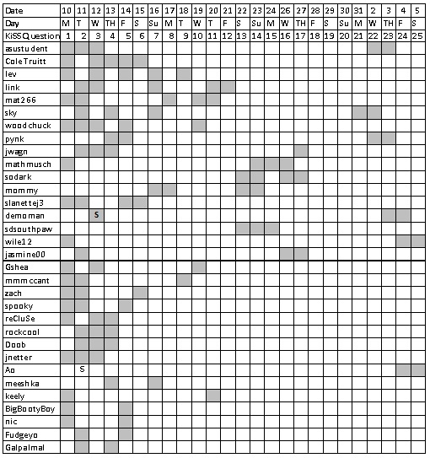
Figure 6. Participation date, day of the week, and problem number for students who participated between 2 and 5 times in the KiSS program.
Figure 7. Participation date, day of the week, and problem number for students who participated between 16 and 20 times in the KiSS program.
Figure 8. Participation date, day of the week, and problem number for students who participated more than 21 times in the KiSS program.

Figure 9. Average percent of problems correctly answered by number of problems answered.

Figure 10. Percent of students who responded correctly to each KiSS problem.

Figure 11. Percent accuracy for each confidence rating. (Dark/light represents percent of inaccurate/accurate responses, respectively.)

Figure 12. Percent of confidence ratings below neutral by number of problems answered.

Some students (n=6) registered after the program had begun. An “s” in the chart indicates the day that they joined.

