Type of the article (Article, Review, Communication, etc.)

Interpretation of water samples by correspondence analysis for radioactive elements in the northern coast of Oman Sea
Farshad Darabi-Golestan ^{1,} *, Mohamad Reza Zare^{2,}
¹* P.H.D. student of Mining engineering, Department of Mining and Metallurgical Engineering, Amirkabir University of Technology, Tehran, 1591634311, IRAN; pooyan@aut.ac.ir
² Department of Physics, Faculty of Sciences, University of Isfahan, Isfahan 81746-73441, I.R. Iran

Abstract: Oman Sea is connecting belt between the Indian Ocean and Persian Gulf. Because it Strategic and environmental aim, presence of natural radionuclide ²²⁶Ra, ²³²Th, ⁴⁰K and ¹³⁷Cs as man-made element is considered. Water samples were taken from 36 marine spots at the coastal strip from Hormoz canyon to Goatr seaport in the northern coast of Oman Sea. Correspondence analysis is used to identify variation and relationship between samples (Q-mood analysis) and variable (R-mood analysis) based on approximate distances. Radioactive elements (²²⁶Ra, ²³²Th and ⁴⁰ K), physical (temperature, pH, turbidity, conductivity, special density) and chemical (salinity, oxygen and chlorophyll) parameters of water for 36 samples handled by correspondence analysis, there are two outstanding result, 1) Radioactive elements show high correlation in factors by greater eigenvalue, and 2) some of the samples such as W13, W24 and rather W02, W05 and W12 show highest activity from Radioactive elements and also temperature and conductivity show nearest relation with them in many factors.

Keywords: Hormoz canyon to Goatr seaport; Correspondence analysis; Radioactive elements; Marine spot samples.

Introduction
The radionuclides are the source of Natural radioactivity in earth ^{[1-2]}. Some effective dose of natural radioactivity received by human acts in the world. large amounts of radionuclides have released into the environment after the Fukushima and Chernobyl nuclear accidents ^{[3]}. The current research tries to create a reference value to future investigation. Therefore, the data can be basic values in the region, while the results always are comparable data in each. It was necessary to mention that this the same type of this research was published for many countries, such as Ireland, Egypt ^{[4-5]}, India ^{[6]}, China ^{[7]}, America ^{[8]}, Turkey ^{[9]} and Mexico ^{[10]}. According to the International Atomic Energy Agency (2003) ^{[11]}, the standard systematic sampling was taken at the northern coastline of Oman Sea.
Water quality assessment studies, especially in coastal seas from natural radionuclides have frequently conducted in many countries at the last years ^{[12-13]}. The variables and samples analysis were done by Correspondence Analysis (CA) according to covariance and distance parameters from R-mode and Q-mode analysis respectively ^{[14-16]}. Accordingly, indicator samples were adjusted in the spatial neighborhood of related variables ^{[17]}.

Materials and Methods
The total number of 36 marine spot were designed in the northern coast of Oman Sea. The first related sample was taken from the Hormoz canyon and it continued by coastal strip to Goatr seaport. The sampling project was done in May 2011 and covered an area between 56° 30΄ to 61° 30΄ in longitude and 25° to 26° in latitude. Figure 1 shows the location of sampling spots, afterward the sample code and location of each sample represented at Table 1.
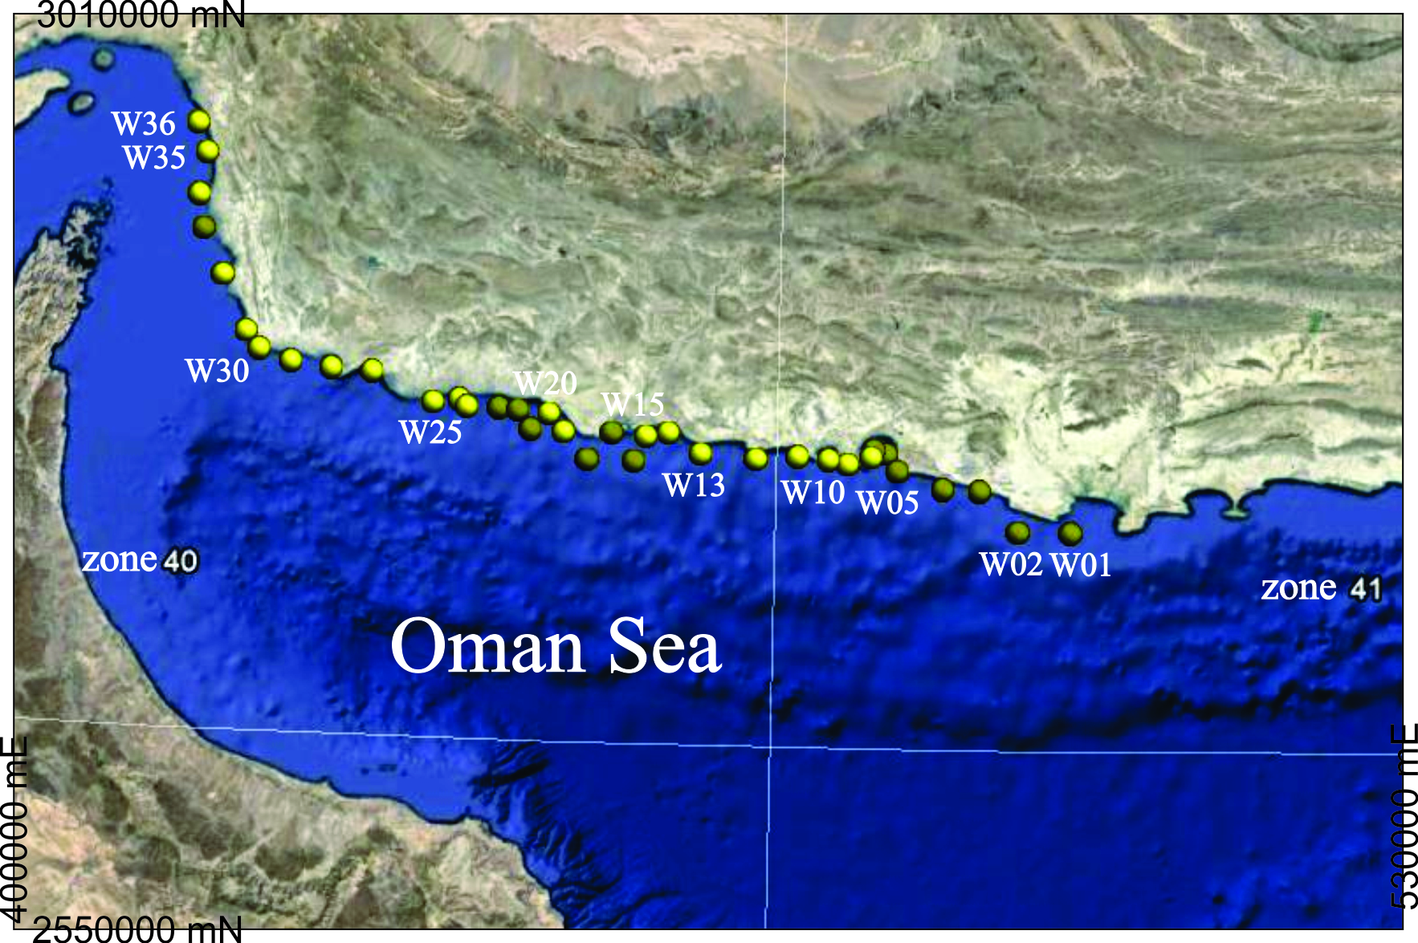
Fig. 1. Locations map of the sampling spots consist of water samples

Table 1. The location of water samples in Oman Sea
Sample code | location | Sample code | location
W01 | Chabahar Seaport (Pasabandar) | W19 | Pi Bashk (Karti)
W02 | Chabahar Seaport (Baris Bala) | W20 | Pi Bashk (Lirdaf)
W03 | Chabahar Seaport (Baris Bala) | W21 | Pi Bashk (Sadich)
W04 | Chabahar Seaport | W22 | Pi Bashk (Sadich)
W05 | Chabahar Seaport | W23 | Pi Bashk (Kentaki)
W06 | Chabahar Seaport (Konarak) | W24 | Pi Bashk (Kentaki)
W07 | Chabahar Seaport (Konarak) | W25 | Pi Bashk (Kentaki)
W08 | Chabahar Seaport (Konarak) | W26 | Jask Seaport
W09 | Chabahar Seaport (Konarak) | W27 | Jask Seaport
W10 | Chabahar Seaport (Konarak) | W28 | Jask Seaport
W11 | Chabahar Seaport (Gordim) | W29 | Jask Seaport
W12 | Pi Bashk (Tong Seaport) | W30 | Jask Seaport
W13 | Pi Bashk (Hoomadan) | W31 | Jask Seaport
W14 | Pi Bashk (Derak) | W32 | Taherooi (Serich)
W15 | Pi Bashk (Derak) | W33 | Taherooi (Mashi)
W16 | Pi Bashk (Derak) | W34 | Taherooi (Mashi)
W17 | Pi Bashk (Karti) | W35 | Taherooi (Sirik Seaport)
W18 | Pi Bashk (Karti) | W36 | Gheshm

Results
3.1. Statistical analysis

A hand-held EXPLORANIUM spectrometer was applied to monitoring and detect the environmental changes. By using the CTD system could record conductivity (mS/cm), temperature (˚C), special density (gr/cm³), salinity (PSU), chlorophyll (mgr/m3), oxygen (ppm), turbidity (NTU) and pH of water. The portable HPGe detector positioned vertically inverse at center of the water sample ^{[18-19]}. The minimum and maximum, mean and median, standard deviation, variance, values of ²²⁶Ra, ²³²Th and ⁴⁰K are showed in Table 2. The boxplot that displays the distribution of median confidence interval box, outlier symbols, median symbol and the minimum and maximum, mean for Ra, Th, and K (Fig. 2).

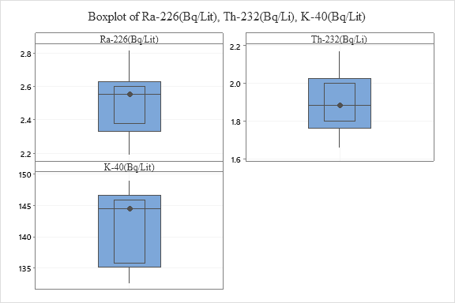
Fig. 2. The boxplot of Ra, Th and K for water samples

Table 2. Descriptive statistics of water samples for ²²⁶Ra, ²³²Th and ⁴⁰K activity concentration.
 | Variable | Minimum | Maximum | Mean | Median | St.Dev. | Variance
water sample (Bq/Lit) | ²²⁶Ra | 2.19 | 2.82 | 2.4917 | 2.555 | 0.1794 | 0.0322
water sample (Bq/Lit) | ²³²Th | 1.66 | 2.17 | 1.9031 | 1.885 | 0.1514 | 0.0229
water sample (Bq/Lit) | ⁴⁰K | 132.6 | 148.87 | 141.48 | 144.42 | 5.87 | 34.51

3.2. Correspondence and K-means analysis

CA method is a useful method in order to geochemical classification of variables ^{[20-21]}. By application of this method could reduce high-dimensional data into subset of data which have low-dimension. These data could easily interpret and show effective and simple dimension. The subspaces reveal the main variances between variables ^{[22-25]}. R-mode and Q-mode are the two main branch of CA method ^{[25-26]}. The Q-mode (represented as sample-to-sample analysis) and R-mode (represented as element-to-element) are the two main results of the CA analysis. The results of R-mode and Q-mode matrix are combined as F-matrix while the distances are distances between the respective modes ^{[27, 19]}. Therefore, the CA could easily indicate the similarity or association between variables (R-mode, which represented by loadings or blue vectors in Fig. 3a) derived from data samples (Q-mode, which represented by scores or red symbols in Fig. 3a). The First (82% of Inertia) and second (9.6% of Inertia) CA factors with highest eigenvalue are the stronger factors. The cumulative proportion of inertia for the first and second factor consist of 91.5% of total variation in the whole samples (Table 3). The symmetric with combination of the first and second factor is displayed at figure 2. Both row and column principal coordinates overlaid in new dimensions. This method could ease difficulty between variables while there are not of primary interest in data (for columns and rows). Therefore, columns (variables) and rows (samples) plotted in new dimension.

Discussion
A set of samples in a K-means cluster are more similar to each other according to some similarity or dissimilarity measures. Therefore, it was used and revealed that samples show different properties due to their parameters. All samples were categorized in 4 groups (Fig. 4), while the first group (which have 13 observations) show higher value for Ph, K, Ra, Th. The second and the third group have 7 and 8 samples, respectively. They are more important for Temp., cond., Salt. Parameters. The fourth group by 8 samples show higher Turb. and Sigma T. The first dimension of CA indicates maximum variance between ²²⁶Ra, ²³²Th and ⁴⁰K parameters and temperature, sigma-T, O₂, conductivity. On the other hand, the second dimension of CA analysis indicates different Eigen vector for pH, turbidity, chlorophyll, and salinity parameters.
Table 3. The Contingency table from CA analysis
Axis | Inertia | Proportion ratio | Cumulative | Histogram
1 | 0.0094 | 0.8190 | 0.8190 | ******************************
2 | 0.0011 | 0.0961 | 0.9151 | ***
3 | 0.0007 | 0.0629 | 0.9780 | **
4 | 0.0001 | 0.0125 | 0.9906

The sample numbers of W13, W 18 and W24 are strongly, in which W12, W05 and W02 are moderately concentrated from ²²⁶Ra, ²³²Th and ⁴⁰K radionuclides (Fig. 4). According to the Figure 2a and 2b, it would have revealed that sample W13 and W18 (Eigenvalues distinguished by black circles, Fig. 4) have been concentrated from ²²⁶Ra, ²³²Th and ⁴⁰K radionuclides (shown by blue eigenvectors, Fig. 3), whereas, W26 and W03 show at least values. On the other hand, W26 and W35 sample numbers considered as highest values of salinity and chlorophyll. All the water variation from radionuclides indicated by the 2D graphical representation of eigenvalues and eigenvectors (Fig. 3), simultaneously in the correspondence (CA) and factor Analysis combination. The sample numbers of W18, W34, W21, W08, W04, W13 and W24 can straighten this idea. Also, the second dimension of variation in CA indicate that turbidity, chlorophyll, and salinity have the minimum similarities with ²²⁶Ra, ²³²Th and ⁴⁰K radionuclides and it is indicated according to W26 and W35 samples.

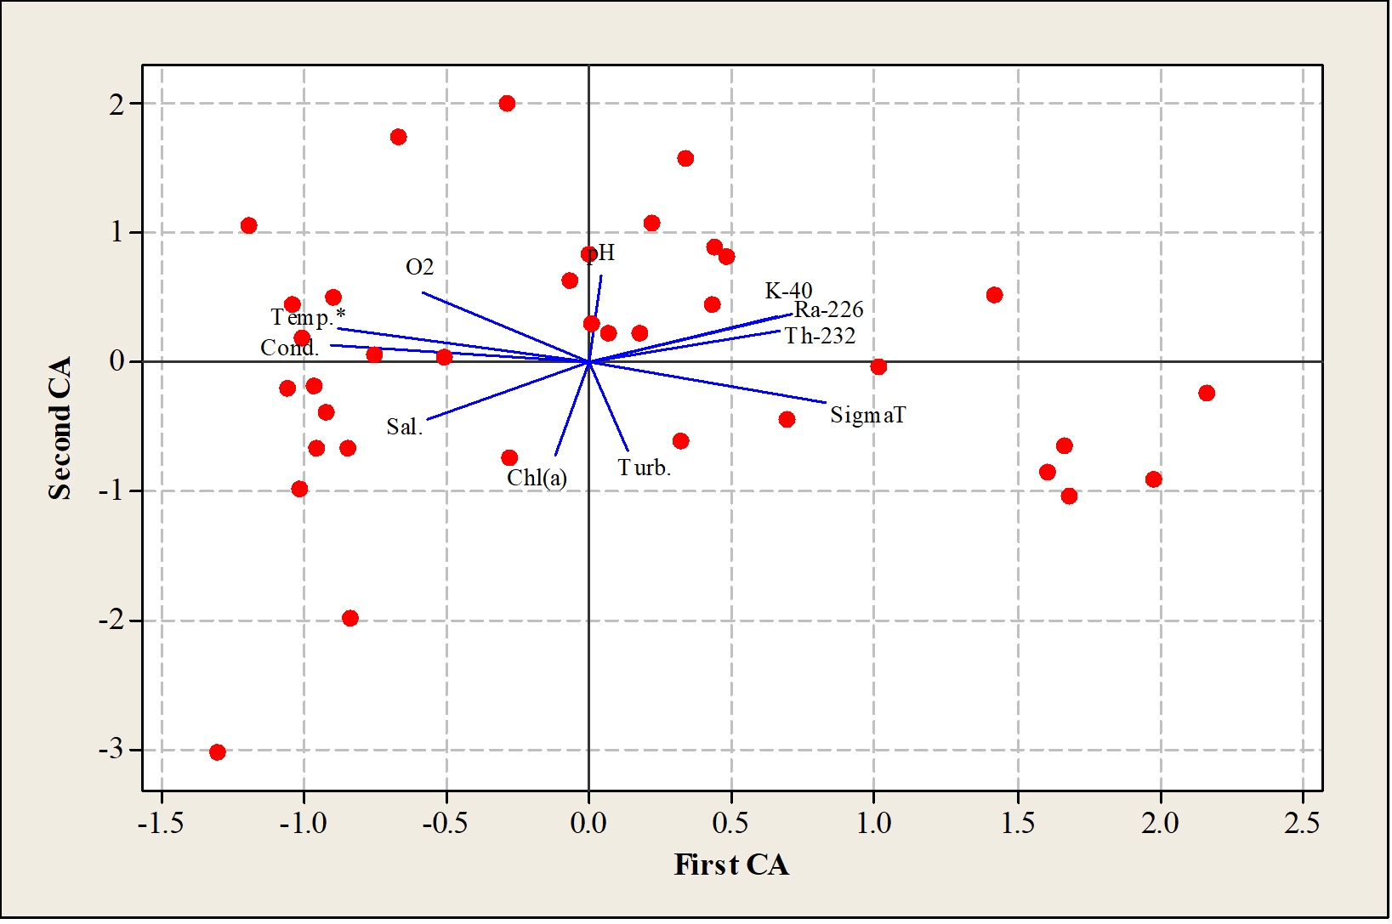
Fig. 3. The 2-D symmetric plot from multivariate CA analysis for the first and second dimensions in the water samples. The parameters and radionuclides are plotted within new dimension according to Euclidian distances between observations by covariance-based and distance-based analysis.

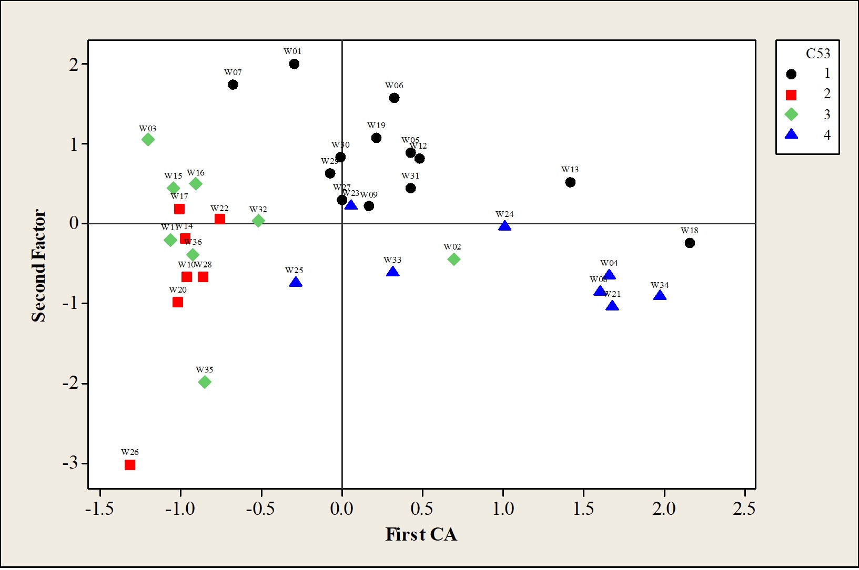
Fig. 4. The graphical combination plot of CA and K-means clustering.

Conclusions
Correspondence analysis applied to recognize water sample and analyzed variable (three radioactive element and eight physical and chemical properties of sample). In these surveys, variables of Ra, Th and K have different specification from conductivity, temperature, special density, salinity, chlorophyll, oxygen, turbidity and pH of water. Accordingly, these radionuclides have same behavior (with high eigenvalue) and correlated in stronger factors. Therefore, samples such as W13, W24, W18 (strongly) and W12, W05 and W02 (moderately) are concentrated from Th, Ra and K. By application of CA and factor multivariate analysis, the first dimension shows the conductivity, temperature, O₂ and salinity parameters have distinctly different from ²²⁶Ra, ²³²Th and ⁴⁰K according to covariance-based (R-mode) analysis. On the other hand, the second dimension indicates temperature, O₂, and conductivity and maybe pH have high correlation with radionuclides. At Finally, after analysis, the values of the ²²⁶Ra, ²³⁵U, ⁴⁰K, ²³²Th, and ¹³⁷Cs concentrations in water samples were lower than that value of the world. Therefore, the data can be basic values in the region and accepted as a reference and comparable data in each time.

References
[1] Abdi, M., Faghihian, H., Mostajaboddavati, M., Hasanzadeh, A. and Kamali, M., 2006. Distribution of natural radionuclides and hot points in coasts of Hormozgan, Persian Gulf, Iran. Journal of radioanalytical and nuclear chemistry, 270(2): 319-324.
[2] Alatise, O., Babalola, I. and Olowofela, J., 2008. Distribution of some natural gamma-emitting radionuclides in the soils of the coastal areas of Nigeria. Journal of environmental radioactivity, 99(11): 1746-1749.
[3] Matisoff, G., Ketterer, M.E., Rosén, K., Mietelski, J.W., Vitko, L.F., Persson, H. and Lokas, E., 2011. Downward migration of Chernobyl-derived radionuclides in soils in Poland and Sweden. Applied geochemistry, 26(1): 105-115.
[4] Harb, S., 2008. Natural radioactivity and external gamma radiation exposure at the coastal Red Sea in Egypt. Radiation protection dosimetry, 130(3): 376-384.
[5] Uosif, M., El-Taher, A. and Abbady, A.G., 2008. Radiological significance of beach sand used for climatotherapy from Safaga, Egypt. Radiation protection dosimetry.
[6] Gouda, M., Hamzawy, A., Badawi, M., El-Khatib, A., Thabet, A. and Abbas, M., 2016. Mathematical method to calculate full-energy peak efficiency of detectors based on transfer technique. Indian Journal of Physics, 90(2): 201-210.
[7] Xu, L., Liu, X., Sun, L., Yan, H., Liu, Y., Luo, Y., Huang, J. and Wang, Y., 2010. Distribution of radionuclides in the guano sediments of Xisha Islands, South China Sea and its implication. Journal of environmental radioactivity, 101(5): 362-368.
[8] Myrick, T., Berven, B. and Haywood, F., 1983. Determination of Concentrations of Selected Radionuclides in Surface Soil in the US. Health Physics, 45(3): 631-642.
[9] Kurnaz, A., Küçükömeroğlu, B., Keser, R., Okumusoglu, N., Korkmaz, F., Karahan, G. and Çevik, U., 2007. Determination of radioactivity levels and hazards of soil and sediment samples in Fırtına Valley (Rize, Turkey). Applied Radiation and Isotopes, 65(11): 1281-1289.
[10] Mireles, F., Davila, J., Quirino, L., Lugo, J., Pinedo, J. and Rios, C., 2003. Natural soil gamma radioactivity levels and resultant population dose in the cities of Zacatecas and Guadalupe, Zacatecas, Mexico. Health physics, 84(3): 368-372.
[11] International Atomic Energy Agency, I., 2003. Collection and Preparation of Bottom Sediment Samples for Analysis of Radionuclides and Trace Elements. IAEA-TECDOC 1360(technical report).
[12] Yasmin, S., Barua, B.S., Kamal, M. and Rashid, M.A., 2014. An Analysis for Distribution of Natural Radionuclides in Soil, Sand and Sediment of Potenga Sea Beach Area of Chittagong, Bangladesh. Journal of Environmental Protection, 5(17): 1553.
[13] Zare, M.R., Kamali, M., Kapourchali, M.F., Bagheri, H., Bagheri, M.K., Abedini, A. and Pakzad, H.R., 2016. Investigation of 235U, 226Ra, 232Th, 40K, 137Cs, and heavy metal concentrations in Anzali international wetland using high-resolution gamma-ray spectrometry and atomic absorption spectroscopy. Environmental Science and Pollution Research, 23(4): 3285-3299.
[14] Aggrawal, D., Bansal, G., Anand, A. and Papic, L., 2016. Types of Customers Surrounding a Brand: A Classification Based on Correspondence Analysis. Communications in Dependability and Quality Management-An International Journal, Serbia, 19(1): 5-17.
[15] Darabi-Golestan, F. and Hezarkhani, A., 2018. Evaluation of elemental mineralization rank using fractal and multivariate techniques and improving the performance by log-ratio transformation. Journal of Geochemical Exploration, 189: 11-24.
[16] Wang, C.-H., 2016. A novel approach to conduct the importance-satisfaction analysis for acquiring typical user groups in business-intelligence systems. Computers in Human Behavior, 54: 673-681.
[17] Kumru, M. and Bakac, M., 2003. R-mode factor analysis applied to the distribution of elements in soils from the Aydın basin, Turkey. Journal of Geochemical Exploration, 77(2): 81-91.
[18] Darabi-Golestan, F., Hezarkhani, A. and Zare, M., 2017. Assessment of 226 Ra, 238 U, 232 Th, 137 Cs and 40 K activities from the northern coastline of Oman Sea (water and sediments). Marine Pollution Bulletin, 118(1): 197-205.
[19] Darabi-Golestan, F. and Hezarkhani, A., 2019a. Discrimination geochemical interaction effects on mineralization at the polymetallic Glojeh deposit, NW Iran by interative backward quadratic modeling. Acta Geochimica.
[20] Belkhiri, L. and Narany, T.S., 2015. Using multivariate statistical analysis, geostatistical techniques and structural equation modeling to identify spatial variability of groundwater quality. Water Resources Management, 29(6): 2073-2089.
[21] Deutsch, J.L., Palmer, K., Deutsch, C.V., Szymanski, J. and Etsell, T.H., 2016. Spatial Modeling of Geometallurgical Properties: Techniques and a Case Study. Natural Resources Research, 25(2): 161-181.
[22] Akbarpour, A., Gholami, N., Azizi, H. and Torab, F.M., 2013. Cluster and R-mode factor analyses on soil geochemical data of Masjed-Daghi exploration area, northwestern Iran. Arabian Journal of Geosciences, 6(9): 3397-3408.
[23] Bu, C.-f., Zhang, P., Wang, C., Yang, Y.-s., Shao, H.-b. and Wu, S.-f., 2016. Spatial distribution of biological soil crusts on the slope of the Chinese Loess Plateau based on canonical correspondence analysis. Catena, 137: 373-381.
[24] Carranza, E.J.M., 2009. Controls on mineral deposit occurrence inferred from analysis of their spatial pattern and spatial association with geological features. Ore Geology Reviews, 35(3): 383-400.
[25] DARABI-GOLESTAN, F. and HEZARKHANI, A., 2019b. Multivariate analysis of log-ratio transformed data and its priority in mining science: Porphyry and polymetallic vein deposits case studies. Maden Tetkik ve Arama Dergisi, 159(159): 185-200.

[26] Ji, H., Zeng, D., Shi, Y., Wu, Y. and Wu, X., 2007. Semi-hierarchical correspondence cluster analysis and regional geochemical pattern recognition. Journal of Geochemical Exploration, 93(2): 109-119
[27] Abdi, H. and Valentin, D., 2007. Multiple correspondence analysis. Encyclopedia of measurement and statistics: 651-657.

