Producing High Purity Nickel Metal Powder from Nickel Wastes through Acidic Leaching by Sulfuric Acid

Mohammad Bagher Oshrieh, Khanali Nekoei*, Hasan Abbaszadeh³
1, 2, 3. Faculty of materials and manufacturing technologies, Malek Ashtar university of technology, Iran.

Abstract
Nickel has found Increasing application in Electronic, automobile manufacturing, plating, and metal industries and so on. Producing high quality metal powders to satisfy increasing demand for advanced materials is of very high importance. There are a few numbers of standard powder production techniques. A acidic leaching has been applied in present research. Sulfuric acid has been used to leach nickel wastes of plating industry. To produce nickel oxide powder furnaces with no protecting atmosphere and to produce pure nickel powder, tube furnace with hydrogen atmosphere has been applied. Variables performed in the research are time, density of sulfuric acid, and amount of hydrogen peroxide. To analyze powders produced, EDS element analysis and to determine size of powder particles, SEM has been applied. It was shown by the results that highest amount of nickel dissolution in sulfuric acid (98%) has taken place during one hour and there is a direct relationship between hydrogen peroxide amount and nickel dissolution in sulfuric acid.
Keywords: nickel; metal powder; recovery; acidic leaching; sulfuric acid

Introduction
Nickel as 24th metal element is one of the most frequent element available in earth’s crust. Wide range usage made of nickel in different industries has led it to be considered as a strategic metal. In fact, this variety of application is resulted from various physical and chemical properties of this metal [1, and 2]. This is one of the important metals in industry and a basic one for modern technologies and industry. It is also important in energy, telecommunication, shape memory alloy, and electronics industries that are necessary for economy, medical industry and or substructures [3, and 4]. Some studies have been performed in this respect which will be referred to. Mansi et al. [5] With leaching of catalysts in a solution of 50% sulfuric acid, solid to liquid ratio 1: 12 and in particle size less than 500 microns for 5 hours, at 100^{°C} with a stirring of 800 rpm, about 99% Recover of nickel. Oza et al. [6] Used ultrasound to recover nickel from the catalysts along with the leaching method. In this work, they were able to extract about 95% of nickel from the text of nickel-alumina catalysts by nitric acid at a concentration of 40% at 90^{°C} and a solid to liquid ratio of 1:10 (g/ml) for 50 minutes. Using ultrasound, the recovery time was reduced from 7 hours to 50 minutes. Randhawa et al. [7] Conducted a study in which the leaching kinetics of nickel-cadmium batteries by sulfuric acid were investigated. Their results showed that the concentration of sulfuric acid up to 10% had a significant effect on the recovery of cadmium and nickel. However, nickel recovery was much lower than cadmium. Addition of hydrogen peroxide improved the nickel leaching kinetics, and nickel recovery increased to 96% at 5 hours of leaching, and nickel leaching also increased with increasing temperature. Driss et al. [8] Used sulfuric acid and hydrochloric acid to recover nickel from palm oil catalysts. In this work, they investigated the effect of acid concentration parameters, solid to liquid ratio, temperature and leach time and found that sulfuric acid is more effective for nickel recovery. If the concentration of sulfuric acid is 67%, the leaching time is 140 minutes, the solid to liquid ratio is 1:14, about 60% of nickel will be recovered at 60^{°C}. If the temperature is above 80 degrees Celsius, this value will decrease. In another study by Abrar et al. [9], The recovery of nickel from a catalyst was investigated using the pressure dissolution method in nitric acid. The catalyst for this study is NiO/Al₂O₃, which is used for direct reduction and production of sponge iron. Results showed that at 140^{°C} maximum dissolution can be obtained but over this optimum temperature a reverse effect is noticed. Another important factor is the Rpm change effect, as a change from 600 to 300 caused a decrease of 10% of dissolution efficiency. Finally, it is shown that efficiency was improved when dissolution time increased. Gharabaghi et al. [10] conducted a study entitled Leaching kinetics of nickel extraction from hazardous scrap by sulfuric acid and optimization of dissolution conditions. It was found that nickel extraction increases with increasing sulfuric acid concentration, temperature and leaching time. Reducing particle size and solid to liquid ratio increased the dissolution of nickel. The extraction speed increased with increasing stirring speed and reached the highest level at 500 rpm. The maximum leaching rate was 97% at 25^{°C} after 30 minutes.

Materials and Method
Main materials used in the research have been prepared from plating wastes. EDS analysis of the material is shown in figure (1). For acidic leaching of the material also, sulfuric acid (98%) has been used.
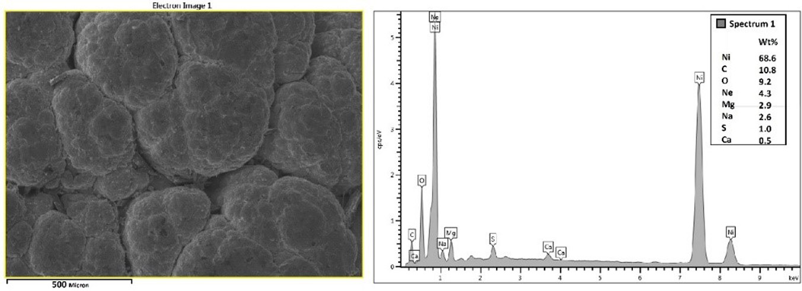
Figure 1- EDS analysis of wastes used in the research.

Reaction times have been selected 5, 10, 20, 30, 40, 50, and 60 minutes; while, sulfuric acid concentrations have been 20, 40, 60, 80, and 98%. One of the methods to increase dissolution speed of nickel wastes in sulfuric acid is adding H₂O₂ which effect of it has been studied through adding 50, 100, 150, 200, and 250cc of the material. To stir and heat the solution in different stages of producing nickel powder, IKA/RCT basic hot plate stirrer (made in Germany) has been used. Producing nickel carbonate from nickel sulfate would be performed by sodium carbonate. Industrial type of sodium carbonate has been used in present research. After production of nickel carbonate, there is a possibility of sodium to be available in produced material which can be removed by several times of washing; because, sodium would be dissolved in water. To do so, distilled water has been used. to produce nickel oxide and finally pure nickel, two different furnaces with controlling atmosphere have been required. In the research and to produce nickel oxide from nickel carbonate; ordinary furnace with no controlling atmosphere has been used for one hour at 700^{ᵒC}. Finally, a hydrogen Fulled tube furnace was used to convert nickel oxide into high purity nickel powder. The reduction process took place in two different cycles. The first cycle was performed at 700°C for 2 hours and the second cycle at 600°C for 4 hours. In general, production stages of nickel powder from nickel wastes include the four following stages:
- Producing nickel sulfate from nickel wastes; (H₂SO₄ + Ni = NiSO₄ + H₂)
- Producing nickel carbonate from nickel sulfate; (H₂SO₄ + Na₂CO₃ = NiCO₃ + Na₂SO₄)
- Producing nickel oxide from nickel carbonate; (NiCO₃ = NiO + CO₂)
- Producing high purity nickel powders from nickel oxide; (NiO + H₂ = Ni + H₂O)
General production procedure of nickel powder is shown in figure (2).
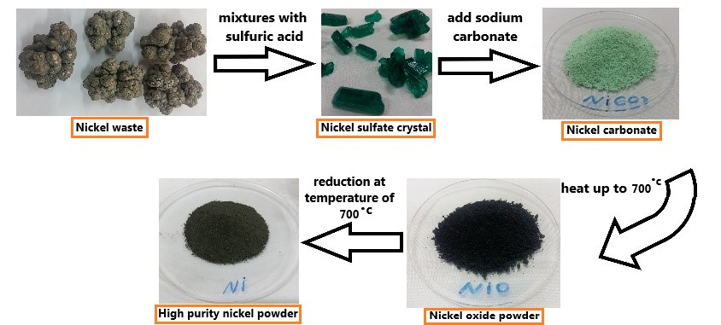
Figure 2- Flowchart of the research to produce high purity nickel powder.

To determine EDS point analysis and to image produced powders, Vega/TScan SEM (made in China) has been used. Minimum diameter of the device where the sample is contacted is 2 nanometers.

Results and Discussion
After all four stages of producing nickel powder through acidic leaching, amounts of the product obtained in tests with final product have been computed and compared in reactions. In table 1, the obtained have been compared with reaction stoichiometry reactions. At first stage, final product is nickel sulfate.
Table 1- Comparing reaction products obtained in the research through stoichiometry.
Stage number | Final product | Final weight of the product in the laboratory | Final product weight according to stoichiometry | Difference (%)
1 | NiSO₄ | 52.73 | 157.78 | 66.5
2 | NiCO₃ | 33.6 | 76.7 | 56.2
3 | NiO | 61.36 | 62.92 | 2.46
4 | Ni | 77.17 | 78.57 | 1.27

According to stoichiometry of the reaction, about 59.84gr nickel would be dissolved in 100gr sulfuric acid. The test and solving nickel waste in sulfuric acid has been performed for several times; and, nickel amount dissolved has been about 15-20gr. End of the test has been considered to be at the point that no additional nickel would be dissolved in the solution and it would be considered as saturated. Final product of the second stage is nickel carbonate. According to the reaction stoichiometry, 68.48gr sodium carbonate has to be consumed in each 100gr of nickel sulfate so that the reaction would be complete; and, finally, there would be 76.7gr nickel carbonate. This amount of sodium carbonate used for produced nickel sulfate in the research is very high; because, less nickel has been dissolved in sulfuric acid, compared to stoichiometry. Therefore, different amounts of sodium carbonate have been tested. Finally, it became clear that 30gr sodium carbonate is appropriate for each 100gr of nickel sulfate solution and the reaction would be complete. Third and fourth stages are well matched with stoichiometry. High difference in stages one and two can be due to type of nickel wastes used as well as purity of acid. Numbers obtained in stoichiometries reactions’ will consider all conditions as ideal which their performance would be very hard and sometimes impossible in practical and lab conditions.
As referred to in the Research Materials and Method, one of the most important parameters in increasing dissolution of nickel wastes is sulfuric acid concentration, time and amount of hydrogen peroxide. The results obtained from effect of these three parameters in dissolution of nickel wastes in sulfuric acid would be presented in this paper. Figure (3) shows effect of sulfuric acid concentration on amount of nickel wastes’ dissolution. The test for all concentrations has been performed during one hour. As shown in the above figure, through increase of sulfuric acid concentration, dissolution amount of nickel wastes would be increased. at 20 and 40% concentrations, dissolution amount is very low and there is no main difference between the two concentrations; however, at 60 to 98% concentrations, a steep slope would be created in dissolution of nickel wastes. This shows that sulfuric acid with concentrations more than 60% can end to acceptable results.
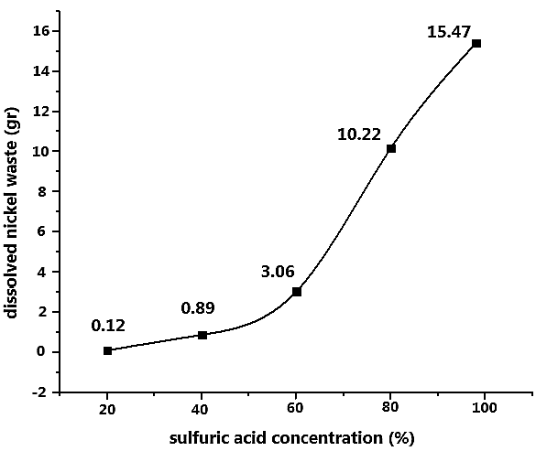
Figure 3- Effect of sulfuric acid concentration in dissolution of nickel wastes.

In continuation of studying parameters, effect of reaction time duration has been dealt with. The test has been performed in sulfuric acid (98%), showing highest efficiency in terms of dissolution in previous section. The results are provided in figure (4). Figure (4) showed that, through increase of dissolution process time, more nickel wastes have been dissolved in sulfuric acid. This dissolution would be continued till saturation of the solution.
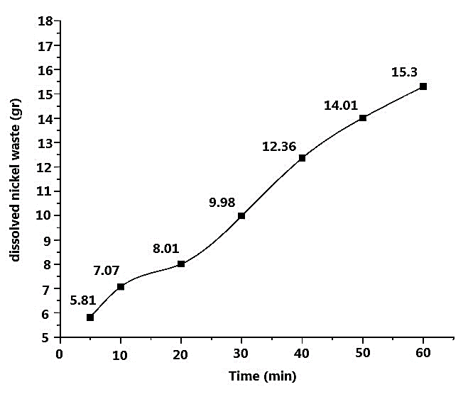
Figure 4- Effect of reaction time duration on dissolution of nickel wastes.

Another important parameter studied was the effect of amount of hydrogen peroxide on amount of dissolution (Fig.5). The test has been performed during one hour dissolution time in sulfuric acid (98%).
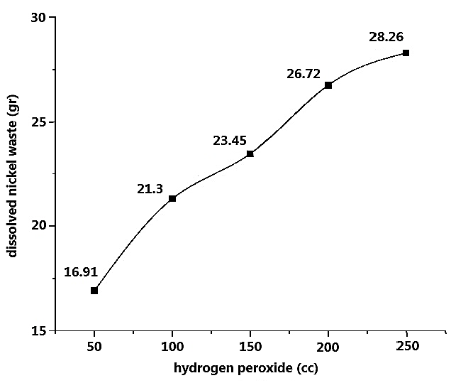
Figure 5- Effect of amount of hydrogen peroxide on dissolution of nickel wastes.
it became clear that adding hydrogen peroxide has positive effect in increasing dissolution of nickel wastes in sulfuric acid. The reason for increased dissolution is increased oxidation and activation of surface of nickel wastes. As shown by the results, in previous test and during one hour 15.3gr nickel wastes have been dissolved in sulfuric acid (98%). This amount has been increased to 16.91gr after adding 50cc hydrogen peroxide to the solution. through increasing of hydrogen peroxide to the solution, dissolution amount of nickel wastes also has been increased. To study purity of nickel powder produced in the research, EDS element analysis has been performed on powders (Fig.6).
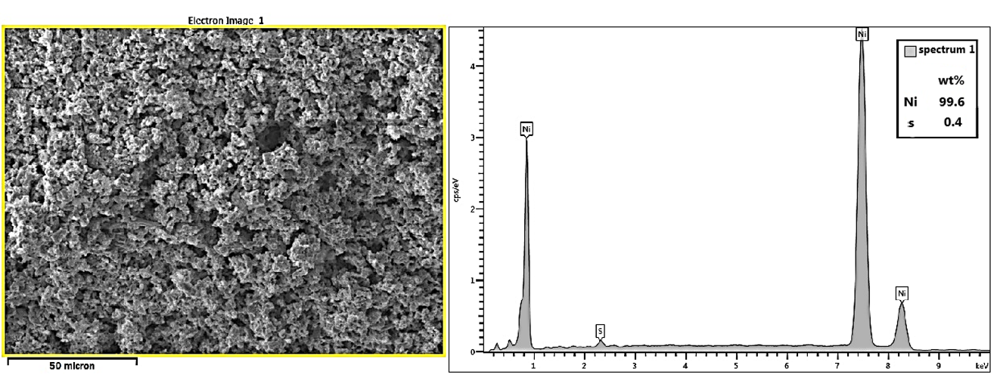
Figure 6- EDS element analysis performed on produced nickel powder.
nickel powder produced is of 99.6% purity which is high; however, existence of 0.4% of sulfur in analyses of powders can be due to following reasons: firstly, in initial analysis of nickel wastes there is about 1% sulfur which has been remained till the final stage of powder production. Secondly, the reason justifying this amount of sulfur goes back to the first stage of nickel powder production and preparation of nickel sulfate through sulfuric acid. To study shape of nickel powder particles produced, images from SEM are shown in figure 7.
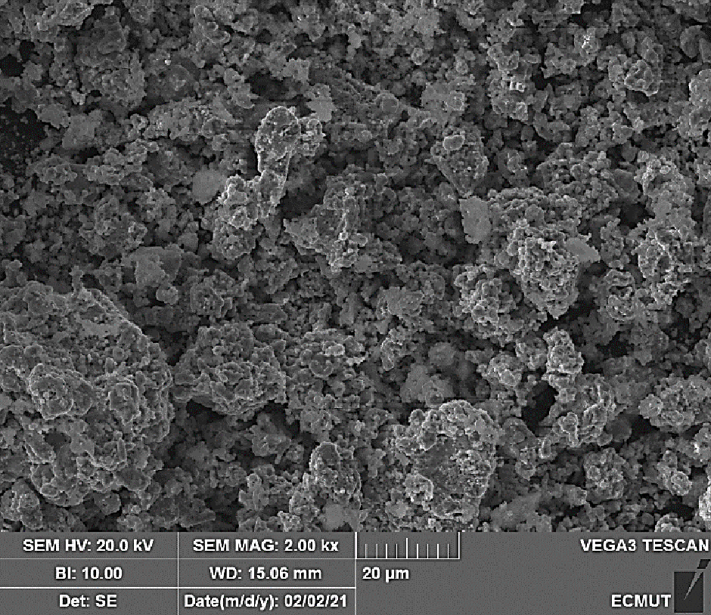
Figure 7- SEM images from nickel powder produced.
it can be suggested that powder particles produced had porous and irregular shape. To determine size distribution of produced powder particles, sifting is one of the common methods. To do so, 80gr of nickel powder has been separated and passed through screen to determine size of particles. Size distribution of powder particles is shown in figure 8.
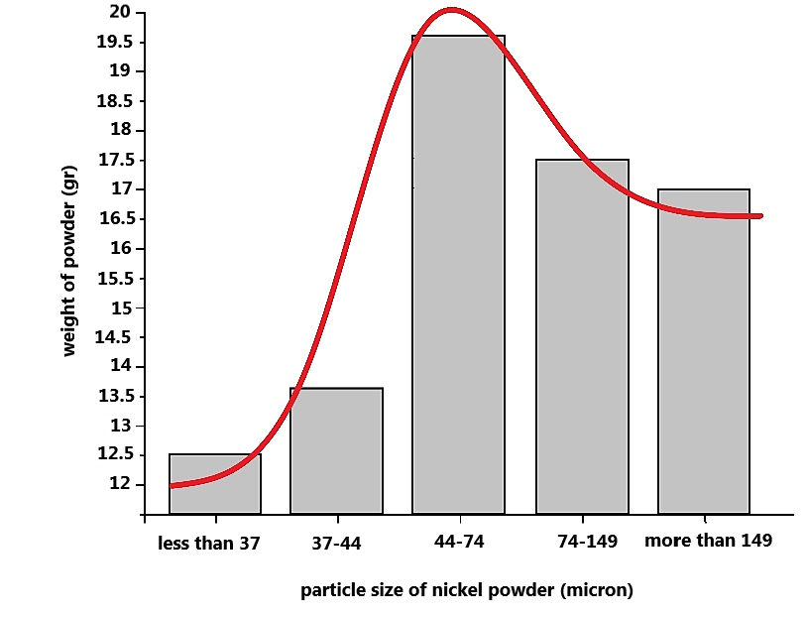
Figure 8- Size distribution of nickel powder produced in the research.
Highest distribution is related to the range of 44-74 microns. Size of powder particles during third and fourth stages related to production of nickel oxide and pure nickel can be controlled. if at reduction stage of powders, temperature would be reduced and time would be increased; lower size of particles would be resulted. Therefore, the reduction temperature was 600 °C and the time was 4 hours. Elemental analysis (EDS) of nickel powder produced was performed after the completion of this cycle (Fig.9). As shown in the figure (9), the nickel analysis shows a value of 100%.
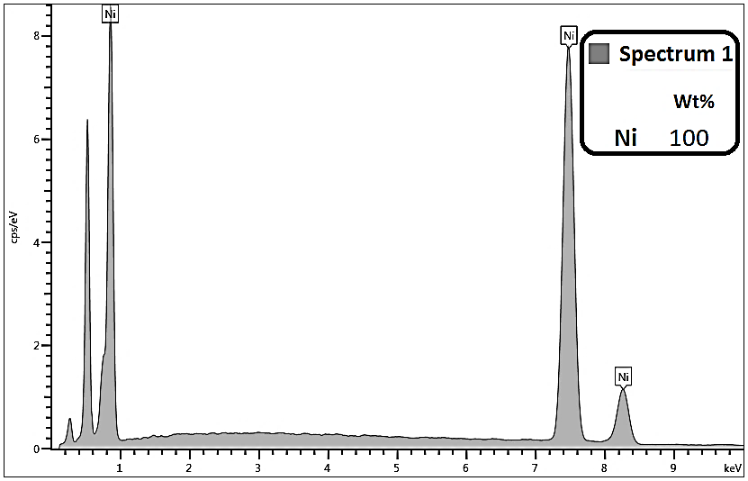
Figure 9- Elemental analysis (EDS) of nickel powder after a cycle of 600 ° C and a time of 4 hours.
SEM images were also obtained from samples of powders produced in this cycle (Fig.10). Due to this shape and compared to the sample of powders produced from the previous cycle and Figure 7, the produced powders were much finer. The dispersion of the powder particle size produced in the second cycle was measured (Fig.11). According to this figure, 80.22% of the produced powders were less than 45 microns.

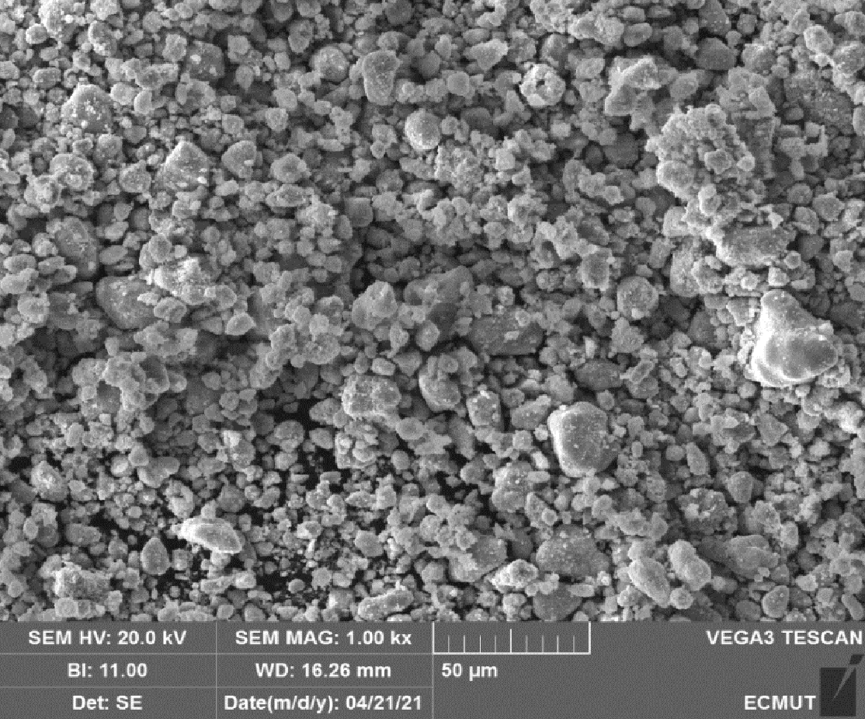
Figure 10- SEM image of nickel powder produced after the second reduction cycle.

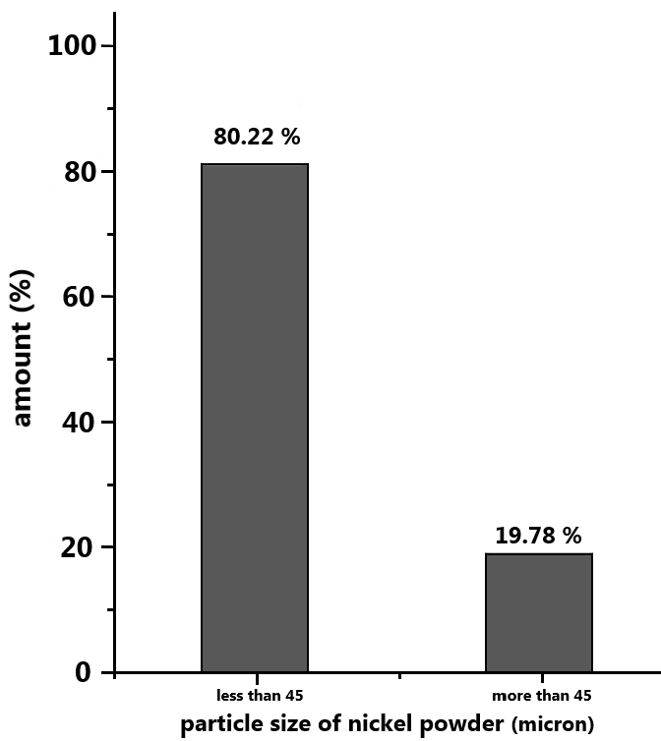
Figure 11- Nickel powder particle size dispersion after the second reduction cycle.

Conclusion
Acidic leaching to produce high purity nickel powder from nickel wastes through sulfuric acid has been performed in the research and the results are as follows:
- The two parameters of sulfuric acid concentration and duration of process have had direct effect on dissolution of nickel wastes in sulfuric acid. That is, upon increase of acid concentration from 20 to 98%, dissolution amount of nickel wastes has been increased from 0.12 to 15.47gr. Also, upon increasing of time from five to 60 minutes, dissolution amount of nickel wastes has been increased from 0.81 to 15.3gr.
- Hydrogen peroxide (H₂O₂) has been considered as one of the main and important factors in increasing dissolution of nickel wastes in sulfuric acid. That is during one hour fixed, 15.3-15.47gr of nickel wastes have been dissolved in the solution with no hydrogen peroxide; however, adding 50cc of hydrogen peroxide during the same time has led to increase of nickel wastes’ dissolution to about 16.91gr. This is about 10% higher than the time no hydrogen peroxide has been used. In industrial scale, it is considered as a considerable amount. In general and upon increase of hydrogen peroxide, dissolution amount of nickel wastes also has been increased due to surface of nickel wastes becoming activated.
- Nickel powder produced through acidic leaching has been highly pure. Elemental analysis (EDS) of this powder in the first reduction cycle (temperature 700°C and time 2 hours), showed 99.6%, which is considered as an acceptable purity. Also, particles of nickel powder have been porous and irregular. Size range of nickel powder has been computed and maximum value has been related to size of particles within the range of 44-74 microns.
- After the second reduction cycle (temperature of 600°C and time of 4 hours), elemental analysis of the produced nickel powder showed 100%. Also, after this cycle, the particle size of nickel powder became smaller than the first cycle. Most of the particle size dispersions were obtained in the range below 45 microns.
Reference
- Rhamdhani, M. A., Jak, E., & Hayes, P. C. ''Basic nickel carbonate: Part I. Microstructure and phase changes during oxidation and reduction processes''. Metallurgical and Materials Transactions B, Vol. 39, No. 2, (2008), 218-233, DOI: 10.1007/s11663-007-9124-4.
- Rhamdhani, M. A., Jak, E., & Hayes, P. C. ''Basic nickel carbonate: Part II. Microstructure evolution during industrial nickel production from basic nickel carbonate''. Metallurgical and Materials Transactions B, Vol. 39, No. 2, (2008), 234-245,‏ DOI: 10.1007/s11663-008-9139-5.
- Mackenzie, M., Virnig, M., & Feather, A. ''The recovery of nickel from high-pressure acid leach solutions using mixed hydroxide product–LIX® 84-INS technology''. Minerals Engineering, Vol. 19, No. 1, (2006), 1220-1233, DOI:10.1016/j.mineng.2006.01.003.
- Shaheen, W. M. ''Thermal behaviour of pure and binary basic nickel carbonate and ammonium molybdate systems''. Materials Letters, Vol. 52, No. 4-5, (2002), 272-282, DOI:10.1016/S0167-577X(01)00406-2.
- Al-Mansi, N. M., and NM Abdel Monem. "Recovery of nickel oxide from spent catalyst." Waste management, Vol. 22, No. 1, (2002), 85-90, DOI:10.1016/S0956-053X(01)00024-1.
- Oza, R., Nikhil S., and Sanjay P. "Recovery of nickel from spent catalysts using ultrasonication‐assisted leaching." Journal of Chemical Technology & Biotechnology, Vol. 86, No. 10, (2011), 1276-1281, DOI: 10.1002/jctb.2649.
- Randhawa, N. S., Kalpataru, G., and Manoj, K. "Leaching kinetics of spent nickel–cadmium battery in sulphuric acid." Hydrometallurgy, Vol. 165, No. 1, (2016), 191-198,‏ DOI: 10.1016/j.hydromet.2015.09.011.
- Idris, J., et al. "Recovery of nickel from spent catalyst from palm oil hydrogenation process using acidic solutions." Journal of Industrial and Engineering Chemistry, Vol. 16, No. 2, (2010), 251-255, DOI:10.1016/j.jiec.2010.01.044. ‏
- Abrar, B., Mohammad H., and Ali P. "Recovery of nickel from reformer catalysts of direct reduction, using the pressurized dissolving method in nitric acid." Engineering, Technology & Applied Science Research, Vol. 6, No. 5, (2016), 1158-1161, ‏ DOI:10.48084/etasr.731.
- Gharabaghi, M., Mehdi I., and Amir R. A. "Leaching kinetics of nickel extraction from hazardous waste by sulphuric acid and optimization dissolution conditions." Chemical Engineering Research and Design, Vol. 91, No. 2, (2013), 325-331, DOI: 10.1016/j.cherd.2012.11.016.

- mohammadoshrieh73@gmail.com
- khnekuee@gmail.com

