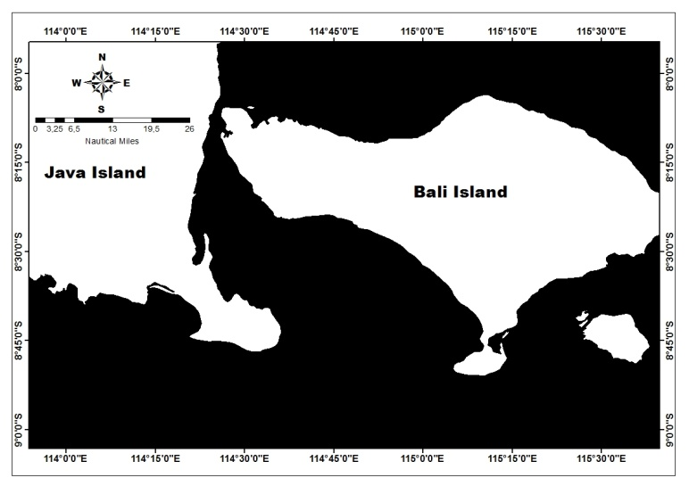

Figure 1. Study area, Bali Strait, located between Bali Island and Java Island.

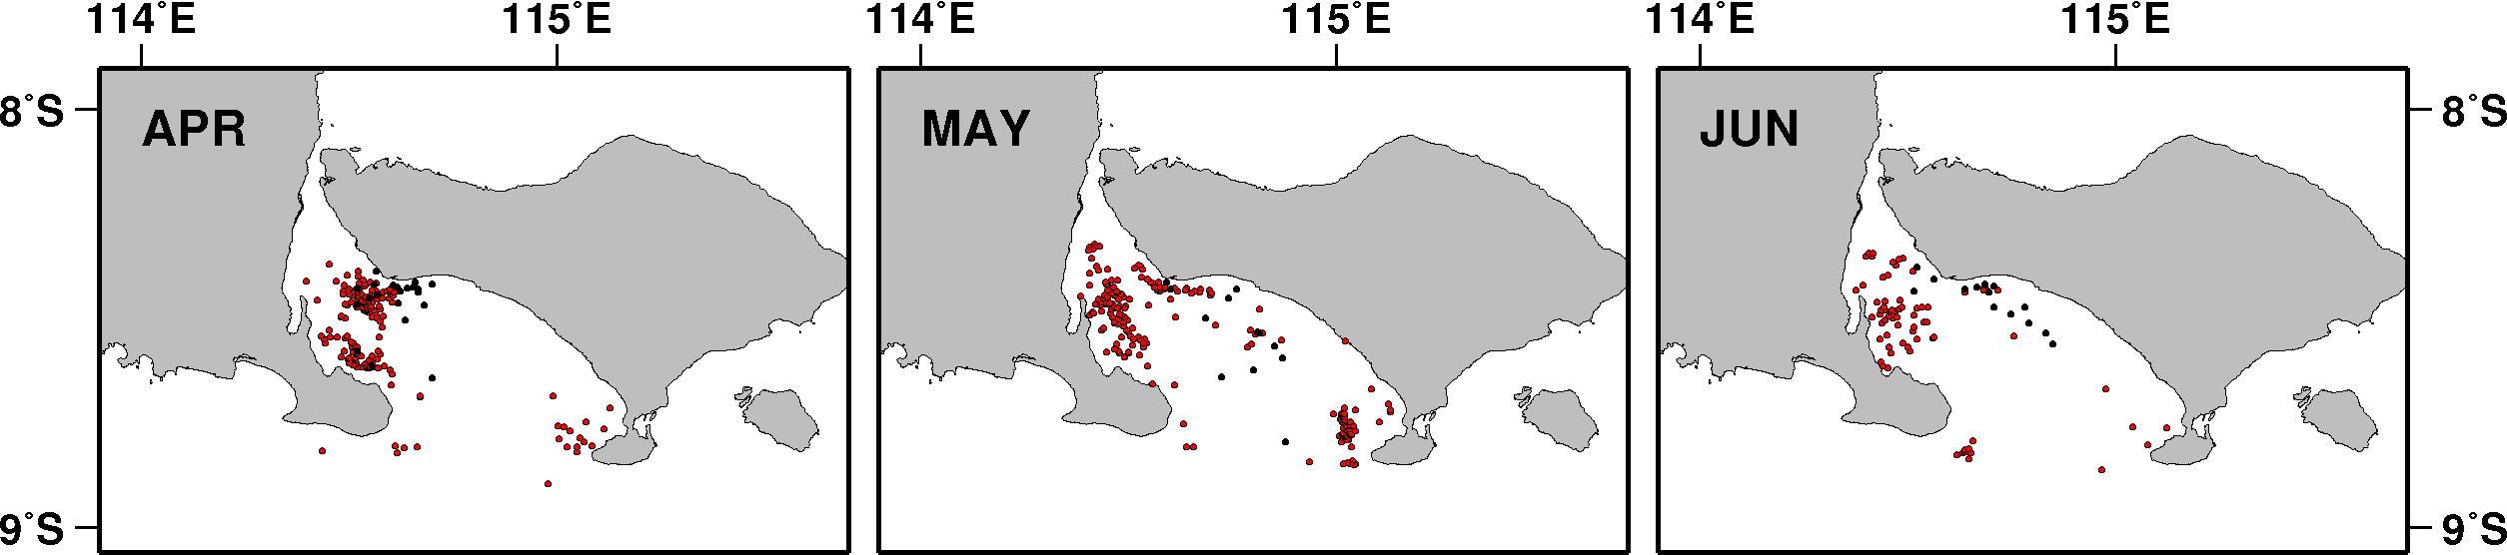
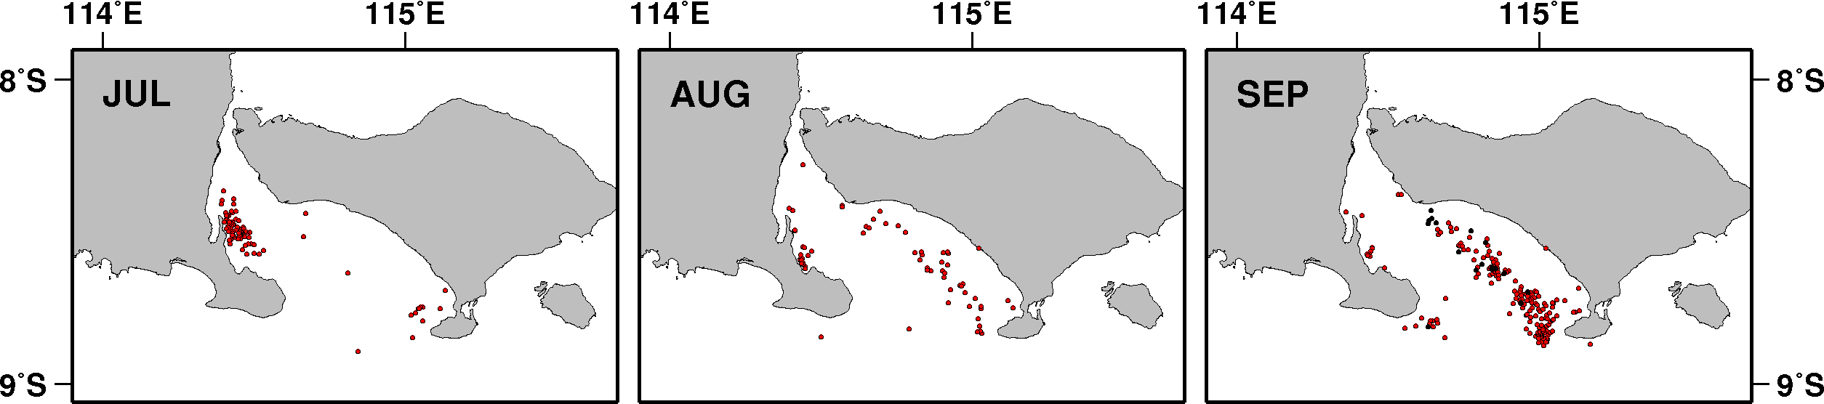

Figure 2. Spatial distribution of fishing location for Sardinella lemuru from VBD (red dot) and in situ (black dot) data during southeast monsoon (April – September) in the Bali Strait.

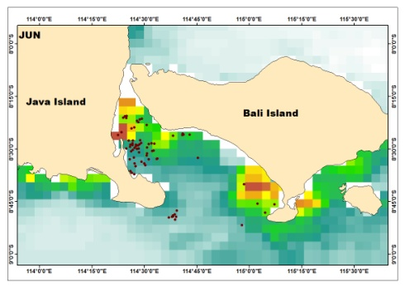
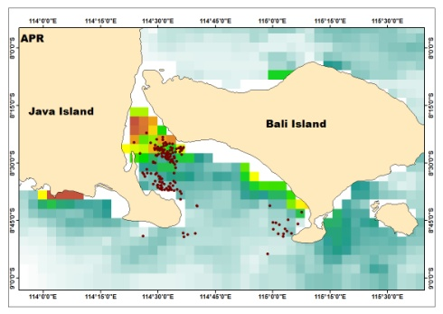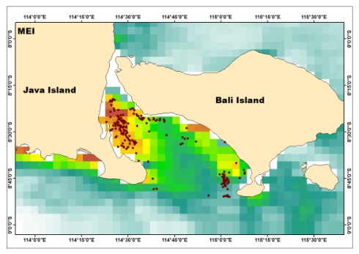
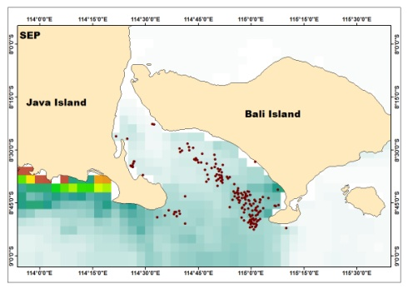
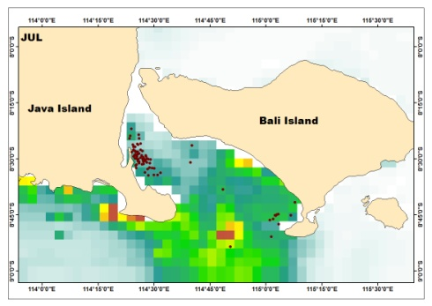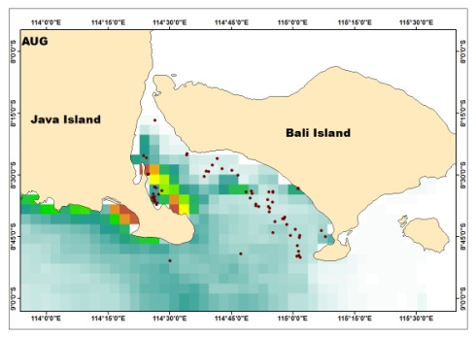

Figure 3. Distribution of fishing location for Sardinella lemuru from VBD (red dot) overlaid on the monthly mean value of sea-surface chlorophyll-a during southeast monsoon (April –September) 2013.

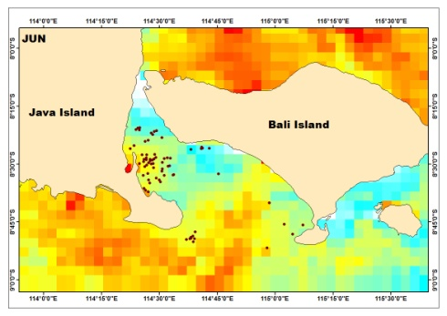
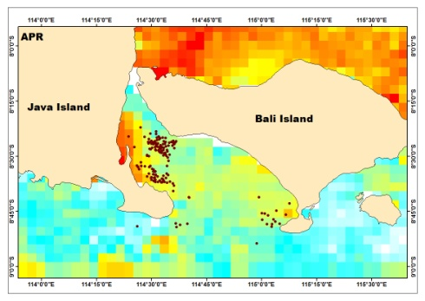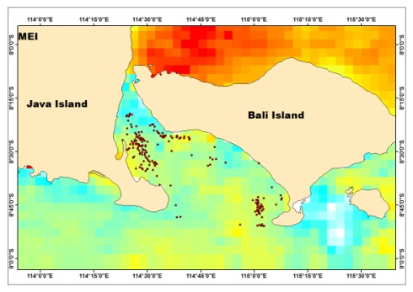
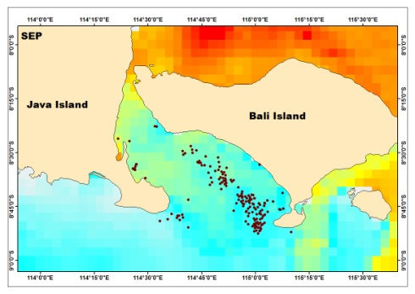
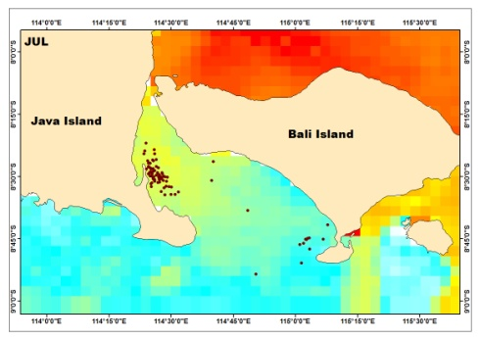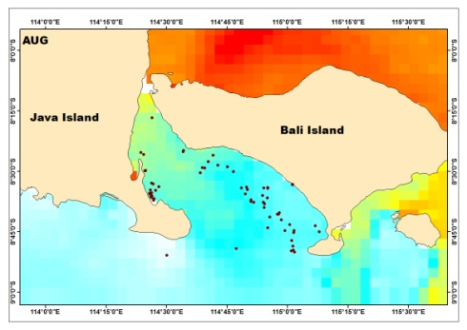

Figure 4. Distribution of fishing location for Sardinella lemuru from VBD (red dot) overlay on the monthly mean value of sea-surface temperature during southeast monsoon (April –September) 2013.

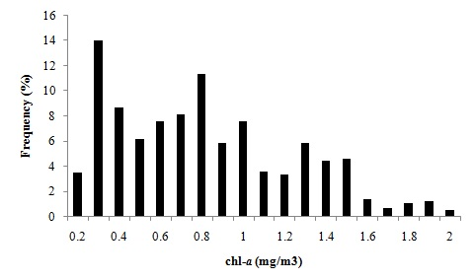
Graph 1. Frequency of sea surface chlorophyll-a (chl-a) during southeast monsoon (April – September) 2013.

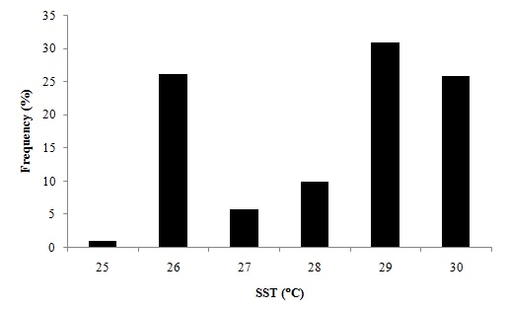
Graph 2. Frequency of sea surface temperature (SST) during southeast monsoon (April – September) 2013.

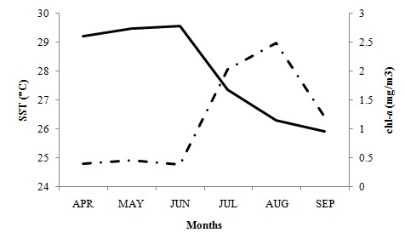
Graph 3. Sea surface temperature (solid line) and chl-a (the line with dashes and 1 dot) variation in Bali Strait during southeast monsoon (April – September) 2013.

Table 1. Number of fishing boats from Visible Infrared Imaging Radiometer Suite boat detection during southeast monsoon 2013 and in situ data.
 | APR | MAY | JUN | JUL | AUG | SEP
VIIRS | 158 | 189 | 74 | 87 | 68 | 168
In situ | 22 | 12 | 14 | - | - | 18

