**FIGURES:**



**Fig 1.** Urethral malignant melanoma presenting as a mass protruding from external urethral meatus on genital examination.

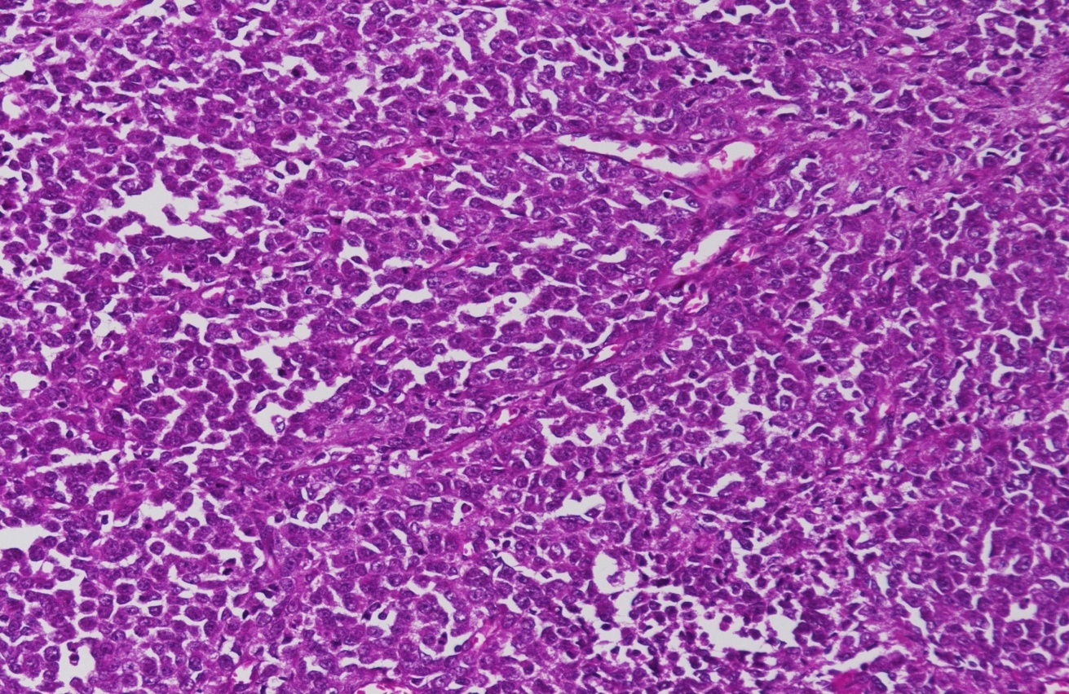

**Fig 2:** Microscopic findings of specimen. Large epitheloid cells with high N/C ratio.Deposition of melanin pigment could not be seen clearly.

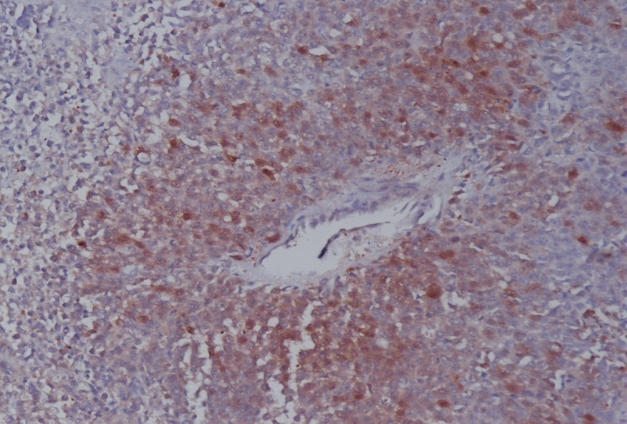

**Fig 3:** The immunohistochemical staining findings of the surgical specimen. The tumor cells were immunoreactive for S-100 protein

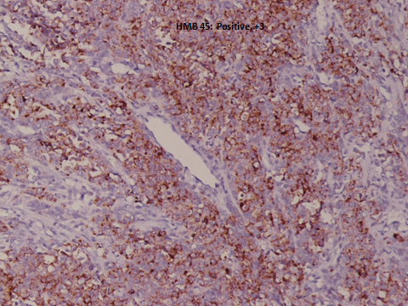

**Fig 4:** The immunohistochemical staining findings of the surgical specimen. The tumor cells were immunoreactive for HMB - 45