December 20, 2018

Journal of Psychological Research
Editorial Board

Dear Editorial Board,

We are submitting a Research Article entitled “Beyond Bloom’s: Students’ Perception of Bloom’s Taxonomy and its Convolution with Cognitive Load.” This work presents the results of research into student perceptions of assessments. It shows that student perceptions of difficulty and of the skills required to complete an assessment task do not always match expert impressions. In addition, it reveals some interesting insight into the factors, unrelated to cognitive skills, that students perceive as barriers to performance, many of which relate to issues of cognitive load. We believe that this article presents fascinating results that would be of general interest to the readership of the Journal of Psychological Research.

This manuscript is not under consideration in any other journal and we declare no conflicts of interest. It contains 3 tables and 3 figures.

We are grateful for your consideration of this work for inclusion in the Journal of Psychological Research. We look forward to corresponding with you and reviewers. As corresponding author, my information is listed below.

Sincerely,

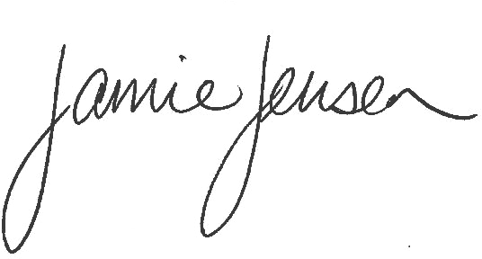
Jamie L. Jensen
Associate Professor
Department of Biology, 4102 LSB
Brigham Young University
Provo, UT 84602

Additional authors include,

Andrea J. Phillips
Department of Biology
Brigham Young University

And

Jace C. Briggs
Department of Biology
Brigham Young University

