Article
Psychological complaints at psychological emergency service associated with referral to extended screening in a psychology school clinic
Caique Rossi Baldassarini¹*, Naiara Alves Pereira¹, Larissa Nicolau Pitta¹, Marcelo Monteiro de Souza¹, Caroline de Oliveira Zago Rosa¹, Fernanda Pessolo Rocha¹
¹ Department of Psychology, Barão de Mauá University Center.
Address: Ramos de Azevedo Street, 423. Ribeirão Preto/SP. Brazil. Zip Code: 14090-062.
*Corresponding Author: Caique Rossi Baldassarini. Department of Psychology, Barão de Mauá University Center. Address: Ramos de Azevedo Street, 423. Ribeirão Preto/SP. Brazil. Zip Code: 14090-062. Email: caiquerossi95@hotmail.com

Abstract: The Psychological Emergency Service (PES) at psychology school clinics is an unscheduled and free psychological service to meet urgent demands. From this service, some patients whose complaints require more time for clinical work are referred to the Extended Screening (ES), a modality composed of six extra appointments. This study aims to analyze the sociodemographic profile of patients seen on PES in a Brazilian Psychology School Clinic, and to identify the demands that motivated referral to the ES, for better qualification of the care offered. This is a descriptive analysis research, carried out based on data from the medical records of 46 patients who went through the PES and were referred to the ES at the institution, between the years 2019 and 2021. Sociodemographic data were collected and, from the session reports, a content analysis of the thematic analysis modality was performed to identify the complaints. A predominance of female patients (71.74%) was observed, with a mean age of 32.28 years, that completed high school education (39.14%), and had an income of one to two Brazilian minimum wages (32.61%). The most frequent complaints were depressive symptoms (56.52%) and difficulties in interpersonal relationships (32.61%). The results obtained, besides allowing the survey of the social and demographic profile of the clientele of the PES at the Psychology School Clinic, and demonstrating its social relevance by providing free psychological care, also show to be of great importance for the definition of more accurate criteria for referral to the ES of patients seen on PES at the service.
Keywords: psychological emergency service; extended screening; psychology school clinic.

1. Introduction
The clinical-school service in Psychology universities has been linked to this undergraduate course since Law 4,119, in 1962, through the regulation of the Psychologist's profession in the Brazilian Classification of Occupations (BCO). The services are essential for the formation of a Psychologist, as they enable the experience of clinical practice, bringing not only theoretical learning, but also providing the conduction of therapeutic processes, in addition to bringing students closer to the population ^{[1]}. Among the services offered, there is the Psychological Emergency Service (PES) modality, which aims to support and welcome the urgent emotional demand of the person who needs some type of immediate care to alleviate their psychological distress, in addition to seeking, through the provision of a service that does not have bureaucratic requirements, to contribute to the reduction of the demand of the urgent psychological care, thus favoring the large portion of the community that does not have the resources to seek private psychological care ^{[2]}.
The Psychological Service, in Brazil, began in the 1970s by Professor Rachel Rosenberg, phD, who, with the help of interns from the Psychology Faculty of the Psychological Counseling Service (PCS) at the University of São Paulo (USP), was inspired by the walk-in clinics, in the United States, which offered immediate and community care. In these years of gestation of the new modality, Brazil lived a time of military repression, where group discussions, questioning and the expression of ideas were repressed by censorship. Furthermore, in Psychology, it was believed that only long-term psychotherapeutic treatment was effective ^{[3]}.
After an unpretentious beginning with psychological assistance to students of a popular pre-university preparatory course at the University of São Paulo, in which students at the time were plagued by uncertainty about the future and the anguish of the present, the revolutionary potential of the implementation of the PES was noticed, with the use of the renewing capacity of attentive, non-directive, customer-centered listening, confident in the person's up-to-date tendency, in which they develop their potential, even if it was through a single meeting with the professional, under the condition that this professional offers their full presence, through their capacity for empathy and total acceptance of the other ^{[4]}.
The consolidation of PES proposal takes place in the 1980s with the formation of the Sedes Sapientiae Institute in São Paulo, where knowledge was systematized and the PES was structured based on the experiences of care, which claimed that professionals develop unique attributes through the clinical practice of psychotherapy. Thus, the delimitation of its field of action is processed, since this modality does not constitute a psychiatric emergency service; does not assist people only in imminent suicide such as the Brazilian Life Valorization Center (known as “CVV”); it is not intended to screen for other referral services; likewise, it is not intended to be a substitute for other psychotherapy services. Substantially, the PES aims to provide immediate listening to the person who is in need or in an emotional crisis ^{[5]}.
The term “emergency service” refers to the idea of ​​some type of service performed by professionals who are available to anyone who needs it and which works at predetermined and uninterrupted time intervals. From the institution's perspective, the PES requires diligence and method of the service offered. The on-call operator is required to be willing to be ahead with the unexpected, with the unplanned and with the expectation that the meeting with the person who is looking for him or her is unique. In addition, from the point of view of the person looking for it, the PES means a reference for some urgent moment ^{[4]}.
Another urgent modality that was found necessary from the experience of the PES was the Extended Screening (ES), because from the complaint identified during the PES, emergency demands, which required more time than a single session often arose, for the patients better understand the moment of life they were going through, as well as glimpse new paths and alternatives for their problems. ES was also designed to serve those people who have nowhere to be referred, either due to exhaustion of the public mental health service or because they do not have financial resources for a private psychotherapeutic treatment, without, however, falling into the trap of transforming this modality of service in a relationship of philanthropic or authoritarian nature, considering the apparent fragility of the patient ^{[4]}.
The ES offered at the Psychology School Clinic of the Barão de Mauá University Center (CBM – Ribeirão Preto) comprises six extra appointments to the PES appointment and is available for those patients in which the interns and supervisor understand that more time is needed for the patient to develop autonomy and self-reflection and, in this way, seek different and possible paths to overcome the adversities that they experience.
The Barão de Mauá University Center (CBM – Ribeirão Preto), through its Psychology School Clinic, offers free psychological care services provided by students from the Faculty of Psychology, who are supervised by professors, a coordinator and trained psychologists ^{[6]}. The city of Ribeirão Preto, where the clinic is located, currently has six Psychosocial Care Centers and a specialized mental health clinic, which serve approximately fourteen thousand patients per year through the Brazilian public health system ^{[7]}. This data shows that, despite having a large number of consultations, this amount is still insufficient for a city with an estimated population of seven hundred and twenty thousand inhabitants, thus emphasizing the social importance of the service provided by psychology school clinics ^{[8]}.
This article aims at the sociodemographic characterization of patients treated on PES and the identification of the psychological demands that motivated the referral to ES at the Psychology School Clinic of the Barão de Mauá University Center since its implementation.

2. Materials and Methods

2.1 Desing and local of study
This is a descriptive analysis research, carried out at the Psychology School Clinic of a private higher education institution in the city of Ribeirão Preto, in the interior of the state of São Paulo, Brazil. The institution, inaugurated in 2013, offers free Psychological Emergency Service, Extended Screening, Psychotherapy, Psychodiagnostic, Neuropsychological Assessment and Professional Guidance. The assistance takes place both by spontaneous patient search and by referrals from other health and education professionals.

2.2 Population, eligibility criteria and sample
The study population consisted of patients seen in PES at the Psychology School Clinic between 2019 and 2021 who were referred to ES. As eligibility criteria, only patients over 18 years old were included. In the performance of care at the institution, a therapeutic contract and Informed Consent Form (ICF) is presented, where patients can indicate agreement in the use of their data, both sociodemographic and from clinical care, for the production of academic studies. All participants in the present study, whose sample consisted of 46 patients, indicated agreement with the ICF.

2.3 Data collection
Data collection was performed by consulting the medical records of the participants. The records, in addition to the patient's sociodemographic data, which were collected for this research, also contain the evolution of each service performed at the Psychology School Clinic. The reports of the PES sessions were consulted, carried out by psychologists of the service and interns of the fourth and fifth year of the undergraduate course in Psychology at Barão de Mauá University Center ^{[9]}.

2.4 Data analysis
From the PES session reports, a content analysis of the thematic analysis modality was carried out, consistent with the instructions by Minayo ^{[10]}, to categorize the complaints presented by the participants during the PES. Qualitative coding was operated by two researchers individually, considering the manifest content of the records. The codes were then grouped into categories. Researchers compared their interpretations to ensure reliability and accuracy. For all cases, the agreement between the two analyst researchers was > 90%. A third researcher on the team, with extensive experience in clinical psychology and mental health, performed a third reading of the data to confirm the final proposed categorization.
The data were tabulated in a spreadsheet of the Microsoft Excel for Windows software, having been double-entered by the researchers involved, in order to obtain reliable and error-free data. Then, the characterization of the sociodemographic profile of the participants was carried out, using descriptive statistics, with measures of central tendency (mean and median) and measures of variability or dispersion (minimum and maximum, standard deviation) for the variable "age”; simple and relative frequency for the variables “gender”, “education” and “income” and relative frequency of the “complaints presented”.

2.5 Ethical aspects
This study was carried out in accordance with the guidelines and regulatory standards for research involving human beings that comply with Resolution No. 466/2012 of the Brazilian National Health Council ^{[11]}. The project was approved by the Research Ethics Committee of the Barão de Mauá University Center under Opinion nº 3.251,726 of April 09, 2019.

3. Results
As for the sociodemographic characteristics of the 46 study participants, age ranged from 18 to 65 years, with a mean of 32.28 years (sd = 10.95) and a median of 30.50. As shown in Table 1, there was a predominance of female participants (71.74%), that completed High School (39.14%) and income from one to two Brazilian minimum wages (32.61%) (in 2021, the Brazilian minimum wage was approximately 192 dollars).

Table 1 – Sociodemographic characteristics of the participants – Ribeirão Preto, Brazil, 2021 (n = 46).
Sociodemographic Variable | Classification | N | %
Sex
 | Feminine | 33 | 71.74
 | Masculine | 13 | 28.26
Education
 | Incomplete Elementary School | 3 | 6.52
 | Complete Elementary School | 1 | 2.17
 | Incomplete High School | 1 | 2.17
 | Complete High School | 18 | 39.14
 | Incomplete Higer Education | 6 | 13.04
 | Complete Higher Education | 17 | 36.96
Income
 | Up to 1 minimum wage | 4 | 8.70
 | 1 to 2 minimum wages | 15 | 32.61
 | 2 to 3 minimum wages | 11 | 23.91
 | 3 to 5 minimum wages | 9 | 19.56
 | Uninformed | 7 | 15.22

Regarding the categorization of the complaints presented during the PES, which motivated the referral to the ES, considering all study participants (n=46), there was a predominance of depressive symptoms (56.52%), followed by difficulties in interpersonal relationships (32.61%) and difficulties in emotional regulation (28.26%) (Figure 1). It is noteworthy that, for each participant, one or more complaints were identified.

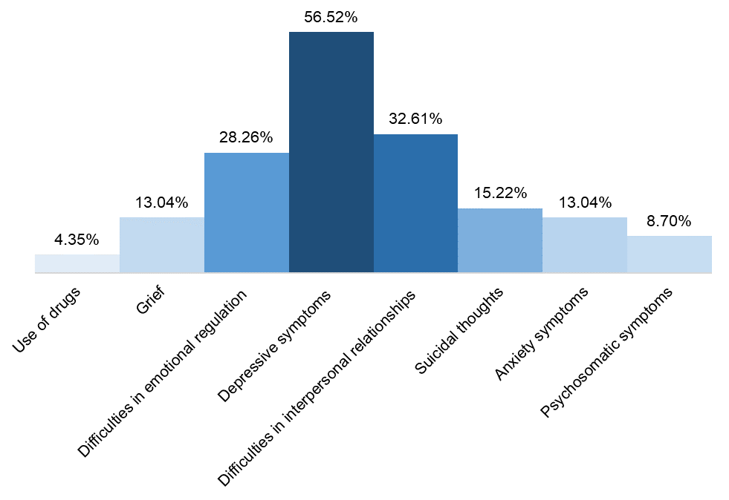
Figure 1 – Complaints presented at the Psychological Emergency Service by all participants referred to the Extended Screening – Ribeirão Preto, Brazil, 2021 (n = 46).

A survey of complaints was also carried out considering the male (n=13) and female (n=33) participants. There was a predominance of depressive symptoms (76.92%) and difficulties in emotional regulation (30.76%) among men (Figure 2) and a predominance of depressive symptoms (48.48%) and difficulties in interpersonal relationships (39.39%) among women. As in the total study sample, it is noteworthy that, for each participant, one or more complaints were identified.
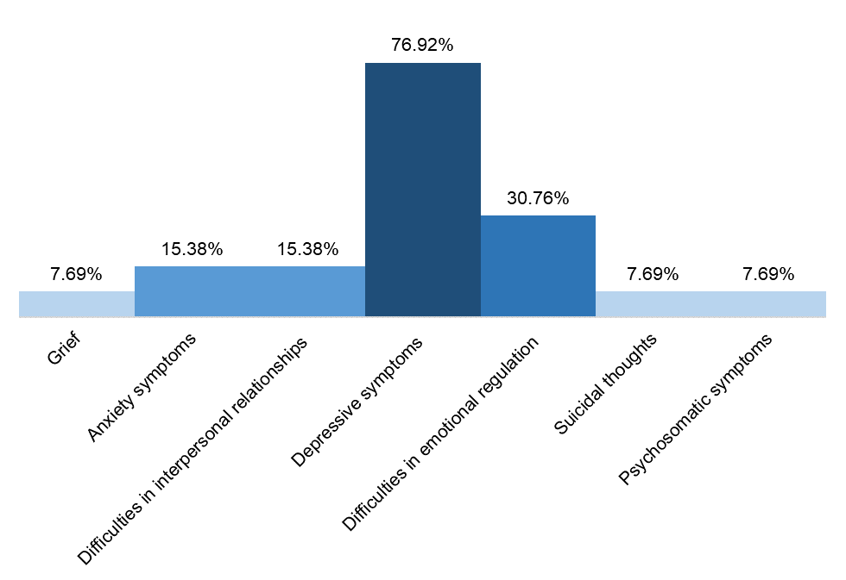
Figure 2 – Complaints presented at the Psychological Emergency Service by male participants referred to the Extended Screening – Ribeirão Preto, Brazil, 2021 (n = 13).

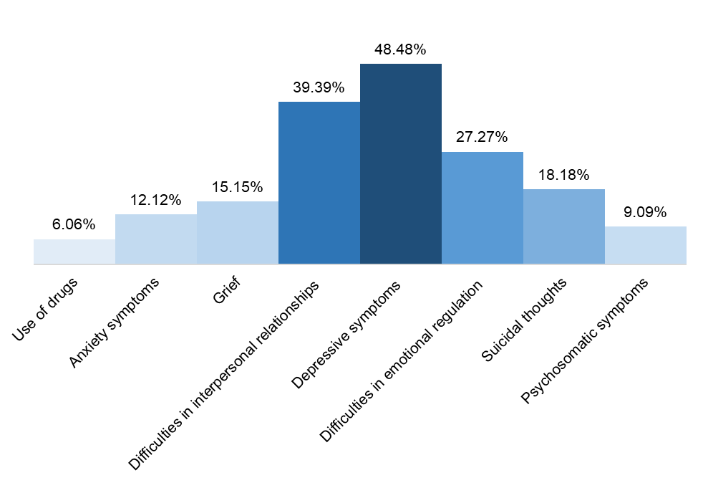
Figure 3 – Complaints presented at the Psychological Emergency Service by female participants referred to the Extended Screening – Ribeirão Preto, Brazil, 2021 (n = 33).

4. Discussion
In the survey of complaints presented by patients treated on PES and referred to ES, more than half (56.52%) of the cases were due to depressive symptoms, confirming Rocha ^{[12(p88)]}: “clinical experience shows that one of the most common problems that lead people to seek or be referred to psychotherapy has been depression”; and Motta ^{[13(p912)]}: "with prevalence rates that reach up to 20% of the world population, depression impacts the social environment in such a way that it is considered the second pathology to cause more damage in the economic and social sphere".
In second place, difficulties in interpersonal relationships appeared, with 32.61% of the complaints referred. It is possible to associate such complaints to the liquid relationships that permeate today's society. With social networks, people have the possibility of "connecting" rather than engaging with each other, making it easier to build and deconstruct relationships, in which there are intentions to be together, but at the same time not establish lasting relationships, causing instability in the relationships that permeate liquid modernity, where there are uncertainties and insecurities in the face of difficulties and risks of a new relationship. Faced with such instabilities, it is possible thatsuperficiality and speed of relationships appear as a form of defense ^{[14, 15]}.
It is important to note that part of the psychological appointments in the study sample took place during the period in which the pandemic caused by COVID-19 began, until its aggravation, a fact that had a profound psychological impact on the Brazilian population, as the fear of contracting the disease, along with the insecurity of the changes brought about by the sanitary measures, necessary for the contingency of the spread of the virus, such as social isolation and quarantine, led to an increase in depressive symptoms, anxiety and problems in interpersonal relationships ^{[16, 17, 18, 19]}.
In this way, the PES and ES accompanied this increase in psychological distress caused by fear and insecurity associated with the loss of work routine and a compulsory confinement, often in a hostile environment, from which there was no escape ^{[16]}. Added to this is the fear of unemployment, physical and psychological violence, loneliness, uncertainty about the future, hopelessness and the uncertainty of life itself ^{[16, 17, 18, 19]}. It can be inferred that these factors contributed to the increase in depressive symptoms and difficulties in interpersonal relationships among patients, and such complaints were recurrent in the assistance provided.
As to what was observed in the present study regarding the greater number of women assisted in PES, the literature indicates that men are often less inclined to seek help due to emotional difficulties, and the construction of the male ideal in contemporary Western society is associated with strength, autonomy and avoidance of possible demonstrations of fragility, impacting the search for mental health professionals among the male public ^{[20, 21]}. The observation regarding the income range of most study participants, from one to two Brazilian minimum wages, reinforces the social relevance of the clinical school of psychology in providing free psychological care to a population that cannot afford private services, and that does not find care in the overloaded Brazilian public health ^{[2, 7, 9]}.
Psychological care in the PES offer provides a format of care that can be performed in a single meeting and constitutes social support, so that the on-call worker is whole to meet the other in the urgency of their psychological distress, offering emotional support, as well as, if the need is identified, the opportunity to carry out up to six ES sessions, helping the individual to have a physical space to express their feelings with someone whom does not maintain an emotional bond ^{[22]}. The cientific literature on the importance of social support to promote the sense of security and well-being of individuals is highlighted, which may favor resilience in the face of adverse life events ^{[23, 24]}.
Although the purpose of the PES is not to carry out a psychological diagnosis and check, for example, the possible existence of comorbidities, this form of care provides patients with a brief understanding of their suffering. This unique meeting is capable of giving voice to the individual's complaints, doubts and expectations at a time of emotional fragility, and may be the gateway to other intervention proposals ^{[25]}. It should also be noted that when the patient is referred to ES, there is an opportunity for the mental health service to better identify existing complaints in a greater number of sessions, contributing to clarify the demand and the possibility of new referrals, internal or external, for a more holistic patient care ^{[26]}.
As limitations of the present study, it is highlighted that the results found refer to the specific clientele of only one psychology school clinic. Therefore, new studies are suggested for a better understanding of the main complaints in PES associated with the referral to ES, with larger samples and from different psychology school clinics, in order to better qualify the care offered in such services.

5. Conclusions

It is concluded that the present study made it possible to survey the sociodemographic characteristics of the clientele assisted in PES at the Psychology School Clinic of Barão de Mauá University Center, as well as the identification of the complaints that motivated the referral of patients to the ES modality.

Regarding the sociodemographic profile of the public served, the predominance of the female gender and the income range from one to two minimum wages is highlighted, pointing to the greater adherence of women to the search for psychological support and the social relevance of free services at psychology school clinics for the lower-income population, in view of the scarcity of mental health professionals in the Brazilian public health system (“Sistema Único de Saúde” - SUS).
This study also proved to be extremely important for the definition of more precise criteria for referral to the ES at the aforementioned Psychology School Clinic, based on the demands that emerge in the PES.

Author Contributions
Caique Rossi Baldassarini: Conceptualization, Methodology, Formal analysis, Investigation, Writing - Original Draft.
Naiara Alves Pereira: Methodology, Investigation, Writing - Original Draft.
Larissa Nicolau Pitta: Methodology, Investigation, Writing - Original Draft.
Marcelo Monteiro de Souza: Methodology, Investigation. Writing - Original Draft.
Caroline de Oliveira Zago Rosa: Writing - Review & Editing, Supervision.
Fernanda Pessolo Rocha: Writing - Review & Editing, Supervision.

Conflict of Interest
The authors declare that there is no conflict of interest regarding the publication of this paper.

Funding: This research did not receive any external funding.

References
[1] Sei MB, Colavin, JRP. Desistência e abandono da psicoterapia em um serviço-escola de Psicologia. Rev bras psicoter. 2016;18(2):37-49.
[2] Prodócimo NF, Hueb MFD. Acolhimento psicológico na clínica escola: um relato de experiência. Perspectivas em Psicologia. 2012;16(1):46-56.
[3] Tassinari M, Durange W. Plantão e a clínica da urgência psicológica. 1st ed. Curitiba: CRV; 2019. 179 p.
[4] Mahfoud M. Plantão Psicológico: novos horizontes. 2E ed. São Paulo: Companhia Ilimitada; 2012. 155 p.
[5] Souza S, Silva Filho FB, Montenegro LAA. Plantão psicológico: ressignificando o humano na experiência da escuta e acolhimento. 1st ed. Curitiba: CRV; 2015. 262 p.
[6] Bovi, N. Barão de Mauá realiza atendimento psicológico gratuito em Ribeirão Preto [Internet]. Ribeirão Preto: Centro Universitário Barão de Mauá; c2020 [cited 2021 Nov 16]. Available from: https://www.baraodemaua.br/noticias/barao-de-maua-realiza-atendimento-psicologico-gratuito-em-ribeirao-preto
[7] Prefeitura Municipal de Ribeirão Preto. Novo Centro de Saúde Mental vai suprir demanda antiga da cidade [Internet]. Ribeirão Preto: g1; c2021 [cited 2021 Nov 16]. Available from: https://g1.globo.com/sp/ribeirao-preto-franca/especial-publicitario/prefeitura-municipal-de-ribeirao-preto/noticia/2021/08/23/novo-centro-de-saude-mental-vai-suprir-demanda-antiga-da-cidade.ghtml
[8] Instituto Brasileiro de Geografia e Estatística. Cidades e Estados: Ribeirão Preto [Internet]. Brasília: IBGE, c2021 [cited 2021 Nov 16]. Available from: https://www.ibge.gov.br/cidades-e-estados/sp/ribeirao-preto.html
[9] Maciel BH, Souza VF, Rocha FP, Rosa COZ. Survey on the Evasion Factors of a Psychology School Clinic. Journal of Psychological Research [Internet]. 2021 [cited 2021 Nov 15];3(4). Available from: https://ojs.bilpublishing.com/index.php/jpr/article/view/3695 DOI: https://doi.org/10.30564/jpr.v3i4.3695
[10] Minayo MCS. O desafio do conhecimento: Pesquisa Qualitativa em Saúde. 14th ed. São Paulo: Hucitec; 2014. 416 p.
[11] Ministério da Saúde. Conselho Nacional de Saúde (Brasil). Resolução n. 466, de 12 de dezembro de 2012. Dispõe sobre diretrizes e normas regulamentadoras de pesquisas envolvendo seres humanos. Diário Oficial da União 13 jun 2013. Seção 1.
[12] Rocha GMA, Bunge M, Strauss V, Honda GG, Peixoto E, Santeiro TV, Enéas MLE. Psicoterapia breve psicodinâmica de caso grave de depressão em serviço-escola: limites e alcance. Contextos Clínic [Internet]. 2016 [cited 2021 Nov 20];9(1): 86-97. Available from: http://www.revistas.unisinos.br/index.php/contextosclinicos/article/view/ctc.2016.91.07 DOI: http://dx.doi.org/10.4013/ctc.2016.91.07
[13] Motta CCC, Moré CLOO, Nunes CHSS. O atendimento psicológico ao paciente com diagnóstico de depressão na Atenção Básica. Ciência & Saúde Coletiva [Internet]. 2017 [cited 2021 Nov 24];3(22):911-920. Available from: https://www.scielo.br/j/csc/a/jNY3hpQHjXWCWV3Y8Hg4Vpq/?lang=pt DOI: https://doi.org/10.1590/1413-81232017223.27982015
[14] Bordignon C, Bonamigo IS. Os jovens e as redes sociais virtuais: Pesquisas práticas psicossociais. Pesqui. prát. Psicossociais [Internet]. 2017 [cited 2021 Nov 29];12(2): 310-326. Available from: http://pepsic.bvsalud.org/scielo.php?script=sci_arttext&pid=S1809-89082017000200006
[15] Guedes CR. Sociabilidade e sociedade de risco: um estudo sobre relações na modernidade. Physis: Revista de Saúde Coletiva [Internet]. 2005 [cited 2021 Nov 29];15(2):353-358. Available from: https://www.scielo.br/j/physis/a/VCCz8xTv7HYsnJpW6VfXYbj/?lang=pt#ModalTablesFigures DOI: https://doi.org/10.1590/S0103-73312005000200009
[16] Silva FRC, Vitoriano FS, Neto GPS, Bezerra MHO. Os efeitos da pandemia nos transtornos de ansiedade. Encontro de Extensão, Docência e Iniciação Científica (EEDIC) [Internet]. 2020 [cited 2021 Nov 29];7. Available from: http://publicacoesacademicas.unicatolicaquixada.edu.br/index.php/eedic/article/view/4274
[17] Pimentel de-Medeiros AGA, Vieira OAG, Beraldo EMM, dos-Santos FFC, Silveira EG, de-Lima-Filho LE, Santana SM. Plantão psicológico cognitivo-comportamental na pandemia da Covid-19. Revista Brasileira de Terapias Cognitivas [Internet]. 2021 [cited 2021 Nov 24];17(1):58-65. Available from: http://www.rbtc.org.br/detalhe_artigo.asp?id=329 DOI: https://doi.org/10.5935/1808-5687.20210008.
[18] Torales J, O‘Higgins M, Castaldelli-Maia JM, Ventriglio A. The outbreak of COVID-19 coronavirus and its impact on global mental health. International Journal of Social Psychiatry [Internet]. 2020 [cited 2021 Nov 24]; 66(4):317-320. Available from: https://journals.sagepub.com/doi/10.1177/0020764020915212 DOI: https://doi.org/10.1177%2F0020764020915212
[19] Usher K, Bhullar N, Durkin J, Gyamfi N, Jackson D. Family violence and COVID-19: Increased vulnerability and reduced options for support. International Journal of Mental Health Nursing [Internet]. 2020 [cited 2021 Nov 24];29(4):549-552. Available from: https://onlinelibrary.wiley.com/doi/10.1111/inm.12735 DOI: https://doi.org/10.1111/inm.12735
[20] Assis FB, Martinhago F, Queiroz, LA. Atenção à saúde mental do homem. 1st ed. Florianópolis: Universidade Federal de Santa Catarina; 2016. 86 p.
[21] Liddon L, Kingerlee R, Barry JA. Gender differences in preferences for psychological treatment, coping strategies, and triggers to help-seeking. British Journal of Clinical Psychology [Internet]. 2017 [cited 2021 Nov 29];57(1):42-58. Available from: https://bpspsychub.onlinelibrary.wiley.com/doi/abs/10.1111/bjc.12147 DOI: https://doi.org/10.1111/bjc.12147
[22] Comin, FS. Plantão psicológico e o cuidado na urgência: panorama de pesquisas e intervenções. Psico-USF [Internet]. 2015 [cited 2021 Nov 20];20(1):164-173. Available from: https://www.scielo.br/j/pusf/a/G7sNXfF8hfZfJFSxZTZHCnR/?format=pdf&lang=pt DOI: https://doi.org/10.1590/1413-82712015200115
[23] Kneavel M. Relationship Between Gender, Stress, and Quality of Social Support. Psychological Reports [Internet]. 2021[cited 2021 Nov 29];124(4):1481-1501. Available from: https://journals.sagepub.com/doi/10.1177/0033294120939844 DOI: https://doi.org/10.1177/0033294120939844
[24] Macedo JP, Dimenstein M, Sousa HR, Costa APA, Silva BIBM. A produção científica brasileira sobre apoio social: tendências e invisibilidades. Gerais, Rev. Interinst. Psicol. [Internet] 2018 [cited 2021 Nov 29];11(2):258-278. Available from: http://pepsic.bvsalud.org/scielo.php?script=sci_arttext&pid=S1983-82202018000200006&lng=pt&nrm=iso DOI: http://dx.doi.org/10.36298/gerais2019110206
[25] Cerioni, R. A. N., Herzberg E. Expectativas de Pacientes acerca do Atendimento Psicológico em um Serviço-Escola: da Escuta à Adesão. Psicologia: Ciência e Profissão [Internet]. 2016 [cited 2021 Nov 28];36(3):597-609. Available from: https://www.scielo.br/j/pcp/a/JYZ5hF6NWwsQQ8pJ96s94hy/?format=pdf&lang=pt DOI: https://doi.org/10.1590/1982-3703001402014
[26] Rocha, MC. Plantão psicológico e triagem: aproximações e distanciamentos. Rev. NUFEN [Internet]. 2011 [cited 2021 Nov 28];3(1):1-16. Available from: http://pepsic.bvsalud.org/pdf/rnufen/v3n1/a07.pdf

