**A Model for Predicting Construction Worker** **Fatigue**

Ahmed Senouci1; Surya Anuradha Garimella2, Kyungki Kim3; Neil Eldin4

1AssociateProfessor, Department of Construction Management, University of Houston, email: [asenouci@central.uh.edu](mailto:asenouci@central.uh.edu)

2Masters Student, Department of Construction Management, University of Houston, email: [sgarimella@uh.edu](mailto:sgarimella@uh.edu)

3Assistant Professor, Durham School of Architectural Engineering & Construction, University of Nebraska, email: [kkim13@unl.edu](mailto:kkim13@unl.edu)

4Professor, Department of Construction Management, University of Houston, email: [neldin@central.uh.edu](mailto:neldin@central.uh.edu)

## Abstract

Fatigue impairs workers’ judgment, reduces their productivity, and jeopardizes their safety. The paper presents a tool to predict workers’ fatigue based on their vital signs. An experimental study was conducted in which the heart rate and sleep quality for three individuals were monitored using fitness trackers (wearable sensors). The data collected was used to develop two models based on regression analysis and Artificial Neural Networks (ANN), to predict their fatigue level. A Borg’s scale was used to estimate the Rating of Perceived Exertion (RPE) of the participants. The two models were able to satisfactorily predict the RPE (workers fatigue level) with an average validity of 75% and 80% for the regression ANN models, respectively. The developed models can provide project managers and superintendents with early warning to avoid potential worker overexertion, injuries, and fatalities.

***Keywords*:** Fatigue Assessment; Linear Regression; Artificial Neural Network, Prediction Models, Heart Rate Monitoring; Sleep Quality; Wearable Sensors.

## Introduction

Construction operations are inherently hazardous as they customarily involve man-machine close interaction, heavy equipment operation, heavy lifts, deep excavation, and overcrowded jobsites [1]. Construction tasks are often labor-intensive and physical in nature. Such work can cause fatigue that leads to poor judgement, lower work quality, decreased productivity, and increased risk for accidents [2, 3]. Fatigue is often the result of long working hours, night shifts, and limited rest periods [4]. Fatigue symptoms include physical and cognitive impairment [5]. In 2014, about 40% of the reported fatalities were due to fatigue [6]. In 2015, the rate of nonfatal injuries was 10.6 per 10,000 workers [7]. Investigating those incidents ascertained that the incidents were caused by overexertion. On average, each of those incidents required 13 days of off-work period. However, our literature search confirmed that only limited information is available on the impact of fatigue on the performance, health, and safety of construction workers.

This paper attempts to fill this gap in the current knowledge by providing tools for predicting workers’ fatigue based on their vital signs. The tools presented here are two models that use the heart rate and sleep quality to predict the expected fatigue level.

## BACKGROUND

Some researchers attempted to use oxygen level, heart rate, and breathing rate to assess the fatigue level of construction workers. However, collecting such data is impractical as the monitoring devices are cumbersome to wear, and the data collection impedes the routine activities of the workers [8]. To resolve this issue, a noninvasive, wireless, wrist-worn monitors were used in the study presented here. These noninvasive monitors record in real time the heart rates and sleep qualities of the participants. The collected data was used to develop regression and ANN models that can predict the fatigue level of the individuals wearing the monitors. The paper presented here focuses mostly on developing and comparing the performance of the two models.

## Previous studies

In 2010, Powell and Copping conducted an experiment to explore the effect of sleep quality on construction workers [9]. The participating workers were continuously fitted with actigraphs for a full week to collect data regarding their sleep quality and mental alertness levels. The study confirmed that a certain level of fatigue would cause judgment impairment, lower performance, and increased accident risk. They also developed a fatigue awareness survey with which they showed that fatigue impairment is viewed as a common problem on construction jobsites.

In 2016, an experiment was conducted to determine the accuracy of wristband trackers in collecting data from construction workers [10]. The experiment involved seven construction workers, and the researchers compared the workers’ heart rates recorded by wristband trackers to the workers’ heart rates recorded by an electrocardiography (ECG). The results showed that the wearable trackers had a mean-average-percentage-error (MAPE) of 4.79% and a correlation coefficient of 0.8 when compared to the data recorded by the EGC monitors.

In 2017, Aryal et al. monitored the physical and mental fatigue of 12 construction workers fitted with wearable sensors [3]. In their investigation, they used the heart rate and thermoregulatory changes to predict the physical fatigue, and the Psychomotor Vigilance Test (PVT) and Electroencephalogram (EEG) sensors to predict the mental fatigue. They reported that boosted tree classifiers gave the best results. They concluded that monitoring thermoregulatory changes were better predictors of workers’ fatigue than heart rate. However, this research did not include the sleep quality of the participants. It should also be noted that the thermoregulatory sensors were attached to the helmet, making it heavier. A more compact, lightweight sensors would be more advantageous for collecting data from construction workers.

## Methodology

Wrist-worn monitors (Fitbit Charge 2) were used to record the heart rate (HR) and sleep quality of the participants in the study presented here. These monitors are affordable, reliable, and not cumbersome in construction activities. They allow continuous monitoring of the heart rates, sleep quality, and the total number of minutes of sleep for each participant. The heart rate was chosen because: 1) it directly reflects the amount of physical effort exerted by the workers, and 2) it is feasible to monitor objectively and continuously. The quality of sleep was chosen because the quantity and quality of sleep directly impact the physical and cognitive abilities of the workers. Sleep is the natural cure for fatigue.

The Rating of Perceived Exertion (RPE) was used for the validation of the study results. RPE is the amount of effort/stress/distress felt by an individual during a physical activity [3, 11]. Perceived exertion is widely assessed using Borg’s Scale [12, 13]. Table 1 provides the description of the scale ratings.

Table.1 - Borg Scale Rating- Revised [14]

|  |  |
| --- | --- |
| **Rating** | **Perceived Exertion** |
| 0 | Rest |
| 1 | Really Easy |
| 2 | Easy |
| 3 | Moderate |
| 4 | Sort of Hard |
| 5 | Hard |
| 6 | Really Hard |
| 7 | Really, Very Hard |
| 8 | Really, Really, Very Hard |
| 9 | Almost Maximal |
| 10 | Maximal |

**Sensors and Sensing Systems**

Fitbit monitors were used in the study to collect the heart rate and sleep quality of the participants. They are comfortable, lightweight, and unobtrusive. The Fitbit uses embedded Photoplethysmography (PPG) sensors to measure the heart rate. The principle behind the PPG sensor is the optical detection of blood volume changes in the microvascular bed of the tissue. It consists of a light-emitting diode (LEDs) and a detector. The PPG sensor monitors changes in the light intensity via reflection from or transmission through the tissue of the wearer. During the night, it records whether the wearer is awake or asleep based on his/her movements.

**Experiment**

The experiment was conducted at the University of Houston. Figure 1 shows the experiment platform adopted in the study. The protocol simulated a common construction task: a manual handling of building materials. Sandbags (10kg) were used as the building materials.

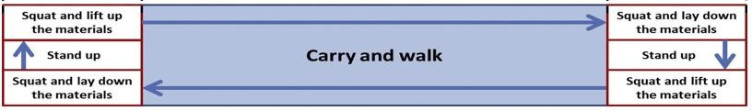

10

m

1.2

m

Figure 1. Schematic Design of Experimental Platform (adapted from [15]).

Three healthy adult participants were selected to conduct the experiment. Before starting the experiment, the participants were briefed on the testing protocol and the use of the Fitbit watches. The participants were requested to continue wearing the watches throughout the next 7 days, even during the nights. Table 2 summarizes the participant demographic features.

Table 2. Participant Demographic Features

|  |  |  |  |  |
| --- | --- | --- | --- | --- |
| **Age** | **Weight (kg)** | **Height (cm)** | **Sex** | **Ethnicity** |
| 23-26 | 68-75 | 165-170 | Male | Asian |

For seven consecutive days, each participant performed a total of 100 trials (pick up-walk-drop off) daily. The Fitbit watch recorded the participant’s heart rate throughout the experiment. The heart rate values were checked every 20 minutes. A two-minute break was scheduled after every 20 cycles of pick up and drop offs. Verbal feedback was received from the participants during each break. The RPE was determined periodically to assess the fatigue level. Figure 3 shows the data collection form. The quantity and quality of sleep were also monitored throughout the 7-day experiment. The collected data was analyzed using classification and regression models to estimate the relationship between fatigue and the monitored parameters.

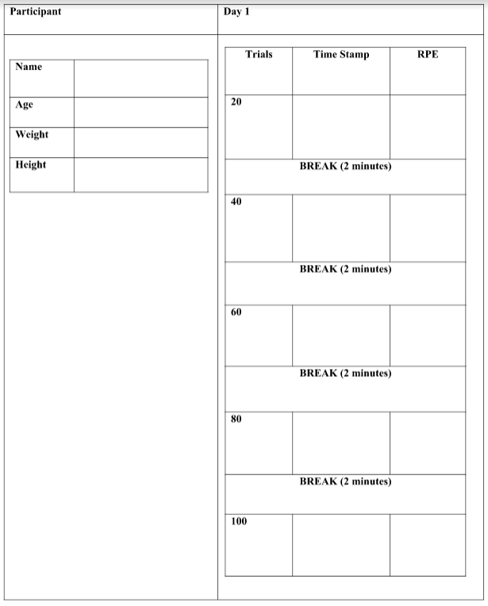

Figure 3. Data Collection Form

### **Data Extraction**

The participant heart rate data was downloaded into Google spreadsheet using the Fitbit Application Program Interface (API), and then imported into Microsoft Excel. Tables 4, 5, and 6 summarize the recorded heart rates for the participants.

Table 4. Heart Rate for Participant #1 

Table 5. Heart Rate for Participant #2 

Table 6. Heart Rate for Participant #3 

Note: The missing data in the above Tables was due to the participant feeling some back pain.

The participant sleep quality data was also extracted daily. Tables 7, 8, and 9 summarize the sleep quality details for the participants.

Table 7. Sleep Quality Data for Participant#1



Table 8. Sleep Quality Data for Participant#2



Table 9. Sleep Quality Data for Participant#3



**DATA ANALYSIS**

The experiment yielded 93 usable data points. These included the heart rate and the sleep quality (minutes asleep) of each participant, as shown in Table 10. The data in Table 10 was used to develop the models for predicting the fatigue level of the participants.

Table 10. Summary of Participants Data

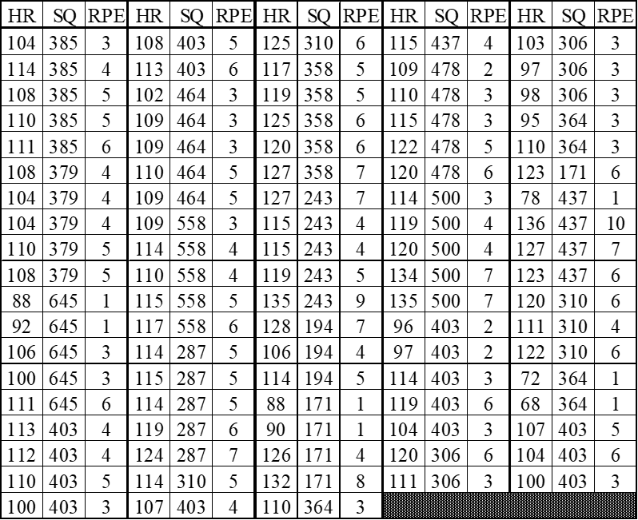

**Linear Regression Model**

Two models, regression analysis and Artificial Neural Network (ANN), were developed to predict the fatigue level. Regression analysis was selected because it is a common statistical methodology to determine the relationship between two or more variables to predict the value of the dependent variable(s). In its simplest form, the model can be developed using the following equation [16]:

(1)

where Yi is the response variable value in the ith trial, β0 and β1 are the regression parameters, Xi is the predictor variable the value in the ith trial and εi is the random error.

In multiple regression models, more than one variable is used to predict the behavior of the response variable. Therefore, Equation (1) can be transformed into the following equation:

$Y_{i}=β_{0}+β_{1}X_{i,1}+β_{2}X_{i,2}+…+β_{n−1}X_{i,n−1}+ε_{i}$ (2)

The regression equation is expected to give the best fit curve and to have variation errors given the following assumptions: (1) the errors around a regression line are independent for each value of the predictor variable; (2) the errors around a regression line are assumed constants for all variable values, and (3) the errors around a regression line are assumed to be normally distributed at each value of X [16].

In the case study presented, the Heart Rate (HR) and Sleep Quality (SQ) were the independent variables while the RPE was the dependent variable. Equation 3 presents the developed model:

$RPE=−8.611+ 0.121 HR−0.001 SQ$ (3)

Since Equation (3) can result in non-integer values, such values were rounded to the nearest integer to match the Borg’s scale ratings. For example, a computed value of 2.20 indicates a higher probability of an “easy” perceiving exertion rating (i.e., RPE=2.0).

The values of the coefﬁcient of multiple determinations R2 and R2-adjusted were found equal to 71.8% and 71.1%, respectively. These values show a good linear correlation between the fatigue exertion level (RPE), the heart rate (HR), and the sleep quality (SQ).

The F-test for regression relation and the t-test for each regression parameter ‘βk’ were also conducted to confirm the soundness of the regression model. The F-test was conducted to determine the F value for the entire model. A hypothesis test was carried out in which the null hypothesis (H0) assumed that the values of the regression coefficients (β0, β1, and β2) are equal to zero (i.e., β0 = β1= β2=0). The alternate hypothesis (H1) assumed that at least one of the coefficients is not equal to zero. As can be seen in Table 11, the F-value (statistical significance) is 114.56, while the critical value for F is 0.00. In other words, the null hypothesis is rejected, and hence at least one coefficient in the developed regression equation is not equal to zero.

Table 11. ANOVA Test Results

|  |  |  |  |  |  |
| --- | --- | --- | --- | --- | --- |
| ANOVA | df | SS | MS | F | Significance Level |
| Regression | 2 | 217.29 | 108.65 | 114.56 | 1.83E-25 |
| Residual | 90 | 85.35 | 0.98 |  |  |
| Total | 92 | 302.65 |  |  |  |

The t-tests were performed to check the significant effect of the predictor related to the response variable. To determine the validity of the regression coefficients individually, t-tests were performed separately for β0, β1, and β2. The t-test for the null hypothesis (H0) assumed that β0= 0, while it assumed that β0≠ 0 for the alternative hypothesis (H1). Similarly, the second null hypothesis assumed that β1 = 0 while it assumed that β1≠ 0 for the alternative hypothesis (H1). Moreover, the third null hypothesis assumed that β2 = 0, while it assumed that β2≠ 0 for the alternative hypothesis (H2).

Table 12 summarizes the results of the t-tests. The coefficients β0, β1, and β2 are accepted at P values of 0.00%, 0.00%, and 20.5%, respectively. In other words, the results show that β0 and β1 are significant while β2 is less significant, which suggests that Sleep Quality (SQ) has a lower impact on RPE.

Table 12. Regression Model Coefficient t-Test Results

|  |  |  |  |  |  |
| --- | --- | --- | --- | --- | --- |
| Coefficients | Values | Standard Error | t-statistic | P-Value | α-Value |
| Intercept (β0) | -8.611 | 1.031 | -8.347 | 7.840 E-13 | 0.05 |
| HR (β1) | 0.012 | 0.008 | 14.725 | 1.070 E-25 | 0.05 |
| SQ (β2) | -0.001 | 0.001 | -1.277 | 0.205 | 0.05 |

**Neural Network Model**

Artificial Neural Network (ANN) models provide good predictions based on available historical data. An ANN mimics the ability of the human brain to predict patterns based on learning and recalling processes. It is an effective prediction tool because of its ability to learn from historical data, especially when relationships among variables are unknown [17]. An ANN model was developed using GMDH Shell DS 3.8.9 package [18]. The data for the selected factors was used to train the ANN. The training criteria were the maximum and minimum absolute errors and the number of training cycles without improvements. The data was divided into two randomly selected sets: training (80%) and validation (20%). The input of the validation dataset was introduced to the trained model to generate the predicted output, which was then compared to the actual output. When the values are close, the model is considered valid. The selection of input and output variables greatly affects the ANN architecture.

In the case study presented here, the ANN had only one output neuron that represents the fatigue exertion level (RPE) and two input neurons representing the heart rate and sleep quality. The hidden layer relied on the available dataset and the nature of outputs. Several iterations were used to generate the optimal number of neurons in the hidden layer. The training and testing processes were carried out successfully with acceptable results. The ANN model values of MSE and mean absolute error (MAE) were found to be equal to 0.064 and 0.088, respectively. The results conﬁrmed the robustness of the developed model.

**Model Validation**

Validation was necessary to confirm the effectiveness of the developed models. This was done by using mathematical validation. Equations (4) and (5) show one approach for calculating the average validity/invalidity percentages (i.e., AVP and AIP) to predict possible errors. The model is sound when the AIP value is close to 0.0, and the model is not appropriate when it is close to 100 [19].

(4)

$AVP=100−AIP$ (5)

Where AIP = average invalidity percentage; AVP = average validity percentage,

The root MSE (RMSE) was estimated using Equation (6). The model is sound when the value of the RMSE is close to 0.

$RMSE=\frac{\sqrt{\sum_{i=1}^{n}{{\left(C_{i}−E_{i}\right)}^{2}}}}{n}$ (6)

Also, the MAE was determined using Equation (7). The MAE value should be close to zero for a sound model (Dikmen et al. 2005).

$MAE=\frac{\sum_{i=1}^{n}{\left|C_{i}−E_{i}\right|}}{n}$ (7)

Where RMSE = root mean squared error; MAE = mean absolute error; Ei = estimated (predicted) value; Ci = actual value, and n = number of data points.

As shown in Table 13, the results of the validation for the regression model showed AVP of 76.1, RMSE of 0.10, and MAE of 0.76. On the other hand, the validation results for the ANN model

Table 13. Model Validation Results

|  |  |  |  |  |
| --- | --- | --- | --- | --- |
| Model | AVP (%) | AIP (%) | MAE | RMSE |
| Regression | 75.9 | 24.1 | 0.75 | 0.10 |
| ANN | 81.0 | 19.0 | 0.74 | 0.24 |

showed AVP of 0.81, RMSE of 0.24 and MAE of 0.74. These values also were considered satisfactory.

Figures 5 and 6 provide a comparison between the actual and predicted results of the two developed models. Both Figures show that the predicted values were within the acceptable limits. However, the results shown in Table 13 and in Figures 5 and 6 indicate that the ANN model provided better results than the regression model. Perhaps this can be explained by realizing that the ANN model considers the nonlinear relation of the dependent and independent variables as well as the correlation between the factors that affect the participants’ fatigue.

Figure 5. Regression Model Validation Plot

Figure 6. ANN Model Validation Plot

**CONCLUSION**

This study presents the development of two models that use the heart rate and sleep quality to predict workers’ fatigue. The two models (Regression analysis and Artificial Neural Network) were developed based on data collected from a simulated construction activity (material handling). The heart rate and sleep quality time were collected using wearable sensors (Fitbit watches). The experiment involved three participants and lasted for 7 days. At the participants used the Borg’s scale to report their perceived Rating of Perceived Exertion (RPE). The developed models were validated and verified. Both models showed that the heart rate is a strong sign for fatigue. The results also showed that combining the sleep quality and heart rate gave better information than solely monitoring of heart rate.

The information gained from this research can provide can assist in creating better work-breaks schedules in labor intensive industries such as construction, manufacturing, and mining. However, to generalize the findings of this investigation, future researchers may need to increase the sample size, involve participants of variable age, gender, and health conditions.

**REFERENCES**

[1] OSHA (2010), “Construction Industry”, <https://www.osha.gov/doc/> (Sep. 1, 2017).

[2] Abdelhamid, T.S. and Everett, J.G. (2002), “Physiological Demands during Construction Work.”  Journal of Construction Engineering and Management, 128(5), 427-437.

[3] Aryal, A., Ghahramani, A., Becerik-Gerber, B. (2017), “Monitoring fatigue in construction workers using physiological measurements”, Automation in Construction, 82, 154-165, 10.1016/j.autcon.2017.03.003.

[4] Williamson, A.M. and Feyer, A.M. (2000), “Moderate sleep deprivation produces impairments in cognitive and motor performance equivalent to legally prescribed levels of alcohol intoxication.” Occupational and Environmental Medicine, 57, 649–655.

[5] Zhang, M., Murphy, L.A., Fang, D., Caban-Martinez, A.J. (2015), “Influence of fatigue on construction workers' physical and cognitive function”, Occupational Medicine (London), 65(3), 245-250.

[6] OSHA(2015). “Commonly Used Statistics.” <https://www.osha.gov/oshstats/commonstats.html> (Aug 1, 2017)

[7] Bureau of Labor Statistics (BLS) (2015), “Nonfatal Occupational Injuries and Illnesses Requiring Days Away From Work”, https://www.bls.gov/news.release/pdf/osh2.pdf.

[8] Gatti, U., Schneider, S., and Migliaccio, G. (2014), “Physiological condition monitoring of construction workers”, Automation in Construction, 44, 227–233. 10.1016/j.autcon.2014.04.013.

[9] Powell, R. and Copping, A. (2010), “Sleep Deprivation and Its Consequences in Construction Workers”, Journal of Construction Engineering and Management, 136(10), https://doi.org/10.1061/(ASCE)CO.1943-7862.0000211

[10] Hwang, S., Seo, J., Jebelli, H., and & Lee, S. (2016), “Feasibility analysis of heart rate monitoring of construction workers using a photoplethysmography (PPG) sensor embedded in a wristband-type activity tracker”, Automation in Construction. 71(2), 372-381, 10.1016/j.autcon.2016.08.029.

[11] Foster C., Florhaug, J.A., Franklin, J., Gottschall, L., Hrovatin, L.A., Parker, S., Doleshal, P., Dodge C. (2001), “Approach to monitoring exercise training”, J Strength Cond Res., 15(1),109-115.

[12] Borg, G. (1990), “Psychophysical scaling with applications in physical work and the perception of exertion”, Scandinavian journal of work, environment & health. 16 Suppl 1. 55-8. 10.5271/sjweh.1815.

[13] Chan, A., Yam, M., W.Y. Chung, J., and & Yi, W. (2012), “Developing a heat stress model for construction workers”, Journal of Facilities Management, 10, 59-74. 10.1108/14725961211200405.

[14] Borg, G.A. (1982), “Psychophysical bases of perceived exertion”, Medicine and Science in Sports and Exercise, 14(5), 377-381.

[15] Hirofumi Tanaka et al. (2001), “Age-Predicted Maximal Heart Rate Revisited”, J Am Coll Cardiol. 2001 Jan;37(1):153-6. doi: 10.1016/s0735-1097(00)01054-8. PMID: 11153730.

[16] Neter, J., Kutner, M.H., Nachtsheim, C.J. and Wasserman, W. (1996), “Applied Linear Statistical Models”, 4th Edition, WCB McGraw-Hill, New York.

[17] Sadiq, R., Rajani, B., and Kleiner, Y. (2004), “Fuzzy-Based Method to Evaluate Soil Corrosivity for Prediction of Water Main Deterioration”, Journal of Infrastructure Systems. 10(4), pp. 149, DOI: 10.1061/(ASCE)1076-0342(2004)10:4(149)

[18] GMDH, Inc. (2021). GMDH Shell. (ComputeSoftware), Retrieved from http:// <https://gmdhsoftware.com/neural-network-software/>

[19] Zayed, T. and Halpin, D. (2005), “Deterministic models for assessing productivity and cost of bored piles”, Construction Management and Economics, 23(5), 531-543.