COVER LETTER

Effect of Fermented Shrimp Waste Level in Feed on Biological Value on Native Chicken

Abun Abun^{1*}, Kiki Haetami², Denny Rusmana¹, and Triyogi Ganda Sukma Atmaja³
¹Department of Animal Nutrition and Feed Technology, Padjadjaran University, Sumedang-West Java, Indonesia.
²Department of Fisheries, Padjadjaran University, Sumedang-West Java, Indonesia.
³Alumni of Animal Husbandry, Padjadjaran University, Sumedang-West Java, Indonesia.
*Corresponding author Tel: +6281394370007; EM: abunhasbunap@gmail.com; abun@unpad.ac.id (0000-0003-1017-4365).

Dear Prof. Guangshun Jiang, Northeast Forestry University, China
Editor-in-Chief Journal of Zoological Research

On behalf of all the authors, I would like to submit an original research article entitled “Effect of Fermented Shrimp Waste Level in Feed on Biological Value on Native Chicken,” by Abun Abun, Kiki Haetami, Denny Rusmana, and Triyogi Ganda Sukma Atmaja. for publication in the Journal of Zoological Research.
I want to ask for the consideration of editors and reviewers so that this article can be accepted and published in the Journal of Zoological Research.
This research did not receive any specific funding, and No data availability.
This article has not been published and is not under consideration for publication elsewhere. We have no conflicts of interest to disclose, but we respectfully request that you review our article immediately.

Thank you for your consideration
November 11, 2021
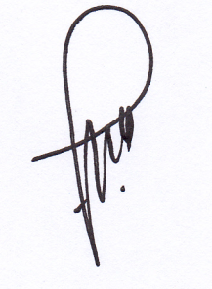

[Dr. Abun, A.]
Department of Animal Nutrition and Feed Technology, Padjadjaran University, Sumedang-West Java, Indonesia, 45363
e-Mail: abunhasbunap@gmail.com; abun@unpad.ac.id

